BA (Hons) Leadership and Management Skills for the Workplace

Module Name and Code: Leading and Implementing Workplace / BMSW6103

Assignment Title: Change Management Portfolio

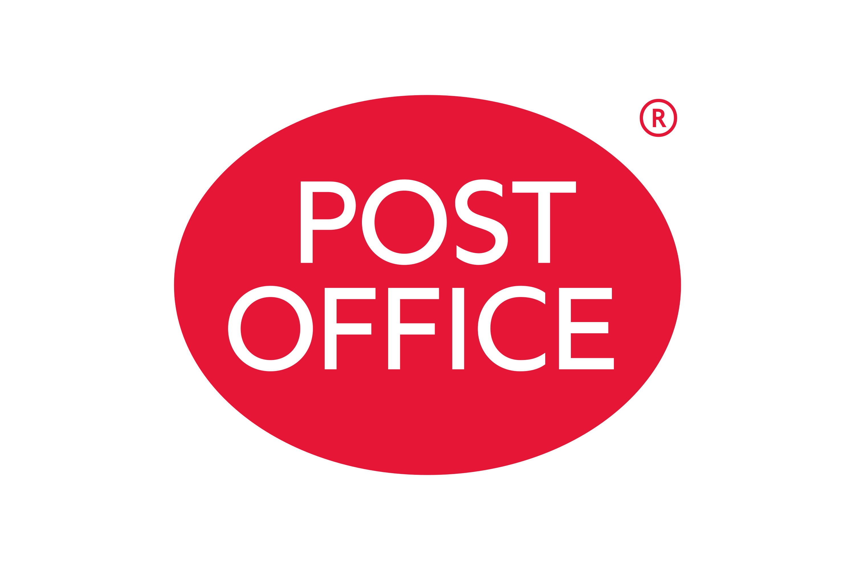

Lecturer: Mr. Nauman Ali
Date:01/07/2022

TABLE OF CONTENTS

1. INTRODUCTION ………………………………………………………………………………………………………………3

2. What is Power? ………………………………………………………………………………………………………………3/4

3. What is Organisation Politics? …………………………………………………………………………………………4

3.1 Power and Politics manifestation at Post Office …………………………………………………………….4

3.2 What caused the strike? ………………………………………………………………………………………………..5

3.3 What are the implications of strike action ……………………………………………………………………..5

3.4 Change Management Model …………………………………………………………………………………………5

3.5 Image of Post Office ………………………………………………………………………………………………………6

3.6 Moral Issues at the Post Office ………………………………………………………………………………………6

4. Stakeholder/ Theories/Analysis ………………………………………………………………………………………6/7

4.1 Power Interest Matrix Model ……………………………………………………………………………………….7/8

4.2 Salience Model …………………………………………………………………………………………………………….8/9

4.3 Critical Stakeholders/ Stakeholders Communication Plan …………………………………………..9/10

4.4 The Difference Between Salience & Power Interest Matrix Model & limitations ………….11

5. Thomas Kilman’s Conflict Resolution Model ………………………………………………………………11/12

5.1 Dispute Resolution based on Thomas Kilman Model ……………………………………………….12/13

5.2 Disputes and Conflict Resolution ……………………………………………………………………………..13/14

6. Conclusion ……………………………………………………………………………………………………………………..15

7. Recommendations ………………………………………………………………………………………………………. 15

8. References ………………………………………………………………………………………………………………….. 15

INTRODUCTION

The Post Office is a national institution that has 11,500 branches across the UK, officially making it the biggest retailer in the UK according to Post Office (2022). Serving the local communities in the UK for centuries, by providing its communities with services such as banking, mail, parcels, bill payments, government services, renewing passports and accessing universal credit, reported by Post Office (2022). The report identifies the critical stakeholders that will be impacted by the strike action and the manifestation of power and politics of Post Office employees and management at play. For the organisation to make these rapid changes, a new change management must be implemented for the Post office to accept the new norms. A dispute that needs to be sorted, to avoid further strike actions and disruptions to the operations of the Crowned owned Post Offices, needs a quick conflict resolution. The report will conclude with its own recommendations to the conflict.

What is Power?

Power is the propensity to coerce people to work or accomplishing something in an organisation. It is the ability to get the people to do what you want them to do. Power in an organisation can be described as an organisational structure and design through a hierarchy system. According to Mullins (2006) it can be interpreted to effect compliance of stakeholder’s practises, and behaviours with or without their consent. A person can have power over you if that person has the authority and control in something that you want. Robbins (1988).
Power an organisation is perceived not by the stakeholders but by the processes and the structure of the organisations. Evidently, people or leaders may leave the organisation, but the organisation will still operate after they are gone. Therefore, organisation power is a fundamental attribute for work and the foundation for implementing techniques in which activities and work are fulfilled. Although power is something that can be exerted there are layers in sources of power. Raven (1992).
Formal Power – is the person that is responsible in an organisation.
- Coercive Power is based on the ability to punish (when work structure or policies are not followed)
- Legitimate Power comes from a person in the hierarchy such as a manager
- Reward Power is something that someone that dispenses the rewards that others want and desire. Stated by Ali (2022).
There are also differences in cultural power distance in business and management from larger power distance cultures (Asian and South American cultures) and smaller power distance cultures UK, USA, European and Australian cultures. These differences can be distinguished by supervisors, privileges information and much more according to Hofstede (2001).
Power assignment in business and management cultures differ on how they assign organisational power and status suggests Trompenaars and Hampden-Turner (1997).
Ascription – orientation: Power and status are ascribed in accordance with person of age, gender and education and connections. (These are found in countries culture influenced by Confucianism, Catholicism and Buddhism)
Achievement – orientation: Power and status are awarded by what they achieve through education knowledge and performance. (This is found in more of the Protestant cultures like North-West Europe and USA) stated by Arrindell (2003).

What is Organisation Politics

According to Robbins and Judge (2016), organisational politics defined is the informal advances to attain power through means other than hard work. Power can be attained directly or indirectly when politics is used in the organisation. Power is attained in many ways by resources or promotions. Robbins and Judge (2016).
Organisational politics are often used by leader’s by getting important resource and finances. People want power for many different reasons. With more money, comes more power, and status, which is why political behaviour is widespread in organisations. Robbins and Judge (2016). The very shape of large organisations is the most fundamental reason why organisational members are motivated towards political behaviour, only so much power is therefore available to distribute among many people who would like more of it, argues Kapoutsis and Thanos (2016),
People often resort to organisational politics because they do not believe that the organisation has an objective and fair way of judging their performance and suitability for promotion, mentioned by Kapoutsis and Thanos (2016).
Similarly, when managers have no objective way of differentiating effective people from less effective, they'll resort to favouritism. when people operate in an unstable and unpredictable environment, they tend to behave politically, uncertainty makes it difficult to determine what they should really be accomplishing according to Robbins and Judge (2016).
According to Robbins and Judge (2016), some people resort to political manoeuvres to integrate themselves with supervisors because they lacked confidence in their own talented skill. most organisational leaders say that they prefer honest feedback from subordinates yet without meaning to these same managers and leaders encourage flattery and praise.

3.1 Manifestation of Power and Politics at Post Office
The power and politics exhibited from the management had caused this dispute. The management had not heeded government guidelines that were set reported Timmins (2022). If the guidelines were met, the post office workers would have had a £250 wage increase. But the management decided to impose a pay freeze stated Timmins (2022). With the post office key workers working through the pandemic, the post office made a huge profit during these few years, enough for the management to provide their workers with a reasonable pay increase but management choose not to according to Timmins (2022). This manifested in power play by post office workers when their union got involved, the Communication Workers Union (CWU). Who supports their members concerns and what is fair. Now members are threating strike action, power is being showed by employees that their demands must be met, as the 2% pay increase and £250 one off payment is an insult to the workers, reported Timmins (2022).

3.2 What caused the strike?
The strike was caused by an offer of a proposal by Post Office management of a pay increase of 2% and a £250 one off payment. Despite making huge profit in those years, the management insisted on a pay freeze from 2021 and 2022. The offer is well below the cost of living and is rising at 7% a year, insisted the CWU.

3.3 What is the implication of strike action?
The strike action will involve 114 branches in the UK that are directly owned by the company, reported by Timmins (2022). The branches are predominantly on high streets and city centres. The post offices affected by the strike also affect the sub-post offices having no cash deliveries or collections. A strike already took place in May 2022, with further strikes planned reported Timmins (2022). Approximately 3,500 staff members were affected by the dispute. Those also affected are the customers that bank with the post office or use other facilities over the counter. The implications would mean a change in new management organisational structure.

3.4 Change Management Model
According to Pathak (2011) Kurt Lewin’s 3 Stage Model is a process of change that has a 3-step change. By moving towards a new desired level of behaviour, and finally Refreezing that new behaviour as the new norm.

- Unfreezing - The Unfreezing stage indicates the importance of preparing for the Change
- Change - Creating an awareness of the need for change is the responsibility of the leadership of the organisation. Change itself is the movement from an old way of doing things to a new way.
- Re-freezing - The Refreezing stage reflects the importance of following up to the change to make it permanent.

Kurt Lewin’s 3 Stage Model changes a systematic process of transition from an old way of doing things to a new way. Brown et al (2016).
Unfreezing, making employees understand the importance of a change and how their jobs will be affected by it. Brown et al (2016). The employees who will be most affected by the change. Must be made aware of why it is needed. Which in effect makes them dissatisfied enough with current operations to be motivated to change.
Change may entail installing new equipment, restructuring the organisation, or implementing a new performance appraisal system. Anything that alters the existing relationships or activities. Brown et al (2016).
Refreezing makes new behaviours relatively permanent and resistant to further change. Examples of Refreezing techniques include repeating newly learned skills in a training session and then role-playing to teach the new skill. In a real-life work situation, Refreezing is necessary because without it the old ways may return, argues Brown et al (2016)
DRIVING FORCES
RESTRAING FORCES
DRIVING FORCES
RESTRAINING FORCES

3.5 Image of Post Office
The Post Office has been around the UK’s high streets and communities for centuries. It is the UK’s largest retailer of more than 11,500 branches. The Post Office is a well-recognised company of the United Kingdom and around the world. Post Office (2022). The Post Office provides mail, parcel, banking, bill payments, travel money and government services too. Post Office (2022). The image of the Post Office will not be tarnished as it has a long-established history with its customers. Although the strike action will affect the customers and workers alike, the customers will understand and empathise with the Post Office workers.

3.6 Moral Issues at the Post Office
While the identified 114 branches on strike action that are owned by the crown. The majority of its 11,000 are not covered by the strike and will resume its normal opening hours. Customers would presume that all Post Offices are all the same. Also, there will be no cash deliveries or collections that would affect the sub post offices. The CWU has said the morale of its members are ‘sky high’. CWU (2022). Right across the country all members were all backing the strike action, who were all enthusiastic and united and standing up for themselves reported by CWU (2022).

4.Stakeholder/ Theories/Analysis
Neo Classical Theory Milton Friedman (1970), on Stakeholders Management suggests that by maximizing profits for shareholders and by being accountable to themselves and the shareholders. The only aim of the business is to utilise its resources and increase its profits so long as it is trades within the rules and regulations. By engaging in open and free competition without fraud and deception.
Socio-economic Theory Edward Freeman (1984) suggests that groups or individuals should benefit if harmed from its organisational activities. Implying that organisations have an obligation to groups other than the shareholders. That accountability should extend to groups considered to be important for the continuity and the welfare of the society.

Who are stakeholders? Stakeholders are list of people who might have an interest in or effected by the organisation. They could include clients, customers, shareholders, trade unions, or people in their community. Some of these people will have a big Influence while others will have none. They are individuals or groups who have power ability to reply to change of the organisation. Eden and Ackerman (1988). A stakeholder is an individual or a group that could affect or impact the success of an organisation’s objectives. Freeman (1984)

Stakeholder Analysis is the ability to identify the critical stakeholders that may affect the success of the organisation. This will help see future problems and difficulties by achieving the organisation goals and better communication between critical stakeholders To understand the stakeholders and their importance two models are illustrated in this report, the Power Interest Matrix Model and the Salience Model.

4.1 Power Interest Matrix Model
According to Ali (2022), lectured that the stakeholders can be assessed and categorised by the assumption of power they possess, and the extent to which they are likely to have or show an interest in the organisation activities. See figure below, the X axis identifies stakeholders ‘Interest’ and on the Y axis identifies stakeholders ‘Power’.

- Power – How much influence do they have on a project or idea.
- Interest – How much interest or benefit they have in a project or an idea.
HIGH

POWER

LOW

HIGH INTEREST LOW

Figure 1: Power Interest Matrix Model
High Power – High Interest: these stakeholders are likely to be decision makers and have the biggest impact on a project success. These Stakeholders need close attention to manage their expectations. These stakeholders need to be managed closely.
High Power - Low Interest: these stakeholders need to be kept informed with what is happening on a project. They may not be interested in the outcome, but these stakeholders yield power. These stakeholders should be dealt with cautiously as they can use their power in a negative way if they are become unsatisfied. So, these stakeholders need to be satisfied.
Low Power – High Interest: Stakeholders need to be adequately informed and talk to them to ensure that no major issues are arising. These stakeholders can often be very helpful with the detail of a project. These stakeholders need to be informed.
Low Power – Low Interest: these stakeholders need monitoring but do not need excessive communication. These stakeholders need to be monitored.

4.2 The Salience Model

The concept of stakeholder salience was proposed by Ronald Mitchell et al in 1997. This is another way of identifying and analysing the requirements of your stakeholders. The salience model unlike the power interest grid which has four parameters to categorise the stakeholders, the salience model has only three para metres. Power interest grid has high power, low power, high interest, and low interest. Ali (2022). The Salience model has only three parameters. The three parameters of salience model are.
- Power - Stakeholders ability to influence the outcome of a deliverable or the entire project. That is what power is all about. Someone at a higher position in the organisation is going to have a lot of power.
- Legitimacy – is the assumption that the actions of an entity are desirable, proper, or appropriate within some socially constructed system of norms, beliefs, values, and definitions. Suchman (1995).
- Urgency - is defined as the degree of stakeholder’s expectation of immediate response time. Not just on time sensitivity but on how critical the relationship is with stakeholder or the importance of their claim according to Mitchell et al (1997).

The different regions of the diagram can represent a specific type of stakeholder, and these can guide the project manager in how to manage them according to Ali (2022).
- Definitive: Stakeholders that have power, legitimacy, and urgency, and deserve focused attention.
- Dormant: Stakeholders that have power, but no legitimacy or urgency. They are unlikely to be involved in the project.
- Dominant: Stakeholders that have power and legitimacy, but little urgency. They have certain expectations that should be met.
- Discretionary: Stakeholders who have legitimacy, but little power or urgency. Regular status updates will keep them happy.
- Dependent: Stakeholders who have legitimacy and urgency, but little power over the project. They need to be managed closely as they can ask another group with more power to push for their requests.
- Demanding: Stakeholders who have little power or legitimacy, but always seek immediate attention. You are better off spending more time with other stakeholders with legitimate concerns.
- Dangerous: Stakeholders who have power and urgency, but no legitimacy. They are not pertinent to the project, so the project manager needs to engage them cautiously, lectured by Ali (2022).
.

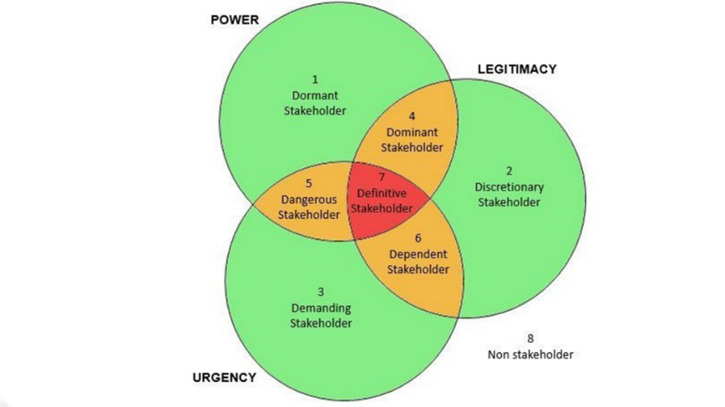

Figure 2: Ali (2022), Salience Model Venn Diagram.

4.3 Critical Stakeholders/ Stakeholders Communication Plan
For the report the Power Interest Matrix was implemented. By categorising the stakeholders in accordance with the importance on how the power and influence on the organisation. Placing them on how high they are in the quadrant or low in a quadrant according to their stake in the organisation. The critical stakeholders identified are the owner/government, workers, managers, and customers and the trade unionists.
Stakeholders, Owner/Government: Post Office is owned by the UK Government. They also legislate laws on how to operate and pay appropriate taxes and having a corporate and social responsibility (CSR), and the welfare of its employees. Doh et al (2019). They have high power, high interest as its their company that is at stake.
Stakeholders, Workers/Managers: The workers as well as the managers get paid wage/salary from the organisation. Effectively they run the day to day running of the organisation whilst identified in the matrix making profit for the company. Freeman et al (2007). They have a High Power, High Influence identified in the matrix.
Stakeholders the customers: These are essentially the people who buy or use a product over the counter at the Post Office. Sending mail, parcels or other government services like passport forms or universal credit payments. They are the consumers that use these services, and gain profits for the organisation. They are High Power, High Influence identified in the matrix.
Stakeholders, The Trade Unions (CWU): This stakeholder is leading its members in assistance in better pay, conditions and to improve public services by either campaigning or by strike action. Gumbrell-McCormick and Hyman (2013). This stakeholder is High Power, High Influence identified in the matrix.

By identifying the stakeholders, they are now processed in the ‘Stakeholders Communication Plan’, in the importance of communication with the organisation and their stakeholders. (See Figure 3 below).

Stakeholder Communication Plan
Stakeholder | Power/Interest | Key Interest & Issues | Communication channel | Frequency | Comments
Community | Low/high | Unaware | Local events or local charities | Occasionally | Keep informed
Customers | High/low | Neutral | Newspaper/flyer/social media word to mouth | Frequent | Keep satisfied
Government | High/high | Supportive | Email/office/letters | Frequent | Manage Closely
Workers and Managers | High/high | Resistant | Emails/memos/newsletter  Or Staff Meetings | Frequent | Manage Closely
Owner or Shareholders | High/high | Resistant | Annual Report/ | Frequent | Manage Closely
Trade Unions | High/high | leading | Members | Moderately | Manage Closely
Figure 3 Stakeholders Communication Plan

4.4 The Difference Between the Salience & Power Interest Matrix Model & Limitations
The stakeholders model of Power Interest Matrix and the Salience Model all identifies stakeholders that are vital to the organisation. These model are imperative to keep your stakeholders engaged through a communication process, Husted and Allen (2011). The Salience Model is a more comprehensive model that identifies stakeholders on the bases of power, urgency and legitimacy for larger projects. Whilst the Power Interest Model is useful for small projects or identifying simple relationships between stakeholders and the organasation. Power Interest Model identifies stakeholders on the basis of power and the interest they are likely to have or show in the organisation’s activities. Husted and Allen (2011). The limitations of Power Interest Matrix Model as that the stakeholder’s interest or power may have changed or increased of the lifetime of the stakeholder and may need to be looked at again. The Limitations of the Salience Model have it takes so a lot of resources and can be very time consuming and monitor all the aspects of the salience model.

5.Thomas Kilman’s Conflict Resolution Model
Assertiveness
Cooperativeness

Figure 4 Thomas Kilman Conflict Resolution Model (1970)

The Thomas Kilmann model of Conflict management organises five conflict management styles based on axis X, is Assertiveness and axis Y, Cooperativeness.
Thomas Kilman argued that people react differently to conflict and even to their conflicting interests. Every style has different degrees of assertiveness and cooperativeness. The quadrants are Competition, Collaboration, Avoidance, Accommodation and Compromise.

5.1 Dispute Resolution based on Thomas Kilman Model
Reflecting on Thomas Kilman’s Conflict Resolution Model (1970), in any conflict, dispute situation, you may respond in one of several ways by competing, accommodating, avoiding, collaborating, or compromising. (See figure 4 above)
- Competition: This is considered a ‘win lose’ approach. You act in an assertive way to achieve your goals without seeking to cooperate. End it just may be at the expense of others. This approach may be appropriate for emergencies when time is of the essence, or when you need a quick, decisive decision, articulated by Kilman and Thomas (2008)

- Avoidance: is when you simply avoid the issue. You're not helping others reach their goals and you are not pursuing your own. This works when the issue is trivial or when you have no chance of winning. It is also very effective when the atmosphere is emotionally charged, and you need to create some space according to Kilman and Thomas (2008).

- Collaborating: style can be described as a ‘win win’ approach. This can be effective for complex scenarios where you need to find a new or innovative solution. This can also mean re framing the challenge to create a bigger space for everyone's ideas. The downside of this style is that it requires a high degree of trust and reaching consensus can require a lot of time and effort to get everyone on board according to Kilman and Thomas (2008).

- Accommodating is to cooperate to a high degree, and just may be at one’s expense and work against one’s goals. This approach is effective when the other party is the expert, who has a better solution. This is a ‘lose-win’ scenario. It can also be effective for preserving future relations reported by Kilman and Thomas 2008).

- Compromising: this is considered a ’lose lose’ scenario. Neither party really gets what they want. It requires a moderate level of assertiveness and cooperation. It may be appropriate for scenarios where you need a temporary solution, but the trap is that you may fall into compromising. As an easy way out. We can use each style when approaching conflict. Our choice of style impacts the outcome of the conflict resolution. Kilman and Thomas (2008).

Using Thomas Kilman’s Conflict Mode Instrument, the approach that everyone should ideally aim for is the Win-Win approach. This can only be done by collaboration. This means that all stakeholders involved in the dispute, employer, employee, and the trade unions (CWU) need to all sit down and discuss their conflict and dispute by agreeing on a resolution that is a win-win for all. The limitations of this is that it very time consuming process which takes a huge amount of effort, especially getting all stakeholders to sing from one hymn sheet.
Again, using the Thomas Kilman’s Conflict Mode Instrument another approach would be Lose-Win approach. This approach may not be a Win-Win but is effective on preserving the future relationships with stakeholders. It may go against one’s goals and the other party being the expert who has the solution would be a ‘Lose-Win’ scenario. The downside to this that the issue may persist and may flare up again in time. It may be a quick fix. But this resolution comes at one’s own expense.

5.2 Dispute and Conflict Resolutions
There is a fine line between a dispute resolution and conflict management according to Dix et al (2008). Whilst a dispute can be defined as a short-term disagreement and a conflict can be defined as a long-term disagreement. While conflicts unlike disputes may not easily be resolved. A dispute however can be resolved through arbitrary, judicial or trade unionists, argued by Burgess and Spangler (2015).
There is different perspective on organisational conflict. A Unitarist perspective is seen as bad and unhealthy for the organisation as it sees itself a good harmonious structure. A Pluralist perspective conflict is inevitable. As all stakeholders have different views, goals, and perspective. They all view things accordingly as they all seek their own objectives. Interactionist perspective conflict is something that is necessary for an organisation’s effective performance. Here, rather the conflict being ignored is embraced, as it is healthy for the organisation to learn and embrace change from conflicts. Townsend (1985). A Radical perspective – stems from Marxism where conflict is seen as an inevitable side of capitalism and endemic in an organisation that is structured on bureaucracy. This type of conflict is viewed on the disparity in power in an unequal nature of organisational life, Meyer, et al (2007).
Disputes need to be addressed as they are seen as warnings when they arise. It needs to be resolved before it escalates and before the relationship of stakeholders breaks down. Organisational disputes can be collective such as strike action, or individual such as raising a grievance of bullying, harassment, or discrimination. Disputes may resolve through such interventions as negotiation, bargaining, mediation, conciliation, arbitration, or trade unionists argues Dix et al (2008).
Mediation is a simpler way of resolving issues within a company or organisation and organisations are more likely to take these steps first. A third party will facilitate between the organisations and employees to come to an agreement. Mcllwrath and Savage (2010). This strategy used will help to keep a good business relationship, once this procedure is done. It is generally very quick for a resolution. Cooley (1985). Mediations is described as formal hearings with witnesses testifying under oath, where in one statute the third party as – neutral – are called interchangeably mediators is described as impasse panels according to Cooley (1985). Everything that has happened and that is said in a mediation is completely confidential. It costs considerably less than litigation according to Bühring-Uhle et al (2006). The mediator always encourages a solution that suits both parties and hopefully allows the both parties to walk away happy, suggests Bühring-Uhle et al (2006). Disadvantages. If the parties cannot come to an agreement, further action will be required, and the cost of the mediation would have been wasted. Parties concerned may also be worried that they may have disclosed sensitive and important aspects of their arguments or their commercial position, which can compromise them when conducting further dispute resolution methods, or if it goes all the way to a trial proceeding.
Adjudication. This option means a neutral third party will give a decision on a dispute in construction industry in the UK according to Gardiner and Leonard (2017). The decision made by the adjudicator will be binding and can decide to take the case further and engage the arbitration or litigation process, suggests Gardiner and Leonard (2017). Benefits. The adjudicator is completely independent to both the disputing parties. Adjudication affectively accesses to pay now, argue later mechanism, states Gardiner and Leonard (2017) which helps maintain the company's cash flow throughout the dispute. It is inexpensive compared to court proceedings. Disadvantages? The adjudicators powers are limited, which may result in further dispute resolution methods being necessary. Also, court proceedings may be required if the losing party fails to pay or adheres to the outcome reached.
Arbitration like adjudication the parties all agree to refer the dispute with a third party, but here the disputes are judged and analysed based on facts, available documents and relative principles of the law governed by the Arbitration Act 1996 according to McIlwrath and Savage (2010). Benefits arbitrators hold stronger powers than adjudicators. Mcllwrath and Savage (2010). Arbitration is completely confidential process. Both parties have a say on who the expert arbitrator. Cooley (1985). Compared to court and litigation, arbitration is a cheaper option. This is more flexible than court proceedings. Bühring-Uhle et al (2006). Disadvantages? There are limited appeal rights when using this method. Parties must bear the cost of both the arbitrator and the venue. There are limited powers available to the arbitrator for party fails to comply with the directions, and rules set out in the process.
Mitigation. This is where the dispute gets referred to the commercial courts. If there are any financial disputes. A wide range of commercial court cases can be dealt with from insurance, commodities, and arbitration. If the case is smaller and less complex it can be dealt by the Circuit Commercial Court suggests GOV.CO.UK Advantages throughout the process, the judge will manage the proceedings according to GOV.CO.UK (2022). Useful for complex financial issues, disputes where a great deal of money is at stake. The parties will obtain an enforceable and binding decision. Disadvantages? It is generally a very slow process. It's extremely often the most expensive way to resolve any given dispute. Unlike the arbitration and adjudication methods, the proceedings are generally public and therefore cannot be kept confidential.
Although third parties involved can conduct resolutions the organisations tend to resist third party involvement and negotiations between employee representatives and management. This is because large organisation prefers to sort their inhouse disputes and manage conflicts within their organisational professional conduct and competencies, argues Euwema et al (2019).

Recommendations
Understanding the complexities of the disputes and the macro environment that had impacted the economy due to the covid-19 pandemic which played a major uncertainty in the markets and around the world. The stakeholders, government and management should take care and heed the government guidelines that would not put the organisation in a precarious situation and resulting in strike action which would disrupt the running of its operations and having ramifications to the wider operations of its organisation and its major stakeholders the consumer. Furthermore, Euwema et al (2019) argues that given the nature of the industrial relations there is latent conflict in the interests of employees and employers that can develop and escalate, like strike actions. So, clear, distinctive, social dialogue and communication is imperative to avoid such disputes and actions.

Conclusion
The manifestation of power and politics that ultimately play a massive part in organisations, leading to conflicts and disputes, from industrial capitalism that the collective, that actions towards strikes, have been going on for centuries articulates Edwards and Nielsen (1985). This inevitability of strike can cause discord between management and employee so action must be taken to restore the relationships between the internal stakeholders. Furthermore, It is important to learn from the methodology and theorists in an evolving organisations and that from conflicts and disputes comes a resolution that is always a learning curve for organisations to learn and survive.

Reference

Arrindell, W. (2003) ‘Culture’s consequences: Comparing values, behaviours, institutions, and organizations across nations: Geert Hofstede, Sage Publications, Thousand Oaks, California.
Bühring-Uhle, C., Kirchhoff, L. and Scherer, G., 2006. Arbitration and mediation in international business. Kluwer Law International BV.
Cooley, J.W., 1985. Arbitration vs. mediation-explaining the differences. Judicature, 69, p.263.
Corporate.postoffice.co.uk. 2022. What we do. [online] Available at: <https://corporate.postoffice.co.uk/en/about/our-story/what-we-do/> [Accessed 7 August 2022].
Corporate.postoffice.co.uk. 2022. Who we are. [online] Available at: <https://corporate.postoffice.co.uk/en/about/our-story/who-we-are/> [Accessed 7 August 2022].
Corporate.postoffice.co.uk. 2022. Who we serve. [online] Available at: <https://corporate.postoffice.co.uk/en/about/our-story/who-we-serve/> [Accessed 7 August 2022].
Cummings, S., Bridgman, T. and Brown, K.G. (2016) ‘Unfreezing change as three steps: Rethinking Kurt Lewin’s legacy for change management’, Human relations (New York), 69(1), pp. 33–60. doi:10.1177/0018726715577707.
CWU. 2022. ‘Determined’ members’ morale is ‘sky high’ after today’s Post Office strike. [online] Available at: <https://www.cwu.org/news/determined-members-morale-is-sky-high-after-todays-post-office-strike/> [Accessed 8 August 2022].
Dix, G., Forth, J. and Sisson, K. (2008) ‘Conflict at Work: The pattern of disputes in Britain since 1980’. NIESR Discussion Paper. 316.
Doh, Jonathan, Bryan W. Husted, and Valentina Marano, 'Corporate Social Responsibility in Emerging Markets', in Abagail McWilliams and others (eds), The Oxford Handbook of Corporate Social Responsibility: Psychological and Organizational Perspectives, Oxford Handbooks [online] edn, Oxford Academic, 6 Nov. 2019), https://doi.org/10.1093/oxfordhb/9780198802280.013.27, accessed 10 Aug. 2022.
Edwards, R. and Nielsen, R.P. (1980) ‘Contested Terrain: The Transformation of the Workplace in the Twentieth Century’, The Academy of Management Review, 5(4), pp. 625–627. doi:10.2307/257476.
Euwema, M.C. et al. (2019) Mediation in Collective Labour Conflicts. 1st ed. 2019. Edited by M.C. Euwema et al. Cham: Springer International Publishing. doi:10.1007/978-3-319-92531-8.
Freeman, R.E., Harrison, J.S. and Wicks, A.C. (2007) Managing for stakeholders survival, reputation, and success. New Haven: Yale University Press. doi:10.12987/9780300138498.
French, J.P. and Raven, B. (1959) ‘The bases of social power’ in Cartwright, D. and Zander, A.F. (Eds) Group Dynamics: Research and Theory. London: Tavistock.
Gardiner, H. and Leonard, E., 2022. Statutory adjudication of construction contracts in the UK. [online] Womble Bond Dickinson. Available at: <https://www.womblebonddickinson.com/uk/insights/articles-and-briefings/statutory-adjudication-construction-contracts-uk#:~:text=Adjudica%C2%ADtion%20is%20a%20form%20of%20dispute%20resolution%20procedure,disputes%20on%20a%20binding%2C%20but%20not%20final%20basis.> [Accessed 10 August 2022].
GOV.CO.UK, 2022. https://www.gov.uk/guidance/take-a-business-dispute-to-the-commercial-court#cases-dealt-with-by-the-court. GOV.CO.UK.
Gumbrell-McCormick, Rebecca, and Richard Hyman, 'Hard Times: Challenges and Responses', Trade Unions in Western Europe: Hard Times, Hard Choices (Oxford, 2013; online edn, Oxford Academic, 23 Jan. 2014), https://doi.org/10.1093/acprof:oso/9780199644414.003.0002, accessed 07 Aug. 2022.
HENDEL, T., FISH, M. and Galon, V. (2005) ‘Leadership style and choice of strategy in conflict management among Israeli nurse managers in general hospitals’, Journal of nursing management. Accepted for publication: 1 July 2004. Oxford, UK: Blackwell Science Ltd, 13(2), pp. 137–146. doi: 10.1111/j.1365-2934.2004.00525.x.
Hofstede, G., Minkov, M. and Hofstede, G.J. (2010) Cultures and organizations: software of the mind. Third edition. New York: McGraw-Hill.
Husted, B. and Allen, D.B. (2011) Corporate social strategy : stakeholder engagement and competitive advantage. Cambridge: Cambridge University Press.
Hyman, R., 1989. Strikes. eBook: Palgrave Macmillan UK.
Kapoutsis, I. and Thanos, I. C. (2018) ‘Politics in organizations: Lessons, challenges and future directions’, European management journal. Oxford: Elsevier Ltd, 36(5), pp. 589–592. doi: 10.1016/j.emj.2018.10.001.
Kilman, R. and Thomas, K., 2008. Thomas-Kilmann conflict MODE instrument. [online] Research Gate. Available at: <https://psycnet.apa.org/doi/10.1037/t02326-000> [Accessed 8 August 2022].
Lyddon, D. (2015), "The changing pattern of UK strikes, 1964-2014", Employee Relations, Vol. 37 No. 6, pp. 733-745. https://doi.org/10.1108/ER-05-2015-0084
McIlwrath, M. and Savage, J., 2010. International arbitration and mediation: a practical guide. Kluwer Law International BV.
Meyer, E., Ashleigh M., George J.M. and Jones G.R. (2007) Contemporary Management. Maidenhead: McGraw-Hill
Mullins, L, & McLean, JE 2019, Mullins: Organisational Behaviour in the Workplace, Pearson Education, Limited, Harlow. Available from: ProQuest eBook Central. [5 August 2022].
Mullins, L.J. (2006). Essentials of Organisational Behaviour. FT Prentice-Hall
Nicolson, P. (1996) Gender, power and organisation: a psychological perspective. London: Routledge.
Pathak, H., 2011. Organization Development. New Delhi: Pearson India.

Raven, B., 1992. The Bases of Power. [Washington, D.C.]: Distributed by ERIC Clearinghouse.
Robbins, S, & Judge, T 2016, Organizational Behavior, eBook, Global Edition, Pearson Education, Limited, Harlow. Available from: ProQuest eBook Central. [5 August 2022].
Robbins, S.P. (1998) Organizational Behaviour. (8th ed) Prentice-Hall
Spangler, Brad., & Burgess, Heidi. (Jul 2012).” Conflicts and Disputes.” Beyond Intractability. [online] Available at <http://www.beyondintractability.org/essay/conflicts-disputes>. [Accessed 8 august 2022].
Thomas, K.W., 2008. Thomas-kilmann conflict mode. TKI Profile and Interpretive Report, 1(11).
Timmins, B., 2022. Post Office strike: Workers to walk out overpay dispute. [online] BBC News. Available at: <https://www.bbc.com/news/business-61300417> [Accessed 6 August 2022].

