Matthew Satterthwaite
Student: 1910496

ACDA4011 – L4 Chemistry

Document: Chemistry of Grenades

23 November 2020

Contents
Contents ii
1 Introduction 1
1.1 Background 1
1.2 Document Scope 1
1.3 Methodology 1
2 Thermochemistry of Explosives 2
2.1 Oxygen Balance 2
2.2 Kistiakowsky-Wilson (KW) Rule 2
2.3 Modified KW Rules 3
2.4 Heat of Formation (∆H) 3
3 The Grenade 4
3.1 Product History 4
3.2 The Ignition Train 4
3.2.1 Figure 3-1 Shows a sectioned example of a HE grenade. 4
4 The Primary Composition (Tetrazene) 6
4.1 Composition Introduction 6
4.2 Production 6
4.3 Material Properties 6
4.4 Calculations 7
4.5 Conclusion 7
5 Delay Composition (Blackpowder) 7
5.1 Composition Introduction 7
5.2 Production 8
5.3 Material Properties 8
5.4 Calculations 8
5.5 Conclusion 10
6 Booster Explosive (PETN) 10
6.1 Composition Introduction 10
6.2 Production 10
6.3 Material Properties 11
6.4 Calculations 11
6.5 Conclusion 12
7 Main Explosive (COMP B) 13
7.1 Composition Introduction 13
7.2 Production 13
7.3 Material Properties 14
7.4 Calculations 14
7.5 Conclusion 15
8 Annex 16
8.1 Annex A 16
9 References 17

List of Figures
Figure 2-1: Hess’ Law 3
Figure 3-1: HE Grenade [5] 4
Figure 3-2: Spring-Loaded Striker 5
Figure 4-1: Tetrazene Chemical Structure 6
Figure 6-1: PETN Nitration 10
Figure 7-1: RDX Structure 13
Figure 7-2: Individual Comparisons of RDX and TNT 16

List of Tables
Table 2-1: KW Rules [2] 2
Table 2-2: Modified KW Rules 3
Table 4-1: SA Material Properties 6
Table 5-1: Blackpowder 7
Table 5-2: Blackpowder Properties 8
Table 6-1: PETN Binders and Plasticizers 10
Table 6-2: PETN Material Properties [15] 11
Table 7-1: RDX/TNT Material Properties 14
Table 7-2: Molecular Proportions of RDX/TNT 60/40 14
Table 7-3: RDX KW Rule 15

Introduction

Background

Explosive devises are used for a variety of different purposes, throughout the world. They are used to make jobs easier in fields like mining and quarrying, to provide entertainment in films or firework displays and of course, they are used in warfare.

Within modern warfare, explosives are used in most munitions’ platforms but very few understand the inner workings of the products.

Document Scope

The purpose of this document is to express and gain a deeper understanding of munitions users in warfare today.

This report will demonstrate the functional process of a standard military grenade.

Methodology

Throughout this document, the author has addressed the different sections of the ignition train.

Each sequence and chosen explosive type have been described separately. Each composition, and the subsequent reactions have been provided.

Thermochemistry of Explosives

Oxygen Balance

Calculations will be carried out to determine the thermochemical properties of the compositions.

The oxygen balance can be defined as a weight percentage of oxygen that is required to achieve exhaustive, stoichiometric oxidation of the fuel present in an explosive composition. [1]

This can be calculated for an explosive formula C_{a}H_{b}N_{c}O_{d} and molecular weight M using the following formula
$$Ω=\frac{[ d-\left(2a\right)- \left(\frac{b}{2}\right)x 1600}{M}$$

D = Number of Oxygens
A= Number of Carbons
B = Number of Hydrogens

Kistiakowsky-Wilson (KW) Rule

To enable people to clarify the problem of decomposition products, a set of rules was created by Kistiakowsky and Wilson in World War II.

The original KW rule can only be used for explosive compositions with an oxygen balance greater than -40%. The rules are displayed below.

Table 2-1: KW Rules [2]
Rule No. | Conditions
1 | Convert carbon atoms to carbon monoxide
2 | Remaining oxygen caused hydrogen to oxidize to water
3 | Further remaining oxygen oxidized carbon monoxide to dioxide
4 | Convert all nitrogen to nitrogen gas N₂

Modified KW Rules

If the chosen composition has an oxygen balance less than -40% then the Modified KW rules must be adopted.
Table 2-2: Modified KW Rules
Rule No. | Conditions
1 | Convert Hydrogen to H₂0
2 | Remaining oxygen to convert C to CO
3 | Further remaining oxygen left converts CO to CO₂
4 | Convert all nitrogen to nitrogen gas N₂

Heat of Formation (∆H)

During a chemical reaction, heat can either be released into, or taken in from the environment.

The heat of formation equation will return a figure of energy required to form the reactants from the products. The unit used for this figure is kJ/Mol.
“A mole is a unit of measurement that is associated with the mass of a chemical substance. The mole is a specific measurement of the number of atoms or molecules in a substance, based on the number of atoms in 12 grams of carbon-12. The mole exists to give scientists an easy way to convert between grams and molecules and back again in chemistry” [3]

Hess’s Law will be used to determine the enthalpy of the detonation.
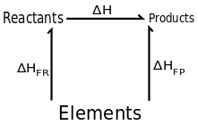

Figure 2-1: Hess’ Law

The Grenade

Product History

A grenade is a small explosive device used in short range combat [4]. They vary from High Explosive (HE) fragmenting munitions, to less lethal variants like smoke (SMK) screening, Flash Bang and gas emitting.

The most common type used is the HE grenade, which usually consists of a core of Trinitrotoluene (TNT) or some other form of HE fill, cased inside a steel container.

These grenades consist of a fuze that detonates either on impact, or after a short time delay. This delay is usually long enough for the user to throw the explosive device into an enemy trench.

The Ignition Train

Figure 3-1 Shows a sectioned example of a HE grenade.

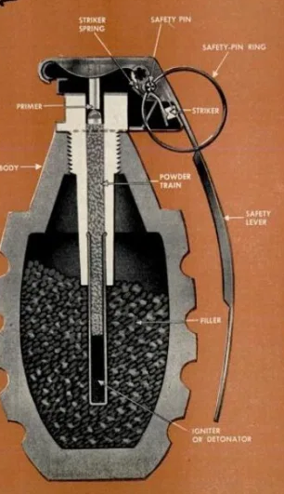
Figure 3-1: HE Grenade [5]

The ignition train of this grenade would start with pulling the safety ring. This will allow the safety lever to lifted, enabling the spring-loaded striker to rotate over and strike the primer.


Figure 3-2: Spring-Loaded Striker

A few standard industry primers, or primary explosives are Mercury Fulminate, Tetrazene, Lead Styphnate, Lead Azide and Silver Azide. Lead styphnate is a relatively weak primary explosive because of its high metal content (44.5%) and therefore is not used in the filling of detonators . [6]

Once the primer is initiated, it will transfer its energy into a pyrotechnic delay composition. Gasless delays are often used at high altitudes, or in conditions of abnormal atmospheric pressures. Gassy delays are used at low altitudes.

As this is a general-purpose grenade, it could utilize a gassy delay composition like blackpowder, or Tetranitrocarbozole and potassium nitrate.

This delay composition provides a steady burn through the powder train before reaching the detonator. This will be fitted with a booster pellet. Typical booster explosives include Pentaerythritol tetranitrate (PETN) and Tetryl.

The final stage of the ignition train is the explosive fill which is ignited by the booster. Secondary explosives are a lot harder to set off than primaries but have far more potential energy. One of the most common secondary explosive fills used within UK service is RDX/TNT. Other examples include HMX and nitrocellulose.

The Primary Composition (Tetrazene)

Composition Introduction

Tetrazene is a very stab sensitive explosive which makes it very suitable to this application. [7]
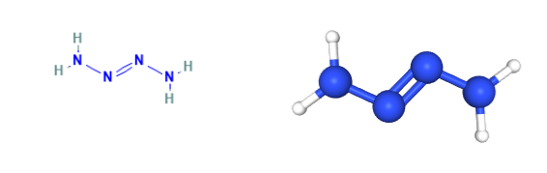
Figure 4-1: Tetrazene Chemical Structure

Production

To prepare Tetrazene, sodium nitrite is dissolved in distilled water and warmed to 55°C.

A solution of amino-guanidine sulfate is then added to the mixture and stirred.

Up to 30 minutes after stirring commenced, tetrazene is formed and decanted, water and alcohol washed then dried at 45-50°C.

The Tetrazene crystals will be placed – not pressed - into an ignition cap protected by a foil disc.

Material Properties

The material properties of SA are displayed below in Table 4-1 [8].
Table 4-1: SA Material Properties

Tetrazene’s detonation heavily rely on its density, i.e. compaction. It will detonate when it is not heavily compacted but weakens when compacted and pressed.

Calculations

The empirical formula for the explosive formula Tetrazene is C₂H₈N₁₀O [9]

$Ω=\frac{[ 1- \left(2x2\right)- \left(\frac{8}{2}\right) x 1600]}{188.152}=$-59.52

With the figure being less than -40%, the modified KW rule will apply and return the following equation.
C₂H₈N₁₀O = ½ H₂0 + 2C + 3½H₂ + 5N₂

This returns -120.91 - -189.12kJ/mol⁻¹. [10]
= +68.21

Conclusion

This formation heat figure suggests that the reaction will absorb energy from its surrounding in the form of heat, this is called an endothermic reaction.
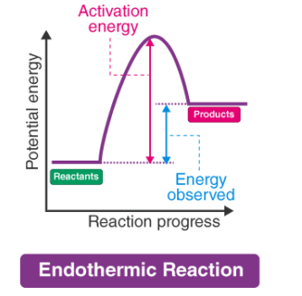
Figure 4-2: Endothermic Diagram [11]

Tetrazene on its own is not likely to be an efficient primary explosive. A more reliable solution could include Tetrazene, but only as an additive to boost sensitization.

Delay Composition (Blackpowder)

Composition Introduction

Blackpowder – also known as Gun Powder – is the most commonly known explosive composition. Frequency appearing in small arms ammunition and fireworks, blackpowder is a simple mixture of 3 ingredients.

Table 5-1: Blackpowder
Ingredient | Chem Formula | % by Weight
Potassium Nitrate | KN0₃ | 75
Charcoal | C | 15
Sulfur | S | 10

The powdered mixture of Sulfur and Charcoal act as the fuel in the equation whilst the potassium nitrate is the oxidizer.

Production

The ingredients used within the blackpowder are vitally important to the performance of your blackpowder. Charcoal manufactured from willow, birch, fir, oak, pine and spruce – when charred properly – are good sources of wood for your charcoal.

Using a mortar and pestle, the individual ingredients are ground into a powder.

Determine the desired mass of explosive and weight out the percentages of that weight- shown in table 5-1.

All ingredients are then ground together in the correct proportions, adding small increments of water to create a clay which can then be sieved or cut into the granule sizes required.

Material Properties

The material properties of Blackpowder is shown below [11].

Table 5-2: Blackpowder Properties

Calculations

In order to calculate the figures for Blackpowder, a mass of composition is required. For the purpose of this section a mass of 20g will be adopted.

The individual molecular masses of the three ingredients are:
Potassium Nitrate – 101g
Charcoal – 12g
Sulfur – 32g

Using these figures, alongside the figures in table 5-1 it is now possible to calculate the combustion products of Blackpowder.

10 KNO₃ + 8C + 3S = 2K₂CO₃ + 3K₂SO₄ + 6CO₂ + 5N₂
10 x (101) + 8 x (12) + 3 x (32)
1010g of Potassium Nitrate 96g of Charcoal 96g of Sulfur = 1202 total
10 KNO₃ + 8C + 3S = 2K₂CO₃ + 3K₂SO₄ + 6CO₂ + 5N₂
10x (-492.71) + 8x (0) + 3x (0) = 2x (-1150.18) + 3x (-1437.7) + 6x (-393.51) + 5x (0)
(-4927.1) + (0) + (0) = (-2300.36) + (4313.1) + (-2361.06) + (0)
Heat of Formation = Products – Reactants
(-8974.52) - (-4927.1) = -4047.42kJ/Mol
Actual Output based upon 20g Mass
(-4047.42) x $\frac{20g}{Total (1202g)}= -67.34kJ$

Conclusion

Blackpowder could be a reliable delay composition in its own right providing the physical properties allow for a slow enough burn rate.

Booster Explosive (PETN)

Composition Introduction

Pentaerythritol Tetranitrate (PETN) is the least reactive of the nitric esters. It forms a very powerful explosive, very commonly used in detonators and booster explosives.

PETN belongs to the same chemical family as Nitroglycerin and is a major ingredient in Semtex [13].

Production

Outside of terrorism, PETN is not often found In its pure form due to its high sensitivity to impact and friction. The composition is usually formulated with binders and plasticizers to desensitize itself.

Typical PETN binders and plasticizers included:
Table 6-1: PETN Binders and Plasticizers

To prepare PETN, pentaerythritol must undergo nitration.
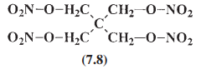

Figure 6-1: PETN Nitration

This can be achieved by added the pentaerythritol to nitric acid at 30°C. the Crude product is then removed through filters, washed, neutralized, and then recrystallized from acetone. [14]

Pentolite – which is a formulation is Wax and PETN - is a very common booster charge and blasting charge.

Material Properties

The material properties for PETN is shown below:
Table 6-2: PETN Material Properties [15]

PETN will burn in air and it will release carbon dioxide, soot, and water.

Calculations

Using the oxygen balance equation, the following calculation was carried out:

$Ω=\frac{[ 12-\left(2x5\right)- \left(\frac{8}{2}\right)x 1600}{316.14}$ = -10.12
Reaction for Decomposition using Standard KW Rule
C₅H₈N₄0₆ = 2CO + 3CO₂ + 4H₂0 + 2N₂
Using Hess’s Law
Hd
C₅H₈N₄0₆
H1
H2
2CO + 3CO₂ + 4H₂0 + 2N₂

5C + 4H₂ + 2N₂ + 6O₂

Using the individual heats of formation provided [12] the heat created by the reaction has been calculated below.
2CO + 3CO₂ + 4H₂0 + 2N₂
CO₂ = -393.51kJ/mol
CO = -110.54kJ/mol
H₂O = -41.82kJ/mol
N2 = 0kJ/mol
C₅H₈N₄0₆ = -538.53kJ/mol = ∆H₁
∆H₂ = -(3 x 393.51) + -(2 x 110.54) + - (4 x 241.82) + -(2 x 0)
= -2368.89kJ/mol
∆Hd = ∆H₂ - ∆H₁
∆Hd = -2368.89 - -538.53
= -1830.36 kJ/mol

Conclusion

Note should be taken of the calculated heat of formation figure. Figures are approximate and will depend on your formation temperature sources.

PETN is a proven booster explosive and would be suited to the desired application providing the composition has sufficient protection against friction and impact. To desensitize the competition, without sacrificing too much performance, a simple binder like wax would be benefit to both production and in-service safety.

Main Explosive (COMP B)

Composition Introduction

The explosive formula RDX is commonly referred to as three different abbreviations. Research Development Explosive, Research Department formula X and also Royal Demolition Explosive. [16]
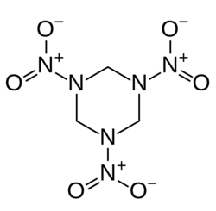
Figure 7-1: RDX Structure

RDX will undergo decomposition when burning and will release nitrogen gas, carbon dioxide, water vapor, soot, and carbon monoxide. When confined, the composition will explode i.e. in a burster cap.

Production

RDX is prepared by using cold nitric acid to nitrate hexamine. The method of preparation is called supercritical anti-solvent (SAS) recrystallization. [17]

RDX is not commonly used as a sole explosive and despite being more explosive than TNT, they are commonly paired together. They were first referred to as Composition B.

Material Properties

The chemical properties of RDX/TNT are shown below.

Table 7-1: RDX/TNT Material Properties

Composition B has a detonation velocity of 8.050m/s. [18]

Calculations

For the purpose of these calculations, the standard RDX/TNT proportion or 60/40 will be used.

To calculate the composition of 60/40 RDX, the proportion of each gram of mixture much be divided by it individual molecular mass. These figures are then multiplied by the number of atoms in each group.
Table 7-2: Molecular Proportions of RDX/TNT 60/40

Using the numbers in the total column, it is n ow possible to calculate the oxygen balance of RDX/TNT. The M figure will be 1g.

$Ω=\frac{[0.0268-\left(2x0.0213\right)- \left(\frac{0.0250}{2}\right)x 1600}{1}$ = -45.28

In this instance, the modified KW rule will need to be used to calculate products of this equations.
C_{0.0213}H_{0.0250}N_{0.0215}O_{0.0268}
Table 7-3: RDX KW Rule
Rule No. | Conditions | Products
1 | Convert Hydrogen to H₂0 | 0.0250H = 0.0125H₂O
2 | Remaining oxygen to convert C to CO | (0.0268-0.0125=0.0143)  0.0143O = 0.0143CO
3 | Further remaining oxygen left converts CO to CO₂ | No Remaining
4 | Convert all nitrogen to nitrogen gas N₂ | 0.0215N = 0.01075N₂

Carbons: 0.0214 – 0.0143 = 0.0071

Therefore RDX/TNT 60/40 = 0.0125H₂O + 0.0143CO + 0.0071C + 0.01075N₂

To demonstrate how differently the products would be behave on their own, their individual oxygen balance and heat of formations have been calculated – see annex A.

Conclusion

RDX is a powerful explosive in its own right but is commonly mixed with TNT to optimize performance.

The addition of additional explosive compositions may not contribute to additional heat generation or oxygen output but potentially adding gaseous products and reducing detonation temperatures.

Annex

Annex A
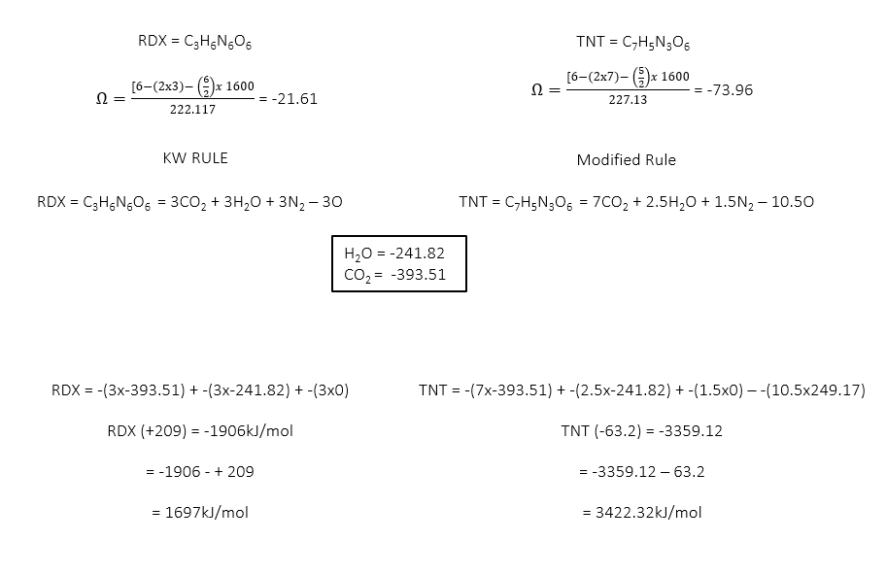
Figure 8-1: Individual Comparisons of RDX and TNT

References

[1] | D. Holley, "Oxygen Balance - OME Chemistry," UWTSD, Swansea, 2020.
[2] | R. J. Akhaven, "Decomposition Reactions," Books 24/7, [Online]. Available: https://www.globalspec.com/reference/55650/203279/decomposition-reactions. [Accessed 27 11 2020].
[3] | S. Writer, "Mole in Chemistry," Reference, 25 March 2020. [Online]. Available: https://www.reference.com/science/mole-chemistry-11f07564224a20ab.
[4] | T. E. o. E. Britannica, "Grenade," Encyclopedia Britannica , 12 March 2020. [Online]. Available: https://www.britannica.com/technology/grenade.
[5] | T. Editor, "Grenade Fundamentals," Savannah Arsenal, [Online]. Available: https://savannaharsenal.com/military-weapons/hand-grenades-and-mines/. [Accessed 27 11 2020].
[6] | J. Akhavan, "Pyrotechnic Primers," in The Chemistry of Explosives, Royal Society of Chemistry, 2011, pp. 171-172.
[7] | N. C. o. B. Information, "Tetrazene," PubCheck compound summary , 2020. [Online]. Available: https://pubchem.ncbi.nlm.nih.gov/compound/5463295. [Accessed Nov 2020].
[9] | J. Akhaven, "Oxygen Balance of Explosives," in The Chemistry of Explosives , Swindon, Cranfield University, 2011, p. 88.
[10] | C. University, "Heats of Formation," in Chemistry of Explosives Ed 3, 2011, pp. 92-95.
[11] | B. S. L. UK, "EHDS1046- G12/G20," BAE Systems, Glascoed, 2019.
[12] | B. S. L. UK, "Charges - Standard Thermodynamic Values," BAE Systems Land UK - Charges Department, Bishopton, Scotland, 2019.
[13] | R. McKie, "The Guardian," PETN: The Explosive of Choice, 30 10 2010.
[14] | J. Akhavan, "The Preparation of Explosives," in The Chemistry of Explosives, Swindon, Cranfield University, 2011, p. 141.
[15] | T. Editors, "Pentaerythritol tetranitrate," ScienceMadness, 7 12 2019. [Online]. Available: http://www.sciencemadness.org/smwiki/index.php/Pentaerythritol_tetranitrate.
[16] | Editors, "RDX Explosive," Science Madness, 26 Oct 2020. [Online]. Available: http://www.sciencemadness.org/smwiki/index.php/RDX.
[17] | K.-H. K. B.-c. l. J. C. Haiyang Dou, "Preparation of RDX," Science Direct - Powder Technology, 02 2013. [Online]. Available: https://www.sciencedirect.com/science/article/abs/pii/S0032591012007917#:~:text=RDX%20powder%20was%20prepared%20using%20a%20supercritical%20anti-solvent,X-ray%20diffraction%20%28XRD%29%2C%20and%20scanning%20electron%20microscopy%20%28SEM%29..
[18] | W. Author, "Composition B," Wiki , 06 2020. [Online]. Available: https://en.m.wikipedia.org/wiki/Composition_B.

