  Component One:  What are the key skills required when working in the housekeeping team? 750 words (+/- 10%)  Contribution to Overall Module Assessment: 25% | Student No: | 2211258
 | Module Title: | Hotel Placement - Operating Hotel Facilities
 | Module Code: | BMIH4006
 | Lecturer: | Kathryn Roberts
Introduction
The hotel industry contains a vast number of duties that are to be held, and one of them is housekeeping. I am aware of the importance this aspect has, and I do understand the skills required in this field. Hence, I will list down my housekeeping skills, along with a personal experience I encountered in the industry.

Key Skills
It is evident that housekeeping plays a vital role in ensuring the hotel is clean, in order, and secure for both guests and employees. Since the responsibility of the housekeeping staff is so significant, the skills required for it are also critical to note. The first skill to note is, evidently, cleanliness. This means being proficient at understanding what amounts to cleanliness and what techniques can be used to certify that a level of cleanliness has been reached. Techniques include mopping, dusting, and disinfecting unclean areas (Brody, 2019). Besides that, another skill important for a housekeeping worker is being detail-oriented. The key to excellent housekeeping is paying attention to detail and making sure not even one speck of dirt goes unnoticed. The ability to spot such stains, plus other discreet areas, is a skill that makes a housekeeper efficient at what they do. Moreover, yet another essential skill that I know of is time management. This skill is purely transferable because it is required in almost every field of life, and so it is required in housekeeping as well. The skill is essential because it includes understanding the time each time requires to get completed and how the workload can be managed effectively. Furthermore, since housekeeping contains physical labour where the workers have to endure bending, lifting, and moving objectives, another skill needed is a lot of stamina. Good stamina would allow the worker to move heavy objects without becoming exhausted almost immediately, be able to stand and lift, and not get aches in joints (Brody, 2019). Moreover, another important skill is communication. Housekeeping workers at a hotel work in teams; I have observed that, so I know that communication needs to flow between members smoothly. The importance of having this skill resides in interacting with colleagues so confusion cannot arise, informing supervisors about progress, understanding instructions, etc. As a result, it is important to exert good communication and exceptional teamwork abilities because they are vital for any housekeeping staff member. Finally, another critical skill is the ability to showcase professionalism. Housekeeping staff gets access to the guests' belongings and rooms while they are staying, which is why they have to stay professional and reliable at all times. This would allow them to respect the privacy of the guests and feel indifferent to everything. Therefore, this skill also includes the ability to not take offence when a guest complains or says something rude or frustrating and just carry on with a cool and calm attitude. Hence, I understand that these skills are important for any housekeeping member. I learned this from lectures and theories, but my knowledge was also increased due to personal experience.

Personal Experience
The personal experience that taught me so much about housekeeping was the time when I decided to be a part of this team in a local motel near my house. It was a summer vacation during my teen years, and I decided to get a job because I was unproductive the whole day, which I did not want to be. As a result, I applied for a housekeeping position, the only position that was adequate for my age and qualification, in that motel and got accepted just two days later. This was my first time working in the hotel industry, and I realized that I did not know much about it. The only impressions I had of the sector were the couple of times I had stayed as a guest, but working in one was a completely different experience. Although the motel was small, the manager was strict, and she made sure housekeeping was done at its finest. Being the youngest in the team, I was assigned the task of changing sheets and pillows only, but I learned so much from the experience that I am sure will affect me for a lifetime. I learned what skills are required for this team, why its duties are so important for the guests, and how nothing negative should be taken to heart unless it is very serious.

Final Thoughts
In conclusion, I would say that since housekeeping is important for a hotel, the job is difficult because the company one is working for holds so many expectations that it gets challenging to navigate through them. But with the right skills, this can be overcome.

Word Count | 778

Component Two:
Contribution to Overall Module Assessment: 25%
In this scenario – You have just been promoted to the team leader for a floor within the hotel. A guest complained that on their arrival, their room had not been properly cleaned. Create an action plan and answer the following questions.

Problem | Why did it happen? | What are you going to do? | How will you prevent this from happening in the future? | What measures would you introduce to improve team effectiveness?
The guest complained, but no immediate action was taken before I was called. | The housekeeping workers were confused and did not know what to do except to fetch me. | I will ensure the guest that their complaint will be taken care of immediately. | I will inform the housekeeping team what they need to do if a similar situation arises. | I will teach the housekeeping team the importance of cleaning rooms for guests, especially for new arrivals.
The room in question is clean except for the pillows and the carpet. | The housekeepers might have missed the spots, forgotten to do the duty, or did not think it was important to do them. | I will instruct the workers to clean these areas at once and will give the room another inspection. | I will make rounds in unoccupied rooms to ensure everything, from the ceiling to the floor, is spick and span. | I will inform my team how they should clean the room and why making sure everything is clean is important.
The guest’s voice is very loud, and other people can hear them. | They are frustrated because no immediate action was taken. | I will lead the guest to a more private corner so the matter can be discussed quietly without disturbing the other guests. | I will take immediate action and take the guest to a room before hearing about the complaint. | I will teach the team why taking immediate action is important and how to deal with a loud guest.
The hotel's reputation is at risk. | The complaints ringing out from the guest would not only guarantee a negative experience but might leave a bad impression on other guests, too (Mmutle and Shonhe, 2017) | I will ensure every other guest's need is taken care of before they have a chance to complain about it. | I will make a note of monitoring reviews and making sure that no complaints can arise. | Training the staff is important in making them realize why rooms have to be cleaned at all times.
The housekeeping workers are incompetent. | They did not receive enough training. | I will set up training programmes for them. | I will make them certain that they should not be afraid of pointing out their weaknesses because I can help them improve. | Provide training and development sessions every day for two weeks.

Component Three:
Contribution to Overall Module Assessment: 50%
Your task is to create and prepare a presentation following the detailed scenario provided below.

As the floor housekeeping manager and given the recent guest complaints, you need to put together a basic training presentation for your colleagues within the housekeeping team to get the best out of them, ensure that brand standard is being achieved and that Health and Safety procedures are also being followed.


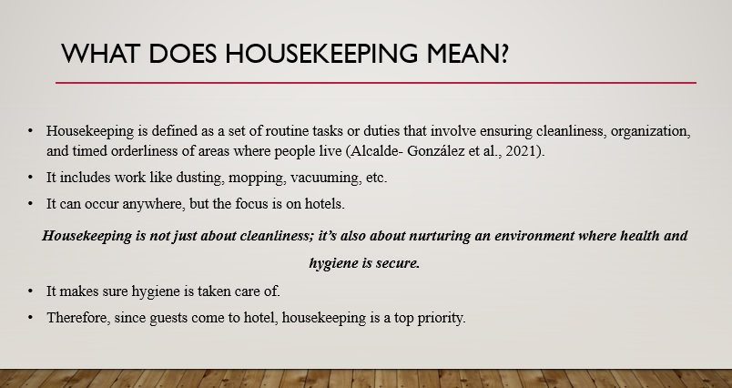

Training Notes: This slide shows what housekeeping means. The definition is unclear to many, so knowing it will shed light on why housekeeping is important.
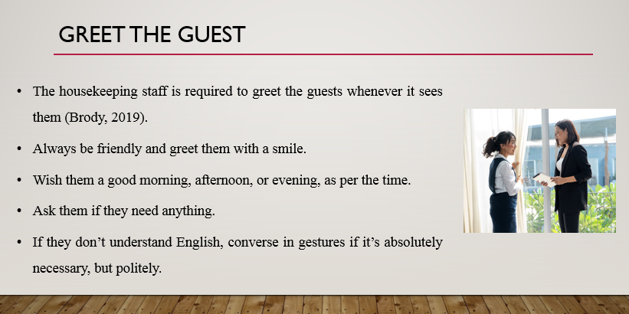

Training Notes: Even though the housekeeping staff is assigned duties, it is vital for them to know how they should treat guests because they would encounter them while on their duty rounds. Being friendly and approachable is key because the guest would find this appreciative. Making them feel important is critical.
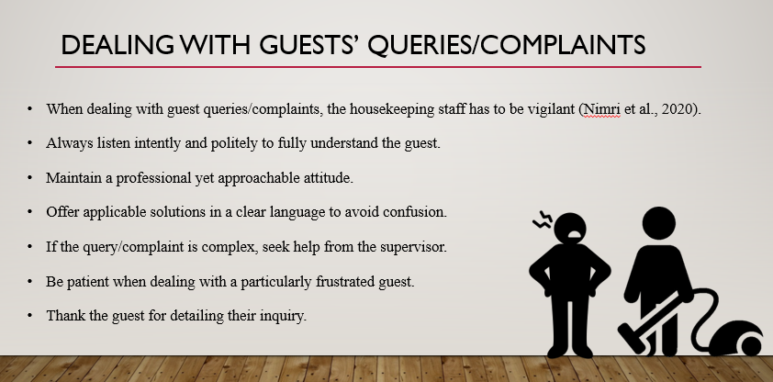

Training Notes: Noting how the guests have to be handled carefully, addressing their inquiries should be done in the same manner by the housekeeping staff. Hence, this slide shows some guidelines on how this scenario can be tackled.
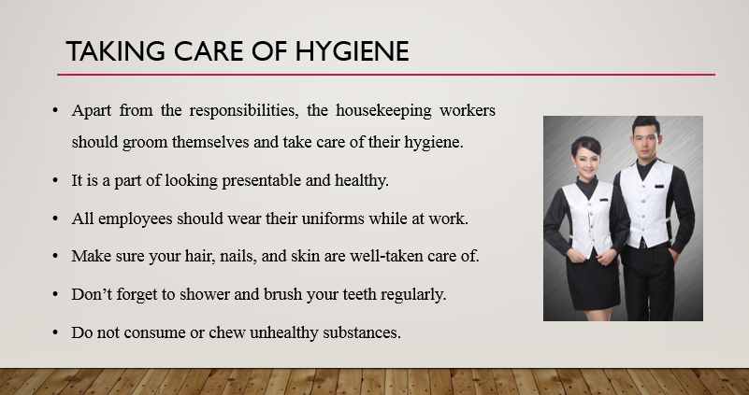

Training Notes: Since the housekeeping staff has to ensure everything the workers in it do is clean and emits good hygiene, it is important they themselves remain clean and healthy. This slide showcases what they need to do so they can look presentable and like an impressive housekeeping staff.
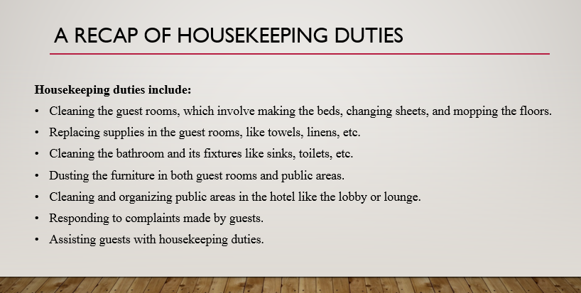

Training Notes: To refresh what needs to be done in housekeeping, these duties are listed down. Every worker on the staff needs to make sure they do these duties timely and in the manner that is expected from them.
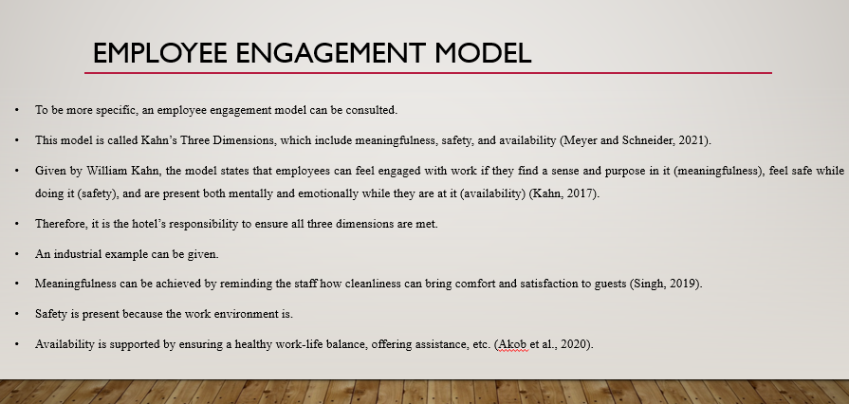
Training Notes: To give a better explanation of how these duties can be upheld, an employee engagement model can be consulted. This model was given by Kahn and is often attributed to the three dimensions he presented, which are given above. Following this model, a clear sense of focus can be achieved. The model is further exemplified with an industry instance, indicating that the hotel has responsibility over its employees.

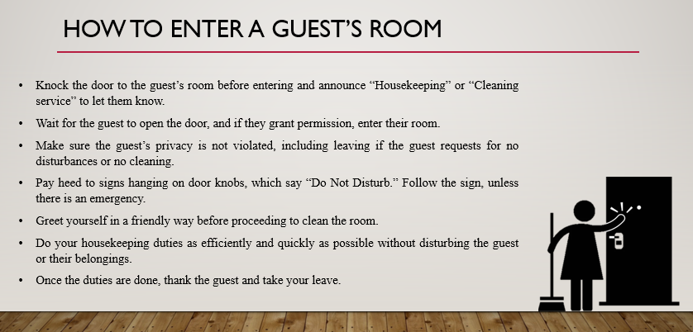

Training Notes: Guests are the most important part of the hotel, so they need to be respected at all times, even when their rooms need cleaning. These steps should be followed to enter a guest’s room.
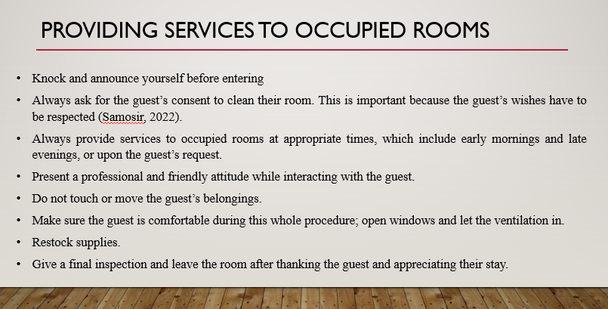

Training Notes: When providing services to an occupied room, these steps should be followed.
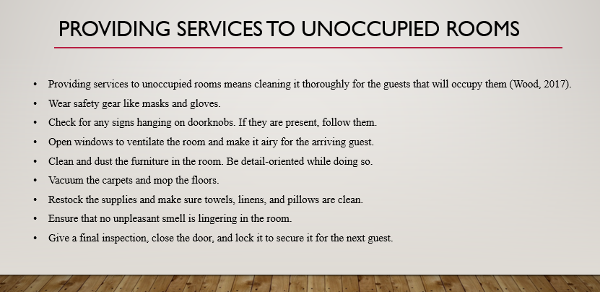

Training Notes: On the other hand, for unoccupied rooms that do not have guests at the moment, these steps should be followed. It is necessary not to miss any of them.
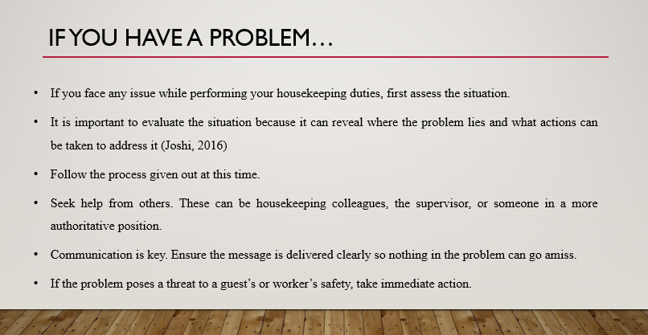

Training Notes: It is common for housekeeping worker to run into problems while they are performing their duty. Hence, if such a case arises, these steps should be followed.

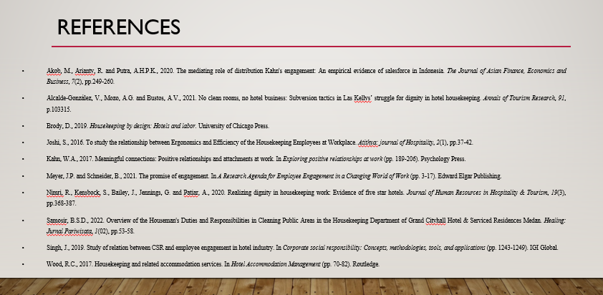

References
Akob, M., Arianty, R. and Putra, A.H.P.K., 2020. The mediating role of distribution Kahn's engagement: An empirical evidence of salesforce in Indonesia. The Journal of Asian Finance, Economics and Business, 7(2), pp.249-260.
Alcalde-González, V., Mozo, A.G. and Bustos, A.V., 2021. No clean rooms, no hotel business: Subversion tactics in Las Kellys’ struggle for dignity in hotel housekeeping. Annals of Tourism Research, 91, p.103315.
Brody, D., 2019. Housekeeping by design: Hotels and labour. University of Chicago Press.
Joshi, S., 2016. To study the relationship between Ergonomics and Efficiency of the Housekeeping Employees at Workplace. Atithya: journal of Hospitality, 2(1), pp.37-42.
Kahn, W.A., 2017. Meaningful connections: Positive relationships and attachments at work. In Exploring positive relationships at work (pp. 189-206). Psychology Press.
Meyer, J.P. and Schneider, B., 2021. The promise of engagement. In A Research Agenda for Employee Engagement in a Changing World of Work (pp. 3-17). Edward Elgar Publishing.
Nimri, R., Kensbock, S., Bailey, J., Jennings, G. and Patiar, A., 2020. Realizing dignity in housekeeping work: Evidence of five-star hotels. Journal of Human Resources in Hospitality & Tourism, 19(3), pp.368-387.
Samosir, B.S.D., 2022. Overview of the Houseman's Duties and Responsibilities in Cleaning Public Areas in the Housekeeping Department of Grand Cityhall Hotel & Serviced Residences Medan. Healing: Jurnal Pariwisata, 1(02), pp.53-58.
Singh, J., 2019. Study of the relation between CSR and employee engagement in the hotel industry. In Corporate social responsibility: Concepts, methodologies, tools, and applications (pp. 1243-1249). IGI Global.
Wood, R.C., 2017. Housekeeping and related accommodation services. In Hotel Accommodation Management (pp. 70-82). Routledge.
Mmutle, T. and Shonhe, L., 2017. Customers’ perception of service quality and its impact on reputation in the hospitality industry. African Journal of Hospitality, Tourism and Leisure, 6(3), pp.1-25.

