Introduction
My experience of swimming in tropical seas and exploring the different underwater life forms, coral reefs and structures hidden from the surface has given me a deep curiosity about the sea and my experience in it.
In this proposal, I will be using three key words stimulated by this experience: dissociation, curiosity and lifeforms, to explore how this experience changes our perspective, drives a desire to know and learn more about new and unfamiliar things, and how forms of life shape our consciousness and awareness of reality. This exploration forms a basis for a question and a project for my dissertation.

Dissociation
Dissociation is a feeling of disconnection from yourself and the world around you. This could be thought of as a temporary psychological separation from ordinary experience through immersion in a new sensory environment. Dissociation is a way of perceiving the world in an alternative state, a sense of feeling detached from your own body and the environment around you.
This interpretation of dissociation helps us understanding the experience of swimming in the sea. The way we perceive our surroundings changes when we enter the water. Vision becomes softer and less defined, sounds are muted, and the acoustics of marine life and bubbles replace the sounds we hear in everyday life. The reduced effects of gravity create a feeling of weightlessness, altering the body's relationship with its environment. Together, these sensory changes create a temporary feeling of detachment from everyday life, allowing the swimmer to become immersed in the underwater world as an observer rather than a participant.
Merleau-Ponty (2013) believes that the way we interpret and see the world is immersive and embodied, and dissociation in this context is a different way of experiencing the world van Sorge (2025) In the context of swimming in the sea as a change in the environment, changes this embodies perception of their surroundings, thereby resulting in a sense of dissociation.
Bachelard (2006) states that being submerged in water, such as the sea, shifts your mind into a more dream-like state, where everyday awareness is suspended, so that a person can experience the world in an alternative way. Bachelard argues that immersion in water enables us to experience reality in a different way rather than removing us from it. In this context, imagination, sensations and immersion become dominant over routine thought. This is an alternative way of thinking about dissociation.

Miki De Goodaboom The Art of Free Diving 02 (2021)
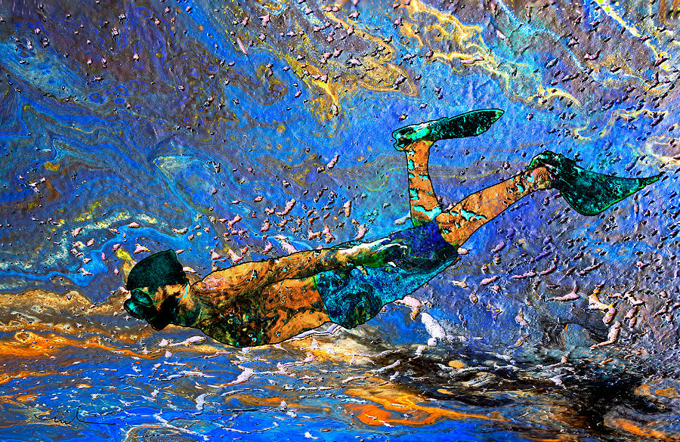
The painting by Miki De Goodaboom shows a free diver swimming underwater whilst demonstrating the abstract colours, flowing textures and capturing a view of what being underwater feels like. De Goodaboom's painting communicates an experience that relates to feelings of dissociation by showing an alternative perspective of reality. The painting demonstrates this with the wavy and distorted visuals.

Created by Nooma (n.d.)

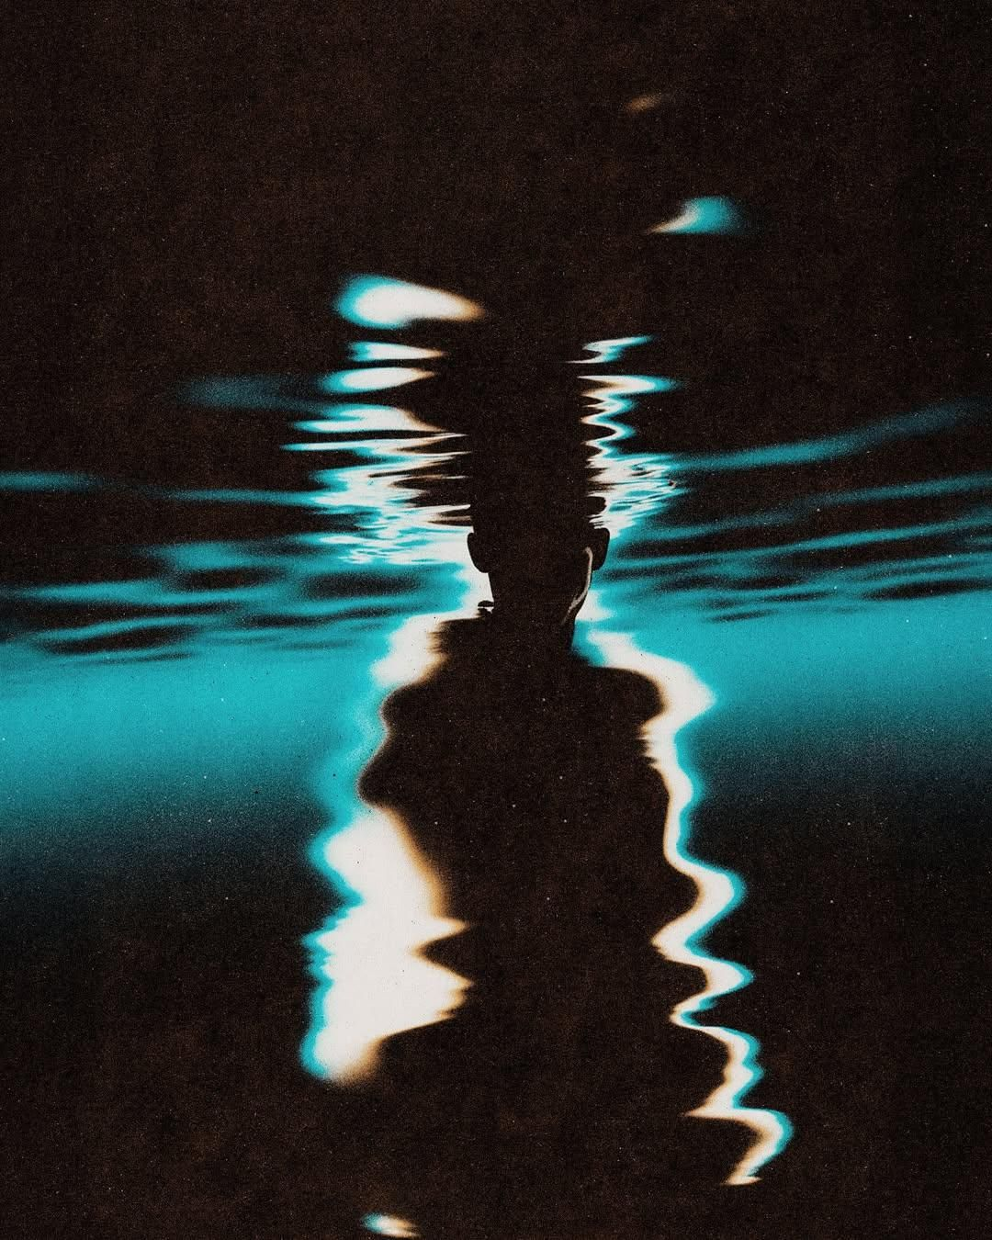
The image shown is a photograph of a person in the sea distorted by the water.
This image uses reflections and distortion to represent a temporary feeling of dissociation. Looking through the water alters your view of the subject, this creates an immersive experience beyond normal reality

Curiosity
I have chosen curiosity as my second keyword as an embodied state that drives a desire to explore unknown and new environments such as underwater sea life.
Curiosity is a drive and urge to explore something new. Curiosity puts your mind into a new state of awareness, making you want to learn or feel new things (Carruthers 2024). To be curious, you must be open to learning, exploring and seeing the world from a different perspective. It is a unique sensation that serves as an itch to know more. Confusion is transformed into a drive to explore.
In the context of new and unknown environments, such as being under the sea, curiosity can put people in vulnerable and unknown situations. This can be seen as an act of bravery, or an act of foolishness.
When someone enters the sea, they experience a shift in reality that encourages them to become curious and accept change through new senses. Instead of taking part in everyday life, they become an observer of the underwater world, creating a more mindful and humbling experience. Curiosity helps people become more open to exploring an unfamiliar environment and discovering things they have not seen before. As they swim through the sea, they experience new sights, sounds and sensations that encourage them to keep exploring and learning more about the underwater world.
Daniel Berlyne: Curiosity and Exploration
Daniel Berlyne's theory of human curiosity (1966) explores why people become curious. He suggests that curiosity is triggered by new, unfamiliar or unusual experiences, creating a desire to explore and learn more. Berlyne believes that this curiosity decreases once questions are answered. If people remain uncertain, they continue to observe and explore. As the underwater environment is unfamiliar and constantly changing, it creates a difference between what is expected and what is experienced, sparking curiosity, encouraging the swimmer to explore deeper in the environment and to discover more about the underwater world.
Umberto Eco: The Open Work
Umberto Eco's Open Work (Eco and Robey 1989) explains that an open work is deliberately ambiguous and open to interpretation. Instead of providing all the answers, it invites the observer to work with the creator by filling in the gaps through their own understanding. This uncertainty stimulates curiosity, encouraging the viewer to explore the work further and create their own meaning.

Chu Okoli: Curiosity (2019)
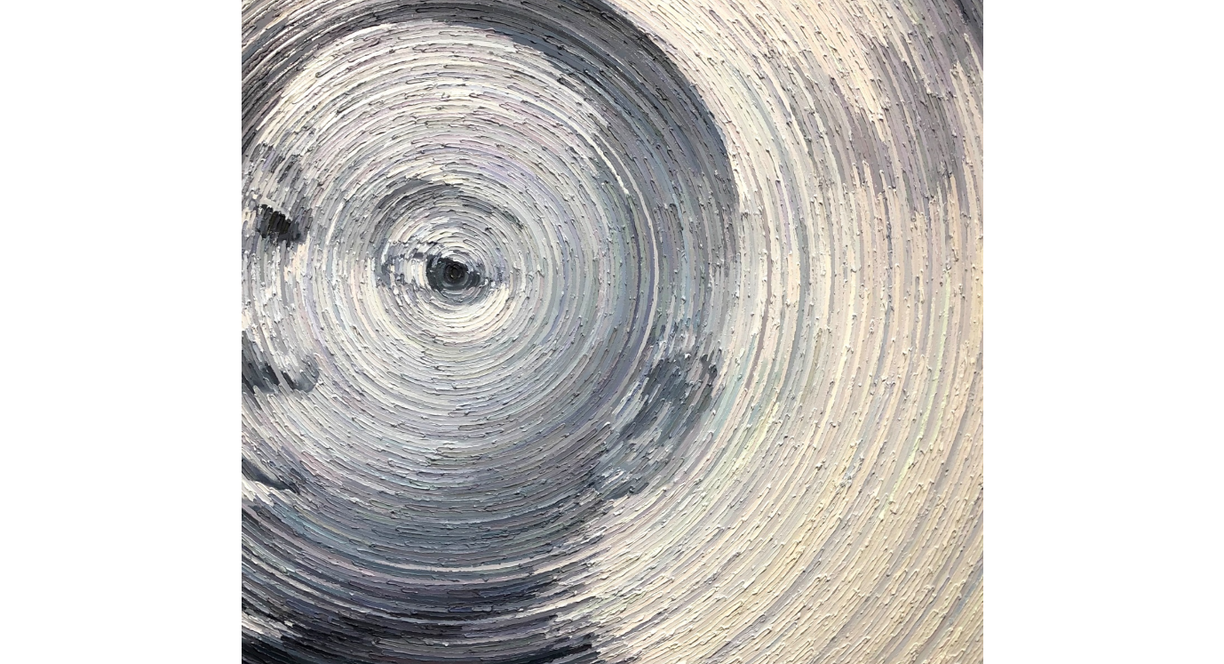
The face and concentric circles in this painting imply interest and wonder. The circles link back to the sea, creating the same visual effects as water with a wavy and distorted look. This asks the viewer to question what the subject is looking at, sparking curiosity and encouraging them to look closer. The muted, circular textures give the artwork a psychedelic feel, a sensation that requires you to move beyond an ordinary perception into the unknown, in a similar way that curiosity demands exploration and questions.

Emily Simmons: "Curiosity at the Fountain" (2026)

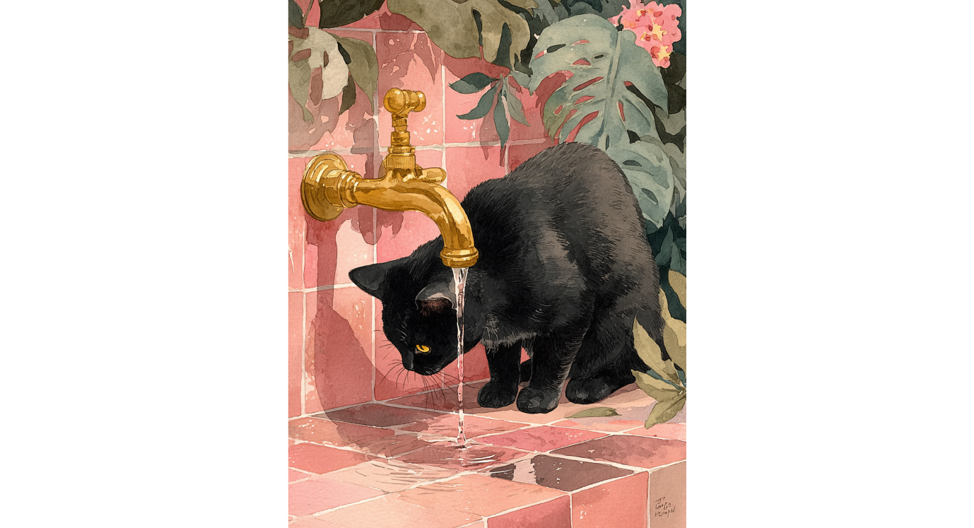
The cat in this painting is absorbed in the moment, a state that often relates to curiosity. It conveys a curious state while also drawing the viewer to wonder what the cat is curious about. Simmons uses water visuals in her work to create a sense of movement through the interaction of light and water, animating the painting.
The sensory embodied experience of being curious stimulates a drive and desire to learn more about the unknown, but it is not just a human phenomenon, but one that is shared across many other lifeforms.

Life form
In its simplest definition, a life form means any living thing, but it can also refer to the overall form and structure of a mature organism, and to a being that we perceive as alien (Dictionary.com, n.d.). Life forms are the main reason why I find the sea so interesting. The underwater life forms are as close to being an alien experience as we can get on Earth. Without life forms, there would be far fewer things to explore and be curious about.
Consciousness gives life forms the ability to experience and perceive the world around them. This can range from simple sensory processing in basic organisms to complex self-awareness in more advanced beings.
Some life forms, although not all, possess consciousness. Without consciousness, we would not be able to experience reality, which links back to my exploration of meaning, curiosity, and existence.
Reber et al (2024) are proposing a new theory of consciousness that challenges traditional views that only highly evolved organisms can experience consciousness. Their Cellular Basis of Consciousness theory sees consciousness as a fundamental part of life that is experienced by all living orgasms including bacteria and amoebas, that have been shown to display behaviours that show learning from their environments. They argue that consciousness is related to the interconnectedness that demonstrates awareness of others.
Peter Godfrey-Smith’s (2016) book Other Minds challenges the idea of human-centred ideas about consciousness, giving an alternative account of how different life forms have evolved different kinds of consciousness his studies of octopuses, he argued that intelligence evolved twice in vertebrates and in cephalopods, producing two very different but both sophisticated kinds of consciousness. In a similar way to Reber et al’s ideas, he believed that consciousness emerges from an interactive relationship with the environment.

Cristina Vergano: Lifeforms IV (2024)
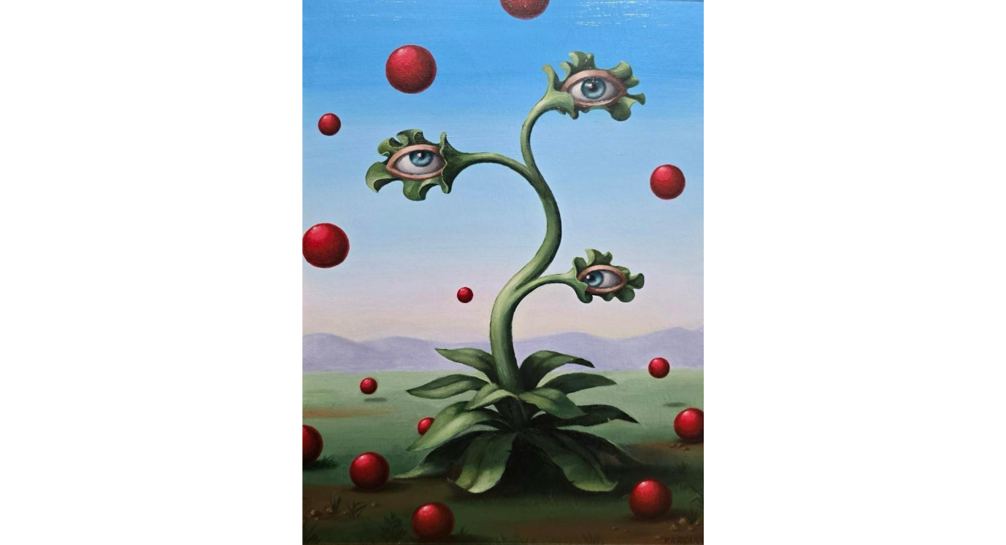
This painting by Cristina Vergano plays with the idea of life form and its consciousness, the idea of a living organism being able to perceive the environment around them. The painting shows us eyes coming out of the plant's stems, similar to how Godfrey-Smith’s work with octopuses as organisms with distributed sensory organs.

Sylvain Lefebvre: Little Lutin Under the Pink Octopus (2023)
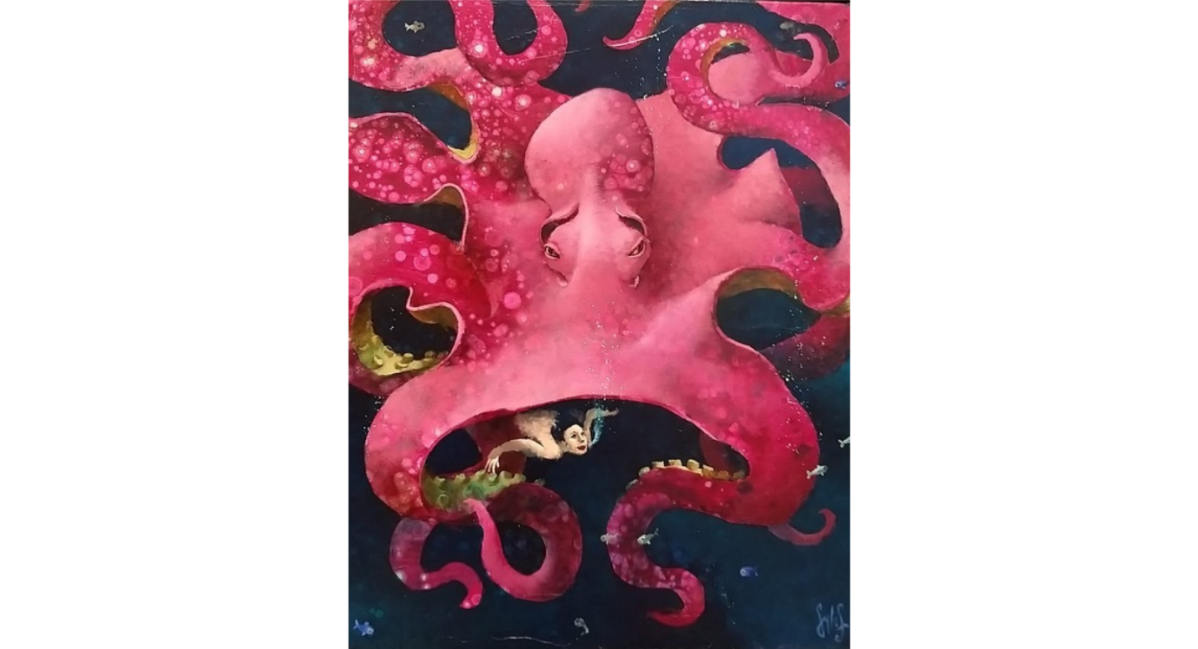
Lefebvre's painting shows an amplified, more fantastical octopus much larger and infused with bright colours. This powerful conception reinforces ideas of difference in terms of the lifeform and consciousness between these underwater creatures and the human depicted in the image.

Discussion
These three key words focus on different perspectives of scale. Dissociation considers the individual experience; it is human-centred. Curiosity focuses on the interaction between the impact of being immersed in an unknown environment that leads to a sense of wonder and a desire to know more. Whereas lifeforms embody everything, both the human and the non-human experience.
They are similar in ways of experience; each of the three key words is founded on ideas of experience: dissociation is an experience of otherness, curiosity is an experience of wonder, and life forms an experience of awareness and consciousness.
Each key word provides a different viewpoint on perspective. Dissociation considers an altered perspective on how we view the world, and curiosity opens up new perspectives of the world. Lifeforms challenge us to think about how organisms can have different perspectives of the world.
In each of these key words, the environment is not a passive backdrop but plays an active role in affecting how we think, feel and perceive the world, so stimuli from the environment can lead to the dissociative reaction and a shifted perception of what is considered to be real. Environmental stimuli are also what trigger a sense of curiosity and desire for discovery. The environment provides the location where lifeforms interact, and consciousness emerges.
In summary, in the context of swimming in the sea, the unfamiliar experience of being underwater changes perception, which leads to a heightened state of curiosity, and an awareness and appreciation of life.

Future Research Ideas
On reflection, this idea of swimming in tropical seas acts as a metaphor, raising questions and curiosity about how humans and others perceive reality, and how immersion into new environments creates situations and opportunities for expanding our knowledge and perspectives of ourselves and others.
Eco’s ideas on the Open Work, show how artwork can also act as a gateway into new, ambiguous and unknown environments that can stimulate similar sensory reactions.
This leads to this question for future exploration: How do unfamiliar environments influence perception, curiosity and our understanding of other life forms, and how can graphic design communicate these experiences?
Practice based projects that emerge from this question could include the following options:
- A project that explores how different environments such as being underwater, in a jungle, in an urban environment create or influence different perspectives, moods and experiences.
- A project that explores an experience of entering an underwater world how perceptions change as one becomes an observer, not a participant in an alien environment
- A project that explores the different perspectives of different life forms that perceive the world underwater

Conclusion
Using my experiences of swimming in tropical seas, I identified three keywords: dissociation, curiosity and lifeforms to explore ideas for my dissertation proposal, using a range of philosophers and theorists, artists and artwork to deepen my understanding of these core concepts. From these explorations, I have identified a research question that I will use to deepen my understanding further about how the unfamiliar stimulates curiosity and affects perceptions. Further reading will help me focus on one of the practice-based project ideas that I have suggested.

References
Bachelard, G. 2006. Water and dreams: an essay on the imagination of matter. Fourth printing 2006. Dallas: Dallas Institute of Humanities and Culture.
Berlyne, D.E. 1966. Curiosity and exploration. Science 153(3731), pp. 25–33. doi: 10.1126/science.153.3731.25.
Carruthers, P. 2024. The Contents and Causes of Curiosity. The British Journal for the Philosophy of Science 75(4), pp. 871–895. doi: 10.1086/716609.
Curiosity (2019) by Chu Okoli - For Sale | Artsy. [no date]. Available at: https://www.artsy.net/artwork/chu-okoli-curiosity [Accessed: 25 July 2026].
‘Curiosity at the Fountain’, curiosity at the fount… (2026) by Emily Simmons - For Sale | Artsy. [no date]. Available at: https://www.artsy.net/artwork/emily-simmons-curiosity-at-the-fountain-curiosity-at-the-fountain-black-cat-painting-cat-wall-art-feline-artwork-black-cat-decor-cat-lover-gift-animal-painting-botanical-wall-art-pink-tile-artwork-tropical-interior-art-contemporary-cat-painting [Accessed: 26 July 2026].
Eco, U. and Robey, D. 1989. The open work. Cambridge, Massachusetts: Harvard University Press.
fineartamerica.com/featured/the-art-of-free-diving-02-miki-de-goodaboom.html. [no date]. Available at: https://fineartamerica.com/featured/the-art-of-free-diving-02-miki-de-goodaboom.html [Accessed: 25 July 2026].
Godfrey-Smith, P. 2017. Other minds: the octopus and the evolution of intelligent life. London: William Collins.
LIFE FORM Definition & Meaning | Dictionary.com. [no date]. Available at: https://www.dictionary.com/browse/life-form [Accessed: 26 July 2026].
Lifeforms IV (2024) by Cristina Vergano | Artsy. [no date]. Available at: https://www.artsy.net/artwork/cristina-vergano-lifeforms-iv [Accessed: 25 July 2026].
Little Lutin Under the Pink Octopus (2023) by Sylvain Lefebvre - For Sale | Artsy. [no date]. Available at: https://www.artsy.net/artwork/sylvain-lefebvre-little-lutin-under-the-pink-octopus [Accessed: 25 July 2026].
Merleau-Ponty, M. 2013. Phenomenology of Perception. London: Routledge. doi: 10.4324/9780203720714.
Pinterest. [no date]. Available at: https://www.pinterest.com/Noorabit/_created/ [Accessed: 26 July 2026].
Reber, A.S., Miller, W.B., Slijepcevic, P. and Baluška, F. 2024. The CBC theory and its entailments. EMBO Reports 25(1), pp. 8–12. doi: 10.1038/s44319-023-00004-6.
van Sorge, L. 2025. Painting as an embodied act of framing: Toward a phenomenological aesthetics with Merleau-Ponty and Derrida. Continental Philosophy Review 58(3), pp. 469–489. doi: 10.1007/s11007-025-09694-2.

