

Student name: Andreea Porumbel
Student ID: 2323115
Module: Digital Skills for Personal and Professional Growth (BMSW4008)
Lecturer: Philippa Fitzgerald
Assignment title: Evidence of Learning (E-Portfolio)
Submission deadline: 6th December 2024 at 23:59pm

Table of Contents
1. Task 1: Questionnaire Analysis 3
2. Discussion on select questions 8
2.1 Recommendations and feedback from the target audience 8
2.2 Involvement of AI Technologies in beauty salon 9
2.3 Investing in professional beautician 9
2.4 Promotional activities using digital marketing 10
3. Task 2: Website and marketing material 11
3.1 Survey Data insights 11
3.2 Market Segmentation 13
3.3 SEO (Search Engine Optimization) 14
3.4 Marketing material 15
4. Task 3: Excel 17
4.1 The importance of Excel in digital era 18
5. Task 4: Video PPT 21
6. References 26

Task 1: Questionnaire Analysis
Question 1
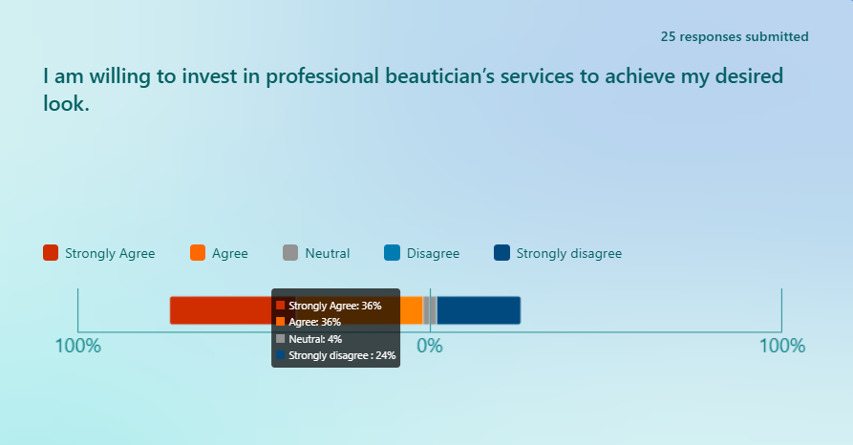
Question 2
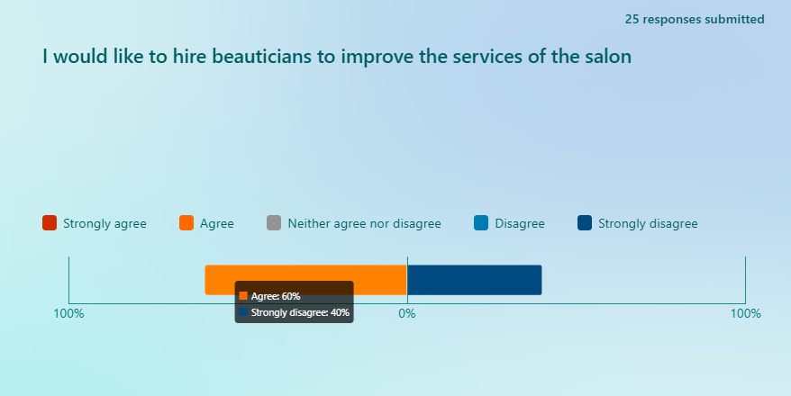
Question 3
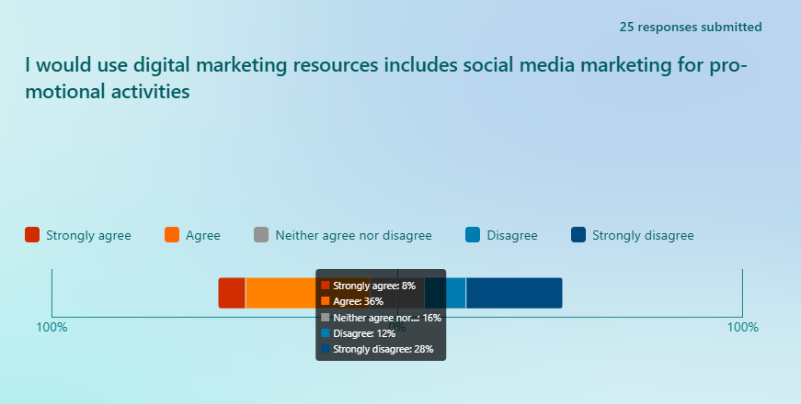
Question 4
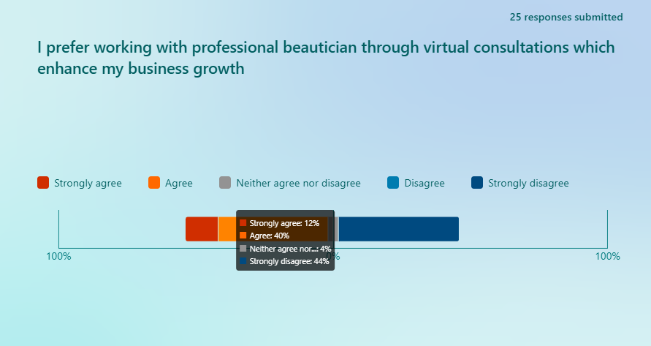
Question 5
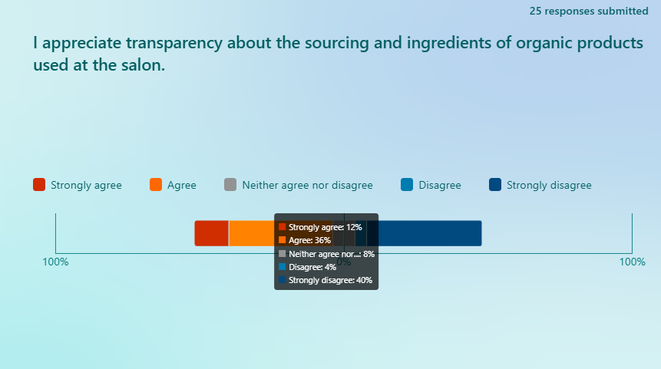
Question 6
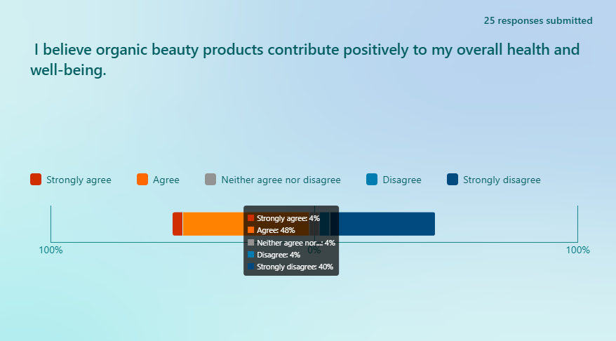
Question 7
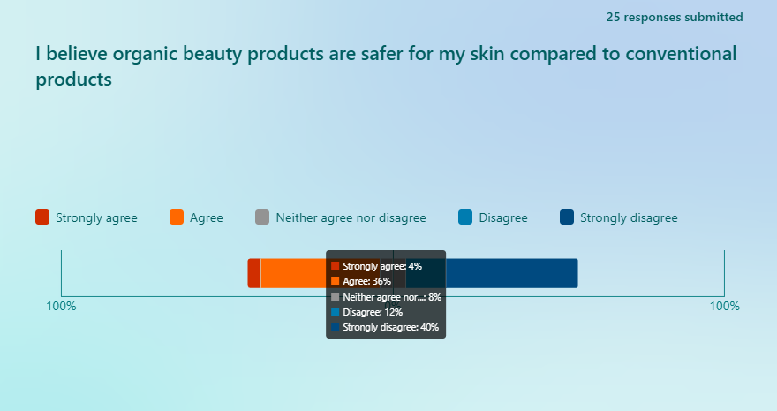
Question 8
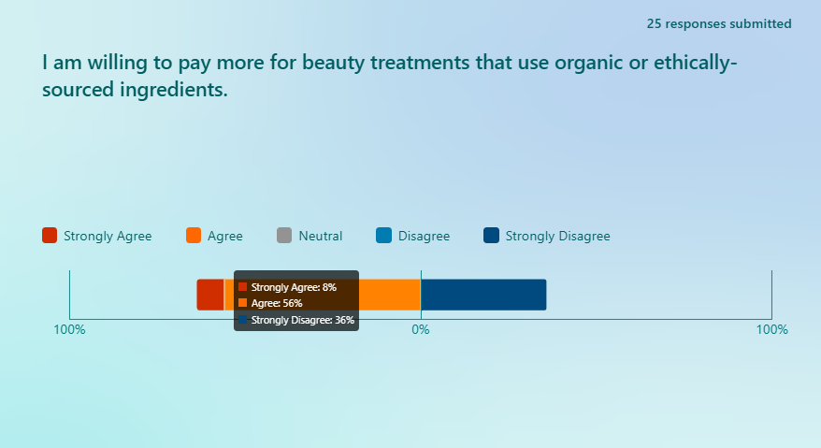
Question 9
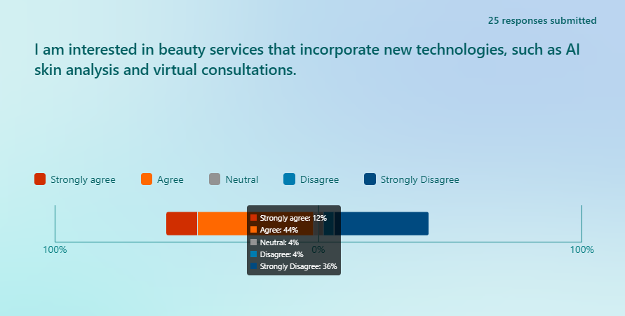
Question 10
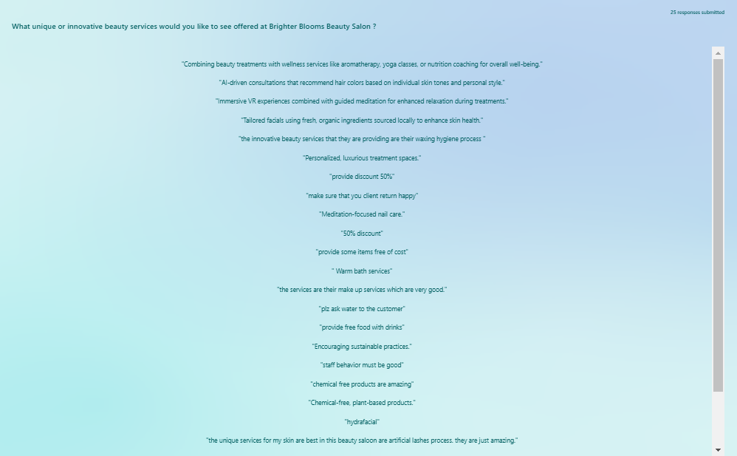
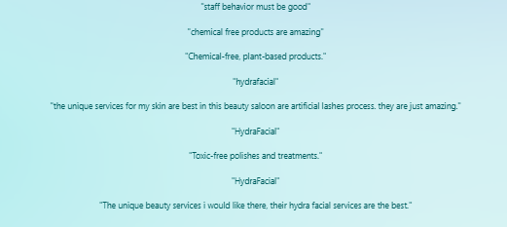

Discussion on select questions
- What unique or innovative beauty services would you like to see offered at Brighter Blooms Beauty Salon? (Question 10)
- I am interested in beauty services that incorporate new technologies, such as AI skin analysis and virtual consultations (Question 9)
- I am willing to invest in professional beautician’s services to achieve my desired look (Question 8).
- I would use digital marketing resources includes social media marketing for promotional activities

Recommendations and feedback from the target audience
According to the responses of the customers, there is an opportunity to diversify the key activities of the Brighter Blooms Beauty Salon by developing a combination of cosmetic services and healthy lifestyle programs that will include aromatherapy, yoga, and nutritionist’s consultations. Moreover, combination would help to address the clients who wish to get the wellness experience apart from the beauty care (Javidi et al., 2020). Increase of personalization and engagement was another recommendation by the clients, in this case concerning hair color and style, where clients recommended that consultations should be made using artificial intelligence. New relaxation techniques such as using virtual reality (VR) guided meditation during treatments were identified as unique.
Healthy and chemical-free products are still the most popular ones; some consumers appreciate plant and local product base in services, such as facial and toxin-free nail treatments. Some of the services include HydraFacial, warm bath treatments, and others which were mentioned as favorite services that are very helpful for client’s hygienic waxing processes and environmental consciousness show that this salon strictly adheres to the best services. Other observations made included improving client appreciation such as offering complimentary beverages; giving out occasional discounts; and special attention offered to clients were also observed. These responses suggest appreciable interest of customers in merging technology, comfort and disease management principles with personal and professional care and making Brighter Blooms a complete beauty parlor service.

Involvement of AI Technologies in beauty salon
According to the survey, 12% strongly agree, 44% agree which demonstrates that the incorporation of AI skin analysis and other virtual consultant have significance influence on the audience. On the other hand, 4% disagree and 36% strongly disagree which shows that audiences don’t want any AI radiation or treatment. For the new technologies to implement, like skin analysis by artificial intelligence and virtual consultation, Brighter Blooms Beauty Salon can help the client and also improve on functioning. Skin analysis apps use artificial intelligence to analyze the skin to give advice on what treatment and products are ideal for the specific skin type, complexion, and issues every client have (Ourahmoune and Jurdi, 2021). This enables the salon, to deliver more unique service, increasing the satisfaction level of the clients and hence increase their loyalty. Customers often describe their problems in detail, and with AI suggestions, therapists are more receptive (de Carvalho Nunes et al., 2019). Therefore, consultations are more efficient. This helps convenience as well as accessibility can be characterized by the ability for a client or a customer to be able to consult with the appropriate specialists regarding their needs for beauty and otherwise without having to visit the office physically. The service can therefore be seen to have access to more customers for instance those that have tight working schedules or those who would wish to explore their options before they commit themselves to a particular service

Investing in professional beautician
The response rate shows that 8% strongly agree, 56% agree and 36% disagree with the statement. The findings shows that for authentic beauty treatment people are willing to pay more for organic products (Asare-Donkor et al., 2020). Sourcing talented beauticians is central for the success of a beauty salon since the relations between quality and expertise of beauticians contributes to the salon services. Trained beautician provide skills, current fashioninh beauty products and methods as well as services of excellent quality customized to meet the needs of the clients. They are also in a better position to judge the features, skin tone and preferences of each client which makes their work more fulfilling and the clients compensated by improved confidence and allegiance.
A well trained beautician also have the input to the type of environment offered in the salon as well as the pleasure of the clients (Hanson, 2019). Their communication skills, ability to listen to the clients and how they provide advice to their clients is always professional, thus making clients comfortable. Clients, when they get the satisfaction that they are in the right hands would then stick to the salon more as a result increasing customer loyalty. Besides, many trained beauticians work here, they always develop their skills through training, so the salon always has current services and innovations. Natnael et al., (2022), commitment towards quality and innovation also to some extent adds values to the salon because it will help in attracting more clients and makes the salon as most trusted beauty house among the clients.

Promotional activities using digital marketing
The response rate reflects that 8% strongly agree, 36% agree, 12% disagree and 28% strongly disagree. The findings shows that integration of digital marketing resources especially social media site highly impact on the promotional activities for the salon. Using web marketing tools, social networks in particular, can make a major positive impact on promo for a beauty salon. Using platforms as Instagram, Facebook or TikTok offers visibility and visually oriented content that is great for beauty transformations, product promotions, and service announcements. The benefit of the ads is that through targeting. Brighter Blooms can interact with the desired population and clients both current and prospective (Alharbi and Alhashim, 2021). It also enables one to directly engage with the clients to provide them with answers to their questions and overall there is creation of a loyal (CHOI et al., 2019). Moreover, an effective and regular usage of High-quality content, offer promotions, and a combination with influencer works Brighter Blooms can increase its awareness and get new clients, to be considered as a salon which is up-to-date on trends and caring about customers.

Task 2: Website and marketing material

Survey Data insights
In the light of survey responses, in the corresponding to the statement of investing in professional beautician services the response arte shows that 39% strongly agree, 36% agree, neutral 4%, and 24% strongly disagree with the statement. The responses shows that investing in professional beautician enhance the credibility of the salon as well as it increase the customer trust and reliability in providing the customer care services. In contrast, the other statement is relate to the hiring the beautician improve the service quality around 60% agree, while contradictory 35% disagree with this statement (Kampani and Jhamb, 2021). Hence, for the business of bright beauty salon hiring the professional beautician will be benefited for the salon progression. In corresponding, using digital marketing and especially social media marketing which includes Facebook, twitter, and Instagram. Moreover, the response rate reflects 8% of respondents are strongly agree, 36% agree, 12% disagree and 28% strongly agree. The findings shows that integrating digital marketing fostering the beauty salon performance and increase the revenue of the salon (Randolph et al., 2021). There is a necessity for the beauty salons to shift to digital marketing in order to increase transparency, attract customers, and maximize interaction. Instagram, Facebook or TikTok provide the opportunity to post good looking images, clients before and after pictures, and different tips and tricks. To increase reach, partnerships with relevant influencers are possible, additional ads to target the local audience are also effective. Those clients are informed via e-mail about new services, latest deals, and promotions, loyalty programs to retain them (De Silva et al., 2021). Furthermore, Google My Business enhances the business for a local search and enables clients to find the salon easily. Combining social media, email, and local SEO, salons are capable of client acquisition and retention. Moreover, virtual consultation which enhance business growth the response arte shows that 12% strongly agree, 47% agree, and 44% disagree of the statement. However, the feedings shows significance of the Telecommunications factors in improving beauty salons and fine looking beauticians have a great impact on the growth of the beauty salons. From the aspect of clients, the current situation allows receiving consultations from beauty specialists from home, and thus the expansion of the salon’s coverage and making the initial consultations available to more people. Due to this service, clients can get a consultation of the services they require before visiting the salon in a one-stop service provision. Moreover, concerned beauticians increase the level of services, experience, and specialized attention clients have to give in order to develop trust on the beautician. Combined all these contribute to the improvement of customers’ loyalty, increase of customers’ flow, and increase of salons’ prestige, which is the proof of the high-quality salon, focused on its customers. Transparency in sourcing the organic products at salon shows 12% strongly agree, 36% agree, 4% disagree and 40% strongly disagree with the statement. Moreover, Products, their sourcing and components must be disclosed to create trusted relationships in the beauty salon. Being specific about where the ingredients are sourced and how a product is manufactured or a service is delivered is another way through which salons can be sure that clients understand their corporate responsibility to quality, safety and ethics. Disclosing such information as organic, non-cruelty, and environmentally-processed materials resonate well with customers driven by natural and environmentally related attributes of beauty. Sharing such information on labels, social media or during consultation provides clients with the ability to make right decisions hence increasing credibility and attracting customers who consider the environment hence improve the client relation and loyalty. In contradictory, organic products highly contribute towards overall health and wellbeing. Significance, the response rate shows that 4% strongly agree, 40% agree, 4% disagree and 40% strongly disagree. This shows that there is division of population for organic products. The response rate shows that strongly agree 4%, agree 36% disagree 12% and strongly disagree 40% this shows that organic products are safer as well as conventional products are reliable for the skin care. The findings shows that paying more for the beauty treatment using organic or sourced ingredients around 8% strongly agree, 56% agree, and 36% disagree with the statement. The response rate reflects that beauty services incorporated new technologies such hydra facial and other skin care treatment through AI and other virtual consultant treatment the salon provides. In respond the response rate shows that 12% strongly agree, 44% agree, 4% disagree and 36% strongly disagree. Asking question related to Any innovative products which the beauty salon can offer include Discount offer 50% off, mediation highly focused on the nail care, warm bath services, customer service by providing the authentic treatment as a swell as offering juices, water and refreshment to their client to build trust. Moreover, using of toxic free polishes and application of eye lashes and maintaining the hygiene process effective especially for waxing.

Market Segmentation
Segmentation | Details
Behavioral | Usage Rate:  Target clients who frequently visit salons for maintenance and wellness.  Loyalty Status:  Focus on creating loyalty programs to retain clients.  Benefits Sought:  Segment clients based on preference for eco-friendly, luxury, or customized treatments.
Geographic | Location:  Primarily target clients within urban areas, with a focus on city centers with high foot traffic.  Climate:  Cater to skincare needs based on regional climate, offering hydration treatments for dry climates and oil-control for humid regions.
Psychographic | Lifestyle: Target eco-conscious clients, wellness enthusiasts, and those prioritizing self-care.  Personality: Focus on clients who seek premium, personalized beauty experiences.  Values: Attract clients with a preference for sustainable, chemical-free, and organic products.
Demographic | Age:  Cater to young adults (20–35) interested in trendy treatments, and adults (35–50) focused on anti-aging.  Gender:  Primarily target female clients, with potential offerings for men’s skincare and grooming.  Income:  Focus on middle to high-income earners willing to invest in premium services

SEO (Search Engine Optimization)
- From the analysis of the questionnaire, the visibility of our website and the marketing collaterals were adjusted to highlight the special and creative beauty services, which clients expressed interest in. Our SEO strategy involved several key steps: keywords, on-page optimization, content creation and local SEO optimization.
- Keyword Research determined which is similar to the mentioned top services clients demanded, including organic beauty treatments, AI-based beauty consultation, and wellness beauty services. These keywords are then used while describing our website content, blog posts, and services we offer to our client base.
- On-Page Optimization Meta tags, headers, and image texts were customized to these keywords to make every page of the site as search-engine friendly as possible. Sections within content were also designed to promote certain services, such as Hydra Facial, environmental responsibility or meditation-centered treatments, which were successful.
- Content Creation For the clients, we have generated useful blogs, FAQs, and service descriptions touching on matters such as chemical-free products, influence of wellness services and how face analysis through Artificial Intelligence works. These content materials are created mostly in natural language incorporating low-competition keywords that are relevant to long-tail searches. Moreover, Local SEO Location convenience is important to many clients therefore local SEO was achieved through the listing of the salon on Google My Business, use of local keywords and ensuring that all our contact information online is accurate.

Marketing material
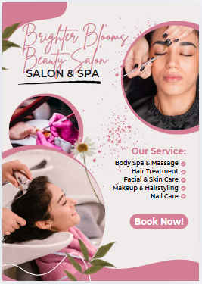
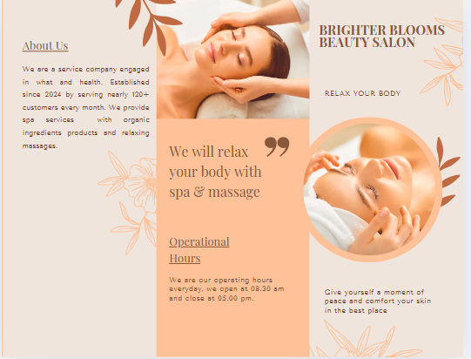
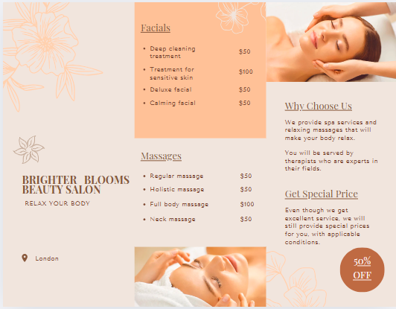

Task 3: Excel
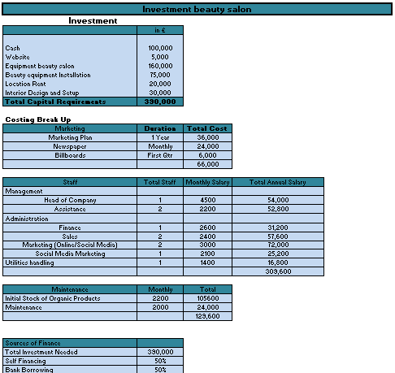

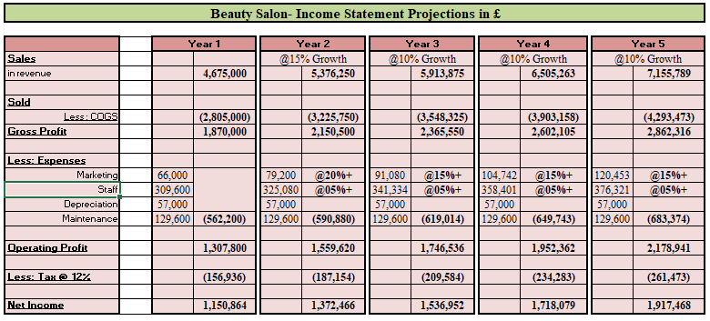

The importance of Excel in digital era
Introduction
In today’s world of big data, knowledge management and analysis and visualization skills are more important than anything else. Moreover, decision making in businesses and organizations continues to adopt data-driven model, then data management tools becomes crucial. Among all these applications, Microsoft Excel remains one of the most critical in this respect. Because of its flexibility, simplicity for usage, and robust features, Taught is a must-have for both a private user and a business owner (Díaz de los Ríos, and Hernández Ramos, 2020). Excel as a tool of the digital age insights on how it enhances data analysis, enables teamwork, and is the total package in building one’s skills.
Collaboration and Integration of Data Analysis and Visualization
Excel stands out as a tool as it is particularly good in handling large volumes of data and can efficiently do a number of computations on the same. By applying features like pivot table, sort, and filters; user can obtain useful information from the data set for the purpose of analysis for pol icy formation (Alexander and Kusleika, 2019). For example, businesses can monitor the level of sales, consumers’ choices and their own stocks, to change their behavior accordingly.
However, Excel provides a list of tools for data visualization that would help users display it in a manner, which will be easily comprehensible. Using excel to come up with graphs charts and dashboards means once the presentation is done it is easy to explain the data to the people with an easier trend to pick from the created part. The world is full of information and putting this information into an understandable picture is important. Significantly the advancement in the digital world, collaboration has been deemed crucial to the achievement of all endeavors (Foulkes, 2020). The recent enhancements of Excel include being able to link the document with the cloud services such as One Drive and SharePoint allowing different users to edit the same Excel at the same time (Díaz de los Ríos et al., 2020). This capability goes hand in hand with transitioning to the elaboration of teamwork and productivity, and the ability to share ideas and make updates from any given place on the globe.
In addition, it is possible easily to import data from other applications databases and external applications which makes data integration possible within Excel (Guerrero et al., 2019). This means that whenever users are dealing with large amounts of data it’s easy for them to import or export data in order to get the latest data. Incorporating cooperation and linkage, Excel helps organizations to reduce their costs and expense (Zhou, 2023). Excel is most popular for its capacity in financial modeling. In budgeting and forecasting and financial analysis and reporting, they share all the necessary Excel tools for financial management (Bernard and Senjayawati, 2019). They can develop specific plans on how to spend money, financially monitor their operations and even determine their viability legally.
Furthermore, Excel incorporates a reporting facility to prepare management or company specific financial statements that can be used and shared with the stakeholders prepared to suit certain requirements. Furthermore, highlight (KPIs) to show the difference between performance and budget estimates. Excel enables organizations to embrace full disclosure of their activities and accountability of their financial process. Competency and Careers understanding of the Excel is gradually considered as a basic keyword in the world of work. Moreover, with corporations looking for staff that have data analytical skills for decision making, Excel has become a basic tool for many jobs (Becker and Gould, 2019). Furthermore, when employed professionally, knowledge of how Excel works can therefore help improve the employment market placement and advancement of any person. Excel can be considered as a platform to understand how more sorts of data analysis can be attained. Moreover, users can be trained to apply formulas and functions, and create simple macros to enhance productivity. Furthermore, the acquisition of these competencies serves as the basis for constructing a positive persona of organizational members of value capable of enhancing productivity and creativity.
Conclusion
Microsoft Excel is important in the digital age as it provides ways of analyzing data, sharing data, managing funds and training people. This makes it a perfect tool for anyone and any organization in the current world that is built on data.

Task 4: Video

https://youtu.be/G1IMwvG4P1E?si=a0EKhcEmerJJ43jt

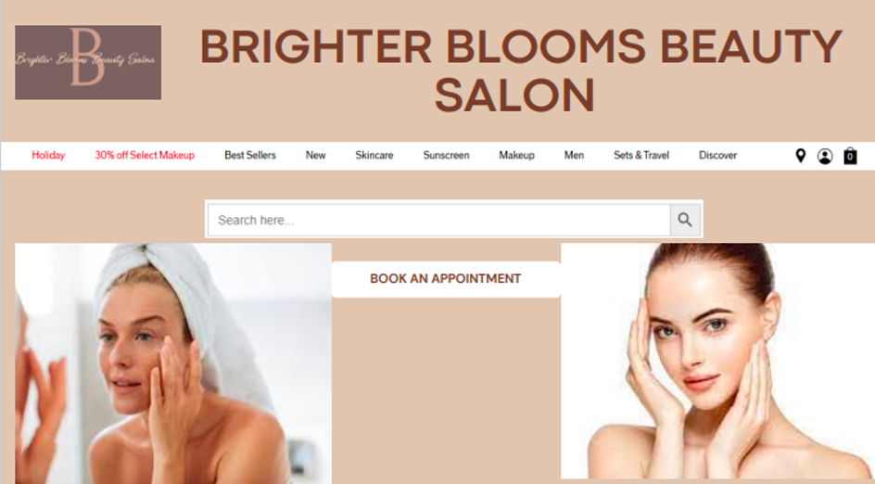
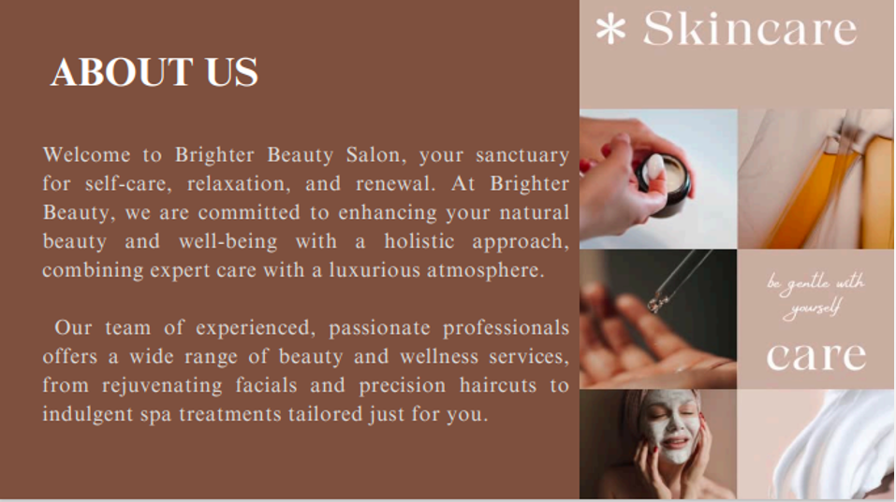

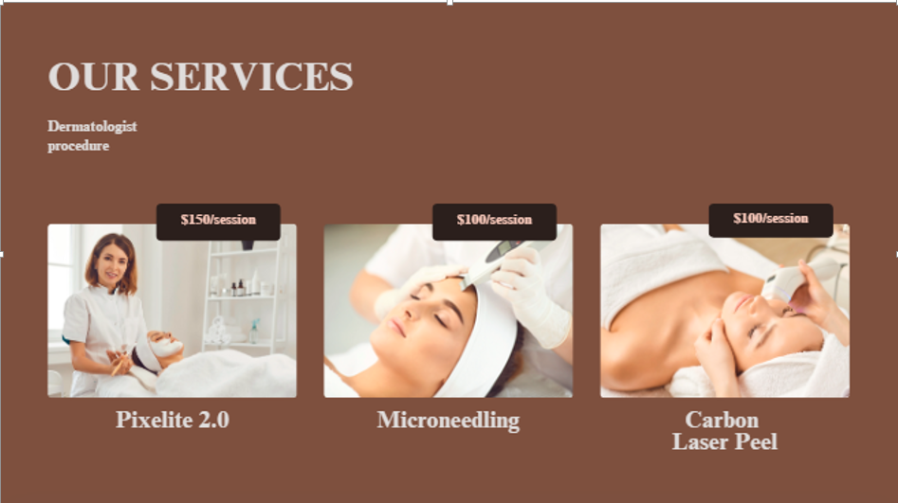
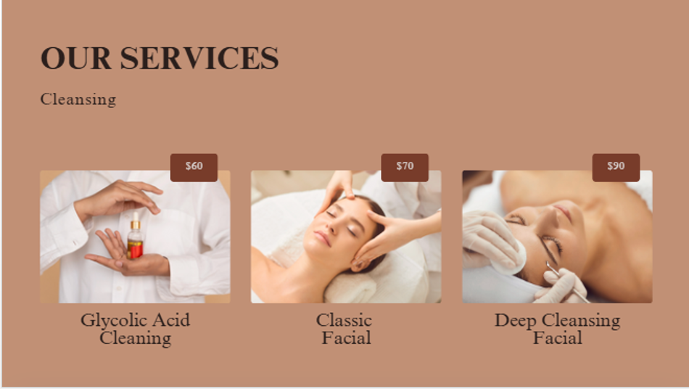
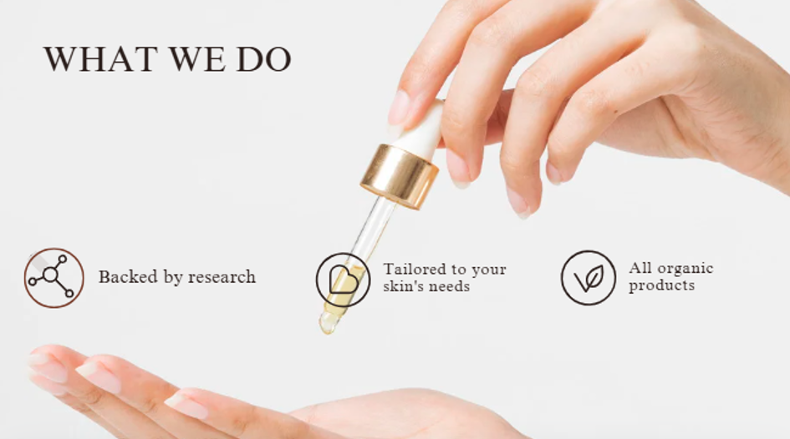
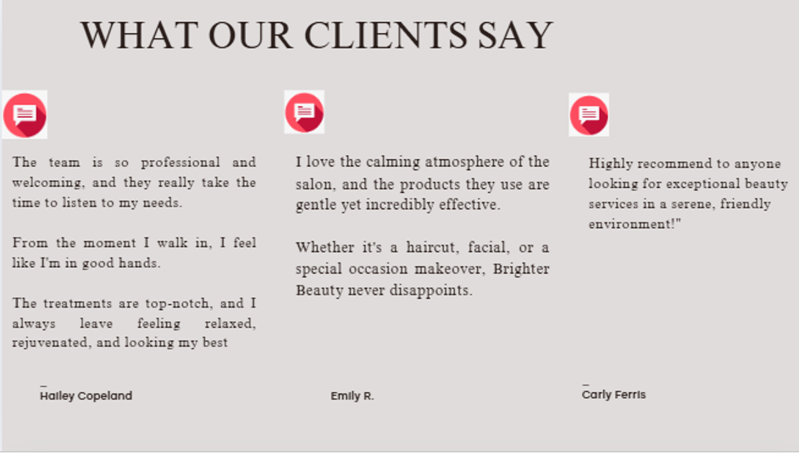
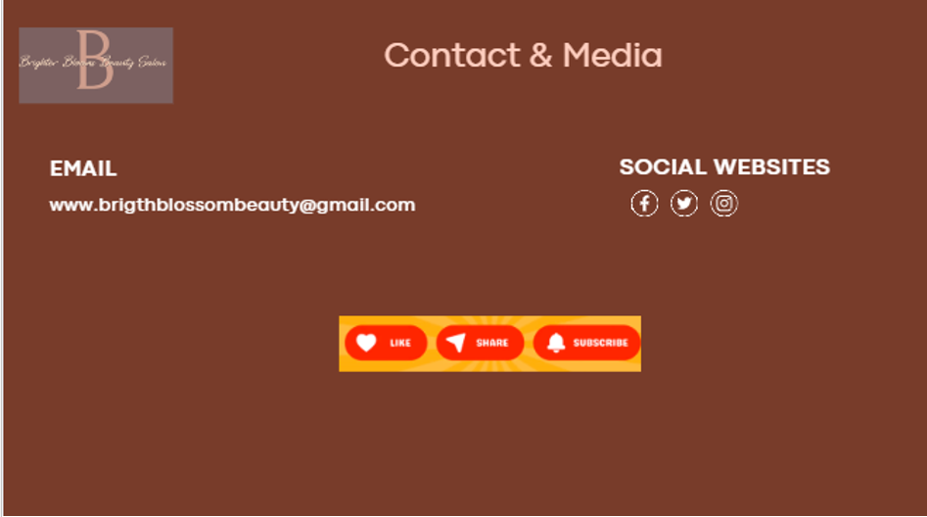

References
Alexander, M. and Kusleika, D., 2019. Excel 2019 power programming with VBA. John Wiley & Sons.
Alharbi, N.M. and Alhashim, H.M., 2021. Beauty salons are key potential sources of disease spread. Infection and drug resistance, pp.1247-1253.
Asare-Donkor, N.K., Kusi Appiah, J., Torve, V., Voegborlo, R.B. and Adimado, A.A., 2020. Formaldehyde exposure and its potential health risk in some beauty salons in Kumasi Metropolis. Journal of Toxicology, 2020(1), p.8875167.
Becker, LT and Gould, EM, 2019. Microsoft power BI: extending excel to manipulate, analyze, and visualize diverse data. Serials Review , 45 (3), pp.184-188.
Bernard, M. and Senjayawati, E., 2019. Developing the Students' Ability in Understanding Mathematics and Self-Confidence with VBA for Excel. Journal of Research and Advances in Mathematics Education, 4(1), pp.45-56.
CHOI, S.I., KIM, H.T., CHOI, W.J., KIM, J.H. and KIM, E.J., 2019. Effects of service attributes on customer satisfaction and loyalty in beauty salon. The Korean Journal of Franchise Management, 10(4), pp.19-29.
de Carvalho Nunes, J.D., Correia, A.M.M., Sampaio, P.G.V., de Oliveira, A.H.S. and da Silva, A.M., 2019. Study of times and movements in the service sector: an analysis in a beauty salon. Independent Journal of Management & Production, 10(2), pp.574-595.
De Silva, T., Männikkö Barbutiu, S., Wakanuma, K. and S Dhameeth, G., 2021. Empowerment through women entrepreneurship: A case from the beauty salon sector in sri lanka. Journal of Women's Entrepreneurship and Education, 2021(1-2)), pp.121-146.
Díaz de los Ríos, M. and Hernández Ramos, E., 2020. Determination of the Hansen solubility parameters and the Hansen sphere radius with the aid of the solver add-in of Microsoft Excel. SN Applied Sciences , 2 , pp.1-7.
Foulkes, L., 2020. Learn Microsoft Office 2019: A Comprehensive Guide to Getting Started with Word, PowerPoint, Excel, Access, and Outlook . Packt Publishing Ltd.
Guerrero, H., Guerrero, R. and Rauscher, 2019. Excel data analysis. Springer International Publishing.
Hanson, K., 2019. Beauty “therapy”: the emotional labor of commercialized listening in the salon industry. International Journal of Listening, 33(3), pp.148-153.
Javidi, M., Kamalikhah, T., Ghobakhloo, Z., Torshizi, Y.F. and Ghobakhloo, S., 2020. Evaluation of knowledge, attitude, and practice of hairdressers in women’s beauty salons in garmsar towards infection control and disinfection. Iran Occupational Health, 17(1), pp.219-32.
Kampani, N. and Jhamb, D., 2021. Uncovering the dimensions of servicescape using mixed method approach–A study of beauty salons. Benchmarking: An International Journal, 28(4), pp.1247-1272.
Natnael, T., Adane, M. and Goraw, S., 2022. Hand hygiene practices during the COVID-19 pandemic and associated factors among barbers and beauty salon workers in Ethiopia. PloS one, 17(7), p.e0269225.
Ourahmoune, N. and Jurdi, H.E., 2021. Beauty salon-a marketplace icon. Consumption Markets & Culture, 24(6), pp.611-619.
Randolph, S.D., Johnson, R., Meyers, D., Washington, D. and Saint-Hillaire, L., 2021. Leveraging social networks of Black women in beauty salons to improve uptake of pre-exposure prophylaxis. Health Education Journal, 80(1), pp.95-105.
Zhou, H., 2023. Excel and Data Mining. In Learn Data Mining Through Excel: A Step-by-Step Approach for Understanding Machine Learning Methods (pp. 1-21). Berkeley, CA: Apress.

