

Changemakers: Creativity and Value Creation
Professions (BMHP5014)

Component 2: Poster and Pitch

Student name: Ioan-Ciprian Tanase
Student number:2414116
Lecturer’s name: Caroline Salami

Task 1: Poster

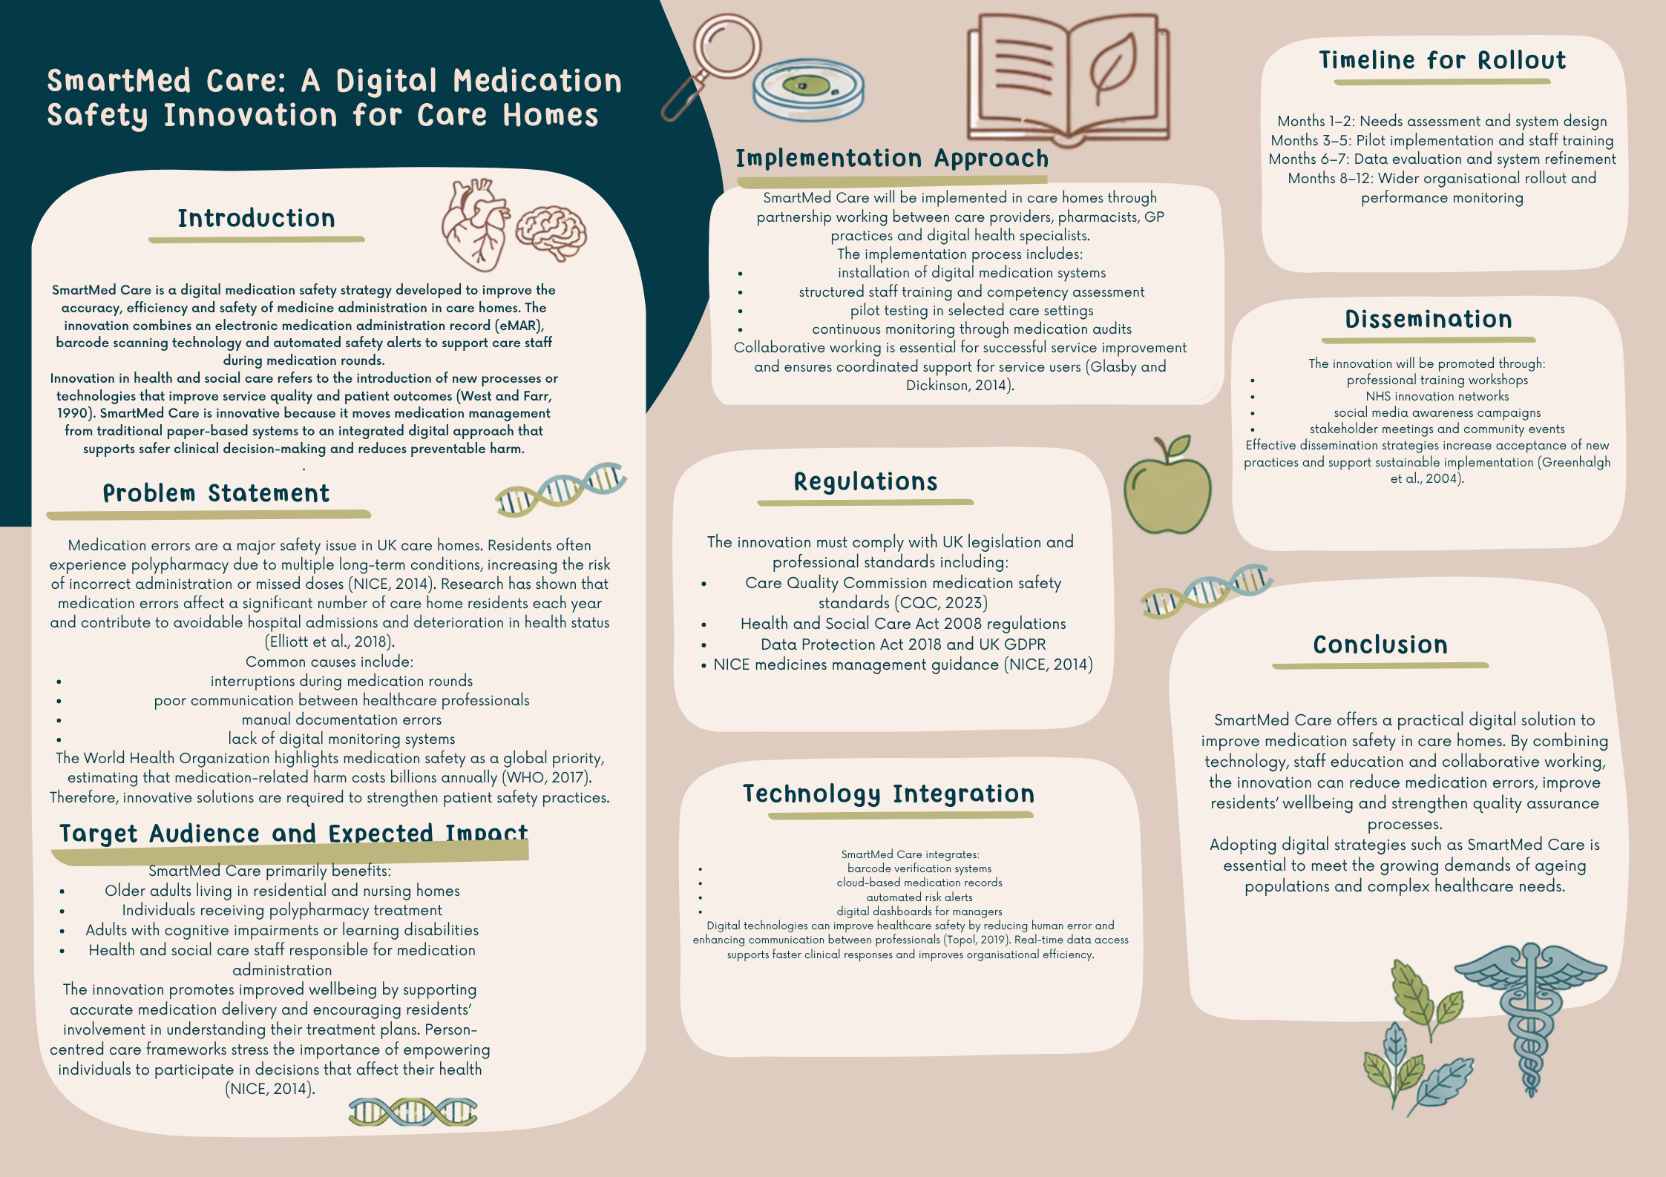
References for Task 1
Care Quality Commission (2023) Medicines optimisation in care homes. Available at:
https://www.cqc.org.uk/guidance-providers/adult-social-care/medicines-optimisation-care-homes
(Accessed: 20 March 2026).
Elliott, R.A., Camacho, E., Jankovic, D., Sculpher, M.J. and Faria, R. (2018) Prevalence and economic burden of medication errors in the NHS in England. Available at:
https://www.york.ac.uk/media/che/documents/papers/researchpapers/CHERP180_medication_errors.pdf
(Accessed: 20 March 2026).
Glasby, J. and Dickinson, H. (2014) Partnership Working in Health and Social Care. Available at:
https://policy.bristoluniversitypress.co.uk/partnership-working-in-health-and-social-care
(Accessed: 20 March 2026).
Greenhalgh, T. et al. (2004) Diffusion of Innovations in Service Organizations. Available at:
https://onlinelibrary.wiley.com/doi/book/10.1002/9780470987407
(Accessed: 20 March 2026).
Kitwood, T. (1997) Dementia Reconsidered: The Person Comes First. Available at:
https://www.mheducation.co.uk/dementia-reconsidered-9780335198559-emea
(Accessed: 20 March 2026).
National Institute for Health and Care Excellence (2014) Managing medicines in care homes (SC1). Available at:
https://www.nice.org.uk/guidance/sc1
(Accessed: 20 March 2026).
Topol, E. (2019) Deep Medicine: How Artificial Intelligence Can Make Healthcare Human Again. Available at:
https://www.basicbooks.com/titles/eric-topol/deep-medicine/9781541644632/
(Accessed: 20 March 2026).
West, M.A. and Farr, J.L. (1990) Innovation and Creativity at Work. Available at:
https://onlinelibrary.wiley.com/doi/book/10.1002/9780470696736
(Accessed: 20 March 2026).
World Health Organization (2017) Medication Without Harm. Available at:
https://www.who.int/initiatives/medication-without-harm
(Accessed: 20 March 2026).
UK Government (2018) Data Protection Act 2018. Available at:
https://www.legislation.gov.uk/ukpga/2018/12/contents/enacted
(Accessed: 20 March 2026).

Task 2: Pitch SmartMed Care – Improving Medication Safety in UK Care Homes

Medication safety continues to be a critical concern within UK health and social care services, particularly in residential care settings where service users often present with complex health needs and require multiple prescribed medicines. This pitch aims to present SmartMed Care as an innovative digital solution that can significantly improve medication management practices in care homes while promoting safer outcomes for vulnerable populations.
To make it easier to assist caretakers during medication rounds, SmartMed Care is a digital drug safety system that incorporates barcode verification, electronic medication administration records (eMAR), and automatic risk alarms. This invention lowers the possibility of human error and increases accountability in medicine processes by offering real-time instruction and documentation support, in contrast to conventional paper-based solutions. Innovation in healthcare encompasses not only the development of new technologies but also the improvement of patient safety and service quality through workable solutions that address actual problems encountered by frontline staff (West and Farr, 1990).
The increasing frequency of medication errors in assisted living facilities is one of the primary reasons this innovation is required. Many locals have several chronic ailments that necessitate complicated prescription schedules, such as diabetes, heart disease, dementia, or respiratory disorders. According to research, prescription mistakes are still frequently made in assisted living facilities, which can result in needless hospital stays, declining health, and a lower standard of living (Elliott et al., 2018). Additionally, inadequate documentation, poor professional communication, and disruptions during medicine administration rounds are frequently linked to manual medication systems.
The World Health Organization has identified medication safety as a global priority, estimating that medication-related harm causes substantial economic and social burden worldwide (WHO, 2017). Therefore, introducing digital systems such as SmartMed Care can contribute to wider patient safety initiatives and support national strategies aimed at improving healthcare quality.
This innovation is particularly relevant for older adults living in residential and nursing homes, as well as adults with learning disabilities who rely on staff support for medication administration. These groups may experience increased vulnerability due to cognitive impairment, reduced physical independence, or communication barriers. By introducing digital reminders, safety alerts, and barcode scanning verification, SmartMed Care supports accurate medication delivery while also promoting a more person-centred approach to care. Person-centred care frameworks emphasise the importance of respecting individuals’ preferences, promoting dignity, and involving service users in decisions that affect their health (Kitwood, 1997).
The impact of SmartMed Care extends beyond individual residents. For care staff, the innovation provides increased confidence and structured support during medication administration. Staff working in social care settings often experience high workloads and emotional stress, which may increase the risk of clinical mistakes. Providing digital tools that guide safe practice can reduce anxiety, improve job satisfaction, and support professional accountability. Additionally, improved medication safety may reduce safeguarding concerns and contribute to stronger organisational governance.
Implementation of SmartMed Care would require collaboration between multiple stakeholders including care home managers, pharmacists, general practitioners, IT specialists, and regulatory bodies. Partnership working is recognised as an essential component of effective health and social care delivery because it promotes coordinated support and shared responsibility for patient outcomes (Glasby and Dickinson, 2014). Training programmes would need to be developed to ensure staff competence in using digital systems, alongside regular audits to monitor effectiveness.
From a legal and ethical perspective, the innovation must comply with UK regulatory frameworks such as the Care Quality Commission standards for medicines management and the Health and Social Care Act regulations. Ensuring compliance with the Data Protection Act 2018 and UK GDPR is also essential, as digital medication systems involve the processing and storage of sensitive personal health data. Maintaining confidentiality, transparency, and informed consent will be critical to gaining trust from service users and their families.
Technology integration plays a key role in enhancing the effectiveness of SmartMed Care. Artificial intelligence features can help identify patterns of medication risk, while cloud-based documentation enables authorised healthcare professionals to access real-time information. Digital transformation within healthcare has been shown to support clinical decision-making and improve service efficiency when implemented responsibly (Topol, 2019). However, it is also important to recognise potential barriers such as resistance to change, digital literacy challenges among staff, and financial costs associated with system adoption.
In order to promote SmartMed Care successfully, dissemination strategies must target both professional and public audiences. Awareness campaigns can be delivered through healthcare conferences, training workshops, social media platforms, and community engagement events. Encouraging the general public to understand the importance of medication safety can strengthen support for innovation and increase transparency within social care services. Research on innovation adoption highlights that effective communication and stakeholder involvement are essential for embedding new practices into routine service delivery (Greenhalgh et al., 2004).
Ultimately, SmartMed Care represents a proactive approach to improving medication safety and supporting the wellbeing of vulnerable populations. By combining digital technology, staff education, and collaborative working, the innovation has the potential to reduce medication errors, improve residents’ quality of life, and strengthen public confidence in care services. As the UK population continues to age and healthcare needs become more complex, adopting innovative strategies such as SmartMed Care will be essential for ensuring sustainable, safe, and person-centred health and social care provision.

Reference for Task 2
Elliott, R.A., Camacho, E., Jankovic, D., Sculpher, M.J. and Faria, R. (2018) Prevalence and economic burden of medication errors in the NHS in England. York: Policy Research Unit in Economic Evaluation of Health and Care Interventions, University of York. Available at: https://www.york.ac.uk/media/che/documents/papers/researchpapers/CHERP180_medication_errors.pdf (Accessed: 20 March 2026).
Glasby, J. and Dickinson, H. (2014) Partnership Working in Health and Social Care: What is Integrated Care and How Can We Deliver It? 2nd edn. Bristol: Policy Press. Available at: https://policy.bristoluniversitypress.co.uk/partnership-working-in-health-and-social-care-second-edition (Accessed: 20 March 2026).
Greenhalgh, T., Robert, G., Macfarlane, F., Bate, P. and Kyriakidou, O. (2004) Diffusion of Innovations in Service Organizations: Systematic Review and Recommendations. Oxford: Blackwell Publishing. Available at: https://onlinelibrary.wiley.com/doi/book/10.1002/9780470987407 (Accessed: 20 March 2026).
Kitwood, T. (1997) Dementia Reconsidered: The Person Comes First. Buckingham: Open University Press. Available at: https://openlibrary.org/books/OL1011528M/Dementia_reconsidered (Accessed: 20 March 2026).
National Institute for Health and Care Excellence (2014) Managing medicines in care homes (SC1). London: NICE. Available at: https://www.nice.org.uk/guidance/sc1 (Accessed: 20 March 2026).
Topol, E. (2019) Deep Medicine: How Artificial Intelligence Can Make Healthcare Human Again. New York: Basic Books. Available at: https://www.basicbooks.com/titles/eric-topol-2/deep-medicine/9781541644632/ (Accessed: 20 March 2026).
West, M.A. and Farr, J.L. (eds.) (1990) Innovation and Creativity at Work: Psychological and Organizational Strategies. Chichester: Wiley. Available at: https://onlinelibrary.wiley.com/doi/book/10.1002/9780470696736 (Accessed: 20 March 2026).
World Health Organization (2017) Medication Without Harm. Geneva: World Health Organization. Available at: https://www.who.int/publications/i/item/WHO-HIS-SDS-2017.6 (Accessed: 20 March 2026).
Care Quality Commission (2024) Medicines optimisation. London: CQC. Available at: https://www.cqc.org.uk/guidance-regulation/providers/assessment/single-assessment-framework/safe/medicines-optimisation (Accessed: 20 March 2026).
UK Government (2018) Data Protection Act 2018. London: The Stationery Office. Available at: https://www.legislation.gov.uk/ukpga/2018/12/contents/enacted (Accessed: 20 March 2026).

