University of Wales Trinity Saint David

Wales institute of Science & Art



Manufacturing Systems & Simulation
Discrete Event Simulation
ACMA 6002

Brogan Carroll
2418025
October 2026

Contents table
Table of Contents
Contents table 1
Table of Figures 2
Introduction 3
Literature Review 4
Discrete Event Simulation in Manufacturing 4
Simulation Verification and Validation 4
Lean Manufacturing and Waste 4
Process Selection & Description 5
Figure 1 shows the process flow diagram for the FESTO CP Laboratory 5
DES Model Development 6
Figure 2 shows the Arena simulation developed to show the FESTO CP Lab 6
Figure 3 shows a snapshot of the time intervals given in the case study 6
Figure 4 shows a table of actions created to validate the model of the process 7
Figure 5 shows the 60:40 drilling distribution across 5 replications 8
Figure 6 shows the comparison of given process times vs the actual process times for each station from replication 1 8
Waste identification and performance analysis 9
Waiting and bottlenecks 9
Excessive WIP (Work in Progress) 9
Transportation 9
Operator intervention 9
Value Analysis 10
Figure 7 shows the equation for percentage value added 10
Summary of results from the report 11
Figure 8 shows a summary of the findings from the simulation report (Appendix B) to show the range across the 5 replications performed 11
Lean Opportunities and Recommendations 12
Summary of Recommendations 13
Figure 9 shows the summary of recommendations, the benefits and limitations 13
Conclusion 14
References 15
Appendix 16
Appendix A: Report analysis for Arena CP Lab simulation 16
Appendix B: a report simulation of a 24 hour period including 5 replications 21

Table of Figures

Figure 1 shows the process flow diagram for the FESTO CP Laboratory 5
Figure 2 shows the Arena simulation developed to show the FESTO CP Lab 6
Figure 3 shows a snapshot of the time intervals given in the case study 6
6
Figure 4 shows a table of actions created to validate the model of the process 7
Figure 5 shows the 60:40 drilling distribution across 5 replications 8
Figure 6 shows the comparison of given process times vs the actual process times for each station from replication 1 8
Figure 7 shows the equation for percentage value added 10
Figure 8 shows a summary of the findings from the simulation report (Appendix B) to show the range across the 5 replications performed 11
Figure 9 shows the summary of recommendations, the benefits and limitations 13

Introduction
Discrete event simulation (DES) is an analytical tool that represents a whole system broken down by a sequence of chronological discrete events. DES is a very powerful and useful tool as it can focus on the interactions between the system components such as machines, operators and parts.

This report aims to apply the DES principles to the Festo 14.0 CP Laboratory which is an automated process to simulate a real-world smart factory found in the University of Wales Trinity Saint David SA1 Campus. The laboratory consists of a sequence of manufacturing operations with quantifiable wait times, processing times and resource usage values. The aim of the report is to develop a current state DES model of the laboratory using Arena simulation software and then use this model to evaluate the performance of the manufacturing system. The results will form using wait times, processing times and resource utilisation to determine sources of waste. After which Lean manufacturing opportunities for improving the system will be evaluated.

Literature Review

Discrete Event Simulation in Manufacturing
According to Agalianos et al. (2020) discrete event simulation is a form of computer-based modelling of a system as a discrete sequence of events. Where they break down that the term ‘discrete’ refers to the simulation of moving forward in time at mutually exclusive intervals. This source is relevant to the project as it acts as a base understanding of what discrete event simulation is and what the role of DES is proving a fundamental understanding for the project.

Negahban and Smith (2014) describe how DES plays an important role in evaluating manufacturing process as it allows us to evaluate alternative operating conditions without changing the production process while Mourtzis (2019) Identifies similar claims to Negahban and Smith (2014) but also explains how operating conditions can be easily be investigated and improved which creates a solid understanding of how important DES is in the manufacturing industry. Kleijnen (1995) then further explains the conclusions drawn by Negahban and Smith (2014) and Mourtzis (2019) by explaining how important model assumptions and data input are very important in making sure these simulations are accurate.

Simulation Verification and Validation
Kleijnen (1995) makes the key recommendation that simulation validations and verifications are necessary to establish confidence in the simulation. This is a very important consideration for this report as the CP Lab minimum, average and maximum values need to be displayed in the correct logic (triangular distributions) for the simulation to run as intended. This point is also emphasised by Rabe, Spieckermann and Wenzel (2009) who also shows how these points are relevant to production and logistics.

Lean Manufacturing and Waste
The focus of Lean Manufacturing principles is to add customer value while reducing activities that don’t add value to as outlined by Hines, Holweg and Rich (2004) who describes how important it is to understand ‘value’ from the customer perspective. This is relevant principle to the project as lean principles need to be applied to improve the process by adding value from a customer perspective. Hamed (2017) then furthers this discussion by explaining examples of waste like unnecessary transportation, excess work in the process (WIP), queue times and processing times are very important to this process. The lean manufacturing principles provide the fundamental framework for evaluating the simulation. This level of thinking will be applied during this report to include lean opportunities and recommendations for the FESTO CP Lab process.

Process Selection & Description
The case study that will be analysed during this report is the FESTO CP laboratory which is an automated production system available at the University of Wales Trinity Saint David Swansea Campus that simulates a real-world smart factory containing 7 main stages which can be seen in figure 1.

Figure 1 shows the process flow diagram for the FESTO CP Laboratory

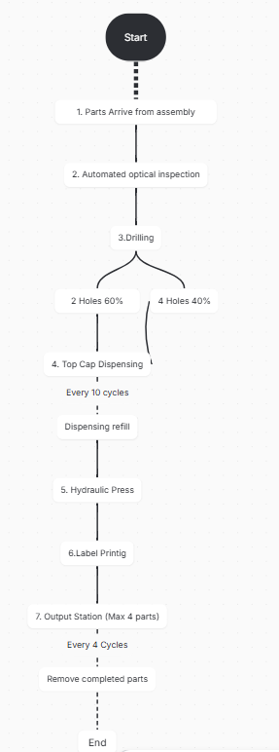
All the stages of the process and minimum, average and maximum times for each stage can be seen in Figure 3.

This process selection is relevant to the brief as it contains a multiple stations, queues, variable processing times, resource constraints, routing decisions and operator interventions which are all important factors when creating DES models in a variety of industries.

DES Model Development
The FESTO CP Laboratory has been modelled using arena to show the flow of components through the manufacturing process. Each component was first modelled using each entity and the data with each entity to represent a systematic flow of what the process looks like using the data provided in the case study around the movements and operation of each of the 7 stages listed in figure 1. Figure 2 shows the arena model developed for this.

Figure 2 shows the Arena simulation developed to show the FESTO CP Lab
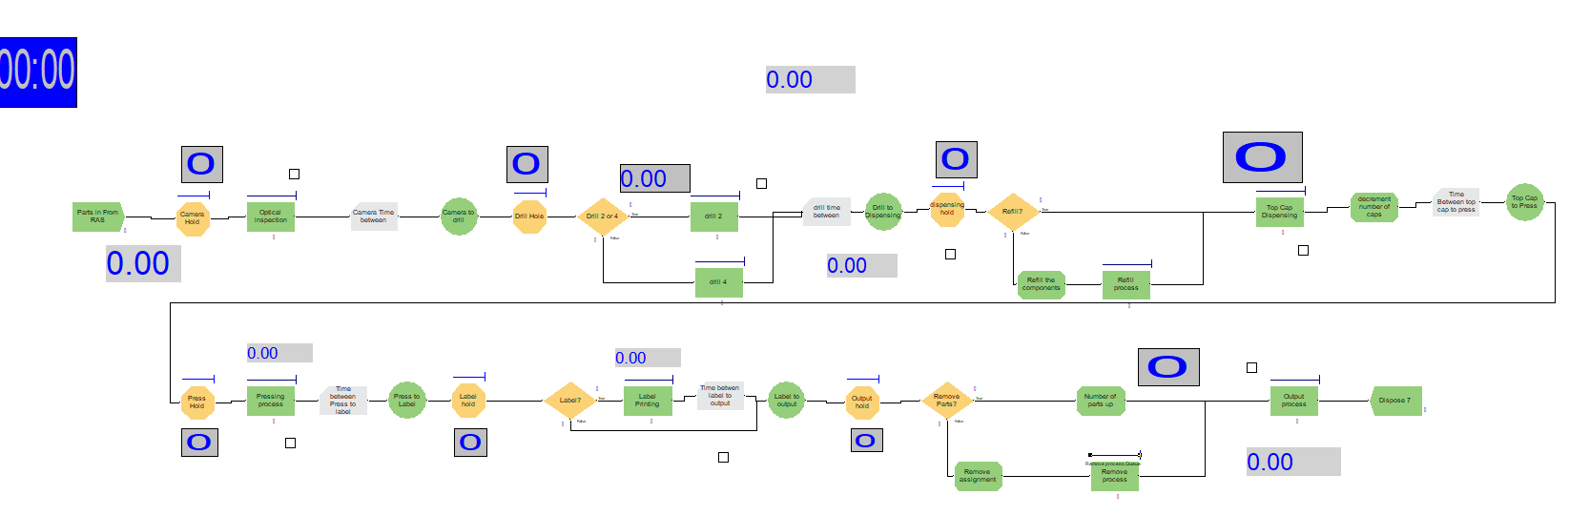

The case study provides the time and states required to be demonstrated in the Arena model (figure 2). All this information can be seen in figure 3 which is a snapshot of the case study timings for each process.

Figure 3 shows a snapshot of the time intervals given in the case study
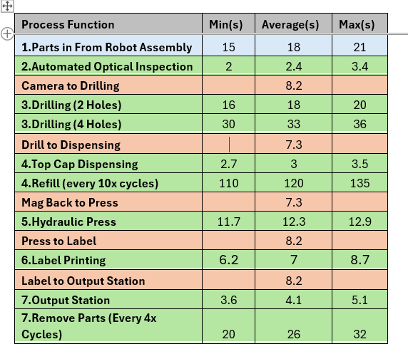(Case Study Doc, 2026)

Triangular distributions were selected for all the phases that show a minimum, maximum and average time value as triangular distributions allows process time variability to be represented rather than having one uniform set time for each activity which accurately displays the actual process.

Decisions are added to the Arena model (Figure 2) such as during the drilling stage as not all the components will have 2 holes drilled some require 4 as seen in figure 3. These decisions are then added to accurately show that 60% of components will have 2 holes drilled while the other 40% of components will have 4 holes drilled. This adds a real-world example to this production as not all products will be processed the same.

Operator capacity logic is also used as one main assumption of the case study one operative refills the dispensing unit and empties the output station, so this is an important variable to add into the model to get an effective analysis of the process.

As already stated, there are some assumptions that have been made for this process which are:
- One operator is used for dispensing refill and emptying the output station.
- The processing times follow the triangular distribution.
- All sections are operating to the max e.g. no machine breakdowns.
- The 60/40 drilling ratio remains constant.

Figure 4 shows a table of actions created to validate the model of the process
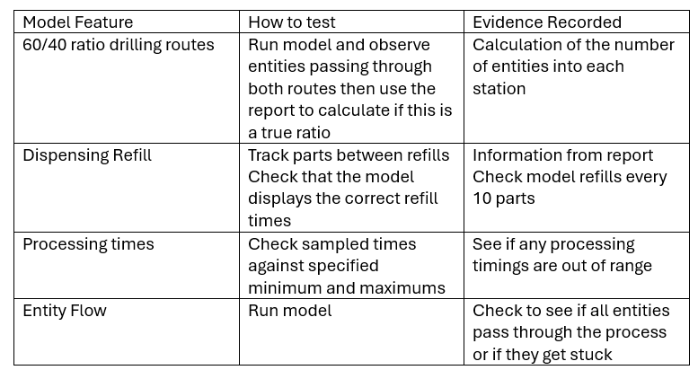
The model had been verified using the actions created in figure 4. This figure explains some of the steps that have been undertaken to validate the process.

The first model feature that has been checked is the 60/40 drilling routes. The first thing that was conducted to ensure that this is working in the model is by running the completed model and evaluating where each entity is travelling to ensure that they are passing through either part. Appendix B shows 5 replications of the simulation showing 24hrs for each replication. This report shows us how many parts pass through either drill 2 or 4 so we can work out the distributions which are highlighted in figure 5.

Figure 5 shows the 60:40 drilling distribution across 5 replications
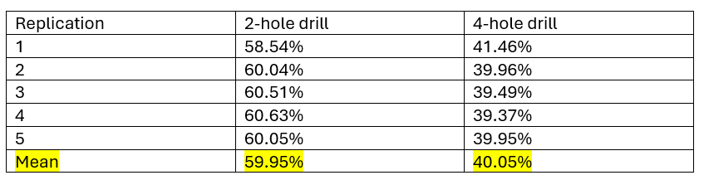

The second model feature that has been checked is the dispensing refill. The refill times were checked by running the model where it could be seen that the dispensing unit was being refilled after 10 parts. The first single replication report (appendix A) states that refill took 0.03383hours (~121s) which falls into the desired refill time range.

The next check that took place was to verify that all the processes conform to the given time ranges in the case study. Figure 6 shows a comparison table of each process, the average time given in the case study and the actual time displayed in the report (appendix A). All the actual processing times conform to the given times in the case study (figure 3)

Figure 6 shows the comparison of given process times vs the actual process times for each station from replication 1
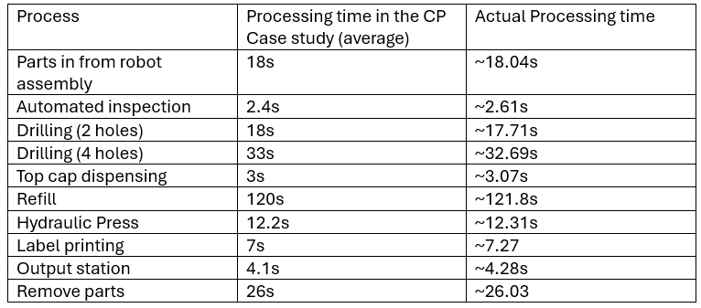
The final part that is checked is the entity flow, by watching the simulation run you can clearly see that all entities flow through the simulation without getting stuck or lost. The only thing clear from the report is that less entities leave (3606) than the entities that enter the process (4795). This is likely due to the simulation ending while parts are still in queues rather than entities becoming lost.

The checks above provide evidence that the Arena model has been implemented correctly according to the process specifications listed in the case study (figure 3) therefore supporting the simulation verification. Validation would require lots of historical performance data from the FESTO CP Lab which is not available. The study can therefore be considered verified but not fully validated without the historical performance details.

Waste identification and performance analysis
The development of the DES model was used to identify any potential source of waste in the CP Laboratory by analysing the time and resources associated with each stage of the process. Lean waste was considered during the literature review and some things found by Hamed and Soliman (2017) were waiting times, transportation and operator movement.

Waiting and bottlenecks
Waiting is identified as the most significant form of waste through the reports found in appendix A and B. Across the 5-replication average (figure 8) each entity spent 2.940hours waiting within the system, compared to the total system time of 2.971 hours. This means that approximately 98.96% of the time each entity was in the process, it spent waiting to be processed. The consistency of this across the 5 replications is good as the range is 2.85 – 3.06 hours which means there is up to ~12 minute variation.

The drilling operation is the main contributing factor to the waiting as over the 5 replications the drilling operation accounts for 98.6% of the entity waiting time. The bottleneck created can be seen through the average queue ahead of the drill being 577.9 components across the 5 replications. For comparison the queues associated with dispensing and the hydraulic press are only 2.06 and 1 components. This more concentrated queue at the drilling station compared to everywhere else is the reason for the bottleneck build up.

Excessive WIP (Work in Progress)
The simulation shows the excess WIP is waste factor of the process. As the average WIP over the 5 replications was approximately 590.5 components. Of this number 97.9% of the components WIP were found in the drilling queue (577.6 components). The Excessive WIP variation is not that large across the 5 replications (figure 8) which shows that the accumulation is always present and not just caused by the single replication seen in appendix A.

Transportation
Transportation is considered a non-value adding time according to the customer perspective. The simulation showed that there was an average entity transportation time of 0.00861 hours which is ~31s. Although this transportation time is not as great as the waiting time it is still a factor contributing to the overall lead time of processing.

Operator intervention
Operator intervention is also highlighted as another limitation of the system as one operator is responsible for filling of the dispensing unit and removing the completed parts from the output stage. The average refill time of the dispensing unit is 120s while it only takes 26s to get 4 completed components at the output station. The simulation showed that over the 5 replications the operator utilisation was high at 78.88% which is a high workload.

Value Analysis
The value-added percentage can be determined using the data from the report (appendix B) as the Arena value-added time per entity was 0.01412 hours (~50.8s) and the Arena reports an NVATime of 0.00592 hours (~21.3s). The report also gives us the total amount of time that an entity takes to go through the whole process as 2.97076 hours using the equation from figure 7.

Figure 7 shows the equation for percentage value added
$$Value Added Percentage= \frac{Value Added processing time}{Total Time in system }x100$$
Information for equation found in the paper NCEI (2009).

If the figures from the report are added to the equation it turns to $\frac{0.01412}{2.97076}x100$ = 0.473%

This equation indicates that only 0.47% of each entities time in the process is considered value adding which is a low amount over the 5-replication average. The low value for value added percentage shows that there are opportunities to reduce waiting and other non-value adding activities in the process.

Value adding from a customer’s point of view would be all of processes that contribute to the overall making of the product such as each of the stations processing time, waiting time would be considered non-value adding from a customer’s perspective and so would transportation between stations. The below list explains which activities would be considered value adding from a customer perspective:
- Drilling – Value adding as it transforms the product.
- Hydraulic pressing - Value adding as it transforms the product.
- Waiting – non-value adding.
- Transportation – Mostly non-value adding.
- Queues/ WIP - non-value adding.
- Operator replenishment – necessary, support rather than value- adding.

Summary of results from the report

Figure 8 shows a summary of the findings from the simulation report (Appendix B) to show the range across the 5 replications performed
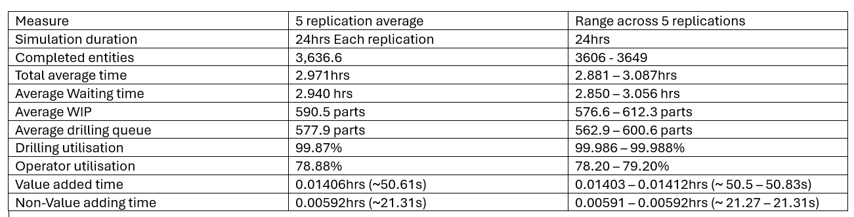

The results from the report generated (figure 8) was conducted using 5 independent replications each of 24 hours of operation. Multiple replications allow the results to be compared rather than in a single replication such as appendix A. The range across the 5 replications allows variation to be assessed which as you can see by figure 8 shows a limited variation between the 5 replications.

Lean Opportunities and Recommendations
The simulation report results (appendix A and B) summarised in figure 8 highlight some important areas that could be more efficient if lean manufacturing principles are applied.

The main finding from the report is that the drilling station provides a large bottleneck to the whole process due to the large utilisation and large drilling queues that increase the cycle time and limit the number of components that can be produced. This would therefore be the main recommendation to improve for this process. One way that this could be optimised is by adding a 3rd drilling station that would drill 4 holes or even add two more drilling stations one for the 2-hole drill and one for the 4-hole drill station. Another way could be by optimising the two drilling stations if they could be improved to reduce processing time, this would reduce the waiting time. These changes could potentially reduce the drilling queues and with that the associated waiting times, although to fully validate this further simulation work would be required.

A lean opportunity for this process would be to controlling the release of parts into the system to reduce the bottleneck seen or to introduce a pull lean method instead of the current release logic shown in the simulation, which does not control the upstream release of components compared to the downstream capability. The current system operates by releasing components independently of downstream capacity which adds to the accumulation before drilling. A pull release method is a control approach that could limit WIP as stated by Reyes, Mula and Diaz-Madroñero (2024) who explain how the pull method can be examined to control the release of components and reduce excessive WIP within the manufacturing system.

Transportation is another part of the simulation that causes a small amount of wasted time so in the lean manufacturing approach would not be considered essential to mitigate.

Finally, the operator activities should be evaluated to reduce the operator’s utilisation and free up some time in the process. An example of this could be to have automated processes in place for refilling of the dispensing units.

Summary of Recommendations

Figure 9 shows the summary of recommendations, the benefits and limitations
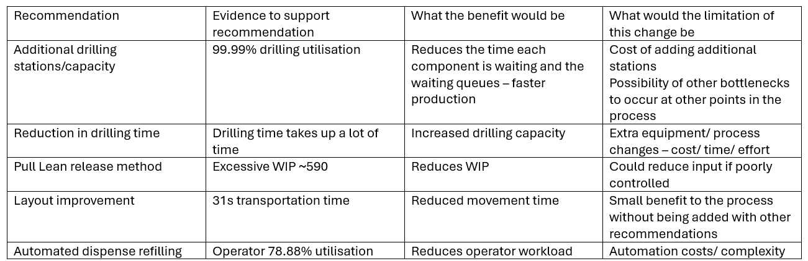

Conclusion
This study used the discrete event simulation software Arena to model and evaluate a current manufacturing process. This model showed a variety of methods for modelling such as triangular distributions and dividing components into 60:40 distributions and different stations. Five independent 24-hour replications were carried out to access variation in the simulation outputs.

The simulation results show that the drilling station is the main restriction in the process due to the excessive waiting times for components which is a result of the process utilisation at the drilling stage approaching 100%. It was observed that 97.9% of the WIP was associated with the drilling process. The waiting times at these stations was also observed to be considerably higher than waiting times at other stations with an average wait time of 2.94 hours across the five replications. There was a relatively small difference between the five replications which demonstrated the high waiting times and WIP was not a result of a single replication.

The value analysis then further highlighted the impact of the waiting at this process as ~0.47% of the process time was considered value adding while the remaining time was observed to be non-value adding activities particularly the waiting times and the transportation.

Based on these findings from the reports generated in Arena, several Lean improvement opportunities have been highlighted (figure 9). Increasing the drilling capacity or reducing the drilling processing time has been highlighted as it would address the primary restriction, while changing from a push lean system to a pull lean system has been identified to reduce the excess WIP.

The overall findings from this report are that there is one major constraint to the process, the drilling process. Particularly around the processing time and the waiting time of the components. It is recommended that this is the key focus for future improvement work, while it should be considered that changing the processing capacity may result in bottlenecks further down in the process.

References
Agalianos, K., Ponisa, S.T., Ponisa, E., Plakas, G. and Efthymiou, O. (2020). Discrete Event Simulation and Digital Twins: Review and Challenges for Logistics. Procedia Manufacturing, [online] 51, pp.1636–1641. doi:10.1016/j.promfg.2020.10.228.
Hamed, M. (2017). A comprehensive review of manufacturing wastes: Toyota production system lean principles. doi:10.6084/m9.figshare.9121283.
Hines, P., Holweg, M. and Rich, N. (2004). ‘Learning to evolve: A review of contemporary lean thinking’, International Journal of Operations & Production Management, 24 Available at: https://leanenterprise.org.uk/wp-content/uploads/2018/12/Learning-to-Evolve-2004.pdf [Accessed 3 Oct. 2026].
Kleijnen, J.P.C. (1995). Verification and validation of simulation models. European Journal of Operational Research, [online] 82(1), pp.145–162. doi:10.1016/0377-2217(94)00016-6.
Mourtzis, D. (2019). Simulation in the design and operation of manufacturing systems: State of the art and new trends. International Journal of Production Research, [online] 58(7), pp.1927–1949. doi:10.1080/00207543.2019.1636321.
NCEI (2009). Lean government metrics guide lean government metrics guide | lean government metrics guide. [online] p.5. Available at: https://www.epa.gov/sites/default/files/2014-04/documents/metrics_guide.pdf [Accessed 21 Sept. 2026].
Negahban, A. and Smith, J.S. (2014). Simulation for manufacturing system design and operation: Literature review and analysis. Journal of Manufacturing Systems, [online] 33(2), pp.241–261. doi:10.1016/j.jmsy.2013.12.007.
Rabe, M., Spieckermann, S. and Wenzel, S. (2009). Verification and Validation for Simulation in Production and Logistics. SNE Simulation Notes Europe, [online] 19(2), pp.21–29. doi:10.11128/sne.19.tn.09935.
Reyes, J., Mula, J. and Diaz-Madroñero, M. (2024). Quantitative insights into the integrated push and pull production problem for lean supply chain planning 4.0. International Journal of Production Research, 62(17), pp.1–25. doi:10.1080/00207543.2024.2312205.

Appendix

Appendix A: Report analysis for Arena CP Lab simulation
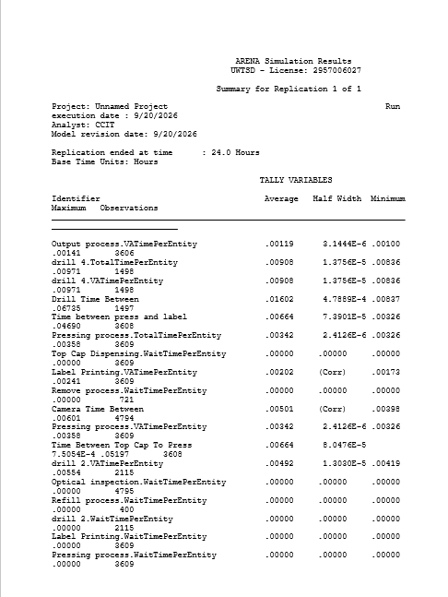

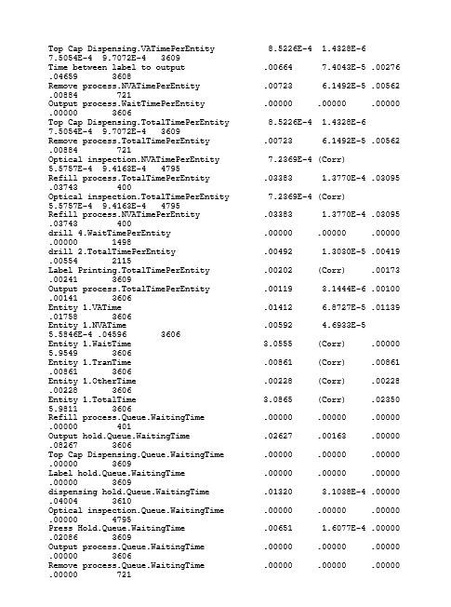

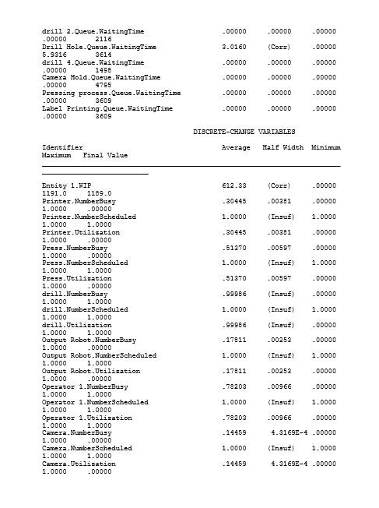

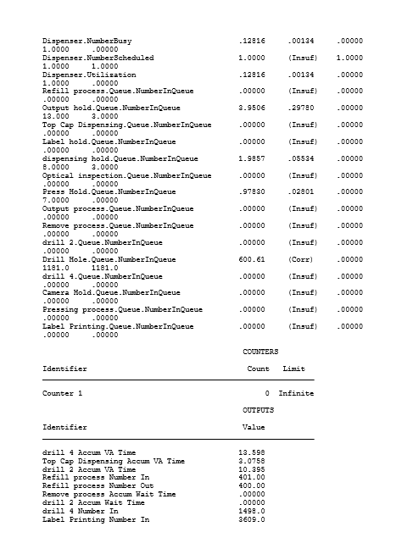

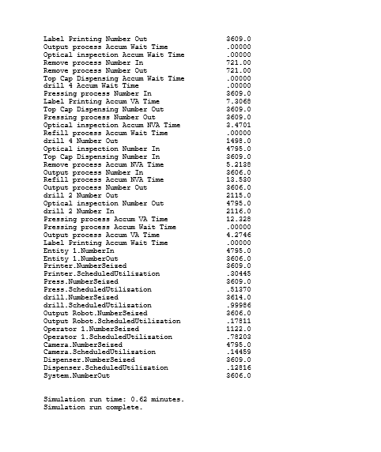

Appendix B: a report simulation of a 24 hour period including 5 replications


