An Exemplar of Modern Architecture
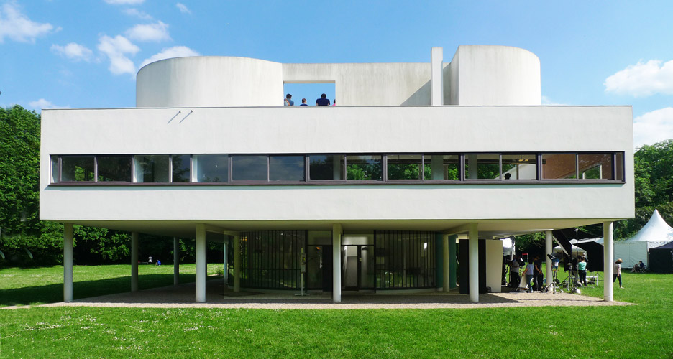

Villa Savoye -Le Corbusier

  - ELLIE MOORE: 2004268
  - ARCHITECTURE M4X01976
  - (BSc)
  - Introduction

The introduction of modern architecture in Europe was defined by developing innovative structural/spatial strategies profound through new building technologies. Villa Savoye is part of the purist movement; it was constructed between 1929-1930 in Poissy, France.
Corbusier intended to make architecture more machine-like to complement man's intellect and technological inventions. Villa Savoye is a revolutionary building designed to function while also revolving around people's daily lives; Corbusier's inspiration to create a social utopia led to the Villa lacking ornamentation and clean lines. The Villa exemplifies purism and the ambition of architects to simplify design (Word Press, 2013).
  - Historical Background

Villa Savoye is deemed a critical building in the development of the international style of modernism; it is the only home in France to be given a national monument during the architects lifetime (Gibson, 2016), initially designed as a country retreat for the Savoye family. It was the final building in Le Corbusier's white villas' collection of private dwellings, created in collaboration with Le Corbusier's cousin P.Jeanneret. Villa Savoye embodies Le Corbusier's purist style of the 1920s (Weston, 2010). The Villa is a revolutionary building, an early example of Le Corbusier's five points' for new constructions (ArchEyes, 2020).

  - Plan and section

Spatially plans and sections of Villa Savoye display the Villa's concrete frame construction, which Corbusier had proclaimed as the 'Five points of New Architecture'. The primary point is the pilotis (Columns); these raise the house off the ground, freeing space below for vehicles and the residence. The second point is the roof garden housed on the flat roof; this replaced ground loss in the plans by development. The third point is the pilots' extension into the structural frame, enabling the buildings partition walls to be arranged freely in what was known to Corbusier as plan libre (free plan). The open façade is the fourth point; the final point is ribbon windows, which provides the Villa with a more even distribution of light (Weston, 2010).
  - Plans

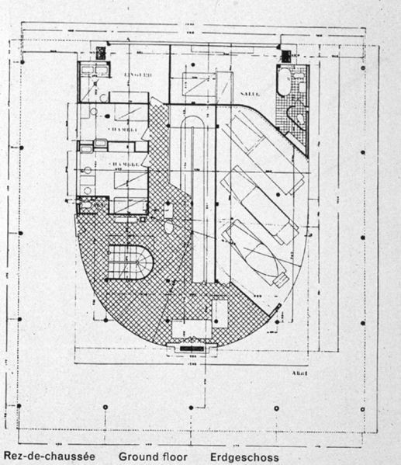
The Villa in plans are based on a precise squared grid marked by twenty-five columns, the grid of the pilots can be seen in plans and sections the orthogonal gride of concrete pillars distanced at 4750mm apart from this square gride at 23,500 mm in length each side, though elevations the grid develops to be rectangular (Bianchini, 2019).

Figure 1 Entrance Floor plan of Villa Savoye -
ArchDaily (2020) Villa Savoye / Le Corbusier. Floor Plan Photographs. Available at: Gallery of AD Classics: Villa Savoye / Le Corbusier - 19 (archdaily.com) (Accessed 22 February 2021)

The entrance floor plan of the Villa shown (Figure 1) demonstrates how the ground floor is free from structural accumulation for the buildings to be organised. The plans reveal how the structure is distinct from the façade, highlighting the structural function of the building. The exterior shown is approximately equal in proportions on each side; this de-emphasises the front and rear. The driveway wraps around the entrance floor level through the pilotis; this shows a scripted entry path in plans that takes you to the building entrance. The ground floor houses the service hall, offices and a garage (Kalra, 2020).
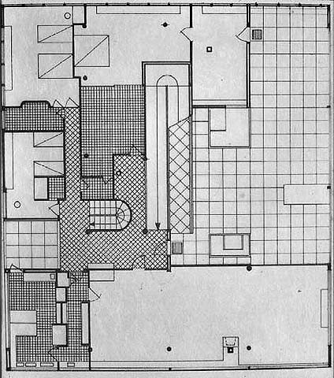
Figure 2 The Ground Floor Plan of Villa Savoye -
Coburn (2011) Villa Savoye – Circulation. Section Photographs. Available at http://haydencarch1390-2011.blogspot.com/2011/09/draft-interactive-pdf-villa-savoye.html: (Accessed 22 February 2021)

The liveable section of the Villa: living room, bathrooms, kitchen, terrace and bedrooms are located on the first floor (Figure 2). The circulation of the plans comprises of a ramp which leads from the entrance floor to the first floor as well as stairs linking all the levels of the building; on ascending the ramp, a hallway meets you, and doors leading to the terrace and living room, this corridor is narrow with little natural light enabling rooms beyond to become spacious; however the bedrooms and kitchen are linked by a galley corridor with an abundance of natural light from the ribbon windows, the living room is the most significant space on plan, the glass wall on both sides of the room provide views onto the roof terrace/surroundings, furthering this the ribbon windows on the terrace give an extension of the view to the surrounding scape (Bianchini, 2019).

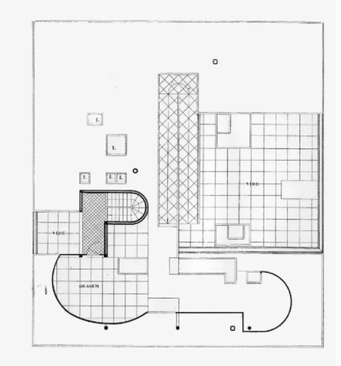

Figure 3 The first Floor Plan of Villa Savoye -
ArchDaily (2020) Villa Savoye / Le Corbusier. Floor Plan Photographs. Available at: Gallery of AD Classics: Villa Savoye / Le Corbusier - 19 (archdaily.com) (Accessed 22 February 2021)

Pilotis support the first floor (Figure 3); the walls are free and arranged to separate the open-plan interior into more functional spaces. The solarium is on the final floor, which has access via an outside ramp; on ascending the ramp, there is a secluded roof space sheltered from wind by curved walls that contrast the rest of the walls plan.
  - section
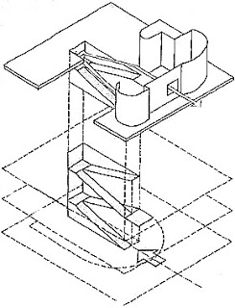

Figure 4 Section of Villa Savoye -
ArchDaily (2020) Villa Savoye / Le Corbusier. Floor Plan Photographs. Available at: Gallery of AD Classics: Villa Savoye / Le Corbusier - 19 (archdaily.com) (Accessed 22 February 2021)

Section drawings (Figure 4) highlight the pre-cast concrete mass of the Villa raised above the site by the pilot, slender columns that liberate internal and external walls from being load-bearing. Ribbon windows cut through the outer walls; these link the internal rooms of the building with the site's surroundings shown in section. (Blake, 1976).

  - Materials and light
  - Materials

Corbusier utilised reinforced concrete and plastered masonry to create Villa Savoye and primary materials such as iron and glass (Corbusier et al, 1964). Reinforced concrete was a modern concept of construction in the 1920s/30s. Villa Savoye was designed with Corbusier's five points of architecture in mind; materials with the structural properties to create this were used. Reinforced concrete was the key construction material as it enabled Corbusier to create curves easily furthermore; its flexibility aided the construction of complex shapes, such as the solarium and the U-shaped ground floor; finally, it offered structural support due to the strength and stability of reinforced concrete (Materials for Design, 2014).
  - light

Le Corbusier designed Villa Savoye with ribbon windows; he has an understanding and intellect of how the lighting of space affects the perception of a building; Corbusier indicated "wide horizontal windows wrapped around the villa to simply provide both light and a view" (Materials for Design, 2014). The floor to ceiling windows in the living room lead out to the terrace, enabling natural light to flood into the living quarters; it was vital in the design that natural light was encased; Villa Savoye was one of the initial buildings to use natural light in room space to create an open plan and healthier living space as a notion (BBC, 2014).

  - Ideas and theories underpinning the design

  - five points of architecture

During 1926, two years previous to when design began on Villa Savoye, Le Corbusier and P. Jeanneret published a manifesto called 'Five Points towards new architecture', points raised in the manifesto are fundamental in the design seen for Villa Savoye. Le Corbusier's five points of New Architecture was utilised to create the plan and layout of the entirety of the Villa. The Five Points are; (1) Supports - Pilots which elevate the building from the ground, (2) Free façade, (3) long horizontal windows, (4) open floor plan and (5) roof garden. Villa Savoye encompasses these five points. These five elements are distinct from the traditional construction of the era that the Villa was constructed, the separate the Villa from other buildings that were created during the period of construction (Archeyes, 2020).

  - five points of architecture within villa Savoye design

In terms of supports, Le Corbusier's raised the ground level of the building; he stated that 'Ground levels of buildings should be raised 3-6m above the existing grade to eliminate the dampness of the soil and to provide both light and air' (Rowe, 1982). The ground floor of Villa Savoye is raised above the ground by pilotis which provided structure support; there are no primary rooms at grade level.
The free design of the façade in Villa Savoye enables Corbusier to design the facade more freely; the carrier system and facade were separated in the Villa. This was aided by the use of reinforced concrete as a carrier system, as Corbusier was able to delete partition walls from the plan, which had no carrier function, enabling a flow between spaces. The piloti (columns) elevate the Villa off the ground, enabling circulation below, freeing the building site for a driveway and parking (Oechslin, 1987).
Le Corbusier first used the term 'Ribbon Windows' in the 1920s during the development of his five points architecture; in Villa Savoye, the windows are horizontally cut across the entire facades for the interior of the building to be naturally lit, the windows also allow inhabitants of the Villa to view the surrounding environment (Choi, 2021)
The frame did not depend on the Villa's floor plans, giving Corbusier freedom when designing the configuration of the rooms within the Villa without concern for supporting walls (Sketchline,2020).
A roof garden is included in Villa Savoye; a terrace roof has been favoured in the design and construction of the Villa instead of a sloped roof, as Corbusier didn't want the roof to have only the function of cover ( Archeyes, 2020)

These five points of architecture which Corbusier's materialised during the design of Villa Savoye, have become the foundations of modern architecture (Moreira, 2020); therefore, the design of the Villa illustrates what modernism was to Corbusier and the ideas behind the five points of architecture arose as he was dedicated to finding a universal language to classify new architecture (Sadek, 2020)

  - Conclusion/summary

To sum up, the points mentioned previously; Villa Savoye was designed by Le Corbusier's interpretation of modern architecture; the Villa design provides architects with a pragmatic resolution and modernist method that could be applied to the design of all buildings. The five points of architecture (encompassing, pilotis, free façade, free plan, roof garden and horizontal windows) all merge in the design and construction of the Villa to make Villa Savoye an influential building of today, expanding this it recognises Le Corbusier as an architectural influencer for global architectural design. The Villa Savoye represents the agglomerate thoughts that Le Corbusier had worked to articulate his essence of modern architecture; during the 1920s, Corbusier, in his plans and writings, considered the nature of contemporary life and the role of the architecture in a new machine age as stated by Corbusier himself 'A house should be a machine for living in' is noted in the forms, plans, elevations and siting of Villa Savoye (Sadek, 2020).

  - References

- ArchDaily (2020) Villa Savoye / Le Corbusier. Floor Plan Photographs. Available at: Gallery of AD Classics: Villa Savoye / Le Corbusier - 19 (archdaily.com) (Accessed 22 February 2021)
- ArchEyes (2020) The Villa Savoye / Le Corbusier. Available at: The Villa Savoye by Le Corbusier: A Modenist Iconic House | ArchEyes (Accessed 22 February 2021).
- Archeyes (2020) The Villa Savoye/Le Corbusier. Available at : The Villa Savoye by Le Corbusier: A Modenist Iconic House | ArchEyes (Accessed 2 March 2021)
- BBC (2014) Learning Zone Class Clips – The Design of the Villa Savoye France – Construction and the Built Environment Video. Available at: http://www.bbc.co.uk/learningzone/clips/the-design-of-the-villa-savoye-france/6424.html. ( Accessed 22 February 2021)
- Bianchini (2019) le Corbusier – Villa Savoye, Part 2, Architecture. Available at : Le Corbusier - Villa Savoye - part 2, architecture (inexhibit.com) (Accessed 22 February 2021).
- Bianchini (2019) Le Corbusier – Villa Savoye/Part 2, Architecture Available at : https://www.inexhibit.com/case-studies/le-corbusier-villa-savoye-part-2-architecture/ (Accessed 24 February 2021)
- Blake (1976) The Mater Builders: Le Corbusier, Mies Van Der Rohe, Frank Lloyd Wright.
- Choi (2021) Elements Of Architecture : 7 Contemporary Ribbon Window Designs. Available at: Elements of Architecture: 7 Contemporary Ribbon Window Designs - Architizer Journal ( Accessed 2 March 2021 )
- Coburn (2011) Villa Savoye – Circulation. Section Photographs. Available at: HaydenCoburn ARCH1390: Draft Interactive PDF: Villa Savoye (haydencarch1390-2011.blogspot.com) (Accessed 22 February 2021)
- Corbusier et al (1964)The Complete Architectural works. Vol. 2 1929- 1934. London: Thames and Hudson
- Gibson (2016) Le Corbusier Villa Savoye Encapsulâtes the Modernist Style. Available at : Le Corbusier's Villa Savoye encapsulates the Modernist style (dezeen.com) (Accessed 22 February 2021).
- Kalra (2020) Villa Savoye: An Architectural Sculpture. Available at: Villa Savoye: An architectural Sculpture - The Arch Insider (Accessed 22 February 2021)
- Materials for Design (2014) Villa Savoye. Available at: http://www.materialsfordesign.com/villa-savoye/ (Accessed 24 February 2021)
- Moreira (2020) The Five Points Of Modern Architecture in Contemporary Projects. Available at: The 5 Points of Modern Architecture in Contemporary Projects | ArchDaily (Accessed 2 March 2021)
- Oechslin (1897) Les Cinq Points D’une Architecture, English trans. Volume 4, page.93
- Rowe (1982) Mannerusm and Modern Architecture, in the Mathematics of the Ideal Villa and Other Essays, MIT Press, 1982, page 42
- Sadek (2020) The Villa Savoye – Le Corbusier. Available at : The Villa Savoye — Le Corbusier. Villa Savoye was Le Corbusier's… | by Yasmine Sadek | Medium (Accessed 2 March 2021)
- Sketchline (2020) Le Corbusier's Five Points of Architecture. Available at: Le Corbusier's Five Points of Architecture - SKETCHLINE (thesketchline.com) (Accessed 2 March 2021)
- villa savoye Le corbusier concept, case study, Floor plan Architectopedia figure 1
- Weston, R., 2010. Key buildings of the 20th century. Page 62.
- WordPress (2013) Utopia/Dystopia. Available at: https://utopiadystopiawwi.wordpress.com/?s=villa+savoye (Accessed 24 February 2021)

