

Student Name: Nedyalko Radev
Student number: 2128093
Module code: BMSW 6104
Module: Strategic Management for SMEs
Lecturer’s Name: Abdallah Naser
Assignment Title: Strategic Plan

Table of Contents:
TASK 1: 4
1. Introduction 4
1.1 Overview of the Dusty Knuckle Bakery 4
1.2 Importance of Strategic Management for SMEs 4
1.3 Objectives of the Report 4
2. Critical Appraisal of Current Strategy 5
2.1 Overview of the Current Strategy (Mission, Vision, Core Values) 5
2.2 Porter’s Five Forces Analysis of Competitive Position 5
2.3 Alignment of Mission and Vision with Strategic Goals 6
3. External and Internal Environment Analysis 7
3.1 PESTLE Analysis 7
3.2 SWOT Analysis 8
3.3 Inclusion of Other Environmental Scanning Tools 9
4. Stakeholder Analysis 10
4.1 Identification of Key Stakeholders 10
4.2 Evaluation of Stakeholder Expectations and Influence Using Power/Interest Grid 11
4.3 Strategies to Manage Stakeholders Effectively 12
5. Strategic Growth Options 12
5.1 Presentation of Three Strategic Growth Options 12
Market Penetration 12
Product Development 13
Market Development 13
5.2 Critical Discussion of the Pros and Cons 13
Market Penetration 13
Product Development 13
Market Development 14
5.3 Justification for the Most Suitable Strategy 14
5.4 Ansoff Growth Matrix for the Dusty Knuckle Bakery: 14
Market Penetration: 15
Product Development: 15
Market Development: 15
Diversification: 16
6. Strategic Recommendations 16
6.1 Detailed Recommendations Based on the Chosen Growth Strategy 16
Diversifying the Product Line: 16
Investing in Research and Development (R&D): 16
Strengthening Digital Marketing: 16
6.2 Discussion on Implementation and Change Management 17
Internal Communication: 17
Supply Chain Adjustments: 17
Pilot Testing and Feedback: 17
6.3 Use of Kotter’s Change Management Model to Support Recommendations 17
7. Competitor Reaction and Mitigation 18
7.1 Potential Competitor Responses to the New Strategy 18
7.2 Strategies to Mitigate Competitor Reactions and Maintain Competitive Advantage 18
8. Conclusion 19
TASK 2: Poster Presentation 20
References: 21

TASK 1:

1. Introduction

1.1 Overview of the Dusty Knuckle Bakery
Dusty Knuckle Bakery is an artisanal bakery located in London that specializes in bread, pastries, and an ecocentric approach. Succeeding through the use of good products, proper relations management, and embracing local communities, the bakery was able to develop a loyal customer base. It has developed body of a bakery and coffee shop and has through time developed modestly owing to wholesale partnership. Like many small and medium sized enterprises, it struggles with scaling without losing its identity. Proper management in strategy delivery is essential here to promote viability for the business within the foreseeable future.

1.2 Importance of Strategic Management for SMEs
Strategic management is central in achieving success in small and medium enterprises such as The Dusty Knuckle Bakery. In contrast to large corporations, SMEs usually have limited resources which necessitates the application of strategic management so that these resources are used in the best possible way. The capacity to assess both the internal and external environment critically helps the SMEs access the market dynamics and shift their strategies in order to gain an edge over competitors (Analoui and Karami, 2003). In addition, the potential of the food and hospitality industry in the UK encourages SMEs to implement strategic planning to remain competitive and foster creativity. It is due to the effective implementation of the strategic processes that The Dusty Knuckle Bakery has a competitive edge and is able to look for avenues for growth without compromising the primary business principles.

1.3 Objectives of the Report
The main goal of this report is to objectively evaluate the strategic positioning of The Dusty Knuckle Bakery by looking at the strategy it has today and how this integrates the mission and vision of the company. This report will analyze the internal and external environments that affect the operations of the bakery by way of established strategic management techniques such as Porter's Five Forces, PESTLE and SWOT. Further, the report will assess the stakeholders’ expectations and recommend measures to ensure the growth is sustainable. The report seeks to focus strategic advice on the areas of growth that do not threaten the organizational prospects for the future, gaining competitive advantage, and managing change effectively, so that The Dusty Knuckle bakery does not fall behind in the competition within the niche market.

2. Critical Appraisal of Current Strategy

2.1 Overview of the Current Strategy (Mission, Vision, Core Values)
Sustainability, quality, and community spirit is how Dusty Knuckle Bakery made its reputation, selling high quality, artisanal baked goods with a focus on ethical sourcing and environmental responsibility. Its mission is to be a thought leader in sustainable baking, without losing its emphasis on craftsmanship and its commitment to community. Both operations and a long-term strategy are driven by the bakery’s focus on sourcing locally and reducing the environmental impact. Yet, it cannot afford to grow quickly due to its commitment to sustainability and it will find itself competing with larger firms that can scale more easily while continuing to be ethically considerate.

2.2 Porter’s Five Forces Analysis of Competitive Position
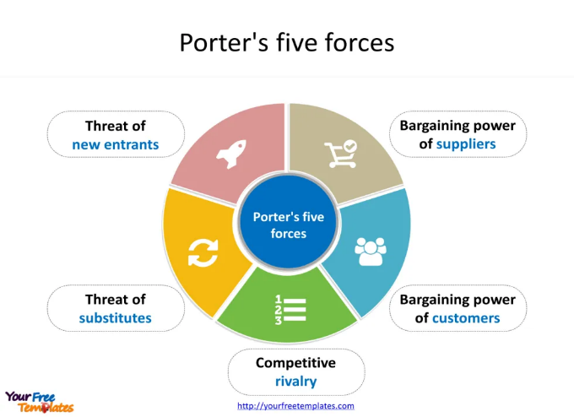
(Wowslides, 2019)

Using Porter’s Five Forces model, The Dusty Knuckle Bakery’s competitive landscape can be critically evaluated. This tool aids to comprehend the external forces that affect the establishment and its market environment, as well as classification.
Threat of New Entrants: While the Dusty .Knuckle’s low entry barriers; Minimal capital requirements, strong brand, loyal customers, and the focus in sustainability and ethics behind the sourcing, give the industry low entry barriers its barriers to entry are quite high (Porter, 2008).
Bargaining Power of Suppliers: Local and ethical sourcing limits the suppliers the bakery has a commitment to, which puts them in a more powerful position. However, strong supplier relations mitigate this risk in that one can achieve a steady supply of high-quality ingredients (Porter, 2008).
Bargaining Power of Customers: The Dusty Knuckle has a unique value proposition: selling sustainability and quality above all else —and baked goods seem to have no end in London. Its loyal customer base as well as drawn not only to the product but also to the company’s ethical stand, this reduces the bargaining power of customer.
Threat of Substitutes: In the case of the bakery industry, the pressure of such substitutes as mass produced goods from supermarkets and other large-scale bakeries is tremendous. Nevertheless, the influence of substitutes is curtailed by the emphasis on artisanal quality and its target market is not particularly price sensitive and more focused on quality and values (Johnson et al., 2020).
Competitive Rivalry: The bakery business is very competitive and further, there are several artisanal bakeries competing with each other in London. Although The Dusty Knuckle’s differentiation strategy has a respectable market share, competitors could also adopt such a sustainability-based model that will limit this differentiation strategy. In order for The Dusty Knuckle to remain competitive, it will have to continue innovating and continue to grow its product lines and stay true to its core values.

2.3 Alignment of Mission and Vision with Strategic Goals
Apart from PESTLE and SWOT, Value Chain Analysis and Benchmarking are vital tools for development of Strategic development of The Dusty Knuckle Bakery. In this case, Value Chain Analysis would be focused on identifying technical efficiencies (e.g. reductions in waste and investment in energy efficient technologies) that the company has pledged to undertake for the sake of sustainability. This analysis minimizes ethical practices while improving profitability. Benchmarking helps the bakery compare the performance with competitors, learn what its strengths and weaknesses are and then ensure continuous improvement to meet industry standards. When used together with PESTLE and SWOT, these tools help provide a fuller picture of factors both internal and external to the bakery and support the ability to make informed decisions and further strategy.

3. External and Internal Environment Analysis

3.1 PESTLE Analysis

Political Factors:
The bakery industry within the UK is highly affected by political situations relating to food safety and hygiene regulations by the government. To continue operating, and still be able to use agency endorsements like the Food Standards Agency (FSA), the Dusty Knuckle Bakery must follow food standards. In addition, Brexit has wreaked havoc on supply chains, adding extra cost to imports, creating uncertainty around the regulations governing food. Of course, The Dusty Knuckle is all about supporting and using locally sourced ingredients, so political developments could considerably change the costs and availability of supplies.
Economic Factors:
Consumer spending from rising costs, including inflation in the UK, might be diminished by demand for luxuries. Nevertheless, consumers are prepared to pay
higher prices when premium quality and sustainability are combined (Nicholson, 2021).
Social Factors:
The Dusty Knuckle also dovetails with the growing trend of healthier eating and ethical consumption, drawing from its ethically produced, locally sourced offerings to help build its market position and maintain community involvement.
Technological Factors:
The food industry has seen its business operations revolutionised by technological advancements. With Digital platforms at hand along with social media and e-commerce for marketing, sending out for the digital explosion of The Dusty Knuckle is a game changer. Furthermore, technology-based tools for increasing production efficiency and inventory control can facilitate the operational streamline (Porter and Heppelmann, 2015).
Legal Factors:
Legal frameworks, which include employment laws, health and safety regulations as well as environmental standards, must be followed by the bakery. Not complying with these regulations can lead to legal penalties, and damage to reputation. To give just one example, such as stringent food labelling legislation requires an accurate listing of ingredients, insofar as allergenic things are concerned.
Environmental Factors:
The Dusty Knuckle has values at its core, making sustainability at the heartbeat. But environmental regulations on waste management and carbon emission make continuous innovation imperative, on the one hand in terms of ecofriendly packaging and on the other to increase use of sustainable energy. Additionally, consumers are becoming increasingly interested in knowing how much 'eco footprint the bakery has, therefore placing this as a key competitive area (Teece, 2018).

3.2 SWOT Analysis

Strengths:
The Dusty Knuckle is strong in the area of sustainability and ethical sourcing, a growing aspect consumer’s care about for products that come in contact with their bodies. It has a strong and established local brand and loyal customer base as it is a crowded market. Along with this, the bakery’s emphasis on artisanal quality allows it to draw a line from mass produced goods, crafting for a niche, certain section concentrating on craftsmanship.
Weaknesses:
However, sustainability and quality focus likely harm its scaling capacity. Although its size is relatively small, its sourcing strategy is local and might mean higher operation costs than the larger competitors that can benefit from economies of scale. Additionally, its market reach is limited due to its small market reach. Market saturation risks may also present the reliance on the local markets, cutting down the possibilities of growth (Drucker, 1986).
Opportunities:
The Dusty Knuckle has several opportunities for expansion. Once there is growing demand from the consumer side for ethical and locally sourced products, the bakery can expand their product line, or work with other ethical brands. Meanwhile, there are advancements in digital marketing and e-commerce to open up new channels to reach a much wider audience than just the local customers serving. The company could leverage partnership with other sustainable businesses to position its brand, enter new markets (Johnson et al., 2020).
Threats:
Artisanal goods aren’t the easiest to contain a price war and with the Dusty Knuckle Bakery competition coming from bigger competitors, it’s offering cheaper alternatives with the threat of rising inflation which could limit spending on items like artisanal goods. Mass produced substitutes bring significant competition on price and the Bakery must keep its unique value proposition (Grant, 2002).

3.3 Inclusion of Other Environmental Scanning Tools

Value Chain Analysis and Benchmarking provide valuable information for strategic growth of The Dusty Knuckle Bakery, in addition to PESTLE and SWOT. Value Chain Analysis also enables the bakery to determine how operational efficiency can be enhanced and costs are saved, which is consistent with the bakery’s sustainability goal to reduce waste and utilize energy efficient technologies. Benchmarking helps the bakery to measure performance against other competitors and identify potential strengths and weaknesses to continuously improve by changing or improving to meet industry standards. These tools work together to offer a better sense of the internal and external factors so that we can use PESTLE and SWOT to effectively guide The Dusty Knuckle’s strategic direction.

4. Stakeholder Analysis

4.1 Identification of Key Stakeholders
To understand The Dusty Knuckle Bakery strategic position, stakeholder analysis is critical and groups key stakeholders according to internal and external divisions.
Employees
Daily operations of the companies are run by these internal stakeholders who are also the employees. They expect job security, fair wages, a pleasant working environment and a way of climbing career ladder. People that work for the bakery and employees are more likely to contribute to the bakery's success and sustainability (Freeman 2010).
Customers
External stakeholders, particularly customers especially in the local community, are very vital. Quality, ethical sourcing and sustainability are their priorities, high quality artisanal products that live up to their values are what they expect. Customer loyalty matters very much to the bakery’s reputation and positioning in the market.
Suppliers
The raw ingredients for The Dusty Knuckle’s products are provided by local suppliers. What they are looking for is long-term mutual benefits, fair trade and reliable demand and timely payments. The fact that these relationships are strengthened by supplier commitments to maintain consistently high levels of quality shapes the bakery’s commitment to ethical sourcing (Mitchell et al., 1997).
Local Community
The local community influences the environmental impact and support of local initiatives in the bakery. This group expects the Dusty Knuckle to hone its environmental footprint and participate in community events furthering its social responsibility.

4.2 Evaluation of Stakeholder Expectations and Influence Using Power/Interest Grid
The Power/Interest Grid offers a useful method to categorize stakeholders by degrees of influence and interest in the company’s activities (Mendelow, 1981). By doing so this frees up the focus of The Dusty Knuckle Bakery’s stakeholder management efforts.
High Power/High Interest (Key Players):
The key players in The Knuckle bakery are employees and customers. Job security and values driven environment is what employees seek, and customer possessing purchasing power and loyalty can create significant revenue and reputation impact on the company.
High Power/Low Interest (Keep Satisfied):
Too powerful and not too interested, suppliers hold the bulk of the power in this relationship. Managing a healthy ethical relationship with your suppliers is key to preventing your staff from not showing up to work tomorrow.
Low Power/High Interest (Keep Informed):
However, the local community has a big stake in the sustainability efforts the bakery is making but is not as powerful as the bakery itself. Keeping this group informed means ongoing communication and community involvement.
Low Power/Low Interest (Minimal Effort):
But distant regulatory bodies have little influence, although they are important for legal compliance. Regulatory changes to be monitored by the bakery should affect the operations (Bryson, 2004).

4.3 Strategies to Manage Stakeholders Effectively
The Power/Interest Grid is effectively managed when a tailored strategy is used to deal with each stakeholder based on their position in it.
Key Players (Employees and Customers):
Ackermann and Eden show that a positive work environment, professional development, and a good customer engagement, such as loyalty programs and open communication, should be core functions of the bakery here.
Keep Satisfied (Suppliers):
It should create a good relationship with suppliers on fair trade basis, effective communication, regular feedback and longstanding contracts to keep away from the distortion of the sourcing ethics norms and also increase loyalty.
Keep Informed (Local Community):
A good way for the bakery to engage with the local community will be through sustainability initiatives and programs, as well as through events, where they are able to build those ties, as well as create more awareness of their values, by renewing their newsletters and social media updates.

5. Strategic Growth Options

5.1 Presentation of Three Strategic Growth Options
Ansoff’s Matrix is a well-known tool for exploring strategic growth of products and markets that we can use to analyze strategic growth for The Dusty Knuckle Bakery. The three strategic growth options for The Dusty Knuckle include:

Market Penetration
It gives focus to the enhancement of the market share in the existing market by means of its existing products. This could bring some of The Dusty Knuckle's potential as the business grows and expands in London in the future to incorporate more marketing, to improve brand awareness and to boost customer loyalty through promotions and loyalty programs.

Product Development
The product development is the introduction of a new product into the existing market. Growth in demand for health consciousness and dietary specificity is leading the way in places for the Dusty Knuckle to diversify its product line by adding new categories like gluten free or vegan.

Market Development
In market development, existing products are entered into new markets. While the Dusty Knuckle could see itself expanding out beyond London, perhaps to other major UK cities, or even to wholesale partnerships with national supermarket chains or cafes that share its sustainability ethos.

5.2 Critical Discussion of the Pros and Cons

Market Penetration
Pros:
Using an established customer base, a low-risk strategy. Minor adjustment of the business model can significantly improve brand presence and customer loyalty with the use of targeted marketing.
Cons:
There is no room for growth in saturated markets. It may lead to unnecessary increased marketing costs, strain out resources, and larger competitors may limit its pricing flexibility (Johnson et al., 2020).

Product Development
Pros:
Diverse customers are attracted to new dietary-specific products because they are aligned with brand commitment to quality and sustainability, helping to differentiate it competitively.
Cons:
This entails significant R&D investments, and so higher risks. Existing customers may be alienated by new products resulting in uncertain market success (Barney, 1997).

Market Development
Pros:
Strategic partnerships enhance the growth potential and economies of scale in gaining new customers base and sales (Porter, 1985).
Cons:
Logistical challenges and significant resource requirements make these types of supply chains higher risks. Expanding may kill the bakery’s artisanal image.

5.3 Justification for the Most Suitable Strategy
The Dusty Knuckle Bakery’s mission of delivering high quality, ethically sourced products make Product Development the most appropriate sustainable growth strategy. This strategy helps the bakery expand its products offerings and attract new customers based on a product demand that has increased with growing consumers' demand for gluten free and also vegan baked goods (Mintzberg, 1994). Conversely, product development can be managed using existing operating procedures, which brings down risks comparatively higher with result of minimum disruption's effect. Product development affords The Dusty Knuckle the opportunity to maintain differentiation in a competitive environment, despite the possible lack of market penetration potential due to market saturation. The bakery has managed to stay afloat by focusing only on innovation and keeping to its value of sustainability and community engagement and this ensures that bakery can continue to be the lead in artisanal and ethical baking.

5.4 Ansoff Growth Matrix for the Dusty Knuckle Bakery:
One of the strategic tools The Dusty Knuckle Bakery utilises to identify growth opportunities is the Ansoff Growth Matrix which investigates the relationship between current and new products and markets. This matrix breaks these potential strategies up into distinct quadrants.
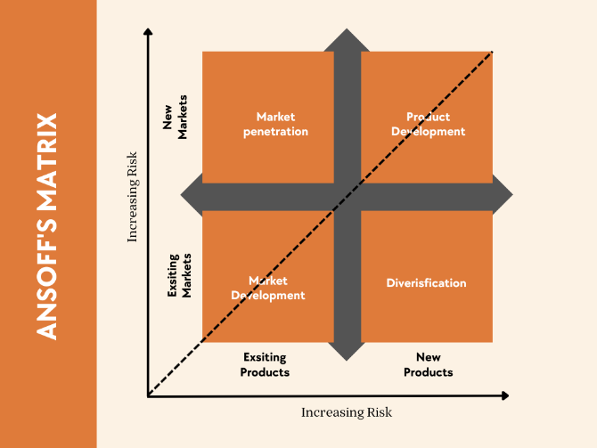
(Ansoff Matrix Dusty Knuckle)

Market Penetration:
The first strategy of this strategy is to grow sales of current products in the existing markets. Target marketing campaigns and strong customer engagement can get them here. The bakery needs to stimulate loyalty among its present customers so that it could expand its market share without changing its product line.

Product Development:
It is in this context that the bakery aims to put new products into existing markets. The approach also fits to the growing need for products in the area of dietary specificity, i.e. gluten-free and vegan. The Dusty Knuckle will also be able to attract new customer segments by aligning product development with consumer trends, thus furthering its commitment to sustainability.

Market Development:
Expansion in new geographic markets, with existing products. The possibilities are to expand or target new regions for the Dusty Knuckle Bakery with online sales. Through this growth through the broader market approach, the bakery gets a wider reach, and the brand ups its already established reputation.
Diversification:
Distribution means introducing new products to new markets. This strategy involves taking on more risk, but it provides to The Dusty Knuckle the ability to innovate and grow its products. Involving local businesses to create unique product lines not only increases visibility but also increases brand loyalty.

6. Strategic Recommendations

6.1 Detailed Recommendations Based on the Chosen Growth Strategy
Given that Product Development has been identified as the most suitable growth strategy for The Dusty Knuckle Bakery, the following recommendations are proposed to ensure successful implementation and sustainable growth:

Diversifying the Product Line:
The bakery needs to be introducing new products that cater to the health-conscious consumers like, gluten free, vegan and organic baked goods. These are increasingly sought after products and are complementary to The Dusty Knuckle’s core values of sustainability and quality. Additionally, seasonal or limited-edition products can stimulate customer engagement, and therefore purchases that occur repeatedly. (Mintzberg, 1994).

Investing in Research and Development (R&D):
Experiencing new ingredients and some sort of refinement of the production methods needs to be allocated to R&D. This approach allows the bakery to remain of good quality and ethically sourced while moving quickly in response to market trends and consumer feedback (Johnson et al., 2020).

Strengthening Digital Marketing:
In order to enable a promotion of new product lines, the Bakery should rely on social media, targeted advertising, and influencer partnerships. Content marketing is what customers will be exposed to via blog posts and video tutorials, as well as other relevant materials used to give information about the products to the consumers.

6.2 Discussion on Implementation and Change Management

Internal Communication:
Success of implementation largely depends on effective internal communication. Training employees to learn the skills and knowledge is possible through regular meetings, workshops and training sessions. An understanding of what is being done, and for whom, results in lowered resistance to change (Kotter, 1996).

Supply Chain Adjustments:
And new product lines often require changes to the supply chain, especially with sourcing ingredients. Gluten free and vegan products should be new standards for the bakery to work closely with suppliers to reach out and achieve a high level of quality. By building relations with ethical suppliers, it ensures product quality and sustainability (Teece, 2018).

Pilot Testing and Feedback:
Before any new products are fully launched, the bakery should run pilot tests to see how the customer will respond. This data driven approach enables to refine the products by the feedbacks, thus decreasing the risk of failing (Barney, 1997).

6.3 Use of Kotter’s Change Management Model to Support Recommendations
The product development strategy is implemented, structured by John Kotter’s Eight Step Change Management Model (1996).
Create a Sense of Urgency: Building a case for change requires a leadership team to stress out the consumer trends and how case for increase of revenue.
Form a Guiding Coalition: Its purpose is to make the bakery articulate a clear vision of how product development enhances market position and distribute this to all stakeholders.
Develop and Communicate the Vision: Its purpose is to make the bakery articulate a clear vision of how product development enhances market position and distribute this to all stakeholders.
Empower Employees and Generate Short-Term Wins: New training and resources should be given to employees to support the change. Launch a very limited range of products, early in the process, hopefully you will get the short-term wins and the momentum will come out of that.
Consolidate Gains and Anchor in Culture: The bakery should begin to embed innovation into the culture of the company, developing its employees and maintaining sustainability as a central preoccupation.
The Dusty Knuckle Bakery’s product development strategy will be successful, if implemented by following Kotter’s model, while still maintaining their sustainability and quality core.

7. Competitor Reaction and Mitigation

7.1 Potential Competitor Responses to the New Strategy
Competition isn’t far behind, as competitors are probably soon going to introduce gluten free and vegan products as well. Larger bakeries and supermarkets may be able to create economies of scale, lower prices (by leveraging economies of scale) and increase digital marketing to try and hold market share. Price wars may be engaged in by competitors offering discounts, and exclusive supplier partnerships developed to secure ingredients, rendering it difficult for The Dusty Knuckle to sustain competitive supply chains in specialty ingredient (Porter, 1985; Grant, 2002).

7.2 Strategies to Mitigate Competitor Reactions and Maintain Competitive Advantage
The Dusty Knuckle Bakery should therefore overcome these potential competitor reactions by emphasizing quality and ethical sourcing of its products as a way to differentiate itself. The bakery can continuously emphasize its commitment to sustainability as well as the use of high quality locally sourced ingredients which should help solidify the bakery’s brand identity and further prevent competitors from replicating its unique value proposition (Barney, 1991). So, it should appeal to consumers who naturally prefer a more sustainable option, even if it costs a little more, helping to prevent price wars.
While another mitigation strategy is to increase customer loyalty through personalisation in marketing and loyalty programs. For loyal customers, the bakery can provide exclusive promotions or give access to the new product first. This will encourage a sense of community and belonging. Apart from that, the bakery will continually innovate by launching seasonal or limited-edition products to maintain customer interest and differentiates the bakery from its competitors (Teece, 2018).
Finally, The Dusty Knuckle should increase the partnerships with local suppliers and create agreements that combine quality and sustainability. In addition to steering the bakery to a steady flow of one-of-a-kind ingredients, this also helps to further solidify the bakery’s positioning as a local supporter.

8. Conclusion
The Dusty Knuckle Bakery's commitment to sustainability, quality, and ethical practices has positioned it strongly in the artisanal bakery market. This report has assessed product development as the best growth strategy through a detailed strategic analysis. Introducing new product lines, like gluten free and vegan, will help the bakery tie in with consumer preferences, while still holding on to its values. To implement this strategy, strong supply chain partnerships, targeted marketing, and a solid change management process are essential for sustainable growth.
With Kotter’s Change Management Model, The Dusty Knuckle can lessen competitive challenge and retain its customers’ loyalty through continuous innovation. The bakery's sustainability mission is also well aligned with this strategy and with the long-term success in a competitive food market, thus making the bakery a leader in ethical and artisanal baking.

TASK 2: Poster Presentation

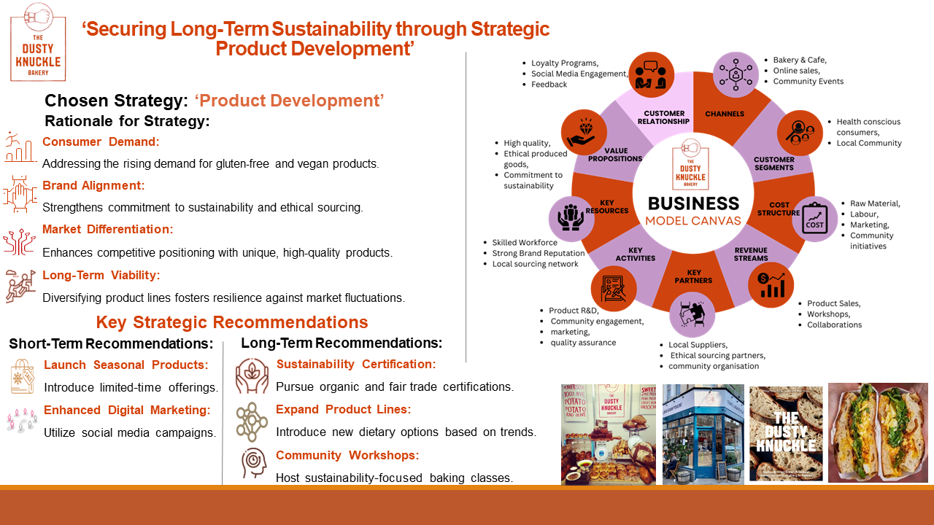

References:

- Analoui, F. and Karami, A., 2003. Strategic Management in Small and Medium Enterprises.
- Ackermann, F. and Eden, C., 2011. Strategic management of stakeholders: Theory and practice. Long range planning, 44(3), pp.179-196.
- Barney, J., 1991. Firm resources and sustained competitive advantage. Journal of management, 17(1), pp.99-120.
- Barney, J.B., 1997. Gaining and sustaining competitive advantage. (No Title).
- Bryson, J.M., 2004. What to do when stakeholders matter: stakeholder identification and analysis techniques. Public management review, 6(1), pp.21-53.
- Drucker, P.F., 1986. Innovation and entre-preneurship: practice and principles. Harper & Row.
- Freeman, R.E., 2010. Strategic management: A stakeholder approach. Cambridge university press.
- Geels, F.W., Pinkse, J. and Zenghelis, D., 2021. Productivity opportunities and risks in a transformative, low-carbon and digital age. The Productivity Institut e Working Paper, 9.
- Grant, R.M., 2002. Contemporary strategy analysis (Vol. 4). Oxford: Blackwell.
- India, T. (2023). Creating a Strategic Business Plan using PESTLE Analysis. [online] Latest University Research Updates. Available at: https://www.tutorsindia.com/blog/creating-a-strategic-business-plan-using-pestle-analysis/.
- Johnson, J., Whittington, R., Regnér, P., Angwin, D., Johnson, G. and Scholes, K., 2020. Exploring strategy. Pearson UK.
- Kotter, J.P., 1996. Leading change. boston, ma: Harvard business school press. kouzes, jm, & posner, bz (2002). The leadership challenge. San Francisco, CA.
- Mendelow, A.L., 1981. Environmental scanning--the impact of the stakeholder concept.
- Mintzberg, H., 1994. The rise and fall of strategic planning. Free Press.
- Mitchell, R.K., Agle, B.R. and Wood, D.J., 1997. Toward a theory of stakeholder identification and salience: Defining the principle of who and what really counts. Academy of management review, 22(4), pp.853-886.
- Norton David, P., 1996. The balanced scorecard: translating strategy into action. Harvard Business School Press, Boston.
- Porter, M.E. and Advantage, C., 1985. Creating and sustaining superior performance.
- Porter, M.E. and Heppelmann, J.E., 2015. How smart, connected products are transforming companies. Harvard business review, 93(10), pp.96-114.
- Porter, M.E., 2008. The five competitive forces that shape strategy. Harvard business review, 86(1), p.78.
- Scott, T. (2024). SWOT analysis: what it is and why, examples, how to do it. [online] LeaderTask - a service for planning and working in teams. Available at: https://www.leadertask.com/articles/swot-analysis.
- Teece, D.J., 2018. Business models and dynamic capabilities. Long range planning, 51(1), pp.40-49.
- Wowslides (2019). Porter’s five forces template - Free PowerPoint Templates. [online] Free PowerPoint Templates. Available at: https://yourfreetemplates.com/porters-five-forces-template/.

