

Module Name: Strategic Management

Module Code: LCMB7003

Student Name: Jamila Begum
Student ID: 2503076

Assignment Title: Individual Report on Zara’s Strategic Management Practices

Lecturer: Dr. Hoang Dang Nguyen.

Word Count: 5495

AI Use Acknowledgement

I acknowledge the use of ChatGPT (https://chat.openai.com/) on various dates between (17 April 2026 to 30 april) to support the research, structuring, proofreading, and writing of this assignment. I used the following types of prompts:

Please provide full insights of strategic management assignment reports according to my pattern.
Please explain and give details insights about overview,pestle analysis,Internal Environment analysis, CSR and Sustainability objectives,Comprehensive and Holistic view of Organization,frameworks like asoff matrix and BCG matrix and Lewins theory
Please check the following paragraph for grammar, clarity, and academic tone, and suggest improvements.

I confirm that I have not presented any AI generated text as my own work. All AI‑assisted outputs were critically reviewed, adapted, and integrated into my own analysis. I confirm that I have copies of my drafts, notes, and other resources I used before and after the use of AI tools, which I may be asked to provide in evidence.
Table of Contents
Section 1: Report 5
Introduction 5
1. Organisational Context and Overview 6
1.1 Overview of Zara 6
1.2 Industry Analysis: Apparel and Fashion Sector 7
2. External and Internal Environment Analysis 9
2.1 PESTEL Analysis and Strategic Impact 9
2.2 Critical Success Factors and Strategic Challenges 11
2.3 Internal Environment Analysis 11
2.4 VRIO Framework Analysis of Strategic Capabilities 12
2.5 Internal Strengths and Competitive Advantage 14
3. CSR and Sustainability Objectives 14
3.1 Definition of CSR Strategy and Sustainability 14
3.2 Zara’s CSR Strategy 15
3.3 Business Objectives of Zara 15
3.4 Alignment Between CSR Strategy and Business Objectives 15
4. Comprehensive and Holistic View of the Organisation 15
4.1 Balanced Scorecard: Definition and Importance 15
4.2 Financial Perspective 16
4.3 Customer Perspective 17
4.4 Internal Business Processes Perspective 17
4.5 Learning and Growth Perspective 17
4.6 Final Evaluation (Integrated Analysis) 18
5. Strategic Choices and Implementation 18
5.1 Definition of Business-Level and Corporate-Level Strategy 18
5.2 Business-Level Strategic Choices 18
5.3 Corporate-Level Strategic Choices 19
5.4 Change Management and Strategic Implementation 20
6. Strategic Evaluation and Recommendations 21
6.1 Definition of Strategic Evaluation 21
6.2 Evaluation Using Ansoff Matrix 21
6.3 Evaluation Using BCG Matrix 22
6.4 Recommendations for Strategic Improvement 24
Conclusion 24
Section 2: Reflective Account (Gibbs Reflective Cycle) 25
References 29

Section 1: Report

Introduction
Strategic management can be described as the analysis, planning and putting into practice of organisational strategies with a view to attaining long-term competitive advantage and sustainable performance (Chiwawa and Wissink, 2021). To analyse its performance and draw major recommendations to facilitate future development and sustainability, this report critically analyses Zara in terms of its organisational context, industry position and strategic environment, internal and external analysis, CSR alignment and strategic frameworks. The objective of this report is to analyse Zara's strategic position and evaluate its internal and external environment to provide recommendations for sustainable competitive advantage and long-term growth.

1. Organisational Context and Overview

1.1 Overview of Zara
Historical Background:
Amancio Ortega Founded Zara in 1975 in A Coruña, Spain (Zara, 2024). From its beginnings as a single retail store, the brand has grown to become an international fashion giant under Inditex. The company Inditex that owns Zara said that the total sales for the Inditex group were up by 7.5 percent to 38.6 billion euros in the year 2024 (Statista, 2024).The company has more than 5,800 stores in more than 90 markets, and Zara alone has more than 2,000 stores around the world. Moreover, Zara designs approximately 450 million products each year, and there is little batch production, which creates a sense of scarcity and stimulates repeat buying.
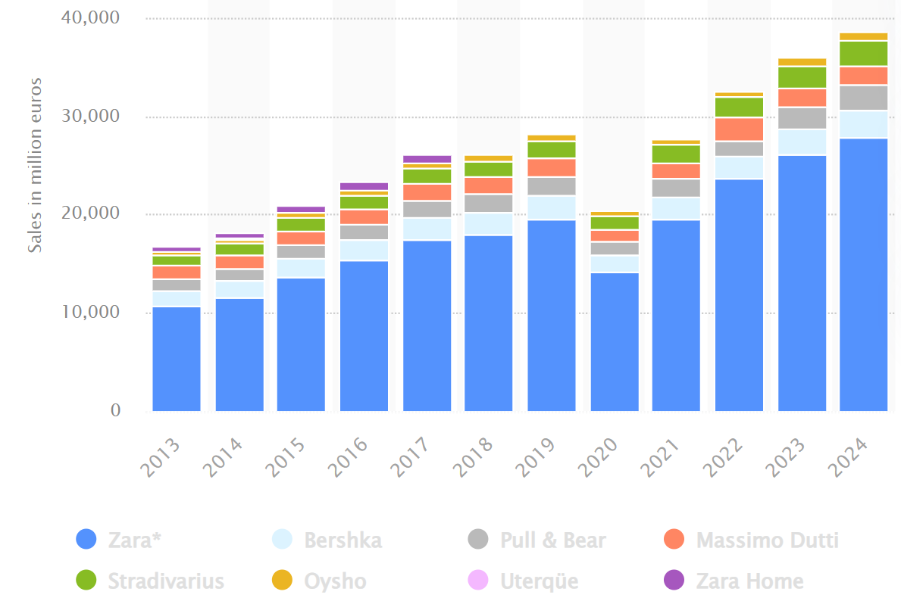
Figure 1: Net Sales of the Inditex Group Worldwide
Source: (Statista, 2024)
Mission, Vision, and Business Model:
The mission of Zara is to offer trendy and quality apparel that is affordable and responsive to the demands of the customers. Its vision is in line with the sustainability strategy of Inditex, which involves the realisation of net-zero emissions by 2040. Zara has a vertical integration and data-driven business model (Zara, 2024). About 60-65 per cent of its production is done in its neighbouring markets like Spain, Portugal and Morocco, which allows them to have a quick turnaround time.

1.2 Industry Analysis: Apparel and Fashion Sector
Industry Overview:
The global apparel and fashion market is projected to reach a value of $1.84 trillion in 2025, representing approximately 1.63% of global GDP (Cardona, 2025). Moreover, among the total population of 3.62 billion, which comprises the world workforce, approximately 430 million are engaged in fashion and textile production sector. Europe is also a major market, and it generates almost half of Inditex's revenue. Asia and the Americas are also important growth areas.
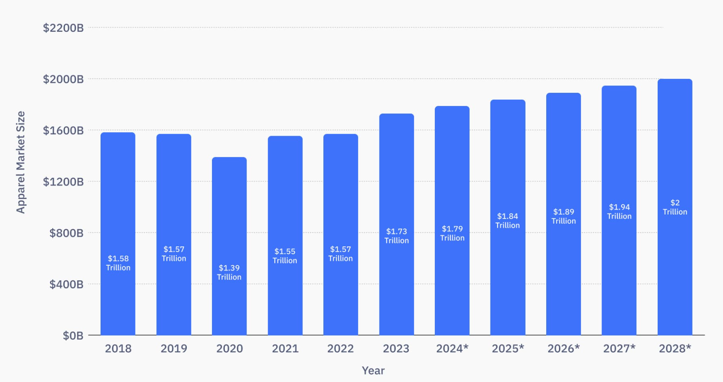
Figure 2: The global apparel and fashion market size
Source: (Cardona, 2025)
Key Competitors:
Zara competes against traditional and online-only brands, such as:
- H&M: It has more than 4,000 stores all over the world and revenues of approximately 20 billion.
- Uniqlo: Specialises in basic apparel, with more than 2.7 trillion in sales.
- Shein: A digital-native over $60 billion company, with thousands of new items added each day (Chen, 2023).
- Mango: A company that reported having revenues over 3 billion and reaching the same European markets.
Market Positioning (Perceptual Map):
Zara competes in the mid-to-high price and high-fashionability segment, distinguishing itself by its quick speed of adaptation to trends and perceived quality (Zara, 2024).
Perceptual Map (Conceptual Representation):
- X-axis: Low (High) Price.
- Y-axis: Fashionability (Low→High)
Positioning:
Very Fashionable, Medium Price → Zara.
High Fashionability, Low Price → Shein.
Mid Price, Moderate Fashionability → H&M.
High Price, Mid Fashionability → Uniqlo.
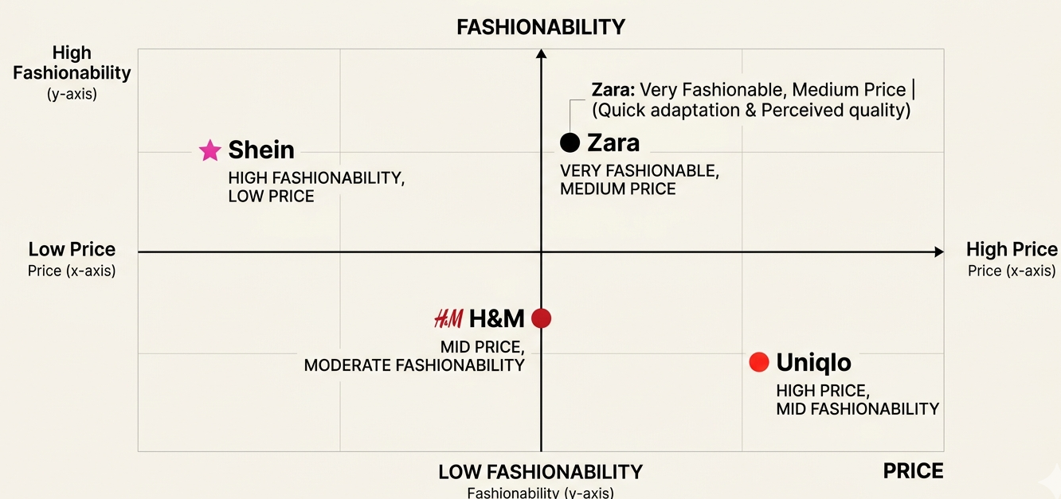
Figure 3: Perceptual Map of Zara
Source: (Self-Made)
The affordable luxury status of Zara has enabled it to appeal to the fashionable customer segment that needs high-quality design at affordable costs.

2. External and Internal Environment Analysis
The external environment denotes macro- level forces that are external to an organisation and that affect the performance of an organisation, such as political, economic, social, technological, environmental and legal factors (Parpandel and Rizea, 2022). Internal environment is the organisational resources, capabilities and competencies that define the responsiveness of a firm to such forces.

2.1 PESTEL Analysis and Strategic Impact
Definition and Importance of PESTEL
PESTEL analysis is a strategy that is employed in the evaluation of the macro-environmental factors on organisational decision-making. PESTEL analysis is crucial in managing risks, identifying opportunities, and defining long-term strategies, such as localisation of supply chain, pricing and sustainability undertakings.
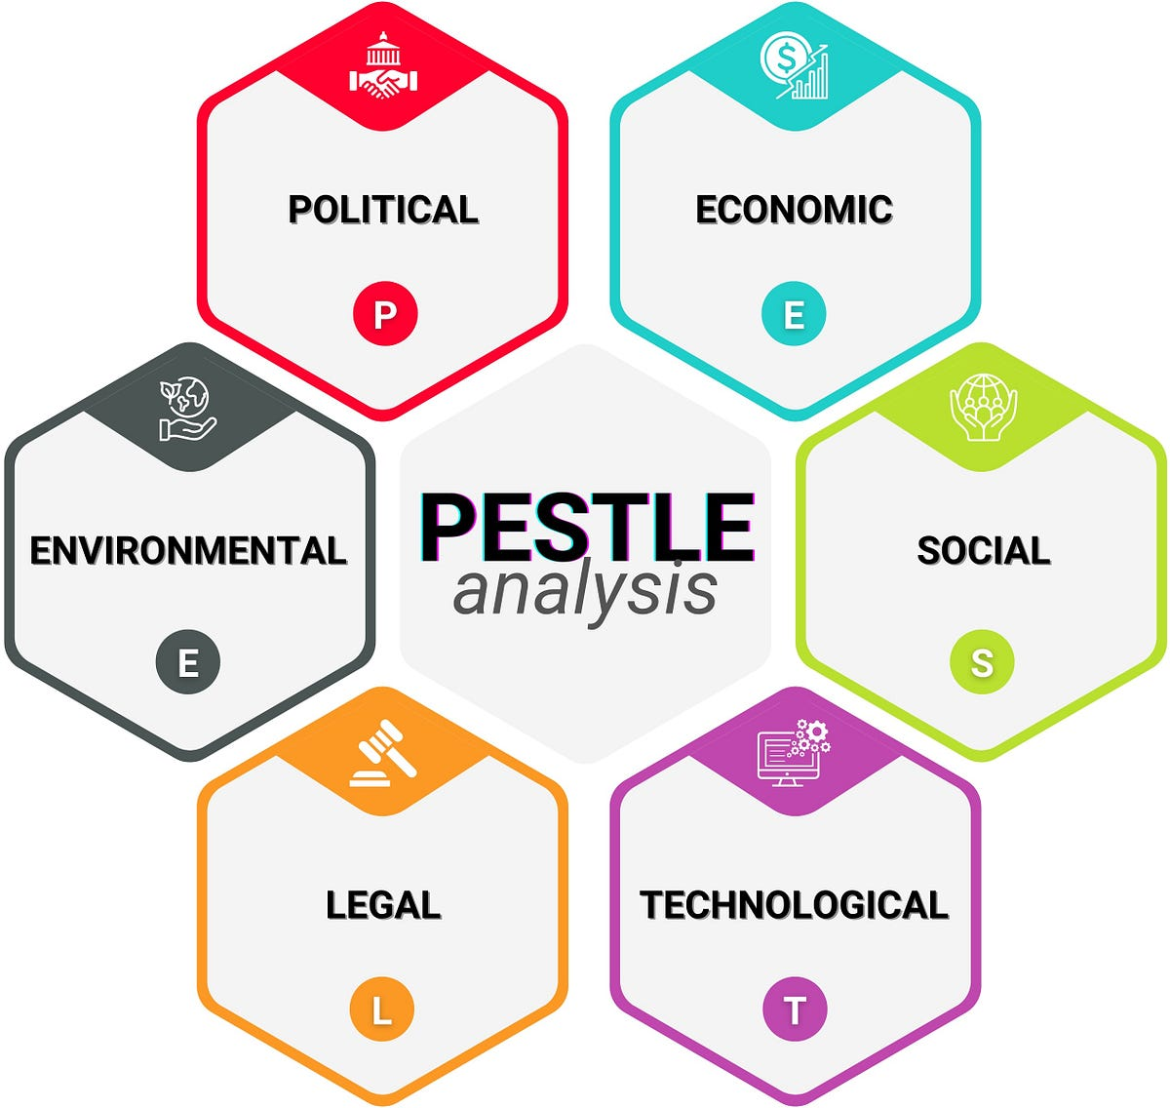
Figure 4: Pestle Analysis
Source: (Iqbal, 2025)
Impact of External Factors on Strategic Decisions
Political Factors: The trade policies and political stability greatly influence the supply chain and cost structure of Zara, especially because about 60-65 per cent of its production is located in Spain, Portugal, and Morocco. For example, trade agreements within the European Union have decreased tariffs among the countries that are members of the union, and the cost of production is estimated to be 10-15 per cent lower (Francois, McQueen and Wignaraja, 2023).
Economic Factors: Volatility in the economy, such as inflation and exchange rates, directly affects the pricing and profitability of Zara. In 2023-2024, the Eurozone inflation is estimated to be 6% on average, which decreased disposable income and clothing expenditures by about 35 (European Central Bank, 2024). Nevertheless, this does not mean that Zara cannot stabilise its demand as opposed to the luxury brands, which saw their demand fall. Also, the quick turnover of inventory (10-12 cycles a year versus the industry average of 46) of Zara leads to holding costs that are up to 20% lower and makes the company resilient in economic crises.
Social Factors: The taste of consumers is changing fast, especially among Gen Z and millennials, who comprise more than 60 per cent of fashion consumption in the world. According to surveys, over 70 per cent of consumers identify with a brand that practices sustainability and half of the consumers are ready to spend more on products that are eco-friendly (Lorek, 2024). This tendency opens an opportunity (the development of sustainable product lines) and a threat (reputational risk of fast fashion).
Technological Factors: Technology plays a crucial role in Zara's competitive advantage, with digital transformation significantly impacting operations. More than 25% of total revenue is attributed to online sales, which is a significant change from traditional retail (Zara, 2024). The data analytics help Zara to process millions of customer interactions in a single day, allowing it to make real-time design changes and shorten the time to develop a product to 2-3 weeks.
Environmental Factors: This fashion industry emits around 10 per cent of all carbon emissions in the world, and uses about 93 billion cubic metres of water per year (Wahab and Saleh, 2024). This poses great environmental pressure on Zara, which is a serious threat to its fast-fashion concept. Nevertheless, it provides the possibility of differentiation as well in the form of sustainability programs. In recent years, Zara has decreased the intensity of greenhouse gas emissions by more than 20% and strives to achieve net-zero emissions by 2040.
Legal Factors: Legal policies, such as labour laws, environmental standards, and consumer protection policies, have a great impact on Zara's operations. EU labour laws raise the cost of production by about 15-20 per cent relative to low-cost areas, but raise the ethical reputation (Ericksno and Kuruvilla, 2022). Moreover, tougher environmental laws are forcing businesses to spend a lot of money to be sustainable, and the costs of compliance are increasing annually by approximately 10%.

2.2 Critical Success Factors and Strategic Challenges
Critical success factors (CSFs) are crucial factors that help organisations gain a competitive advantage, and strategic challenges are external factors that cripple performance and growth (Ubaid, 2023).
Critical Success Factors and Strategic Challenges in the Fashion Industry
The strategic challenges of Zara are directly related to the critical success factors in the fast-fashion industry, which include speed-to-market, supply chain efficiency, innovation, and strong brand positioning. For example, the fact that Zara has over 20,000 designs each year and has a high inventory turnover allows it to be flexible when competing with its competitors, such as Shein and H&M (Zara, 2024). Nevertheless, it is this same velocity that heightens operational strains particularly when inflation and regulatory compliance adds 10-15 percent to the expenses.
Similarly, digital integration where e-commerce represents more than 30 percent of all apparel sales is a success factor as well as a competitive requirement. Zara needs to constantly innovate online to be able to keep up with the online aggressive growth of competitors (Arthnova, 2025). Moreover, fast production leads to profitability, which is opposite to sustainability expectations and poses reputational and regulatory risks. Therefore, the parts of the success are also the weaknesses of Zara, which must be carefully balanced strategically.

2.3 Internal Environment Analysis
Resources:
- Tangible Resources: The physical resources available to Zara are its vast retail store system of more than 2,000 stores and its highly automated logistics system. Its distribution centres are capable of handling more than 60,000 items in one hour, and hence fast distribution around the globe (Zara, 2024). Inditex has a good investment capacity; it brings in more than 35 billion euros in revenue.
- Intangible Resources: The intangible resources at Zara are good brand equity and data analytics capabilities (Ortiz Cuadrado, 2022). The brand enjoys millions of customers every year, and customer loyalty is high. Moreover, the capability of Zara to gather and process real-time store data helps in decision-making and product design, minimising forecasting errors by about 20-30%.
Capabilities:
- Supply Chain Agility: The supply chain of Zara allows developing and distributing products in 2-3 weeks, which is 4-6 months on average in the industry (Garro, 2024). This ability lowers the risk of inventory and makes it more responsive to trends.
- Digital Integration Capability: The omnichannel approach adopted by Zara combines online and offline retailing, and online transactions make up more than a quarter of its total income (Zara, 2024). This feature improves the experience of customers and performance.
Core Competencies:
- Fast-Fashion Innovation: The total number of items made by Zara is more than 450 million every year, constantly updating the product line and gaining new customers (Zara, 2024).
- Customer-Centric Design: Zara leverages customer feedback, which is real-time and used to inform design, increasing product-market fit and decreasing unsold inventory (Zara, 2024).

2.4 VRIO Framework Analysis of Strategic Capabilities
Strategic capabilities are the skills of an organisation to make use of its resources and competencies to attain sustained competitive advantage (Simon and Kumar, 2023). According to the internal analysis, Zara has the following key capabilities: supply chain agility, and Digital Integration Capability. These capabilities are assessed using the VRIO framework below regarding their value, rarity, imitability, and organisational support.
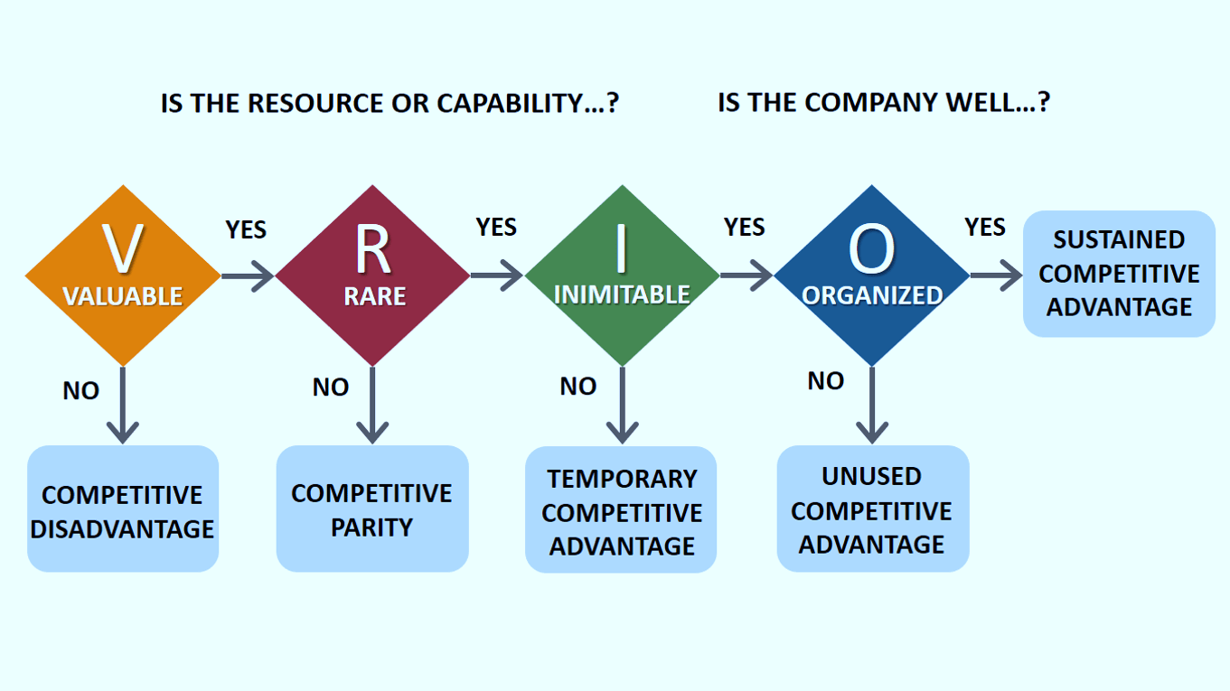
Figure 5: VRIO Framework
Source: (Bruin, 2022)
VRIO Analysis of Supply Chain Agility:
Value: The supply chain agility of Zara generates a lot of value because it helps minimize the lead time to 2-3 weeks and maximize the inventory turnover to 10-12 times/year. This enhances the reaction to market trends and lowers the stock holding by 20% (Jasiński, 2024).
Rarity: This ability is not common as most of the competitors have a longer production cycle of 4-6 months. Zara has a unique market advantage due to its capacity to design, produce and distribute products very quickly (Nguyen, 2023).
Imitability: Vertical integration is costly and complex making the supply chain hard to imitate. It takes a lot of money and time to replicate such infrastructure (Zara, 2024).
Organisation: Zara is organised well to cash in on this strength with a centralised decision-making body and effective coordination between design, production and distribution (Pirone, 2023).
VRIO Analysis of Digital Integration Capability:
Value: Digital integration helps Zara to boost the accuracy of demand forecasting by about 25 percent and facilitates online and offline customer experiences, boosting sales and engagement (Jasiński, 2024).
Rarity: Zara is one of the few competitors that use digital tools as intensely as possible, as others have generally not yet integrated physical stores and digital platforms at the same level (Chen, 2023).
Imitability: This is an averagely hard to copy feature since Zara has an established culture of data-driven and an ongoing investment in technology. It is easy to duplicate tools but not the organisational expertise that drives them (Sarkis and Sundarraj, 2024).
Organisation: Zara also facilitates this capacity, by constantly investing, and Inditex invests more than 1 billion in technologies and logistics every year in order to stay aligned to strategic goals (Pirone, 2023).

2.5 Internal Strengths and Competitive Advantage
Internal strengths are the distinctive resources and capabilities that can allow an organisation to be superior to its competitors (Arregle and Campbell, 2024). In the case of Zara, the ability to respond quickly to new trends in the supply chain, high brand equity, and the use of data as a form of decision-making are some of the strengths that add to the competitive advantage.
Most importantly, the capacity of Zara to match its internal strengths to the external opportunities, including digital change and sustainability, promotes its competitiveness in the long term. Although the company still faces issues like environmental issues and escalating prices, Zara is constantly investing in innovation and efficiency, which will keep it ahead of the pack in the fast-fashion industry around the world.

3. CSR and Sustainability Objectives

3.1 Definition of CSR Strategy and Sustainability
Corporate Social Responsibility (CSR) strategy is defined as a systematic way in which an organisation engages in its social, environmental and ethical responsibilities and in the process generating value to the stakeholders (Wan-Jan, 2022). In this regard, sustainability is inclined towards addressing the current business demands without jeopardising future generations, especially in environmental conservation, social justice, and economic sustainability.

3.2 Zara’s CSR Strategy
Zara has incorporated CSR into its long-term plan via its sustainability programme. Some of the main CSR activities the company has are reaching net-zero emissions by 2040, using more sustainable materials (100 per cent sustainable cotton, linen, and polyester by 2030), decreasing greenhouse gases, and enhancing the supply chain transparency. Moreover, Zara follows a rigorous labour code and ethical sourcing guidelines, especially in its vertically integrated supply chain in Spain, Portugal and Morocco (Nguyen, 2023).

3.3 Business Objectives of Zara
The key business goals of Zara are to continue to achieve speed-to-market, profitability through effective inventory control, brand positioning as a cheap luxury, and digital and global market penetration (Zara, 2024). Innovation, customer-focused design, and operational efficiency are also part of the strategies of the company to maintain its competitive advantage.

3.4 Alignment Between CSR Strategy and Business Objectives
The CSR strategy of Zara is more or less in harmony with the business goals, but there are certain tensions. On the one hand, sustainability activities contribute to brand image and customer loyalty, especially among customers who are environmentally aware, to support revenue growth and positioning. Sustainable materials and energy efficiency also help to reduce costs in the long term and make it more resilient (Wan-Jan, 2022).
Nevertheless, there is a glaring concern in the fact that the fast-fashion concept and the sustainability ambitions of Zara are at odds.

4. Comprehensive and Holistic View of the Organisation

4.1 Balanced Scorecard: Definition and Importance
The Balanced Scorecard is a strategic performance measurement system which was developed by Kaplan and Norton (1992), whereby the tool incorporates both financial and non-financial measurements to give a complete picture of organisational performance (Alshammari, 2021). It is helpful since it reflects business operations on strategic goals, enhances decision-making and provides long-term value creation through the balance between the short-term financial performance, customer satisfaction and internal performance and organisational learning.
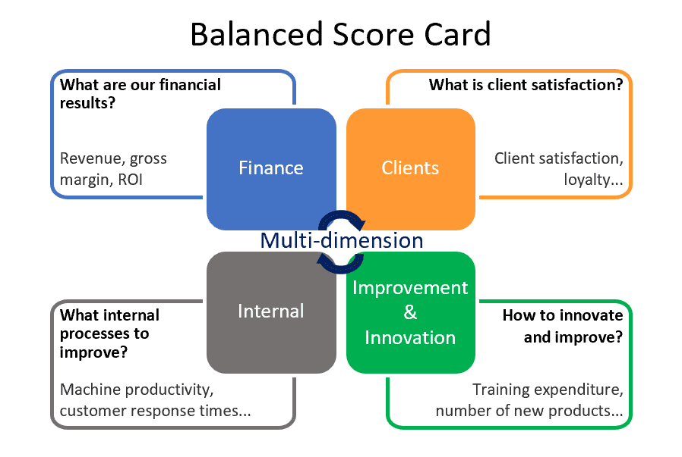
Figure 6: Balance Scorecard Approach
Source: (Wevalgo, 2024)

4.2 Financial Perspective
- Objectives: Zara focuses on maximising its profitability, revenue growth and cost efficiency by utilising the fast-fashion model and optimising the supply chain (Nguyen, 2023).
- KPIs and Targets: The key performance measures are the annual revenue growth (target: the constant growth by the standards of the industry), inventory turnover (10-12 rotations per year), and cost reduction (target: 15-20% decrease in holding costs) (Jasiński, 2024).
- Initiatives: Zara spends a lot of money on logistics and technology, spending more than 1 billion yearly in order to speed up its production cycle to keep it fast and efficient. Its supply chain is highly vertical and helps it to control costs and respond (Zara, 2024).

4.3 Customer Perspective
- Objectives: The organisation is aiming at boosting customer satisfaction, building brand loyalty and positioning the organisation as an affordable luxury fashion brand (Grant Parsons, 2023).
- KPIs and Targets: KPIs consist of customer retention rates, contribution of online sales (target: more than 25-30%), and brand perception indicators that pertain to quality and sustainability (Cardona, 2025).
- Initiatives: Zara implements an omnichannel approach, incorporating online and offline customer experience (Zara, 2024). It also uses real-time customer feedback and data analytics to quickly adapt designs, ensuring high product relevance and customer engagement.

4.4 Internal Business Processes Perspective
- Objectives: The important goal is to enhance operational efficiency, supply chain responsiveness and sustainability practices(Parpandel and Rizea, 2022).
- KPIs and Targets: Key KPIs are the time spent on product development (2 to 3 weeks), efficiency in production, and sustainability performance, e.g., the emission reduction (goal: net-zero by 2040).
- Initiatives: Zara takes advantage of vertical integration and automated distribution centres, which can process more than 60,000 items in a single day (Zara, 2024).

4.5 Learning and Growth Perspective
- Objectives: Zara seeks to improve innovation ability, human capabilities, and digitisation (García-Álvarez, 2024).
- KPIs and Targets: KPIs are productivity of employees, investment in technology, and effectiveness of data analytics (target: increase in demand forecasting accuracy by 2030).
- Initiatives: The firm is spending heavily on digital infrastructure and analytics, so it can make decisions in real-time. Innovation and flexibility are supported by continuous training of employees and a data-driven culture (Pirone, 2023).

4.6 Final Evaluation (Integrated Analysis)
Integrating all four views, Zara has a good overall performance but with an element of strategic imbalance. The company is very successful in financial terms, as it is able to demonstrate high revenue growth and cost effectiveness (Nguyen, 2023). On the customer side, it is highly satisfied and loyal to the brand due to trend responsiveness and omnichannel incorporation.
Nevertheless, even though Zara has reached three major goals in an effective manner (financial performance, customer satisfaction, and operational efficiency), the company has restrictions in terms of sustainability in the areas of internal processes. The ecological footprint of fast fashion implies that the approach is not completely effective.
Recommendations:
As the strategy is mostly working, the only changes needed are incremental changes instead of radical ones:
- Increase investment in circular fashion models, such as recycling and resale programmes
- Minimise environmental impact by reducing volumes of production.
- Improve the integrity of the sustainability reporting to increase stakeholder trust.
- Expand sustainable product lines beyond current objectives.

5. Strategic Choices and Implementation

5.1 Definition of Business-Level and Corporate-Level Strategy
Business-level strategy is the way in which a company competes in a given industry in order to gain a competitive advantage, either by cost leadership, differentiation, or both (Roth and Morrison, 2023). Corporate-level strategy, on the other hand, focuses on the overall scope and direction of the organisation, including decisions related to growth, diversification, and market expansion. The two levels should be aligned to achieve strategic success in the long term.

5.2 Business-Level Strategic Choices
Identification of Relevant Options:
As the previous analysis has shown, Zara is in a very dynamic and competitive fast-fashion industry. Although the generic strategies proposed by Porter can be cost leadership and differentiation, not all of them can be considered equally appropriate. A pure cost leadership approach like that of competitors such as Shein is not entirely suitable for Zara because it has a relatively high cost of production and focuses on quality and brand perception (Arthnova, 2025).
Rather than that, Zara adheres to a hybrid approach, which integrates the aspects of differentiation and cost-effectiveness. The company stands out as it has quick product development, high-fashionability, responsiveness to customer trends, and moderate pricing due to its effective supply chain management.
Recommended Business-Level Strategy:
It is suggested that Zara should not abandon its hybrid approach but reinvent its differentiation with the help of sustainability and innovation. Since consumers are moving towards more ethical and environmentally friendly brands, Zara can improve its value proposition by becoming more sustainably embedded in its product design and operations. This will not only cement brand loyalty but also legitimise its pricing strategy and stay competitive.

5.3 Corporate-Level Strategic Choices
Identification of Relevant Options
Zara (Inditex) has a couple of strategic options at the corporate level. Unrelated diversification is not appropriate due to Zara’s strong focus on fashion and retail competencies (Pirone, 2023). Nonetheless, related diversification, like the entry into the models of circular fashion (recycling, resale, repair services), is very relevant.
Another important strategic alternative is international expansion. Zara already has operations in the global market, yet there are tremendous prospects in the emerging markets where there is a high demand for fashion at low prices.
Recommended Corporate-Level Strategy
Zara should prioritise:
- Growth into new markets with the help of an omnichannel approach.
- Investment in associated diversification, especially circular and sustainable fashion models.
These plans support the current Zara strengths in logistics, digitalisation, and brand value, which guarantee expansion and sustainability.

5.4 Change Management and Strategic Implementation
Application of Lewin’s Change Model
Lewin’s Change Management Model is a three-stage framework that is used to help business organisations implement and stabilise change effectively (HRC, 2023). The application of this model is as follows:
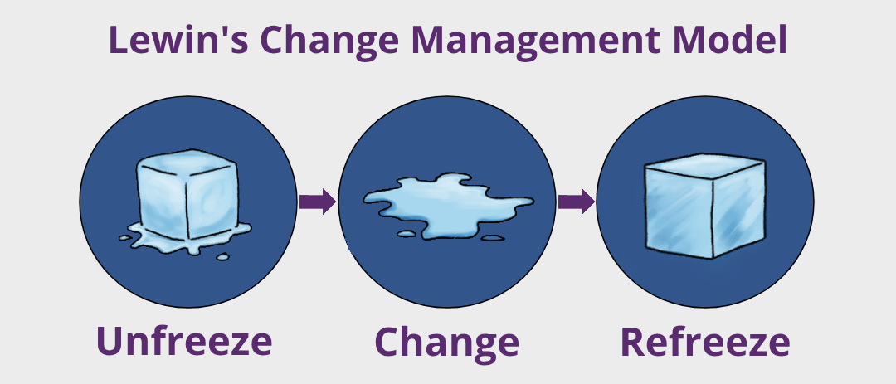
Figure 7: Lewin's Change Management Model
Source: (HRC, 2023)
Unfreeze: Zara has successfully recognised the necessity to change because of the digital disruption and sustainability pressures (Nguyen, 2023). The change to e-commerce and sustainability objectives indicates organisational preparedness.
Change: The company has undergone major transformations such as digitalisation, automation of logistics, and integration of the online and offline channels. This stage is also reflected in sustainability efforts like the use of renewable energy and the use of sustainable materials (Wahab and Saleh, 2024).
Refreeze: Zara has partially institutionalised these changes by incorporating them in the long-term strategy (Zara, 2024). Nevertheless, the fast-fashion model remains incompatible with sustainability goals, which means that they do not stabilise fully.
Critical Assessment:
Zara has been successful in its change management, both regarding digital transformation and operational efficiency, which allows successful strategy execution (Pirone, 2023). But changes related to sustainability are less advanced, posing a strategic tension. Thus, change management is mostly successful, but the future implementation has certain challenges unless the structural adjustments are deepened.

6. Strategic Evaluation and Recommendations

6.1 Definition of Strategic Evaluation
Strategic evaluation entails the evaluation of the effectiveness of an organisation's strategy in meeting its goals and maintaining competitive advantage (Sarkis and Sundarraj, 2024). It combines findings of the internal and external analysis to decide whether the existing strategy is aligned, efficient and responsive to the future challenges.

6.2 Evaluation Using Ansoff Matrix
Ansoff Matrix is a strategic planning model that determines four growth strategies: market penetration, product development, market development, and diversification (Quantive, 2024). It aids organisations in analysing growth possibilities on both the existing and new markets and products.
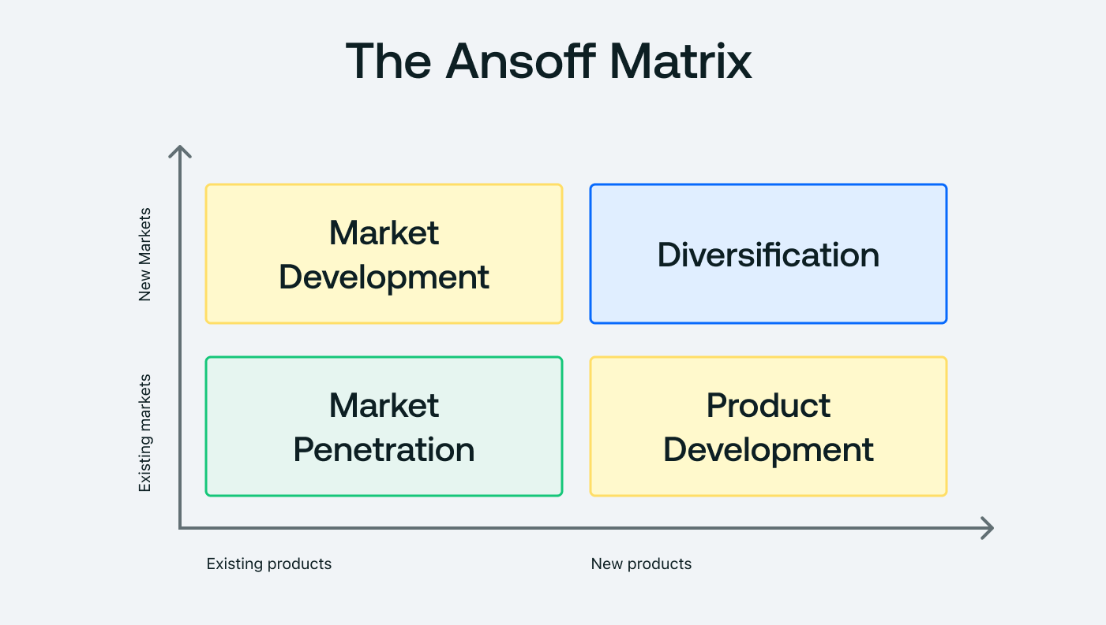
Figure 8: Ansoff Matrix
Source: (Quantive, 2024)
Market Penetration (Existing Products, Existing Markets)
Market penetration is highly utilised in Zara, where sales among current markets are promoted by high rates of product release, low prices and good brand positioning (Pirone, 2023). Its model of low production and high inventory turnover promotes repeat buys and customer loyalty. This has been a very efficient way of ensuring that the levels of revenue are maintained.
Product Development (New Products, Existing Markets)
Zara has a strength in product development. The company designs more than 20,000 new designs each year and constantly renews its collections in accordance with real-time customer information (Zara, 2024). This has enabled Zara to be very sensitive to shifting fashion trends, hence having a high competitive advantage.
Market Development (Existing Products, New Markets)
Zara has penetrated more than 90 countries, indicating a good market development strategy (Lopez and Fan, 2024). There are still growth opportunities in emerging markets like Asia and Africa. The omnichannel model of the company helps it grow and also lessens the dependency on physical stores.
Diversification (New Products, New Markets)
Zara is diversifying, but at an early stage. The company is starting to venture into sustainable fashion, including recycling and environmentally-friendly product lines (Nguyen, 2023). But diversification into circular business models remains untapped and has major growth potential in the future.

6.3 Evaluation Using BCG Matrix
The BCG Matrix divides business units into four types according to the market growth and market share of business units: Stars, Cash Cows, Question Marks and Dogs. It assists organisations in planning their resources and portfolio management of their business.

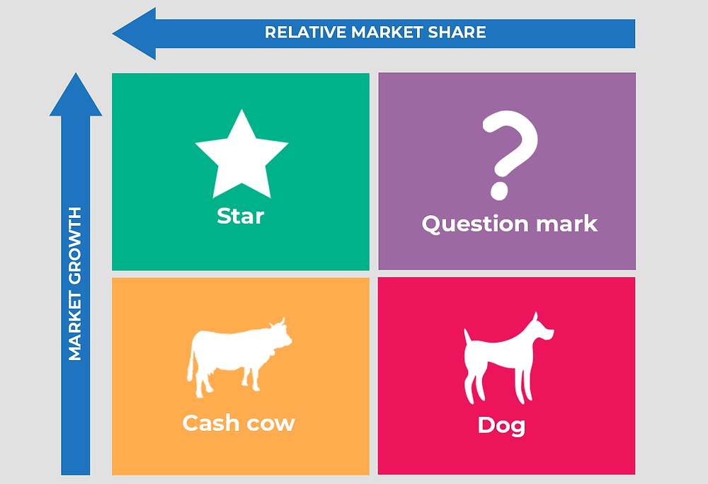
Figure 9: BCG Matrix
Source: (Peak Frameworks Team, 2023)
Stars (High Growth, High Market Share)
Zara could be described as a Star since it has a high growth in the global fashion industry, and it has a consistent market share. Its quick fashion business model and international nature bring high revenues and necessitate constant investment in innovation and technology (Nguyen, 2023).
Cash Cows (Low Growth, High Market Share)
Some of the mature markets, especially in Europe, are Cash Cows to Zara. These markets bring stable and predictable revenue, which contributes to the investments in newer markets and innovations (Statista, 2024).
Question Marks (High Growth, Low Market Share)
Question Marks can be regarded as emerging markets, including some parts of Asia and Africa. These areas present a great growth potential, but they need strategic investment to grow the market share and brand recognition (Dekimpe, 2024).
Dogs (Low Growth, Low Market Share)
The Dogs category may include some of the underperforming stores or regions. The strategy employed by Zara to address this is by shutting down the physical stores that are not profitable and focusing on online platforms (Zara, 2024).

6.4 Recommendations for Strategic Improvement
- Expand into circular fashion models (recycling, resale and repair services) to improve sustainability issues and lower the environmental footprint, which is in line with growing regulatory and consumer pressure.
- Optimise production through the use of more advanced demand forecasting and smaller production batches in order to reduce excess production and maintain agility and cost efficiency.
- Increase market penetration by expanding digitally using growth strategies to increase market presence globally and stay competitive in the growing e-commerce based apparel market.
- Enhance branding and transparency in sustainability programs in order to develop customer confidence and brand positioning in a very competitive environment.
- Invest strategic alliances to develop sustainability in materials and processes that will be innovative so that in the long term they will remain competitive and they will meet the environmental requirements.
These recommendations ensure that Zara’s success factors are not only sustained but also adapted to overcome its strategic challenges.

Conclusion
The report shows that Zara has a robust competitive advantage due to its responsive supply chain, evidence-based abilities, and hybrid approach. Although the company has outstanding financial performance, customer satisfaction, and operational efficiency, sustainability issues are also a major concern. The strategic tools define opportunities in a circular fashion, digital growth, and new markets. Overall, incremental strategic improvements focused on sustainability, innovation, and transparency will strengthen Zara's long-term competitiveness and ensure balanced organisational performance.

Section 2: Reflective Account (Gibbs Reflective Cycle)
The Reflective Cycle is a systematic model of reflection developed by Gibbs as a method of systematic assessment of experiences by describing, feeling, evaluating, analysing, concluding and planning actions (Collidu, 2022). This part is a reflection on the researching, analysing, and preparing process of Section 1 to determine the learning outcomes and areas of improvement.
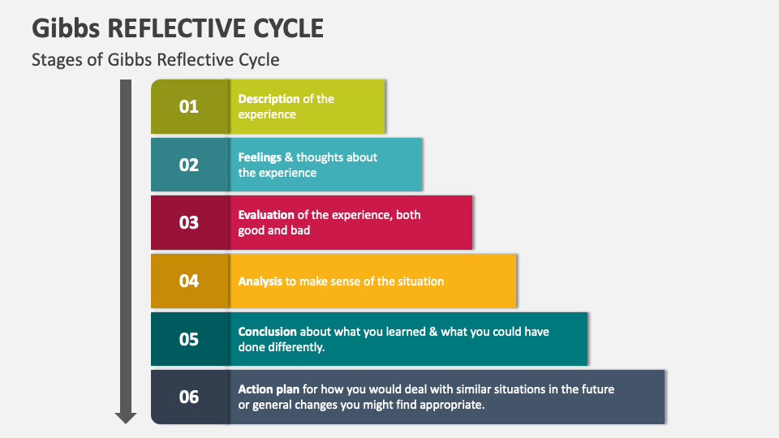
Figure 10: Gibbs Reflective Cycle
Source: (Collidu, 2022)
1. Description
Section 1 was developed with a structured and systematic approach to researching the organisational context of Zara, its industry environment, and strategic position. The secondary data collection started with the establishment of the appropriate academic sources, industry reports, and reliable business databases to collect the required data. I was keen on making sure that the information was up-to-date, valid, and pertinent to strategic management models.
I used multiple strategic tools such as PESTEL analysis, VRIO framework, Balanced Scorecard, Ansoff Matrix, and BCG Matrix to analyse Zara’s internal and external environment. These strategic management frameworks help to develop a thorough understanding of the business environment (Fuertes, 2023). For example, PESTEL assisted in the analysis of macro-environmental factors like political instability, inflation and sustainability laws, whereas VRIO aided in the examination of internal Zara resources like supply chain flexibility and brand loyalty.
Saunders (2021) also notes that a structured research design enhances the reliability and validity of scholarly results. I made sure that quantitative data like numbers of revenue, rate of production and market shares were represented to reinforce the analysis. My writing had various drafts, as I kept on perfecting the structure, clarity, and logical connection of the sections.
2. Feelings
When first starting the assignment, I felt uncertain because of the difficulty of incorporating a variety of strategic frameworks into a single, consistent report. The abundance of information on the international activities of Zara and the trends in the industry initially seemed overwhelming. Another issue that I was worried about was whether I could preserve the quality of my academic work and balance word counts and structure.
I became more and more confident. I felt more at ease with the analysis of data and with the correlations of theoretical models with practical business scenarios. I was also inspired when I began to realise how frameworks such as the Balanced Scorecard and VRIO model relate to each other to articulate organisational performance. Moon (2023) notes that reflective learning starts with confusion but progresses to deeper insights with systematic involvement, which is the exact situation with me.
During the last phases, I was pleased with my skills in critically analysing the strategy of Zara and creating a well-structured academic report. Nevertheless, I was also a bit under pressure in terms of time management, particularly when it came to editing and referencing.
3. Evaluation
There were weaknesses and strengths to the overall process. My ability to use strategic frameworks in order to analyse Zara from different perspectives was one of the key strengths. The fact that quantitative information, like an increase in revenues, production volumes, and market trends, was included helped me to make the analysis more credible.
The other strength was the capability of linking theory and practice. For instance, applying VRIO helped identify Zara’s sustainable competitive advantage, while PESTEL highlighted external risks such as inflation and environmental regulations. Baba and HakemZadeh (2023) state that theoretical and real-world evidence can enhance the quality of strategic decision-making, which I tried to do throughout the report.
Nevertheless, my approach had its flaws as well. This was a limitation on the critical depth initially in some parts, as I used more description than evaluation. Time management was another problem as I allocated excessive time to data collection, which minimised the time I had to edit and refine.
4. Analysis
This phase of reflection brings out the enhanced learning process of the assignment. Research competency was one of the most valuable skills that was acquired. I was taught to source out reputable academic and industry references and derive useful information to make strategic analysis. McGrath (2025) states that the research is not only about gathering data but also about interpreting it critically, which I used when analysing the strategic position of Zara. The other essential learning outcome was to develop analytical thinking. The application of frameworks like PESTEL, VRIO, and Balanced Scorecard made me think critically about how various internal and external forces interrelate to affect business performance.
In addition, my writing abilities in academic performance increased, especially in the presentation of argument and logical flow. Nevertheless, I also understood that in the future I will need to be more critical. The quality of academic work involves not only presenting information but also interpreting and supporting arguments, which I need to work on.
5. Conclusion
In this reflective analysis, it is clear that the task of doing Section 1 helped me a lot in learning about the concepts of strategic management and their practical implementation. I developed strong research and analytical skills, improved my ability to apply theoretical frameworks, and gained experience in structuring an academic report.
6. Action Plan
Area for Improvement | Action to be Taken | Timeline | Expected Outcome
Critical Analysis | Practice applying frameworks with stronger evaluation and justification rather than description | Next 2 months | Improved depth of analysis in academic work
Time Management | Develop a structured timetable for research, writing, and editing stages | Immediate and ongoing | Better efficiency and reduced last-minute pressure
Academic Writing | Read academic writing guides and practice structured paragraph development | Next 1–2 months | Improved clarity and coherence in writing
Referencing Skills | Use citation tools and cross-check the Harvard referencing style regularly | Immediate | Accurate and consistent referencing
Research Skills | Increase the use of peer-reviewed journals and academic databases such as Google Scholar | Ongoing | Higher quality and credibility of sources
Proofreading | Allocate dedicated time for reviewing and editing final drafts | Before submission of each assignment | Improved accuracy and overall quality

References
Alshammari, A.M. (2021). The evaluation of the impact of using balanced scorecard on strategic performance in small and medium enterprises. research.thea.ie, [online] 6(3). Available at: https://research.thea.ie/handle/20.500.12065/283 [Accessed 19 Apr. 2026].
Arregle, J.-L. and Campbell, J.T. (2024). The dynamic interplay of capability strengths and weaknesses: investigating the bases of temporary competitive advantage. Strategic Management Journal, 31(13), pp.1386–1409. doi:https://doi.org/10.1002/smj.893.
Arthnova (2025). How Shein Became Bigger Than Zara While Staying Invisible. [online] Medium. Available at: https://medium.com/@arthnovaofficial/how-shein-became-bigger-than-zara-while-staying-invisible-a9f533704c7c [Accessed 19 Apr. 2026].
Baba, V.V. and HakemZadeh, F. (2023). Toward a theory of evidence based decision making. Management Decision, 50(5), pp.832–867. doi:https://doi.org/10.1108/00251741211227546.
Bruin, L. de (2022). VRIO Framework EXPLAINED with EXAMPLES | B2U. [online] B2U - Business-to-you.com. Available at: https://www.business-to-you.com/vrio-from-firm-resources-to-competitive-advantage/ [Accessed 19 Apr. 2026].
Cardona, N. (2025). Global Apparel Industry Statistics (2024) | UniformMarket. [online] Uniform Market. Available at: https://www.uniformmarket.com/statistics/global-apparel-industry-statistics [Accessed 19 Apr. 2026].
Chen, Y. (2023). Analysis of Marketing Strategies of Cross-border E-commerce Platforms in the United States-Shein. Highlights in Business, Economics and Management, [online] 19(6), pp.478–483. doi:https://doi.org/10.54097/hbem.v19i.11985.
Chiwawa, N. and Wissink, H. (2021). Strategic management practices in organisations with specific reference to the public sector. Africa’s Public Service Delivery & Performance Review, 9(1). doi:https://doi.org/10.4102/apsdpr.v9i1.540.
Collidu (2022). Gibbs Reflective Cycle. [online] www.collidu.com. Available at: https://www.collidu.com/presentation-gibbs-reflective-cycle [Accessed 19 Apr. 2026].
Dekimpe, M.G. (2024). The increasing power of store brands: Building loyalty and market share. Long Range Planning, [online] 30(6), pp.917–930. doi:https://doi.org/10.1016/s0024-6301(97)00077-0.
Ericksno, C.L. and Kuruvilla, S. (2022). Labor Costs and the Social Dumping Debate in the European Union. ILR Review, 48(1), pp.28–47. doi:https://doi.org/10.1177/001979399404800103.
European Central Bank (2024). Economic Bulletin Issue 6, 2024. [online] European Central Bank. Available at: https://www.ecb.europa.eu/press/economic-bulletin/html/eb202406.en.html [Accessed 19 Apr. 2026].
Francois, J.F., McQueen, M. and Wignaraja, G. (2023). European Union–developing country FTAs: overview and analysis. World Development, 33(10), pp.1545–1565. doi:https://doi.org/10.1016/j.worlddev.2005.05.006.
Fuertes, G. (2023). Conceptual Framework for the Strategic management: a Literature Review—descriptive. Management Research, 2020(6253013), pp.1–21. doi:https://doi.org/10.1155/2020/6253013.
García-Álvarez, M.T. (2024). Analysis of the effects of ICTs in knowledge management and innovation: The case of Zara Group. Computers in Human Behavior, [online] 51(6), pp.994–1002. Available at: https://www.sciencedirect.com/science/article/pii/S0747563214005305 [Accessed 18 Apr. 2026].
Garro, A. (2024). New product demand forecasting and distribution optimization : a case study at Zara. [online] dspace.mit.edu. Available at: https://dspace.mit.edu/handle/1721.1/66072 [Accessed 19 Apr. 2026].
Grant Parsons, A. (2023). Corporate branding, Emotional Attachment and Brand loyalty: the Case of Luxury Fashion Branding. Journal of Fashion Marketing and Management: an International Journal, [online] 17(4), pp.403–423. Available at: https://www.emerald.com/insight/content/doi/10.1108/jfmm-03-2013-0032/full/html [Accessed 19 Apr. 2026].
HRC (2023). Lewin’s Change Management Model - HRC Online. [online] hrcoursesonline.com. Available at: https://hrcoursesonline.com/lewins-change-management-model/ [Accessed 19 Apr. 2026].
Iqbal, A. (2025). PESTLE Analysis: The CEO’s Guide to Future-Proofing a Business. [online] Medium. Available at: https://medium.com/techno-preneurship/pestle-analysis-the-ceos-guide-to-future-proofing-a-business-877e6c4e20ea [Accessed 19 Apr. 2026].
Jasiński, P. (2024). The demand planning renaissance: A data-driven approach. Journal of Supply Chain Management, Logistics and Procurement, 7(1), p.6. doi:https://doi.org/10.69554/xmob6236.
Lopez, C. and Fan, Y. (2024). Internationalisation of the Spanish fashion brand Zara. Journal of Fashion Marketing and Management: An International Journal, 13(2), pp.279–296.
Lorek, A. (2024). Current trends in the consumer behaviour towards eco-friendly products. Economic and Environmental Studies, [online] 15(2 (34)), pp.115–129. Available at: https://www.ceeol.com/search/article-detail?id=412048 [Accessed 19 Apr. 2026].
McGrath, K. (2025). Doing critical research in information systems: a case of theory and practice not informing each other. Information Systems Journal, 15(2), pp.85–101. doi:https://doi.org/10.1111/j.1365-2575.2005.00187.x.
Moon, J.A., ( 2023). Reflection in learning and professional development: Theory and practice. Routledge.
Nguyen, T. (2023). Zara’s organization apparatus : what is the key behind Zara’s fast fashion success? [online] www.theseus.fi. Available at: https://www.theseus.fi/handle/10024/797609 [Accessed 19 Apr. 2026].
Ortiz Cuadrado, M. (2022). Valuing an intangible asset. Valuation of a brand name. Zara´s brand as an example. repositorio.comillas.edu, [online] 7(3). Available at: https://repositorio.comillas.edu/xmlui/handle/11531/15816 [Accessed 19 Apr. 2026].
Parpandel, D.E. and Rizea, I.C. (2022). The impact of external environment on organizational development strategy. [online] mpra.ub.uni-muenchen.de. Available at: https://mpra.ub.uni-muenchen.de/id/eprint/26303 [Accessed 19 Apr. 2026].
Peak Frameworks Team (2023). What is the BCG Matrix? Explaining its Components and Quadrants. [online] Peak Frameworks. Available at: https://www.peakframeworks.com/post/bcg-matrix [Accessed 19 Apr. 2026].
Pirone, C. (2023). Benetton and Zara information systems:a comparative analysis. [online] Upc.edu. Available at: https://upcommons.upc.edu/entities/publication/10f9379a-06ed-49ae-8f56-c44db8f73874 [Accessed 19 Apr. 2026].
Quantive (2024). What Is The Ansoff Matrix: Definition, Steps & Examples. [online] Quantive.com. Available at: https://quantive.com/resources/articles/ansoff-matrix [Accessed 19 Apr. 2026].
Roth, K. and Morrison, A.J. (2023). Business-Level Competitive Strategy: A Contingency Link to Internationalization. Journal of Management, 18(3), pp.473–487. doi:https://doi.org/10.1177/014920639201800303.
Sarkis, J. and Sundarraj, R.P. (2024). Factors for strategic evaluation of enterprise information technologies. International Journal of Physical Distribution & Logistics Management, 30(3/4), pp.196–220. doi:https://doi.org/10.1108/09600030010325966.
Saunders, M., (2021). Research methods for business students. Person Education Limited.
Simon, A. and Kumar, V. (2023). Strategic capabilities and their relationship to organisational success and its measures. Management Decision, 49(8), pp.1305–1326. doi:https://doi.org/10.1108/00251741111163133.
Statista (2024). Inditex: net sales worldwide by brand 2024| Statista. [online] Statista. Available at: https://www.statista.com/statistics/456505/sales-inditex-group-worldwide-by-format/?srsltid=AfmBOoo_UQ7CN3td-GYBTrJeTLjZ602urMDgOj_uoEIEfYYZWOiQGQt8 [Accessed 19 Apr. 2026].
Ubaid, A.M. (2023). The critical success factors of the highly competitive organizations; a systematic literature review. The TQM Journal, 6(2). doi:https://doi.org/10.1108/tqm-11-2022-0333.
Wahab, S.A. and Saleh, Y. (2024). Environmental Sustainability and Innovations in the Fashion Industry. Journal of Textiles Coloration and Polymer Science, [online] 0(0). doi:https://doi.org/10.21608/jtcps.2024.259736.1314.
Wan-Jan, W.S. (2022). Defining corporate social responsibility. Journal of Public Affairs, 6(3-4), pp.176–184. doi:https://doi.org/10.1002/pa.227.
Wevalgo (2024). Balanced Scorecard (BSC) approach: definition, Limits and Benefits. [online] wevalgo. Available at: https://www.wevalgo.com/know-how/operational-excellence/performance-management/balanced-scorecard [Accessed 17 Apr. 2026].
Zara (2024). Company-+ Info | ZARA. [online] www.zara.com. Available at: https://www.zara.com/us/en/z-company-corp1391.html [Accessed 19 Apr. 2026].

