University of Wells Trinity Saint David
Managing Enterprise in 21st Century
Module number: BMSW4006

BUSSINES PLAN
GRANNY’S KITCHEN
Group work by:

Irina Vucheva (2011269)
Vasilena Mersinkova (2014054)
Aminat Morakinyo (2009818)
Vanessa Gonzales (2011622)
Clementina Manzo (2011261)

LECTURE NAME: MALANI GUNARATNAM
MODULE LIDER: AFZAL MUNA
DATE: 28.04.2021

BUSINESS PLAN

Cover Letter

Malani Gunaratnam
m.gunaratnam@uwtsd.ac.uk

Dear Ms Gunaratnam:

My name is Vasilena Mersinkova, I am one of the partners that founded “Granny`s Kitchen” LLP. I am writing this letter on behalf of our team, and to present to you our business plan with the hope that you will appreciate our idea and support our future work. Please find enclosed a thorough business plan with all supporting paperwork.
We are a team of five ladies that gathered few months ago, decided to join forces and bring an idea to life. We truly believe that a healthy and balanced diet is crucial for our children`s health. Therefore, we are determined to provide our neighbors with fresh, homemade food for their children. Furthermore, to support families in need, we will take social responsibility by hiring mothers that struggle to find a job. Our focus at the beginning will be catering for nurseries, childminders, and private customers. We will build a trusted brand that people associate with the taste of their childhood, brought with a modern twist and sustainable approach.
As a startup business we have invested £5000 of personal finances each (£25 000 in total). As owners we would like each to apply for another £25 000 of fixed interest loan. That would make £125 000 of investments that will allow us to develop our business concept.
Thank you in advance for your time and consideration. We hope you will review this plan and give us the opportunity to answer your questions in person, we would be happy to meet you at any time that is convenient for you.

Sincerely,
Granny`s kitchen team

Table of Contents

1. Executive Summary 5
2. Mission 7
3. Vision 7
4. The Company 7
4.1. Company Objectives 7
4.2. Company History 8
4.3. Company Structure 8
5. Service offering (Products) 11
5.1 Product description 11
5.2 Alternative providers 11
6. Market and Customer Analysis 12
6.1 Product……………………………………………………………………………………………………12
6.2 Price………………………………………………………………………………………………………13
6.3 Place……………………………………………………………………………………………………...14
6.4 Promotion………………………………………………………………………………………………...14
6.4.1 Target audience and buyer persona…………………………………………………………… 14
6.4.2 Market analysis 15
6.4.3 Marketing startegy 15
6.5 Physical evidence 15
6.6 Process……………………………………………………………………………………………………………………………………16
7. Operations 18
7.1 People, Skills and procedures 19
7.2 Operatins & Procedures 20
7.3 Site Location 20
7.4 The Managerial Skills 21
8. Technology Plan……………………………………………………......................................................21
9. Management and organization 23
10. Social responsibility and sustainability 27
11. Milestones………………………………………………………………………………………………….29
12. Financial Management 31
12.1 Fundraising Strategy 31
12.2 Projected Profit or loss 32
12.3 Projected Cash Flow 33
12.4 Projected Balance Sheet 34
13. Conclusion…………………………………………………………………………………………………36 References………………......................................................................................................................37
Appendices……………………………………………………………………………………………………..39

- Executive summary.

“Granny`s kitchen” is a premium quality food service providing nutritious meals tailored to the needs of children aged from 6 to 36 months. We are a team of five ladies that are not afraid to roll up our sleeves and work hard for what we believe in.
This project is not just working for us. It represents our vision for the future of our children – a better world, where healthy food and a sustainable approach is a way of life, where we know what we eat and how to prepare it with care for the planet.
We will be selling pre-ordered, pre-cooked food in boxes of 12 or 24 meals, exclusively online, without a commercial area.
We will be offering meals that are based on a variety of tastes and food types. The recipes are selected based on the latest research in child nutrition. We will focus on offering meals with more plant-based protein, low glycemic index, and healthy fats. Moreover, we will offer healthy treats like protein-rich biscuits and snacks.
To validate our idea of sustainability, we will be using only recycled and bio-degradable packaging. Besides, selling in bulk reduces our carbon footprint while minimizing packaging and delivery expenses.
Takeaways and food delivery have always been a favorite dining option for British people. Moreover, the various food delivery options have made these services more accessible than ever. The convenience of having your dinner a click away allows families to spend more quality time together.
The food delivery and takeaway market in the United Kingdom was valued at £8.5 billion in 2019. (Lock, 2020) The users of meal delivery apps have doubled in 2020 comparing to 2015 and the revenues have gone up by almost 300%. (Curry, 2021) Based on this and considering that the COVID-19 crisis would be under control, we have estimated a potential customer base of at least 55 000 people.
We will be working with the biggest food delivery providers which will allow us to use their marketing platforms and reach more potential customers.
We will start with a business-to-customer target market, where our main audience will be mothers aged 28-35 years old; however, we want to also appeal to male parents. After one year we will extend our reach to business customers; we will be providing discounts for bigger orders.

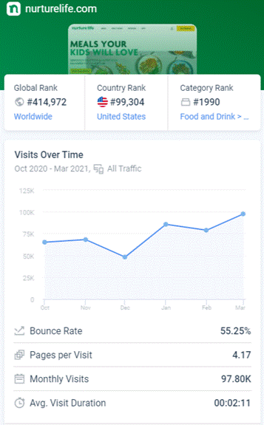
Our main competitors are Mamamade and Nurture life. After analyzing their business model and statistics, we have concluded that our online presence will be most important. (Nurture life, 2021) We will be promoting our services on social media by creating engaging content to generate traffic and brand awareness. Moreover, using platforms like Just Eat will give us a competitive advantage as no other children delivery service is using them for distribution.
After determining the profit margin of our product, we have set the price of one meal to £1.99 which is the best value for money on this market.
We will display a physical evidence of our products and work process on our website and social media accounts. The website will showcase testimonials, product descriptions and nutritional values as well as blog posts and educational content.
Once we reach profitability, we will diversify the range of our products; furthermore, we will be looking for more investments to expand our reach in other boroughs. Once we establish our brand, we will be offering others the opportunity to be our partners as franchisees.
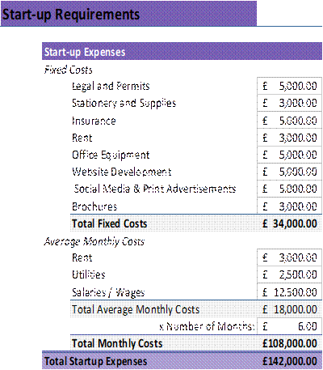
After calculating our monthly costs and initial investments, we have estimated our startup expenses to £142,000.
Each partner will contribute with £5000 cash of personal funds, times five that is £25,000 in cash.
We are applying for another £125,000 of funding from a Startup loan company that offers schemes backed up from the government and works in partnership with Wandsworth council.
Each partner in the business can individually apply for up to £25,000. As we are five partners, that would make £125,000.

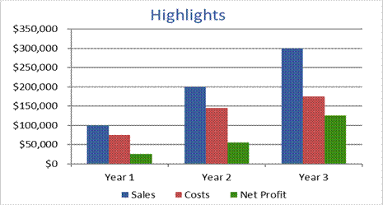
We expect our net profit to increase by 200% each year and to return the investments within five years of staring the business.

- Mission.

Our mission is to facilitate families and assist them in looking after their children`s health and wellbeing by providing healthy, balanced, and various meals, prepared with the idea of sustainability in mind.

- Vision.
Our aim is to establish a brand that people trust and associate with wholesome food and home comfort. We will achieve this by giving the peace of mind for busy parents that their children`s nutrition is well looked after and calculated following the latest research and guidelines.
Besides, as a family orientated company, we take a social responsibility to hire mothers and housewives, offering them flexibility and support for them to be able to look after their families and spend quality time with their children.
Moreover, we are developing a website, that, as well as on-line orders, will be guiding our clients through a healthy lifestyle and sustainable living.
To develop various seasonal menus, we are establishing connections with local farmers and suppliers that share our ethos and are willing to go the extra mile in supplying the highest quality products.
We are passionate and committed to this project, because with hard work and dedication success will follow!

- The company.

  - Company objectives.

- To provide wholesome, diverse food for children aged 6 to 36 months.
- To offer seasonal menus, prepared with locally produced ingredients.
- Gradual transition in the change of menus, for the children to get used to the new ingredients.
- To reach people from more backgrounds and religious congregations, we will exclude pork meat and will use halal meat only.
- To build trust in our customers and educate them about nutrition for children.
- To take social responsibility and support local communities by hiring mothers and offering them flexibility and support.
- Developing a website that offers not only on-line bookings and request, but also credible information about healthy and sustainable lifestyle.
- Creating a network of like-minded partners.
- Working with local farms and suppliers that offer local, organic or Fairtrade products.
- As we establish the brand, we will be offering to others the opportunity to use our platform as franchisees.

  - Company history.

We are a team of four ladies that decided to combine their transferrable skills and start a business that reflects our approach to life. The last year was though and exhausting for all of us, nevertheless, it made us appreciate what is essential in terms of life and business. Many companies suffered great losses; however, opportunities have been provided for new businesses to start.
As the hectic London life resumes, we decided to grab the opportunity and enter the catering and takeaway market. The type of business model we are after is the so called “ghost kitchen”, where there is no commercial area, just the kitchen premises.
Our combined transferable skills are enabling us to save from costs like marketing, duty manager, customer service assistant and operational manager.
As the essence of the business is preparing of food, we will hire a qualified chef with background in international cuisine. Most of us have some experience in this or similar industry; therefore, we will be taking turns in assisting the chef with food preparation or tidying up the kitchen. This will allow us to save some expenses and learn the nature of the business in detail.
As we expand our business, we will hire a manager and a duty manager to make sure that all processes are running smoothly. We will also pay per task to HR manager. He will be recruited permanently once we increase the volume and hire more people.
We do have a contract with a certified accountant firm based in Bromley and with an IT specialist that will developpe and maintain our website.

  - Company structure.

Granny`s Kitchen is registered as a Limited Liability Partnership with five partners that hold equal shares. Each owner has more than 8 years in working experience in a different field. Initially, we will hire a qualified chef; we do have a contract with an accounting firm and web site developer.
/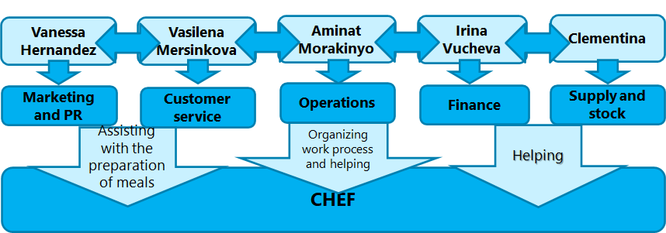

Fig. 1 Company structure at start-up.

- Irina Vucheva.

- Studied Business administration in Bulgaria.
- 12 years of experience in sales, administration, and project management.
- Irina`s biggest work achievement is an approved Grant of 200,000$ for the foundation of Dimitar Berbatov for the talented and successful children of Bulgaria.
- Manages the administration and finances of the company, responsible for budget planning, daily and monthly reports, pricing.
- Excellent analytical, planning and technology skills.
- Receives equal share of the profits.

- Vasilena Mersinkova.

- Chemistry high school in Bulgaria.
- Three years of experience running a Franchise; five years of experience in a family run restaurant.
- Vasilena was rewarded as Franchisee of 2020 in her company.
- Customer service assistant, taking orders and assisting the chef in the kitchen.
- Excellent verbal and written communication skills; knowledge in food safety and hygiene standards in the restaurant industry; good organizational skills.
- Receives equal share of the profits.

- Aminat Olamide Morakinyo.

- Amota High School in Nigeria.
- 10 years of experience as a Health care assistant.
- Operational manager; organizing and distributing daily tasks and work in the kitchen; organizes orders and labels them to be distributed accordingly.
- Excellent interpersonal and organizational skills, knowledge in health and safety standards.
- Receives equal share of the profits.

- Vanessa Gonzalez.

- Jesus Maria High School in Spain.
- Three years of experience in hospitality as assistant chef; five years of experience in marketing and public relations.
- Developing marketing strategies and campaigns, managing social media accounts, public relations; updating the app and website content.
- Excellent communication, interpersonal and presentation skills; knowledge in market research methods and statistics.
- Receives equal share of the profits.

- Clementina Monza.

- Supplying products and materials; managing stock and stock takes.
- Excellent driving skills; excellent organizational skills.

- Chef.

- A qualified chef with experience in international cuisine.
- We will hire a parent that supports a family.
- Salary – £8 per hour.

- Accountant.

- We have a contract with Adiva accountants Ltd.
- Payment £540 per year.

- IT specialist - £13,000 initial investment for website development, social media and printed advertisement and brochures.

CHEF 7
CHEF 1
CHEF 6
CHEF 2
CHEF 5
CHEF 3
CHEF 4

Deputy manager
Brand keeping
Financial manager
Operations
Marketing and PR
Logistics
Irina Vucheva
Vasilena Mersinkovaa
Aminat Morakinyo
Vanessa Hernandez
Clementina Manzo

HR MANAGER
MANAGER

KITCHEN ASSISTANTS

Fig.2 Company structure after business expand.

5. Service Offering (Products)

5.1 Product Description

Boxed meals: Main organic ingredients will be chicken, salads, fruits, vegetables, turkey, cheese, potatoes, pasta, deserts and toppings.
6 different meals will consist of:
- Chicken caesar salad
- Chicken salad with red grapes, rokets, avocado
- Garden hummus and provolone
- Hawaiian sunrise with turkey ham
- Pear, walnut and goat cheese salad
- Baked potato bar with toppings, macaroni salad, fruit and desert.
All styles of meals catering will include vegetarian, full fat, dairy free and allergy free options.
We plan to modify individual meals at our customer’s request so that the product can be completely- tailored. However due to the extra work involved in this custom meal product, the cost will be higher with 2 pounds.

5.2. Alternative Providers
The Market niche for Freshly cooked baby meals is still developing and we have found just 5 main competitors which are still in the early stages of their offerings and do not offer the service through the popular platforms such as Deliveroo and Just EAT. For further support of our research and findings: Wildchildkitchen, Ratatouie, Littlecooksco, Cookfood, Smartinfusedfood.

  - Marketing and Customer Analysis
Before, completing a full analysis of our marketing plan we first we need to determine our business’s 7Ps. This is called a Marketing Mix and the P’s stand for for, Product, Price, Place, Promotion, Physical evidence, and Process. (Qld.gov.au, 2017)
The Marketing Mix below includes important market analysis and segmentation.
  - Product
The solutions our product brings is to make the lives of mothers or fathers easier by providing them premium pre-cooked meals. Parents will have more time to focus their efforts on the wellbeing of their child without worrying about what they will eat next. Less time will be spent on searching recipes, what is good or not for the infants, cooking and throwing away food they do not like. The meals we provide are completely nutritious and palatable as they provide the essential macro and micronutrients their children need as well as the taste they prefer. As researched conducted by Hardwick and Sidnell (2014) has found that infant’s nutrition should be packed with plant-based proteins, low glycemic carbohydrates, healthy monounsaturated, and polyunsaturated fats. Thus, our products will meet all the indicated nutrition requirements for the upmost health of the children we feed.
Primary research has been carried out by surveying mothers in person, which will, helped us understand the variety of tastes, food types, packaging for the foods and delivery used. The results of surveying 10 women in the Wandsworth council have shown that sustainability in the packaging, the process from food preparation to food delivery is preferred to be environmentally friendly as food waste and carbon emission are a growing concern in today’s day and age. Furthermore, the Charity Commission’s (2013) policy will affect positively Granny’s Kitchen’ operations, as the requirements they have set out will be fully met.
Secondary research shows that Mamamade’s food is highly unpalatable according to their customers. (Trustpilot, 2021) This means that the taste is plain; the children do not wish to consume the as well as the parents. Additionally there are no trial packages for parents to see what their kids would prefer and the cancellation process has also been a common issue. All of these reviews result in food wastage and unhappy customers, but provide an opportunity for us as to what we need to focus on.
Initially, the product range will consist of 6 different meals. This variety in meals will validate our business idea as well as the exact customer requirements, which is the conclusion by the primary research. Additionally, these 6 meals will include protein rich baked cookies, preservatives and GMO free sauces suited for children. These bonus items will promote our sales, as it will bring greater value to our customers. Furthermore, packaging will have written text and visuals on how to prepare the food for the baby in a couple of simple steps.
  - Price
To fully understand the price set for our product, we have taken the approach to first broke down the expenses applied to every meal.
Food supplied for the meal preparation of 6 meals is calculated to be £4.
The cost per meal is: £1,5. (4/6)
The hourly pay for our chef is £8. (Minimum wage)
The average meals prepared per hour is 18. (From physical work carried out)
The cost per meals per hour: £27 (18x1,5)
However, we need to take into account the daily working hours are 6 hours.
Thus, the daily output of meals is 108 (18x6).
Total Hourly Cost: £35 (worker £8 + food supplies £27)
Total Cost per Meal: (27 + 8) / 108 = 35 /108 = 0.3240
To determine the Profit margins of our products, we have carried out research of the average sale price by competitors in the industry.
Mamamade is a subscription based meal preparation company targeting mothers and father who want to have a week’s worth of food.
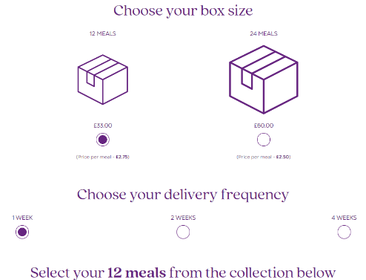
The two packages they are having as of 2021 cost £33 and £60. As seen in the image taken from Mamamade. The lowest price per meal they offer is £2,5, therefore our pricings will be £1.99.
Profit margin per meal: 500%
However, due to other variable costs and fixed cost explained in the financial section of this business plan, it is safe to set the Profit Margin to 200%.
In conclusion, the Sale price of our goods will be £1,99 per meal.
As discussed in the Target Market section of the Marketing Plan, consumers will have the financial affordability and in fact the price is very appealing for the value they receive.
1 box of 12 meals will be: £27.6 (2,30x12)
1 box of 24 meals will be: £47.76 (1,99x24)
Our aim is to sell boxes of meals instead of separate meals. This will provide us with bulk orders for our business to customer target market. Individual meals with cost more due to shipping and packaging, whereas the price of shipping will be lower for a bulk order which lowers expenses and increase profits.
Our business-to-business target market will have 10% off the sales prices for B2C with a minimum order quantity of 200 meals.
B2B price: £358,2 for 200 meals.
Minimum order quantity will be required as Nurseries and other institutions have higher volume of daily consummative. The number of children at a nursery range from 10 to 150 (BabyCentre UK, 2021). Thus, we believe that 200 meals will be sufficient for 1 or 2 days’ worth of food for the children. Moreover, B2B will be our scalability after we have successfully operated with the B2C market.
  - Place
Wandsworth council area in London will be our initial startup location as the kitchen and offices will be based there. The area of operation will cover the whole of United Kingdom as long as the Post code provided by the customers can be reached with our shipping company.
  - Promotion
The promotion section will cover the Target Audience, Buyer Persona, Market segmentation, Market analysis and Marketing Strategy.
    - Target Audience and Buyer Persona
Age: 28–35-year-old. Statistics carried out by Statista (2019) state the average age of mothers at childbirth in the United Kingdom is 30.7 as of the year 2019. In 2000 the average age was 28.5.
Gender: Female. However, we want to also appeal to the male parents who are taking care of their children.
Income: The Household income levels is £30 000. In the UK this is the average income levels for parents with children in the year of 2020. (Webber and O'Neill, 2021)
We are considering the number of jobless mothers after giving childbirth. The daily childcare does not allow the mother to work. This duration usually continues until the child has reached the age of 3 years old. Fortunately, statistics have shown that women in the UK are more likely to maintain their job positions and stay at work than before. (Romei, 2019)
Types: Business to Customer and Business to Business.
Regions: National, United Kingdom.

    - Market Analysis
The food delivery and takeaway market in the United Kingdom was valued at £8.5 billion in 2019. The various online delivery options have made food easily accessible to any individual or business customer than it has ever been. Additionally, the expected users of online delivery are 11 million for 2019 alone. (Lock, 2020)
The number of single parents is 1.8 million and they are equal to a quarter of families with children aged 0-13 years old. (Guy, 2021) Thus, if we only take 5% of the 11 million online food service delivery users, that would mean 55 000 people at least is our potential customer base.
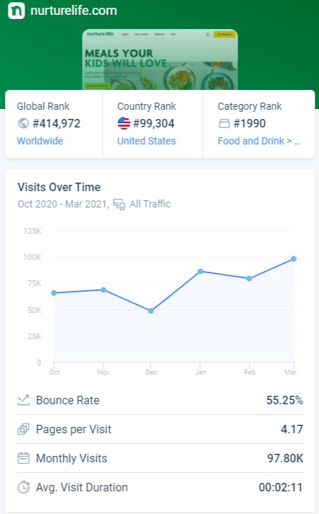
The biggest food delivery providers in the UK are ranked in order of JustEAt, Deliveroo and Hungryhouse. (Iqbal, 2021) These companies will be one of our main promotional strategy as they have delivery drivers, customer support and marketing teams which will increase our reach to our target audience and thus increase sales.
    - Marketing Strategy
By analyzing our main competitors, Mamamade and Nurture Life who operate within the food delivery industry, we can conclude that our online presence will be at the upmost capability. Our marketing team will promote our services by creating engaging content on our website blogs, social media accounts, such as Facebook, Instagram, Pinterest and Twitter. These platforms will help us reach to thousands of parents and will generate website traffic and brand awareness as seen as the statistics displayed regarding Nurturelife’s website traffic. (Nurturelife, 2021) Furthermore, just by entering JustEat and other platforms, we will have a great competitive advantage as no other children delivery service is available.
The Social media post schedule is set as: 1 post per day. The promotional post are at least 3 times a week displaying the benefit and intrinsic value our meals bring to the parents. The other post will be engagement based, such as toddler photos of sports and games. These will bring out a unique and genuine sense of our brand as it shows the relatability of the owners and the customers.
In conclusion, this blue ocean thinking presents us a great marketing strategy to showcase the value we bring to the time bound parents across the UK.
  - Physical evidence
Customers will see Physical evidence of our business that will mainly display on our website and social media accounts.
The website which will showcase testimonials, product descriptions, clear photos of the meals and the nutritional value, blog posts and educational content, our brand story, the prices and contact details of our team. Community building forums and chats will connect our clients and will create an online intangible evidence of our mission, brand, and desire to provide the parents of what they deserve. This type of physical evidence has proven to work incredibly well as Mamamade (2020) has successfully built their online-based business.
The physical environment of our offices and kitchens will be displayed on the website though a promotional video of our services. We will not be operating with a physical store as the expenses of running one are high and by working solely online with our order processing, we have a much bigger reach to our target market. Stakeholders, such as investors will have to opportunity to visit our premises and decide if they wish to invest in our startup business. Furthermore, the physical premises will be regulated through food standard agencies in the United Kingdom.
  - Process
Our process of operation will be as described in the steps below:
- Purchase food supplies from organic farms and supplies
- Receive and safely store food supplies.
- The food that we need to prepare the meals, is selected, and cooked within 3 hours. This will keep the freshness of the products and palatability.
- Prepared meals will be packaged in eco-friendly boxes, which will further increase the expiry date of the prepared meals by 3 days.
- Orders fulfillment will be handled by our Operations Assistant
- Shipping courier picks up and delivers items within the same day of dispatch. These include Deliveroo, Just Eat and Hungry House.
- Order is delivered to the end customer.
- Our website will have an order tracking service for the ease of mind of the customers.
The Process laid out above will save time and will increase efficiency in our day- to- day business activities. Furthermore, it will ensure that every parent receives the right order requested and the same standard of service.
- CHOOSE YOUR MEALS
Select from a menu of delicious, nutritionally balanced meals made with real, clean ingredients like organic veggies & antibiotic-free proteins.
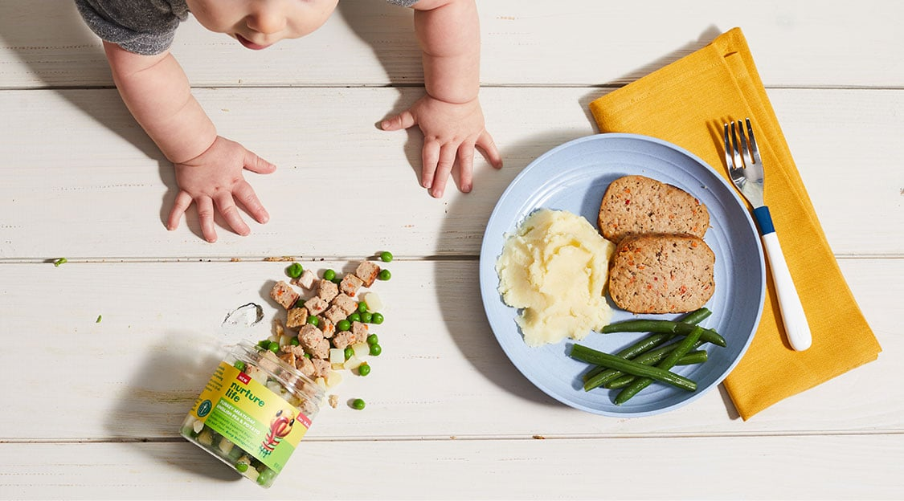

- WE COOK & DELIVER
Our chef-made meals are prepared in our kitchen and delivered fresh to your door.
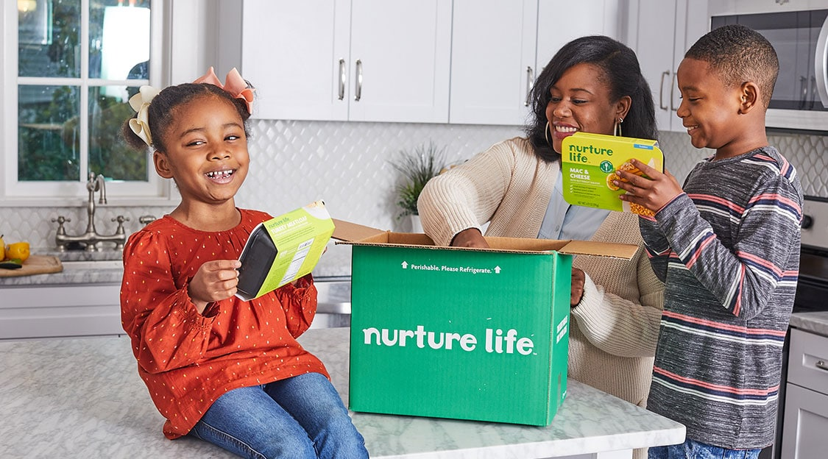
- EAT. LOVE. REPEAT.
Serve up every meal in under 2 minutes and let your family dive into flavours they will love created by our chefs & dietitians. Skip, pause or cancel at any time.

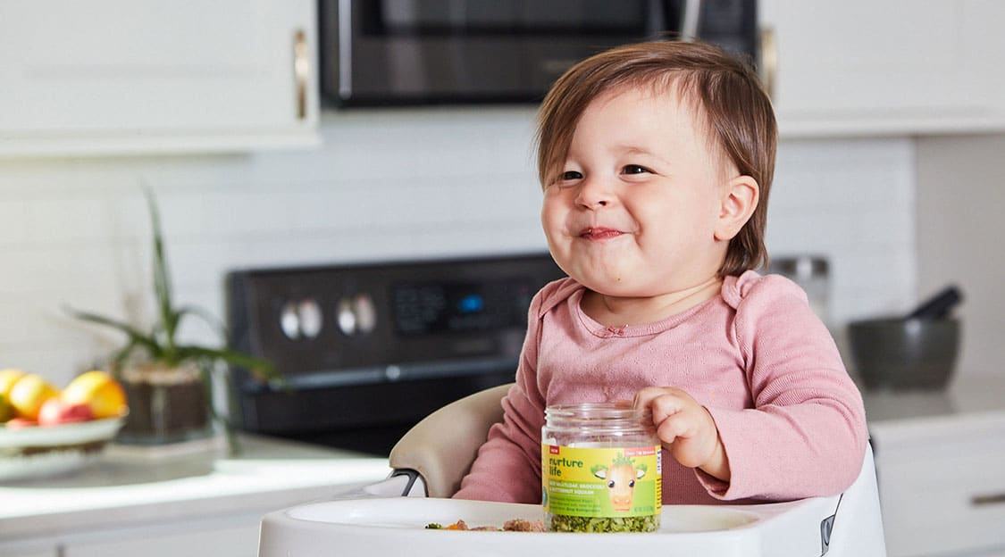

The Market niche for Freshly cooked baby meals is still developing and we have found just 5 main competitors which are still in the early stages of their offerings and do not offer the service through the popular platforms such as Deliveroo and Just EAT. For further support of our research and findings: Wildchildkitchen, Ratatouie, Littlecooksco, Cookfood, Smartinfusedfood.

  - Operations

The operations have main and very important role for our company start and future success. Operations are daily actions and tasks, which are essential for the preparation of our products, ordering of the products, delivering to the customer, ordering of all need materials and supply, daily meetings, solving customer and employee issues in a positive and timely manner. Operations of our business are very important as in the whole process from the customer order up to the payment and the delivery there are many different and complicated tasks that need to be completed at the same time with very strict and fast manner.

The operations are the way to create a business. Starting from the type of business would like to be opened, there is any niche market in mind, if will be unique selling point, if the product can be liked or not, how the food can be sold, if will be take way, having own driver for delivery or putting the shop on delivery app. They also can give us an idea how much start up or capital needs to start the business. We check in the area how many competitors of the same business there are. We compare other business to see what could be done to not be more expensive than others or what can be introduced that other businesses do not have (Suneja, M.P., 2020).
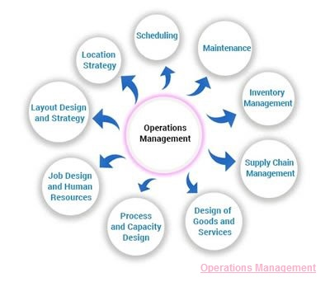
7.1 People, rules, and procedures

The person looking after the operations will help also to register the business with the Local council mostly if in the Business plan there is a chance to sell meat or diary food and it need to be done at least 1 month before the opening of the business because there could be the possibility to be rejected. They help you to register for the course for HACCP, Health and safety and level 2 food hygienic that are mandatory to have when opening a business (Wang, Y., 2020).
When all the paperwork is ready and accepted, there will be a visit from one of Environmental Health Officer's from the local authority to inspect the premises. The purpose of the officer is also to make sure the business production is safe as it operates with food.
The operations are processes that the business has chosen to follow on their platform, which order is going where, whether it is coming from an end user or a Nursery at a later stage. The Operations Assistant is responsible for looking if any items are finished for the day and make sure to amend it on the website platform. He organizes the day for the chef, as it is a new business, he does not have an extra chef, so he helps also with the preparation, like cleaning the vegetables, put the grocery away, tidy up the kitchen, prepare the delivery box to make sure the chef is free and ready to start cooking.
The operation looks after the product price, supplier quality of product. With accounts department he opens the accounts for the supplier, so he does not need to be worried regarding payment (Cummings, C., 2020).

7.2 Operations & Procedures
The operations on any business need well-structured processes and well- defined roles of each member of the team. As many new businesses start with just enough to operate, to survive they need to carefully choose the people that they are allocating on specific tasks. Although, one may not know how to cook he certainly knows how to prepare the ingredients, wash, and sort them, so they are prepared for cooking (Jaaron, A.A., 2021).
Five People are owners of the Business. We have one person supplying the materials in the kitchen two people will be doing the administration and marketing,1 in finance, 1 in operations ( who . what. When). We need to hire an accountant, IT specialist and a chef. The main initial concept was housewives to cook for everybody but as you remember we changed it to freshly made traditional Italian, Bulgarian and international MEALS for children aged between 6-36 months. As we want to work on two streams B2C and B2B we need to decide how we are going to achieve that scale. To be honest if we want to go larger scale with homemade food which is made from housewives, does not really apply as she will not be able to make massive amount of food (Wang, Y., 2020)

7.3 Site location
The business will be in South West London and we will rent a kitchen. We are creative individuals who are thinking broadly. After conducting Primary research with over 50 mums in the Borough we found out that they want to work something in between the hours their child is attending a nursery and feel like they are contributing something to the Family budget. Therefore, we are willing to hire hourly housewives in the future, after the 1 year when the business will include B2B offering as well. Then we will need more labor hours with cooking and packaging.
We shall hire six housewives which will be on percentage of earnings let us say 60/40. Please have in mind that we do not do any orders but use Deliveroo and Eat in.
We believe we shall have bio menu as guarantee of good quality and all the foods to be packaged and to write what they contain. (Cummings, C., 2020).
  - The Managerial skills
There will be need of strict implementation of best practices and the structure of productive communications to ensure that everyone communicates at best productive level and efficiency to minimize customer complaints and ensure that every issue is resolved in very good time manner.
  - Technology Plan
Now in our plan there are fixed strict receipts which part-time housewives need to follow, but there is need for more procedures and details about it to secure the customers satisfactions and happiness.
There is need of strict contracts and procedures which will targeting to control the technology of the whole process starting from suppliers as we need quality and healthy food, then procedures for the specific receipt as we do not want to have one food, prepared from the different housewives to taste, or look in a different way (Cummings, C., 2020).
There is a need, and it is necessary for a Standardized meal preparation. Company standards and services expectations are essential part of our Business Operations to make sure that all the different steps and processes are going smoothly and properly from the start to the end when we take feedback from the customer.
In our Technology Plan there is need for plan to invest in non-plastic materials as a new company we need to follow and comply with fast reactions about all new trends and high technologies (Suneja, M.P., 2020).
In our budget there is need for planning unpredicted expenses for new innovations and high technologies as this is a must in now day technologies and operations.
When it comes to what we need as materials mainly we will need caps, bottles, paper bags, paper plates with focus for less plastic materials involved. The food will come ready and then separated as per the customer orders and expectations (Samimi, A., 2020).
From the day one of the start of the business, we aim to deliver high quality and healthy food at an affordable price to our customers.

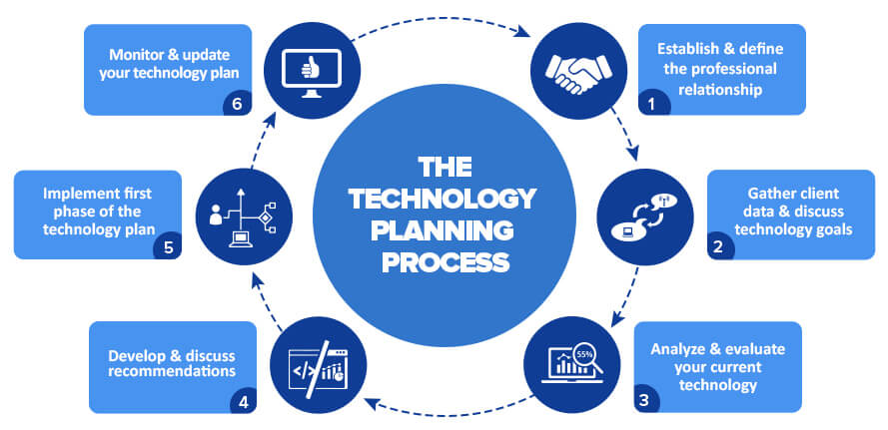

Another important point, which needs attention and control, is our customer’s personal data. We will need to register in the data protection register and to set clear and secure protection procedures for protecting our customer personal details and data.
Customers will use our online platform to place an order and they will complete online payments that means we will need extra cost for IT specialist, which will need to set protection systems for our customer details.
This procedure needs to be offered to our customers since they login in on our website, they will need to agree or disagree to receive our special offers and promotions vie email or phone text messages.
There is need of personal message offering, for example special threat for the loyal customer birthdays and personal celebrations.
In the situation involving different people preparing food there is need for strict health and safety procedures and daily control as there is no time and cost for mistakes and negative customer feedback.
We need also fixed contractual terms with the delivery companies as very often, because of their delay or mistakes there are customer issues and problems. This is the reason why we need to write fixed procedures for customer compensations and ensuring minimum or zero complaining (Azevedo, T.C., 2020).
In the future technology plans we need to set specific personal paper bags with for example the loyal customers initials and our logo on the plates, bottles and bags as this will support our marketing brand name in the long term (Angeles, R., 2014).
Our technology plan is focused on the customer in the first place. Then on the quality and healthy ingredients of the food.
This is the reasons why there are fixed steps we follow in our plan, starting from when the customer places the order, then how fast the order details will get to the right person, then how long will take the real time for the preparation of the food. Along that we make sure they are to the high standards and quality, then they way and time frames which we apply to get the food as fast as possible to the customer home, office, or location. As we can see the process is time consuming and involves few steps and this is the reason why there is need to set the operations of effective and productive communications, very strict time frames for each step in order to avoid any delays (Wang, Y., 2020).
Health and Safety is of main priority when it comes to the providing food for young children. In our Technology Plan we will have a whole section with instructions how to store and teach children to new tastes, although they can be quite picky! The nature of our business is providing the best quality foods but we need also to ensure that our employee are operating in the best environment and then the products which we produce and deliver to our customers comply with all legal and health regulations and expectations.

  - Management and organization.
Management is of main importance for every organisation. At first, to save from additional costs, we will all share management functions based on our experience. As we expand our business, we plan to have one manager and one deputy manager to ensure everything is under daily control and actions. We will also pay per task to HR manager, but he will not be recruited to work permanent for the company until we increase the volume and increase the numbers of housewives or employees in future (Hu, M., 2020).
Both the manager and the duty manager will be paid with two components first will be base fixed salary and the second will be based on bonus scheme depending of the achieved KPIs and targets for the periods of three, six, nine and twelve months.
We planning to have two main meetings during the week and then if need we can increase them. The first meeting will be on Monday and the Second meeting will be on Wednesday in
order to be sure that if there are any issues at the start of the week they will be solved up to the next meeting (Samimi, A., 2020).
The working schedule for the shifts will be completed by manager for the next four weeks in advance and will be submit for approval by the five owners.
In order to ensure that it is all set and based on best practices the HR will have the task to submit for approval job descriptions, daily tasks and responsibilities for all members including the management in order to firstly comply with the law and secondly for the owners to have better control (Baker, J., 2012).
All the supplier orders need to be submit and order for four week time covering as per the needs of the business and all orders must be preapproved before sent to the suppliers from the owners.
Management and duty management responsibilities below:
- Daily Planning of taska
- Daily measuring the supplies available
- Daily recording the expectations for next week suppliers orders
- Quality and freshness control
- Daily review of issues and solving customer issues.
- Planning next four weeks schedule according the company needs and not overspending the company wages budgets.
- Daily effective and productive communications with all members
- Coaching and teaching new members and improving current ones for future promotions
- Control over the daily and weekly cost for the production of the food and expenses and taking fast decisions to prevent loss and damages.

Function of Manager

Management is not an easy process. The manager is responsible to create a positive environment in which individuals are working together in groups efficiently in order to be productive and accomplish selected aims (Koontz and Weihrich, 1990)
There are six main functions of the manager and they all need to be well organized in order for the manager to be successful.
  - Planning
The work the manager is to plan what to be done. The management of each company need to plan and make sure plan is according the company targets, objectives and values. Research shows that the most successful managers have great planning skills. In our company planning is applied through changes every month, daily activities, schedules, holidays, inventories, visits, banking and so many events that require planning (Tomey, A.M., 2008 ).
  - Organizing
Second important function is to set clearly their goals and targets. The Manager needs runs many activities and events. Their organizational skills play a vital role for the outcome of aby business. They can either drawn you or make the company very successful.
  - Coordinating
Coordinating the team members and all operations contributes to a smoother operation.
  - Staffing
Human factor is very important and people management is the key for all results. The Manager has to be flexible, caring for the well –being of the team members and be very good at interpersonal communication.
  - Directing
Giving the right and clear directions plus enough information is also main function of the manager ( Bush, T., Bell, L 2019 ).
  - Controlling
This function is final but crucial. Every management needs to exercise some form of control in order to ensure the set outcomes are achieved in efficient manner. The feedback of the operations gives important information to the Management and can help with future improvements of the processes. However, the Control function is a must for every management team as a means of implementation of the first five functions (Marquis and Huston, 2009).
On theory and in real life management there is some differences and most of the time they come from the different personalities and the environment the people are finding themselves in. The practical application of those functions can vary from a Manager to Manager; therefore, they should always be open to learning of new ways of resolving and managing issues.
There are three manager roles as per below:
• Interpersonal
– figure head, leader
• Informational
– monitor, disseminator, spokesperson
• Decisional
– Entrepreneur, disturbance handler, resource allocator, negotiator
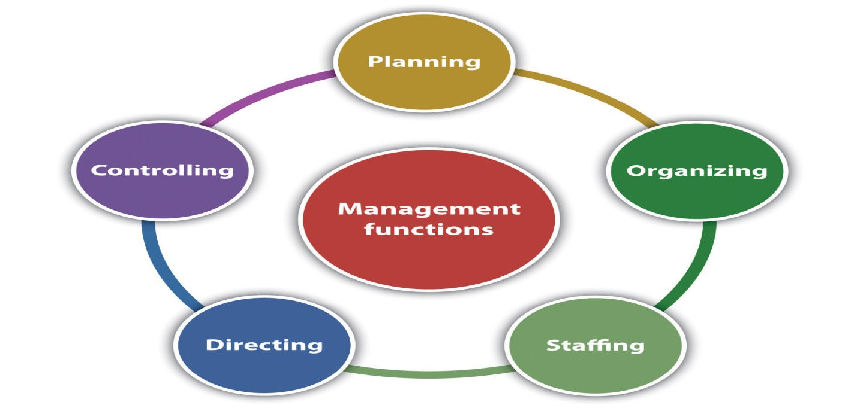

It will be management responsibility to work with the HR and complete every three months personal development reviews to all members working for the company. The purpose of this review is to set smart targets and objectives in short term in next three months and in long term in next 6 to 12 months.

The main purpose of the one to one review is to evaluate the current performance, to set clear solutions and need actions for improvements based on last month performance and to ensure that member is fully contributing our company values and mission.
There should be in place set smart KPIs which need to be achieved on every three months period. It is management responsibility to take weekly and daily actions and meetings one to one when there is issues and need for fast improvement and amendments so the goals will get achieved at the end of the period.

  - Social responsibility and sustainability.
Environmental responsibility
We plan to focus in using mostly paper caps, bags and to reduce rubbish waste.
All the materials left or rubbish we plan to do our best as social responsible company we will do all what is need for reducing the environment damage.
Ones per every three months we plan to organize special event for cleaning our local area in order to give personal example to others,that we need to contribute to decrease the damage to the local area and all in the globe with small activities, but more often and by more companies and people (Keskin, B.B., 2020).
Human rights responsibility
Here we will support with very good and fair conditions and contract points for all our members and we will give them opportunity to progress in the future and to even give suggestions and feedback for improving the sales and net profit (Jaaron, A.A., 2021).
Social sustainability
We hope that with our health and quality food we will support the social health and better life with less sickness and issues coming because of poor low quality food. This way we will achieve both our success and profit as company and at the same time we will add value in people life and health. To have mission which contribute the society as feeling better and eat quality and healthy food is very important for us (Azevedo, T.C., 2020).
As the family can buy fresh healthy food from us means they will have more time to spend together, they will have more time to improve themselves or learn new skills. All this will contribute for the sustainability supported by our company products.
Charity
We plan to set in our mission to help and support children with disabilities and from every £50 spend from our customers we will donate to disability charity £1 as support the children which suffer and live in pain.
Values
Our set values will be:
- To ensure the customer receive high level of service
- To make our customer having more free time
- health quality food
- good competitive prices
With all this tools and activities we hope that we will be responsible company which will contribute the society with quality products and great mission and values.
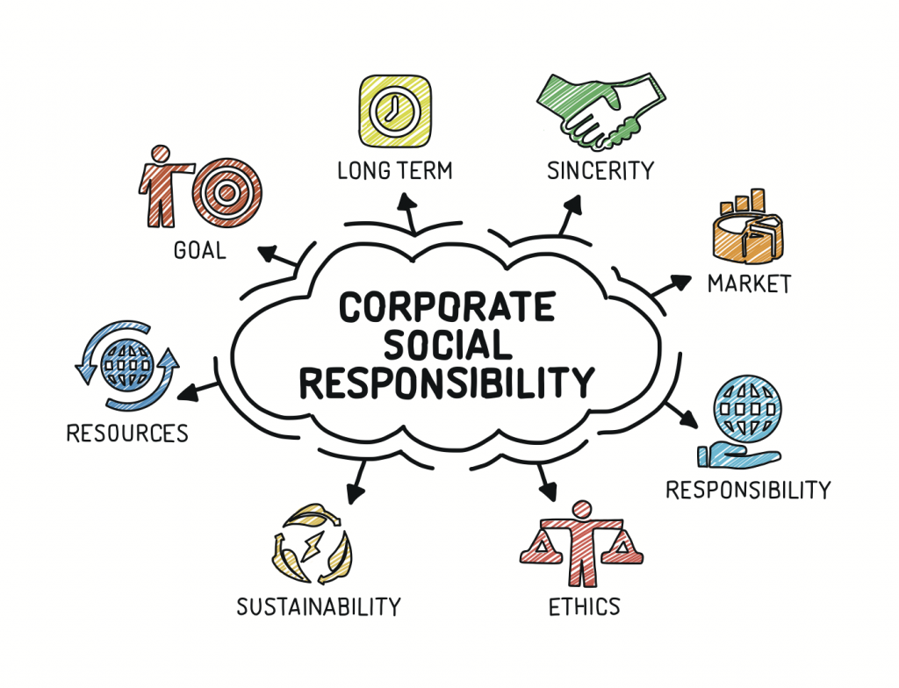

  - Milestones
 | Milestone | Start Date | Duration | End Date | Budget | Invisible
 | Milestone #1 | 9/15/2020 | 60 | 11/14/2020 | £ 15,000.00 | 0
 | Milestone #2 | 10/15/2020 | 60 | 12/14/2020 | £ 20,000.00 | 44,119
 | Milestone #3 | 11/14/2020 | 60 | 1/13/2021 | £ 30,000.00 | 44,149
 | Milestone #4 | 12/14/2020 | 120 | 4/13/2021 | £ 30,000.00 | 44,179
 | Milestone #5 | 1/13/2021 | 120 | 5/13/2021 | £ 10,000.00 | 44,209
 | Milestone #6 | 2/12/2021 | 30 | 3/14/2021 | £ 20,000.00 | 44,239
 | Total |  |  |  | £ 125,000.00

  - Financial Management
Finance can be a daunting area of any Business especially when people have ideas but lack entrepreneurial experience. Attempting to form a Business and trying to grow it Is an individual has its challenges therefore Wandsworth Council has partnered with Start up Loans company which offer schemes to help Entrepreneurs in the Borough. It Is a scheme backed up by the UK Government. It is the best form of provision of fixed income personal loan combined with the so essential mentoring of individuals looking to start or grow a Business. All owners or partners in the business can individually apply for up to a £25,000 fixed-interest loan each. If multiple business partners are each applying for a loan for the same business, a maximum of £100,000 may be lent for that business in its lifetime. As the owners of the Business are 5 people we are aiming for the £100,000 Scheme.
In the conditions of World Pandemia that we are currently facing we should not underestimate the rapidly changing conditions of the markets and that ALL businesses are affected. We have identified an opportunity to deliver a service of demand and create job placements. Although the economy shrank by 9.9% in 2020 with is the biggest contraction since 1709, the companies managed to be flexible and adjust their business models as well as their working patterns. They completely transitioned to online shopping and takeaways. (Partington, 2021).
We will construct a Financial plan based on the following assumptions:
- Direct food costs will be less than or equal to 30% of total direct costs
- No unforeseen changes in the Government Grand Funding Availability
- Continued interest in using Catering Services from Nurseries in the South West London
- Slow economic Growth, No food crisis or recession bigger than 50%
- Fixed Interest Rate of 6.5% p.a.
- Long-term Interest Rate of 6.5% p.a.
- 5 year repayment term
12.1 Fundraising Strategy
Our Startup costs primarily cover inventory costs, the web presence of the Business, the Salaries of employees and the lease of a Commecrial Kitchen. Our assumptions are shown in the table above as fixed costs. The Startup funding will be cash of £25,000 by each owner contributing with an equal share and Startup Loan of £100,000 of which each individual has an equal share of £25,000.

13. Conclusion.
We chose this business model based on the experience from the latest pandemic. Although there is always a possibility for a worst-case scenario, we have constructed our business plan based on the current political and social situation, considering the latest statistics and financial environment forecast. The takeaway market and food delivery apps were few of the businesses that continued to operate in a lockdown. The UK market provides the clientele and opportunities for those who can compete and provide the best value for money. Preparing food for the family is a time-consuming process, besides, not everyone has the knowledge and skills to do it. People always seek to provide the best for their children, and this is exactly what we offer – nutritious meals prepared with care for the planet and their future.
We are convinced that we are going to succeed because what we offer is not just food – it is convenience, trust, and care. With hard work and dedication success will follow.
As we can see from the balance sheet our company have slow start for the first six months trading, but from the start of the 2021 the net incomes increased with 5k only for the first four months of the year which is very positive data.
We need to work over the expenses as we clearly can see that is normal to have high expenses when starting the company, but since is settle one part of the expenses need to be reduced instead the amount to be reinvested in updates and innovations for improving the customers approach and service.
All five owners start withdrawals for equal amounts of 1k per month from the fifth month of the startup of the company. The Company starts repayments of the 125k loan from the first month with 1k per month as a start and in the second year this will increase up to next years until is paid off.
The owners and the management need to control expenses and liabilities as they visibly can increase in the future months.
We predict increasing of the sales especially during the busy months between September and December, but despite this there is a need for good control over the cash available as we need to be ready to stay stable and to respond to any pandemics or lockdowns in order to stay sustainable and profitable.
There is need of updating the quarterly budget with clearly set monthly and weekly expenses and targets and any discrepancies need to be discussed over the weekly meetings between the owners and management with following actions.
Based on the financial data the opinion is that our company can have bright future if it is managed properly.

References
BabyCentre UK. (2021). Day nurseries. [online] Available at: https://www.babycentre.co.uk/a537554/day-nurseries#:~:text=The%20number%20of%20children%20at,there%20at%20the%20same%20time.&text=The%20exact%20ratios%20change%20based,of%20each%20child’s%20care%20session . [Accessed 11 Apr. 2021].
Curry, D. (2021) Food delivery app revenue and usage statistics (2021) Available at: https://www.businessofapps.com/data/food-delivery-app-market/#2 [Assessed: 19 April 2021]
Guy. (2021). Families and households - Office for National Statistics. [online] Available at: https://www.ons.gov.uk/peoplepopulationandcommunity/birthsdeathsandmarriages/families/datasets/familiesandhouseholdsfamiliesandhouseholds [Accessed 11 Apr. 2021].
Hardwick, J. and Sidnell, A. (2014). Infant nutrition – diet between 6 and 24 months, implications for paediatric growth, overweight and obesity. Nutrition Bulletin, [online] 39(4), pp.354–363. Available at: https://onlinelibrary.wiley.com/doi/full/10.1111/nbu.12118 [Accessed 10 Apr. 2021].
Iqbal, M. (2019). Deliveroo Revenue and Usage Statistics (2020). [online] Available at: https://www.businessofapps.com/data/deliveroo-statistics/#:~:text=The%20total%20value%20of%20the,service%20market%20as%20a%20whole. [Accessed 11 Apr. 2021].
Lock,. S. (2020). Topic: Food delivery and takeaway market in the United Kingdom (UK). [online] Available at: https://www.statista.com/topics/4679/food-delivery-and-takeaway-market-in-the-united-kingdom-uk / [Accessed 11 Apr. 2021].
Mamamade. (2020). Contact Us - Mamamade. [online] Available at: https://mamamadefood.com/pages/contact [Accessed 11 Apr. 2021].
‌Nurture Life. (2021). SimilarWeb [online] Available at: https://www.nurturelife.com/ [Accessed 11 Apr. 2021].

Partington, R. (2021). UK economy hit by record slump in 2020 but double-dip recession avoided. [online] the Guardian. Available at: https://www.theguardian.com/business/2021/feb/12/uk-avoided-double-dip-recession-despite-covid-slump-in-2020-ons-gdp [Accessed 27 Mar. 2021].

Qld.gov.au. (2017). The 7 Ps of marketing | Business Queensland. [online] Available at: https://www.business.qld.gov.au/running-business/marketing-sales/marketing-promotion/marketing-basics/seven-ps-marketing [Accessed 08 Apr. 2021].
Romei, V. (2019). Proportion of UK mothers in work hits record high. [online] FinancialTimes. Available at: https://www.ft.com/content/360de9aa-f650-11e9-9ef3-eca8fc8f2d65 [Accessed 11 Apr. 2021].
Statista. (2019). Average age of mothers in the UK 2019 | Statista. [online] Available at: https://www.statista.com/statistics/294590/mother-average-age-of-at-childbirth-england-and-wales/ [Accessed 11 Apr. 2021].
Trustpilot. (2021). Mamamade. [online] Available at: https://uk.trustpilot.com/review/mamamadefood.com [Accessed 11 Apr. 2021].
Webber, D., O’Neil, J. (2021). Average household income, UK. [online] Ons.gov.uk. Available at: https://www.ons.gov.uk/peoplepopulationandcommunity/personalandhouseholdfinances/incomeandwealth/bulletins/householddisposableincomeandinequality/financialyear2020 [Accessed 11 Apr. 2021].].
‌

‌

Appendix 1
Appendix2


