Feasibility Plan for an International Meeting

Student Name: IULIANA MATEVICI
Student ID: 2211946
Module: International Meetings Management (BMIH6007)
Lecturer: Kathryn Flynn (Module Lead) / Chris Wilkin

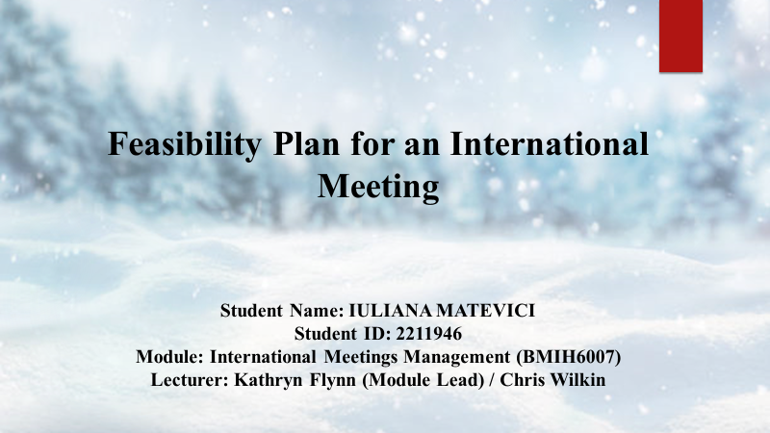

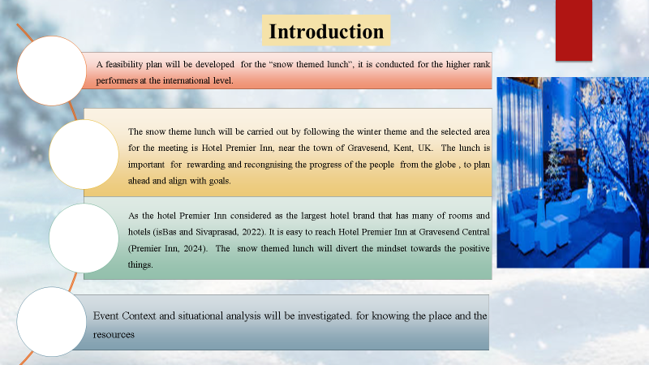

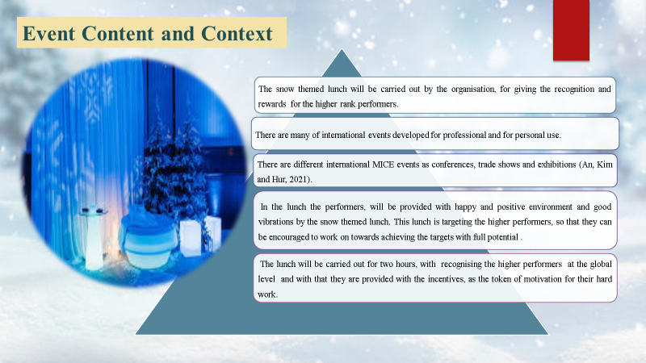

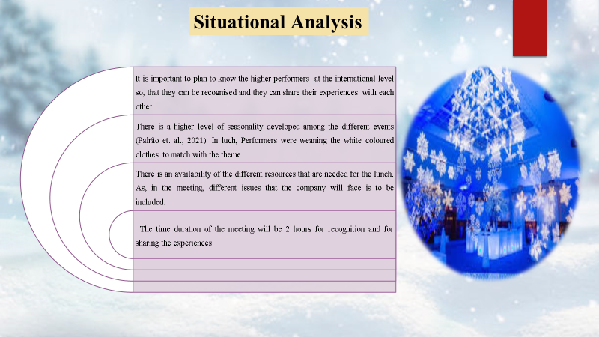
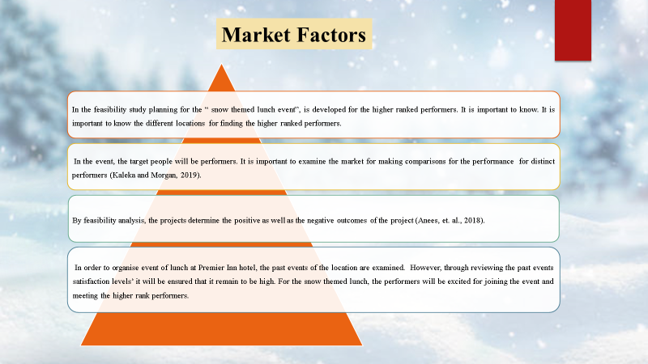

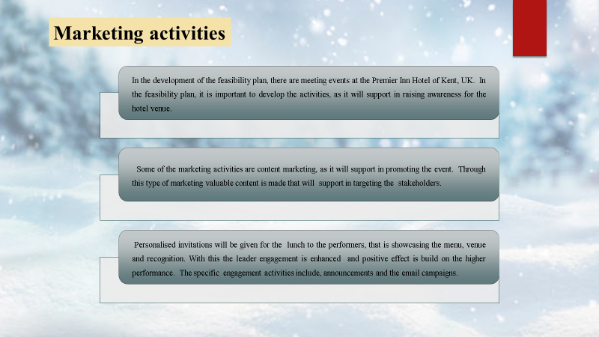

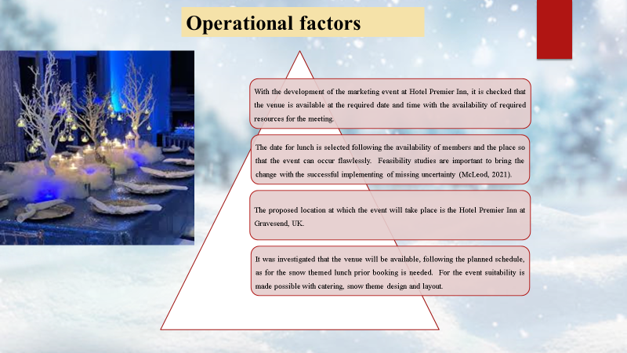

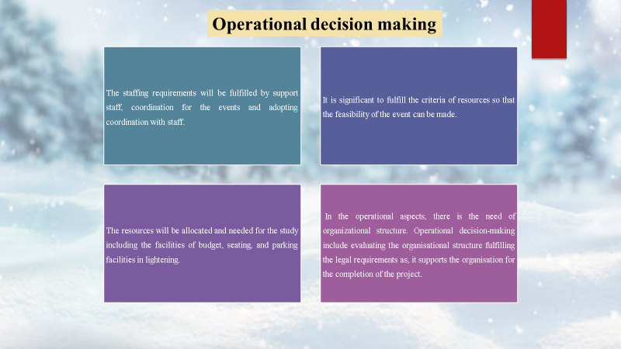

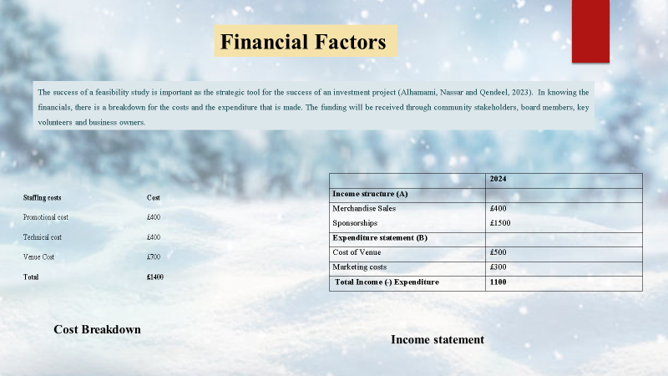

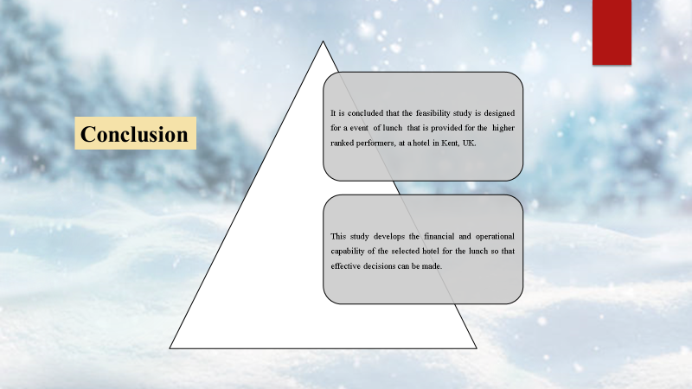

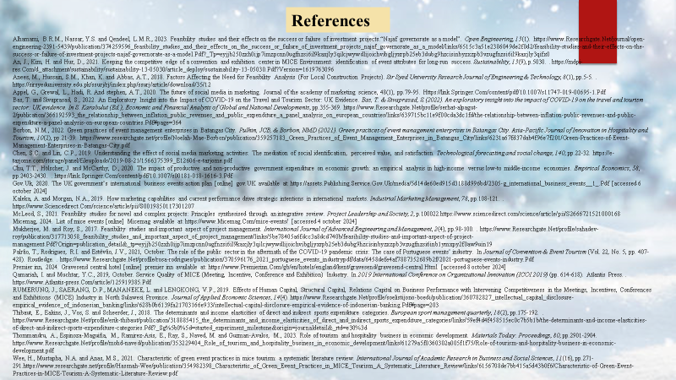

References
- Alhamami, B.R.M., Nassar, Y.S. and Qendeel, L.M.R., 2023. Feasibility studies and their effects on the success or failure of investment projects.“Najaf governorate as a model”. Open Engineering, 13(1). https://www.Researchgate.Net/journal/open-engineering-2391-5439/publication/374259596_feasibility_studies_and_their_effects_on_the_success_or_failure_of_investment_projects_najaf_governorate_as_a_model/links/6515c3a51e2386049de2f0d2/feasibility-studies-and-their-effects-on-the-success-or-failure-of-investment-projects-najaf-governorate-as-a-model.Pdf?_Tp=eyjjb250zxh0ijp7imzpcnn0ugfnzsi6il9kaxjly3qilcjwywdlijoichvibgljyxrpb25eb3dubg9hzcisinbyzxzpb3vzugfnzsi6il9kaxjly3qifx
- An, J., Kim, H. and Hur, D., 2021. Keeping the competitive edge of a convention and exhibition center in MICE Environment: identification of event attributes for long-run success. Sustainability, 13(9), p.5030. . https://mdpi-res.Com/d_attachment/sustainability/sustainability-13-05030/article_deploy/sustainability-13-05030.Pdf?Version=1619763096
- Aneesa, M., Hussain, S.M., Khan, K. and Abbas, A.T., 2018. Factors Affecting the Need for Feasibility Analysis (For Local Construction Projects). Sir Syed University Research Journal of Engineering & Technology, 8(1), pp.5-5. . https://sirsyeduniversity.edu.pk/ssurj/rj/index.php/ssurj/article/download/35/12
- Appel, G., Grewal, L., Hadi, R. And stephen, A.T., 2020. The future of social media in marketing. Journal of the academy of marketing science, 48(1), pp.79-95. Https://link.Springer.Com/content/pdf/10.1007/s11747-019-00695-1.Pdf
- Bas, T. and Sivaprasad, S., 2022. An Exploratory Insight into the Impact of COVID-19 on the Travel and Tourism Sector: UK Evidence. Bas, T. & Sivaprasad, S.(2022). An exploratory insight into the impact of COVID-19 on the travel and tourism sector: UK evidence. In S. Karabulut (Ed.), Economic and Financial Analysis of Global and National Developments, pp.355-369. https://www.Researchgate.Net/profile/serhat-alpagut-2/publication/366192593_the_relationship_between_inflation_public_revenues_and_public_expenditure_a_panel_analysis_on_european_countries/links/639715bc11e9f00cda3dc1fd/the-relationship-between-inflation-public-revenues-and-public-expenditure-a-panel-analysis-on-european-countries.Pdf#page=364
- Borbon, N.M., 2022. Green practices of event management enterprises in Batangas City. Pulhin, JCB, & Borbon, NMD (2021). Green practices of event management enterprises in Batangas City. Asia-Pacific Journal of Innovation in Hospitality and Tourism, 10(2), pp.21-39. https://www.researchgate.net/profile/Noelah-Mae-Borbon/publication/359257183_Green_Practices_of_Event_Management_Enterprises_in_Batangas_City/links/6231a67fd37dab4f96e7f201/Green-Practices-of-Event-Management-Enterprises-in-Batangas-City.pd

- Chen, S.C. and Lin, C.P., 2019. Understanding the effect of social media marketing activities: The mediation of social identification, perceived value, and satisfaction. Technological forecasting and social change, 140, pp.22-32. https://e-tarjome.com/storage/panel/fileuploads/2019-08-21/1566375399_E12606-e-tarjome.pdf
- Chu, T.T., Hölscher, J. and McCarthy, D., 2020. The impact of productive and non-productive government expenditure on economic growth: an empirical analysis in high-income versus low-to middle-income economies. Empirical Economics, 58, pp.2403-2430. . https://link.Springer.Com/content/pdf/10.1007/s00181-018-1616-3.Pdf
- Gov.Uk, 2020. The UK government’s international business events action plan [online] gov.UK available at: https://assets.Publishing.Service.Gov.Uk/media/5d14de60ed915d3188d996bd/2305-g_international_business_events__1_.Pdf [accessed 6 october 2024]
- Kaleka, A. and Morgan, N.A., 2019. How marketing capabilities and current performance drive strategic intentions in international markets. Industrial Marketing Management, 78, pp.108-121. . https://www.Sciencedirect.Com/science/article/pii/S0019850117301207
- McLeod, S., 2021. Feasibility studies for novel and complex projects: Principles synthesised through an integrative review. Project Leadership and Society, 2, p.100022.https://www.sciencedirect.com/science/article/pii/S2666721521000168
- Micemag, 2024. List of mice events [online] Micemag available at: https://www.Micemag.Com/mice-events/ [accessed 4 october 2024]
- Mukherjee, M. and Roy, S., 2017. Feasibility studies and important aspect of project management. International Journal of Advanced Engineering and Management, 2(4), pp.98-100. . https://www.Researchgate.Net/profile/sahadev-roy/publication/317713058_feasibility_studies_and_important_aspect_of_project_management/links/5be78405a6fdcc3a8dcd740b/feasibility-studies-and-important-aspect-of-project-management.Pdf?Origin=publication_detail&_tp=eyjjb250zxh0ijp7imzpcnn0ugfnzsi6il9kaxjly3qilcjwywdlijoichvibgljyxrpb25eb3dubg9hzcisinbyzxzpb3vzugfnzsi6inb1ymxpy2f0aw9uin19
- Palrão, T., Rodrigues, R.I. and Estêvão, J.V., 2021, October. The role of the public sector in the aftermath of the COVID-19 pandemic crisis: The case of Portuguese events’ industry. In Journal of Convention & Event Tourism (Vol. 22, No. 5, pp. 407-428). Routledge. . https://www.Researchgate.Net/profile/rosa-rodrigues/publication/370596176_2021_portuguese_events_industrypdf/data/6458defe4af7887352689b2f/2021-portuguese-events-industry.Pdf
- Premier inn, 2024. Gravesend central hotel [online] premier inn available at: https://www.Premierinn.Com/gb/en/hotels/england/kent/gravesend/gravesend-central.Html [accessed 8 october 2024]

- Qamariah, I. and Muchtar, Y.C., 2019, October. Service Quality of MICE (Meeting, Incentive, Conference and Exhibition) Industry. In 2019 International Conference on Organizational Innovation (ICOI 2019) (pp. 614-618). Atlantis Press. . https://www.Atlantis-press.Com/article/125919385.Pdf
- RUMERUNG, J., SAERANG, D.P., MANANEKE, L. and LENGKONG, V.P., 2019. Effects of Human Capital, Structural Capital, Relations Capital on Business Performance with Intervening Competitiveness in the Meetings, Incentives, Conferences and Exhibitions (MICE) Industry in North Sulawesi Province. Journal of Applied Economic Sciences, 14(4). https://www.Researchgate.Net/profile/soelistijono-boedi/publication/360782827_intellectual_capital_disclosure-empirical_evidence_of_indonesian_banking/links/628b0b6139fa21703166e933/intellectual-capital-disclosure-empirical-evidence-of-indonesian-banking.Pdf#page=203
- Thibaut, E., Eakins, J., Vos, S. and Scheerder, J., 2018. The determinants and income elasticities of direct and indirect sports expenditure categories. European sport management quarterly, 18(2), pp.175-192. . https://www.Researchgate.Net/profile/erik-thibaut/publication/318885415_the_determinants_and_income_elasticities_of_direct_and_indirect_sports_expenditure_categories/links/59ef4d4f458515ec0c7b5b1b/the-determinants-and-income-elasticities-of-direct-and-indirect-sports-expenditure-categories.Pdf?_Sg%5b0%5d=started_experiment_milestone&origin=journaldetail&_rtd=e30%3d
- Thommandru, A., Espinoza-Maguiña, M., Ramirez-Asis, E., Ray, S., Naved, M. and Guzman-Avalos, M., 2023. Role of tourism and hospitality business in economic development. Materials Today: Proceedings, 80, pp.2901-2904. https://www.Researchgate.Net/profile/mohd-naved/publication/353229404_Role_of_tourism_and_hospitality_business_in_economic_development/links/61279a5f0360302a005f1f75/Role-of-tourism-and-hospitality-business-in-economic-development.pdf
- Wee, H., Mustapha, N.A. and Anas, M.S., 2021. Characteristic of green event practices in mice tourism: a systematic literature review. International Journal of Academic Research in Business and Social Sciences, 11(16), pp.271-291.https://www.researchgate.net/profile/Hassnah-Wee/publication/354982398_Characteristic_of_Green_Event_Practices_in_MICE_Tourism_A_Systematic_Literature_Review/links/6156708de7bb415a5d43b0f6/Characteristic-of-Green-Event-Practices-in-MICE-Tourism-A-Systematic-Literature-Review.pdf

