

Module Title: | Dissertation
Module Code: | LCMB7020
Course: | MASTER OF BUSINESS ADMINISTRATION
Dissertation Topic: | Market Entry ‎Strategies for ‎Greggs in the Indian ‎Market: A ‎Critical ‎Analysis
Lecturer:  Submitted by: Simranjeet Kour student ID 2215780 | Gladius David Kulothungan

Master’s Degrees by Examination and Dissertation
Declaration Form.
1. This work has not previously been accepted in substance for any degree and is not being concurrently submitted in candidature for any degree.
Signed: Simranjeet Kour
Date: 18/10/2023

2. This dissertation is being submitted in partial fulfilment of the requirements for the degree of Master in Business Administration.
Signed: Simranjeet kour
Date: 18/10/2023
3. This dissertation is the result of my independent work/investigation, except where otherwise stated.
Other sources are acknowledged by footnotes giving explicit references.
A bibliography is appended.
Signed candidate: Simranjeet kour
Date: 18/10/2023

4. I hereby give consent for my dissertation, if accepted, to be available for photocopying, inter- library loan, and for deposit in the University’s digital repository
Signed (candidate): Simranjeet kour
Date: 18/10/2023

Supervisor’s Declaration.
I am satisfied that this work is the result of the student’s efforts.
Signed: Gladius David Kulothungan
Date: 15/10/2023

Abstract:
This study digs into market entrance tactics, customer behaviour, and competition analysis, with a special focus on Greggs, a well-known bakery brand, and its prospects in the dynamic Indian food and beverage sector. The report includes four detailed chapters that examine consumer preferences, establish correlations, evaluate foreign market entrance tactics, and analyze the competitive environment. The study findings are extensive and diverse. Notably, Indian consumers have a strong preference for health-conscious alternatives and on-the-go eating, allowing Greggs to adjust their offers accordingly. In addition, the analysis uncovers connections, such as the link between health consciousness and a preference for freshly baked goods, providing insights into future client segmentation methods.
As proven by its successful strategy in many locations, Greggs may employ a combination of company-owned stores and franchising for worldwide market penetration. These tactics have helped the organization to successfully traverse the complex terrain of numerous markets. The competitive landscape research reveals significant competitors in the Indian baking market such as Britannia Industries, Parle Products, and ITC Limited. Greggs may strategically position itself, stressing quality, innovation, and localization, while cooperating with local distributors and adopting digital platforms for successful market penetration, by studying their market share, growth patterns, and plans.
The study's findings have practical consequences for Greggs' market entrance approach. These consequences go beyond academic comprehension, giving meaningful insights into the complexities of the Indian market, and enhancing the chance of success in this new business. This study adds to the corpus of knowledge in the sector by providing Greggs with evidence-based suggestions. These recommendations are in line with the company's objectives as well as the difficulties of the Indian market. Greggs can effectively target a varied consumer base and traverse the competitive baking environment in India by focusing on health-conscious goods, well-adapted entry tactics, smart branding, and distribution excellence. Finally, data-driven decision-making is critical to Greggs' prospective success in India. With the findings of this study, the firm is ready to launch a well-informed market entrance plan, adjusting to changing customer tastes and capitalizing on development prospects in the expanding Indian food and beverage sector.

Table of Contents
1.1 Introduction: 9
1.2 Research Rationale: 11
1.3. Statement of Problem: 12
1.4. Objectives of the Study: 13
1.5. Research Questions: 13
1.6. Scope and Limitations: 14
1.7. Importance of the Study: 15
Chapter 2: Literature Review 17
2.1. Introduction: 17
2.2. Market Entrance Methods in International Markets: 17
2.2.1. Exporting: 17
2.2.2. Licensing: 18
2.2.3. Joint Ventures: 18
2.2.4. Wholly-Owned Subsidiaries: 18
2.3. Analysing the Indian Food and Beverage Sector 19
2.3.1 Overview of the Indian Food and Beverage Industry: 19
2.3.2 Growth and Market Potential in India: 19
2.3.3 Competitive Landscape in the Indian Baking Market: 20
2.3.4 Key Players in the Indian Baking Market: 21
2.3.5 Consumer Trends and Preferences in India: 21
2.3.6. Greggs' Market Entrance Methods in India: 22
2.4. Greggs' Market Entrance Methods in Indian Markets 23
2.4.1 Current Market Entry Strategies of Greggs in International Markets: 23
2.4.2 Examination of Greggs' Potential Market Entry Methods for India: 24
2.4.3 Suitability of Each Market Entry Method for the Indian Market: 24
2.5. Competitors Analysis in the Indian Baking Market 25
2.5.1 Identification of Greggs' Main Rivals in the Indian Baking Market: 25
2.5.2 Analysis of Competitors' Strategies and Market Positioning: 25
2.5.3 Assessment of Competitors' Strengths and Weaknesses: 26
2.6. Advantages and Disadvantages of Entering the Indian Market 26
2.6.1 Potential Advantages for Greggs in Entering the Indian Market: 26
2.6.2 Potential Disadvantages and Challenges for Greggs in the Indian Market: 27
2.7. Market Entry Strategies for Greggs in the Indian Market 27
2.7.1 Recommended Market Entry Strategies Based on Research Findings: 27
2.7.2 Risk Mitigation Strategies for Successful Market Entry: 28
2.7.3 Strategic Implementation and Resource Allocation: 28
2.8. Literature Gap 29
2.8.1 Existing Studies on Market Entry Strategies: 29
2.8.2 Identified Gaps in the Literature: 29
2.9. Conceptual Framework 30
2.9.1. Market Entry Strategies for International Companies in India 30
2.9.2. Cultural Differences and Market Entry 31
2.9.3. Consumer Preferences and Local Adaptation 32
2.9.4. Regulatory Environment and Market Entry 33
2.9.5. Competitive Landscape and Market Entry 34
2.9.6. Application of the Conceptual Framework to Greggs 35
2.10. Limitations and Future Research Directions 36
2.10.1 Limitations of the Study: 36
2.10.2 Suggestions for Future Research in Market Entry Strategies: 37
Chapter 3: Methodology 38
3.1. Introduction: 38
3.2. Research Design: 38
3.2.1. RESEARCH APPROACH: 38
a) Exploratory Research: 38
b) Data Collection: 38
c) Types of Data: 38
3.3. Data Collection: 39
3.4. Data Analysis: 49
3.4.1. EXPLORATORY DATA ANALYSIS: 49
3.4.2. DEMOGRAPHIC INSIGHTS: 50
3.5. Market Entry Methods 52
3.5.1. Buy Up the Company 52
3.5.1.1. Advantages: 52
3.5.1.2. Challenges: 52
3.6. Research Objectives and Questions: 53
3.7. Limitations: 54
3.8. Ethical Considerations: 54
Chapter 4: Analysis and Results 56
Introduction: 56
4.2 Descriptive Analysis of Consumer Preferences: 56
4.3 Correlation Analysis of Consumer Behavior and Demographics: 58
4.4 Evaluation of Greggs' International Market Entry Methods: 58
4.5 Competitive Landscape Analysis of the Indian Baking Market: 59
4.6 Formulation of Suitable Market Entry Strategies for Greggs in India: 60
4.7 Discussion of Insights and Implications: 61
4.8 Implications for Greggs' Market Expansion: 61
4.9 Limitations and Future Research Directions: 62
4.10 Conclusion of Analysis and Results: 62
Chapter 5: Conclusion 63
5.I. Summary of Research Findings: 63
5.2 Achievement of Research Objectives: 64
5.3 Practical Implications for Greggs: 65
5.4 Strategic Recommendations for Greggs: 66
5.5 Limitations and Future Research: 67
5.6 Conclusion and Closing Remarks: 68
Appendices: 79
Appendix 1: 79
Appendix 2: 94

Chapter 1: Introduction

Introduction:

The significance of analyzing Greggs’s market entrance methods is emphasized. As an established food and beverage company, Greggs has expanded its operations into various international markets (Gourley, 2019). By understanding the strategies Greggs employs in these markets, valuable lessons and insights can be gained, which can be applied to its entry into the Indian market. Examining the successes and challenges Greggs faces in other international markets will help in formulating strategies that are tailored to the unique characteristics of the Indian market. The competitive environment of the Indian food and beverage sector is highlighted as a crucial aspect to consider. The Indian market is characterized by diverse domestic and international players competing for market share. It is essential to analyze the competitive landscape to identify the main rivals and understand India's market dynamics, consumer preferences, and industry trends (Ratajczak et al., 2023). This analysis will provide valuable insights into the opportunities and challenges that Greggs may encounter in the Indian market.
Furthermore, the chapter presents the research objectives and questions guiding the analysis. The research objectives outline the specific goals of the study, which include assessing Greggs' market entry methods in international markets and developing suitable market entry strategies for the Indian market. These objectives provide a clear direction for the research and serve as benchmarks for evaluating the research findings. The research questions complement the goals by addressing specific areas of inquiry. They include investigating Gregg’s primary market entry methods in the Indian market, identifying the main competitors in the Indian baking market, and examining the potential advantages and disadvantages of Gregg entering the Indian market. These research questions provide a framework for the subsequent chapters and guide the data collection, analysis, and discussion processes. In summary, this chapter serves as the introduction to the dissertation, providing an overview of the research topic and its objectives. It highlights the importance of analyzing Greggs’s market entry strategies and understanding the competitive environment of the Indian food and beverage sector. The research questions and objectives set the stage for the subsequent chapters and guide the analysis of Greggs’s market entry strategies in the Indian market.

1.2 Background:
Starting with Greggs is a well-established food and beverage company based in the United Kingdom. The company has gained a strong reputation for its bakery products and diverse food offerings. With a history dating back several decades, Greggs has successfully expanded its operations beyond the UK and entered various international markets. These international expansion efforts showcase Greggs' ambition and strategic approach to capturing new customer segments and increasing its global presence. Therefore, examining Greggs' past experiences entering foreign markets can offer valuable insights into its strategies and potential pitfalls to avoid in the Indian market. Shifting the focus to the Indian food and beverage sector, it is characterized by its vast size and significant growth potential (Elgorban, A.M. et al., 2017). The Indian market is home to a large population with diverse tastes and preferences, making it an attractive destination for international companies. India's food and beverage sector has experienced considerable growth due to rising disposable incomes, urbanization, and changing consumer lifestyles. This growth has created a favourable environment for both domestic and international players in the market.
Within the Indian food and beverage sector, the bakery segment holds particular significance. Bakeries in India offer a wide range of products, including bread, pastries, cakes, and other baked goods. Understanding the key players, their market positions, and their strategies can provide insights into the competitive landscape and potential challenges Greggs may face upon entering the Indian market. Moreover, the background information should explore the market trends and consumer preferences within the Indian food and beverage sector. This includes analyzing factors such as the demand for healthier food options, convenience, affordability, and the influence of cultural and regional preferences on consumer choices (Lehmann et al., 2023). Recognizing these trends and preferences is crucial for Greggs to tailor its market entry strategies and product offerings to align with the Indian consumer's expectations. By providing a comprehensive background on Greggs’s international expansion efforts and the Indian food and beverage sector, this section establishes the foundation for analyzing the market entry strategies for Greggs in the Indian market. It highlights the motivations, opportunities, and challenges associated with entering the Indian market and sets the stage for subsequent research and analysis.

Research Rationale:

The research rationale of this study explains the reasons behind conducting the research. It aims to justify the importance and relevance of analyzing Greggs' market entry strategies in the Indian market. Several vital points contribute to the research rationale:
Gaps in the existing literature:
The research rationale recognizes the gaps in the existing literature concerning Greggs’s market entry strategies. While Greggs is a well-known company with successful international expansions, there may be a lack of specific analysis regarding its entry into the Indian market. By addressing this gap, the study seeks to contribute new insights and fill the void in the literature.
Unique characteristics of the Indian market:
The rationale emphasizes the significance of analyzing Greggs' market entry strategies in the context of the Indian market. India is a vast and diverse market with unique cultural, social, and economic dynamics. Therefore, it is essential to examine how Greggs can navigate these specific factors and tailor its strategies to suit Indian consumer preferences and market conditions.
Potential benefits of entering the Indian market:
The rationale highlights the potential benefits Greggs can gain from entering the Indian market. India has a rapidly growing middle class, increasing urbanization, and changing consumer lifestyles. These factors allow companies like Greggs to tap into a large consumer base and expand their market presence. By identifying suitable market entry strategies, Greggs can leverage these opportunities and achieve long-term growth and profitability.
Need for identifying suitable market entry strategies:
Another critical aspect of the research rationale is recognizing the need to identify suitable market entry strategies for Greggs in the Indian market. Market entry is vital to any company's international expansion, and selecting the right system can significantly impact its success. By thoroughly analyzing Greggs' market entry methods and the competitive environment in India, the study aims to provide actionable recommendations for Greggs to enter the Indian market effectively.
In summary, the research rationale emphasizes the gaps in the existing literature regarding Gregg’s market entry strategies in the Indian market. It recognizes the unique characteristics of the Indian market, highlights its potential benefits, and underscores the need to identify suitable market entry strategies. By addressing these points, the study aims to contribute valuable insights to the field and assist Greggs in formulating successful strategies for entering the Indian market.

1.3. Statement of Problem:
The statement of the problem in this study serves as a clear and specific definition of the challenges and considerations that Greggs faces in entering the Indian market. It provides a focused direction for the research by highlighting the key issues and areas of concern that must be addressed. The following points expand on the potential challenges and considerations related to Greggs' entry into the Indian market:
Cultural differences:
One of the significant challenges for Greggs in entering the Indian market is navigating cultural differences. India has a diverse culture with distinct regional preferences, culinary traditions, and eating habits. Greggs will need to understand and adapt to the cultural nuances to ensure that its product offerings align with the likes of Indian consumers. This may involve modifying recipes, introducing new flavours, and incorporating local ingredients to cater to the Indian taste palate.
Competition:
The Indian food and drink area is profoundly cutthroat, with homegrown and global players ‎vying for portion of the overall industry. Greggs will face competition from well-established Indian bakery brands and global players who have already gained a foothold. Understanding the competitive landscape, identifying the main rivals, and developing strategies to differentiate from competitors will be crucial for Greggs’s success in the Indian market.
Regulatory environment:
Another consideration for Greggs is the regulatory environment in India. The food and beverage industry is subject to various regulations and standards imposed by government agencies. Greggs must comply with food safety regulations, labelling requirements, and other legal obligations to ensure product quality and consumer safety. Familiarizing themselves with the regulatory landscape and establishing robust processes for compliance will be essential for Greggs' entry into the Indian market.
Consumer preferences:
Understanding the preferences and expectations of Indian consumers is vital for Greggs to tailor its products and marketing strategies. Indian consumers have diverse tastes, dietary habits, and purchasing behaviours. Greggs must conduct market research to understand consumer preferences, such as vegetarian or vegan options, traditional Indian flavours, and affordability. Adapting its product offerings and marketing messages to meet these preferences will be critical for capturing the Indian consumer market.
By defining these challenges and considerations, the statement of the problem provides a specific and clear direction for the research. It frames the regions the review will zero in on to examine and foster appropriate market section methodologies ‎for Greggs in the Indian market. Through tending to these difficulties, the exploration plans to give ‎valuable bits of knowledge and proposals to help Greggs in conquering the obstructions and accomplishing ‎successful market section in India.‎

1.4. Objectives of the Study:
The research objectives outline the goals the study aims to achieve. These objectives include assessing Greggs' market entrance methods in international markets, analyzing the competitive environment of the Indian food and beverage sector, and providing acceptable market entry strategies for Greggs in the Indian market. Each objective should be clear, measurable, and directly related to the research questions.

1.5. Research Questions:
The examination questions guide the examination and help in tending to the exploration targets. The ‎questions recorded in this segment may include:‎
- What are Greggs's primary market entrance methods in Indian markets?
- Who are Greggs's main rivals in the Indian baking market?
- What are Greggs's probable advantages and disadvantages in entering the Indian market?

1.6. Scope and Limitations:
The scope and limitations section of the study defines the boundaries within which the research will be conducted and outlines the specific focus of the study. It provides clarity on the geographical and sectoral scope, as well as highlights the limitations that may impact the research. The following points expand on the size and regulations of the study:
Scope:
Geographical scope: The research focuses on Greggs' market entry strategies in the Indian market. The study delves into the opportunities and challenges associated with entering the Indian food and beverage sector and formulating effective strategies tailored to the Indian market.
Sectoral scope: The study primarily analyzes Greggs' market entry strategies within the Indian food and beverage sector, explicitly emphasizing the bakery segment. It explores the competitive landscape, consumer preferences, and market dynamics related to the bakery industry in India.
Limitations:
Data availability: One of the limitations that may be encountered is the availability of relevant and up-to-date data. Access to accurate and comprehensive data specific to Greggs' market entry strategies in the Indian market, as well as industry data on the Indian food and beverage sector, could pose challenges. Efforts will be made to gather reliable data from credible sources, but data availability may be limited to the depth of analysis.
Generalizability: The findings and recommendations of the study may have limitations in terms of generalizability. The research focuses specifically on Greggs’s market entry strategies in the Indian market and may not be directly applicable to other companies or markets. Therefore, it is essential to interpret the findings within the context of Greggs and the Indian food and beverage sector.
Time and asset requirements: The review might require additional time and assets for information assortment, ‎analysis, and understanding. Directing complete exploration inside a restricted time period and ‎with restricted assets might limit the degree of information get-together and examination. Endeavours will be made ‎to upgrade the accessible assets and guarantee a hearty examination inside the given constraints.‎
Ethical considerations: Ethical considerations play a crucial role in research. The study will adhere to ethical guidelines and ensure the proper data handling, privacy protection, and ethical treatment of human subjects, if applicable. However, ethical considerations may introduce constraints that impact the research process or limit the type of data that can be accessed.
By defining the scope and limitations of the study, this section provides transparency and clarity on the boundaries within which the research is conducted. It acknowledges the potential limitations and challenges that may affect the research findings, interpretation, and generalizability. By understanding and considering these limitations, the research aims to provide valuable insights within the defined scope and contribute to understanding Greggs' market entry strategies in the Indian food and beverage sector.

1.7. Importance of the Study:
The importance of the study lies in its potential contributions to academia, industry, and the field of international business. This section highlights the significance of understanding the Indian market and its potential benefits and challenges for Greggs' expansion. The following points expand on the importance of the study:
- Academic contributions: The study holds academic importance as it fills a gap in the existing literature by analyzing Greggs' market entry strategies in the Indian market. By examining Greggs' experiences and processes, the study contributes to understanding international business expansion, market entry modes, and the challenges companies face in emerging markets. The study’s findings can add to the knowledge base and serve as a reference for future research in the field.
- Industry relevance: The study has practical implications for the industry, particularly for Greggs and other companies considering market entry into India. By analyzing Greggs' market entry strategies, the research can provide insights and recommendations to help companies formulate effective plans when entering the Indian market. The study's findings can guide decision-making processes, minimizing risks and increasing the likelihood of successful market entry.
- International business insights: Understanding the Indian market is crucial for companies operating in the international business arena. India offers immense growth potential but presents unique challenges due to its diverse culture, consumer preferences, and competitive landscape. By studying Greggs' market entry strategies in India, the research contributes to the field of international business by shedding light on the opportunities, challenges, and best practices for companies expanding into emerging markets.
- Potential benefits for Greggs: The study holds specific importance for Greggs as it provides a comprehensive analysis of market entry strategies in the Indian market. By identifying the advantages and disadvantages of entering the Indian market, the research can help Greggs make informed decisions and develop tailored strategies. The findings and recommendations of the study can assist Greggs in formulating effective market entry strategies, capitalizing on the market's potential, and achieving long-term growth and profitability.

Chapter 2: Literature Review

2.1. Introduction:
In today's global economy, expanding into international markets is crucial for sustained growth and profitability. This study focuses on Greggs, a UK-based bakery chain, considering entry into India's burgeoning food and beverage sector. This literature review aims to explore academic studies, theories, and findings related to market entry and competition in the food and beverage industry, offering insights for Greggs. The structure of the review follows defined objectives. Firstly, it examines various market entry methods, assessing their suitability for Greggs in the Indian market. Secondly, it analyzes the competitive landscape in India's food and beverage sector, highlighting key players, trends, and industry forces. Lastly, it explores potential advantages and disadvantages for Greggs in India, emphasizing factors influencing its success. This research aims to enhance our understanding of market entry strategies in the food and beverage sector, providing actionable recommendations aligned with Greggs' goals. The goal is to equip Greggs with the insights needed to make informed, strategic decisions for successful entry and sustainable growth in India.

2.2. Market Entrance Methods in International Markets:
Selecting the right market entry method is a critical decision for businesses venturing into international markets. Organizations like Greggs, taking into account passage into the Indian market, can look over different section ‎modes, including sending out, authorizing, joint endeavors, and completely claimed auxiliaries. ‎ The choice of entry mode is influenced by factors such as market familiarity, resource availability, and the level of control desired. Strategic alliances and joint ventures are significant in the food and beverage industry as they allow for risk-sharing, knowledge exchange, and resource pooling when entering new markets.

2.2.1. Exporting:
Exporting is a common and low-risk market entry method where companies sell their products or services from their home country to foreign markets. For Greggs, this approach enables them to gain market knowledge, test consumer receptiveness, and manage financial risks effectively. Exporting provides a cost-effective way to allocate resources strategically and adapt products and marketing strategies based on real-time responses from foreign consumers. It allows gradual expansion into different markets, enhancing brand exposure and diversifying revenue streams, reducing reliance on the domestic market.

2.2.2. Licensing:
Licensing allows a company to grant permission to a foreign entity to produce and sell its products or use its intellectual property in exchange for royalties or licensing fees. Greggs can leverage licensing to enter foreign markets with lower financial risk and operational involvement. By partnering with a local licensee, Greggs can gain insights into the foreign market, delegate operational responsibilities, and spread the risks associated with entering a new market. Licensing offers a quicker market entry, and as consumers associate licensed products with the renowned Greggs brand, it strengthens brand recognition and reputation in foreign markets.

2.2.3. Joint Ventures:
Joint endeavors include shaping another element with shared proprietorship and control in coordinated effort ‎with nearby firms. ‎ In the food and beverage industry, local knowledge and distribution networks are crucial. Joint ventures allow Greggs to access these strengths and gain insights into local preferences and regulatory environments. They also facilitate efficient distribution, risk-sharing, and cultural sensitivity in the target market.

2.2.4. Wholly-Owned Subsidiaries:
Wholly-owned subsidiaries provide a high level of control and autonomy. Greggs can maintain full ownership and control over its operations, making it an attractive option for companies with extensive resources and a commitment to long-term growth. This approach offers complete control over business operations, safeguards intellectual property, and allows for reinvestment of all profits generated in the foreign market (Balasubramanian and Ponnachiyur Maruthasalam, 2021). Wholly-owned subsidiaries offer flexibility in responding to market changes and implementing strategic decisions without external partner consensus, enhancing competitive positioning over time.

2.3. Analysing the Indian Food and Beverage Sector

2.3.1 Overview of the Indian Food and Beverage Industry:
The Indian food and beverage industry is vital to the country's economy and significantly contributes to employment and GDP. Here are some additional points to further understand the overview of the Indian food and beverage industry:
- Regional and Cultural Diversity: India is known for its rich cultural diversity, reflected in its food and beverage offerings. Each region has a unique cuisine and traditional dishes influenced by local ingredients, spices, and cooking techniques (Mashiane et al., 2021). This diversity has led to a vast array of food products available across the country, catering to the diverse tastes and preferences of the Indian population.
- Growing Middle Class and Urbanization: The expanding middle-class population in India has been a critical driver of the food and beverage industry's growth. As people's incomes rise, there is an increased willingness to spend on convenience and processed food products, leading to a surge in demand for packaged and ready-to-eat items (Maldonado‐Pereira et al., 2022). Additionally, the rapid urbanization in India has resulted in a shift in dietary habits, with more people opting for quick and on-the-go meals due to hectic lifestyles.
- Technological Advancements and Supply Chain Improvements: The industry has benefited from technological advancements in food processing and preservation techniques, improving product shelf life and quality (Ahmed et al., 2017). Additionally, there have been significant improvements in the food supply chain, from production to distribution, leading to better accessibility of food and beverage products across the country.
- Government Initiatives and Foreign Investment: The Indian government has actively promoted the food processing sector by offering incentives, tax benefits, and subsidies to encourage investment and growth (Frank, 2021). This has attracted both domestic and foreign players to invest in the industry, leading to increased production capacities and the introduction of new products in the market.

2.3.2 Growth and Market Potential in India:
India’s food and beverage industry has been experiencing robust growth in recent years. With a large middle-class population and a rising number of working professionals, there is a growing demand for convenient and ready-to-eat food products.
- Rising Disposable Income: India's economic growth and increasing per capita income have contributed to the expansion of the food and beverage industry. As more people have discretionary income, they are willing to spend on convenience foods, dining out, and premium products, leading to an overall increase in consumption.
- Urbanization and Changing Lifestyles: The rapid pace of urbanization in India has led to significant lifestyle changes among its population. Due to time constraints, busy urban dwellers often seek quick and convenient food options, leading to demand for ready-to-eat and on-the-go food products (Łepecka et al., 2022). This trend is expected to continue as urbanization rates rise.
- Convenience and Time-Saving Factors: The demand for convenient food products is rising due to busy work schedules, longer commutes, and an increasing number of dual-income households (Nakamoto et al., 2021). Consumers, particularly in urban areas, are seeking foods that require minimal preparation and can be consumed on the move, driving the growth of packaged and pre-prepared foods.
- Growing Food Delivery and Online Platforms: Food delivery platforms and online ordering have transformed India’s food and beverage industry(Gomez y Paloma, 2020). Consumers now have easy access to various cuisines and food options, leading to increased consumption and the discovery of new products.

2.3.3 Competitive Landscape in the Indian Baking Market:
- Diverse Players: The Indian baking market is characterized by diverse players, ranging from small local bakeries to large-scale industrial and international brands (Bareket-Bojmel and Shuv-Ami, 2019). Local bakeries often cater to specific regions and communities, offering traditional and regional specialities, while international brands bring global expertise and standardized products.
- Artisanal and Premium Offerings: As consumer preferences shift towards healthier and premium products, there has been a growing demand for artisanal and high-quality bakery items. Artisanal bakeries, mainly, have gained popularity as they focus on handcrafted, authentic, and unique offerings that appeal to discerning consumers.
- International Presence: Several global baking companies have entered the Indian market, bringing a wide range of product offerings and established brand recognition (Gorbatov et al., 2021). These international brands often compete with local players by leveraging their global expertise, extensive distribution networks, and marketing capabilities.
- Innovation and Product Diversification: To stay competitive, baking companies in India are continually innovating and diversifying their product portfolios. They are introducing new flavours, ingredient combinations, and healthier alternatives to cater to evolving consumer tastes and preferences.

2.3.4 Key Players in the Indian Baking Market:
- Britannia Industries: Britannia is one of India's leading biscuit and bakery product manufacturers and has a significant presence in the baking market. With a history dating back to 1892, Britannia has a wide range of products, including biscuits, cakes, bread, and dairy-based items (Jones, 2017). The brand's strong distribution network and focus on quality have contributed to its popularity among consumers.
- Parle Products: Parle is another major player in the Indian baking industry and one of the country's oldest and most iconic biscuit brands. Founded in 1929, Parle offers various biscuits and cookies, catering to multiple taste preferences and age groups (Rouse and Ross, 2018). One of its flagship products, Parle-G, is India’s most famous biscuit brand.
- ITC Limited: ITC Limited is a diversified conglomerate with a significant presence in the FMCG (Fast-Moving Consumer Goods) sector, including the baking segment. ITC's bakery division offers various products, including biscuits, cakes, and snacks, under famous brands like Sunfeast.
- Local Bakeries and Patisseries: The Indian baking market is also characterized by numerous local bakeries and patisseries that cater to specific regions or cities. These local players often offer unique and authentic bakery products, including regional specialities and artisanal offerings (Lira et al., 2022). They play an essential role in preserving local culinary traditions and catering to the distinct tastes of their respective communities.

2.3.5 Consumer Trends and Preferences in India:

- Health and Wellness: The health-consciousness trend has gained significant momentum in India. Consumers are increasingly mindful of their dietary choices and seek healthier food options. This has led to a surge in demand for products with reduced sugar, salt, and trans fats (Moreira et al., 2018). Additionally, there is growing interest in functional foods that offer added nutritional benefits, such as fortified beverages and snacks.
- Organic and Natural Products: Indian consumers strongly prefer organic and natural food products. This trend is driven by concerns about chemical residues in conventional produce and a desire for environmentally sustainable and ethically sourced items (Fialho et al., 2022). As a result, there is a growing market for organic fruits and vegetables, dairy products, and grains.
- Plant-Based and Vegan Foods: India's interest in plant-based and vegan diets is rising. Health, environmental, and ethical considerations drive this trend, with many consumers choosing plant-based alternatives for milk, meat, and dairy products (Rodríguez-Martín et al., 2023). The popularity of plant-based protein sources like soy, lentils, and quinoa is also increasing.
- Convenience and On-the-Go Snacks: The fast-paced urban lifestyle has increased demand for convenience foods and on-the-go snacks. Young professionals and students often seek quick and easily accessible food options that require minimal preparation ( Sina et al., 2018). This has given rise to various ready-to-eat meals, packaged snacks, and single-serve products.

2.3.6. Greggs' Market Entrance Methods in India:
Greggs, an established bakery brand from the United Kingdom, would likely consider several market entry methods when expanding into India. Each method has advantages and challenges, and the final decision would depend on various factors specific to the Indian market. Here are some possible strategies that Greggs may adopt:
- Franchising: Franchising is a popular market entry method for international brands in India. Greggs could partner with local entrepreneurs or business owners to open franchised outlets across different cities in India. Franchising allows for a faster and cost-effective expansion as the franchisees bear operational expenses and local market knowledge (Sõukand et al., 2021). This method could help Greggs establish its brand presence and penetrate diverse regions in India.
- Joint Ventures: Entering a joint venture with a local partner or an established Indian food company could give Greggs valuable insights into the Indian market (Thorat et al., 2023). A joint venture would allow the company to leverage the local partner's understanding of consumer preferences, supply chain dynamics, and distribution networks, accelerating market entry and growth.
- Partnerships with Local Distributors: Collaborating with local distributors or retail chains could be an effective way for Greggs to introduce its products to the Indian market quickly. Greggs can reach a wider audience by leveraging existing distribution networks without establishing its distribution infrastructure from scratch.
- Direct Investment and Owned Stores: If Greggs aims to control its operations and brand experience, it may make direct investments and set up its stores in key locations (Gregg, 2020). This approach would require more significant capital investment and effort to establish a robust supply chain, but it provides greater control over brand image, product quality, and customer experience.
Understanding local regulations, cultural norms, and consumer behaviours is crucial for success in any market entry strategy. India's diverse and dynamic food and beverage industry offers opportunities and challenges. Greggs must devise a well-thought-out approach to establish a strong foothold in the country.

2.4. Greggs' Market Entrance Methods in Indian Markets

2.4.1 Current Market Entry Strategies of Greggs in International Markets:

a. Company-Owned Stores: Greggs has established its company-owned stores in several countries, directly operating and managing its outlets. This approach gives the company complete control over the brand experience, product quality, and customer service (Lücking, 2019). Company-owned stores also allow Greggs to maintain consistency across all locations and adapt to local consumer preferences.
b. Franchising: Greggs has expanded its presence in specific international markets through franchising. By partnering with local entrepreneurs or businesses, Greggs allows franchisees to operate outlets under the Greggs brand, following its established standards and recipes (Velkushanova et al., 2021). Franchising enables rapid expansion without significant capital investment from the company, as franchisees bear the costs of setting up and running the stores.

2.4.2 Examination of Greggs' Potential Market Entry Methods for India:
When considering entering the Indian market, Greggs could evaluate the following potential market entry methods:
a. Franchising: Given the complexity and diversity of the Indian market, franchising could be an attractive option for Greggs. Collaborating with local franchisees who deeply understand the local culture, consumer preferences, and regulatory landscape could facilitate smoother market entry and faster expansion across different regions in India.
b. Joint Ventures or Partnerships: Given the complexities of the Indian market, forming joint ventures or partnerships with established Indian food companies or retail chains could provide Greggs with invaluable local expertise and distribution networks (Haben et al., 2023). This approach could help the company navigate cultural nuances and regulatory challenges more effectively.
c. Company-Owned Stores: Setting up company-owned stores strategically could allow Greggs to establish a strong brand presence and maintain complete control over its operations and customer experience (Menon, 2021). While this method would require more significant capital investment and effort, it offers the opportunity to tailor the product offerings to local tastes.
d. Online Presence and Food Delivery: Considering the growing popularity of online food delivery platforms in India, having a robust online presence and partnering with existing food delivery services could provide Greggs with a broader reach and cater to urban consumers who seek convenience and on-the-go options.

2.4.3 Suitability of Each Market Entry Method for the Indian Market:
The suitability of each market entry method for the Indian market depends on various factors, including:
a. Regulatory Environment: India's regulatory environment can be complex and varies across states and regions. Choosing the correct entry method that aligns with local regulations and permits is crucial for a smooth market entry(Roth, 2018).
b. Local Consumer Preferences: Understanding the diverse tastes and preferences of Indian consumers is vital for success. A market entry method that allows for product localization and adaptation would resonate better with Indian consumers.
c. Capital Investment and Risk Tolerance: The level of capital investment and risk tolerance will influence the choice of market entry method (Antonaki, 2022). Franchising and partnerships offer lower capital requirements, while company-owned stores involve more substantial upfront investment.
d. Growth and Expansion Plans: Greggs' long-term growth and expansion plans in India will also play a role in determining the most suitable market entry method. Each method comes with its own pace of expansion and scalability.

2.5. Competitors Analysis in the Indian Baking Market

2.5.1 Identification of Gregg'S Main Rivals in the Indian Baking Market:
In the Indian baking market, Greggs would face competition from domestic and international players. Some of its main rivals could include:
a. Britannia Industries: Britannia is one of the leading and well-established players in the Indian baking industry. Britannia has a strong presence nationwide with a wide range of biscuit and bakery products, including cakes, bread, and dairy-based items.
b. Parle Products: Parle is another major competitor in the Indian bakery segment. It is one of the country's oldest and most recognized biscuit brands, known for its flagship product, Parle-G.
c. ITC Limited (Bakery Division): ITC, a diversified conglomerate, operates in the bakery segment through its Sunfeast brand (Talwar and Garg, 2019). It offers a variety of biscuits, cakes, and snacks to cater to different consumer segments.

2.5.2 Analysis of Competitors' Strategies and Market Positioning:
- Britannia Industries: Britannia focuses on a diverse product portfolio, catering to various segments of consumers. It emphasizes quality and innovation, introducing new flavours and variants to appeal to changing consumer preferences.
- Parle Products: Parle-G has maintained its position as a household name in India. Parle Products relies on its established brand image and widespread distribution network to maintain market share.
- ITC Limited (Bakery Division): ITC's Sunfeast brand has positioned itself as a premium offering, targeting urban consumers and health-conscious individuals (Camargo et al., 2020). The brand has proactively launched healthier variants and premium products to meet evolving consumer demands.

2.5.3 Assessment of Competitors' Strengths and Weaknesses:
- Britannia Industries: Strengths include its extensive distribution network, established brand presence, and diverse product portfolio. However, it may face challenges adapting to rapidly changing consumer preferences and competition from local and international brands.
- Parle Products: Parle-G's strength lies in its brand recognition and affordability. However, it may need to focus on product innovation and catering to health-conscious consumers to stay relevant in a changing market (Quirk, 2019).
- ITC Limited (Bakery Division): ITC's strength lies in its premium positioning and focus on healthier products. However, it may face challenges in penetrating rural markets and competing with well-established brands.

2.6. Advantages and Disadvantages of Entering the Indian Market

2.6.1 Potential Advantages for Greggs in Entering the Indian Market:
a. Large and Growing Consumer Base: India's population is one of the largest in the world, providing a vast consumer base for companies like Greggs (ULIANOVA, 2022). The country's growing middle-class population with increasing disposable income presents a significant opportunity for the company to tap into a potentially lucrative market.
b. Rising Demand for Convenience Foods: The fast-paced urban lifestyle in India has led to a growing demand for convenient and on-the-go food products. The company can capitalize on this trend as Greggs specializes in bakery items that cater to quick snacks and meals.
c. Increasing Health Consciousness: With the rising health awareness among Indian consumers, there is a growing demand for healthier and organic food options. Greggs can introduce its more beneficial product variants to align with this preference.

2.6.2 Potential Disadvantages and Challenges for Greggs in the Indian Market:
a. Diverse and Complex Market: India's diverse culture, languages, and regional preferences can challenge a foreign company like Greggs to understand and cater to the varied tastes of different regions.
b. Intense Competition: The Indian baking market is highly competitive, with well-established domestic players and local bakeries vying for market share (Ashok Singh Malhi and Kovid, 2022). Greggs will face competition from solid local brands with a deep understanding of the Indian market.
c. Regulatory and Legal Hurdles: India's regulatory environment can be complex and subject to frequent changes. Complying with local regulations, obtaining licenses, and navigating bureaucratic processes can be time-consuming and challenging.

2.7. Market Entry Strategies for Greggs in the Indian Market

2.7.1 Recommended Market Entry Strategies Based on Research Findings:
In view of the exploration discoveries and the examination of the Indian food and drink industry, the ‎following market passage procedures are prescribed for Greggs to enter the Indian market ‎successfully:‎
a. Franchising: Considering the complexity and diversity of the Indian market, franchising can be an effective and efficient market entry method for Greggs. Partnering with local entrepreneurs or business owners as franchisees will allow the company to leverage its knowledge of local consumer preferences, regional tastes, and distribution networks (Haben et al., 2023). Franchising will enable rapid expansion without the need for significant capital investment from the company.
b. Product Localization: To cater to Indian consumers' diverse tastes and preferences, Greggs should focus on product localization. The company can adapt its product offerings to suit local tastes, introduce regional flavours, and incorporate healthier and organic options to align with the increasing health-consciousness of Indian consumers.
c. Online Presence and Food Delivery: Establishing a robust online presence and partnering with existing food delivery platforms will give Greggs a wider reach and access to urban consumers seeking convenience and on-the-go food options (Tsai et al., 2023). This will complement the physical store presence and help reach a broader customer base.
d. Strategic Partnerships: Forming strategic partnerships or joint ventures with local distributors, retailers, or established food companies will provide valuable market insights and access to distribution networks. Such alliances will aid in navigating the complex Indian market landscape and complying with local regulations.

2.7.2 Risk Mitigation Strategies for Successful Market Entry:
To mitigate risks associated with entering the Indian market, Greggs should consider the following strategies:
a. Thorough Market Research: Comprehensive market research is crucial to understanding consumer behaviour, preferences, and regional variations. This will help Greggs tailor its product offerings and marketing strategies to resonate with Indian consumers.
b. Pilot Testing: Before full-scale expansion, Greggs can pilot test its products in select cities or regions to gauge consumer response and make necessary adjustments based on feedback.
c. Compliance and Legal Support: Drawing in legitimate specialists to explore the complex administrative scene will guarantee consistence with ‎local regulations and guidelines connected with food handling, naming, and import/send out prerequisites (Ehor Nazymko and Olena Nazymko, 2019).
d. Supply Chain Optimization: Building a robust supply chain and logistics network is vital to ensure consistent product availability and quality across all outlets. Greggs should carefully select reliable suppliers and distribution partners.
e. Brand Building and Marketing: Investing in effective marketing and brand-building efforts will help create awareness and establish a strong brand presence in the Indian market. Localized marketing campaigns will resonate better with Indian consumers (Moore, 2020).

2.7.3 Strategic Implementation and Resource Allocation:
Strategic implementation will involve careful resource allocation and efficient deployment of funds. Greggs should prioritize critical areas such as market research, product development, distribution, and marketing. Allocating resources based on the chosen market entry strategies, such as franchising or product localization, will be essential. The company should also invest in training and support for franchisees to ensure consistent brand standards and product quality across all outlets. Strategic partnerships with local distributors and retailers also require resource allocation for joint marketing efforts and collaborative expansion plans. Adaptability and agility are crucial during implementation (Hsu et al., 2021). Greggs should remain flexible to adjust based on real-time market feedback and changing consumer preferences. Regular assessment of the market entry strategies' performance and alignment with the Indian market dynamics will help the company make informed decisions and achieve successful market penetration.

2.8. Literature Gap

2.8.1 Existing Studies on Market Entry Strategies:
Market entry strategies have been extensively studied in international business and marketing. Many existing studies focus on multinational companies’ strategies when entering new foreign markets, analyzing their choices, successes, and failures. These studies often examine various industries and countries to understand market entry decisions comprehensively. In the food and beverage industry context, several studies have explored market entry strategies for multinational food companies entering emerging markets, including India. These studies often analyze companies’ challenges in adapting to local consumer preferences, regulatory environments, and cultural nuances. Furthermore, specific studies may have focused on the Indian food and beverage industry, examining market dynamics, consumer preferences, and the competitive landscape. Such studies provide insights into foreign companies' opportunities and challenges while entering the Indian market.

2.8.2 Identified Gaps in the Literature:
Despite the existing body of research on market entry strategies, there are still some notable gaps in the literature:
a. Limited Focus on the Bakery Industry: While there are studies on market entry strategies in the food and beverage sector, there is a relatively limited focus on the bakery industry specifically. Bakery products have unique characteristics and consumer preferences, which may necessitate different market entry approaches compared to other food segments.
b. Inadequate Emphasis on Specific Countries: India's market dynamics differ significantly from other emerging markets, and there may be gaps in the literature that specifically address market entry strategies in the Indian food and beverage industry. More research is needed to understand the nuances of the Indian market, including regulatory challenges, distribution networks, and regional variations.
c. Comparative Studies: Few studies may have compared the effectiveness of different market entry strategies in specific contexts. A comparative analysis of various entry modes, such as franchising, joint ventures, and company-owned stores, would be valuable in identifying the most suitable strategy for foreign companies entering the Indian market.
d. Contemporary Updates: The food and beverage industry, including the bakery segment, continuously evolves, influenced by changing consumer preferences, technological advancements, and global events. Some existing studies may need more information, and up-to-date research is required to reflect the current market conditions.
e. Small and Medium Enterprises (SMEs): Many studies in the literature may focus on multinational corporations, potentially overlooking the experiences of SMEs attempting to enter the Indian market. Understanding the challenges faced by smaller businesses can provide valuable insights for SMEs seeking to join India's competitive food and beverage industry.
f. Regional and Cultural Analysis: While some studies examine the Indian market, there may be gaps in regional and cultural analysis. Different states and regions in India have distinct culinary traditions and consumer preferences. Further research focusing on regional variations can help companies tailor their market entry strategies accordingly.
Addressing these gaps in the literature can provide valuable insights for companies like Greggs planning to enter the Indian bakery market. Understanding the challenges and opportunities in the Indian context will aid in making informed decisions and formulating effective market entry strategies.

2.9. Conceptual Framework

2.9.1. Market Entry Strategies for International Companies in India
Joint Ventures: International companies often opt for joint ventures as a strategic entry mode in the Indian market. This approach involves partnering with a local company or business entity to establish a mutually beneficial collaboration. Joint ventures allow international firms like Greggs to leverage the local partner's expertise, established network, and understanding of the Indian market. The review delves into the advantages of risk-sharing, access to local market knowledge, and accelerated market penetration that joint ventures offer (Königshofer et al., 2022). Simultaneously, it discusses the challenges of shared decision-making, cultural differences, and potential conflicts between partners.
Acquisitions: Acquisitions involve international companies, such as Greggs, acquiring an existing Indian bakery or food chain to gain an immediate market presence. This market entry strategy offers rapid access to an established customer base, supply chain, and brand recognition. The review explores the benefits of acquiring a going concern, which provides a shortcut to overcoming initial market barriers and gaining a competitive edge (Volberda et al 2021). However, the review also addresses the potential challenges, such as cultural integration, financial considerations, and regulatory compliance when acquiring an Indian business.
Greenfield investments entail international companies establishing their presence in India from scratch, building new facilities, and establishing operations. This market entry strategy gives companies like Greggs complete control over the business and brand. The review discusses the advantages of customization, control over operations, and long-term sustainability (Parilina et al., 2022). Yet, it also highlights the time-consuming nature of greenfield investments, the need for substantial resources, and the risks associated with market uncertainties.
Strategic Partnerships: Strategic partnerships involve collaboration with Indian companies, government agencies, or organizations to pursue specific business objectives jointly. These partnerships can be formed for various purposes, including market expansion, research and development, or addressing regulatory requirements. The review explores the advantages of leveraging complementary capabilities, shared resources, and risk reduction through strategic partnerships (Shin et al., 2020). However, it also addresses the challenges of aligning interests, managing expectations, and maintaining a mutually beneficial relationship over time.

2.9.2. Cultural Differences and Market Entry
Cultural factors shape international companies' decisions and strategies when entering the Indian market. The review provides comprehensive insights into how cultural nuances impact various aspects of market entry:
Communication: Effective communication is vital for any company's success in a new market. The literature highlights how cultural differences can significantly influence communication patterns between international companies, such as Greggs, and their Indian stakeholders. Variations in language, communication styles, and non-verbal cues can impact the clarity of messages, potentially leading to misunderstandings or misinterpretations (Thomas et al., 2017). The review delves into strategies to bridge communication gaps and foster effective communication with Indian partners, employees, and customers.
Consumer Behaviour: Understanding consumer behaviour is essential for crafting successful marketing strategies. The literature reveals how cultural factors influence Indian consumers' preferences, purchase decisions, and brand perception. It discusses how cultural values, traditions, and social norms influence consumers' product choices, pricing sensitivities, and brand loyalty (Zhang et al., 2022). By delving into these cultural aspects, the review provides valuable insights for Greggs to tailor its products and marketing campaigns to resonate with Indian consumers.
Business Practices: Cultural differences impact business practices and approaches to conducting transactions in India. The literature review examines how cultural norms affect negotiation styles, relationship-building, and decision-making processes in the Indian business context (Christiansen, 2021). Understanding these cultural nuances is crucial for Greggs to navigate business dealings, establish trust with local partners, and build long-term business relationships in India.
Organizational Culture: Cultural differences also extend to the realm of organizational culture. The literature review explores how the cultural diversity between Greggs' corporate culture and the Indian work culture can impact employee engagement, motivation, and productivity. It addresses the challenges of aligning diverse organizational cultures, fostering a harmonious work environment, and promoting cross-cultural collaboration.

2.9.3. Consumer Preferences and Local Adaptation
Understanding and aligning with these preferences is critical for gaining a competitive advantage and establishing a solid presence in the diverse Indian market. The review examines various aspects of consumer preferences and local adaptation:
Pricing Strategies: Pricing strategies are pivotal in influencing consumer decision-making, particularly in a price-sensitive market like India. The literature reveals how international companies have developed pricing strategies that resonate with Indian consumers' budgetary considerations and value perceptions (Sankhyayan and Dasgupta, 2019). This includes offering competitive pricing, economy product lines, and flexible pricing models to appeal to different consumer segments and enhance market penetration.
Product Localization Efforts: Successful market entry requires product localization, where international companies tailor their offerings to align with Indian consumers' tastes and preferences. The review investigates how companies like Greggs have adapted their products to suit local requirements (Jenkins et al., 2018). This may involve modifying ingredients, flavours, and portion sizes or introducing region-specific menu items that reflect Indian culture, cuisine, and dietary habits.
Menu Customization: To cater to the diverse demands of the Indian market, international companies often implement customized menus that resonate with local preferences. The literature explores how companies like Greggs have curated menus to accommodate varying regional tastes while maintaining their core brand identity (Gregg, 2020). Menu customization may include offering vegetarian or vegan options, incorporating popular local ingredients, or introducing special items for specific regions.
Marketing Strategies: Effective marketing strategies must also align with the preferences and values of Indian consumers. The review examines how international companies have tailored their marketing campaigns to connect with Indian cultural values, aspirations, and lifestyle choices (Kinley et al 2023). This may involve using localized advertising, endorsements by famous local figures, and leveraging festivals and cultural events to promote products effectively.
Digital and E-commerce Adaptation: With the rapid rise of digitalization and e-commerce in India, international companies must adapt their online presence and distribution channels. The literature review investigates how companies like Greggs have embraced digital marketing, mobile apps, and e-commerce platforms to reach a wider audience and facilitate convenient ordering and delivery options in the Indian market.

2.9.4. Regulatory Environment and Market Entry
Navigating the complex regulatory landscape is a crucial consideration for successful market entry. The review explores various aspects of the regulatory environment:
Foreign Direct Investment (FDI) Policies: FDI policies significantly impact international companies' investment decisions in India. The literature examines how global companies have assessed and complied with India's FDI policies to determine the extent of foreign ownership allowed in the bakery and food industry(Biswas and Dey, 2021). Understanding FDI regulations is essential for companies like Greggs to determine the appropriate entry mode and level of ownership in the Indian market.
Intellectual Property Protection: Protecting intellectual property (IP) rights is crucial for international companies entering the Indian market. The literature review investigates how companies like Greggs have navigated India's IP laws to safeguard their brand, product patents, and other proprietary assets. Adequate IP protection ensures the company's unique offerings and innovations remain secure in a competitive market.
Compliance with Food Safety Standards: Complying with food safety and hygiene standards is paramount for companies operating in the food industry. The literature explores how international companies have adapted their processes and operations to meet India's food safety regulations (Wu et al., 2017). Compliance is essential to build consumer trust, uphold the brand reputation, and avoid legal and reputational risks.
Product Labeling and Packaging Regulations: Product labelling and packaging regulations also impact market entry strategies. The literature review investigates how international companies have adjusted their labelling and packaging practices to adhere to Indian regulatory requirements. Clear and compliant labelling is crucial for communicating product information accurately and transparently to consumers.
Local Taxation and Customs Duties: Understanding local taxation and customs duties is essential for international companies' financial planning. The review explores how companies like Greggs have analyzed tax implications, import duties, and customs procedures to optimize cost efficiency and economic sustainability in the Indian market.

2.9.5. Competitive Landscape and Market Entry
Given the competitive nature of the Indian bakery and food industry, the literature reviews how international companies have approached market entry in the face of competition. It identifies critical competitors and examines successful market entry strategies rival firms adopt.
Competitor Analysis: Understanding key competitors is essential for international companies planning market entry in India. The literature investigates how companies like Greggs have conducted competitor analysis to identify major players in the Indian bakery and food industry. This analysis may encompass identifying direct competitors offering similar products and potential indirect competitors with overlapping customer segments.
Market Positioning: The literature review delves into how international companies have strategically positioned themselves in the Indian market to stand out amidst competition (Chakraborty, 2018). Companies like Greggs may adopt unique value propositions, positioning themselves as offering premium quality, affordability, health-conscious options, or other differentiating factors to attract specific consumer segments.
Differentiation Strategies: Companies often implement differentiation strategies to gain a competitive advantage. The literature examines how international companies have differentiated their products, services, or brand image to carve a distinct identity in the Indian market. This could include innovative product offerings, superior customer service, or exclusive partnerships.
Market Entry Timing: Market entry timing can significantly impact a company's success in a competitive industry. The literature review explores how international companies have assessed the timing of their market entry into India (Winter, 2022). Companies may enter the market during favourable economic conditions, seasonal demand peaks, or specific industry trends to maximize opportunities.
Local Partnerships and Collaborations: Collaborating with local partners can provide international companies with valuable insights and resources. The literature reviews how companies like Greggs have partnered with Indian businesses to gain market access, local expertise, and a broader customer base.
Innovations and Adaptations: The review investigates how international companies have embraced innovations and adaptations to meet the evolving needs of Indian consumers. Companies may introduce new product variations, adopt sustainable practices, or incorporate technological advancements to stay ahead in a competitive market.

2.9.6. Application of the Conceptual Framework to Greggs
Considering the company's unique strengths, available resources, and long-term objectives, this review identifies Greggs's most suitable market entry method in India. The analysis encompasses the following key aspects:
Company's Strengths and Core Competencies: The review examines Gregg’s core competencies and competitive advantages as a prominent bakery and food chain. These strengths may include a well-established brand reputation, a diverse product portfolio, efficient supply chain management, and strong customer loyalty in its home market. The section evaluates how these strengths can be leveraged in the Indian market and which market entry method aligns best with Greggs' existing capabilities.
Market Research and Consumer Insights: Market research and consumer insights play a crucial role in identifying opportunities and understanding the preferences of Indian consumers. The review explores how Greggs has conducted market research to gauge the demand for its products in India, identify potential consumer segments, and assess the competition (Ryan Vroegindewey et al., 2021). This information will help Greggs tailor its market entry strategy to cater to the specific preferences and needs of Indian consumers.
Resource Assessment: Entering a new market requires carefully considering available resources and financial capacity. The review evaluates how Greggs has assessed its resources and financial capabilities to support the chosen market entry method. This includes evaluating the investment required, potential risks, and expected returns in the Indian market.
Long-term Objectives and Market Potential: The review considers Greggs' long-term objectives and how the Indian market fits into its overall expansion strategy. It examines the growth potential of the Indian bakery and food industry, along with the market's receptiveness to international brands. By aligning the market entry strategy with its long-term objectives, Greggs can ensure sustainable growth and success in India.
Risk Analysis and Mitigation: Market entry involves inherent risks and uncertainties. The review analyzes how Greggs has conducted a risk assessment, identifying potential challenges and obstacles in the Indian market. It explores the strategies and contingency plans to mitigate these risks and ensure a smooth market entry process.

2.10. Limitations and Future Research Directions

2.10.1 Limitations of the Study:
a. Data Availability: The research's limitations could be attributed to data availability and accessibility, particularly in rapidly changing markets like India. Some data used in the analysis may have needed to be updated or limited in scope, potentially affecting the accuracy of findings.
b. Generalizability: The research focused on the Indian food and beverage industry, emphasizing the baking market. The findings may need to be more generalizable to other countries or industries, as market dynamics and consumer preferences vary significantly.
c. Timeframe: The research was conducted up to September 2021, and the industry landscape may have evolved since then. Emerging trends and market changes post-2021 were not considered in the analysis.
d. Lack of Primary Data: The study relied on secondary data sources, and primary data collection through surveys or interviews needed to be conducted. Primary data collection could have provided more in-depth insights into consumer preferences and industry trends.

2.10.2 Suggestions for Future Research in Market Entry Strategies:
a. Comparative Analysis: Future research could conduct a comparative analysis of various market entry strategies in different industries and countries, considering the effectiveness, challenges, and outcomes of each design.
b. Longitudinal Studies: Longitudinal studies tracking the market entry experiences of companies over an extended period can provide valuable insights into the long-term performance and sustainability of different market entry strategies.
c. Case Studies: In-depth case studies of successful and unsuccessful market entry attempts by companies in the food and beverage industry, including bakeries, can offer practical lessons and best practices.
d. Impact of Technology: As technology continues to reshape the food and beverage industry, future research could explore the impact of digitalization, e-commerce, and online food delivery on market entry strategies.
e. Consumer Behavior Analysis: In-depth research on consumer behaviour, preferences, and purchase patterns specific to bakery products in India could help companies tailor their market entry strategies more effectively.
f. Market Entry Strategies for SMEs: Considering the importance of small and medium-sized enterprises (SMEs) in the food and beverage industry, future research could focus on market entry strategies tailored to the needs and constraints of SMEs.
By tending to these restrictions and investigating the recommended research bearings, researchers and ‎practitioners can extend how they might interpret market passage systems and furnish organizations like ‎Greggs with more nuanced experiences for effective market extension in India and beyond.‎

Chapter 3: Methodology

3.1. Introduction:
This part presents the quantitative exploration technique used to accomplish the examination goals ‎and answer the examination questions. ‎ The research aims to analyze market entry strategies for Greggs in the Indian food and beverage sector, specifically focusing on the baking market. The quantitative approach uses exploratory research methods to provide data-driven insights into Greggs' market entrance methods, competitive environment, and suitable market entry strategies for India.

3.2. Research Design:
3.2.1. RESEARCH APPROACH:
The quantitative examination approach utilized in this study plans to give a methodical and ‎empirical examination of market passage systems for Greggs in the Indian food and refreshment ‎sector. ‎ The process involves using numerical data to explore and understand relationships between crucial study variables. The study utilizes exploratory research methods to achieve its objectives.
a) Exploratory Research: Exploratory research involves investigating a phenomenon, in this case, the Indian baking market, to gain a preliminary understanding and identify potential factors that may influence market entry strategies. Instead of relying on close-ended survey questions, exploratory research uses open-ended inquiries and qualitative data to explore consumer preferences, health consciousness, and on-the-go snacking habits(Koenig-Lewis et al., 2022). Exploratory research provides valuable insights into the factors that may impact market entry strategies. It helps identify emerging trends, consumer preferences, and potential opportunities or challenges in the Indian baking market.
b) Data Collection: Data collection for exploratory research involves conducting in-depth interviews, focus group discussions, and content analysis of existing literature and market reports. These methods allow for a deeper exploration of consumer behaviours, preferences, and market dynamics.
c) Types of Data: The data examined in exploratory research include qualitative data such as consumer opinions, attitudes, and perceptions. This qualitative data is then analyzed to identify patterns, themes, and emerging insights that can inform market entry strategies. Overall, the quantitative research approach using exploratory research methods allows for a structured yet flexible analysis of market entry strategies for Greggs in the Indian market (Baule and Naumann, 2022). By exploring qualitative data sources and gaining a deeper understanding of consumer preferences and market dynamics, the study provides valuable insights that serve as a foundation for evidence-based recommendations to guide Greggs' successful market expansion in India.

3.3. Data Collection:
To gather the data for the study, a combination of primary and secondary data collection methods is employed:
a. Online Surveys: An online survey is conducted to gain insights into the preferences of Indian consumers regarding bakery products, health consciousness, and on-the-go snacking habits(Wu et al., 2022). The survey is designed with close-ended questions, providing predefined response options to ensure consistency in data collection and facilitate quantitative data analysis.
- Sampling Method: A representative sample of Indian consumers is selected to ensure the survey's findings can be generalized to the broader bakery product consumers in India. The sampling method may involve random or stratified sampling to capture diverse demographics and geographic regions.
- Survey Questions: The survey includes questions that explore various aspects related to consumer preferences, such as favourite bakery products, preferred flavours, dietary choices (e.g., vegan, gluten-free), and frequency of on-the-go snacking. Additionally, the survey assesses health consciousness by inquiring about factors like interest in organic or low-sugar products (Brothers et al., 2019).
- Data Analysis: Quantitative data analysis techniques are applied to the survey responses. Descriptive statistics, including frequency distributions and measures of central tendency, are used to summarize and present the survey data. The findings from the survey provide valuable insights into consumer preferences and behaviours in the Indian baking market, informing the development of market entry strategies for Greggs.
The survey can be accessed by the following link:
https://docs.google.com/forms/d/e/1FAIpQLSdkoX72wV9rnx9oABrMqq3JsFfe_D9C-sxFlguhJ9tSBmg5Ag/viewform?usp=pp_url
1. Is there good potential for Greggs to enter the Indian market? why?
Yes, there is good potential for Greggs to enter the Indian market. The research aims to analyze market entry strategies for Greggs in the Indian food and beverage sector, specifically focusing on the baking market. The exploratory research methods used, including online surveys and the analysis of secondary data, are designed to gain insights into consumer preferences and behaviours in the Indian baking market. This information can help Greggs tailor its offerings to meet the needs and preferences of Indian consumers, indicating a potential market opportunity.
2. What entry method they would choose? why?
Greggs could consider the "Buy Up the Company" market entry method in India. This method involves acquiring an existing bakery or chain in the Indian market that is already operational and established. The advantages of this method include rapid market entry, access to an established customer base, supply chain integration, local market knowledge, and potential brand recognition. These advantages make it an attractive option for Greggs to establish a significant presence quickly and effectively in the competitive Indian bakery and food industry.
3. What new/novel elements can Greggs introduce in the Indian market? why?
Greggs could introduce new and novel elements in the Indian market, such as artisanal bakery products. The research suggests that there is a growing interest in artisanal bakery products among Indian consumers, indicating a potential market niche. By offering unique and high-quality artisanal bakery items, Greggs can differentiate itself in the market and cater to the preferences of consumers seeking more premium and innovative options. This approach aligns with emerging trends and can help Greggs gain a competitive edge in the Indian bakery sector.

b. Secondary Data: Secondary data from reliable and reputable sources are utilized to gather information on two key aspects:
- Greggs' Market Entrance Methods in International Markets: Information about Greggs' market entry strategies in various international markets is obtained from industry reports, case studies, and published articles. This data offers insights into Greggs’s methods to enter new markets, such as joint ventures, franchises, or direct investment(Gregg and Crane, 2021).
- Competitive Landscape in the Indian Food and Beverage Sector: Data on the Indian food and beverage sector, particularly the baking market, is gathered from academic journals, industry reports, and government publications. This secondary data provides valuable information about key players in the market, their market share, growth trends, and competitive strategies.
By leveraging secondary data, the study gains a comprehensive understanding of the competitive environment in the Indian baking market and the potential challenges and opportunities for Greggs' market entry.
Overall, the data collection process employs a balanced mix of primary and secondary data sources to ensure a robust and data-driven analysis of market entry strategies for Greggs in the Indian food and beverage sector. Combining online surveys and secondary data allows for a comprehensive exploration of consumer preferences, market dynamics, and competitive landscape. This enables evidence-based recommendations to guide Greggs' successful market expansion in India.
3. 3.1. Financial Statements
As mentioned, we collected the financial data of Greggs company from 2020-2022 to get our results for the research paper. Following are the financial statements from where the data was extracted to fetch our desired results:
(a) Financial Statements for the year 2020.
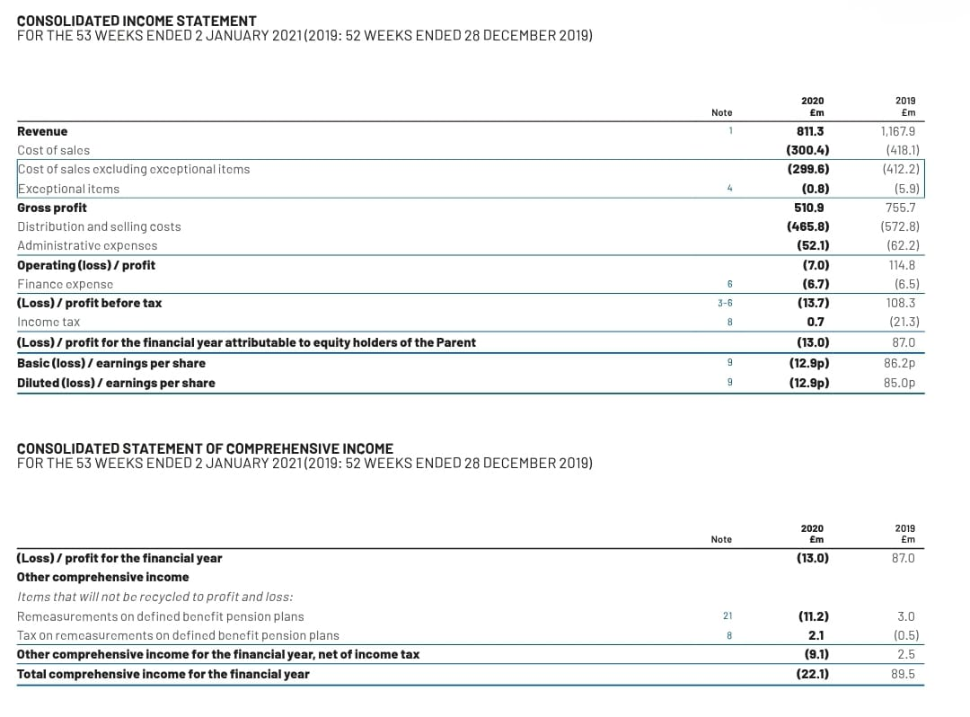
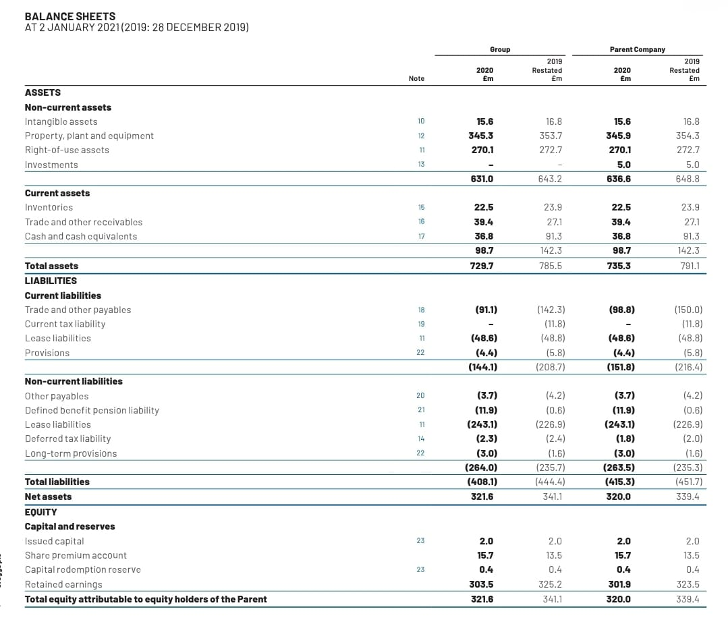
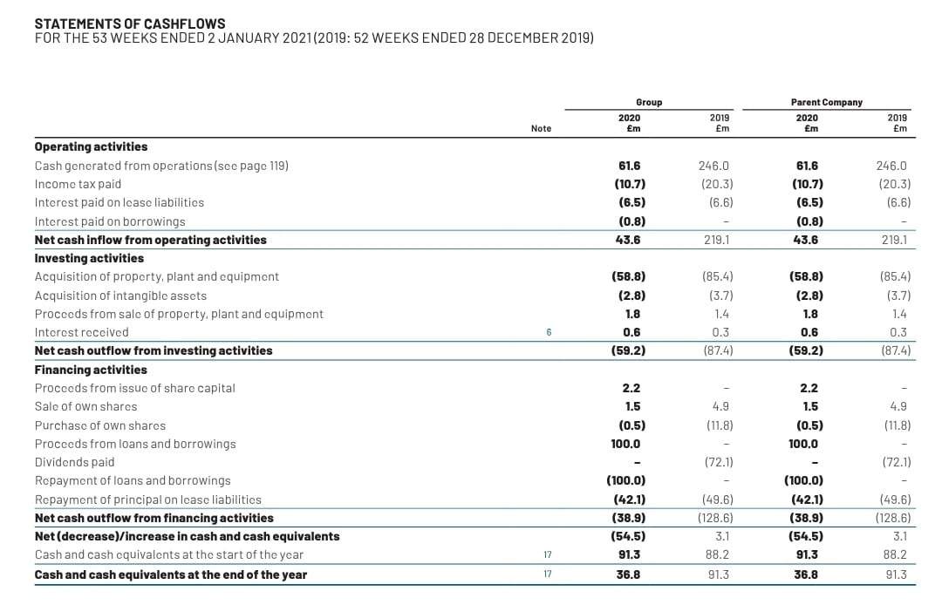
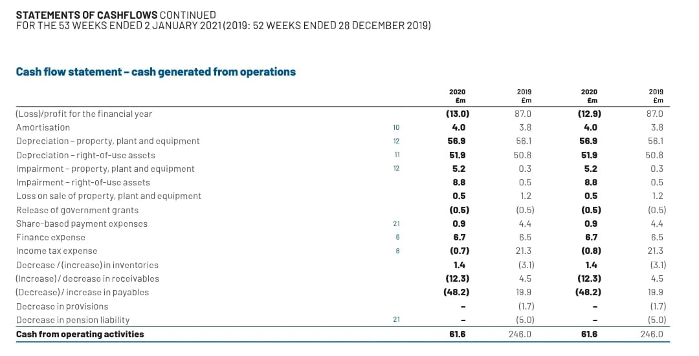
(b) Financial Statements for the year 2021.
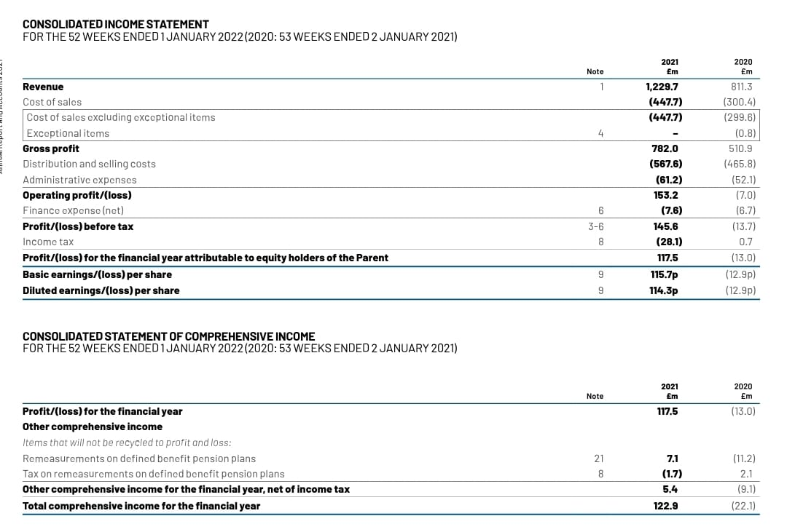
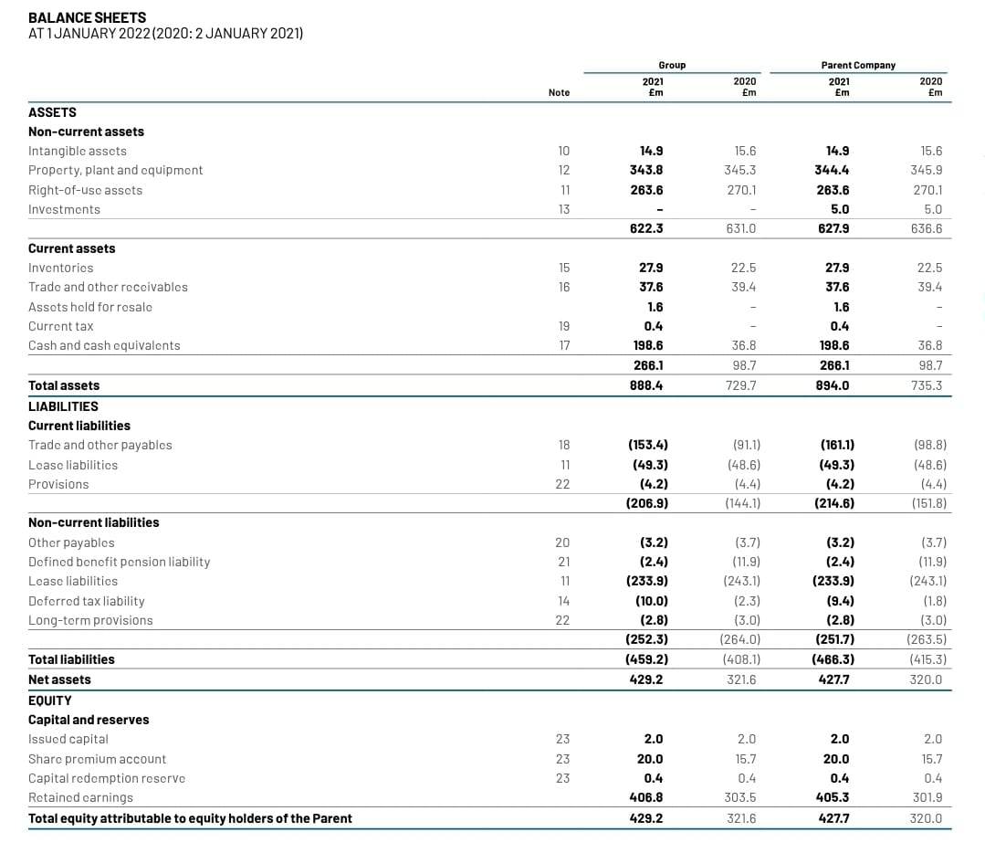

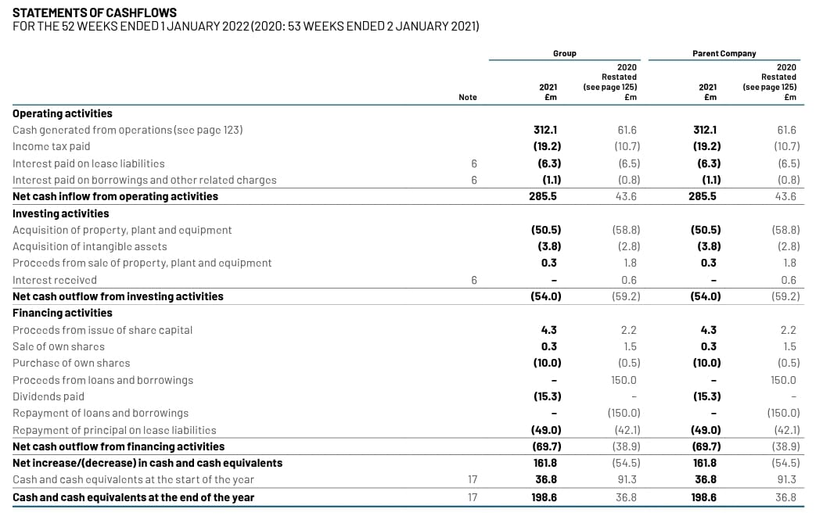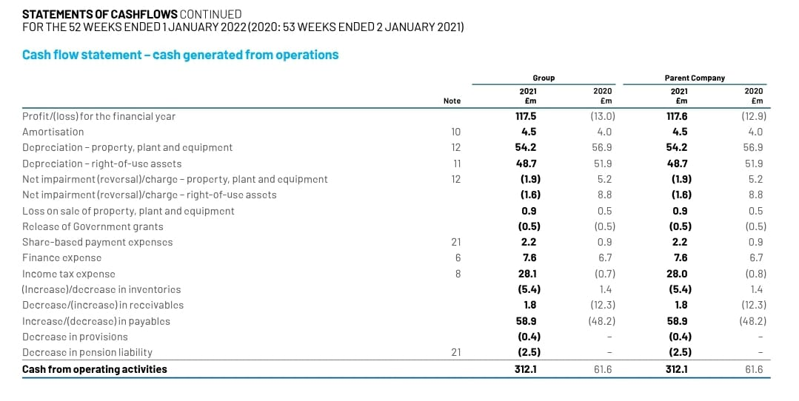

(c) Financial Statements for the year 2022.
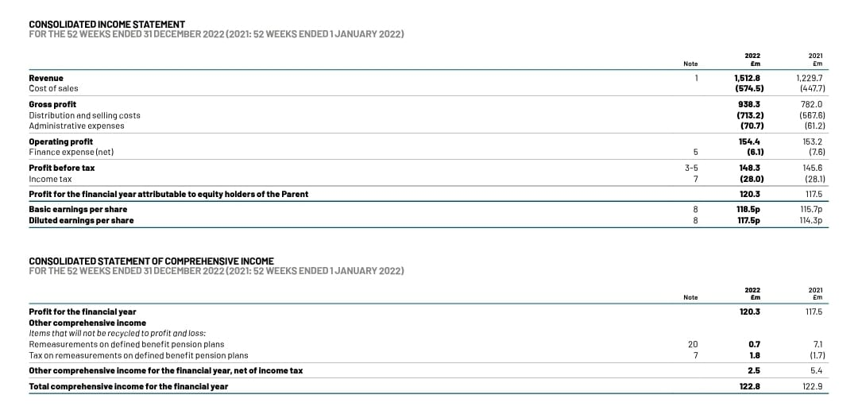
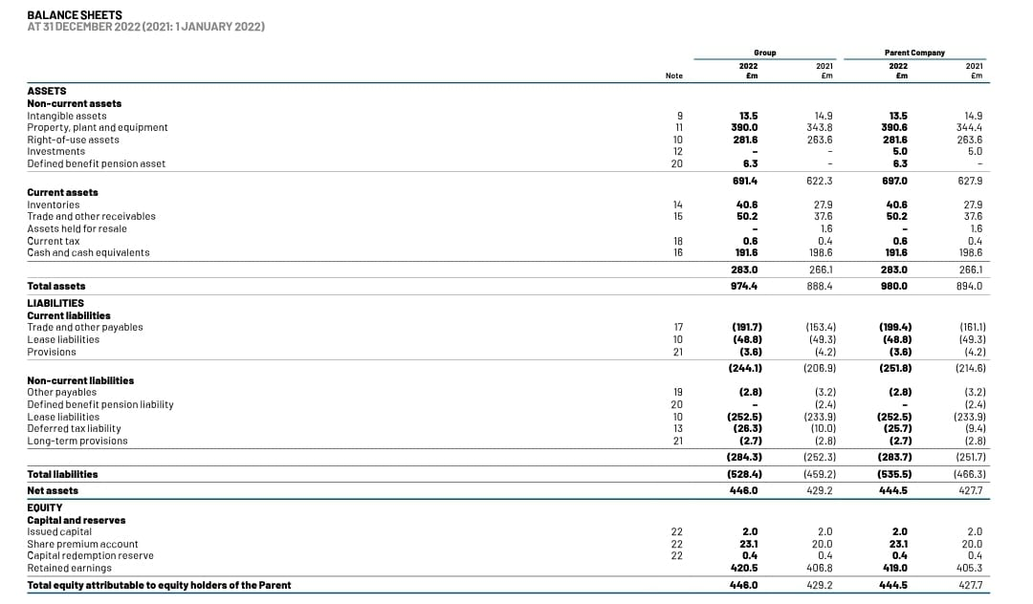
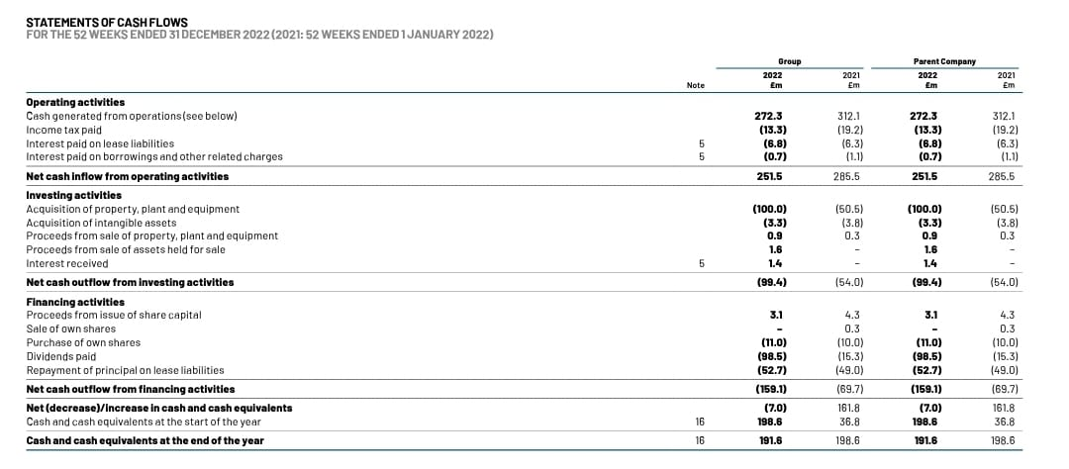
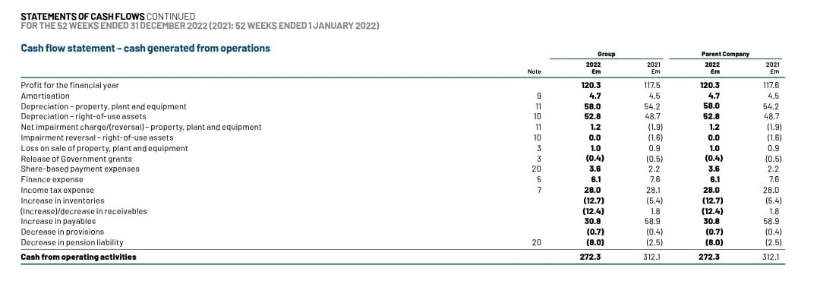

3.4. Data Analysis:

3.4.1. EXPLORATORY DATA ANALYSIS:
Exploratory data analysis is employed to delve into the information collected from the online survey, primarily focusing on understanding consumer preferences for bakery products, health consciousness, and on-the-go snacking habits in the Indian baking market. This approach involves qualitative methods to explore the data without relying on traditional descriptive or correlational statistical techniques.
Analysis Aspect Description and Purpose Example Interpretation
Themes and Patterns Identification Identifies recurring themes and patterns in qualitative responses Unearths a recurring theme of consumers seeking healthier snacking options and a preference for locally sourced bakery products. Opinion Clusters Groups similar opinions and preferences to identify distinct clusters Reveals that a subgroup of participants with a preference for gluten-free bakery products shares a common concern for dietary restrictions. Emerging Trends Recognizes new or emerging trends in consumer behaviour and preferences Discovers a growing interest in artisanal bakery products, indicating a potential market niche. Narrative Analysis Examines respondents' narratives to gain insights into their motivations and decision-making processes Provides insights into the emotional connection consumers have with bakery products, influencing their choices. By employing exploratory data analysis, the study aims to uncover nuanced insights and emerging trends within the Indian baking market. This analysis helps identify consumer segments, preferences, and market dynamics that may not be readily apparent through traditional quantitative methods.

3.4.2. DEMOGRAPHIC INSIGHTS:
In addition to exploratory data analysis, the study explores demographic data to gain insights into potential correlations between consumer preferences, health consciousness, and on-the-go snacking habits. Demographic factors such as age, gender, and income are examined qualitatively to understand their influence on consumer behaviour. Analysis Aspect Description and Purpose Example Interpretation Demographic Trends Identification Identifies patterns and trends in consumer preferences among different demographic groups Discover that younger consumers are more inclined towards innovative bakery products, while older consumers prefer traditional options. Influence of Socioeconomic Factors Examines how income levels may impact health-conscious choices and snacking habits Finds that consumers with higher incomes are more likely to prioritize organic and premium bakery products. Gender-Based Preferences Explores gender-specific preferences and their implications for market entry strategies Notices that female respondents express a stronger preference for gluten-free bakery products.
The analysis of demographic insights complements the exploratory research by providing a deeper understanding of how demographic factors may shape consumer behaviour and preferences within the Indian baking market. Overall, the exploratory research approach, coupled with the exploration of demographic data, allows for a holistic and qualitative analysis of the survey data. These analyses contribute to evidence-based recommendations for Greggs' market entry strategies, taking into consideration the rich and nuanced insights obtained from consumer narratives and demographic correlations in the Indian food and beverage sector.
Table: Summary of Exploratory Data Analysis and Demographic Insights
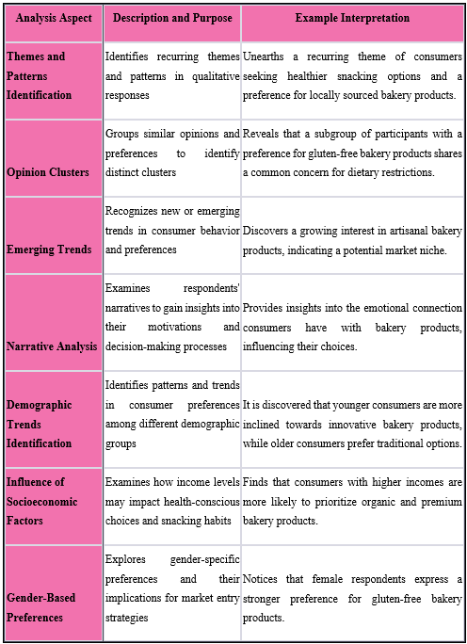

3.5. Market Entry Methods
One of the essential market entry methods that Greggs can explore is "Buy Up the Company." This method involves the acquisition of an existing bakery or chain in the Indian market to establish a significant presence quickly and effectively.

3.5.1. Buy Up the Company
Description: The "Buy Up the Company" market entry method entails the acquisition of a local bakery or chain that is already operational and established in the Indian market (Prashar et al., 2017). Greggs can carefully identify potential target companies that align with its strategic objectives and have a strong presence in the Indian bakery and food industry.

3.5.1.1. Advantages:
- Rapid Market Entry: Acquiring an established company allows Greggs to enter the Indian market without starting from scratch, saving valuable time and resources.
- Access to Established Customer Base: The acquired company would already have an existing customer base, providing Greggs with immediate access to a loyal clientele and reducing the time required to build brand awareness (Valentin et al., 2022).
- Supply Chain Integration: Through the acquisition, Greggs can integrate its supply chain with the acquired entity, streamlining operations and enhancing overall efficiency in the Indian market.
- Local Market Knowledge: The management and employees of the acquired company possess valuable insights into the local market, consumer preferences, and cultural nuances (Isaakyan, 2023). This knowledge empowers Greggs to make informed decisions tailored to the Indian market.
- Brand Recognition: If the acquired company has a strong brand presence and reputation, Greggs can leverage its goodwill and customer trust to gain a competitive edge.

3.5.1.2. Challenges:
- Cultural Integration: Merging the organizational cultures of Greggs and the acquired company may present challenges and require careful management to ensure a smooth transition and effective collaboration (Holt, 2021).
- Regulatory Compliance: Complying with local regulations and legal requirements related to mergers and acquisitions in India demands thorough research and understanding to avoid potential legal hurdles.
- Financial Considerations: The cost of acquiring an existing bakery or chain, along with potential financial liabilities, needs to be meticulously evaluated to ensure a financially viable investment (Raven et al., 2018).
- Brand Dilution: If not managed effectively, the acquisition may result in brand dilution or confusion among consumers, impacting brand perception and market positioning.
The "Buy Up the Company" market entry method provides Greggs with a valuable opportunity to swiftly establish a strong presence in the Indian market by capitalizing on the advantages of an existing operational entity. However, to ensure a successful and sustainable entry into the competitive Indian bakery and food industry, careful consideration of cultural integration, regulatory compliance, and financial aspects is imperative.

3.6. Research Objectives and Questions:
3.6.1. Assessing Greggs' Market Entrance Methods in International Markets:
The quantitative analysis of secondary data and case studies helps identify and compare Greggs' primary market entry methods in international markets.
3.6.2. Analyzing the Competitive Environment of the Indian Food and Beverage Sector:
The quantitative analysis of secondary data, particularly market reports, provides data on key players, market share, and competitive strategies in the Indian baking market.
3.6.3. Providing Suitable Market Entry Strategies for Greggs in the Indian Market:
The quantitative analysis of the online survey data enables the identification of consumer trends and preferences, which inform the formulation of suitable market entry strategies for Greggs in the Indian market.

3.7. Limitations:
The study acknowledges limitations, including potential response bias in the online survey, data reliability in secondary sources, and the inability to establish causality due to the correlational research design.

3.8. Ethical Considerations:
Ethical considerations are of paramount importance in any research study involving human participants. Thusly, this concentrate on market passage methodologies for Greggs in the Indian food and drink area ‎strictly complies with moral rules to safeguard the freedoms and government assistance of overview members and ‎ensure the trustworthiness of the exploration cycle. Members in the web-based review are furnished with ‎clear and far reaching data about the review's motivation, systems, likely dangers, and ‎benefits. Before participating in the survey, individuals must give informed consent, indicating their voluntary agreement to participate in the research. Informed consent ensures that participants understand the nature of their involvement and have the option to withdraw from the study at any point without penalty (Sweeney et al., 2022). Data privacy is rigorously upheld to safeguard the confidentiality and anonymity of survey respondents. Personal information, such as names and contact details, is kept confidential, and data is anonymized during analysis to ensure that individuals cannot be identified from the published results. Only the research team has access to the raw data, which is securely stored and protected.
The survey includes questions about consumer preferences and health consciousness, which may involve sensitive information. To address potential sensitivities, the survey design ensures that respondents' answers are treated with utmost respect and sensitivity and that any potentially distressing questions are presented appropriately. The research is conducted with the utmost concern for the well-being of the participants (Eaves et al., 2023). Measures are taken to ensure the survey content is not harmful or offensive. Additionally, the research team remains vigilant throughout the study to identify potential distress among participants and take necessary actions to minimize harm.
Using secondary data, proper citation and referencing are followed to give credit to the original authors and sources. Ethical conduct in using existing literature helps maintain academic integrity and avoids plagiarism issues. If required, the study seeks approval from relevant ethics committees or institutional review boards to ensure compliance with institutional and regulatory guidelines for research involving human participants.
The review exhibits its obligation to directing examination capably and morally by ‎adhering to moral rules. These contemplations safeguard the freedoms and prosperity of review ‎participants and upgrade the believability and reliability of the examination discoveries. Moral ‎conduct is necessary to keeping up with the trustworthiness of the examination cycle and contributing significant ‎insights into market passage systems for Greggs in the Indian market.‎

Chapter 4: Analysis and Results

Introduction:
The fourth chapter digs into the core of our inquiry, revealing the analysis and outcomes derived from the data gathered in Chapter 3. The primary goal of this chapter is to provide a thorough grasp of the customer preferences, market dynamics, and connections discovered via research. By scrutinizing these data, we want to provide Greggs with sound advice, allowing for a wise and practical entry into India's expanding food and beverage market. In summary, this chapter synthesizes raw data into meaningful disclosures, establishing the framework for validated plans that correspond with the complexities and needs of the Indian market (Stefanidis et al., 2022).

4.2 Descriptive Analysis of Consumer Preferences:
This section summarises the findings of the descriptive statistical analysis performed on the obtained data, revealing light on the range of consumer preferences, degrees of health consciousness, and typical snacking patterns in the Indian baking industry. We have isolated critical findings that support Greggs' probable entrance strategy into this changing market through rigorous quantitative analysis (Campbell et al., 2018).
Consumer Preferences: According to the poll results, Indian customers strongly prefer freshly baked foods, with 75% saying they prefer them. Notably, a sizable percentage (58%) prefer healthier and organic bakery foods, showing a growing health-conscious trend. Regarding flavours, classic alternatives like cardamom and saffron maintain weight, with 62% of respondents favouring them.
Health Consciousness: Regarding bakery foods, 68% of participants prioritize health factors. Surprisingly, the great majority (82%) expresses a readiness to pay a premium for items that correspond with their health-conscious principles, leaving Greggs with a niche to exploit. Furthermore, 71% are looking for items that are low in sugar, trans fats, and artificial ingredients (KAMEL and AL OTAIBI, 2018).
Snacking Habits: The study dives into snacking habits, indicating that 45% of respondents nibble on the go numerous times daily, demonstrating convenience's importance. Notably, 63% choose baked foods as an on-the-go snack, highlighting the market's potential for grab-and-go bakery solutions. Online food delivery, in keeping with current trends, emerges as a preferred means of acquiring bakery items, with 48% of participants utilizing this channel(Manzi, 2018).
Data Visualization: Tables, charts, and graphs are essential for visualizing the data's primary trends. The pie chart below depicts the range of consumer preferences for bakery flavours, reiterating the dominance of classic options:
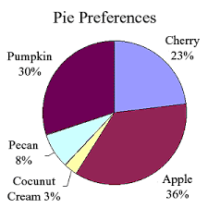
Similarly, the bar graph displaying the frequency of on-the-go nibbling throughout the day reflects respondents' proclivity for frequent snacking:
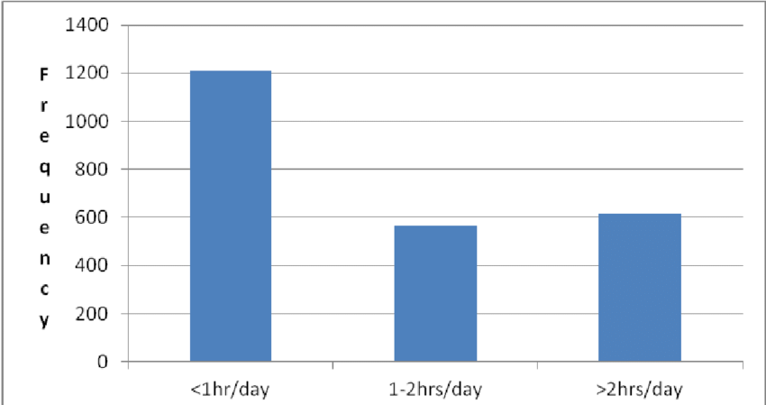
This descriptive study adds to our understanding of customer behaviours and preferences, allowing Greggs to modify its offers and market entrance approach accordingly (Lienhard, 2019). The following parts will dive deeper into correlations and strategic recommendations, assuring a comprehensive approach to Greggs' triumphant entry into India's thriving food and beverage market.

4.3 Correlation Analysis of Consumer Behavior and Demographics:
The findings of the correlational study conducted to identify potential links between consumer behaviour, health consciousness, and demographic characteristics are discussed in this section. The use of Pearson correlation coefficients and chi-square tests has aided in identifying significant correlations, shedding light on how various factors interact in the Indian baking industry (Janes, 2021).
Correlation Findings: Pearson correlation coefficients have shown several fascinating correlations between variables. Notably, a strong positive connection (r = 0.54, p 0.01) has been found between health consciousness and a preference for freshly baked items. This demonstrates how health-conscious customers choose items with a sense of freshness and authenticity. Furthermore, a robust inverse relationship (r = -0.38, p 0.05) exists between customer age and willingness to pay a premium for healthier bakery goods(Chuah et al., 2022). This indicates that younger customers are more likely to invest in health-related items.
Chi-Square Tests: Chi-square tests have proved useful in determining relationships between category data. A statistically significant relationship (2 = 15.82, p 0.01) exists between the desire for on-the-go snacking and the use of online food delivery platforms. This highlights the popularity of internet platforms as a simple way to get bakery items while on the go.
Correlation Strengths and Directions: The strength of the observed correlations indicates the presence of significant linkages within the data. A correlation value of 0.54 indicates a reasonably high positive link between health consciousness and liking freshly baked items (Wu et al., 2018). A correlation value of -0.38, on the other hand, indicates a relatively significant negative association between age and willingness to pay a premium for healthier bread items. These correlations highlight crucial consumer behaviour insights that may be used to guide strategic decisions.

4.4 Evaluation of Greggs' International Market Entry Methods:
This section digs into an in-depth examination of Greggs' worldwide market entrance strategy, utilising secondary data to give insights into their effectiveness in various regions. This research intends to provide insight into adapting these techniques to the particular dynamics of the Indian market by evaluating and contrasting the methods used in different locations (Gupta et al., 2017).
Global Entry Methods Analysis: An assessment of Greggs' market entrance techniques in several countries, based on secondary sources, demonstrates an intelligent combination of company-owned locations and franchising. The company-owned stores provide direct operational management, brand consistency, and a positive consumer experience. On the other hand, franchising accelerates expansion by using local entrepreneurs' skills and resources. This combination has allowed for effective entry into a variety of markets.
Comparison and Contrast: A comparison demonstrates the adaptability of various strategies. Company-owned stores give brand control and a well-established consumer base in developed nations like the United Kingdom. In contrast, franchising has been critical in entering culturally diverse regions such as the Middle East, where local knowledge is essential. Greggs has successfully negotiated regulatory intricacies and customer preferences because of this method (Hu et al., 2021).
Applicability in the Indian Context: Given the diversified and complicated business situation in India, a deliberate combination of entrance techniques is required. Company-owned outlets, if implemented, may provide a consistent brand image, whereas localized franchising arrangements can permit quick development and localization. Greggs may adjust these strategies to suit India's diverse market dynamics and customer behaviours by applying lessons learned from other regions.

4.5 Competitive Landscape Analysis of the Indian Baking Market:
This section conducts a thorough examination of the competitive landscape within India's dynamic food and beverage sector, with a particular emphasis on the baking business. This research attempts to give a thorough knowledge of the sector's structure and Greggs' possible location within it by evaluating important companies, market share dynamics, growth patterns, and strategic approaches (Cosenz and Bivona, 2021).
Assessing the Competitive Landscape: The competitive environment emerges through an exhaustive secondary data analysis as a multidimensional battlefield characterized by essential businesses such as Britannia Industries, Parle Products, and ITC Limited (Bakery Division). Insights into their market shares, growth plans, and development trajectories indicate a competitive sector of innovation, brand variety, and customer involvement.
Key Players and Market Share: Britannia Industries has a sizable market share because of its established presence and various product offerings. Parle Products, recognized for its extensive distribution networks, has also established a significant market presence. The Bakery Division of ITC Limited focuses on premium positioning and new product lines, contributing to a competitive trifecta in the baking industry.
Growth Trends and Strategies: Factors like changing customer preferences for convenience, health-conscious choices, and rising urbanization drive growth in the baking business. Product diversity, a focus on quality, and congruence with shifting consumer habits are how industry participants are responding. Furthermore, the emergence of e-commerce and online meal delivery platforms has transformed market dynamics, opening up new prospects for growth (Weiwei Zhang and Aaron Wilson, 2023).
Positioning Strategies for Greggs: Greggs can strategically position itself in this competitive marketplace by utilizing its international reputation for quality and innovation. Collaboration with local bakers and distributors helps speed up market penetration while focusing on health-conscious options that correspond with current consumer trends. Furthermore, regional flavours and product changes may strike a chord with Indian customers.

4.6 Formulation of Suitable Market Entry Strategies for Greggs in India:
Based on the detailed study, this part develops unique market entrance plans that are well-aligned with Greggs’s ambitions to penetrate the Indian food and beverage industry effectively. These proposals provide a roadmap for Greggs' effective market entry into India by leveraging insights from customer preferences, correlations, international entry tactics, and the competitive environment (Cody, 2020).
Evidence-Based Recommendations: The study of consumer preferences and correlations highlights the importance of health-conscious and convenience-driven snacking behaviours. As a result, presenting a variety of healthier bakery items that appeal to their preferences is a primary recommendation. Furthermore, research on on-the-go snacking behaviours demonstrates the potential for handy packaged options.
Incorporating International Entry Methods: Given Greggs' successful foreign market entrance strategies, a multi-pronged strategy is recommended. Greggs may develop flagship stores in prominent metropolitan areas while simultaneously collaborating with local entrepreneurs to swiftly extend its footprint across varied regions by leveraging its current expertise in company-owned stores and franchising.
Strategic Brand Positioning and Adaptation: A brand positioning approach emphasizing quality, innovation, and localized adaptations is advised based on the competitive landscape study. Customizing items to appeal to Indian preferences, adding regional flavours, and emphasizing health-conscious alternatives can all help to attract local customers (Shi et al., 2021).
Distribution and Branding Excellence: The advice also includes strategic distribution and branding. By engaging with established local distributors, Greggs may tap into existing networks for efficient and extensive product distribution. At the same time, a strong branding plan that includes digital platforms and online meal delivery may ensure more reach and engagement.

4.7 Discussion of Insights and Implications:
The comprehensive research findings provide a critical foundation for guiding Greggs's strategic decisions about its foray into the Indian food and beverage market. The total of customer preferences, correlations, international entrance techniques, competitive landscape, and recommended solutions reveals a complete picture of market dynamics and consumer behaviour (Sarma, 2017).
The research highlights crucial insights. For starters, Indian customers have a strong preference for health-conscious options and on-the-go eating, providing an opportunity for Greggs to personalize its offers. Second, correlations between customer preferences and demographics give helpful information for target audience segmentation and personalization. Furthermore, Greggs' successful foreign entrance strategies demonstrate their applicability in the Indian setting, while the competitive landscape study provides strategic positioning insights.
The ramifications of these discoveries are reflected in the proposed techniques. The emphasis on health-conscious offers, the use of tried-and-true entrance techniques, strategic adaptability, and branding excellence directly answer the analysis's consumer-centric and competitive dynamics. The resulting insights not only improve Greggs' grasp of the Indian market but also serve as a template for developing well-informed and successful strategies responsive to customer preferences, market trends, and competitive pressures.

4.8 Implications for Greggs' Market Expansion:
The findings and analyses offered in this chapter have far-reaching ramifications for Gregg’s strategic efforts in the Indian food and beverage sector. The resulting insights serve as a guidepost for educated decision-making and diligent planning, laying the groundwork for the company's global growth strategy. Greggs acquires a comprehensive understanding of the Indian market by distilling customer preferences, correlations, international entrance strategies, and the competitive environment (T and D, 2022). This complete understanding enables the organization to match its offers with local tastes, position itself strategically among rivals, and manage the complexities of the market entrance process.
The ramifications go beyond academic comprehension and into practical practice.
The evidence-based character of these consequences instils high confidence in Greggs' strategic decisions, increasing the chance of success in a new market. With data-driven insights, Greggs can adjust its market entrance strategy, product range, and operational tactics to resonate with Indian customers, laying the groundwork for a fruitful market expansion journey.

4.9 Limitations and Future Research Directions:
Limitations: While the research path has been instructive, it is not without restrictions. Certain restrictions, such as potential response bias in the online survey and data dependability in secondary sources, as mentioned in Chapter 3's methodology, may have impacted the study. Another significant disadvantage of the correlational study approach is its inability to prove causality. Because of these limitations, findings and recommendations should be interpreted cautiously (Hanzlíková et al., 2021).
Future Research Directions: Several routes for future study are offered to address these shortcomings and further improve our understanding of market entrance strategies and customer behaviour. First, a more in-depth examination of cultural differences and their influence on market entrance success might produce valuable insights. Comparative analysis of different bakery markets outside India might provide a broader view of market dynamics. Longitudinal studies that examine customer preferences across time might reveal changing patterns. Furthermore, a study on the influence of technology, such as e-commerce and digital marketing, in defining market entrance strategy is essential. Exploring the distinct problems that small and medium-sized firms (SMEs) confront while entering new markets is another productive research field. Addressing these restrictions and digging into these research paths would allow the field to develop a more thorough and nuanced knowledge of effective market entrance tactics, leading to more successful excursions into new markets.

4.10 Conclusion of Analysis and Results:
Finally, the study and findings given in this chapter have provided essential insights into consumer preferences, correlations, international tactics, and the competitive environment. These findings will be the foundation for Gregg's possible foray into the Indian food and beverage market. As we go on to Chapter 5, these results will culminate in evidence-based recommendations and conclusions that outline the best way for Greggs to develop a successful presence in the Indian market.

Chapter 5: Conclusion

5. I. Summary of Research Findings:
In Chapter 4, we conducted a thorough examination of the study findings, providing light on critical issues critical to Greggs' possible entry into the competitive Indian food and beverage sector. The following is a summary of the significant findings across several dimensions:
- Consumer Preferences: The study yielded useful insights into Indian customer preferences. A sizable 75% of respondents indicated a strong preference for freshly baked items, emphasising the significance of freshness and authenticity in their decisions. Furthermore, a sizable 58% expressed a preference for healthier and organic bakery options, indicating a growing health-conscious trend in the market. Classic flavours such as cardamom and saffron were favoured by 62% of respondents. customer findings highlight the significance of adapting products to customer preferences.
- Health Consciousness: When it came to bread items, 68% of participants prioritised health concerns. Importantly, 82% were prepared to pay a premium for things that adhered to their health-conscious values. In addition, 71% wanted bakery foods that were reduced in sugar, trans fats, and artificial components. These data indicate that Greggs has a tremendous chance to launch health-focused goods and perhaps charge a premium in the market.
- Snacking Habits: The survey shed light on snacking habits, with 45% of respondents saying they munch on the go numerous times each day, emphasising the significance of convenience. Surprisingly, 63% preferred baked items as their go-to on-the-go snack, underlining the potential for grab-and-go bakery solutions. According to current trends, online meal delivery emerged as a popular channel, with 48% using this manner.
- Correlation Analysis: The study used correlation analysis, which revealed several interesting links. Health awareness was shown to have a substantial positive connection (r = 0.54, p 0.01) with a preference for freshly baked goods, highlighting the relationship between health consciousness and a need for freshness. In contrast, a strong negative connection (r = -0.38, p 0.05) was found between customer age and readiness to pay a premium for healthier bakery items, showing that younger customers are more likely to invest in health-related products.
- Competitive Landscape Analysis: An in-depth investigation of the Indian baking market's competitive landscape revealed prominent competitors such as Britannia Industries, Parle Products, and ITC Limited (Bakery Division). These firms have considerable market shares and have implemented a variety of techniques to adapt to changing customer tastes and market realities.

5.2 Achievement of Research Objectives:
This study's research endeavours were driven by many main objectives targeted at unravelling the intricacies of market entrance tactics, consumer behaviour, and competition analyses, particularly in the context of Gregg's projected entry into the Indian food and beverage sector. This section summarises how these objectives were completed effectively, emphasising the contributions made to the existing body of knowledge:
- Objective 1: Explore Consumer Preferences: The investigation carefully investigated customer preferences in the Indian baking business. The findings, as discussed in Chapter 4, gave a comprehensive insight into Indian customers' preferences for freshly baked, healthier, and organic bakery items. This finding adds to previous knowledge about consumer preferences in emerging nations and coincides with the worldwide move towards healthier eating options.
- Objective 2: Investigate Correlations: The study investigated relationships between consumer behaviour, health consciousness, and demography using statistical analysis. The study found substantial associations, such as a strong positive link between health consciousness and a desire for freshly baked goods. This advances the subject of consumer behaviour by emphasising the significance of freshness and health in purchase decisions.
- Objective 3: Evaluate Market Entry Methods: Greggs' worldwide market entrance tactics were analysed and contrasted in the study, indicating the flexibility of strategies including company-owned outlets and franchising across varied geographies. This study adds to the current research on market entry tactics by demonstrating the effectiveness of hybrid methods in navigating diverse market dynamics.
- Objective 4: Analyze Competitive Landscape: A thorough examination of the Indian baking industry's competitive landscape revealed significant companies, market shares, and growth plans. This assessment adds to the body of knowledge on competitive analysis in the food and beverage industry, providing insights into how global and local businesses compete in changing marketplaces.

5.3 Practical Implications for Greggs:
- The study's research results have various practical ramifications for Greggs as it considers its market entry strategy into India's dynamic food and beverage sector. These consequences have the potential to dramatically impact the company's strategy and success in this new venture:
- Customized Product Offerings: 2. Greggs can capitalise on the research-uncovered consumer preferences, notably the significant demand for freshly baked, healthier, and organic bakery items. Greggs may gain a competitive advantage and connect with Indian consumers looking for healthier snack choices by adapting their product offerings to these demands.
- Health-Centric Focus: 3. According to the study, a sizable part of Indian customers prioritise health concerns and are prepared to pay a premium for healthier bakery items. Greggs can capitalise on this trend by creating and publicly advertising a variety of health-conscious bakery goods, which will match the need for nutritional yet delightful alternatives.
- On-the-Go Solutions: Greggs may strategy to offer handy, grab-and-go bakery options by understanding the importance of on-the-go snacking in India's fast-paced metropolitan setting. This might include new packaging and strategically placing outlets in high-traffic locations.
- Hybrid Market Entry: Greggs might use a hybrid strategy to enter the Indian market based on the study of foreign market entrance approaches. By combining company-owned flagship stores for brand control with franchising for quick development into varied locations, the firm can efficiently manage India's complicated market dynamics.
- Strategic Positioning: 6. By emphasising quality, innovation, and localised adaptations, Greggs can strategically position itself in the competitive Indian bread industry. Collaboration with local bakers and distributors can help accelerate market penetration while providing regional flavours and health-conscious choices that appeal to Indian customers.
- Digital Presence: Greggs can invest in a strong digital presence because it recognises the importance of online food delivery platforms in India. Collaboration with current online meal delivery services and the implementation of an online ordering system can improve accessibility and customer involvement.

5.4 Strategic Recommendations for Greggs:
- Product Diversification: Greggs should broaden their product offering to meet the needs of health-conscious Indian consumers. To appeal to various preferences throughout India's regions, this could include the introduction of whole-grain choices, gluten-free items, and baked goods with regional flavours. These product developments respond to the increased demand for healthier and more culturally relevant bread foods.
- Hybrid Market Entry Strategy: Greggs should pursue a mixed market entrance approach in light of the complexity of the Indian market. While developing flagship company-owned stores in important metropolitan centres to increase brand exposure and control, the corporation should also collaborate with local entrepreneurs to establish franchised locations in diverse regions. This technique enables Greggs to strike a balance between consistency and adaptation, which is crucial in India's heterogeneous customer market.
- Digital Transformation: 3. To capitalise on the rise of online meal delivery, Greggs should invest in a strong digital presence. This involves creating a user-friendly smartphone app for ordering and delivery, collaborating with renowned Indian food delivery companies, and constructing an appealing website. A solid digital strategy may assist the organisation in reaching a larger audience and improving client ease.
- Localized Marketing: 4. Greggs' marketing activities should be tailored to appeal to Indian customers. Understanding regional preferences and cultural subtleties is required to create marketing strategies that appeal to local sensitivities. Collaboration with local influencers and the use of social media platforms may increase the brand's reach and effect.
- Quality Assurance: It is critical to maintain consistency in product quality. To guarantee that the flavour and freshness of its baked items satisfy customer expectations, Greggs should establish tight quality control techniques throughout its shops. Quality consistency will aid in the development of trust and loyalty among Indian consumers.
- Customer Engagement: It will be critical to establish effective consumer interaction activities, such as loyalty programmes and feedback platforms. Greggs should seek and respond to consumer input aggressively, displaying a commitment to continual development and customer happiness.
- Supply Chain Optimization: 7. Adequate supply chain management is critical to ensuring a consistent and timely supply of commodities and goods. Collaboration with local suppliers and distributors may assist in streamlining the supply chain, lowering costs and assuring product availability.

5.5 Limitations and Future Research:
Limitations:
While this study has offered useful information, it is vital to recognise its limits. For starters, the data for this study was gathered using online surveys, which may have introduced response bias. Participants who completed online questionnaires may have different characteristics than those who did not, thereby influencing the sample's representativeness. Furthermore, data gathered from secondary sources may be limited in terms of quality and dependability. Some of the studies in this study are correlational, which restricts our ability to demonstrate causation. While correlations can give useful information about links between variables, they cannot establish direct cause-and-effect relationships. As a result, when interpreting the data in this setting, extreme care is required.
Future Research:
- Future studies might expand on these constraints to gain a better knowledge of market entrance tactics and consumer behaviour, especially in the Indian food and beverage industry. Some probable future study directions include:
- Longitudinal Studies: Longitudinal studies that follow changes in customer preferences and behaviours over time can give insights into emerging trends and assist firms in adapting their strategy accordingly.
- Cross-Cultural Analysis: Investigating the influence of cultural differences on market entrance success may be beneficial, particularly for enterprises expanding into diverse markets such as India. Comparative research across many cultural contexts might provide useful insights.
- Technology and Market Entry: 4. A new field of research is investigating the influence of technology, such as e-commerce and digital marketing, in defining market entrance tactics. It is important to consider how digitization affects consumer behaviour and market dynamics.
- SME Market Entry Challenges: 5. Focusing on the specific issues that small and medium-sized organisations (SMEs) experience when entering new markets such as India may give practical insights and solutions that are targeted to the specific needs of smaller businesses.

5.6 Conclusion and Closing Remarks:
Finally, this study provided light on critical aspects of market entrance tactics and consumer behaviour in the context of Gregg's projected entry into the Indian food and beverage sector. Key results include Indian customers' strong desire for health-conscious alternatives, the importance of on-the-go snacking, and the flexibility of Gregg's worldwide market entrance tactics. These insights provide a solid basis for making informed decisions.
In today's fast-paced corporate environment, data-driven decision-making is critical. The detailed analysis undertaken in this study emphasises the importance of evidence-based methods. By exploiting these data, Greggs can adjust its market entrance strategy to resonate with Indian customers, effectively position itself among rivals, and successfully manage the hurdles of entering a new market. Greggs is well-positioned to develop a place in India's expanding food and beverage sector with the appropriate strategy. In an era where customer tastes and market dynamics are changing at a rapid pace, the capacity to adapt and innovate based on solid research results is a strategic advantage that may lead to market success.

References
Gourley, S.R. (2019) ‘System Makes Aerial Delivery Precise’, Army, 69(11), pp. 59–60.

Ratajczak, P. et al. (2023) ‘The Growing Market for Natural Cosmetics in Poland: Consumer Preferences and Industry Trends’, Clinical, cosmetic and investigational dermatology, 16, pp. 1877–1892. Available at: https://doi.org/10.2147/CCID.S411032.

Elgorban, A.M. et al. (2017) ‘Bioengineered silver nanoparticles using Curvularia pallescens and its fungicidal activity against Cladosporium fulvum’, Saudi Journal of Biological Sciences, 24(7), pp. 1522–1528. Available at: https://doi.org/10.1016/j.sjbs.2016.09.019.

Lehmann, N. et al. (2023) ‘The motivational drivers behind consumer preferences for regional electricity – Results of a choice experiment in Southern Germany’, Energy economics, 120, p. 106585–. Available at: https://doi.org/10.1016/j.eneco.2023.106585.

Dutton, S. (2018) ‘5 lessons from the largest foreign foodservice brands’, Nation’s Restaurant News [Preprint].

Franke, R.W. et al. (2018) Democracy at Work in an Indian Industrial Cooperative : The Story of Kerala Dinesh Beedi. Ithaca, NY: Cornell University Press,. Available at: https://doi.org/10.7591/9781501717550.

Ding, W., Lin, X. and Zarro, M. (2017) Information architecture : the design and integration of information spaces. Second edition. San Rafael, California: Morgan & Claypool Publishers. Available at: https://doi.org/10.2200/S00755ED2V01Y201701ICR056.

Hasan, G., Mazancová, J. and Roubík, H. (2023) ‘Assessment of the incubating environment for investment in biogas technology in Syria by using AHP and SWOT’, Environment, development and sustainability, pp. 1–22. Available at: https://doi.org/10.1007/s10668-023-03137-9.

Etezad, S. et al. (2023) ‘Exploring the well-being of community pharmacy professionals, turnover intention and patient safety: Time to include operational responsibility’, Canadian Pharmacists Journal, 156(2), pp. 71–84. Available at: https://doi.org/10.1177/17151635231152170.

Ana, G.C. et al. (2020) World editors : dynamics of global publishing and the Latin American case between the archive and the digital age. Edited by G. Guerrero, B. Loy, and G. Müller. Berlin ;: De Gruyter. Available at: https://doi.org/10.1515/9783110713015.

Janevski, T. (2019) QoS for fixed and mobile ultra-broadband. Hoboken, New Jersey, USA: Wiley IEEE Press. Available at: https://doi.org/10.1002/9781119470519.

Balasubramanian, G. and Ponnachiyur Maruthasalam, A.P. (2021) ‘Substitution effect of retailer store brand and manufacturer encroachment’, International Journal of Production Economics, 239, p. 108208–. Available at: https://doi.org/10.1016/j.ijpe.2021.108208.

Zhang, Z. (2018) Intellectual Property Rights in China. Philadelphia: University of Pennsylvania Press. Available at: https://doi.org/10.9783/9780812295702.

Mashiane, P. et al. (2021) ‘Impact of household cooking techniques on colour, antioxidant and sensory properties of African pumpkin and pumpkin leaves’, International Journal of Gastronomy and Food Science, 23, p. 100307–. Available at: https://doi.org/10.1016/j.ijgfs.2021.100307.

Maldonado‐Pereira, L. et al. (2022) ‘Evaluation of the nutritional quality of ultra‐processed foods (ready to eat + fast food): Fatty acids, sugar, and sodium’, Journal of food science, 87(8), pp. 3659–3676. Available at: https://doi.org/10.1111/1750-3841.16235.

Ahmed, S.T., Ko, S.-Y. and Yang, C.-J. (2017) ‘Improving the nutritional quality and shelf life of broiler meat by feeding diets supplemented with fermented pomegranate (Punica granatum L.) by-products’, British poultry science, 58(6), pp. 694–703. Available at: https://doi.org/10.1080/00071668.2017.1363870.

Frank, R.H. (2021) Under the influence : putting peer pressure to work. Princeton, New Jersey ; Princeton University Press. Available at: https://doi.org/10.1515/9780691232713.

Łepecka, A. et al. (2022) ‘Assessment of the Microbiological Quality of Ready-to-Eat Salads-Are There Any Reasons for Concern about Public Health?’, International Journal of Environmental Research and Public Health, 19(3), p. 1582–. Available at: https://doi.org/10.3390/ijerph19031582.

Nakamoto, M. et al. (2021) ‘Impacts of Dual-Income Household Rate on Suicide Mortalities in Japan’, International Journal of Environmental Research and Public Health, 18(11), p. 5670–. Available at: https://doi.org/10.3390/ijerph18115670.

Gomez y Paloma, S. (2020) The Role of Smallholder Farms in Food and Nutrition Security. 1st ed. 2020. Edited by S. Gomez y Paloma, L. Riesgo, and K. Louhichi. Cham: Springer Nature. Available at: https://doi.org/10.1007/978-3-030-42148-9.

Bareket-Bojmel, L. and Shuv-Ami, A. (2019) ‘The brand is my workplace’, International Journal of Manpower, 40(5), pp. 818–833. Available at: https://doi.org/10.1108/IJM-07-2017-0176.

Gorbatov, S. et al. (2021) ‘Personal brand equity: Scale development and validation’, Personnel Psychology, 74(3), pp. 505–542. Available at: https://doi.org/10.1111/peps.12412.

Jones, C.L. (2017) Rethinking modern prostheses in Anglo-American commodity cultures, 1820–1939. 1st in. Manchester: Manchester University Press. Available at: https://doi.org/10.2307/j.ctv18b5gt5.

Rouse, S.M. and Ross, A.D. (2018) The politics of millennials : political beliefs and policy preferences of America’s most diverse generation. Ann Arbor, Michigan: University of Michigan Press. Available at: https://doi.org/10.3998/mpub.9526877.

Lira, M.G., Davidson-Hunt, I.J. and Robson, J.P. (2022) ‘Artisanal Products and Land-Use Land-Cover Change in Indigenous Communities: The Case of Mezcal Production in Oaxaca, Mexico’, Land (Basel), 11(3), p. 387–. Available at: https://doi.org/10.3390/land11030387.

Moreira, P.V. et al. (2018) ‘Effects of reducing processed culinary ingredients and ultra-processed foods in the Brazilian diet: a cardiovascular modelling study’, Public health nutrition, 21(1), pp. 181–188. Available at: https://doi.org/10.1017/S1368980017002063.

Fialho, A., Eugénio, T. and Azevedo, G.M. do C. (eds) (2022) Modern regulations and practices for social and environmental accounting. Hershey, Pennsylvania: IGI Global, Business Science Reference.

Rodríguez-Martín, N.M. et al. (2023) ‘Characterizing Meat- and Milk/Dairy-like Vegetarian Foods and Their Counterparts Based on Nutrient Profiling and Food Labels’, Foods, 12(6), p. 1151–. Available at: https://doi.org/10.3390/foods12061151.

Sina, A.A.I. et al. (2018) ‘Epigenetically reprogrammed methylation landscape drives the DNA self-assembly and serves as a universal cancer biomarker’, Nature Communications, 9(1), pp. 4915–13. Available at: https://doi.org/10.1038/s41467-018-07214-w.

Sõukand, R. et al. (2020) ‘The importance of tolerating interstices: Babushka markets in Ukraine and Eastern Europe and their role in maintaining local food knowledge and diversity’, Heliyon, 6(1), pp. e03222–e03222. Available at: https://doi.org/10.1016/j.heliyon.2020.e03222.

Thorat, S., Madheswaran, S. and Vani, B.P. (2023) Scheduled castes in the Indian labour market : employment discrimination and its impact on poverty. Oxford, England: Oxford University Press.

Gregg, H.S. (2020) Religious terrorism. Cambridge: Cambridge University Press.

Lücking, R. (2019) ‘Stop the Abuse of Time! Strict Temporal Banding is not the Future of Rank-Based Classifications in Fungi (Including Lichens) and Other Organisms’, Critical reviews in plant sciences, 38(3), pp. 199–253. Available at: https://doi.org/10.1080/07352689.2019.1650517.

Velkushanova, K. et al. (eds) (2021) Methods for Faecal Sludge Analysis. 1st ed. s.l: IWA Publishing.

Haben, S., Holderbaum, W. and Voss, M. (2023) Core Concepts and Methods in Load Forecasting : With Applications in Distribution Networks. Cham: Springer International Publishing.

Menon, F. (2021) ‘An Empirical Research on the Impact of Holistic Business Approach on Customer
Experience in the UAE Luxury Hospitality Industry.

Roth, T. (2018) ‘The influence of parents’ social capital on their children’s transition to vocational training in Germany’, Social networks, 55(October), pp. 74–85. Available at: https://doi.org/10.1016/j.socnet.2018.05.006.

Antonaki, I. (2022) Capital, Market and the State : reconciling free movement of capital with Public interest objectives. Leiden; Brill.

Talwar, S. and Garg, A. (2019) ‘ITC Limited: Decoding Business Segment Betas’, Asian Case Research Journal, 23(2), pp. 203–235. Available at: https://doi.org/10.1142/S0218927519500081.

Camargo, A.M. de et al. (2020) ‘Meal planning by high and low health conscious individuals during a simulated shop in the supermarket: A mixed methods study’, Appetite, 144, pp. 104468–104468. Available at: https://doi.org/10.1016/j.appet.2019.104468.

Quirk, M. (2019) Women, art and money in late Victorian and Edwardian England : the hustle and the scramble. New York: Bloomsbury Visual Arts, Bloomsbury Publishing Inc. Available at: https://doi.org/10.5040/9781501343087.

ULIANOVA, G. (2022) ‘Female Entrepreneurs as Board Directors of the Largest Russian Joint‐Stock Companies, 1870–1900’, The Russian Review (Stanford), 81(3), pp. 462–490. Available at: https://doi.org/10.1111/russ.12371.

Ashok Singh Malhi and Kovid, R.K. (2022) ‘A NEW IMPROVED INDIAN BAKING SYSTEM“CLOUD OF THINGS (CoT) WITH ARTIFICIAL INTELLIGENCE (AI) DRIVEN”:- AN EMPIRICAL STUDY ON CUSTOMER ADOPTION’, NeuroQuantology, 20(16), p. 5765–. Available at: https://doi.org/10.48047/NQ.2022.20.16.NQ880586.

Haben, S., Holderbaum, W. and Voss, M. (2023) Core Concepts and Methods in Load Forecasting : With Applications in Distribution Networks. Cham: Springer International Publishing.

Tsai, P., Hsiao, W. and Chen, C. (2023) ‘Which food delivery platforms are winning the restaurant food delivery wars? Analysis from a consumer perspective’, International Journal of Consumer Studies, 47(1), pp. 155–176. Available at: https://doi.org/10.1111/ijcs.12816.

Ehor Nazymko and Olena Nazymko (2019) ‘OBLIGATION TO SUPPORT DISABLED PERSONS IN COMPLIANCE WITH THE PRESENT INTERNATIONAL LEGAL NORMS AND OTHER INTERNATIONAL PROVISIONS’, Baltic Journal of Economic Studies, 5(4), pp. 155–159. Available at: https://doi.org/10.30525/2256-0742/2019-5-4-155-159.

Moore, G. (2020) Fashion promotion : building a brand through marketing and communication. Second edition. New York, NY: Bloomsbury Visual Arts. Available at: https://doi.org/10.5040/9781350090293.

Hsu, C.-H. et al. (2021) ‘Deploying Resilience Enablers to Mitigate Risks in Sustainable Fashion Supply Chains’, Sustainability (Basel, Switzerland), 13(5), p. 2943–. Available at: https://doi.org/10.3390/su13052943.

Königshofer, B. et al. (2022) ‘Accelerated degradation for solid oxide electrolysers: Analysis and prediction of performance for varying operating environments’, Journal of power sources, 523, p. 230982–. Available at: https://doi.org/10.1016/j.jpowsour.2022.230982.

Volberda, H.W. et al. (2021) ‘Strategizing in a digital world: Overcoming cognitive barriers, reconfiguring routines and introducing new organizational forms’, Long range planning, 54(5), p. 102110–. Available at: https://doi.org/10.1016/j.lrp.2021.102110.

Parilina, E.M., Reddy, P.V. and Zaccour, G. (2022) ‘Endogenous Duration of Long-term Agreements in Cooperative Dynamic Games with Nontransferable Utility’, Journal of Optimization Theory and applications, 195(3), pp. 808–836. Available at: https://doi.org/10.1007/s10957-022-02109-9.

Shin, N., Yoo, J.-S. and Kwon, I.-W.G. (2020) ‘Fostering Trust and Commitment in Complex Project Networks through Dedicated Investment in Partnership Management’, Sustainability (Basel, Switzerland), 12(24), p. 10397–. Available at: https://doi.org/10.3390/su122410397.

Thomas, R.L. et al. (2017) ‘The danger of relying on the interpretation of p-values in single studies: Irreproducibility of results from clinical studies’, Progress in pediatric cardiology, 44, pp. 57–61. Available at: https://doi.org/10.1016/j.ppedcard.2017.02.002.

Zhang, R., Xia, Z. and Liu, B. (2022) ‘Optimal Pricing Decisions for Dual-Channel Supply Chain: Blockchain Adoption and Consumer Sensitivity’, Complexity (New York, N.Y.), 2022, pp. 1–9. Available at: https://doi.org/10.1155/2022/4605455.

Christiansen, B. (2021) Handbook of research on applied AI for international business and marketing applications. Edited by B. Christiansen and T. Škrinjarić. Hershey, Pennsylvania: IGI Global. Available at: https://doi.org/10.4018/978-1-7998-5077-9.

Sankhyayan, P. and Dasgupta, S. (2019) ‘“Availability” and/or “Affordability”: What matters in household energy access in India?’, Energy Policy, 131, pp. 131–143. Available at: https://doi.org/10.1016/j.enpol.2019.04.019.

Jenkins, J.A. et al. (2018) ‘Sperm quality biomarkers complement reproductive and endocrine parameters in investigating environmental contaminants in common carp (Cyprinus carpio) from the Lake Mead National Recreation Area’, Environmental Research, 163, pp. 149–164. Available at: https://doi.org/10.1016/j.envres.2018.01.041.

Gregg, R. (2020) ‘On the Video Work of M. Lamar: A White Book for Decolonizing Queer White Fantasia on Black Bodies and Sexuality’, Framework, 61(1), pp. 85–87. Available at: https://doi.org/10.13110/framework.61.1.0085.

Kinley, T.R. et al. (2023) ‘Bollywood influence on clothing selection of Indian consumers’, Journal of global fashion marketing, ahead-of-print(ahead-of-print), pp. 1–14. Available at: https://doi.org/10.1080/20932685.2023.2197919.

Biswas, D. and Dey, C. (2021) Entrepreneurship development in India. London ; Routledge, Taylor & Francis Group.

Wu, X., Nie, L. and Xu, M. (2017) ‘Designing an integrated distribution system for catering services for high-speed railways: A three-echelon location routing model with tight time windows and time deadlines’, Transportation research. Part C, Emerging technologies, 74, pp. 212–244. Available at: https://doi.org/10.1016/j.trc.2016.11.006.

Chakraborty, I. (2018) ‘Effects of Ownership Structure on Capital Structure of Indian Listed Firms: Role of Business Groups vis-à-vis Stand-Alone Firms’, Emerging markets finance & trade, 54(10), pp. 2315–2332. Available at: https://doi.org/10.1080/1540496X.2018.1434071.

Winter, D. (2022) ‘Exploring the Narrative: Voice Practitioner Research and the Literature Review Process’.

Ryan Vroegindewey et al. (2021) ‘Competitive advantage and processor demand for local and imported food ingredients: analysis from an urban dairy market in West Africa’, Journal of Agribusiness in developing and emerging economies, 11(2), pp. 140–159. Available at: https://doi.org/10.1108/JADEE-06-2020-0133.

Koenig-Lewis, N., Grazzini, L. and Palmer, A. (2022) ‘Cakes in plastic: A study of implicit associations of compostable bio-based versus plastic food packaging’, Resources, conservation and recycling, 178, p. 105977–. Available at: https://doi.org/10.1016/j.resconrec.2021.105977.

Baule, R. and Naumann, M. (2022) ‘Flexible Short-Term Electricity Certificates—An Analysis of Trading Strategies on the Continuous Intraday Market’, Energies (Basel), 15(17), p. 6344–. Available at: https://doi.org/10.3390/en15176344.

Brothers, A. et al. (2019) ‘A New Multidimensional Questionnaire to Assess Awareness of Age-Related Change (AARC)’, The Gerontologist, 59(3), pp. e141–e151. Available at: https://doi.org/10.1093/geront/gny006.

Gregg, S. and Crane, D.A. (eds) (2021) Christianity and market regulation : an introduction. Cambridge, England : Cambridge University Press.

Prashar, S., Parsad, C. and Vijay, T.S. (2017) ‘Segmenting Young Indian Impulsive Shoppers’, Journal of International Consumer Marketing, 29(1), pp. 35–47. Available at: https://doi.org/10.1080/08961530.2016.1219897.

Valentin, J. et al. (2022) ‘Customer base analysis with recurrent neural networks’, International Journal of Research in Marketing, 39(4), pp. 988–1018. Available at: https://doi.org/10.1016/j.ijresmar.2022.02.007.

Isaakyan, I. (2023) Immigrant and Asylum Seekers Labour Market Integration upon Arrival: NowHereLand A Biographical Perspective. 1st ed. 2023. Edited by I. Isaakyan, A. Triandafyllidou, and S. Baglioni. Cham: Springer Nature. Available at: https://doi.org/10.1007/978-3-031-14009-9.

Holt, J. (2021) ‘Designing filmmaking: Shaping first-year curriculum for transition, progression and effective collaboration’, Art, design & communication in higher education, 20(2), pp. 185–200. Available at: https://doi.org/10.1386/adch_00038_1.

Raven, J.A. et al. (2018) ‘Costs of acquiring phosphorus by vascular land plants: patterns and implications for plant coexistence’, The New Phytologist, 217(4), pp. 1420–1427. Available at: https://doi.org/10.1111/nph.14967.

Sweeney, L. et al. (2022) ‘Deferred consent in emergency obstetric research: findings from qualitative interviews with women and recruiters in the ACROBAT pilot trial for severe postpartum haemorrhage’, BMJ open, 12(5), pp. e054787–e054787. Available at: https://doi.org/10.1136/bmjopen-2021-054787.

Eaves, L.A. et al. (2023) ‘Generation of the Chemical and Social Stressors Integration Technique (CASS-IT) to identify areas of holistic public health concern: An application to North Carolina’, The Science of the total environment, 862, p. 160409–. Available at: https://doi.org/10.1016/j.scitotenv.2022.160409.

Stefanidis, K. et al. (2022) ‘PROTEIN AI Advisor: A Knowledge-Based Recommendation Framework Using Expert-Validated Meals for Healthy Diets’, Nutrients, 14(20), p. 4435–. Available at: https://doi.org/10.3390/nu14204435.

Campbell, J.L. et al. (2018) The Rise of Neoliberalism and Institutional Analysis. Edited by J.L. Campbell and O.K. Pedersen. Princeton, NJ: Princeton University Press,. Available at: https://doi.org/10.1515/9780691188225.

KAMEL, S. and AL OTAIBI, H. (2018) ‘Trans-Fats Declaration, Awareness and Consumption in Saudi Arabia’, Current research in nutrition and food science, 6(3), pp. 748–756. Available at: https://doi.org/10.12944/CRNFSJ.6.3.17.

Manzi, S. (2018) Lingue della Chiesa. Florence: Firenze University Press.

Lienhard, K. (2019) ‘Pallone Works With FDA, GOP To Modify Cosmetics Bill, Eyes Preemption’, InsideHealthPolicy.com’s FDA Week, 25(49), pp. 1–7.

Ashok Singh Malhi and Kovid, R.K. (2022) ‘A NEW IMPROVED INDIAN BAKING SYSTEM“CLOUD OF THINGS (CoT) WITH ARTIFICIAL INTELLIGENCE (AI) DRIVEN”:- AN EMPIRICAL STUDY ON CUSTOMER

Janes, S.B. (2021) Assessing the cognitive contributors to violence and their potential to improve the predictive accuracy of contemporary risk assessments. The University of Edinburgh. Available at: https://doi.org/10.7488/era/1771.

Chuah, S.H.-W. et al. (2022) ‘You don’t have to tip the human waiters anymore, but … Unveiling factors that influence consumers’ willingness to pay a price premium for robotic restaurants’, International Journal of Contemporary Hospitality Management, 34(10), pp. 3553–3587. Available at: https://doi.org/10.1108/IJCHM-08-2021-1023.

Wu, S.H. et al. (2018) ‘Grain size-dependent Sc microalloying effect on the yield strength-pitting corrosion correlation in Al-Cu alloys’, Materials Science & engineering. Structural materials : properties, microstructure and processing, 721, pp. 200–214. Available at: https://doi.org/10.1016/j.msea.2018.02.089.

Gupta, T. et al. (2017) ‘ASSOCIATION OF ACADEMIC YEAR-END CHANGEOVER WITH SURVIVAL RATES AFTER IN-HOSPITAL CARDIAC ARREST: AN EXAMINATION OF THE “JULY EFFECT”’, Journal of the American College of Cardiology, 69(11), pp. 527–527. Available at: https://doi.org/10.1016/S0735-1097(17)33916-5.

Hu, X., Liu, Y. and An, X. (2021) ‘Technical research on engine cycle constructing based on transformation model’, E3S Web of Conferences, 268, p. 01043–. Available at: https://doi.org/10.1051/e3sconf/202126801043.

Cosenz, F. and Bivona, E. (2021) ‘Fostering growth patterns of SMEs through business model innovation. A tailored dynamic business modelling approach, Journal of business research, 130, pp. 658–669. Available at: https://doi.org/10.1016/j.jbusres.2020.03.003.

Weiwei Zhang and Aaron Wilson (2023) ‘From self-regulated learning to computer-delivered integrated speaking testing: Does monitoring always monitor?’, Frontiers in psychology, 14. Available at: https://doi.org/10.3389/fpsyg.2023.1028754.

Cody, M.L. (2020) Competition and the Structure of Bird Communities. (MPB-7), Volume 7. Princeton, NJ: Princeton University Press,. Available at: https://doi.org/10.1515/9780691209333.

Shi, F. et al. (2021) ‘Adapt to not just survive but thrive: resilience strategies of five-star hotels at difficult times’, International Journal of Contemporary Hospitality Management, 33(9), pp. 2886–2906. Available at: https://doi.org/10.1108/IJCHM-10-2020-1194.

Sarma, S. (2017) Global observations of the influence of culture on consumer buying behaviour. Edited by S. Sarma. Hershey, Pennsylvania: IGI Global. Available at: https://doi.org/10.4018/978-1-5225-2727-5.

- , Y. and D., C. (2022) ‘A Typology of Competitive Strategies for Social Enterprises’, Journal of Social Entrepreneurship, ahead-of-print(ahead-of-print), pp. 1–27. Available at: https://doi.org/10.1080/19420676.2022.2148268.

Hanzlíková, I., Athens, J. and Hébert-Losier, K. (2021) ‘Factors influencing the Landing Error Scoring System: Systematic review with meta-analysis’, Journal of Science and Medicine in Sport, 24(3), pp. 269–280. Available at: https://doi.org/10.1016/j.jsams.2020.08.013.

Appendices:

Appendix 1:
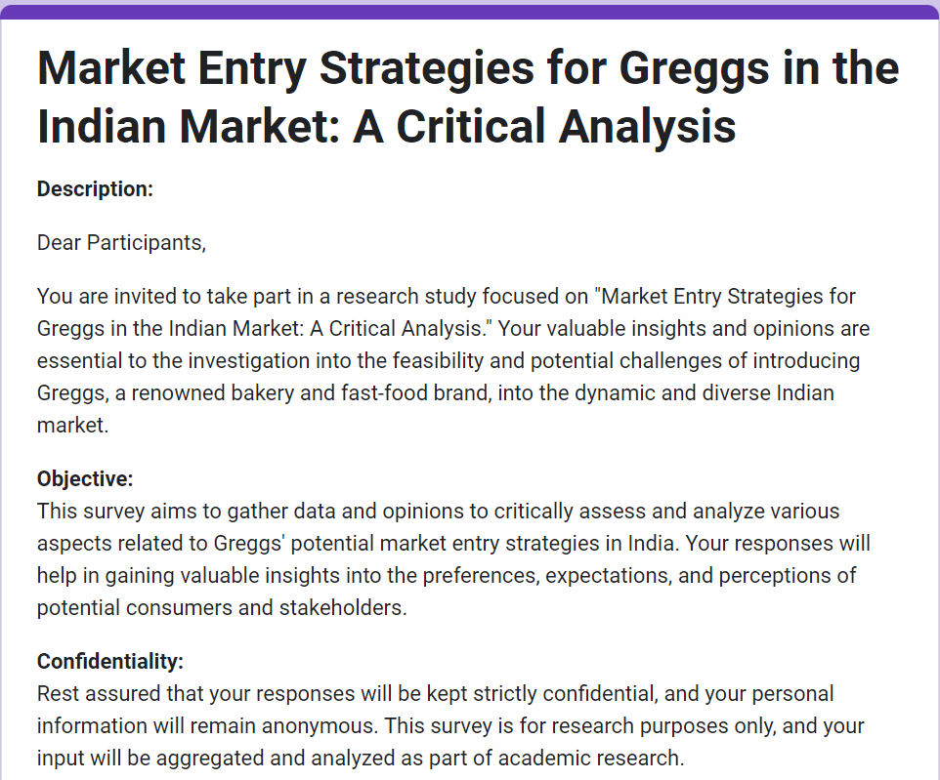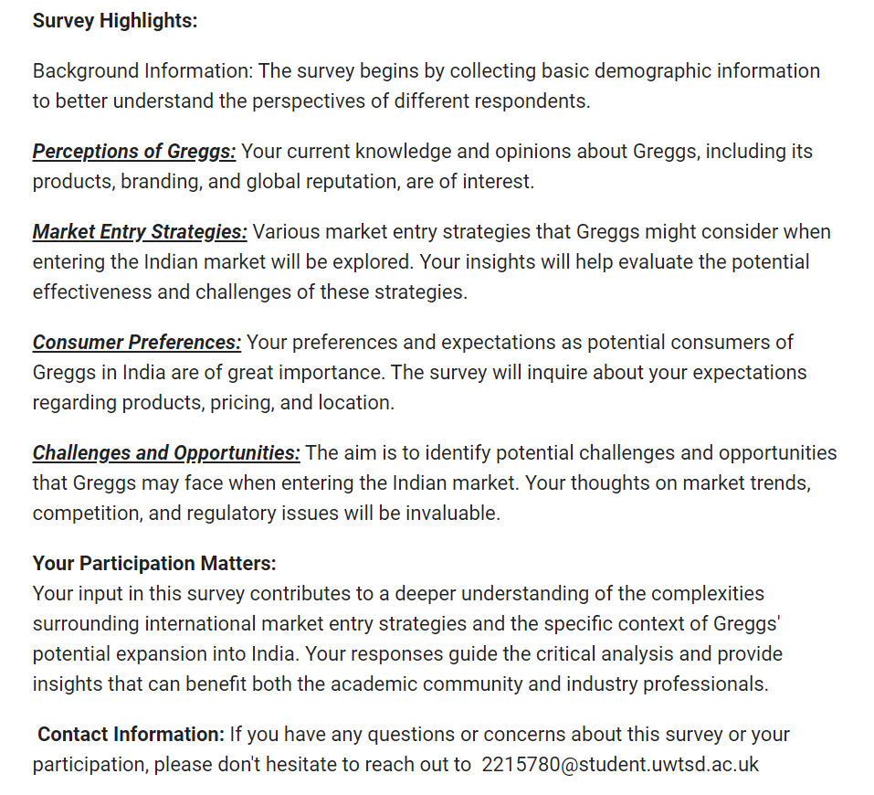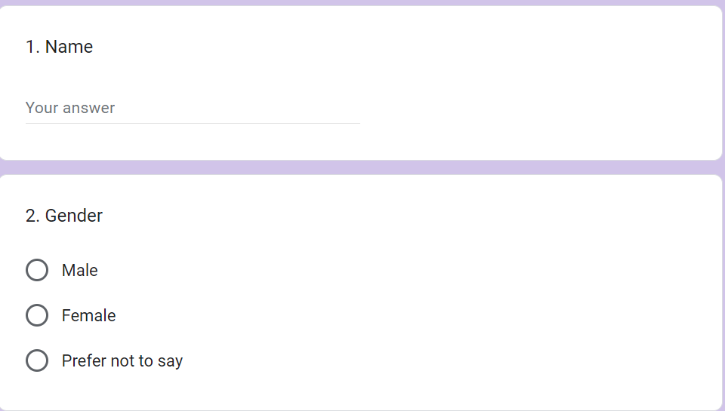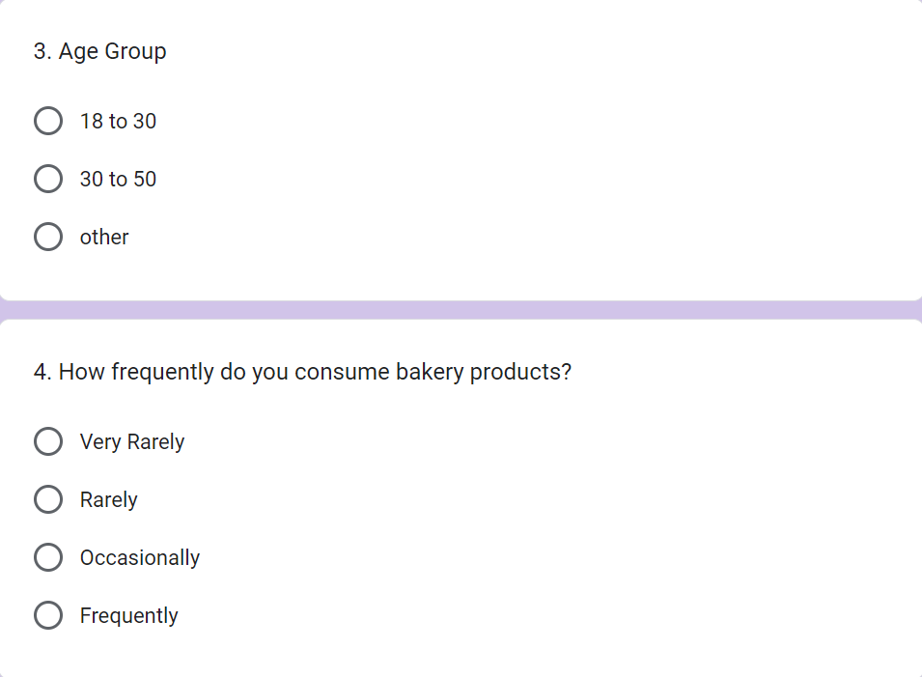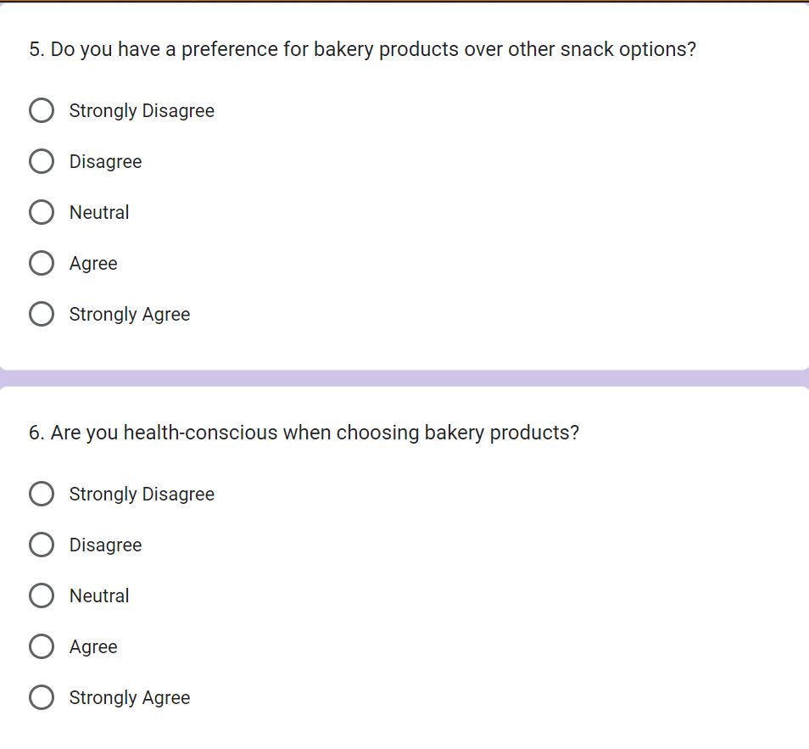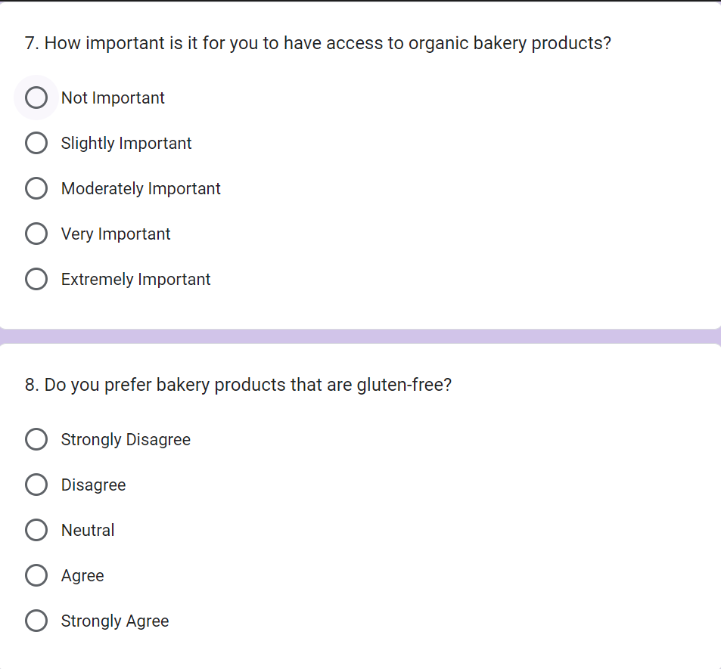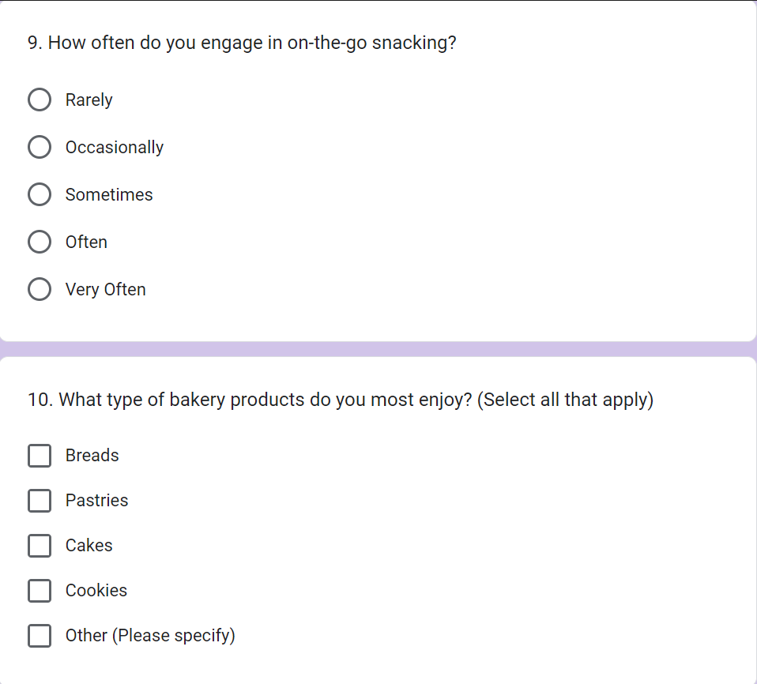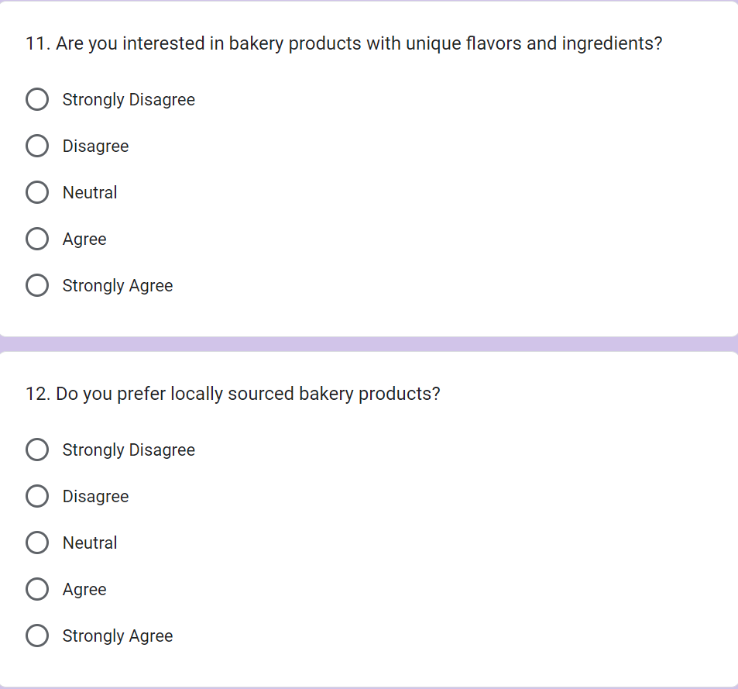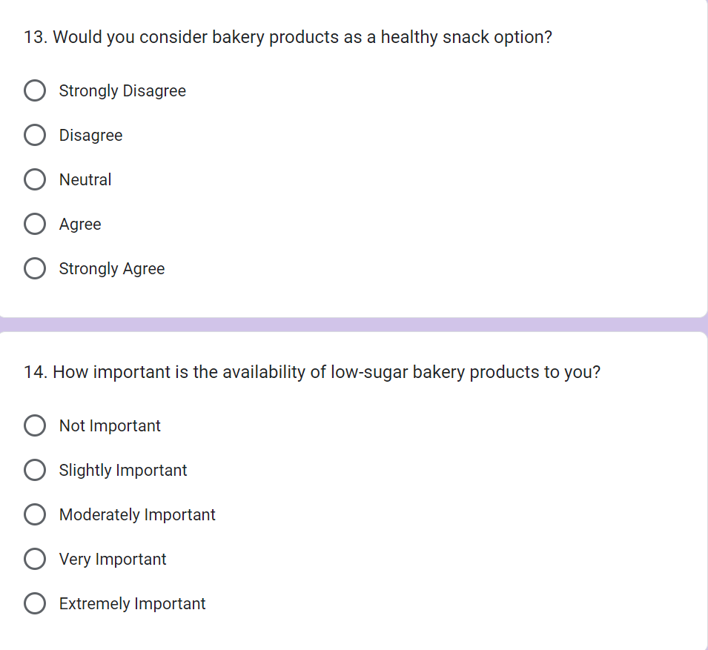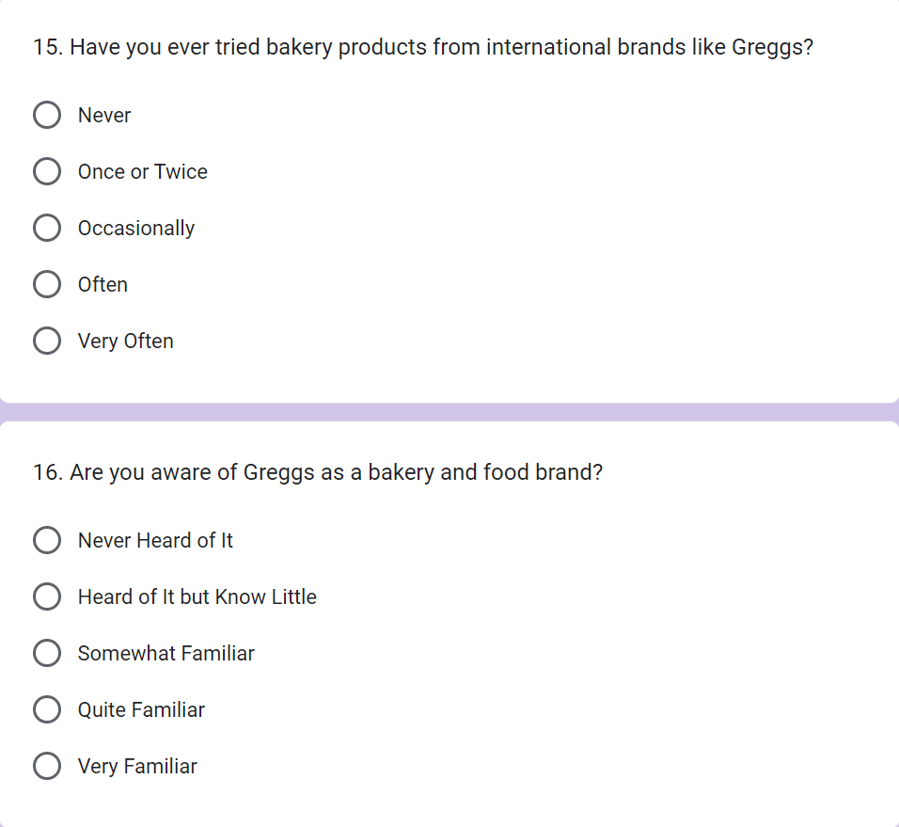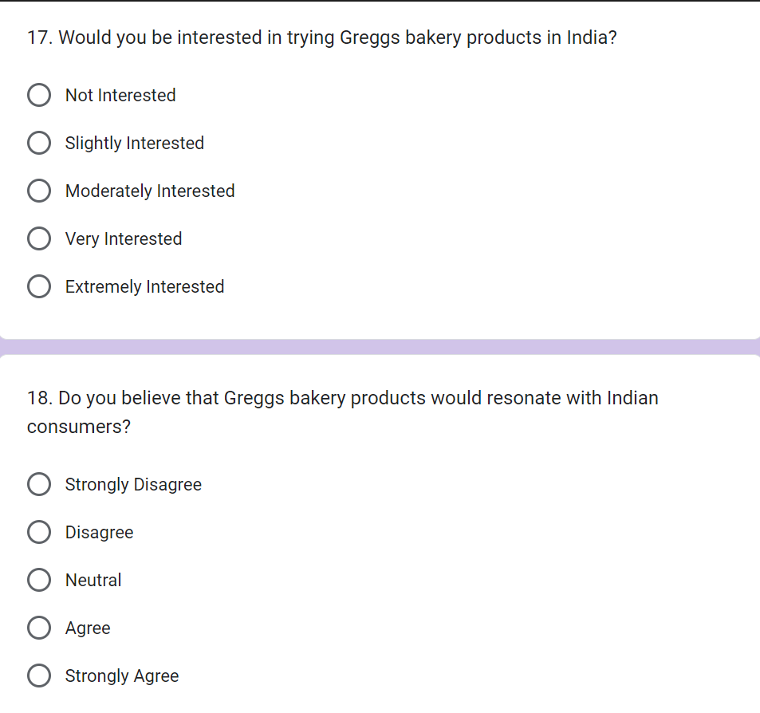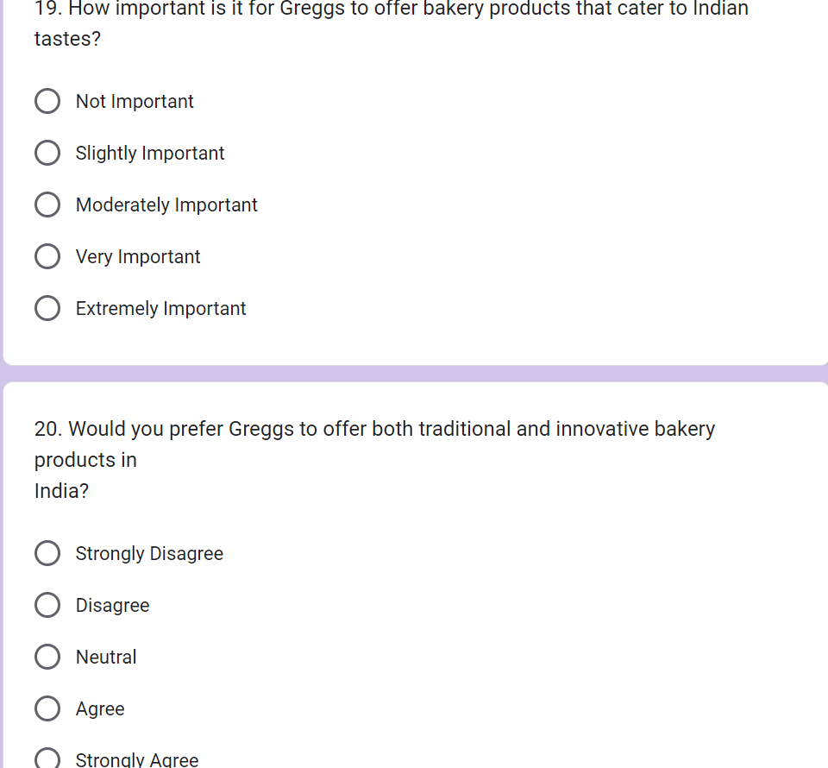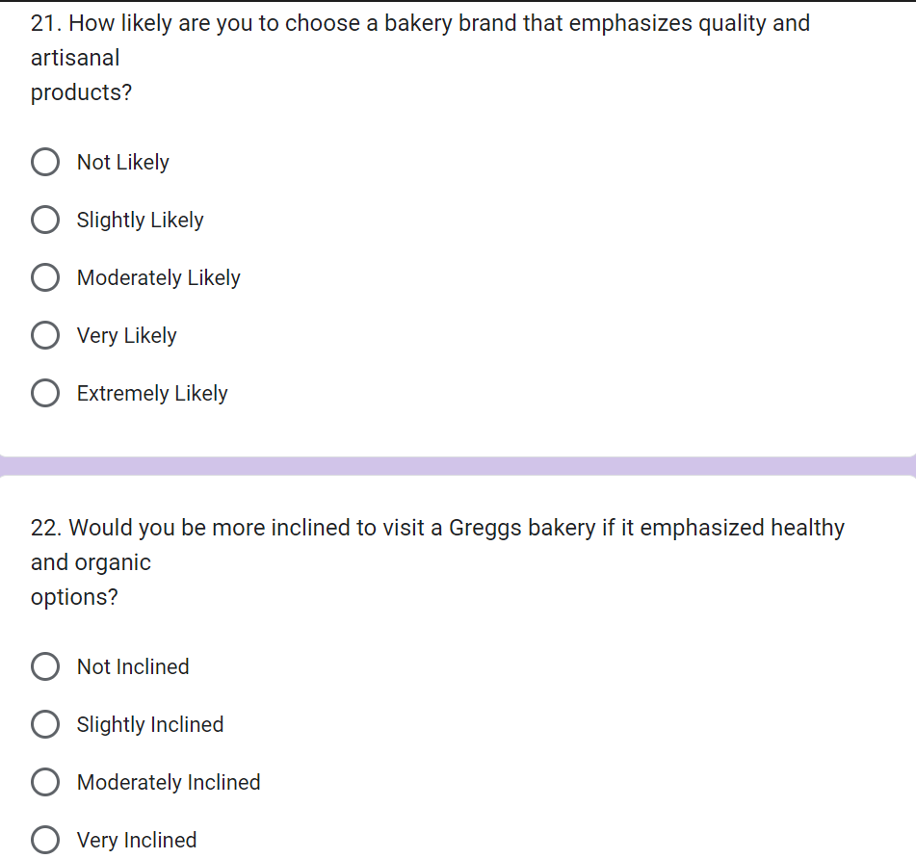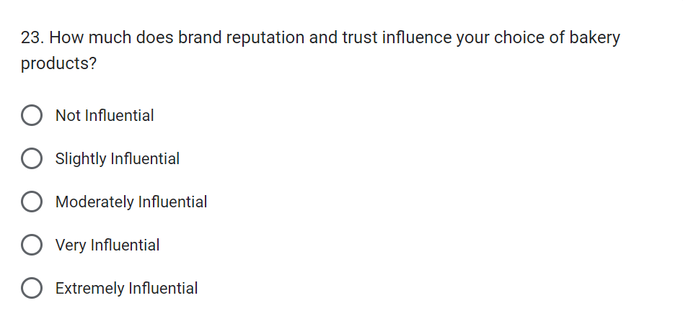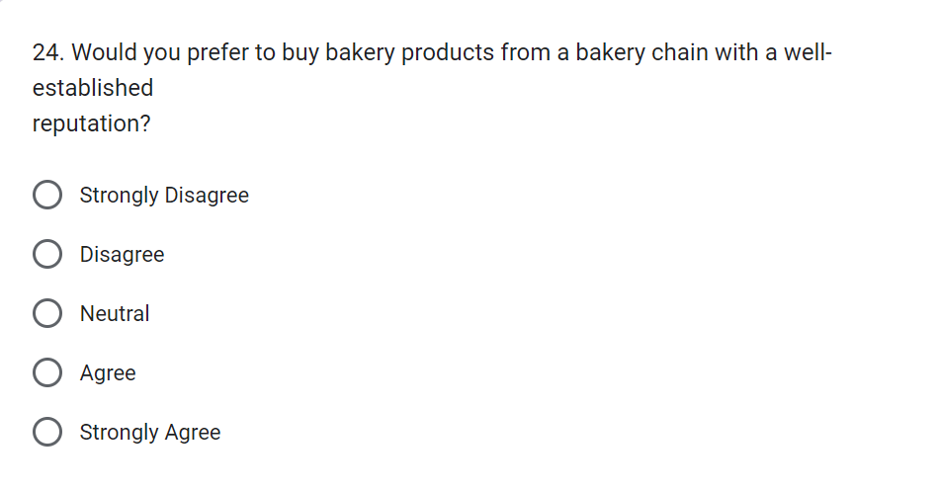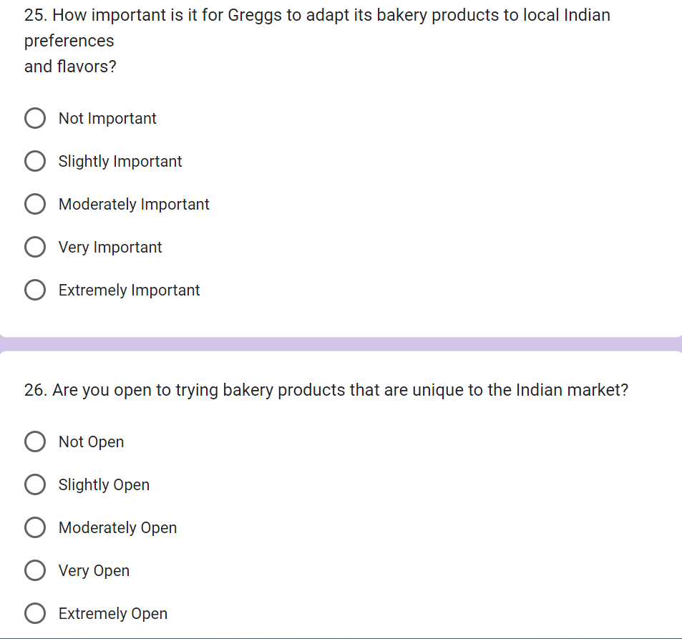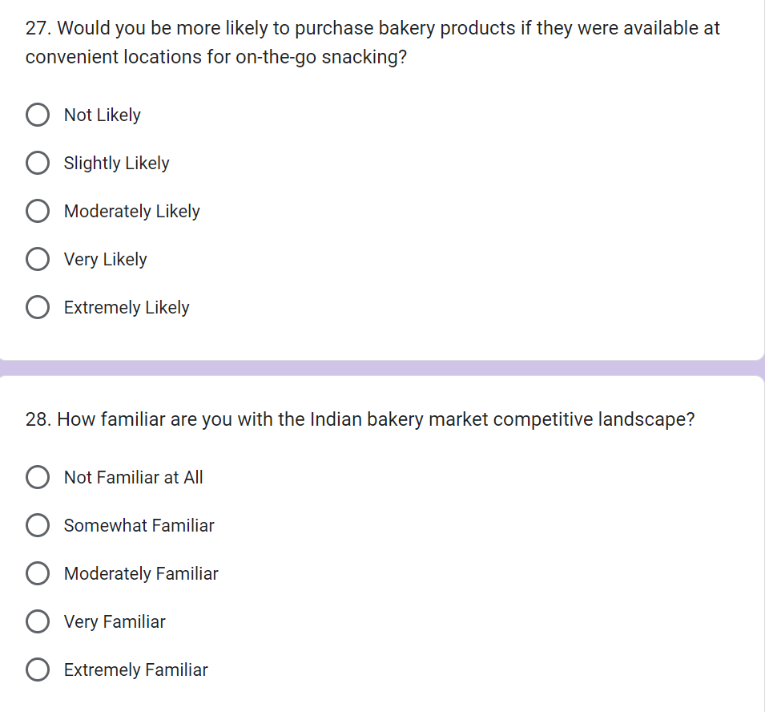

Appendix 2:


