

An analysis of the impact of perceived service quality on guest satisfaction: a case study of DoubleTree by Hilton Southampton

Name: Gheorghita Elenna Tudorache
Student Number: 2238425
Programme of Study: International Hotel Management
Module name: Hotel Placement Project
Module Code: BMIH6008
Declaration
I affirm that I have not applied any AI tools in facilitating the elements of structuring my research, refining my language and organising my ideas in this assignment. The entire analysis, critical analysis and final content will be my own. I have checked, revised and assumed the completeness and accuracy of this submission.
Acknowledgement
I would also like to say that I am grateful to my supervisor, who guided me and gave me an opportunity to receive valuable feedback during this research. Since this paper was only carried out as a secondary source, I also admit the input that was made by the published academic literature and online resources that informed the analysis. Lastly, I would like to mention that I am still supported and influenced by my family and friends.
Abstract
The study focused on the effect of perceptions of service quality on guest satisfaction in DoubleTree by Hilton Southampton using a secondary qualitative case study design. The purpose of the study was to find the areas of service quality based on which the guests were satisfied, to understand the level of the provided service quality, which is reflected in the secondary data sources, and construct viable recommendations applicable to the placement hotel. The study was based on the academic literature, industry reports, and available online reviews (publicly available) that were conducted between January 2026 and February 2026, which were backed by the placement-based observations of the operations.
The results showed that the service quality was determined by the combination of numerous interrelated variables, such as interaction between frontline staff, housekeeping, responsiveness, service recovery efficacy, and digital reputation. Satisfaction of guests was not defined by only the physical facilities or other adherence to brand standards, but also by emotional engagement, quality of communication, and perceived attention. The aspects that were often mentioned in positive reviews were accommodating employees, well-furnished rooms, and smooth check-in procedures. Disparities, however, were noticed at times of high demand, especially in the areas of late room preparation, lack of communication between departments, and imbalanced handling of complaints. The discussion proved that the gap between expectations and performance had a great impact on the result of satisfaction. Guest satisfaction was enhanced when the personalised attention and responsiveness were in line with the expectations of the guests. On the other hand, workloads and staff shortages occasionally undermined service consistency, thus resulting in dissatisfaction because of operational pressures. Digital platforms multiplied both positive and negative experiences, future expectations of the guests and shaped the decision on whether to book a room.
It was concluded that the quality of service at the hotel, DoubleTree Southampton, was a multidimensional variable and contextual variable instead of being a constant operational variable. The standardised quality of the service frameworks gave helpful advice but did not quite reflect the situational realities of day-to-day hotel operations. The study suggested that frontline staffing should be reinforced at the most critical times, service recovery processes should be institutionalised, communication among departments should be better and enhanced, continuous staff training should be encouraged, systematic review online monitoring should be adopted, feedback on quality improvement cycles should be integrated with the guests, service quality framework needs to be localised and staff wellbeing programmes should be enhanced.
In general, the analysis has revealed that long-term guest satisfaction was based on the ability to provide services consistently, manage operations flexibly, and take active measures to secure digital reputation in a competitive high-end hospitality setting.

Contents
Chapter 1: Introduction 8
1.1 Background of the Study 8
1.2 Research Problem and Context 8
1.3 Research Aim 8
1.4 Research Objectives 9
1.5 Research Questions 9
1.7 Structure of the Research Project 9
Chapter 2: Literature Review 10
2.1 Introduction to the Literature Review 10
2.2 Concept of Service Quality in Hospitality 10
2.3 Service Quality Models in Hotel Operations 11
2.4 Concept of Guest Satisfaction 12
2.5 Literature Gap and Conceptual Framework 12
Chapter 3: Research Methodology 13
3.1 Introduction 13
3.2 Research Philosophy 13
3.3 Research Approach 14
3.4 Research Design 14
3.5 Data Selection Criteria 14
Chapter 4: Findings and Discussion 16
4.1 Introduction 16
4.2 Findings 16
4.2.1 Frontline Service and Staff Interaction 16
4.2.2 Housekeeping Standards and Room Experience 18
4.2.3 Responsiveness and Service Recovery 20
4.2.4 Digital Reviews and Guest Expectations 21
4.3 Discussion 24
4.3.1 Service Quality as a Multidimensional Experience 24
4.3.2 Guest Satisfaction and Expectation–Performance Gaps 24
4.3.3 Operational Pressures and Service Consistency 25
4.3.4 Digital Influence and Reputation Management 26
4.3.5 Implications for DoubleTree by Hilton Southampton 27
4.4 Chapter Summary 27
Chapter 5: Conclusion and Recommendations 28
5.1 Conclusion 28
5.2 Recommendations and Practical Strategies 30
Reference List 33
Appendices 38
Appendix A: Summary of Key Literature Themes Related to Service Quality and Guest Satisfaction 38

Chapter 1: Introduction

1.1 Background of the Study
Hospitality services are important in human interaction, operational processes and management coordination of the service, and all these have an impact on the overall guest perception of the service (Cooper and Hall, 2016). The hospitality industry also makes a great contribution to overall economic growth, job opportunities, and competitive aspects in the region. Hotels have a direct bearing on the tourism activity through assisting business traveling, recreational travel, and the short break markets, and in this respect, service quality is a strategic consideration and not an operational consideration (Thommandru et al., 2023). The study has its basis on the professional placement experience of the student at the DoubleTree by Hilton Southampton. Placement-based learning helps students to see real-life challenges of service delivery and organisational practices that cannot be entirely perceived by secondary data (ASET, 2017). The context of placement, hence, offers an applied base to studying the way in which perceived service quality is offered, experienced and assessed in a working hotel setting.

1.2 Research Problem and Context
Even though the quality of services offered by hotels is strategic, most hotels continue to struggle in ensuring that the quality of service delivery across departments and shifts is uniform. There may be differences between the anticipated and the actual service delivery due to operational pressures, staffing, and differences in training of the employees (Bardi, 2010). The gaps may adversely impact customer satisfaction, especially at a high-end hotel, where it is expected to be high. At DoubleTree by Hilton Southampton, service consistency, communication and service recovery issues were pointed out during the placement experience. Although academic studies have examined service quality and guest satisfaction in a broad manner, there is still a necessity to conduct some context-specific analysis that reveals the working realities of hotel properties (Conrady and Buck, 2012). This paper will fill such a gap by providing a hotel case study based on placement experience.

1.3 Research Aim
This research will focus on the impact of the perception of the quality of the service on the guest satisfaction at DoubleTree by Hilton Southampton by critically analysing the existing academic literature, industry reports, and internet-based guest reviews, as well as official hospitality statistics, and providing a practical recommendation on how to improve the quality of the service.

1.4 Research Objectives
- To identify the key service quality factors influencing guest satisfaction in upscale hotel settings, with specific reference to DoubleTree by Hilton Southampton.
- To critically evaluate how service quality and guest satisfaction are reflected and discussed in secondary sources relating to DoubleTree by Hilton Southampton.
- To develop evidence-based recommendations to enhance perceived service quality and guest satisfaction at DoubleTree by Hilton Southampton?

1.5 Research Questions
- What service quality factors are most strongly associated with guest satisfaction in upscale hotel settings, with particular reference to DoubleTree by Hilton Southampton?
- How are service quality and guest satisfaction represented and evaluated in secondary qualitative data relating to DoubleTree by Hilton Southampton?
- How can service quality practices at DoubleTree by Hilton Southampton be enhanced to improve guest satisfaction?

1.7 Structure of the Research Project
This Research Project is divided into five chapters. The first chapter is the introduction of the research background, problem, aim, objectives, and significance. Chapter Two is a critical literature review on the topic of service quality and guest satisfaction in hospitality. Chapter Three describes the methodology of the research, such as the research design, data sources, and ethics. Chapter Four discusses the results based on the research questions, and Chapter Five summarises the major findings, limitations, and proposals that conclude the research.

Chapter 2: Literature Review

2.1 Introduction to the Literature Review
The chapter assesses available literature on the topic of service quality and guest satisfaction in the framework of hotel operations and, in particular, in the context of the placement at DoubleTree by Hilton Southampton. The targeted review assists in placing the study in the context of the research in the hospitality industry and also aids in the formation of analytical clarity (Cooper and Hall, 2016). The quality of service and satisfaction of the customers are not key issues in the hotel performance because they affect customer experience and competitiveness (QAA, 2011). This chapter explores the concept of service quality, important models of operations, theories of guest satisfaction and their interconnection, and then the gaps in existing literature are pointed out. Such insights are the conceptual basis of the analysis of service practices and provide recommendations.

2.2 Concept of Service Quality in Hospitality
Service quality in hospitality is the extent to which a given service satisfies or surpasses the expectations of the guests in terms of tangible and intangible aspects of service provision. Hospitality services, unlike manufactured product are intangible, simultaneous, heterogeneous and perishable, and this makes it harder to control quality and standardisation (Johnston, Clark and Shulver, 2012). Such features imply that the quality of services is usually evaluated in a subjective manner, as perceived by the guests, without any objective measures (Hayes and Miller, 2012). This challenge becomes more pronounced when managers must anticipate fluctuating guest expectations, peak demand periods, and varying service encounters occurring simultaneously across departments. Service quality management, therefore, involves cross-departmental coordination rather than isolated operational control. Service quality management thus entails the coordination of departments instead of unilateral control in the operations. Employees are emphasised as they are at the centre of the service quality perception, as they have direct interaction with the service. Frontline employees have a role in shaping the understanding of service encounters by guests based on the communication patterns, responsiveness, and emotional labour (Mill, 2012). For example, reception responsiveness, housekeeping attentiveness, and restaurant service behaviour significantly shape overall guest experience and satisfaction levels. This enables human resource practices in ensuring that the quality of services is maintained. The external factors that worsen the situation of maintaining the same degree of service in hotels include demand changes, shortage of staff, and limitations imposed by operations. To address these pressures, hospitality organisations are finding it necessary to modify their management practices to please the guests, as they continue to exist (Okumus, 2020).

2.3 Service Quality Models in Hotel Operations
Service quality models have been constructed to conceptualise and measure systematically the way guests rate service performance. The SERVQUAL model is one of the most popular models used in the studies of the hospitality industry, and the model measures the quality of services offered in five dimensions, namely, reliability, responsiveness, assurance, empathy, and tangibles. It is a model that is rooted in the discrepancy between the expectations and perceived service delivery of the guests and provides the managers with a systematic mechanism of establishing the areas that are weak in the operations (Johnston, Clark and Shulver, 2012). Although SERVQUAL is a valuable diagnostic tool, critics say the measurement of expectations is volatile and situational, especially in a dynamic hotel environment where the perceptions of the visitors can change over time during their stay.
Another measure is SERVPERF that dwells on the particular performance perceptions in lieu of expectation gaps. This model is easier to collect data and has been demonstrated to give more consistent data in service-intensive sectors like the hospitality industry (Marshall, 2015). The two SERVQUAL and SERVPERF are, however, based on standardised dimensions that might not ensure the capture of situational factors that are unique to a particular hotel, e.g. purpose of travel, cultural background, or emotional aspect of service encounters.
In addition to those quantitative models, scholars are now becoming more aware of the usefulness of qualitative service quality paradigms that can study guest accounts, staff behaviours, and business rituals. Qualitative methods make it possible to better understand the process of service quality construction at the frontline level, in organisational culture and managerial systems (Grbich, 2006). The viewpoint emphasises that service quality is not a measure of outcome but a socially constructed process that is influenced by the behaviour of employees, the design of service, and the context of an organisation.
Although very useful, generic models of service quality have weaknesses when strictly applied to the actual hotel activities. Hotels make use of a complex environment that is affected by the number of staff, demand variations, and changes in service delivery, which makes it hard to apply universal measurement structures at the same time (McGivern, 2006). Consequently, researchers note that models should be customised to meet local operation realities as opposed to mechanical application.
Following these constraints, recent studies in hospitality propose a blend of formal approaches to quality of service provision and situational interpretation. This allows the managers to have models as guiding tools when integrating the operational insight, as well as guest feedback into decision making (Johnston, Clark and Shulver, 2012). This paper, therefore, takes a critical view of service quality models as interpretive frameworks to service quality models instead of the prescriptive measurement instruments.

2.4 Concept of Guest Satisfaction
Guest satisfaction is used to refer to the degree to which the services offered within the hotel are able to meet or surpass the needs and expectations that the guests have towards the services rendered by the hotel, and it is a combination of cognitive evaluation and emotional reaction (Faulkner, Moscardo and Laws, 2001). The concept of satisfaction in the hospitality industry is influenced not only by the performance of its service but also by symbolic and experience aspects of comfort, recognition, and perceived value (Khan et al., 2020). In Doubletree Southampton, the guest needs are usually based on cleanliness, responsiveness of the staff, efficiency of the check-in and personalised communication, and the wants are based on ambience and other service features. The achievement of technical service standards does not necessarily lead to satisfaction since the lack of emotional or situational expectations could diminish satisfaction. It is here that the significance of considering both functional and experiential aspects when gauging the results of guest satisfaction lies (Eyuboglu and Eyuboglu, 2020).

2.5 Literature Gap and Conceptual Framework
Despite the extensive literature on the topic of service quality and guest satisfaction, a number of gaps are still apparent. Much of the available literature is based on generic service quality frameworks and high-level surveys and contains little information about the property specifics of operational reality (Greetham, 2014). This restricts knowledge of the way of experience and management of service quality at individual hotel levels. Higher education advice is increasingly advocating applied research that is applied between theory and professional practice (QAA, 2018). Project Report fills in this gap by selecting one branded hotel and basing on the experience of placement as a way of offering a context-sensitive piece of information (Fantthorne, 2004). This theoretical emphasis justifies the research objectives of the study.
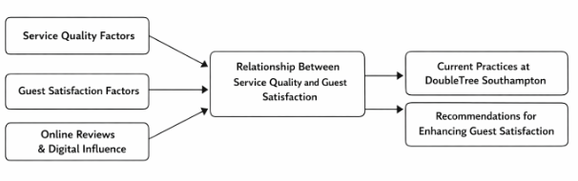
Figure 1: Conceptual Framework; Source: (Self-made)
Conceptual Framework demonstrates how the factors of service quality, the factors of guest satisfaction, and online reviews and digital influence are important factors in their input as influencing the relationship between service quality and guest satisfaction factors in an upscale hotel situation. All these are added up to make the guests feel and judge their experience as a whole. The main connection then leads to an evaluation of the existing practices of service quality at the DoubleTree by Hilton Southampton.

Chapter 3: Research Methodology

3.1 Introduction
The chapter summarises the research approach employed in defining the service quality and the satisfaction of guests at DoubleTree by Hilton Southampton, based on a secondary case study in qualitative research. The study was undertaken as a placement-based project, which combined both operational insight and academic analysis. The data were collected between January and February 2026, and the sources were publicly available, including TripAdvisor, Booking.com, Google Reviews, Hilton corporate publications, and industry reports. These sources offered narrative data regarding frontline service, housekeeping, responsiveness and service recovery. The secondary qualitative method was taken because of access and additional ethical limitations, which provided the possibility to create a meaningful assessment of guest perceptions and follow the research goals and the operational situation in the case hotel.

3.2 Research Philosophy
This study takes the interpretivist philosophy, which acknowledges that the quality of service and the satisfaction of the guests are socially constructed experiences, influenced by personal expectations, feelings, and context. In the hospitality setting, like the DoubleTree, Southampton, guest satisfaction cannot be quantified as a measurable phenomenon but rather by individual stories and experiences of service. The interpretivism approach is thus suitable because the study aims at analysing the feedback comments left by guests, not on the basis of the numerical values of performance. The study aims to make an interpretation by analysing the content of qualitative reviews and understanding the experience of guests in terms of interactions with staff, responsiveness in their services and the atmosphere of the hotel (Flick, 2018; Tribe, 2009).

3.3 Research Approach
The qualitative method used was inductive, and the themes developed out of the data analysed as opposed to testing hypotheses. This was especially appropriate because the study aimed at investigating the perception of the guests in the DoubleTree Southampton using secondary sources like online reviews and hospitality reports. Patterns that are associated with staff behaviour, communication, cleanliness and service recovery were identified naturally and across a variety of guest stories with the help of induction. As opposed to rigorously enforcing frameworks, the methodology enabled the real guest experiences to inform analytical categories (Maxwell, 2012).

3.4 Research Design
The design of the study is a qualitative and exploratory case study, which is based on DoubleTree by Hilton Southampton, through secondary data as well as placement-based observational insight. Frontline service delivery, guest-staff interaction, check-in procedures, housekeeping responsiveness and service recovery practices were informally observed during the placement period, and they assisted in formulating the inductive guidance of the research. The following operational observations were used to testify to the identification of the primary themes of service quality that were further analysed using online guest reviews, scholarly sources, and industry reports. The design promotes an interpretative interpretation of the guest satisfaction as it will integrate both real-life experience in the hotel with documentary interpretation, which makes it possible to give meaning to the contextualisation of service quality practices in the chosen hotel environment (Creswell, 2014; Veal, 2006).

3.5 Data Selection Criteria
The sources that were selected were based on the need to find those that directly covered the topic of service quality and guest satisfaction, as well as hotel operations in the context of hospitality (Braun and Clarke, 2013). The study will rely exclusively on secondary data sources, including peer-reviewed academic literature, hospitality industry reports, publicly available company information, and online guest review platforms (e.g. aggregated review data from recognised booking and review websites).
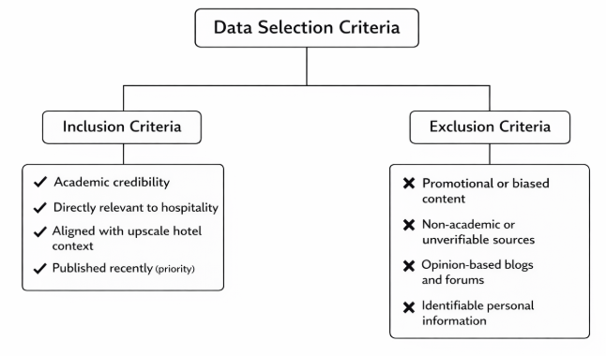
Figure 2: Data Selection Criteria; Source: (Self-made)
In order to ensure integrity in academics, proper citation and recognition of all sources were observed. In line with UWTSD Research Ethics and Integrity Policy, ethical approval was formally obtained through completion of the PG2 Ethics Application Form, which was reviewed and approved prior to commencing the study.

Chapter 4: Findings and Discussion

4.1 Introduction
The chapter is a presentation and critical discussion of the findings of secondary qualitative data that was associated with the experiences of guests in DoubleTree by Hilton Southampton. The information has been gathered in January and February 2026 on the publicly available online review sites (TripAdvisor, Booking.com and Google Reviews), corporate publications of Hilton, reports in the industry, and operational observations through placements.
The results are structured in three main themes in accordance with the research objectives, and they are service quality dimensions, guest satisfaction outcomes and operational practices that affect service delivery. These findings are then discussed in the discussion section with regard to the current literature, with implications for how these findings relate to the operations of a hotel and areas that the managers need to look into. Thus, this chapter serves as a strong linkage of theory and practice in terms of showing how quality of service is experienced, perceived and managed in the actual upscale hotel setting.

4.2 Findings

4.2.1 Frontline Service and Staff Interaction
The guest reviews suggest that the frontline staff have an important role in the overall level of customer satisfaction (Putra and Dewi, 2023). The attitude of hotel reception staff is quite pleasant and professional, as many customers comment. Numerous application feedbacks describe the lovely reception of the customers and their successful check-in as it was very efficient, and the staff are friendly, professional, and warm. It demonstrates that the guest experience of the hotel is centred on personal contact and quality of customer service (Ponsignon and Derbaix, 2020). The responsive service to the queries also worked well in intensifying the impact of the staff on the satisfaction, with the guests enjoying the helpfulness of the staff with their questions.

Figure 3: Guest review on TripAdvisor; Source: (TripAdvisor, 2026)
The negative reviews, in their turn, revealed aspects that can be enhanced, particularly where there are peaks where the operational pressure affects the service quality (Aydogan et al., 2024). Some of the guests spoke of time wastage in taking in and service differences in various shifts. Indicatively, some reviews have cited that no workers were present when they were at the company during peak periods, creating a longer wait time in the process of seeking service. The room allocation system also received a complaint from one of the guests since the room was not ready yet, as it had heating issues, and thus they had to wait until long before they had their room. Another review also described waiting as long as an hour in the bar area before a maintenance issue was resolved, and then they could be allowed to enter their room.
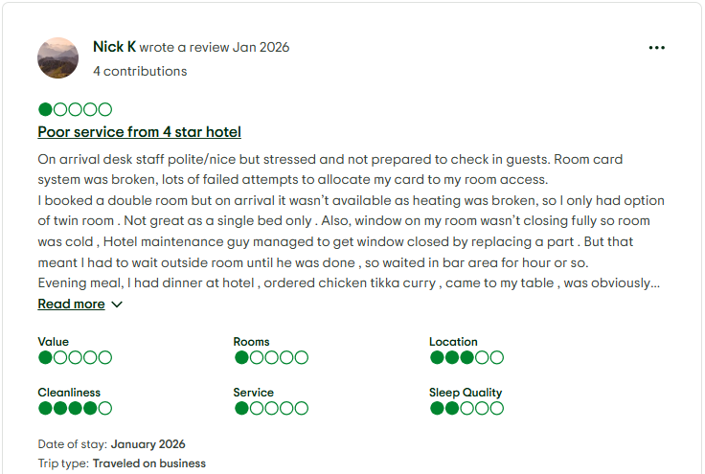
Figure 4: Guest review on TripAdvisor; Source: (TripAdvisor, 2026)
These observations are in line with the observations in the placement test, which indicated the excessive levels of crowding which exposed the frontline staff to a lot of pressure. This was a contributor to rushed contacts, and this has a bearing on the personalisation of service and the satisfaction of the guests. Even though the general performance of the staff members was generally favourable, it was evident that the unreliability of the services, particularly during high demand, had an overall impact on the guest experience. These results show that the hotel is doing well in the sphere of customer service, but it should improve the sphere of service consistency during the peak seasons to achieve a high level of customer satisfaction (Khan et al., 2022).

4.2.2 Housekeeping Standards and Room Experience
In numerous guest reviews, housekeeping is the key to the satisfaction of the guests (Casal-Ribeiro et al., 2023). Before positive reviews, many highlighted the room cleanliness, comfortable beds and the modern facilities. Visitors used to relate clean rooms to the professionalism of the personnel and regarded it as a great display of value for money. As an example, the hotel has received excellent reviews due to comfortable beds, a quiet and cosy environment, and one of the reviews mentioned the convenient facilities offered in the room. Lack of cleanliness in the rooms was unanimously overcome by the high level of service and attention that the hotel offered its guests in the positive reviews.
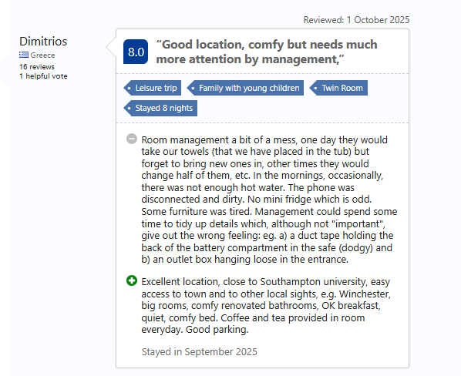
Figure 5: Guest review on Booking.com; Source: (Booking.com, 2026)
Nevertheless, a lower, but significant percentage of the reviews expressed concerns regarding housekeeping. The complaints included the late room availability and irregular furnishing replenishment (Pekdemir and Kucukaltan, 2024). There were occurrences where guests missed towels being changed or the dirty phones that were found in the room, and it had an effect on the overall quality of the service delivery. The guest cited in one of the reviews that there was a disconnected phone, no hot water, no mini fridge, and this did not enhance the comfort that they were supposed to have in a hotel of that calibre. The other issue reported was the old furniture in the room, which appeared to influence the general impression of the hotel's guests. These results indicate that the level of housekeeping performance can be deemed as effective, but service reliability can be weakened at the time of high demand, which directly affects the satisfaction of guests and quality perceptions (Djajasinga et al., 2021).

4.2.3 Responsiveness and Service Recovery
The efficiency with which issues and complaints are handled is an important factor that contributes to guest satisfaction (Dastane, 2020). Offering positive reviews, there were often cases when problems were fixed in time, which caused a greater level of satisfaction. As an illustration, visitors have noted good results when maintenance problems like room facility problems are quickly resolved, with some even being granted a room change or free services to the clients due to the delays. Such gestures as free meals or an upgrade usually transformed what might have been a negative experience into a better one, building loyalty and increasing the overall satisfaction of the guests (Ponsignon and Derbaix, 2020).
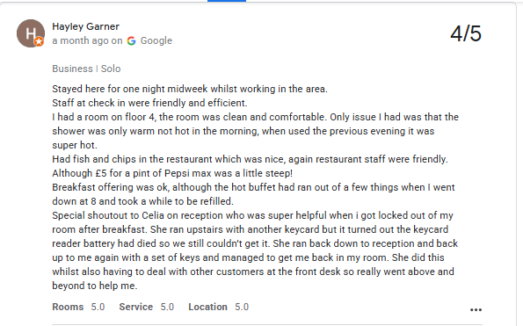
Figure 6: Guest review on Google; Source: (Google, 2026)
Nevertheless, some cases when complaints were not resolved or managed properly also occurred, which resulted in frustration and lower ratings (Abualigah et al., 2023). One of the guests remarked that they had been waiting long before their problems with their room were resolved, even after the guests had reported the problem, which created a bad attitude towards the quality of the services they received. In one more review, the guest has stated that he or she was treated unjustly after inquiring about the quality of the food. There was an exacerbation of the problem in this instance, yet it was not resolved, posing a feeling of discontent.
Placement observations established that the inconsistency in the handling of complaints was a consistent problem. Most of the guests were happy with the fast manner in which their issues were addressed, but others experienced slow service recovery or delayed services. Dissatisfaction and confusion were observed, especially when the managers were not available, and there was no clear process of escalation.
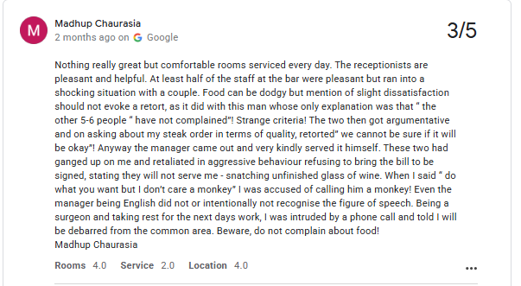
Figure 7: Guest review on Google; Source: (Google, 2026)
It underscores the importance of systematic service recovery mechanisms to uphold the confidence of the guests and save the brand image of the hotel. The active way of solving complaints will help to make a negative experience positive and guarantee the guest loyalty in the long run.

4.2.4 Digital Reviews and Guest Expectations
Online reviews have turned into a crucial element that influences the guest expectations prior to their arrival, in addition to the review being about those who have already stayed (Jayawardena et al., 2023). Positive feedback can also be taken as an assurance to the prospective guests and assures them of their decision to book. As an example, one of the guests gave positive reviews about the location of the hotel, clean rooms, and friendly service, pointing out that he had been going back there several times and would not stop going back. Such positive digital presence improves the image of the hotel and leads to new reservations because it preconditions the appearance of a high-quality and comfortable stay (D'Souza and D'Souza, 2023).
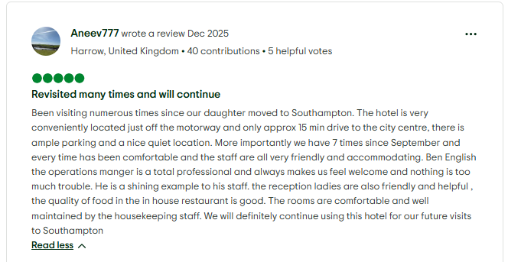
Figure 8: Guest review on TripAdvisor; Source: (TripAdvisor, 2026)
The effects of negative reviews on the perception of the guests can be significant. Visitors with service or amenity concerns will have a higher chance to share their dissatisfaction online, and this fact may influence the future expectations of new visitors (Casal-Ribeiro et al., 2023). Indicatively, one of the guests posted a negative comment regarding their experience at DoubleTree Southampton, which included the restaurant serving them late even after placing an order, and failure to respond to their booking inquiries. Such feedback may create awareness regarding service deficiencies, which may make potential guests more conscious of such aspects as room quality, staff attitude, and their service efficiency. Negative incidents, however few, may cause the guest to be more critical towards such minor effects as evidenced by the review where the guest believed that his experience was not as expected based on the premium price paid.
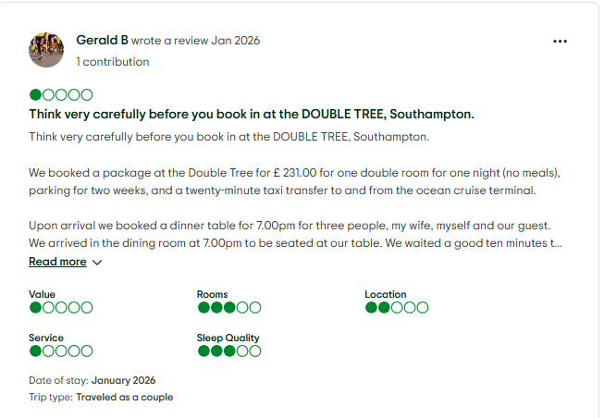
Figure 9: Guest review on TripAdvisor; Source: (TripAdvisor, 2026)
Placement observations proved that guests used to discuss online reviews prior to the stay, and in certain instances, online reviews resulted in the lack of consistency between the experience described in the reviews and the one that was experienced at all. This implies that the expectation of the guests was based on the previous reviews, which were either positive or negative, and were based on a higher standard, which is not necessarily the same as the service that is offered.
The implication of the same to the DoubleTree Southampton is apparent: online reputation management plays a key role. It is necessary to address negative feedback as soon as possible and ensure a positive online image when managing expectations of guests and the effects of a negative understanding (D'Souza and D'Souza, 2023). The strategy with regular interactions with guests via online reviews and proactive responding to complaints can assist in meeting the expectations of guests with the real experience, saving the reputation of the hotel and promoting their further reservations.

4.3 Discussion

4.3.1 Service Quality as a Multidimensional Experience
Service quality at the DoubleTree Southampton cannot be limited to a single factor of operation. Rather, it is a result of a complex interaction of multiple factors, among them the behaviour of the staff, physical setting, responsiveness and emotional involvement. This is in line with the literature in the hospitality industry that perceives service quality as a multidimensional construct that is affected by functional aspects, including operational effectiveness and experiential aspects that comprise emotional and interpersonal contacts (Johnston, Clark, and Shulver, 2012). Frontline employees, especially in the hospitality sector, play a pivotal role in determining whether the guests will be satisfied or not with the services they receive. As seen in the results, the front-line personnel play a decisive role in terms of how the guests see the quality of their experience at large. This confirms the argument by Mill (2012) that emotional labour and interpersonal communication are critical in the service provision of high quality. Emotional labour is the ability or habit of employees to regulate their emotions so that they can meet the demands of their job, particularly in sectors such as hospitality, where they have to deal with customers at the customer interface on a regular and continuous basis. The satisfaction level of the guests was directly connected to the positive interactions with the employees. Such interactions like welcoming the guests at check-in, offering personalised treatments during meals, and helping the guests with their specific requests played a great role in the perceptions of the guests towards the hotel.
Nonetheless, the results also reflected the weaknesses in the service delivery, especially in peak hours. Some of the reviews highlighted that the quality of service was sometimes erratic and was usually associated with some operational problems, like staff shortage or increased waiting time. These discrepancies are indicative of operational difficulties that become more intense during periods of high demand, which expose areas of the hotel at which its service systems can be improved. Frontline staff tended to be good; however, the areas in which the service was not available when guests needed it affected their satisfaction. This observation underlines the premise that any operational problem can suffocate the general experience of the service, despite the excellence of other operations by the hotel.

4.3.2 Guest Satisfaction and Expectation–Performance Gaps
The level of guest satisfaction at the DoubleTree Southampton was highly related to the effectiveness of the services offered by the hotel to meet the personal expectations of the guests, and not necessarily the objective standards of service quality. This observation reaffirms the fact that Faulkner, Moscardo, and Laws (2001) assert that people should not only get satisfaction with the appropriateness of the cognitive appraisal of service quality (i.e., how clean the room is or if the amenities meet the expected standards) but also with the feeling and situational reactions to service provision. Essentially, the concept of satisfaction is not only about adjusting to the expectations of the emotional nature, but also the fundamental functional expectations.
Cleanliness, responsiveness of staff and personalised communication of the guests were of great importance to them at the DoubleTree Southampton. Where these factors were uniform and achieved the expectations of the guests, the level of satisfaction was much better. The most common comments in the positive reviews were the comfort of the rooms, the attentiveness of the staff, and the welcoming atmosphere. In the cases when these factors existed, guests believed that their stay did not fall below their expectations but was even higher and led to positive feedback and an increase in the score of satisfaction.
The study, however, also noted how the service delivery gap caused dissatisfaction. Housekeeping reliability was one of the areas that were identified to have gaps. Some reviews also said that there was inconsistency in the standards of cleaning, especially during peak times, which affected the total experience. Indicatively, there have been complaints of rooms not being cleaned properly and facilities not being replaced as requested by some of the guests. Furthermore, dissatisfaction was worsened in cases where service recovery was not quick and successful. This supports the conclusion of Eyuboglu and Eyuboglu (2020) that the satisfaction of guests is not only dependent on first-time service interactions but also on the cumulative experience that guests may have with a hotel throughout their time. The gaps in service that arise when they are present may create negative perceptions that may eclipse an otherwise good stay.

4.3.3 Operational Pressures and Service Consistency
The operational issues of DoubleTree Southampton could be observed via the guest reviews as well as by observing placement. Shortages of staff, changeable demand and workload imbalances among the contributing factors to service inconsistencies were reported. These pressures were felt especially during those occasions when the demand was high, like on weekends or when there were local events and the hotel was fully occupied. The high number of guests imposed a lot of pressure on the operation systems, which influenced the efficiency and quality of service provision.
This goes along with Okumus (2020), who notes that operational instability is a problem that lingers in a hotel setting. High occupancy usually leads to decreased personalisation of service, increased wait time, and sometimes a failure of quality room cleanliness and maintenance. Among the areas of concern highlighted in one of the reviews included tardiness in check-ins, lack of room bookings and unequal response by the staff to the requests made by the guests, all of which were indicative of how the operational challenges had affected the service delivery.
Although there are models such as SERVQUAL that are usually employed to quantify the service quality, the results indicate that these models, despite being helpful, might be somewhat ineffective in revealing the intricacies and situational realities that a hotel such as DoubleTree Southampton has to encounter. According to McGivern (2006), the service models should be localised to fit local operational settings as opposed to using them in a blanket fashion.

4.3.4 Digital Influence and Reputation Management
The results highlight the rising significance of the online platform in the formation of perceptions and decision-making among guests. Online reviews and ratings are also becoming the favourite ways through which guests develop expectations about a hotel even before they even grow their feet on the ground.
Nevertheless, negative reviews affect the perception of guests more directly and noticeably. Another important conclusion of the study is that negative online comments enhanced the level of dissatisfaction and increased the level of service delivery paradoxical evaluation. An example is that when former clients had written bad things about certain problems like slow check-in procedures, poor housekeeping, or slow service, the new guests were more susceptible to such problems occurring during their stay. This shows the capability of negative reviews to produce greater expectations and more critical judgments on the quality of services, even in the case of the slightest problems.
This shows the significance of responsible reputation management, especially when responding to negative reviews. The effects of negative perceptions can be reduced by timely responding to complaints and visibly trying to solve service failures to retain the trust of guests. Not doing this can result in a degradation of the online ratings of the hotel, which is a direct influence on subsequent guest reservations. The increased importance of the digital feedback requires the effective management of the reputation that involves the review monitoring and the timely response to the guest concerns.

4.3.5 Implications for DoubleTree by Hilton Southampton
The results indicate that the DoubleTree Southampton hotel is doing well in various fundamental areas of service, especially in guest comfort, employee hospitality, and the general feeling of the hotel. Nonetheless, it is difficult to be consistent at times when there is demand. Operational pressures at such periods as staffing shortages and variable guest demand do not support the hotel in delivering the same level of service at all times.
The work experience demonstrated feasible areas of enhancement, especially with regard to interdepartmental coordination and service recovery measures. By improving communication systems, establishing more explicit channels for guests to escalate issues, and giving frontline employees the ability to make decisions, the service delivery may be improved overall. These measures would be used in reducing the effects of operational pressure and maintaining the quality of the services even when there is a rush.
In addition, the results indicate that though DoubleTree Southampton is compliant with the brand standards, it also needs to implement flexible operational practices that will respond to the local conditions. A combination of practical realities in the hotel sector with the hypothetical service quality models can make it easier to deal with the problem of high occupancy, variable demand, and service recovery, and eventually achieve a high level of sustained guest satisfaction and improved reputation (QAA, 2018).

4.4 Chapter Summary
This chapter explored service quality and guest satisfaction of DoubleTree by Hilton Southampton through secondary qualitative data and observation of the placement. The main results showed that frontline employees, the reliability of housekeeping, responsiveness, and digital reputation played the leading role in creating guest experience. The discussion showed that the quality of services is a process constructed socially based on emotional involvement, operation systems and contexts. These insights can be utilised in coming up with specific recommendations in order to improve service delivery, and they have been represented with consideration in the next chapter.

Chapter 5: Conclusion and Recommendations

5.1 Conclusion
The study design of the presented placement-based research involved a secondary qualitative case study to evaluate the effect of the perceived quality of the provided services on the guest satisfaction at the DoubleTree by Hilton Southampton. The research incorporated both scholarly sources, organisational reports, web-based guest ratings, and placement visits to examine the experience of service quality, its interpretation, and operationalisation in a high-end hotel set-up.
The purpose of the research was to define the important service quality variables that make a difference to guest satisfaction, contribute to the critical evaluation of the above variables by referring to secondary sources on the case hotel, and to come up with effective recommendations on the way to improve the performance in service delivery. These were achieved by the systematic review of the user-created content and literature on hospitality, so as to get both perspectives and operational realities of the subject matter.
The results of Chapter 4 demonstrated that the frontline staff behaviour, the consistency of housekeeping, the responsiveness of stewardship to guest requests, and the efficiency of service recovery processes are the main factors of guest satisfaction in DoubleTree Southampton. However, a number of the reviews were positive, though there were frequent complaints associated with late check-in, the inability to prepare, the lack of communication among departments, and a poor response to complaints during high operational activities. These issues put the insecure state of delivery of service quality under lights of a high-demand hospitality setting.
The research establishes that the quality of the service provided in a hotel is not limited to the physical facilities and official service quality requirements. It is rather a social construction based on the interactions between the guest and the staff, emotional involvement, and circumstances. Where physical facilities were satisfactory, disappointment ensued when individual attention or prompt attentiveness was not attained. This is in line with current studies on hospitality, which may indicate that emotional and relational aspects of service significantly determine the perception of the guests.
It was found that digital platforms like TripAdvisor, Booking.com, and Google Reviews have a considerable impact on the expectations of the guests before arrival and the improvement in service results after leaving. Online feedback also served as a mirror of the operational performance as well as a reputational engine towards subsequent bookings. This confirms the essence of proactive review management and round-the-clock feedback of the guest sentiment as quality assurance measures.
The study has also identified some shortcomings in the generic service quality models when they are used to individual hotel properties. Although models like SERVQUAL and SERVPERF provide systematic methods to assess the performance of the service, they fail to reflect the complexity of operations, staffing issues, and situational limitations faced in DoubleTree Southampton. Placement observations proved that the change of service delivery varies with the changing occupancy levels, availability of staff, and coordination of organisational functions, which is mostly underexplored in standardised models.
The research presented in the study offered practical insight into the way service quality is performed in practice, and this was achieved through the adoption of a placement-based qualitative approach. The placement period was useful in supporting data in the review since it enabled observation of the pressures experienced by frontline teams, especially during high occupancies. Informal observation of reception processes, housekeeping coordination, and complaint process resonated the operational realities in ways that are not always evident in published literature, the experience of the guest.
Nevertheless, the article is constrained by the fact that it is based on secondary data, and there are no primary interviews with guests or employees. The need to preserve ethics and have access to the participants was limiting the direct interaction with the participants, which means that the findings are not made using first-hand narratives but using publicly available materials and professional observation. Although triangulation was useful to enhance credibility, future studies would be enhanced by using the staff's views in order to comprehend internal service processes and organisational culture.
Amid these drawbacks, the study was able to fulfil its goals by defining the key dimensions of service quality, analysing the existing practice based on secondary evidence, and drawing recommendations based on both scholarly theory and practice experience. The results underline the fact that serving guests well means constantly focusing on ensuring that staff are competent, coordinated in operations, and a service culture is offered.
In general, this project can indicate that the management of service quality in a luxury hotel is a flexible and situation-specific process. The hospitality industry in which DoubleTree by Hilton Southampton is located is competitive, and its requirements influence the choice of its brand, online presence, and customer experience. Long-term guest satisfaction, hence, is not only in the continuity of technical standards but responsive, people-centred service provision.

5.2 Recommendations and Practical Strategies
As per the results and the findings of the placement, one can propose the following recommendations to improve the service quality and guest satisfaction of DoubleTree by Hilton Southampton:
1. Strengthen Frontline Staffing During Peak Periods
In most cases, guest dissatisfaction was noted when there are high occupancy rates, and staff are overwhelmed. To respond to this, the hotel must adopt a model of flexible staffing that encompasses a cross-trained workforce and one that has on-call facilities. This plan will make sure that it has enough employees to sustain high standards of service when it is busy. This can help reduce the waiting times in the reception, and the turnaround time of housekeeping can be improved so that the hotel provides a more efficient and smoother experience to guests, even at busy times.
2. Formalise Service Recovery Procedures
Clear and property-specific service recovery protocols are essential to be introduced. These need to enable frontline employees to manage trivial guest concerns as and when, as well as create clear lines of escalation channels in cases of more complicated grievances. Giving employees a free hand, like the right to give free drinks or room upgrades, will allow avoiding the development of dissatisfaction into negative recommendations. An initiative in problem resolution will also show that the hotel cares about the satisfaction of its guests and strengthens a favourable brand image.
3. Improve Interdepartmental Communication
Placement observations identified problems with communication between housekeeping and reception, which influenced the consistency of service. The hotel could also introduce daily operational briefings and compile digital dashboards to enhance coordination. This would enable employees in other departments to be in the know of the room preparation and guest requests. Improved communication would minimise the risk of inconsistencies in services and accomplish the overall guest experience by guaranteeing faster response rates and improved service alignment.
4. Invest in Continuous Staff Development
The training programs must be aimed at the development of emotional intelligence, communication skills, and engaging with the guests, all of which are essential in providing high-quality service. Periodic refreshers at times when business is slow might serve to remind staff about the standards of service and keep them motivated. Through the acquisition of technical skills as well as soft skills, the hotel will have employees who are fully prepared to meet the requirements of the job and eventually enhance the relationship with the guests and service delivery.
5. Implement Systematic Review Monitoring
The importance of online reviews is significant in determining the perception of guests. As part of an effort to manage its online reputation successfully, DoubleTree Southampton ought to conduct monthly online review analysis in order to determine recurrent service problems. The responses by the management to it must be timely, individualised, and show responsibility for the deficiencies. The lessons of the online reviews can be used to make staffing choices, training focus and operational enhancements so that the hotel is always sensitive to the feedback of the guests.
6. Integrate Guest Feedback into Quality Improvement Cycles
The review of the guests should be a part of the continuous improvement process of the hotel. The hotel will be able to facilitate information-based decision-making by establishing feedback summaries for the department leaders. These summaries will make sure that guest views will be the direct channel through which service improvements are made, thus forming a more customised way of fulfilling the expectations of the guests. The integration of guest feedback into the quality improvement cycles will assist the DoubleTree Southampton to remain sensitive to the needs and likes of its customers.
7. Localise Service Quality Frameworks
Instead of using generic models of service quality, DoubleTree Southampton needs to use its quality management structures that it has to adjust to its own guest profile and issues related to its operations. The localised service quality approach will enable the hotel to meet its own operational requirements and position it more closely to the market. The customised approach will make sure that the quality level of the hotel will be relevant and attainable.
8. Enhance Staff Wellbeing and Retention
The causes of the problems that were identified as adverse to service consistency were staff turnover and high workloads. To deal with this, the hotel needs to come up with wellbeing programs, employee recognition, and career developmental programs. These will enhance the morale of the staff and minimise attrition, resulting in a more stable and motivated workforce. The result will be better and more stable service quality, as well as greater customer satisfaction, improved employee welfare, which is in turn beneficial to the hotel and its image.
With these strategies, Hilton Southampton of the DoubleTree can increase its operational strength, improve customer satisfaction, protect its brand name and promote employee performance. The recommendations will combine scholarly research with practical information gained during the placement experience and will be both feasible and applicable to the work of the hotel.

Reference List
Abualigah, A, Koburtay, T, Bourini, I, Badar, K and Gerged, A M (2023). Towards sustainable development in the hospitality sector: Does green human resource management stimulate green creativity? A moderated mediation model, Business Strategy and the Environment, 32(6), pp. 3217–3232.
ASET (2017) Good Practice Guide for Workbased and Placement Learning in Higher Education. Sheffield: ASET.
Aydogan, M, de Esteban Curiel, J, Antonovica, A and Cetin, G (2024) ‘Characteristics of crises resilient organisations in the hospitality and tourism industry’, International Journal of Contemporary Hospitality Management, 36(4), pp. 1432–1453.
Bardi, J A (2010) Hotel Front Office Management. Hoboken: Wiley.
Baumeister, R. F., & Tierney, J. (2018). Willpower: Rediscovering the greatest human strength. Penguin.
Bazeley, P (2013) Qualitative Data Analysis: Practical Strategies. London: Sage.
Booking.com. (2026) Hilton Southampton, Southampton – guest reviews. Available at: https://www.booking.com/reviews/gb/hotel/hilton-southampton-southampton.en-gb.html (Accessed: 16 February 2026).
Braun, V and Clarke, V (2013) Successful Qualitative Research: A Practical Guide for Beginners. London: Sage.
Bryman, A (2008) Social Research Methods. 2nd edn. Oxford: Oxford University Press.
Casado, M A (2012) Housekeeping Management. Hoboken: Wiley.
Casal-Ribeiro, M, Boavida-Portugal, I, Peres, R and Seabra, C (2023) ‘Review of crisis management frameworks in tourism and hospitality: A meta-analysis approach’, Sustainability, 15(15), p. 12047.
Collis, J and Hussey, R (2014) Business Research: A Practical Guide for Undergraduate and Postgraduate Students. 4th edn. Basingstoke: Palgrave Macmillan.
Conrady, R and Buck, M (2012) Trends and Issues in Global Tourism. Berlin: Springer.
Cooper, C and Hall, M (2016) Contemporary Tourism: An International Approach. Oxford: Goodfellow.
Cotterill, S (2011) Critical Thinking Skills: Developing Effective Analysis and Argument. Basingstoke: Palgrave Macmillan.
Cottrell, S (2014) Dissertation and Project Reports: A Step by Step Guide. Basingstoke: Palgrave Macmillan.
Creswell, J W (2014) Research Design: Qualitative, Quantitative, and Mixed Methods Approaches. 4th edn. London: Sage.
D’Souza, E and D’Souza, K (2023) ‘A study on the impact of innovative technologies in the hospitality industry’, Journal of Tourism, Hospitality and Culinary Arts, 15(1), pp. 1–23.
Darcy, S, Buhalis, D and Ambrose, I (2012) Best Practice in Accessible Tourism: Inclusion, Disability, Ageing Population and Tourism. Bristol: Channel View.
Dastane, D O (2020) ‘Impact of digital marketing on online purchase intention: Mediation effect of customer relationship management’, Journal of Asian Business Strategy, 10, pp. 142–158.
Denscombe, M (2010) The Good Research Guide: For Small-Scale Social Research Projects. 4th edn. Maidenhead: Open University Press.
Diamantopoulos, A and Schlegelmilch, B B (2002) Taking the Fear Out of Data Analysis. London: Dryden.
Djajasinga, N D, Sulastri, L, Sudirman, A, Sari, A L and Rihardi, E L (2021) ‘Practices in human resources and employee turnover in the hospitality industry’, Proceedings of the 2nd Annual Conference on Blended Learning, Educational Technology and Innovation (ACBLETI 2020), pp. 113–117.
Duan, J, Xie, C and Morrison, A M (2022) ‘Tourism crises and impacts on destinations: A systematic review of the tourism and hospitality literature’, Journal of Hospitality and Tourism Research, 46(4), pp. 667–695.
Eyuboglu, S and Eyuboglu, K (2020) ‘Tourism development and economic growth: An asymmetric panel causality test’, Current Issues in Tourism, 23(6), pp. 659–665.
Fallon, M and Rutherford, D (2010) Hotel Management and Operations. Hoboken: Wiley.
Fantthorne, C (2004) Work Placements: Survival Guide for Students. Basingstoke: Macmillan.
Faulkner, B, Moscardo, G and Laws, E (2001) Tourism in the 21st Century: Reflections on Experience. London: Continuum.
Flick, U (2018) An Introduction to Qualitative Research. 5th edn. London: Sage.
Google. (2026) DoubleTree by Hilton Southampton reviews – Google Travel. Available at: https://www.google.ie/travel/hotels/entity/ChcIpYeBkrOE7pZeGgsvZy8xdGZnMms3aBAB/reviews (Accessed: 17 February 2026).
Grbich, C (2006) Qualitative Data Analysis: An Introduction. London: Sage.
Greetham, B (2014) How to Write Your Undergraduate Dissertation. Basingstoke: Palgrave Macmillan.
Guest, G, Namey, E and Saldaña, J (2012) Collecting and Analyzing Qualitative Data: A Field Manual for Applied Research. London: Sage.
Hagg, E (2013) Internship Guide. Dhaka: The Hague.
Hayes, D K and Miller, A A (2012) Revenue Management for the Hospitality Industry. Hoboken: Wiley.
Jayawardena, C, Ahmad, A, Valeri, M and Jaharadak, A A (2023) ‘Technology acceptance antecedents in digital transformation in the hospitality industry’, International Journal of Hospitality Management, 108, p. 103350.
Johnston, R, Clark, G and Shulver, M (2012) Service Operations Management. 4th edn. Harlow: Pearson.
Kalvet, T, Olesk, M, Tiits, M and Raun, J (2020) ‘Innovative tools for tourism and cultural tourism impact assessment’, Sustainability, 12(18), p. 7470.
Khan, A, Bibi, S, Lorenzo, A, Lyu, J and Babar, Z U (2020) ‘Tourism and development in developing economies: A policy implication perspective’, Sustainability, 12(4), p. 1618.
Khan, R U, Salamzadeh, Y, Iqbal, Q and Yang, S (2022) ‘The impact of customer relationship management and company reputation on customer loyalty: The mediating role of customer satisfaction’, Journal of Relationship Marketing, 21(1), pp. 1–26.
Laws, E, Prideaux, B and Chon, K (2007) Crisis Management in Tourism. Wallingford: CABI.
Marshall, C (2015) Designing Qualitative Research. 6th edn. London: Sage.
Maxwell, J A (2012) Qualitative Research Design: An Interactive Approach. London: Sage.
McGivern, Y (2006) The Practice of Market and Social Research: An Introduction. Harlow: Prentice Hall.
Merriam, S B and Tisdell, E J (2016) Qualitative Research: A Guide to Design and Implementation. 4th edn. San Francisco: Jossey-Bass.
Miles, M B, Huberman, A M and Saldaña, J (2014) Qualitative Data Analysis: A Methods Sourcebook. 3rd edn. London: Sage.
Mill, R C (2012) Resorts Management and Operations. 3rd edn. Hoboken: Wiley.
Molina-Castillo, F J, Meroño-Cerdán, A L, Lopez-Nicolas, C and Fernandez-Espinar, L (2023) ‘Innovation and technology in the hospitality sector: Outcome and performance’, Businesses, 3(1), pp. 198–219.
Okumus, F (2020) ‘Leadership research in hospitality and tourism’, International Journal of Contemporary Hospitality Management, 32(6), pp. 2029–2034.
Pallant, J (2010) SPSS Survival Manual. 4th edn. Maidenhead: Open University Press.
Patton, M Q (2015) Qualitative Research and Evaluation Methods. 4th edn. London: Sage.
Pekdemir, T and Küçükaltan, E G (2024) ‘Organizational resilience and crisis management relationship in hospitality businesses’, İşletme Araştırmaları Dergisi, 16(1), pp. 206–222.
Pham, N T, Thanh, T V, Tučková, Z and Thuy, V T N (2020) ‘The role of green human resource management in driving hotel environmental performance: Interaction and mediation analysis’, International Journal of Hospitality Management, 88, p. 102392.
Ponsignon, F and Derbaix, M (2020) ‘The impact of interactive technologies on the social experience: An empirical study in a cultural tourism context’, Tourism Management Perspectives, 35, p. 100723.
Putra, M A A and Dewi, L K C (2023) ‘The influence of customer relationship marketing and service quality on customer satisfaction with brand image as a mediating variable’, Journal of Social Science, 4(5), pp. 2215–2223.
QAA (2011) A Toolkit for Enhancing Personal Development Planning Strategy, Policy and Practice in Higher Education Institutions. Gloucester: QAA.
QAA (2018) UK Quality Code for Higher Education: Advice and Guidance on Work-Based Learning. London: QAA.
Robson, C (2016) Real World Research. 4th edn. Chichester: Wiley.
Saldaña, J (2016) The Coding Manual for Qualitative Researchers. 3rd edn. London: Sage.
Saunders, M, Lewis, P and Thornhill, A (2012) Research Methods for Business Students. 6th edn. Harlow: Pearson.
Silverman, D (2011) Qualitative Research Methods. 3rd edn. London: Sage.
Snyder, C. R., Lopez, S. J., & Pedrotti, J. T. (2015). Positive psychology: The scientific and practical explorations of human strengths (3rd ed.). Sage.
Stake, R E (1995) The Art of Case Study Research. Thousand Oaks: Sage.
Sukach, O, Kozlovska, S and Sushko, N (2021) ‘Modern management technologies in the hospitality industry’, Baltic Journal of Economic Studies, 7(3), pp. 168–176.
Tewani, J (2009) Hotel Front Office: Operations and Management. Oxford: Oxford University Press.
Thomas, G (2011) How to Do Your Case Study: A Guide for Students and Researchers. London: Sage.
Thommandru, A, Espinoza-Maguiña, M, Ramirez-Asis, E, Ray, S, Naved, M and Guzman-Avalos, M (2023) ‘Role of tourism and hospitality business in economic development’, Materials Today: Proceedings, 80, pp. 2901–2904.
Tribe, J (2009) Philosophical Issues in Tourism. Bristol: Channel View.
TripAdvisor (2026) DoubleTree by Hilton Southampton, Southampton, Hampshire, England – Traveller Reviews. Available at: https://www.tripadvisor.com/Hotel_Review-g186299-d192589-Reviews-DoubleTree_by_Hilton_Southampton-Southampton_Hampshire_England.html (Accessed: 15 February 2026).
Vallen, G K and Vallen, J J (2014) Check-in Check-out: Managing Hotel Operations. 9th edn. Harlow: Pearson.
Veal, A J (2006) Research Methods for Leisure and Tourism. 3rd edn. Harlow: Prentice Hall.
Vohs, K. D., & Baumeister, R. F. (Eds.). (2019). Handbook of self-regulation: Research, theory, and applications (2nd ed.). Guilford Press.
Wasela, K (2023) ‘The role of intangible cultural heritage in the development of cultural tourism’, International Journal of Eco-Cultural Tourism, Hospitality Planning and Development, 6(2), pp. 15–28.
Wood, R (2013) Key Concepts in Hospitality Management. London: Sage.
Yin, R K (2003) Case Study Research: Design and Methods. 4th edn. London: Sage.

Appendices

Appendix A: Summary of Key Literature Themes Related to Service Quality and Guest Satisfaction
Theme | Key Authors | Core Focus of the Literature | Critical Insight for This Study
Concept of Service Quality in Hospitality | Johnston, Clark and Shulver (2012); Hayes and Miller (2012); Mill (2012); Okumus (2020) | Service quality is shaped by intangible service characteristics, frontline employee behaviour, and operational systems within hotels | Literature highlights the difficulty of achieving consistent service quality due to human and contextual variability, reinforcing the need for context-specific analysis
Service Quality Models and Frameworks | Grbich (2006); Marshall (2015); McGivern (2006) | Service quality models attempt to translate guest perceptions into structured analytical dimensions | Existing models offer useful guidance but may oversimplify operational realities, particularly in individual hotel case contexts
Guest Satisfaction in Hospitality | Faulkner, Moscardo and Laws (2001); Khan et al. (2020); Eyuboglu and Eyuboglu (2020) | Guest satisfaction reflects cognitive and emotional evaluation of service experiences over time | Satisfaction is distinct from service quality and influenced by expectations, emotions, and perceived value, requiring a holistic assessment.
Relationship Between Service Quality and Satisfaction | Putra and Dewi (2023); Khan et al. (2022); Dastane (2020); Abualigah et al. (2023) | Service quality is a key antecedent of satisfaction, often mediated by relational and organisational factors. | Literature suggests satisfaction is shaped by both service delivery and perception management, supporting an integrated analytical approach.
Digital Influence and Online Reviews | D’Souza and D’Souza (2023); Jayawardena et al. (2023); Ponsignon and Derbaix (2020) | Online reviews shape expectations, perceived service quality, and satisfaction judgments. | Online feedback provides valuable insight but may be subjective or biased, requiring careful secondary qualitative interpretation.
Service Quality in Branded Hotel Chains | Djajasinga et al. (2021); Aydogan et al. (2024); Pekdemir and Küçükaltan (2024); Casal-Ribeiro et al. (2023) | Branded hotels balance standardisation with local operational realities and crisis resilience. | Workforce practices and organisational adaptability are critical to sustaining service quality under pressure.
Research Gaps and Applied Hospitality Research | Greetham (2014); QAA (2018); Fantthorne (2004); Hagg (2013) | Limited placement-based and property-specific service quality studies exist | Supports the justification for a secondary qualitative case study focused on DoubleTree by Hilton Southampton

