SOULEYMANE DIALLO.

DS 1 ASSESSMENT.

Photo 1
IPHONE (15 pro max).
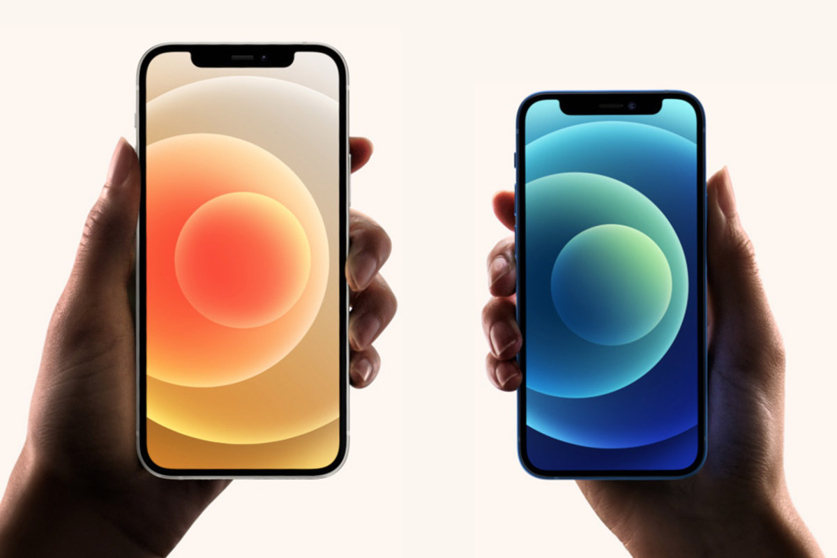
I use my iPhone (15pro max) daily to communicate with family and friends, browse the internet and do a research on staff I want to get it as for example; If I want to preach new clothes or shoes I can just open safari on my iPhone and just look at the staffs I want to buy and order it to my house. Also, with my iPhone 15 pro max I can make payments without needing my physical bank card and learn new things. As the iPhone has so many new features to use, for example: with iPhone I can facetime someone who live in a whole different country.

Photo 2
GOOGLE SEARCH.
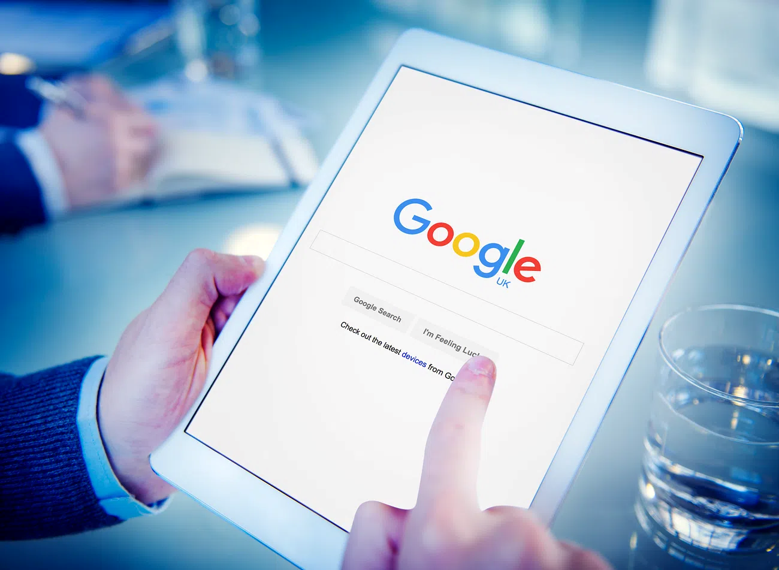
Firstly, I think everyone’s uses google search daily.
Using google daily make my life easier especially when I’m traveling to a new place that I don’t know, I uses google map on google search to navigate me to my destination for example: if I’m travelling to new place that I never been before I can just ask google search to show me how long the journey will take me to reach there and also to l show me the quickest way. Google search has so many others features that I also use in my daily life for example: Gmail is very important I use Gmail to communicate with my colleagues from work by just sending them an email I can do this by using my home computer or my iPhone.
I also use google search to check the weather and sometime translate languages.

Photo 3
BANK TRANSFER.
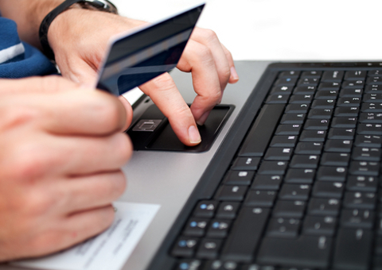
Bank transfer and online baking every day I use bank transfer to move money from my saving to my current account for my daily use I can make this transaction by just login online through my iPhone.
In additional with the access of wallet on iPhone I can just download my bank card on my phone to make certain payment without needing cash.
also, I can just receive money from others by just using bank transfer and it doesn’t matter where in the world they’re at and I can receive the transaction within a sec after the payment.

Photo 4
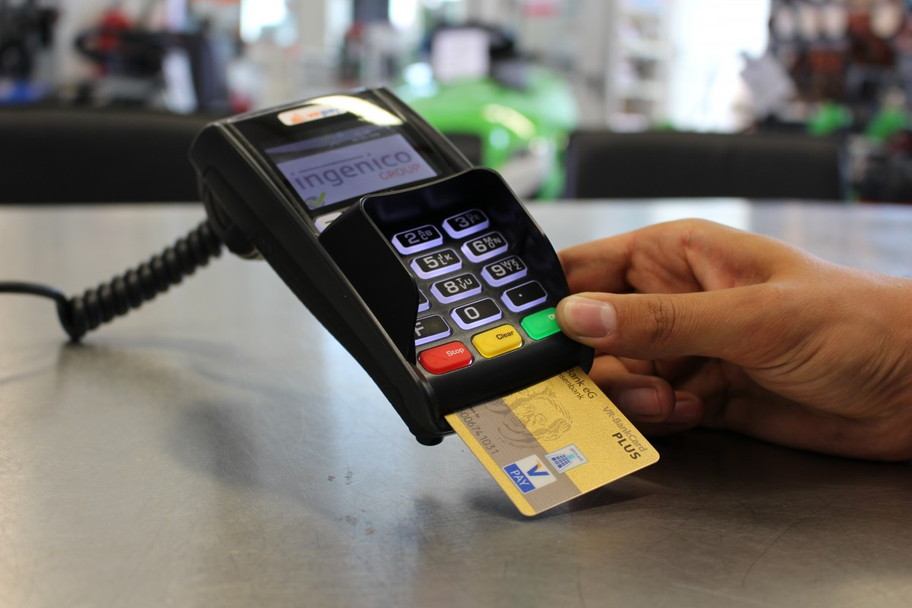
I use ATM machine daily to withdraw money and check my bank balance and manage my money conveniently. Sometimes having cash with me is important as some store might not accept apple pay and I have to pay by cash this is a good valued reason that I use ATM machine daily .

Photo 5
YOUTUBE.
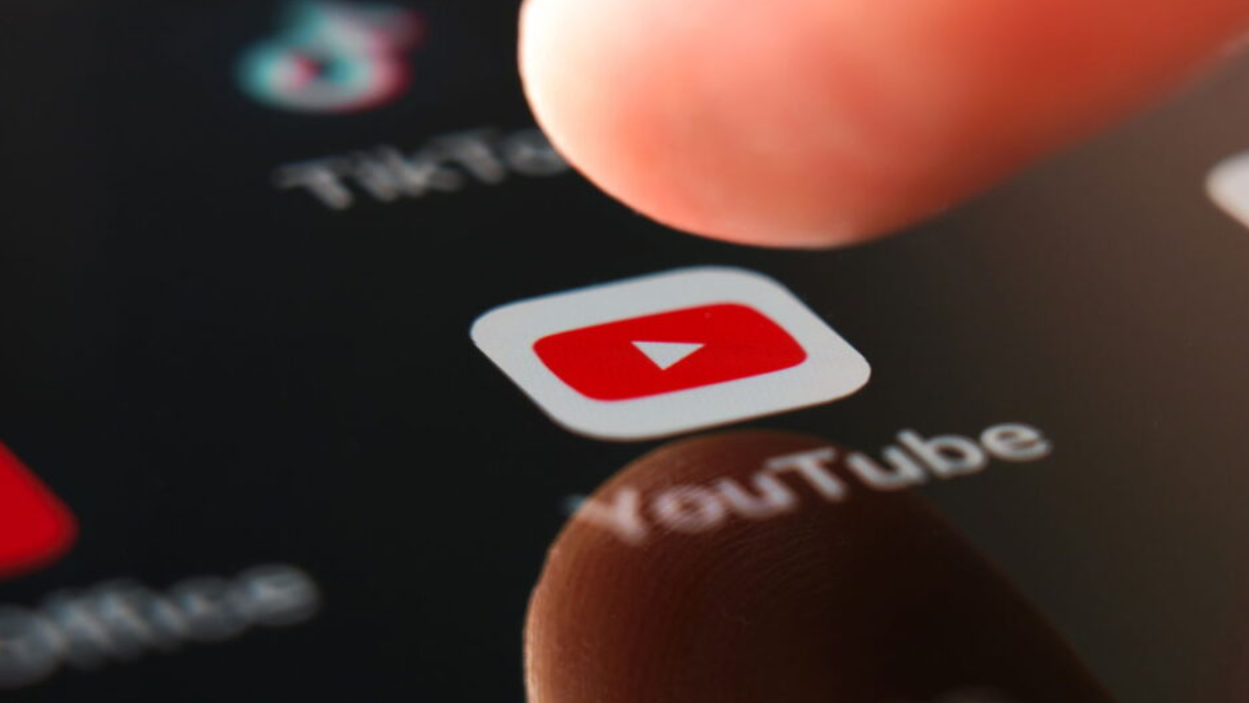
YouTube is big part of my daily use; I use YouTube to listen to music which help me stay focus and relax. Also watch some football clips and learn some skills to replicate in my game. As am a big football fan and also, I play for football must of time for me YouTube is essential to me.

Photo 6
SMART WATCH.
. 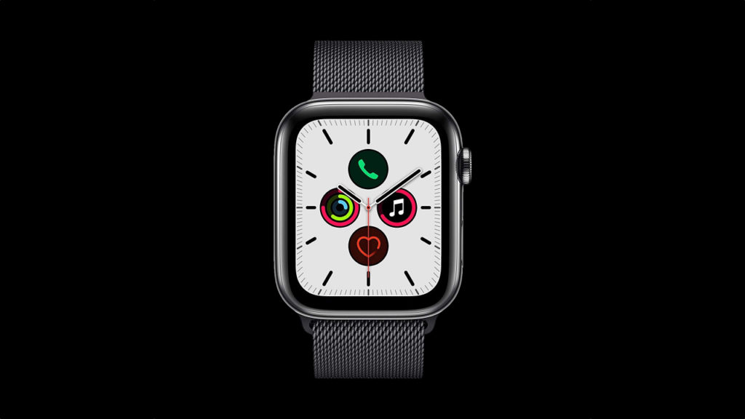

I use a smartwatch daily to check the time, track my steps, monitor my fitness and receive notifications helping me stay active and organised. For me having a smart watch is a big part of my life as I depend on it must of time to track staff, because sometime my phone will run out battery so I will have to rely on my smart watch to receive some phone calls.

My Short Reflection.
I use digital technology daily, such as google, my mobile phone and bank transfer, ATM and YouTube and smart watch all these tools help me communicate and help me found information that is relevant to life.
For example: sometimes I don’t have to rush to a cash machine to withdraw cash if I need to buy sometimes, I just use my phone or smart watch to pay with it.

Submission Checklist
Before you submit, please check:
​​​ ☐ I added 4–6 screenshots
☐ I wrote short sentences for each screenshot
☐ I wrote my short reflection
☐ My work is my own
☐ My file opens correctly
​​☐ My file opens correctly

