Project Management
Assignment 1

Table of Contents
Introduction 3
Project Overview and Initial Plan 4
Project Stakeholders 6
Project Financing and Budget 8
Project Timeline 8
Project Risk Factors 9
Delays and Overruns of the Project 10
What Went Wrong 11
Conclusion 12
References 13

Introduction
The administration of a project that is both massive and intricate might frequently call for a substantial expenditure of both time and resources. The Crossrail project in the United Kingdom, also known as the Elizabeth line, is an undertaking that exemplifies the type of work that is being done and can therefore serve as an example of such an endeavor. However, this project has not only been a mammoth undertaking for the United Kingdom (UK), but it has also been a living nightmare for the country as a result of the fact that it has taken an exceptionally extended period of time to complete and that it has significantly gone over its allotted spending limit. As a direct consequence of this, the entire Crossrail project, in addition to its stakeholders, dangers, finances, and timetables, has been researched and analyzed during the course of this research. In addition, it has investigated the factors that contributed to the failure of the project, which resulted in the delays and cost overruns that were seen.

Project Overview and Initial Plan
Crossrail Limited was founded as a wholly owned corporation by Transport for London (TfL) with the purpose of designing, constructing, and operating the Crossrail project in order to expedite the growth of London (BBC, 2022). The culture of the organization is built on a foundation of core values such as a dedication to security, honesty, respect, inspiration, and teamwork. As a component of Crossrail, which is the greatest construction project in Europe, the Elizabeth Route will be built. The Elizabeth Route will be a 100-kilometer train route with 40 stops and 42 kilometers of new tunnels built underneath central London (Dodgson et al., 2020). New train line in London that runs from west to east and connects Heathrow Airport, Canary Wharf, and the city center to run at high frequencies and at a low cost. Following chart shows the routes of the project:
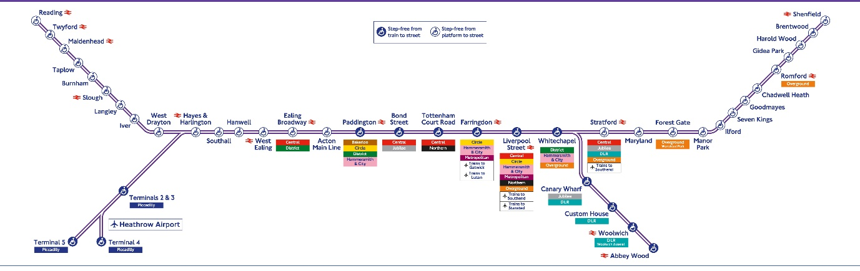
  - Figure 01: Routes of the Cross Rail Project | Source: (Dodgson et al., 2020)
This endeavor is made possible thanks to funding from both TfL and the DfT. (Department for Transport). This transportation strategy for the United Kingdom has always been at the forefront of innovation. This undertaking is considered a megaproject due of its size, breadth, and level of difficulty. It shortened travel times all across country, increased the capacity of London's rail system by 10%, and lessened the number of people who jammed themselves onto trains as well as subway cars (Lloyd-Davies and Rowark, 2021).
The facility will make it easier to transfer between different modes of public transit, cut down on crowding, ensure faster travel times, expand travel options that are more direct, and enhance rail services. It may also be beneficial to the economy of London by helping to preserve important industries and communities. As a consequence of this, it contributes to the expansion and sustainable development of the economy of the United Kingdom, in addition to supporting the transportation demands of the city of London, both today and in the long term (Worsnop, Miraglia and Davies, 2022). The project has also a minimum indicative service which is given as follows:
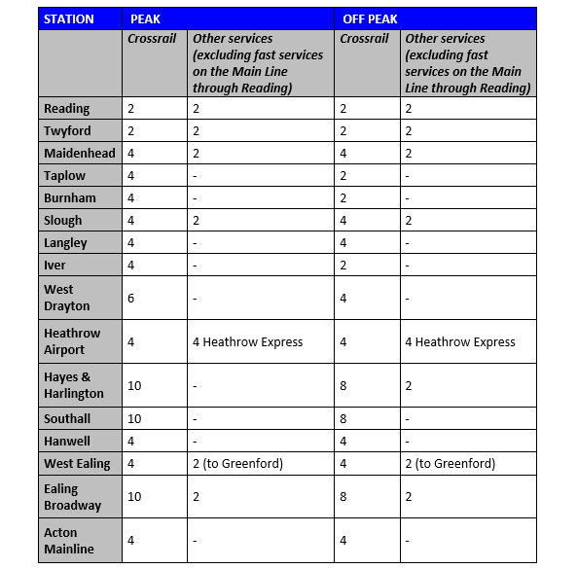
  - Figure 02: Crossrail Project Minimum Indicative Service | Source: (Bailey, 2017)
Beside the minimum indicative service of the project during the peak hours, the following graph shows the peak service style of the project as well:
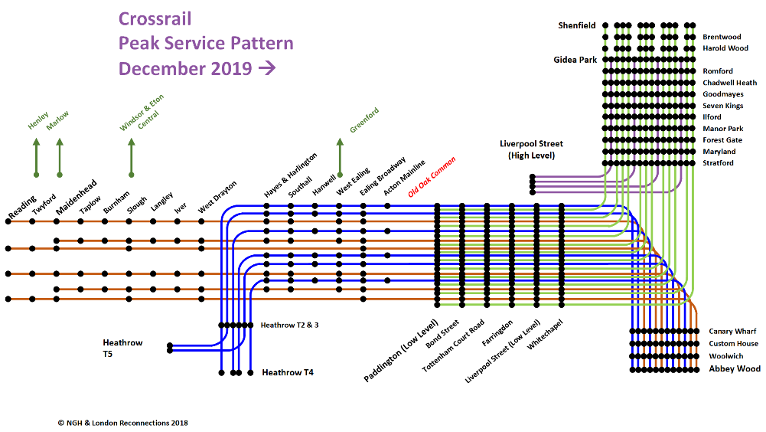
  - Figure 03: Peak Service Pattern | Source: (crossrail.co.uk, 2022)
Initially, in the year 2001, work on the detailed designs for what would eventually become the Elizabeth line got underway. After signing an agreement with the Department for Transport in December 2008, Transport for London established the project organization Crossrail Limited as a subsidiary of its business. The initial budget of the project was £14.8 billion (Dodgson et al., 2020). Also, it was initially planned to open the project within 2018 but later it delayed to 2023. Also, the costs were increased to £25 billion (BBC, 2022). So, overall, this has been a mega project for the UK and thus this article analyzes the Cross Infrastructure project in London, United Kingdom. This study will analyze the Cross Rail project that is currently being undertaken in London. The discussion then turns to the economics and finances of the project. In addition, it has allay issues that will continue to surface well into the later stages of the project. In addition, risk assessment and management are discussed.

Project Stakeholders
Project stakeholders are those parties related to a project who are close to the project and has a level of power and interest of the project and its outcomes (Cooke and Tate, 2014). For the Crossrail project, the stakeholders were larger in numbers and thus it needed to be managed in an efficient way. Some of the key stakeholders of the Crossrail project are given below:

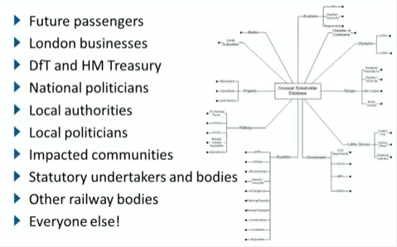
  - Figure 04: Stakeholders of the Project | Source: (Bailey, 2017)
Here, the most important stakeholder of the project is the future passengers of the project. Their comfort and convenience have been considered with utmost significance. Local Authorities: There are different local authorities who are another type of stakeholder of the project. Again, there the DfT and HM treasuries., local political, different communities, different statutory bodies, railway bodies and many other types of stakeholders. This tells that the project has a very wide range of stakeholder, covering every type of person of the economy as a whole. Thus, these stakeholders were managed using 4 different sections within the project management team which is as follows:
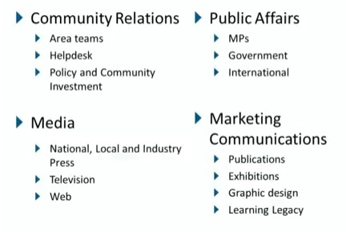
  - Figure 05: Different types of Stakeholders and their Management | Source: (Bailey, 2017)
Here as it can be seen the stakeholders have been dealt within 4 different groups. Those are community relations, public affairs, marketing communications, and media. However, these strategies have worked well for the Crossrail project and the stakeholder’s morale towards the project has been improved a lot. Following illustration shows the reputation of the project over different groups of stakeholders:
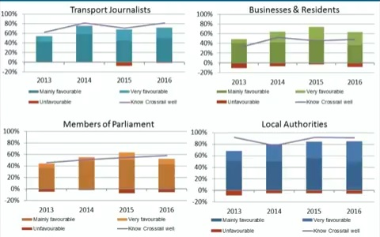
  - Figure 06: Reputation of the project among different stakeholders | Source: (Lloyd-Davies and Rowark, 2021)

Project Financing and Budget
At first, it was anticipated that the project would cost a total of 14.8 billion dollars to complete. Nevertheless, once everything was counted up and accounted for, the total came to around 25 billion dollars (Stärk et al., 2019). Despite this, this vast budget was funded by a number of different sources from a variety of different places. These sources are characterized by the following characteristics:
Source of Financing | Funding in Millions
Direct funding of DfT | £ 4,960.00
BRS | £ 4,100.00
NR Financing | £ 2,300.00
TfL Funding | £ 1,900.00
Loan from DfT to GLA | £ 1,300.00
DfT to TfL Loan | £ 750.00
Others | £ 2,480.00
Total | £ 17,790.00
  - Figure 07: Budget of the Project | Source: (Worsnop, Miraglia and Davies, 2022)

Project Timeline
The timetable for the Crossrail project is so extensive that it required more than eighty years from the inception of the idea for such a project to the completion of the project in its entirety (Dodgson et al., 2020). The earliest known idea for the project dates all the way back to the year 1941. In later stages, various different problems caused the entire project to be repeatedly postponed. 2009 marked the beginning of the building phase of the project (Dulake, 2013). And the first route didn't open until the year 2022. The following is a timeline, along with the most significant events that have occurred in relation to the project:
Years | Major Events
1941 to 1948 | Initial Proposal
1989 | Proposal of three schemes for the Crossrail
2001 | Promoted with CLRL or Cross London Rail Links
2005 | Crossrail Bill announced on the Parliament
2008 | Crossrail Act 2008 passed
2009 | Start of the construction
2022 | Paddington and Abbey Wood route opened
2023 | Full route will open
  - Figure 08: Major event and timeline of the Crossrail Project | Source: (Worsnop, Miraglia and Davies, 2022)

Project Risk Factors
The Crossrail project was fraught with a variety of risks that were not present in any other similar endeavor. In order for the project to be a success, it is imperative that high priority be given to addressing these potential challenges. In order for the Elizabeth line to open and become fully functional from central station, it is necessary for the Bond Street station to continue to work normally. There were different significant risks which are as follows:
- Risk of Budget Discrepancy: The years 2018 through 2020, which elapsed between the signing of the agreement and the beginning of the project, were crucial for the risk.
- Risk of Incomplete Installation: The risk of incomplete installation of different equipment existed in the project as well (Lloyd-Davies and Rowark, 2021). For this, the risk was handled with a quick solution to the technological advancements.
- Risk of Meeting Critical Deadlines: There were certain deadlines which were very critical. That means, the failure to meet those deadlines ultimately delayed the project. Such risks were very affecting for the project and made the project lengthier.
- Risk of Lack of Professionalism: It is considered that the professionalism of the engineers during the project was not up to mark to run the project in due time and with the initial budget of the project.
- Risks of Technological Discrepancies: The possibility of the project experiencing technological disruptions was still another significant danger associated with it (BBC, 2022). During the phase of the project that dealt with a "bring to order" strategy, this also caused the project a great deal of suffering.

Delays and Overruns of the Project
To finish the job successfully a substantial amount of time was necessary. 1941 was the year that saw the initial conception of the project come to light (BBC, 2022). On the other hand, the law that authorized the construction of the train line was passed in 2005, and the Crossrail Act was passed in 2008. Because of this, the year 2009 marked the beginning of the year that saw the beginning of the project's actual construction.
On the other hand, from the very beginning of the project, it was intended that it would be finished far more quickly than it has taken up to this point to finish it. This extraordinarily protracted delay is due to a number of distinct variables, the most important of which is that Covid-19 had an effect (Dodgson et al., 2020). If the crisis that was caused by covid-19 hadn't occurred, it's possible that the project would have been finished more quickly. On the other hand, when it was first envisaged, it was anticipated that the whole cost of the project would be approximately 14.8 billion pounds. Despite this, it ended up costing £10 billion more than anticipated because of the unusual expenses and engineering challenges that developed along the construction.

What Went Wrong
Projects are very sensitive tasks that needs to be taken care of (Heerkens, 2018). The Crossrail venture was the most significant undertaking in all of Europe (Lloyd-Davies and Rowark, 2021). The trains and the stations that were a part of the project were extremely interesting to look at. They were developed in order to ensure the continued expansion of the service. The current obstacle to Transport for London (TfL) is to provide a service that is satisfactory. During the course of the project, there were a number of mishaps that led to both injuries and fatalities.
At that point in time, this was one of the many challenging low periods that the project had encountered. Despite this, it was the greatest infrastructure project that had ever been attempted in Europe, and the premise that guided its completion was "on time and on budget" (Stark et al., 2019). Because the management at that time was so confident in themselves, they allowed automobiles to drive through the tunnels so that they could use the experience as part of a marketing. Crossrail promised that it would be possible to run trains through into existing stations, but things immediately began to fall wrong despite these assurances (Worsnop, Miraglia and Davies, 2022). Despite the fact that the tunneling had been finished without any problems, the technological side of things were not going as planned.
There were three signaling systems that refused to "communicate" with the new trains. The Bond Street station fell significantly further behind. The undertaking endured a precipitous, humiliating fall from favor, and it eventually turned into something of a running joke (BBC, 2022). There were those who assumed it might never actually open. The sticking of mud was a significant issue that contributed to the delays and budget overrun as well.

Conclusion
TfL (Transport for London) and the Department for Transport (DfT) are the primary sponsors of the Cross-rail project in the United Kingdom, as evidenced by the information provided above (department for transport). The total cost of the project was £14.8 billion, of which approximately one-third was funded by the federal government. Loans from development banks such as the European Investment Bank, bank debt, and bonds could all contribute to the required level of debt financing for the Crossrail project. Crossrail is essential to preserving and enhancing London's position as a global financial hub. In addition, it is reasonable to assume that major projects and programs will require modification as they progress through their various phases of development. Cost and time overruns are generally recognized as the most significant issues associated with complex, lengthy projects.

References
Bailey, R. (2017). Community first: Crossrail stakeholder management case study - PR Academy. [online] PR Academy. Available at: https://pracademy.co.uk/insights/community-first-crossrail-stakeholder-management-case-study/.
BBC (2022). Elizabeth line: How the ‘perfect’ project became a nightmare. BBC News. [online] 17 May. Available at: https://www.bbc.com/news/uk-england-london-61409591.
Cooke, H. and Tate, K. (2014). Project management. 1st ed. New York: Mcgraw-Hill.
crossrail.co.uk (2022). Building the Rail Tunnels. [online] Crossrail. Available at: https://www.crossrail.co.uk/project/tunnelling/railway-tunnels/.
Dodgson, M., Gann, D., Davies, A. and MacAulay, S. (2020). Innovation Strategy in New Transportation Systems: The Case of Crossrail. SSRN Electronic Journal, 22. doi:10.2139/ssrn.2662451.
Dulake, C. (2013). Crossrail - design and construction / Crossrail - Entwurf, Bemessung und Ausführung. Geomechanics and Tunnelling, 4(5), pp.592–604. doi:10.1002/geot.201100028.
Heerkens, G.R. (2018). Project management. Mcgraw-Hill Education.
Lloyd-Davies, K. and Rowark, M. (2021). Crossrail project: procuring infrastructure for London’s Elizabeth line. Proceedings of the Institution of Civil Engineers - Civil Engineering, 170(6), pp.35–41. doi:10.1680/jcien.17.00002.
Stärk, A., Pujol, R.S., Hill, N. and Kettle, C.T. (2019). Compensation grouting - Balance between asset protection and collateral damage through the example of Crossrail C510. Geomechanics and Tunnelling, 10(5), pp.489–496. doi:10.1002/geot.201700034.
Worsnop, T., Miraglia, S. and Davies, A. (2022). Balancing Open and Closed Innovation in Megaprojects: Insights from Crossrail. Project Management Journal, 47(4), pp.79–94. doi:10.1177/875697281604700407.

