Peter Kenrick

Simulation of Digital Modulation Techniques

Contents
I. Contents 1
II. Introduction 1
III. Main body 1
A. Definitions 1
1. Modulation/Demodulation 1
2. Carrier Wave 2
3. Types of modulation 2
4. Bernoulli Binary Number generator 2
5. AWGN 2
6. Filter 2
7. Failure 3
B. Set-up 3
1. ASK 3
2. PSK 4
3. QPSK 4
C. Results 5
IV. Conclusions 5
V. Recommendations 5
VI. References 7
VII. Appendices 8

Introduction
Modulation and Demodulation are an important part of data transmission. They allow data to be sent over a much larger distance with less interference and data loss. As more and more people become reliant on this, the need for better technology increases.
The aim of this assignment is to compare 3 different types of modulation (ASK, PSK and QPSK) using a digital simulator (Simulink) and assess the results of the modulator and demodulator when the signal is in the presence of Noise (AWGN).

Main body

Definitions

Modulation/Demodulation
Modulation and Demodulation is, in the opinion of Leis [1], the process in which a signal (data being transmitted in binary) has a carrier wave applied to it in some way (see below for a few different methods). Once the carrier wave has been applied, the data can then be transmitted and received. On the receiving end the demodulator then removes the noise and carrier wave to obtain the original data.

Carrier Wave
The carrier wave is a single frequency wave used to transmit data as per The Encyclopaedia Britannica [2].

Types of modulation
There are quite a few types of modulation available to use however this report will focus on three: ASK, PSK and QPSK; all these definitions are according to tutorialspoint.com [3].

ASK
Amplitude Shift Keying: This type of modulation multiplies the data by the carrier wave which results in no signal being sent for a “0” and the carrier wave being sent for a “1”.

PSK
Phase Shift Keying: This type of modulation utilises the phase of the carrier wave to transmit the data. A binary “0” would be sent with the carrier wave out of phase and the “1” would be sent with the carrier wave in phase.

QPSK
Quadrature Phase Shift Keying: This is the same principle as PSK however it divides the waves up further into multiple phase angles (π/4, 3π /4, 5π /4, 7π /4). Each element represents more than one bit of information, this allows it to transmit twice as much data in the same amount of time.

Bernoulli Binary Number generator
This device creates a random string of data which is used in the experiment to simulate the data being transmitted. This is used instead of a specific string of data for convenience of not having to create 200 bits of information and to properly access the systems’ ability to modulate and demodulate data.

AWGN
Additive White Gaussian Noise: When transmitting data over the air or over a long distance, random noise interferes with the signal. The greater the distance or the noisier the intervening gap, the more noise there will be therefore decreasing the chance of recovering the original message. This device introduces that noise to simulate the distance and the amount of noise can be increased or decreased. In this experiment the volume of the white noise ranges from 0dB to -75dB.

Filter
According to Pactitis [4], a filter is a device which can, depending on how it is constructed, be used to remove or reduce frequencies of certain wavelengths. This is very useful for these systems as the original frequency is known (the carrier wave) and therefore any noise can be “filtered out” to leave the original signal. It is then the demodulators job to remove the carrier wave and convert it to the simple data stream.
The filter used in all three systems was the same to allow for comparison for the actual system. It is a Lowpass filter which only allows low frequency wavelengths to pass. As seen in the image below (Figure 1 – Filter Design), the Fpass is 3Hz and the Fstop is 95Hz, this means that anything under 3Hz is able to pass and anything over 95Hz is cancelled out. The closer together these numbers are, the better the filter. This will also increase the complexity of the filter which is represented by the Order.
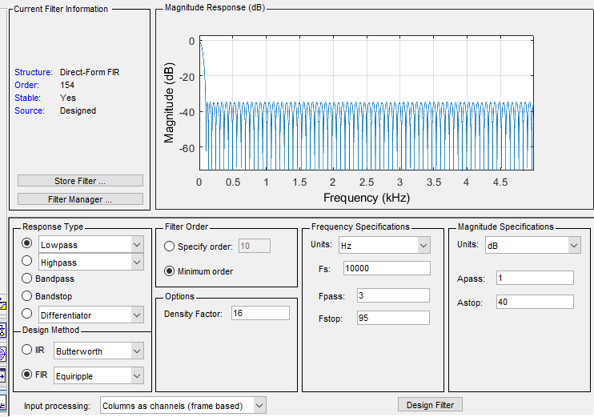
Figure 1 – Filter Design

Failure
Failure is when the data received is not recoverable, depending on the way in which the signal is sent there might be some means of recovering the data if only a few bits are lost. For this report, the failure will be 1 in 10 bits.

Set-up

ASK
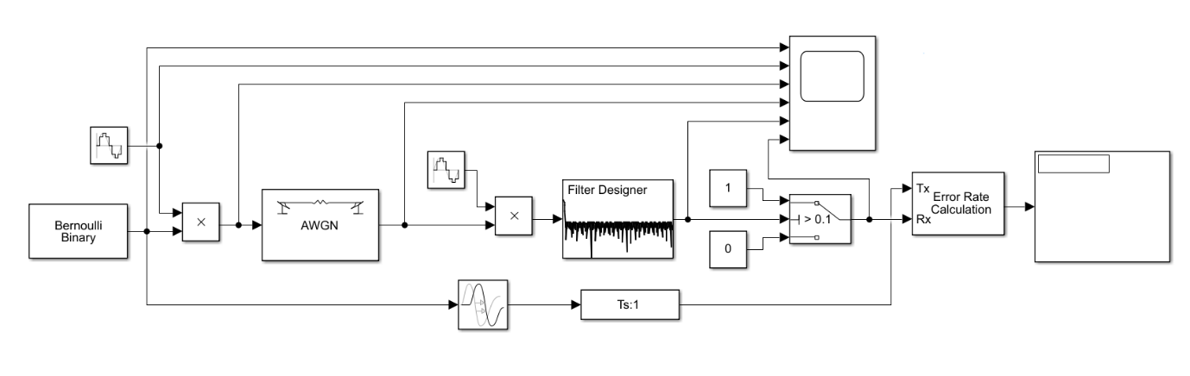
Figure 2 - ASK Modulator
The ASK model starts with the Bernoulli Binary number generator, the data is immediately multiplied by the Carrier wave. This is the simplest of the systems.
For the demodulation, the signal is again multiplied by the Carrier wave, this will constructively interfere with the signal to boost it. When it passes through the filter the noise from the AWGN is removed much as the filter can. The signal is then passed through a switch converts the Carrier wave data into the binary data by flipping back and forth between 1 and 0 when ever the signal goes over or under the threshold set.

PSK
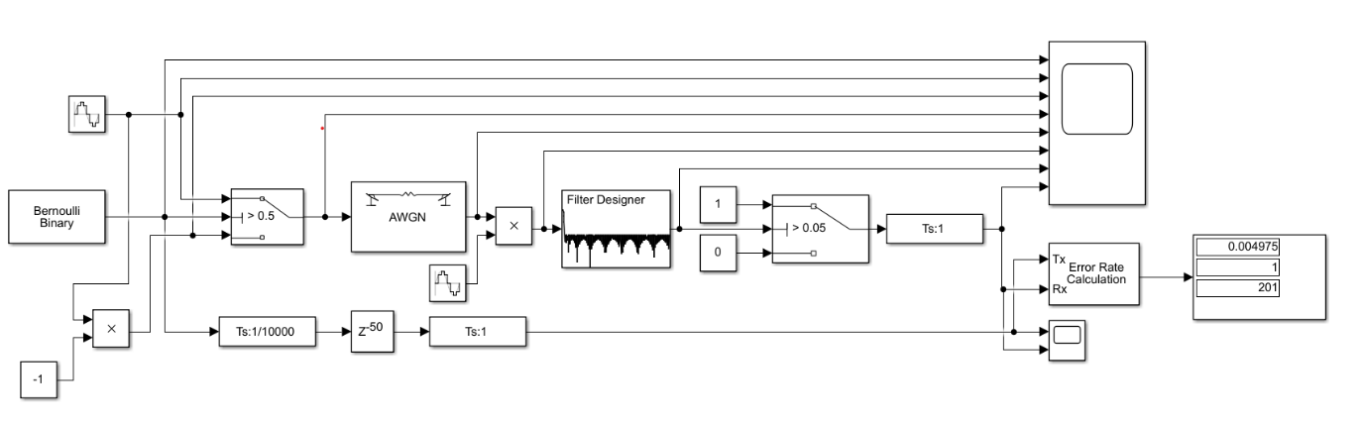
Figure 3 - PSK Modulator
With the PSK, the data is first put through a switch which flips between the Carrier wave, and the same Carrier wave out of phase. The switch’s threshold is set to 0.5 here meaning a 1 bit would transmit the Carrier wave and a 0 bit would transmit the out of phase Carrier wave.
For Demodulation, the data is multiplied by the Carrier wave again then is passed through the filter and switch, same as ASK although the cut off for the switch is different.

QPSK
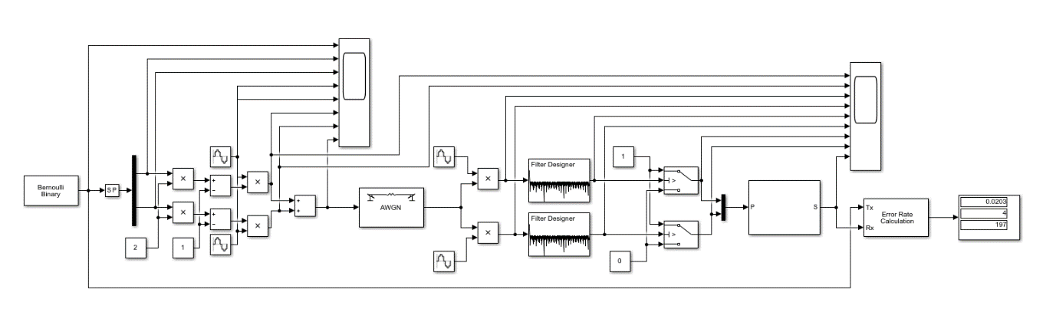
Figure 4 - QPSK Modulator
QPSK is the most complex of these three, the data for this model must be paired up and each alternating bit is then multiplied by 2 and has 1 subtracted from it. This takes it from 0 and 1 to -1 and 1. Both data streams are then multiplied by Carrier waves which are out of phase with each other (in this case 90°). The two streams are added to each other and transmitted.
For the Demodulation, the stream is split into two. One of the streams is multiplied by the Carrier wave, the other is multiplied by the out of phase Carrier wave. This causes constructive interference in both streams for the respective bits of data. Then, like the two systems above, they are passed through filters and switches which converts them back into data streams. In this model the two bits of data are collected back and combined. This model does have more of a delay than the others.

Results
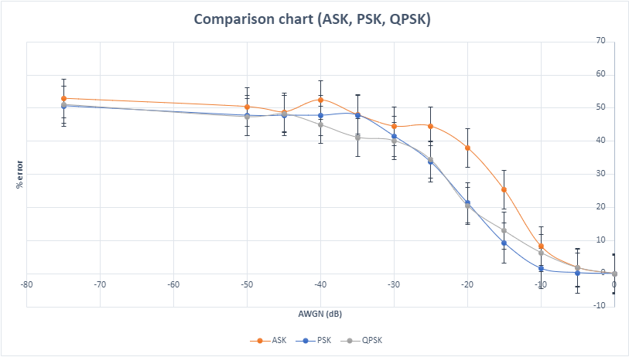
Figure 5 - Results
From the graph above it is clear to see that the ASK is fails first, then the QPSK, then PSK. This is to be expected as the ASK is overly simplistic, it will work well for the lower noise levels it does fail quite early.
The PSK has the best results overall however the QPSK does catch up to it at the -20 - -30dB range.
At about -30dB AWGN the results become meaningless as to get worse than a 50% fail rate you would need to be inverting the data.

Conclusions
- ASK is very simple and good for small systems, cheap and works well for low noise levels
- PSK works very well for slightly more noise and is under 10% error until about -16dB according to this data
- QPSK starts out like the ASK but can deal with more noise better. Given that it is also streaming two bits of data at the same time it would be expected to be worse than a single bit transmission.

Recommendations
- FSK – Frequency Shift Keying; this is another method of transmitting the data like ASK except instead of transmitting no carrier wave for the “0”, a lower frequency carrier wave is transmitted. This could be investigated for additional comparison.
- 8QAM/16QAM – 8 and 16 QAM are the same method as QAM except they transmit over more
- Having two separate data streams for the QPSK. This will better show its ability to transmit two bits at the same time.
- More sampling – This report was done with 200 samples however performing more samples will give a better indication of the true % error within each Modulator/Demodulator system
- AGWN values – This report has AGWN values from 0 to -50dB in increments of 5, using smaller increments would give a more accurate graph
- Filter – Improving the filter will generate less errors
- Physical experimentation – Recreating the systems in a lab using a physical simulation would provide more realistic results.

References

[1] | J. W. Leis, Communication Systems Principles Using MATLAB, 2019, pp. 155-267.
[2] | Britannica, “Encyclopedia Britannica,” Britannica, The Editors of Encyclopaedia, 20 07 1998. [Online]. Available: https://www.britannica.com/technology/carrier-wave. [Accessed 26 03 2021].
[3] | Tutorialspoint, “https://www.tutorialspoint.com,” Tutorialspoint, [Online]. Available: https://www.tutorialspoint.com/principles_of_communication/principles_of_communication_digital_modulation_techniques.htm. [Accessed 23 03 2021].
[4] | S. A. Pactitis, Active Filters, Boca Raton: CRC Press, 2018.

Appendices
AWGN (dB) | ASK 1 | ASK 2 | ASK 3 | ASK 4 | ASK Av. %
0 | 0 | 0 | 0 | 0 | 0
-5 | 0.015 | 0.02 | 0.02 | 0.02 | 1.875
-10 | 0.09 | 0.06 | 0.09 | 0.095 | 8.375
-15 | 0.255 | 0.27 | 0.24 | 0.25 | 25.375
-20 | 0.375 | 0.4 | 0.375 | 0.37 | 38
-25 | 0.45 | 0.47 | 0.445 | 0.415 | 44.5
-30 | 0.455 | 0.43 | 0.46 | 0.435 | 44.5
-35 | 0.485 | 0.485 | 0.505 | 0.445 | 48
-40 | 0.495 | 0.535 | 0.525 | 0.54 | 52.375
-45 | 0.41 | 0.545 | 0.515 | 0.48 | 48.75
-50 | 0.53 | 0.515 | 0.475 | 0.495 | 50.375
-75 | 0.525 | 0.565 | 0.5 | 0.525 | 52.875
AWGN (dB) | PSK 1 | PSK 2 | PSK 3 | PSK 4 | PSK Av. %
0 | 0 | 0 | 0 | 0 | 0
-5 | 0.004975 | 0 | 0.004975 | 0 | 0.24875
-10 | 0.0199 | 0.004975 | 0.01493 | 0.02488 | 1.617125
-15 | 0.1095 | 0.1045 | 0.0796 | 0.0796 | 9.33
-20 | 0.2289 | 0.1891 | 0.2139 | 0.2239 | 21.395
-25 | 0.3433 | 0.2687 | 0.3483 | 0.3881 | 33.71
-30 | 0.4129 | 0.4179 | 0.4229 | 0.408 | 41.5425
-35 | 0.4776 | 0.5224 | 0.4478 | 0.4677 | 47.8875
-40 | 0.4428 | 0.4577 | 0.5323 | 0.4776 | 47.76
-45 | 0.4577 | 0.5423 | 0.4428 | 0.4677 | 47.7625
-50 | 0.4478 | 0.408 | 0.5124 | 0.5423 | 47.7625
-75 | 0.4876 | 0.5174 | 0.4925 | 0.5274 | 50.6225
AWGN (dB) | QPSK | QPSK8 | QPSK9 | QPSK10 | QPSK Av. %
0 | 0 | 0 | 0 | 0 | 0
-5 | 0.01015 | 0.02538 | 0.01523 | 0.0203 | 1.7765
-10 | 0.04569 | 0.07614 | 0.06091 | 0.07107 | 6.34525
-15 | 0.132 | 0.1371 | 0.1066 | 0.1421 | 12.945
-20 | 0.198 | 0.2284 | 0.1878 | 0.2081 | 20.5575
-25 | 0.3452 | 0.2893 | 0.3604 | 0.3807 | 34.39
-30 | 0.4518 | 0.401 | 0.3858 | 0.3655 | 40.1025
-35 | 0.3858 | 0.3807 | 0.4365 | 0.4416 | 41.115
-40 | 0.401 | 0.4467 | 0.4721 | 0.4772 | 44.925
-45 | 0.4518 | 0.4975 | 0.4569 | 0.5228 | 48.225
-50 | 0.5076 | 0.4416 | 0.4619 | 0.4822 | 47.3325
-75 | 0.5076 | 0.4975 | 0.5584 | 0.4772 | 51.0175

