BMSW4002:
Effective Team Work and Communication

Module Lecturer: Ejiro Esohwode

Effective Team Work and Communication

Oluwasegun Aregbesola
1906876

Contents
1. Introduction 3
2. Types and models of Communication 3
2.1. Shannon and Weaver 3
2.2. Berlo 5
2.3. Schramm 6
3. Workplace Communication 7
3.1 Purpose of Workplace Communication 7
3.2 Effectiveness of Workplace Communication 7
3.3: Role of culture in Workplace Communication 8
4. Conclusion 8
5. Appendix 8

Introduction

Communication:
--- the imparting or exchanging of information by speaking, writing, or using some other medium.
(Google Dictionary Definition)

A very simple yet complex concept, communication is the act of sending messages to someone or something. On the surface level, it is as simple as something being sent from one thing (the sender) to the other (the recipient), usually containing a message (the content).
Communication can occur anywhere, but it is common in every living being, especially humans. A cat can communicate with a cat, a baby can communicate with a adult and a human’s own body can communicate with itself. Communication is very important: without it, it is not far off to say that almost everything in the world today would not exist. Who would tell a builder where to build? Who would teach a child how to communicate? Who would teach an animal to survive? Who would tell the heart when to pump extra blood? Who would tell a computer how to execute certain commands? Many of these questions boil down to communication, as every living being is influenced by it. Even more complex is that there is normal communication and effective communication, which can drastically alter the results of events.

Types and models of Communication

As stated before, communication can look simple but can be very complex. Someone could communicate to another person on how to create a Word Document, but there might be certain things that are omitted which can affect the other person’s understanding of how to do something. Because of this, many have made countless theories about what communication really consists of, which are explained below:

Shannon and Weaver

The Shannon Weaver model of communication was created in 1948 when Claude Elwood Shannon wrote an article called “A Mathematical Theory of Communication” in the Bell System Technical Journal, assisted by Warren Weaver.
Shannon was an American mathematician and Weaver was a scientist. The Mathematical theory later came to be known as Shannon Weaver model of communication or “mother of all models.” This model is more technological than other linear models that are presented in terms of communication models.

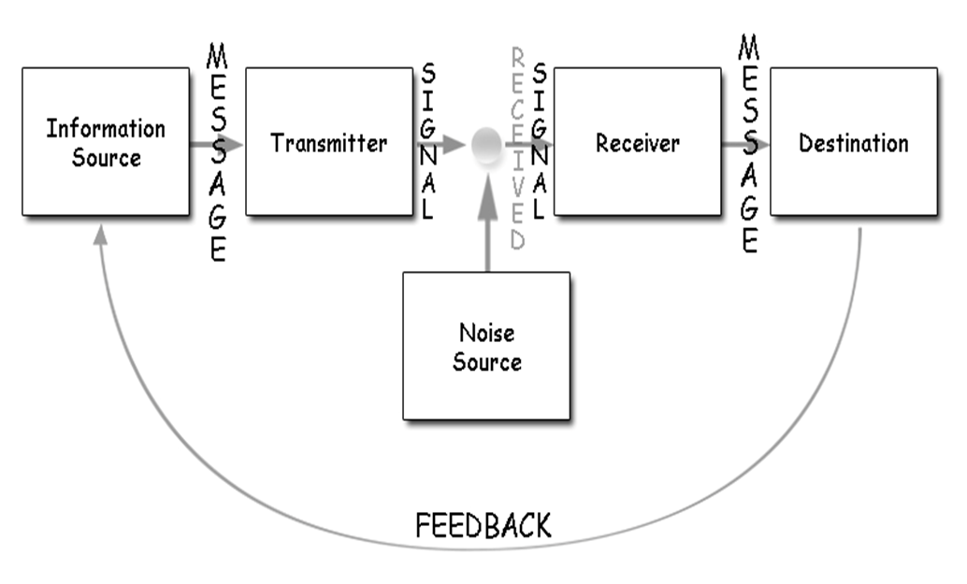
Figure 1: Shannon Weaver Communication model

Information source – usually the sender who makes the message, chooses the channel and sends the message.
Transmitter –the message is then encrypted using a encoder which converts messages into signals or binary data. It might also directly refer to the machine.
Channel – the channel is the medium used to send message.
Receiver – after going through the channel, the message is decrypted using a decoder which convert signals or binary data into message or the receiver who translates the message from signals.
Destination – where a message finally lands in someone or something, which is called the receiver. The receiver provides feedback according to the message.
Noise –a physical disturbance like environment, people, etc. which does not let the message get to the receiver as what is sent. This can affect the quality and content of the message.

An advantage to this model of communication is that it addresses communication as a two-way process. It makes the model applicable in general communication.
A disadvantage against this, however, is that it is suited more for interpersonal communication than group communication and mass communication, as it could affect everyone’s communication.

Berlo

David Berlo developed a different model of communication from the Shannon Weaver’s model in 1960. The model also focuses on encoding and decoding which happens before sender sends the message and before receiver receives the message respectively, albeit more detailed.
Instead of five main components, Berlo’s model has four components to describe the communication process. They are sender, message, channel and receiver, shown below:

Figure 2: Berlo's Model of Communication
As this model is a derivative of the Shannon Weaver model, most of the components are regarded the same. However, each of the components are affected by many factors in details.
The sender, or source, can affected by five things:
- communication skills, which determine how easily it is for someone to grasp the message based on language comprehension.
- The attitude of the person sending the message.
- The knowledge of unfamiliar or familiar topics by the sender.
- Social systems can further differentiate messages.
- Culture can change a receiver can interpret a message as offensive when it is accepted in other cultures.
The context of the message can be affected by its factors: content, elements, treatment of the message, structure of the message and the code of the message (like videos or text.)
The channel is the medium used to send the message, which can include telephones or the internet. In general communication, the five senses of a human being is the channel: hearing, seeing, touching, smelling and tasting.
The receiver is the person who gets the message. The model puts great emphasis on the belief that the thinking pattern and all other factors of the receiver must be in sync to that of the sender for the communication to be effective. This includes:
- Communication skills
- Attitudes
- Knowledge
- Social Systems, and
- Culture.
It is worthwhile to base certain elements off Berlo’s model, as it goes into detail of each of its four components and its factors. On the other hand, many criticise the model for being a linear explanation of communication: there is no acknowledgment of noise, or social barriers, or any other factor outside of the sender and the receiver to affect communication.

Schramm
Another communication model based off the Shannon Weaver model is the simple yet explained model of Wilber Schramm. Unlike Berlo, he strongly believes that communication is a two-way process, which does not complete until the sender receives feedback. Developed in 1954, 6 years after Shannon and Weaver’s model, there is a noticeable difference about how the
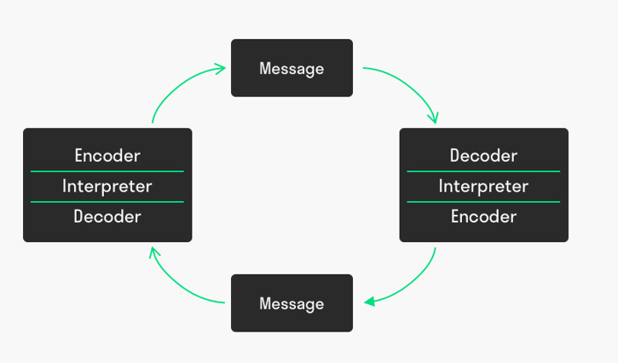
The model is show below:

Figure 3: Schramm Model of Communication. Notice how it is circular.
Compared to other two models shown before, Schramm is circular, suggesting that it is a cycle that does not end. This boosts Schramm’s point that two is needed to send and receive a message. Both the sender and the recipient have to encode and decode the message to interpret the message correctly. There are three, or five, main components of the model.
The source, or sender, of the message can also act as the encoder. This works by similar principbes with Berlo, that being that the perceptions, knowledge, attitude, experiences and skills that the sender has can actively encode the message.
The recipient, likewise, acts as the decoder, since multiple factors determine whether the original message is interpreted the same way the sender intended for it to be interpreted. This, Schramm belives, is a psychological process as the the stimulus (the message) is sent to the brain for interpretation after being decoded. Communication is successful when the recipient correctly interprets the message from the source.
The message is defined as information, which can be communicated through words, characters and symbols. It is the context of the communication process and plays an important role in the model.
The reply from the recipient to the sender’s message is called feedback. Feedback can be both verbal and non-verbal. Sometimes it is a verbal response, sometimes it is just a sigh or a nod. Feedback is often expressed in writing, an email for instance.
The model works well to explain continuous feedback instead of communication not being a one-way street. By expressing that communication is not linear, the model shows that communication is complex, which is why it is easy for people to mishear or misinterpret words and meanings.
Unfortunately, it still suffers problems other models have with the claim that mass communication is unequal and therefore only really works well with one-on-one communication.

Workplace Communication

Workplace communication is not quite different from normal communication: it is the process of exchanging information and ideas, both verbal and non-verbal between one person/group and another person/group within an organization. These can include e-mails, text messages, notes, calls, and so on. Workplace communication is more specialized and centered around employees and how they interact with each other within companies, inside and outside of work.

3.1 Purpose of Workplace Communication
The purpose of workplace communication is highly critical for any chance with success in business. Without communication, the direction of the business can be easily swayed by many individuals, causing the business to achieve far less than the aims of the company originally were.
The main purpose for good workplace communication is to have the business grow in a natural and positive way. By being joined up internally and having strong lines of communication, companies can ensure that the message they are delivering externally is consistent, which can lead to a natural progression in ideas, innovation and
Workplace communication is highly advisable for building effective teams. is really all about how those team members communicate and collaborate together. Teams that are effective can be relied on to get certain tasks done: and with good communication a manager can always have updates and progression reports on how the task is being done, leading to further good communication with higher positional people in the company, which benefits PR.

3.2 Effectiveness of Workplace Communication
The effectiveness of workplace communication cannot be undermined. Well planned events or schedules can lead to massive increase in business productivity.
A good example of effective workplace communication allows employees to have innovative ideas. This is good as it helps give a business a certain identity. Take HUGO BOSS for example; the founder, Hugo Ferdinand Boss, had started a brand that was highly popular in the 1930’s which led for the name to be known across Germany, even in the times of World War II, because he had good communication with his employees to develop fashion related to that era.
If employees are given freedom to innovate, then it can also increase motivation for certain individuals, increasing the rate at which employees might work at, increasing productivity in the company. For example, if someone in a food restaurant was given the opportunity to create a new menu or recipe, they would be willing to be more engaged in the production of said “exclusive” menu. This could lead to a new unique brand ID, showing other employees ways to rise up in the company and create new team managers.

3.3: Role of culture in Workplace Communication

Communication culture is important to advertise unique workplaces, enticing new workers to the business. Not only that, but it has more to do with how each workplace must communicate. A food restaurant cannot communicate the same way a fashion store can.

Conclusion
All in all, communication, verbal and non-verbal, is very important in today’s day and age. No matter where technology goes, communication is effective in any medium to create, build, interpret, teach and even breathe and survive. Most businesses would not survive without some form of good workplace communication, and living beings could not evolve without communication between each other within its species.
It is important that effective communication is used, as it could mean the difference between something failing or something having huge success. Many world events happened because of poor communication, and it is best to follow in the practise of good communication lest history repeat itself.

Appendix

Sources:
Communication - Google Dictionary
The Shannon and Weaver Model of Communcation – uploaded by businesstopia
Link: https://www.businesstopia.net/communication/shannon-and-weaver-model-communication
The Berlo Model of Communication
Link: https://moodle.uwtsd.ac.uk/mod/resource/view.php?id=212415
The Schramm Model of Communication
Link: https://www.toolshero.com/communication-skills/schramm-communication-model/
Citation: Schram, W. E. (1954). The process and effects of mass communication.
The Importance of Communication within a Workplace
Link: https://www.michaelpage.co.uk/advice/management-advice/development-and-retention/importance-good-communication-workplace

