MARYAM QUDOOS
STUDENT ID 2313040

Strategic Data Warehousing Implementation for DHL Supply Chain UK & Ireland

Table of Contents
1.1 OLTP vs Data Warehouse (250 words) 2
1.2: Data Warehouse Architecture & ETL 3
ETL Process Explanation 5
Operational Assurance 5
1.3 Data Marts for Management Decision-Making 6
1.4 OLTP Normalisation vs Dimensional Modelling 7
Task 2 – Data Warehouse Design & Implementation 9
2.1 Source System Identification 9
2.2 Star Schema Design 10
Primary Star Schema: Shipment Performance Analytics 10
Secondary Star Schema: Warehouse Operations Analytics 11
Aggregate Table: Monthly Delivery Performance 12
Metadata Table: Service Type Reference 12
Design Justification 13
2.3 Data Marts and Schema 13
2.3.1 Operations Data Mart 14
2.3.2 Finance Data Mart 15
2.3.3 Client Service Data Mart 16
Data Mart Summary 17
2.4: ETL Plan (Simplified) – DHL Supply Chain Data Warehouse 18
2.5 Data Quality & Governance 19
References and Bibliography 19

Task 1 – Data Warehousing Strategy Report

OLTP vs Data Warehouse (250 words)

Introduction to DHL's Current Systems
Currently, DHL Supply Chain runs a number of Online Transaction Processing (OLTP) systems, including Order Management Systems (OMS), Transportation Management Systems (TMS), and Warehouse Management Systems (WMS). The main purpose of these systems is to assist with routine logistics tasks like order processing, vehicle tracking, inventory updates, and shipment scheduling.

OLTP Systems: Operational Efficiency Focus
Real-time transactional efficiency is the main focus of OLTP systems. For instance, a transaction must be immediately documented when inventory is picked up at Heathrow Logistics Park or a cargo departs the Daventry distribution hub. To prevent duplication and guarantee quick insert, update, and delete operations, these databases are substantially normalised. However, because data is dispersed across systems and optimised for operational speed rather than analytical reporting, OLTP environments are unsuitable for strategic analysis.
In contrast, a data warehouse combines historical data from several operating systems into a single, unified store. It facilitates analysis, trend identification, and decision-making rather than transaction processing. A warehouse for DHL would aggregate shipment, fleet, financial, and customer performance data from hubs in the UK and Europe, including Rotterdam, Düsseldorf, and Lyon.
Increased visibility is the main advantage for DHL leadership. Executives could examine profitability by customer or logistical route, SLA compliance, warehouse utilisation trends, and cross-regional delivery performance. A data warehouse responds to strategic queries like "Which European routes generate the highest delays or costs?" in contrast to OLTP systems, which respond to operational queries like "Where is this shipment now?"

DHL may therefore move from operational reporting to data-driven logistics optimisation and predictive decision-making by investing in a data warehouse.

Aspect | OLTP Systems | Data Warehouse
Purpose | Record events (“Where is shipment #12345?”) | Analyse trends (“Which routes are underperforming?”)
Design | Normalised – many tables, few joins | Dimensional (Star Schema) – few tables, many joins optimised
Data | Current state only, no history preservation | Historical + current data, years of data for trend analysis
Users | Operations staff – warehouse, drivers, clerks | Management, analysts, directors, strategists
Example (DHL) | WMS scan records “Item picked at Daventry at 14:32” | Client profitability analysis – “Which clients are most profitable by service type?”

1.2: Data Warehouse Architecture & ETL
A data warehouse's design usually takes a layered approach, with source systems feeding into a central repository through an Extraction, Transformation, and Loading (ETL) process that eventually supports end-user analytical tools. For DHL, this would combine external sources like client portals for order patterns and customs APIs for cross-border data from Rotterdam with internal sources like WMS (warehouse data from Daventry racks and bins), TMS (fleet GPS from Düsseldorf routes), OMS (order details from Glasgow JIT deliveries), and financial systems (invoicing from Heathrow pharma distributions).

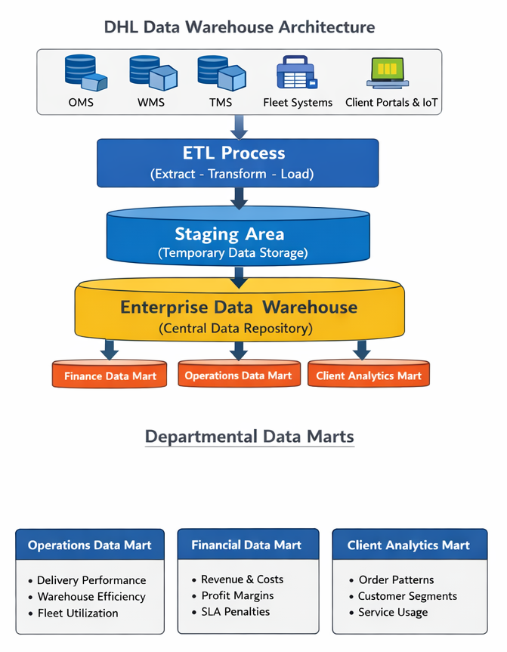

Data from various DHL operational sources, including as fleet GPS and fuel usage systems, warehouse inventory systems from Eurocentral and Lyon, cargo tracking systems from Daventry and Rotterdam, financial billing platforms, and client contract databases, will be integrated into the warehouse. DHL can do away with its current disjointed reporting environment by combining data from these various systems into a single data warehouse. This will allow for consistent data access, better operational visibility, improved decision-making, and more effective performance monitoring throughout supply chain and logistics operations.

ETL Process Explanation
1. Extract
Periodically, data is taken out of functional systems like WMS and TMS without interfering with ongoing transactions. Usually, extraction takes place through incremental updates or during periods of low activity.
2. Transform
Data is cleaned and standardised:
• Converting currencies throughout Europe
• Standardised codes for shipment status
• Elimination of redundant customer records
• Coordinating time zones between nations
Business rules are applied, such as calculating delivery delays or carbon emissions per shipment.
3. Load
Cleaned data is loaded into the warehouse in structured analytical formats.
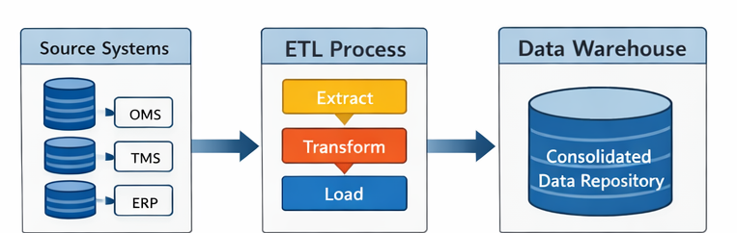

Operational Assurance
The CEO can be reassured that ETL processes:
- Do not replace existing systems
- Run separately from operational databases
- Use scheduled or incremental loading
- Prevent disruption to warehouse or transport activities
Thus, DHL continues daily logistics operations while gaining enterprise-wide analytical intelligence.

1.3 Data Marts for Management Decision-Making
Sourced from the core business data warehouse, data marts function as department-specific analytical environments designed to offer actionable insights for management decision-making. They provide the organization's strategic, operational, and financial planning with targeted, dependable, and consistent indicators.
1. Operations Data Mart – Managing Director
Focus: Enhancing operational efficiency across DHL’s UK and European hubs.
Key Insights:
- On-time delivery (OTD) performance across hubs and routes
- Warehouse throughput and utilisation rates
- Cross-border shipment delays and bottlenecks
- Fleet deployment and utilisation metrics
Example Application: With the use of this data mart, executives can identify operational inefficiencies, such as traffic along the corridor between Europe and Eastern Europe or inefficient handling of urgent pharmaceutical shipments at Heathrow, enabling prompt interventions to enhance service quality and throughput.
2. Financial Data Mart – Finance Director
Focus: Profitability analysis and cost optimisation.
Integrated Data Sources:
- Freight revenue and contract pricing
- Fuel, labour, and warehouse operational costs
- SLA penalties and client-specific profitability metrics
Capabilities:
- Profit margin analysis by logistics lane or client
- Comparative cost evaluation across transport modes
- Invoice accuracy and reconciliation reporting
Strategic Value: The finance team can evaluate the feasibility of premium express services, manage resource allocation, and guarantee profitable service delivery throughout UK and European operations by giving a clear picture of revenue vs operational expenditure.
3. Client Intelligence Data Mart – Sales & Marketing Director
Focus: Understanding client behaviour and optimising service offerings.
Data Coverage:
- Client ordering patterns and historical trends
- Industry sector performance benchmarks
- Delivery reliability and SLA compliance
- Service utilisation across products and regions
Business Value: makes it possible to identify high-value retail and automotive customers, improves demand forecasting for the expansion of e-commerce, and makes it easier to create customised logistics solutions that meet the demands of specific clients.
Strategic Advantage: DHL eliminates manual report compilation, guarantees reliable and consistent performance metrics, and enables executives to make quicker, data-driven decisions that are in line with operational, financial, and commercial goals throughout the UK and European network by centralising department-specific analytics into dedicated data marts.
Data Mart | Focus / Department | Key Data & Metrics | Strategic Value / Business Use
Operations Data Mart | Managing Director – Operations | The performance of on-time delivery (OTD) Warehouse utilisation and throughput Delays in cross-border shipments and fleet utilisation | Determine inefficiencies and bottlenecks; optimise fleet deployment and hub operations; and increase service dependability throughout UK and European hubs.
Financial Data Mart | Finance Director | SLA penalties; fuel, labour, and warehouse expenses; freight revenue and contract price; and client profitability | Examine profit margins for each logistics lane; compare expenses for various means of transportation; verify invoice accuracy; and maximise profitability.
Client Intelligence Data Mart | Sales & Marketing Director | Customer order trends and patterns; industry sector performance; SLA compliance and delivery dependability; and service utilisation | Determine high-value customers; assist demand forecasting for the expansion of e-commerce; enable customised logistical solutions; and improve customer satisfaction

1.4 OLTP Normalisation vs Dimensional Modelling
DHL's OLTP systems use normalised database structures, which partition data into numerous related tables to remove duplication. To guarantee effective transactional updates, for instance, shipment, customer, vehicle, and route data are kept apart.
This format makes analytical enquiries difficult and slow, even though it is appropriate for operations.
Dimensional modelling, which is intended for reporting and analysis, is used in data warehouses. A Star Schema is used to arrange data into Facts and Dimensions.

DHL Logistics Star Schema
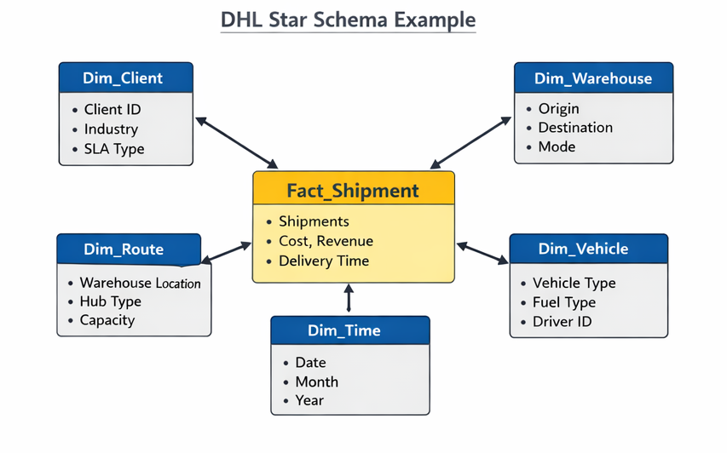
Feature | OLTP Systems (Normalized) | Data Warehouse (Dimensional Modelling)
Purpose | facilitates regular transactions (efficiency of operations) | Supports strategic reporting and analysis (business intelligence)
Data Structure | Several connected, highly normalised tables to cut down on redundancy | Denormalised and arranged using Star Schema into Facts and Dimensions
Example Tables | Shipment, Customer, Vehicle, Route | Dimensions: Client, Warehouse, Route, Vehicle, Time; Fact_Shipment (Shipment ID, Delivery Time, Transport Cost, Distance, Revenue, Carbon Emissions)
Query Performance | Complex and slower for analytical queries | Simplified and faster for analysis
Analysis Examples | Not optimized for cross-sectional reporting | Trends in warehouse productivity, customer profitability, and delivery performance by region
Advantages | Effective transactional updates that prevent redundant data | Easy reporting, business insights, trend analysis
Disadvantages | Large data collections are difficult to compile and evaluate. | Requires ETL process to populate fact and dimension tables

Task 2 – Data Warehouse Design & Implementation

2.1 Source System Identification
DHL’s data warehouse will integrate both internal and external systems:

Source Type | Location / Scope | Key Data Captured
WMS (Warehouse Management Systems) | Daventry – Retail / E-commerce | Inventory levels, Pick/pack times, Put-away times, Space utilisation, Staff assignments
 | Heathrow – Pharmaceutical / High-value | Temperature logs, Chain of custody, High-value tracking
 | Lyon – Fresh Produce / Cold Chain | Cold chain monitoring, Expiry date tracking, Fresh produce handling
 | Eurocentral (Glasgow) – Automotive / JIT | Just-in-time inventory, Manufacturing sequencing
TMS (Transportation Management Systems) | UK Fleet Management | Shipment tracking, Route details, Transit times, Freight costs, Carrier details
 | Düsseldorf – Automotive / Eastern Europe | Cross-border shipments, Customs documentation, JIT delivery scheduling
 | Rotterdam – Ocean Freight / Bulk | Container tracking, Bulk chemical storage, Cross-docking operations
OMS (Order Management Systems) | Global Order Management | Client orders, Order lines, Requested delivery dates, Special handling, Order status
 | Client Portals | Client forecasts, Promotional calendars, Seasonal demand data
Financial Systems (ERP) | UK Finance ERP | Invoicing details, Revenue per shipment, Payment terms, Fuel surcharges, Labour costs
 | EU Finance ERP | Cross-border costs, Customs duties, Currency conversion
Fleet Telematics | N/A | GPS tracking (location, speed, route adherence), Fuel systems (consumption, idle time, efficiency), Maintenance systems (schedules, repair history, vehicle availability)
Returns Management & Quality Control | N/A | Return reason codes, Disposition (re-stock / scrap / repair), Damage assessment, Inspection records
Customs Systems | N/A | Border clearance status, Customs duty calculations, Documentation requirements
Weather Data | N/A | Route weather conditions, Delay predictions, Seasonal impact analysis
Market Data & Carrier Partner Systems | N/A | Fuel price indices, Economic indicators, Industry growth trends, Third-party tracking, Partner rates, Service level performance

Together, these sources provide the financial performance, customer interactions, shipment movement, and operational execution needed for enterprise analytics.

2.2 Star Schema Design

To handle DHL's primary business operations, a number of interconnected star schemas have been created based on Kimball's dimensional modelling methodology (Kimball & Ross, 2013). With subsidiary schemas for warehouse operations and financial performance, as well as metadata and aggregate tables for executive reporting, the primary schema facilitates shipping performance analytics.

Primary Star Schema: Shipment Performance Analytics

Dimension | Description | Key Attributes
DimClient | Master data for clients | Client_SK (PK), Client_ID, Client_Name, Industry_Sector, SLA_Target_Days, Contract_Type, Credit_Terms, Valid_From, Valid_To, Current_Flag
DimDate | Master data for dates | Date_SK (PK), Full_Date, Day_of_Week, Week_Number, Month_Name, Quarter, Year, Is_Bank_Holiday, UK_Holiday, German_Holiday, French_Holiday, Dutch_Holiday
DimRoute | Master data for shipment routes | Route_SK (PK), Origin_Hub, Origin_Country, Dest_Hub, Dest_Country, Transport_Mode, Lane_Type, Standard_Distance
DimService | Metadata – service types | Service_SK (PK), Service_Type, Service_Class, Service_Level, SLA_Guarantee, Surcharge_Pct
DimVehicle | Master data for fleet | Vehicle_SK (PK), Vehicle_Reg, Vehicle_Type, Fuel_Type, Euro_Class, Capacity_CBM, Owned_or_Sub, Emission_Standard, Maintenance_Status
DimWarehouse | Master data for facilities | Warehouse_SK (PK), Hub_Location, Specialisation, Total_Space_SQM, Automated_Level, Storage_Capacity, Temperature_Control, Hazardous_Capable
Fact Table: FactShipment
Field | Type | Description
Shipment_SK | INT (PK) | Unique shipment identifier
Client_SK | INT (FK) | References DimClient
Date_SK | INT (FK) | References DimDate
Route_SK | INT (FK) | References DimRoute
Service_SK | INT (FK) | References DimService
Vehicle_SK | INT (FK) | References DimVehicle
Warehouse_SK | INT (FK) | References DimWarehouse
Measures | — | Planned_Transit_Days, Actual_Transit_Days, Transit_Variance, Total_Freight_Cost, Shipment_Revenue, Calculated_Profit, Number_of_Packages, Total_Weight_KG, Carbon_Emission_KG, Is_On_Time, Fuel_Surcharge_Applied, Customs_Duty_Paid

Secondary Star Schema: Warehouse Operations Analytics
Figure 2.3 – DHL Warehouse Operations Star Schema
Fact Table: FactWarehouseActivity
Field | Type | Description
Activity_SK | INT (PK) | Unique warehouse activity record
Date_SK | INT (FK) | References DimDate
Warehouse_SK | INT (FK) | References DimWarehouse
Product_SK | INT (FK) | References DimProduct
Employee_SK | INT (FK) | References DimEmployee
Client_SK | INT (FK) | References DimClient
Measures | — | Pick_Time_Minutes, Pack_Time_Minutes, Putaway_Time_Minutes, Quantity_Processed, Storage_Days, Space_Utilised_SQM, Damage_Quantity, Returns_Processed
Benefits: Optimizes warehouse throughput, resource allocation, and operational efficiency.

Aggregate Table: Monthly Delivery Performance
Figure 2.4 – FactMonthlyPerformance (Aggregate Table)
Field | Type | Description
Year, Month | INT | Partition keys
Client_SK, Route_SK, Service_SK | INT (FKs) | References dimensions
Aggregate Measures | — | Total_Shipments, On_Time_Shipments, SLA_Compliance_Pct, Avg_Transit_Days, Total_Revenue, Total_Cost, Total_Profit, Avg_Profit_Margin, Total_Carbon_Emissions, Avg_Cost_Per_Shipment
Purpose: Sub-second executive dashboards; reduces querying large fact tables (~50M rows) to manageable summary (~50k rows).

Metadata Table: Service Type Reference
Figure 2.5 – DimServiceType
Field | Type | Description
Service_Type_Code | VARCHAR(10) (PK) | e.g., 'EXP', 'STD', 'ECO'
Service_Type_Name | VARCHAR(30) | e.g., 'Express', 'Standard', 'Economy'
Service_Class | VARCHAR(30) | e.g., 'Pharma', 'Retail', 'Bulk'
Description | VARCHAR(200) | Full service description
Base_Price_Per_KG | DECIMAL(8,2) | Standard rate
Surcharge_Rules | VARCHAR(500) | JSON/XML rules
SLA_Guarantee_Hours | INT | Target delivery window
Active_Flag | BOOLEAN | Currently offered
Valid_From / Valid_To | DATE | Service lifecycle

Sample Data:
Code | Name | Class | Description
EXP-PH | Express | Pharma | Urgent pharmaceutical delivery
STD-RT | Standard | Retail | Standard retail fulfilment
ECO-BK | Economy | Bulk | Economy bulk chemical delivery
JIT-AT | Just-in-Time | Automotive | JIT automotive components
CLD-FR | Cold Chain | Fresh | Temperature-controlled fresh delivery

Design Justification

Element | Justification | DHL-Specific Benefit
Fact tables at atomic grain | Maximum analytical flexibility | Drill down to the shipment level from the executive dashboard
Conformed dimensions | Consistent definitions | In terms of operations, profitability, and service reporting, "client" is the same.
Type 2 SCD for clients | Tracks historical SLA/contract changes | Accurate SLA compliance analysis
Surrogate keys | Independent from source IDs | Handles mergers/acquisitions gracefully
Separate date dimension | Enables time-based analysis | supports seasonal, holiday, and day-of-week trends
Aggregate table | Pre-calculated KPIs | Executive dashboard reaction in less than a second
Metadata table | Central source for classifying services | Consistent definitions throughout European operations

2.3 Data Marts and Schema
Three departmental data marts were created in accordance with Inmon's (2005) Data Mart Architecture to meet the analytical requirements of important DHL stakeholders. The Enterprise Data Warehouse (EDW) serves as the single source of truth for each data mart, which is customised for particular business operations.

Figure 2.6: DHL Departmental Data Marts Architecture
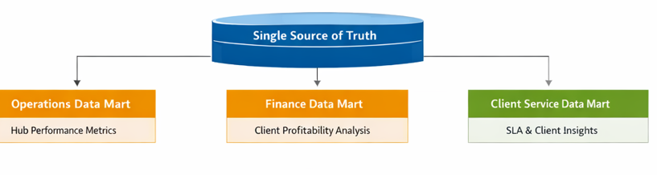

2.3.1 Operations Data Mart
Target Users: Managing Director & Hub Operations Managers
Purpose: Real-time monitoring of hub and fleet performance to identify bottlenecks and optimize efficiency.
Fact Table: Fact_Hourly_Hub_Performance (Real-time Operations Data)
Column | Type | Description
Date_SK | INT (FK) | References DimDate
Time_SK | INT (FK) | References DimTime
Hub_SK | INT (FK) | References DimHub
Route_SK | INT (FK) | References DimRoute
Measures
Shipments_Received | INT | Inbound volume
Shipments_Dispatched | INT | Outbound volume
Average_Pick_Time_Min | DEC(6,2) | Picking efficiency
Average_Pack_Time_Min | DEC(6,2) | Packing efficiency
Space_Utilization_Pct | DEC(5,2) | Warehouse capacity used
Staff_On_Shift | INT | Workforce availability
Productivity_Per_Staff | DEC(8,2) | Units processed per employee
OTIF_Performance | DEC(5,2) | On-Time In-Full %
Active_Bottlenecks | INT | Current operational issues
Fact Table: Fact_Transport_Efficiency (Fleet Performance Data)
Column | Type | Description
Date_SK | INT (FK) | References DimDate
Route_SK | INT (FK) | References DimRoute
Vehicle_SK | INT (FK) | References DimVehicle
Measures
Total_Trips | INT | Trips completed
Avg_Transit_Time | DEC(6,2) | Average hours per trip
Fuel_Consumed_Litres | DEC(10,2) | Fuel usage
Cost_Per_Mile | DEC(8,2) | Operational cost efficiency
On_Time_Percentage | DEC(5,2) | Fleet punctuality
Carbon_Emission_KG | DEC(10,2) | Environmental footprint
Associated Dimensions: Dim_Date, Dim_Time, Dim_Hub, Dim_Route, Dim_Vehicle

2.3.2 Finance Data Mart
Target Users: Finance Director & Commercial Team
Purpose: Enable profitability and cost analysis across clients, contracts, and services.
Fact Table: Fact_Client_Profitability (Core Profitability Analysis)
Column | Type | Description
Date_SK | INT (FK) | References DimDate
Client_SK | INT (FK) | References DimClient
Contract_SK | INT (FK) | References DimContract
Service_SK | INT (FK) | References DimService
Route_SK | INT (FK) | References DimRoute
Revenue Measures
Base_Revenue | DEC(18,2) | Standard charges
Surcharge_Revenue | DEC(18,2) | Premium/urgent fees
Fuel_Surcharge | DEC(18,2) | Fuel adjustment revenue
Total_Revenue | DEC(18,2) | Sum of revenue
Cost Measures
Transport_Cost | DEC(18,2) | Freight, fuel, driver costs
Warehouse_Cost | DEC(18,2) | Storage, labour, equipment
VAS_Cost | DEC(18,2) | Value-added services
Customs_Duty | DEC(18,2) | Cross-border duties
Returns_Cost | DEC(18,2) | Reverse logistics
Total_Cost | DEC(18,2) | Sum of all costs
Profitability Measures
Gross_Profit | DEC(18,2) | Total_Revenue - Total_Cost
Profit_Margin_Pct | DEC(5,2) | Gross_Profit / Total_Revenue * 100
Contribution_Margin | DEC(18,2) | Revenue - Variable Costs
EBITDA | DEC(18,2) | Earnings before interest
Fact Table: Fact_Cost_Analysis (Detailed Cost Drivers)
Column | Type | Description
Date_SK | INT (FK) | References DimDate
Route_SK | INT (FK) | References DimRoute
Vehicle_SK | INT (FK) | References DimVehicle
Fuel_Cost | DEC(18,2) | Trip fuel expenses
Labour_Cost | DEC(18,2) | Driver and warehouse labour
Maintenance_Cost | DEC(18,2) | Fleet maintenance
Overhead_Cost | DEC(18,2) | Indirect costs
Total_Cost | DEC(18,2) | Total cost per trip/route
Cost_Per_Mile | DEC(8,2) | Efficiency metric
Cost_Per_Shipment | DEC(8,2) | Allocation per shipment
Associated Dimensions: Dim_Date, Dim_Client, Dim_Contract, Dim_Service, Dim_Route, Dim_Vehicle

2.3.3 Client Service Data Mart
Target Users: Sales & Marketing Director, Account Managers
Purpose: Track SLA compliance, client satisfaction, and growth/risk indicators.
Fact Table: Fact_Client_Service_Performance (SLA & Service Quality)
Column | Type | Description
Date_SK | INT (FK) | References DimDate
Client_SK | INT (FK) | References DimClient
Service_SK | INT (FK) | References DimService
Route_SK | INT (FK) | References DimRoute
Service Measures
Total_Shipments | INT | Volume of business
On_Time_Deliveries | INT | SLA compliance
In_Full_Deliveries | INT | Complete orders
OTIF_Deliveries | INT | On-Time In-Full
OTIF_Percentage | DEC(5,2) | Service level score
Damage_Claims | INT | Damages reported
Returns_Processed | INT | Returns handled
SLA_Breaches | INT | Contract violations
Average_Transit_Days | DEC(6,2) | Delivery speed
Client_Satisfaction_Score | DEC(3,1) | Survey results

Fact Table: Fact_Client_Trend_Analysis (Growth & Risk Indicators)
Column | Type | Description
Year | INT | Year of measurement
Month | INT | Month of measurement
Client_SK | INT (FK) | References DimClient
Sector | VARCHAR(50) | From DimClient
Volume_Current_Month | INT | Current month shipments
Volume_Previous_Month | INT | Previous month shipments
Volume_Change_Pct | DEC(5,2) | Growth rate
Revenue_Current_Month | DEC(18,2) | Current month revenue
Revenue_Previous_Month | DEC(18,2) | Previous month revenue
Revenue_Change_Pct | DEC(5,2) | Growth rate
SLA_Trend_3Month | DEC(5,2) | Rolling SLA average
Risk_Score | DEC(3,1) | At-risk indicator
Cross_Sell_Score | DEC(3,1) | Opportunity score
Dim_Client_Extended (Enriched Client Master Data)
Column | Type | Description
Client_SK | INT (PK) | Surrogate key
Client_ID | VARCHAR(20) | Source system ID
Client_Name | VARCHAR(100) | Full client name
Industry_Sector | VARCHAR(50) | Sector classification
Key_Accounts | BOOLEAN | Strategic client flag
Acquisition_Date | DATE | Client start date
Contract_Value | DEC(18,2) | Annual contract value
Services_Used | VARCHAR(200) | Active service list
Relationship_Manager | VARCHAR(100) | Account manager
Next_Review_Date | DATE | Contract renewal
Risk_Level | VARCHAR(20) | High / Medium / Low

Data Mart Summary

Data Mart | Primary Users | Key Facts | Update Frequency | Business Purpose
Operations | Managing Director, Hub Managers | Hub performance, fleet efficiency | Real-time (15-min) | Monitor operations, identify bottlenecks
Finance | Finance Director, Commercial Team | Client profitability, cost analysis | Daily 06:00 | Optimize pricing, control costs
Client Service | Sales & Marketing Director, Account Managers | SLA compliance, client trends | Daily 06:00 | Improve retention, identify growth opportunities

2.4: ETL Plan (Simplified) – DHL Supply Chain Data Warehouse
Overview
Without interfering with regular OLTP operations, the ETL (Extract, Transform, Load) process is intended to combine DHL's operational data from several UK and European hubs into the central data warehouse. WMS, OMS, TMS, fleet systems, ERP, client portals, and IoT devices are examples of data sources. In order to facilitate both detailed and aggregated analysis, ETL makes sure that data is cleaned, harmonised, and enriched before being entered into fact and dimension tables.
1. Extraction
Data is extracted from source systems at scheduled intervals (real-time, hourly, or daily, depending on business criticality):
Source System | Data Extracted | Frequency
WMS (Daventry, Heathrow, Eurocentral, Lyon) | Inventory levels, pick/pack times, warehouse activity | Hourly
OMS | Orders, client details, requested delivery dates | Real-time
TMS / Fleet Systems | Vehicle tracking, routes, fuel usage, delivery confirmation | 15-min intervals
Financial ERP | Invoice amounts, costs, surcharges, revenue | Daily
Client Portals & IoT | SLA feedback, service requests, cold-chain monitoring | Real-time
2. Transformation
During transformation, data is cleansed, standardized, and enhanced:
- Cleansing: Remove duplicates, correct invalid values (e.g., negative weights or missing SKU codes).
- Validation: Ensure data integrity, e.g., all shipment records link to a valid client ID.
- Standardization: Convert units (e.g., weights in KG, distance in KM), normalize date formats, harmonize hub names across countries.
- Derivation / Enrichment: Calculate transit variance (Actual vs Planned), fuel cost per shipment, carbon emission per km.
- Aggregation: Summarize daily or monthly metrics for executive dashboards (FactMonthlyPerformance).
- Surrogate Key Mapping: Assign unique keys for dimensions (Client_SK, Vehicle_SK) to maintain consistency even if source IDs change.
3. Loading
- Staging Area: Temporary tables store cleansed data to ensure source systems are not impacted.
- Dimension Tables: Slowly Changing Dimensions (Type 2) track historical changes in clients, routes, and vehicles.
- Fact Tables: Atomic-level records loaded first (FactShipment, FactWarehouseActivity).
- Aggregate Tables: Pre-calculated summaries for dashboards (FactMonthlyPerformance) update after fact table loads.
4. Scheduling & Monitoring
- ETL pipelines run in incremental or full-load mode depending on source.
- Logging, error alerts, and reconciliation checks ensure no data loss.
- Automated rollback strategies maintain data warehouse consistency.
Benefits for DHL
• Timely, reliable, and integrated operational insight.
• Facilitates drilling down from overall KPIs to specific shipment-level information.
• Lessens the influence on day-to-day logistics activities.
• Guarantees adherence to SLA reporting and multi-country regulatory requirements.

2.5 Data Quality & Governance

DHL needs to have governance procedures in place to guarantee data consistency, correctness, and compliance. Duplicate client or shipping records are avoided through master data management. Financial and client data are safeguarded via role-based access control. Transparency during audits is ensured by data lineage tracking. GDPR compliance is crucial for operations in the UK and the EU. Long-term warehouse dependability is maintained via automated validation procedures and ongoing monitoring.

References
- Codd, E.F. (1970) 'A relational model of data for large shared data banks', Communications of the ACM, 13(6), pp. 377-387
- Connolly, T. and Begg, C. (2015) Database Systems: A Practical Approach to Design, Implementation, and Management. 6th edn. Harlow: Pearson Education
- DAMA International (2017) DAMA-DMBOK: Data Management Body of Knowledge. 2nd edn. New Jersey: Technics Publications.
- Davenport, T.H. (2014) Big Data at Work: Dispelling the Myths, Uncovering the Opportunities. Boston: Harvard Business Review Press
- Eckerson, W.W. (2010) Performance Dashboards: Measuring, Monitoring, and Managing Your Business. 2nd edn. Hoboken: John Wiley & Sons.
- Golfarelli, M. and Rizzi, S. (2009) Data Warehouse Design: Modern Principles and Methodologies. New York: McGraw-Hill.
- Imhoff, C., Galemmo, N. and Geiger, J.G. (2003) Mastering Data Warehouse Design: Relational and Dimensional Techniques. Indianapolis: Wiley Publishing.
- Inmon, W.H. (2005) Building the Data Warehouse. 4th edn. Indianapolis: Wiley Publishing.
- Kimball, R. and Ross, M. (2013) The Data Warehouse Toolkit: The Definitive Guide to Dimensional Modeling. 3rd edn. Indianapolis: John Wiley & Sons
- Langley, C.J. and Capgemini (2023) *2023 Third-Party Logistics Study: The State of LogisticsOutsourcing*. Available at: https://www.kornferry.com/ (Accessed: [Current Date]).
- Ponniah, P. (2010) Data Warehousing Fundamentals for IT Professionals. 2nd edn. Hoboken: John Wiley & Sons.

