Dumitru Razvan Tudora
Student nr:1913294
Marketing Fundamentals1
Brace’s Bakery
Tushara Balendran

Table of Contents
- Introduction 3
- Blogs 3
Blog 1 4
Blog 2 5
Blog 3 6
Blog 4 7
Blog 5 8
Blog 6 9
- Conclusion 10
- References 11

Introduction
Blogging is considered as procurement of a website and broadcasting unique content on it. It can be used to maintain communication with the customers and building rapport with them. The present is based on Braces bakery ltd and located in the United Kingdom (Martins, Pinho, and Ferreira, 2017.). The company deals in slices of bread, muffins, cakes, and rolls and provides services to the consumers all through the Wales and South West of England. The company was established in the year 1902 by George Brace. The operations are supervised by the director and managing director of the company. The assignment presents six blogs regarding the company's information that can be useful for its customers (Louis, Fairchild, and Setarehnejad, 2019). The company was successful in expanding the market with a broad range of products.

Blogs
All about Braces Bakery
Braces bakery Ltd. belongs to the industry of food production, and it was privately held. The headquarters of the company is situated in Newport, Crumlin. Since the year of establishment, Braces was involved in baking products, and people have trusted it. The company was dedicated to family morals and ethics. The establishment uses the top ingredients in producing goods with ecological sourcing. Focus is given on the main goals of the company by considering both the employees and customers. The firm is engaged in producing better quality products with high standards.
Further, the selected company supplies sliced bread daily that arrives at the store within twelve hours of packing. Additionally, the company has made continuous investments in equipment and standards. The mission of Braces bakery Ltd. is to deliver products that fulfill the requirements of increasing health-conscious customers.
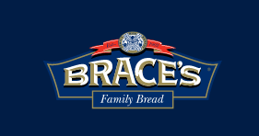
(Source: Braces Bakery, 2020)

Blog 1
Welsh Legends Range at Braces Bakery
Braces Bakery has introduced the latest range of blunders called Welsh legends. Each of the products in the new range stands on its excellence. The new range consists of Gwynny, Caradoc, heulwen , tiger bay, etc. The features of the product include bold colors that distinguish each of the items. The company has a range of protein-packed products that comprise Welsh Cakes and pieces of bread.
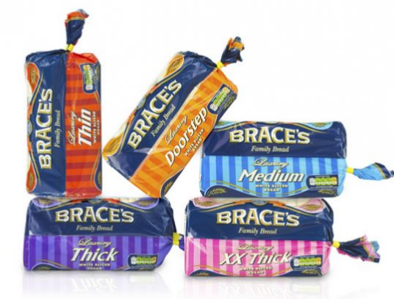
(Source: CaerphillyObserver, 2018)
It was planned to deliver tasty bakery products in the market that sustain an active standard of living. Identity has been given to each loaf by the company, and all were set at a distance on the shelf. Thus, each of the items has been prudently considered before the name was given that rejoices Welsh culture. Consequently, the highest quality products are provided by Braces Bakery Ltd.

Blog 2
Cost-effective and best prices
Braces bakery is involved in the manufacture of a wide range of products. Various discounts are offered by the company so that the consumers can buy healthy food items. The company's purpose is to deliver the right quality product at reasonable prices to sustain in the long run. The new range of products was introduced at low prices. Products like thick white sliced bread and luxury white sliced bread are available quickly and at low cost. The offer of products is offered by the company with its own label to increase the demand for the product. Different kinds of discount offers are available to buy directly from the store or through online purchasing.
Additional products are added by the company that is more tasty and full of protein by considering the increase in health-aware behavior of the people at large. Customers are benefited from purchasing through the use of credit or debit cards.

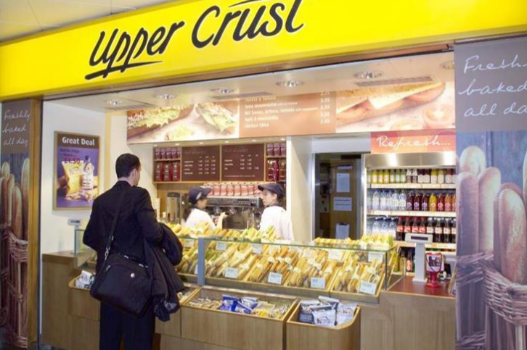
(Source: Cherubini. E, 2020)

Blog 3
Products on the shelves of the local and international supermarket
Braces Bakery was the first bakery in the United Kingdom that has received British Retail Consortium and is devoted to continually delivering better standards. The local distribution area of the establishment covers South Wales and Southwest of England. The products of the bakery to approximately 3000 stores daily. A properly devoted distribution fleet is involved in the process of delivering the products.
The goods are transported directly from the bakeries or from the goods yard of the company situated at Caple Hendre adjacent to Ammanford and Dursley in Gloucestershire. The company is also dedicated to bringing the goods to the store within 12 hours of packing. The focus is to balance the products by understanding consumer demands and the latest trends in the market.
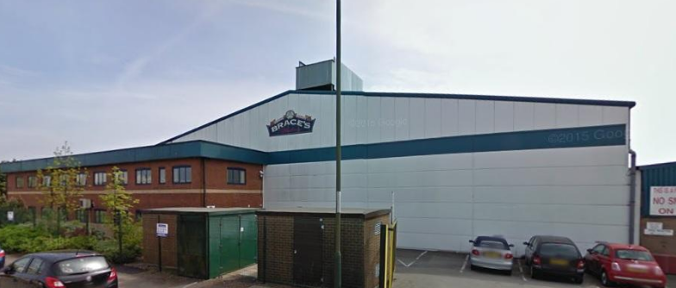
(Source: South Wales Argus, 2016)
The availability of the products at the nearest store has provided convenience to the customers and reduced transportation costs. Introduction of new stores at the local market is planned that is beneficial to acquire necessary products easily.

Blog 4
Support to Digital Campaign
Braces bakery ltd. was always committed to family beliefs over its existence. The company has progressively increased its distribution to the superstores and shops. The website provides details regarding the information of the products followed by the improved navigation system that helps in using the website. The clear and vibrant images with the description of each product are provided. The company's products are managed through the three main channels, which include Twitter, Facebook, and Instagram.


Through these social media, details of the products can be easily accessed by the public. The 'bread for all seasons' was created with different packaging over the year. Further, the TV advertisement provides details regarding the new range of products. The fresh doorstep loaf was launched, which has received a favorable verdict. Additionally, emails and telephonic conversations are used to provide details regarding the new product launch with specific descriptions.
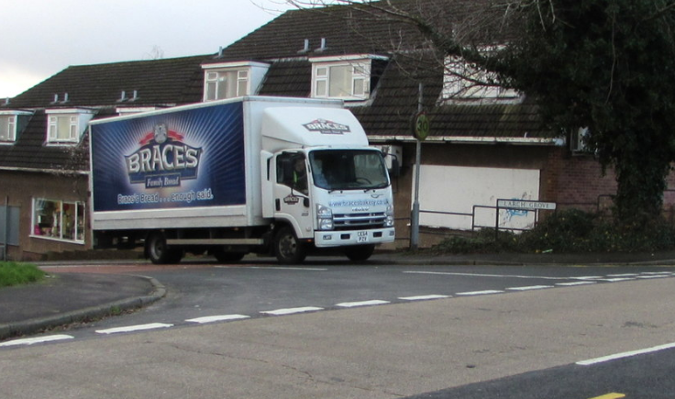
(Source: Geograph, 2018)

Blog 5
Redesigning of packaging and well-structured stores
The bread sliced has been rebranded by Braces Bakery Ltd. with the packaging that will develop the carbon footprint of the company. The latest packaging is the total redesigning of the various bread products of the bakery. The aspects are to reduce the color used to create eco-friendly products. The brand name has been redesigned along with the bread van to match with the Braces' slice bread. The new design of the products contains a QR code that can acquire more information regarding the product. The code can be scanned on mobile phones, and relevant data can be achieved. Displays are also organized in the stores so that it is easy to reach the product without wasting any time.
The stores are appropriately arranged so the products can be accessed very easily. Customers don't have to spend more time searching for the products as they are correctly placed.

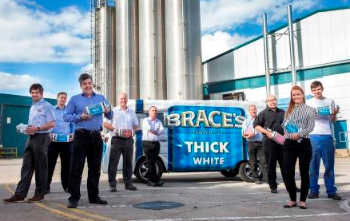
(Source: Farrell. S, 2017)

Blog 6
Excellence personnel and Immediate billing
Braces bakery Ltd. uses various programs to offer loyalty to its employees. To improve the performance of the group, well-compensated assistance is provided to them. Outstanding sales services are provided that give complete information regarding the company's products. Professionals are hired for the introduction of the latest developments in the market by considering the current market trends. The environment of the company is extremely efficient for the employees as they are a valuable asset to the business. With proper devotion and trustworthiness, the enterprise accomplishes its responsibilities to the employees and consumers.
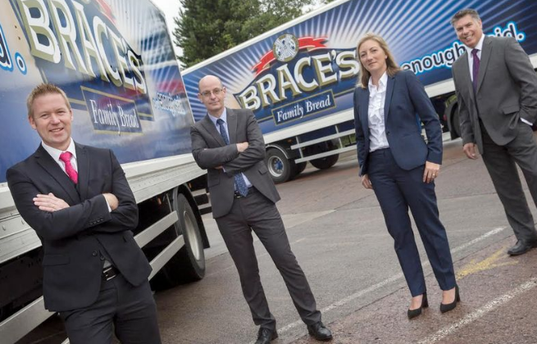
(Source: WalesOnline, 2015)
The marketing mix procedure in Braces bakery Ltd. focuses on the method to satisfy the consumers by way of quick billing. Products are readily available at the local and national market stores that guide the buyers to purchase the goods. The management team concentrates on the problems faced by the customers and address their issues and resolve them. The company is operating on various investment plans to offer better services to customers. The self-billing counter facility is available to the shoppers that make them content to avoid the long queues in billing. The privileges available to the customers are very satisfied in nature. The productivity and profitability of the company have been enhanced.

Conclusion
In the above report, six blogs have been presented that emphasizes on marketing mix elements applied by Braces bakery ltd. The delivered blogs can be used as a source to obtain information regarding the existing and new products of the company. This information is relevant to the group members and the target viewers. It also discusses the various distribution platforms of the company that includes stores at the national as well as international level. The promotion strategy of Braces bakery through digital campaigns is explained, followed by the redesigning process of the existing goods to capture the market.
Details regarding the new range of products are also given in the report. The products are available at affordable prices and at the nearest stores. This is the main advantage to the customers of Braces bakery Ltd. The supermarkets and stores are managed in such a way that the products are effortlessly accessible. The quality of the products and on-time delivery has developed a reputation for the company and increased its profitability and productivity. Lastly, it can be stated that Braces bakery ltd was involved in providing the best quality goods at a reasonable price and at the proper time.

References
Braces Bakery, 2020. Our-process. [Online] Available through <https://www.bracesbakery.co.uk/our-process/> [Accessesd on 30th December, 2020]
CaerphillyObserver, 2018.New Aldi deal for Crumlin’s Brace’s Bakery.[Online]. Available through <https://caerphilly.observer/news/968806/new-aldi-deal-for-bakery/> [Accessesd on 30th December, 2020]
Cherubini. E, 2020.City snapshot: SSP braces for £135m coronavirus revenue hit .[Online]. Available through <https://www.thegrocer.co.uk/results/city-snapshot-ssp-braces-for-135m-coronavirus-revenue-hit/603265.article> [Accessesd on 30th December, 2020]
Farrell. S, 2017.BAKERY BRACED FOR CHALLENGING MARKET. [Online]. Available through <https://www.insidermedia.com/news/wales/bakery-braced-for-challenging-market> [Accessesd on 30th December, 2020]
Geograph, 2018.Brace's Family Bread lorry, Larch Grove, Malpas, Newport.[Online]. Available through <https://www.geograph.org.uk/photo/6010410> [Accessesd on 30th December, 2020]
Louis, L., Fairchild, R. and Setarehnejad, A., 2019. Effects of ingredients on sensory attributes of gluten-free breads available in the UK. British Food Journal.
Martins, Z.E., Pinho, O. and Ferreira, I.M.P.L.V.O., 2017. Food industry by-products used as functional ingredients of bakery products. Trends in Food Science & Technology, 67, pp.106-128.
South Wales Argus, 2016.Over 30 jobs will go after Braces Bakery closes Croespenmaen head office. [Online].Available through<https://www.southwalesargus.co.uk/news/14305588.over-30-jobs-will-go-after-braces-bakery-closes-croespenmaen-head-office/>. [Accessesd on 30th December, 2020]
WalesOnline, 2015.Brace's Bakery reveals new look board of directors following appointment of CEO. [online] Available through <https://www.walesonline.co.uk/business/business-news/braces-bakery-reveals-new-look-9833316> [Accessesd on 30th December, 2020]

