Usability Comparison of a Set of Websites
Research Proposal
Callum Bain
Dr Nik Whitehead

Contents
Figures 3
1. Introduction 4
2. Background to the Proposed Research 5
3. Aims & Objectives 7
4. Project Design 8
4.1 Outline of Project Process 8
4.2 Data Collection 8
4.3 Data Evaluation 8
4.4 Risks & Limitations 9
4.5 Ethical Issues 9
5. Resources & Planning 10
5.1 Resources Required 10
5.1.1 Hardware Resources 10
5.1.2 Software Resources 10
5.1.3 Other Resources 10
5.2 Planning Chart 10
6. Reference List 11

Figures
Figure 1- Worldwide Market Share of Desktop PCs vs Mobile Devices 6
Figure 2- Preliminary Gantt Chart 10

1. Introduction
The purpose of the project is to examine and compare a selected set of websites against a series of chosen accessibility and usability criteria, including complying with various standards in place such as being effective when used in tandem with screen readers, or having options to deal with various forms of blindness. Each individual has a need for different methods of interacting with web content, for example using a keyboard instead of a computer mouse, or requiring a screen reader, [1]. It is vital that websites are expected to be usable for those with additional requirements than those without.
It is also important to assess technical requirements of websites when discussing usability, such as compatibility with various web browsers, different technologies accounting for the rising prevalence of smartphone users against personal computers, [2], and the intuitiveness of websites to ensure that ease of use is foremost in design. Achieving these conditions will be carried out through constant testing and development.
This project is worth investigating as standards and guidelines for usability & accessibility are constantly advancing, developing & evolving, [3], as well as being an area of personal interest, with building websites and the steps required to take in order to present a website to a broader audience.

2. Background to the Proposed Research
Usability can be defined in various ways: Juristo, Windl and Constantine state that usability reflects how easy to “learn and use” software is, how productive users can be while working with the software, and how much support users need, [4], while Lawrence and Tavakol define good usability as when a user uses “something almost or completely without noticing” that they are “using an interface” to do what is needed, and go on to pose key aspects when rating usability regardless of the item, including whether any member of a target population can use the item as intended, whether it can be used with ease, and if the usability approach contributes positively to the main purpose, [5].
An important detail of usability is accessibility, which primarily refers to designing something in a way so it is useable to those with disabilities, which can range from visual such as blindness to physical disabilities. Therefore, web accessibility refers to designing & developing websites, tools, and technology so those with disabilities can use them, specifically perceive, understand, navigate, and interact, [6]. Expanding this, universal design refers to the process of creating such products to be useable by people with the widest range of abilities and all possible situations, [7].
Guidelines for website accessibility have been defined in the past according to the World Wide Web Consortium (W3C)’s Web Content Accessibility Guidelines (WCAG) since 1999. The currently released guidelines, WCAG 2.1, includes details on perceivable information including text alternatives such as braille, larger print etc., operable components such as navigation & using a keyboard interface, and understandability such as the readability of text & data, [8].
The most important aspect of usability for any website is user interface (UI) design; a good interface is easy to use & understand whilst meeting the needs of the intended user. Specifically, good UI provides easy and natural interaction between the user and the system, allowing them to carry out whatever tasks they intend to do, [9]. UI which does not meet these criteria will naturally be difficult to use or frustrating. Therefore, it is imperative that there are a set of followed rules when considering UI design; Schneiderman proposed “Eight Golden Rules” of interface design, which are applicable to most interactive systems. Some of these rules include striving for consistency such as keeping the fonts, colours and layout of pages the same across the entire website, seeking universal accessibility including recognizing the needs of diverse users while keeping information clear and concise, and keeping users in control of their interface, keeping it as tidy and clean as possible without unexpected pop-ups, [10].
Usability testing is achieved through performing tasks on one or more user interfaces. Dumas and Fox state that all valid usability tests follow six characteristics: The focus on usability, the intended participants are end-users and potential end-users, there is a product or system to evaluate, participants perform tasks while thinking out loud, data is recorded and analysed, and the results of the test are communicated to the appropriate audiences, [11].
The advance in technology has also increased the need for usability tests on different platforms, for example the need for mobile usability testing as a priority alongside PC testing; the percentage of website traffic on mobile devices has increased by almost 30% from 2015, [2], facilitating the need for an increased focus to this type of usability test. Zhang and Adipat highlight some challenges in mobile usability testing, including a smaller screen size, differences in display resolutions between PC and various phone models, and lower bandwidth connections affecting applications, [12].
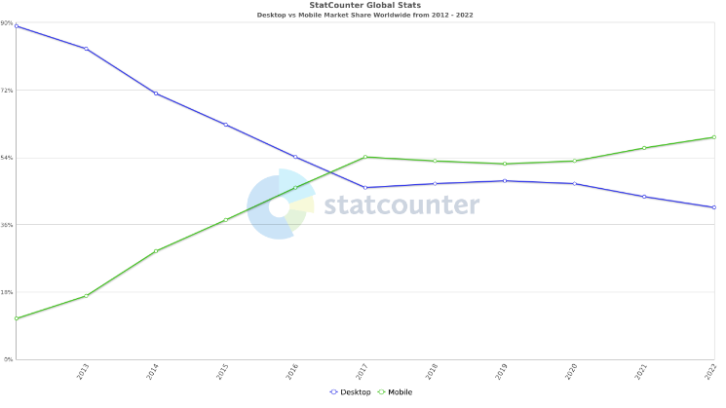
Figure 1- Worldwide Market Share of Desktop PCs vs Mobile Devices
As with most forms of tests, there are issues inherent in the process and evaluation of usability testing. Alshamari and Mayhew highlighted some of these issues including the “Evaluator Effect” in which multiple evaluators highlighting different problems rather then the same one, [13], the appropriate amount of users to test in one study, inappropriately selected tasks which can influence the final result, and the incorrect prioritization of problems, [14]. Dumas and Fox also mention the appropriate amount of test participants, whilst also mentioning inaccurate measurement criteria for tests and overall usability, the issues of out-loud thinking whilst conducing tests, and the overall reliability of tests when compared to older benchmarks, [11].

3. Aims & Objectives
- To investigate & evaluate a set of websites for their merit against various criteria of usability & accessibility.
  - Explore the various standards in place for viewing and navigating web content.
  - Determine the usability & accessibility criteria required to judge the website set against.
  - Evaluate the websites against the criteria found within the standards.
  - Compare the results of the evaluated set of websites against each other.

4. Project Design

4.1 Outline of Project Process
The main process for the project will be the collection of comparative data which will be created by testing the set of websites against the usability data decided by comparing various web guidelines, then choosing the tasks which appear most frequently and those with the most impact to usability.
When the criteria have been selected and tested against the websites, the results found on all sites will be compared with each other in order to determine which task had the most prevalent effect to the set overall, and which tasks could be improved by collecting more data.

4.2 Data Collection
The criteria to judge against the set of websites will be collected via comparing various articles detailing the guidelines in relation to website usability and accessibility.
The data recorded from performing the tasks against the set of websites will be collected first-hand and recorded appropriately. Some data will also be collected from secondary sources in relation to legacy data from past experiments for comparison.

4.3 Data Evaluation
In relation to data collected first-hand, it will be suited according to the thoroughness of the relevant test and will be compared to similar relevant data when the experiments have been completed. Should the data not match with what is expected, the tests will be run again in order to isolate outlier data and confirm the expected results.
Second-hand data collected from journals, articles etc. will be compared to the expected results of the undertaken tests and evaluated similarly; if the data does not match with what is expected, it will be replaced with appropriate data when necessary.

4.4 Risks & Limitations
There are different risk factors which can hinder the experiment & comparison of the website set, such as sudden unavailability of a website in the set, the tools used to collect the data not operating as they should, and delays in receiving or collecting data. There is always a possibility of unavailability of resources. In the chance of these factors occurring, a contingency plan will be used in its stead, such as using a different form of testing.
There are also possible limitations to the project, including a lack of time required to complete the project and its experiments and the project having a limited scope which can result in incomplete or incorrect data. As above, a contingency plan will be put in place should any of these issues arise.

4.5 Ethical Issues
Due to the nature of the experiment/project, most data will be drawn from the results of tests undertaken on websites and sourced from either first-hand experience or taken from research articles/journals. Therefore, this project carries a low ethical risk.
All collected information and data will be treated with due respect and dignity. Any data of a personal nature will be handled as strictly confidential, will be anonymised, and deleted following the finalisation of the project.

5. Resources & Planning

5.1 Resources Required

5.1.1 Hardware Resources
- A personal computer connected to the internet
- A smartphone connected to the internet

5.1.2 Software Resources
- Internet/Wi-Fi connection
- An internet-enabled web browser, i.e., Google Chrome
- Screen reading software, i.e., Windows Narrator, ChromeVox
- Other appropriate testing software

5.1.3 Other Resources
- A library of appropriate journals and articles to support primary and secondary data

5.2 Planning Chart
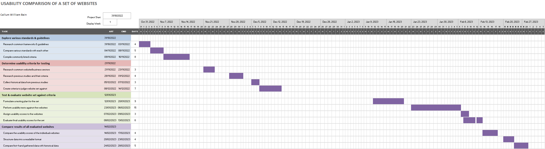
Figure 2- Preliminary Gantt Chart

6. Reference List

[1] | Understanding WCAG 2.1 - Service Manual - GOV.UK, GOV.UK, 2022.
[2] | Statista, “Global mobile traffic 2022 | Statista,” 20 July 2022. [Online]. Available: https://www.statista.com/statistics/277125/share-of-website-traffic-coming-from-mobile-devices/. [Accessed 19 October 2022].
[3] | World Wide Web Consortium, “WCAG 3 Introduction | Web Accessibility Initiative (WAI) | W3C,” 6 July 2022. [Online]. Available: https://www.w3.org/WAI/standards-guidelines/wcag/wcag3-intro/. [Accessed 19 October 2022].
[4] | N. Juristo, H. Windl and L. Constantine, “Introducting Usability,” IEEE Software, vol. 18, pp. 20-21, 2001.
[5] | D. Lawrence and S. Tavakol, “Balanced Website Design: Optimising Aesthetics, Usability and Purpose,” Springer, 2007, p. 38.
[6] | World Wide Web Consotrium, “Introduction to Web Accessibility | Web Accessibility Initiative (WAI) | W3C,” 31 March 2022. [Online]. Available: https://www.w3.org/WAI/fundamentals/accessibility-intro/. [Accessed 20 October 2022].
[7] | S. L. Henry, S. Abou-Zahra and J. Brewer, “The Role of Accessibility in a Universal Web,” in 11th Web for All Conference, New York City, 2014.
[8] | World Wide Web Consortium, “Web Content Accessibility Guidelines (WCAG) 2.1,” 5 June 2018. [Online]. Available: https://www.w3.org/TR/WCAG21/. [Accessed 20 October 2022].
[9] | D. L. Stone, C. Jarrett, M. Woodroffe and S. Minocha, “Introducing User Interface Design,” in User Interface Design And Evaluation, Morgan Kaufmann, 2005, pp. 3-6.
[10] | B. Schneiderman and C. Plaisant, “Designing the User Interface: Strategies for Effective Human-Computer Interaction: Sixth Edition,” Pearson, 2016.
[11] | J. S. Dumas and J. E. Fox, “Usability Testing: Current Practice and Future Directions,” in Human-Computer Interaction: Development Process, CRC Press, 2007, pp. 232-243.
[12] | D. Zhang and D. Adipat, “Challenges, Methodoligies, and Issues in teh Usability Testing of Mobile Applications,” International Journal of Human-Computer Interaction, vol. 18, no. 3, pp. 293-308, 2005.
[13] | N. E. Jacobson, M. Hertzum and B. E. John, “The Evaluator Effect in Usability Studies: Problem Detection and Severity Judgements,” Proceedings of the Human Factors and Ergonomics Society Annual Meeting, vol. 42, no. 19, pp. 1336-1340, 1998.
[14] | M. Alshamari and P. Mayhew, “Technical Review: Current Issues of Usability Testing,” IETE Technical Review, vol. 26, no. 6, pp. 402-406, 2009.

