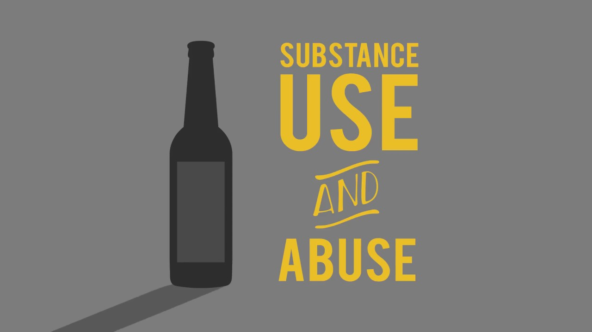
Substance Use
This practice log is to assist youth workers working with young people relating to the topic of substance use. Within the practice log the writer will clarify the differences between substance use, misuse and abuse; and provide steps to addressing the issue with young people; and how to minimise and/or prevent the dangers associated with it. This practice log will include limitations to addressing a substance use issue with young people and suggestions to overcome these limitations.
The writer has a bias with substance use and will remove all bias within this practice log to ensure a neutral point of view to allow the readers to gather all the information needed and implement it into their beliefs within their practice. With the non-bias approach it will enable youth work practitioners to maintain their non-bias youth work approach which coincides with the National Occupation Standards for Youth Work where it states that ‘youth workers safeguards the welfare of young people, and provides them with a safe environment in which to explore their values, beliefs, ideas and issues’ (2012).
Substance use is a growing concern in todays society which is contrary to what statistics show. Statistics show that seventy six percent of young people have never tried drugs (Mentor UK, 2018), but how much of this is accurate? The drugs mentioned in this research are all illegal meaning the responses provided are potentially dishonest. Debois stated that ‘dishonesty among research is common due to social desirability bias and attempting to protect privacy’ (2019). An article from the Guardian explains that ‘Fewer young people in treatment for drugs yet more admit to use’ (2018). Using this information the writer has created this practice log to address the growing concern to educate youth work practitioners and young people of the risks associated with substance use.
What is a substance?
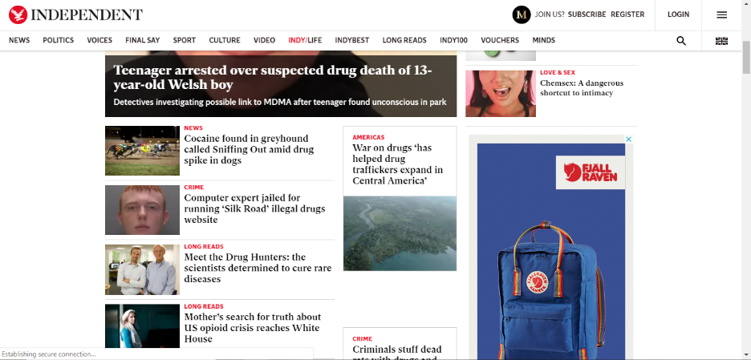
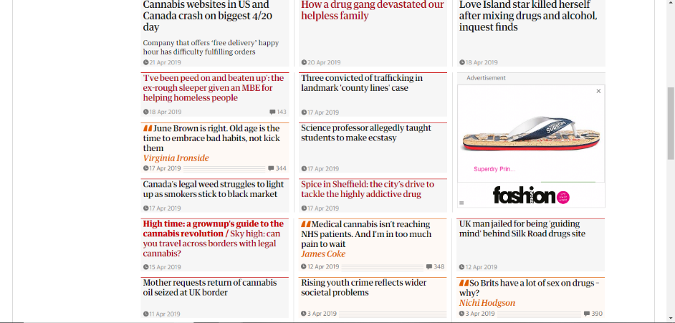
Most people are unaware as to what the terms substance and drugs entail. Pyramid Healthcare (2018) states that a substance is ‘anything that can alter a person’s mood or cognition. Substances can range from caffeine and alcohol to cocaine and heroin’. From the definition, we can see that they can vary in extremity from caffeine to painkillers to hard drugs which is interesting because if asked the question ‘Do you do drugs?’ most responses will be ‘No’. This is due to social norms dictated by the media always referring to drugs as a growing concern and always showing them in a negative viewpoint as seen below:

(The Independent, 2019)
(The Guardian, 2019)
Looking at these headlines there are only two positive headlines making the consensus of drug use negative.
Substance use
From the definition of a substance we can see that substances are a part of most people’s daily lives. When referring to substance use, we are referring to recreational use. Recreational substances include (but are not limited to):
- Caffeine
- Alcohol
- Painkillers
- Medicinal Marijuana (United Kingdom)
- Marijuana (United States of America)
Looking at the list we can see these are legal substances (Country dependant) however, although not legal, some people use more severe substances for recreational use.
In the eyes of the law this is unacceptable and a punishable offence. As a youth work practitioner, we cannot tell young people what they can and cannot do. Our job as youth workers is to educate them on the risks and dangers of doing so. This does not mean youth workers condone the use of illegal substances but will report if there is a safeguarding concern.

Substance Misuse
Substance misuse refers to the use of a substance for a purpose that is not consistent with legal or medical guidelines, most often with prescription medications.
(Pyramid Health Care, No date on page)

Looking at the definition provided by Pyramid Healthcare we can see that substance misuse is a more common occurrence in everyday life. Substance misuse can vary in severity from little to no effect to death. There are a few variables with regards to that statement and that being the severity of the substance, the individual and other outside factors. Taking three paracetamols within four hours compared to the two every four hours is considered as substance misuse, although this may not have a drastic effect on an individual, it is the recommended dosage by doctors.
Drug doses…
…recommended on product labels are usually derived from dose determination studies, in which the clinical effects of various doses are examined. In such studies it may be determined that a 10 mg/kg bodyweight (bw) dose is ineffective, 20 mg/kg bw and 30 mg/kg bw doses are effective but a 100 mg/kg bw dose is toxic; 20 mg/kg would then be considered the minimally effective dose and would be the lowest dose (possibly of a range) recommended on product labels.
(Maddison, J., Page, S., and Church, D., 2008)

Substance Abuse
If regular use results in one of the following, then an individual likely may have a substance abuse problem.
- Health complications as a result of substance abuse
- Inability to carry out daily responsibilities
- Physical dependence
- Withdrawal symptoms if usage stops
- “Cravings” for drug or alcohol
(Pyramid Health Care, No date on page)

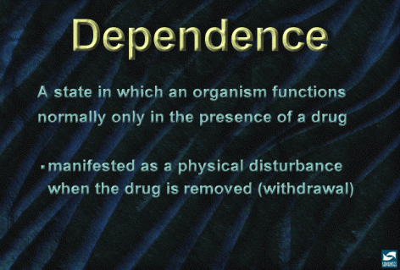
Looking at the definition provided by Pyramid Health Care we can identify drug abuse however, drug abuse/dependency can sometimes be hard to identify especially if you do not see someone on a regular basis. Being able to identify drug abuse can be crucial to ensure the safety of the person in question as it has gone beyond recreational use and now, they believe they cannot function without it creating dependency.
(National Institute on Drug Abuse, 2007)
The statement provided by the National Institute on Drug Abuse identifies that if someone abusing a substance has the substance removed, they begin experiencing withdrawal symptoms. Withdrawal symptoms vary between each person and each substance varying between physical symptoms and mental and emotional symptoms.
Four Mental and Emotional Withdrawal Symptoms
- Anxiety: Anxiety, panic attacks, restlessness, irritability
- Depression: Social isolation, lack of enjoyment, fatigue, poor appetite
- Sleep: Insomnia, difficulty falling asleep or staying asleep
- Cognitive: Poor concentration, poor memory
(Addictions and Recovery, 2019)
Mental and emotional withdrawals are from substances such as Cocaine, Marijuana and Ecstasy.
Six Physical Withdrawal Symptoms
- Head: Headaches, dizziness
- Chest: Chest tightness, difficulty breathing
- Heart: Racing heart, skipped beats, palpitations
- GI: Nausea, vomiting, diarrhea, stomach aches
- Muscles: Muscle tension, twitches, tremors, shakes, muscle aches
- Skin: Sweating, tingling
(Addictions and Recovery, 2019)
Physical withdrawals are from substances such as Alcohol, Opiates and Tranquilisers.
IMPORTANT NOTE!
It is important to note that you should never remove substances instantly as some have dangerous withdrawal symptoms e.g. Alcohol and Tranquilisers. Both substances are listed as having the most dangerous withdrawal symptoms consisting of:
- Grand mal seizures
- Heart attacks
- Strokes
- Hallucinations
- Delirium tremens (DTs)
(Addictions and Recovery, 2019)
Anyone suffering from substance abuse require a medically supervised detox to ensure minimal risk to their health.
Substance use and the law
The United Kingdom have three laws in place around the area of drugs those being, The Misuse of Drugs act 1971, The Medicines act 1968 and the Psychoactive substances act 2016.
The Psychoactive substances act has been created in recent years as a result of the Misuse of Drugs act being outdated and unable to update with new legal and illegal drugs being created. The production of new drugs takes some time to be covered by the Misuse of Drugs act meaning drug manufacturers, producers and distributors kept adapting their drugs to avoid the law. Below are the punishments for both possession and supply of drugs within the United Kingdom by class:
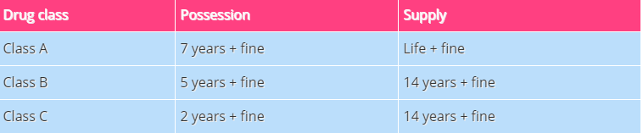
(DrugWise, 2017)

Where do all these drugs come from if they are illegal? County Lines.
County Lines is a very serious issue where criminal gangs set up a drug dealing operation in a place outside their usual operating area. Gangs will move their drug dealing from big cities (e.g. London, Manchester, Liverpool etc.) to smaller towns in order to make more money. This can have a really big effect on the community who live there and bring with it serious criminal behaviour.
(Fearless, no date on page)
Young people are the main victims of County lines as they are the ones used to transport the drugs. Drug lords draw them in to work for them and use extreme measures to ensure compliance. Some measures are to take family members hostage. For further reading on County Lines please follow this link:
https://www.fearless.org/en/campaigns/county-lines
The National youth Federation have provided a document for youth workers: Dealing with Drugs, Alcohol and Tobacco in Youth Work Settings: Guidelines for Youth Workers (Page 9-12, 2004). Within this document it provides a step by step guide on how to deal with an issue within a youth environment. Following these steps are at the discretion of the youth worker as people may agree or disagree with the steps.
The approach the writer believes should be taken follows the safeguarding rules. These are to make a report if the young person is in danger of being harmed or if they are going to harm someone else. This is made clear to young people when they begin to make a disclosure or attend a youth setting. Doing so builds trust between young people and their peers.

YOUTH WORKERS DO NOT CONDONE THE USE OF ILLEGAL SUBSTANCES
It should be made clear that youth workers do not encourage the use of illegal substances, youth workers are in place to educate young people and empower them to make their own decisions.
Addiction
Most people are aware that drugs have a negative effect on the body, so why do they still take them?
Narconon conducted a study and found seven main reasons as to why people use substances in their life. They state that ‘taking substances starts as a choice, it does not just happen’ (2019).
Fell in with the wrong crowd
Everyone is doing it
My curiosity grew really strong

It seemed like fun
I could relax

I could fit in
We would do anything that was bad

Substance use amongst young people is proven to lead to addiction more than in adulthood; the reason for this is due to the development of the limbic system within the brain. The limbic system within the brain does not fully develop until twenty-five years of age (University of Rochester Medical Center Rochester, 2019).
“There is a part of the brain responsible for addiction. The name for this part of the brain is the limbic system. This system, also known as the “brain reward system,” is responsible for producing feelings of pleasure.”
(Addiction Centre, 2019)
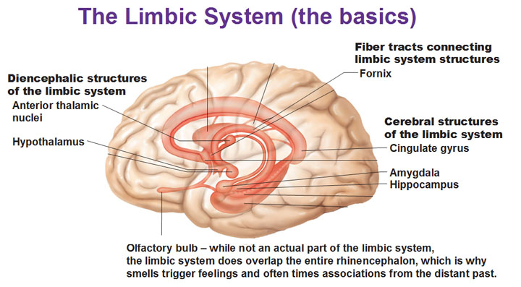
(Antranik, No date on page)
The Biochemistry of addiction
The limbic system produces feelings of pleasure because of a natural chemical within the brain known as dopamine. Whenever something activates the limbic system, the brain assumes something necessary to survival is happening. This behaviour is then rewarded by creating feelings of pleasure. Actions that naturally activate the limbic system include (but not limited to) food, drinking, sex and music. Why do we not get addicted to these in a negative way? This is due to the brain producing a natural amount of dopamine to simulate the brain, when using substances dopamine levels raise ten times higher than normal (Addiction Centre, 2019). Continuous abuse of substances damages the brain where it is no longer able to naturally produce normal levels of dopamine.
“In essence, drugs take the reward system hostage”
(Addiction Centre, 2019)
Following this point a person is unable to feel good without the drug that produces dopamine levels the brain has come accustomed to. Recovery from this point is still possible, seeking help from a medical professional would enable them to do a fully supervised detox and assist in returning dopamine levels and production to normal.

Steps to take to addressing the issue
Addressing the issue can be quite a sensitive topic. When addressing the issue avoid using terms such as ‘Good’ or ‘Bad’ (Toni O’Hara, 2019). The reason these terms should be avoided is because we have no right to tell anyone what they can or cannot do, our job is to educate not dictate. If we think about it in terms of our money, we would not be happy being told what we can and cannot buy so who are we to tell young people what they can and cannot do? Youth clubs are a safe environment for young people and so if young people do attend youth clubs under the influence the last thing to do is to ask them to leave. Them attending the youth club is safer than them being outside under the influence as there are people there and they can stay out of trouble (YMCA Swansea, 2019). Alongside this, youth clubs are the best place to educate young people on the risks of substance use due to the voluntary participation. Youth clubs are a great place for signposting as they have connections with many other organisations to provide support to young people seeking help and support.
“You can make a big difference to the decisions that young people make about drugs, particularly if you:
- Listen to your children
- Encourage independence
- Place limits, consequences and expectations on your children’s behaviour and administer fair and consistent discipline
- Are nurturing and express warmth to, and about, your children
- Encourage your children to express their opinions and discuss their options in their lives
If you are worried your child may be drinking or taking drugs:
- Pick your time to talk – not when they’re rushing off to school or, if they are using, when they’re high.
- Know their friends – peer pressure is one of the most influential factors affecting young people’s alcohol consumption. Children whose friends drink alcohol are five times more likely to drink than those whose friends do not.
- Be a good role model – though it may not always seem like it, children look to their parents and carers for guidance and you shouldn’t underestimate your influence. 11 year olds whose mothers drink heavily are 80% more likely to develop problematic drinking habits than those whose mothers don’t drink heavily.
- Encourage them to talk honestly – not just to tell you what you what they think you want to hear.
- Don’t panic – if your child has tried drugs, be calm when discussing it with them. Show love and concern rather than anger.”
(Mentor UK, 2018)
Above are some simple steps to addressing the issue of substance use. This guidance is written from a parent’s perspective of a young person however they can be adapted to be used in any situation whilst working with young people. These steps are in line with youth work practice in being non judgemental and encourages educating young people on the dangers to allow them to make their own decision on whether they will continue taking substances.
Identifying substance use and abuse can be made slightly simpler by using the scale below: 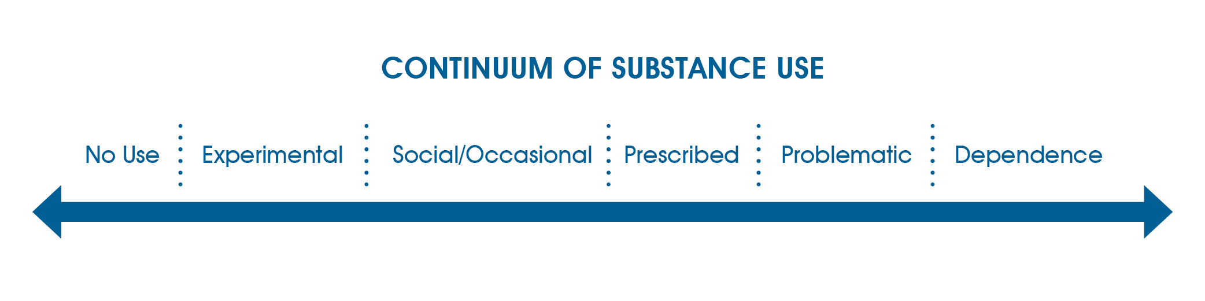
(Toronto, No date on page)
Working alongside the young people and aiding them to identify where they fall on the scale encourages empowerment within youth work, which falls in line with the five pillars of youth work (WLGA, 2018). Allowing the young person to identify where they fall are on the scale provides a visual representation of their current situation and allows them to make a more informed decision regarding requiring help or not.
Limitations
Understanding one’s limitations is crucial to dealing with any topic within youth work, the last thing a youth worker wants to do is worsen a situation. The appendices of the practice log shall include signposting to other organisations who are knowledgeable in the topic area of substance use.
The main limitation to addressing any issue with young people is knowledge, more specifically lack of. As educator’s youth workers providing inaccurate information around a topic area will lead to ill-informed decision making and potentially causing problems in a young person’s life.
Language is a key limitation with addressing an issue such as substance use. The use of language such as ‘Good’ or ‘Bad’ should be avoided (Toni O’Hara, 2019). Youth workers are educators not dictators and so we should be informing young people of the risks to enable them to make their own educated choices. Providing young people with all the knowledge in the world does not mean they will not use or stop using substances, choices are what makes people human as stated by Jean-Paul Sartre.
“We are our choices.”
(Jean-Paul Sartre, no date on page)
Personal limitations do exist, such as using substances yourself. Using substances personally could lead to a bias when delivering a session. The main limitation here is hypocrisy, this is dishonest to young people if they are presented with the dangers and risk, but they are aware the youth worker uses them.
Our grosse conceipts, who think honestie the best policie.
Translation: Honesty is the best Policy
(Sir Edwin Sandys, 1599)
Being honest with young people is vitally important to develop trust. Being honest with young people if you do or have used substances in the past will encourage young people to think more on the topic. Knowing people do recover from substance use can assure young people that there is help for them. The flip side is that they could have the mindset of it being promoted because their peers take substances themselves.
Overview
Substance use is a sensitive topic to approach. Addressing the issue with a non-bias, non-judgmental approach is the most effective way to enable cooperation with the young people. Sharing experiences with young people can be beneficial to build the trust and provide young people with comfort in knowing there is help available if wanted.
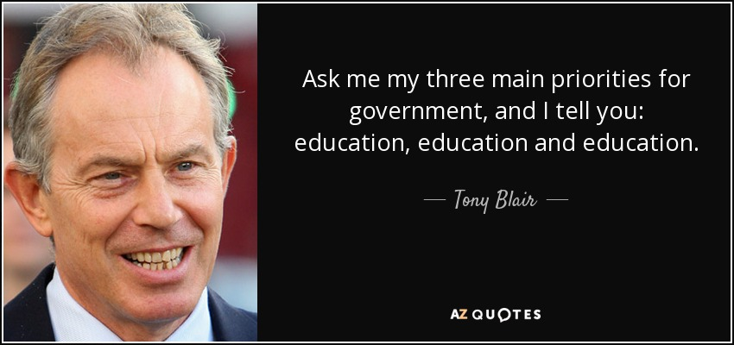
(Tony Blair, 1997)
Stated in his electoral speech, Tony Blair mentioned the importance of education. As educators it is a youth workers job to provide young people with all the knowledge they desire to enable them to make educated decisions on their own and chose the direction of their lives.
Appendices
The Misuse of Drugs Act (1971)
The Medicines Act (1968)
Psychoactive substances Act (2016)
InfoNation
Address: 47 The Kingsway, Swansea, SA1 5HG
Phone: 01792 484 010
Email: info-nation@swansea.gov.uk

YMCA
Address: YMCA Swansea, 1 The Kingsway, Swansea, SA1 5JQ
Phone: 01792 652032
Email: info@ymcaswansea.org.uk

Reference list
Addiction Centre, (2019), Addictive Substances and Changes in the Brain, [Online], Available at: https://www.addictioncenter.com/addiction/addiction-brain/, Accessed: 11/04/2019
Addictions and Recovery, (2019), Drug and Alcohol Withdrawal, [Online], Available at: https://www.addictionsandrecovery.org/withdrawal.htm, Accessed: 11/04/2019
Antranik, (No date on page), The Limbic System and the Reticular Formation, [Online], Available at: https://antranik.org/the-limbic-system-and-the-reticular-formation/, Accessed 16/04/2019
Blair, T., (1997), Leader's speech, Brighton 1997, [Online], Available at: http://www.britishpoliticalspeech.org/speech-archive.htm?speech=203, Accessed: 24/04/2019
Debois, S., (2019), 10 Advantages and Disadvantages of Questionnaires (Updated 2019), [Online], Available at: https://surveyanyplace.com/questionnaire-pros-and-cons/, Accessed: 15/04/2019
DrugWise, (2017), What are the UK drug laws?, [Online], Available at: https://www.drugwise.org.uk/what-are-the-uk-drug-laws/, Accessed: 16/04/2019
Fearless, (No date on Page), COUNTY LINES, [Online], Available at: https://www.fearless.org/en/campaigns/county-lines, Accessed: 24/04/2019
Gayle, D., (2018), Fewer young people in treatment for drugs yet more admit to use, [Online], Available at: https://www.theguardian.com/society/2018/dec/07/fewer-young-people-in-treatment-for-drugs-yet-more-admit-to-use, Accessed: 14/04/2019
LSIS, (2012), National Occupational Standards: Youth work, [Online], Available at: http://www.nya.org.uk/wp-content/uploads/2014/06/National-Occupation-Standards-for-Youth-Work.pdf, Accessed: 14/04/2019
Maddison, J., Page, S., and Church, D., (2008), Small Animal Clinical Pharmacology, [Online], Available at: https://www.sciencedirect.com/book/9780702028588/small-animal-clinical-pharmacology#book-info, Accessed: 11/04/2019
MentorUK, (2018), Get the facts about young people and drugs, [Online], Available at: https://mentoruk.org.uk/get-the-facts/, Accessed: 11/04/2019
Narconon, (2019), Why do People Start Taking Drugs?, [Online], Available at: https://www.narconon.org/drug-addiction/why-do-people-start-taking-drugs/, Accessed: 11/04/2019
National Youth Federation, (2004), DEALING WITH DRUGS, ALCOHOL AND TOBACCO IN YOUTH WORK SETTINGS: GUIDELINES FOR YOUTH WORKERS, [Online], Available at: http://www.drugs.ie/resourcesfiles/guides/2982-3162.pdf, Accessed: 24/04/2019
National Institute on Drug Abuse, (2007), The Neurobiology of Drug Addiction, [Online], Available at: https://www.drugabuse.gov/publications/teaching-packets/neurobiology-drug-addiction/section-iii-action-heroin-morphine/8-definition-dependence, Accessed 24/04/2019
O’Hara, T., (2019), iNFONATION interview, Conducted: 11/04/2019
Penn State PRO Wellness, (2018), Teen Health: Substance Use and Abuse, [Online], Available at: https://www.youtube.com/watch?v=6fmhLcYSn-Y, Accessed, 11/04/2019
Pyramid Healthcare, (2018), Substance Use, Misuse, and Abuse: What are the Differences?, [Online], Available at: https://www.pyramidhealthcarepa.com/substance-use-misuse-and-abuse/, Accessed: 11/04/2019
Sandys, E., (1599), Honesty is the best policy, [Online], Available at: https://www.phrases.org.uk/meanings/honesty-is-the-best-policy.html, Accessed: 15/04/2019
Sartre, J., (No date on page), We are our choices, [Online], Available at: https://www.goodreads.com/quotes/tag/choices, Accessed: 15/04/2019
The Guardian, (2019), Drugs, [Online], Available at: https://www.theguardian.com/society/drugs, Accessed: 13/04/2019
The Independent, (2019), Drugs, [Online], Available at: https://www.independent.co.uk/topic/Drugs, Accessed: 13/04/2019
Toronto, (No date on page), The continuum of substance use, [Online], Available at: https://www.toronto.ca/community-people/health-wellness-care/health-programs-advice/alcohol-and-other-drugs/toronto-drug-strategy-2/community-dialogue-a-public-health-approach-to-drugs/rates-of-substance-use/, Accessed: 15/04/2019
University of Rochester Medical Center Rochester, (2019), Understanding the Teen Brain, [Online], Available at: https://www.urmc.rochester.edu/encyclopedia/content.aspx?ContentTypeID=1&ContentID=3051, Accessed: 14/04/2019
WLGA, (2018), The five pillars of youth work, [Online], Available at: http://www.cwvys.org.uk/wp-content/uploads/2018/11/YOUTH-WORK-IN-WALES-PRINCIPLES-AND-PURPOSES.pdf, Accessed: 14/04/2019
YMCA Swansea, (2019), Supervision 2, Conducted 05/03/2019

