

Assignment Title:
Health and Safety Audit

MSc Property and Facilities Management

Module: Health and Safety Management
Module Code: M7X01806
Lecturer: Dr Juan Ferriz-Papi
Student: Simon Williams
Student Number: 1502958

Table of Contents
2.0 Introduction 3
3.0 Background 4
4.0 Main Body 4
4.1 The Facility and Health and Safety Legislation 4
4.2 How Risk was Assessed 5
4.3 How Risk was Mitigated and Managed 6
5.0 Key Findings, Recommendations and Conclusions 9
6.0 References 11
7.0 Appendices 12

1.0 Introduction
Health and Safety in the work place has seen a major transformation since the inception the of the Health and Safety Commission (HSC) and its enforcing body, the Health and Safety Executive (HSE) in 1974. The HSC and the HSE were formed when Health and Safety at Work etc Act 1974 received Royal Assent on 31 July 1974. Both organisations were primarily responsible for ensuring the appropriate Health and Safety measures were implemented within a workplace to protect the welfare of the employees (Cepero, 2014). In order to achieve these set objectives, the HSC put greater responsibility on the employer to ensure the health safety and welfare of all individuals that could be affected by the work they were tasked with undertaking. Since 1974 there has been an expansion of legislation to ensure health, safety and welfare of people in the work place and such legislation continues to evolve and develop today. The adoption of a risk-based approach for controlling health and safety however, is a relatively modern method within the UK occupational health and safety (OH&S) field (Health and Safety Executive (HSE, 2000)).
The aim of this report is to develop and provide a practical assessment for health and safety that will comply with current legislation in this area and follow the risk-based approach which the industry has adopted. This will be presented in the form of a case study audit that will identify and assess the perceived hazards and risks that could have a detrimental effect on the health safety and welfare of individuals within a selected working environment. In order to ensure that the audit is comprehensive it will include detail such as site visits, risk assessments, interviews, fault tree analysis, and will also refer to the relevant legislation.
The pre-selected area that will form part of the investigation is the Construction Wales Innovation Centre (CWIC) located at the University of Wales Trinity Saint David’s SA1 Swansea Waterfront Innovation Quarter. The area is used by students, staff and members of the public and the activities that are undertaken within the centre, cover a wide range; from built environment software training to applied heritage carpentry and roofing programmes. The HUB will provide specialised training and includes a purpose built scaffolding centre. There are many risk factors that need to be considered in order for the CWIC to operate effectively and comply with current health and safety legislation.

2.0 Background

The HSE (2017) states that as part of managing the health and safety of an organisation, the employer or responsible person must control the risks in the workplace in accordance with The Management of Health and Safety at Work Regulations 1999 (MHSWR). Regulation 3 states that every employer shall make a suitable and sufficient assessment of the risks to the health and safety of his employees to which they are exposed whilst they are at work; and the risks to the health and safety of persons not in his employment arising out of or in connection with the conduct by him of his undertaking. Legislation requires employers to reduce risks to a level that is as low as is reasonably practicable. It is envisaged that this will be controlled by undertaking appropriate risk assessment and utilising appropriate risk management. Risk assessment and management as we understand them today are relatively new notions and were established from a scientific field only within the past 3-4 decades. (Aven, 2016).

3.0 Main Body
The main body of this report will demonstrate how the risk was identified and how the risk was mitigated and managed.

3.1 The Facility and Health and Safety Legislation
The Construction Wales Innovation Centre (CWIC) located at the University of Wales Trinity Saint David is a purpose-built facility. The University itself is responsible for meeting the requirements of the current health and safety legislation such as the Health and Safety at Work, etc Act 1974 and the Management of Health and Safety at Work Regulations 1999. This audit primarily focused on the areas which could present risk if measures were not in place such as but not limited to: -
- The Workplace (Health, Safety and Welfare) Regulations 1992
- The Health and Safety (Display Screen Equipment) Regulations 1992
- The Electricity at Work Regulations 1989
- The Health and Safety (First Aid) Regulations 1981
- The Regulatory Reform (Fire Safety) Order 2005a
- The Control of Substances Hazardous to Health Regulations 2002

3.2 How Risk was Assessed
To conduct and undertake the audit the site was visited with the Health and Safety manager. During the visit questions were addressed to the Health and Safety manager in order to establish any existing concerns that had already identified from previous risk assessments. The interview did not highlight any real concerns and therefore, the audit of the site was undertaken independently. Questions that were established for the purpose of the audit and clarified with the Health and Safety manager were:

- What is the premises predominately used for?
- Who will use the facility?
- What chemical will be used on site i.e. cleaning products and if there any storage cupboard for COSHH?
- Is there a fist aid provisions onsite?

The first task when embarking on an assessment of risk is to identify the hazards. A hazard is any scenario that has the potential to cause harm, including ill health and injury; damage to property, plant, products or the environment, production losses or increased liabilities (HSE, 2019). This was undertaken by walking around the site and identifying hazards that under the right conditions could be expected to cause harm to the occupants. During the visit, particular focus was given to identifying long term hazards that were not easily detectable, such as high levels of noise and exposure to harmful substances such as dust. The next section of the audit was to decide who might be at risk of harm and how might that harm occur. This was identified using a risk assessment. A risk assessment according to the HSE, (2006) is nothing more than a careful examination of what, in a working environment, could cause harm to people. By undertaking a risk assessment the objective is to identify any existing hazards or hazards that could develop as a result of external influence. The process in which the risk assessment would be carried out started with assessing the site and determining activity characterisation.
The method chosen for the audit was that of a safety risk matrix risk assessment. A simple yet effective approach which is supported by many professionals working within the field off health and safety. It is the method of multiplying the severity of the consequence by the likelihood of its occurrence (Waring & Glendon, 1998). The principle of this method is, that if the likelihood of an event occurring is low then it would be given a score of 1 however, if the likelihood of the same event was high it would be given the score of 5. Using the same principle, if the severity of the occurrence is measured, a score of 1 will be given for non-severe and 5 for very severe. Once both the consequence and likelihood figure have been obtain then a risk level can be determined. This method is classed as a quantitative risk assessment and will provide the probability of impact which will result from the occurrence of a particular event. An example of this is shown in fig.1.

Fig.1 Safety Risk Matrix
Consequence |  |  |  | Occurrence
 | People | Assets | Severity Rating | 1 | 2 | 3 | 4 | 5
 |  |  |  | Highly Unlikely | Unlikely | Possible | Likely | Highley Likely
 | Zero Injury | Zero Damage | 0 | Acceptable Risk Manage for continual Improvements
 | Very Minor Injury | Very Minor  Damage | 1
 | Minor Injury | Minor Damage | 2
 | Moderate Injury | Moderate Damage | 3
 | Significant Injury | Major Damage | 4 | Measures to be implemented to reduce risk |  | Intolerable Levels of Risk
 | Fatality | Extensive Damage | 5
The safety risk matrices therefore show that:
Likelihood (Occurrence) X (Multiply) Severity (Consequence) = Risk.

4.3 How Risk was Mitigated and Managed
In order to mitigate the risk identified by the risk assessment, risk management was implemented. Risk management is defined by Channing, (2014) as the eradication or minimisation of the adverse effects of risks to which an organisation is exposed. Fig.3 shows the path the risk was managed.
The risk management process began by evaluating the results from the risk assessment. Option analysis was undertaken to establish the best course of action to mitigate the risk imposed, this was achieved by carrying out fault tree analysis.

Fig.3 Risk assessment and Management Process.
Further to the safety risk matrix assessment, fault tree analysis was used to evaluate the risks and decide on precautions by way of corrective actions. Fault tree analysis is defined by Goh, (2018) as a diagram that displays the logical interrelationship between the basic causes of the hazard. Fault tree analysis can be simple or complex depending on the system in question. By using the fault tree analysis method for this audit, it was possible to determine measures that needed to be put in place to avoid possible hazards arising.

This method starts with the “event” or “possible accident” and works backwards to determine the possible causational factor that could lead to the event. Therefore, once all events had been identified the next stage was to identify the causes or sub-causes which lead to event. Once all the information had been gathered, the fault tree was able to be constructed. Fig 4. shows the symbols required to construct the fault tree and the meaning of each symbol (Waghmode and Patil, 2013).

Fig. 4 Symbols of Fault Tree

A simple example of how fault tree analysis is used is shown in fig.5.
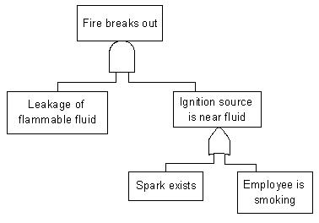

Fig. 5 Fault Tree Analysis Process
The fault tree analysis that was conducted as part of this audit can be viewed in section 6.
The Safety Risk Matrix found a number of hazards that could cause harm to people who will use the site and are identified in section 4 of this report.

4.0 Key Findings, Recommendations and Conclusions
The risk identified directly related to the activities that were to be carried out on site. The main issues found were:
The Risk of Noise
Due to the nature of the activities that will be under taken at the CWIC it is recommended that appropriate segregation be implemented and that appropriate PPE be available for anyone in this area should noise level be excessive.
Slips, Trips and Falls
It is likely that there will be a number of issues that could leave to slips, trips and falls such as students bags, trailing leads, spilt fluids etc. It is recommended that inductions be given to all visitors, toolbox talks given to staff to manage and eliminate the risk when there occur.
Falling from Height
With the provision of training of scaffold erecting there will always be a risk of falling. This risk must be managed by ensuring that no students access the scaffolding equipment without the presence of a qualified instructor. All appropriate PPE, harnesses should also be worn at all times when accessing the equipment. Equipment should also be safety checked before every use.
Manual Handling
It was identified that staff and students could be affected by the risks associated with manual handling. The audit identified that some measures were in place however recommendations for training in lifting practices would need be provided for anybody who undertakes lifting of substantial loads.
COSHH
No COSHH storage facilities were identified on the audit and therefore it is recommended a suitable storage facility be installed where COSHH can be stored along with relevant data sheets.
First Aid
No first aid kit or box could be seen at the facility. Due to some of the activities that will be undertaken at the facility It is recommended that a suitable first aid kit be provided.

Section 6 shows the results of selected risk assessment and gives corrective actions to show how the identified risks should be managed.

In concluding this report, it is noted that the facility was well managed and that there were very few hazards present at the site when it was inspected. However, some noteworthy hazards were identified that had the potential to cause harm during the risk assessment. These hazards did have some mitigating measures in place however, corrective actions were proposed to reduce the risk further. It is suggested that these corrective actions are evaluated and monitored at the suggested reviewing schedule to ensure the hazards do not re-occur.

5.0 References

- Channing, J. (2014). Safety at work. 8th ed. Abingdon, Oxon: Routledge.
- Aven, T. (2016). Risk assessment and risk management: Review of recent advances on their foundation. European Journal of Operational Research, 253(1), pp.1-13.
- Cox, L. (2008). What’s Wrong with Risk Matrices? Risk Analysis, 28(2), 497-512.
- Franks, A., Whitehead, R., Crossthwaite, P., & Smail, L. (2002). Application of QRA in operational safety issues. Research Report RR 025 for Health and Safety Executive; Sudbury: HSE Books. Available at: http://www.hse.gov.uk/research/rrpdf/rr025.pdf. (Accessed: 28th November 2018).
- Goh, Y. (2018). Introduction to Workplace Safety and Health Management: A Systems Thinking Approach. Singapore: World Scientific Publishing Co Pte Ltd
- Health and Safety Executive, (2000.) Management of Health and Safety at Work. Management of Health and Safety at Work Regulations 1999. Approved Code of Practice and Guidance, HMSO, London, L21.
- Hillson, D., & Simon, P. (2007). Practical Project Risk Management: the ATOM methodology. Vienna, VA: Management Concepts.
- HSE, Five Steps to Risk Assessment. (2006). Merseyside, United Kingdom: HSE Books.
- Hse.gov.uk. (2019). Risk management: Identify the hazards. [online] Available at: http://www.hse.gov.uk/risk/identify-the-hazards.htm [Accessed 5 Dec. 2018]
- Julian, T. (2011). What’s right with risk matrices? A great tool for managers. Available at: http://31000risk.wordpress.com/article/what-s-right-with-risk-matrices-3dksezemjiq54-4/ (Accessed:30th November 2018).
- Middleton, M., & Franks, A. (2001). Using Risk Matrices. Chemical Engineer (723).
- Waring, A. and Glendon, A. (1998). Managing Risk: Critical issues for survival and success into the 21st century. 1st ed. London: Cengage Learning EMEA.

6.0 Appendices

1. Safety Risk Matrix Assessment Examples

2. Fault Tree analysis Diagrams

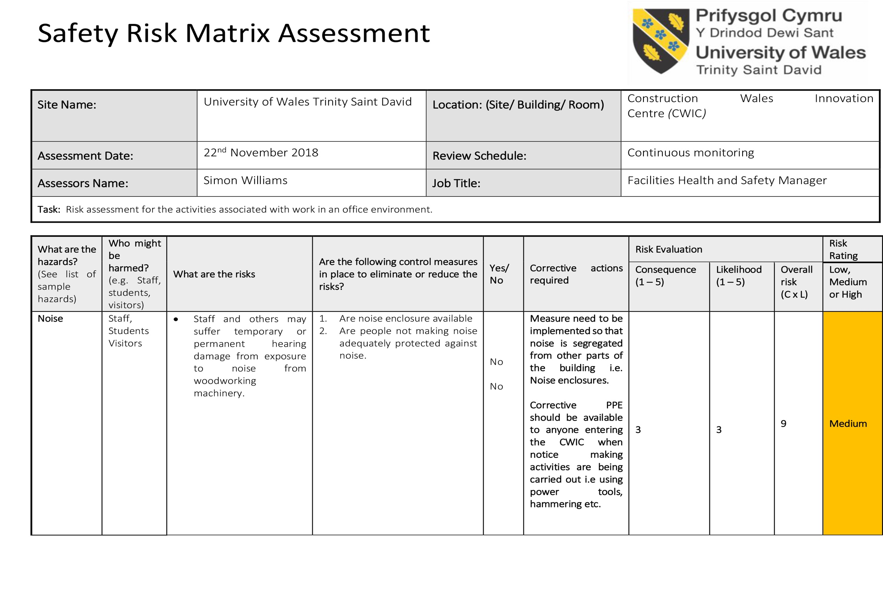
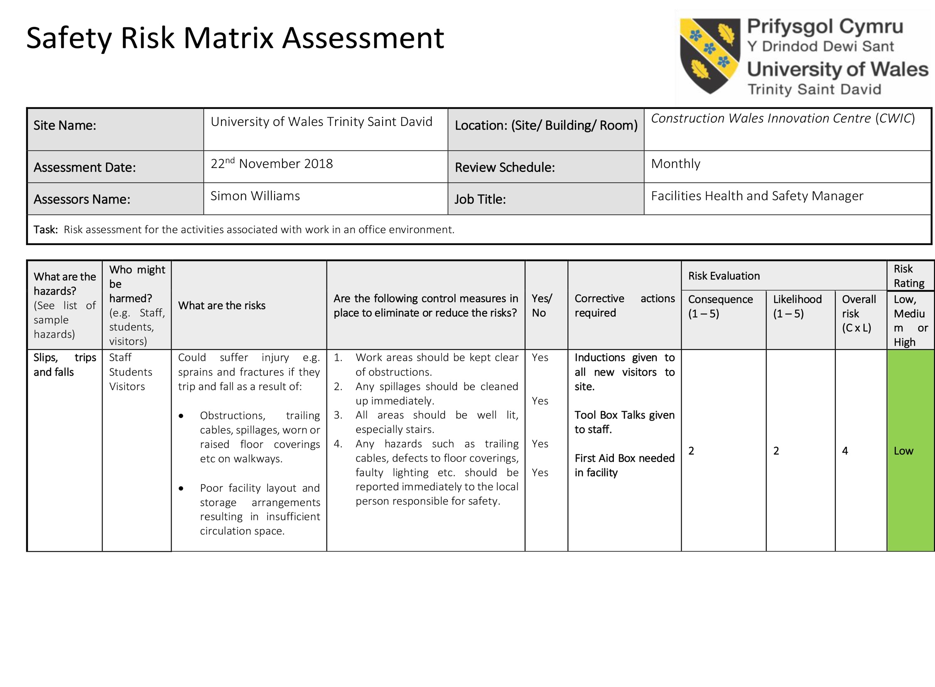

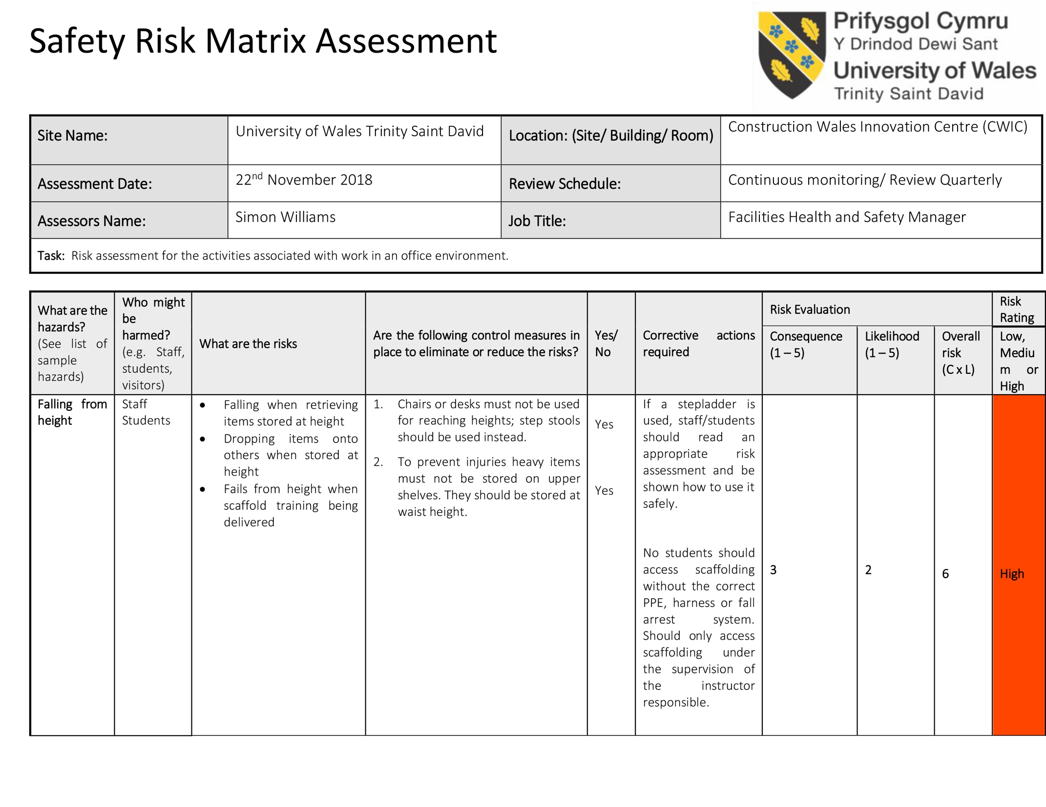
Fault Tree Analysis 1
Risk Management

Below is a fault tree analysis construction for the risk of slips trips and falls at the Construction Wales Innovation Centre.

Fault Tree Analysis 2
Risk Management

Below is a fault tree analysis construction for the risk of falling from height at the Construction Wales Innovation Centre.

