This campaign is aimed at parents and caregivers of all different types. It will look at positive and negative effects that can affect a child that will have repercussions for the rest of their lives.
Before the baby is born
While the foetus is growing in the mother’s womb. This is a very important time for the developing foetus as it starts to become familiar with mum’s voice, this helps the foetus to be relaxed in a positive way. If the mother is happy throughout the pregnancy, this can affect the foetus as it picks up on its mother’s emotions causing it to
be content and happy. This could help the child in later life to have a positive outlook.
Periods of Development
Once the baby is born the baby will start to form an attachment with the mother this can happen straight as they recognise the mothers voice, from the womb. From birth to 6 months attachments start to form through interaction between the caregiver and the baby. Feeding, showing love and comfort when the baby cries or is distressed help to form the bond that is growing between the caregiver and the baby. Any interaction as in reading or playing, even cuddles help the baby see the caregiver as a special person who will help to give them comfort and keep them safe. Baby helps with the bonding process by smiling, usually around six weeks, gurgling and babbling and even giggling help to endear the baby to the caregiver. Baby connects with the caregiver by using body language such as a smile or by making eye contact with the caregiver. The baby will make noises such as coos and by laughing to get the caregiver to interact with them. By responding to the baby’s body language, you are helping your baby learn about communication, social behaviour and emotions and encourages your baby to keep trying to communicate. The bond becomes so strong that the main caregiver would protect her offspring with her life.
Caregivers can be the mother, father or grandparents. In some cases foster or adopted parents take on the role of caregiver.

After the baby is born mother could develop Postnatal Depression, which could give her feelings of being inadequate and make her feel that she does not care for her baby. The unhappiness in the family home could cause the baby to become withdrawn. This could affect the child in later life.
If this continues in the baby’s life this could cause problems on developing bonds with other people in later life.
If the mother is not in a good relationship. The future could turn out quite different for both the mother and the foetus.
- If the mother is being abused.
- Both verbal and physical.
- Not eating properly.
- Mother drinking heavily and smoking throughout the pregnancy.
The foetus would pick up on mum’s distress, fear, frustration and loneliness this could cause the foetus to not grow properly. The more unhappy mum is, the more stressed the foetus could become which could unfortunately cause a miscarriage.



As a toddler going to preschool would be hard and confusing. The toddler could show behaviors so as to avoid the need to engage with others. This could make it more difficult to support the toddler.
Once the child finds that shouting will stop the teacher and they would then get the attention they desired, they will continue to be disruptive in the classroom environment.
The child may try to work hard in lessons by listening to what the teacher is saying but sometimes they may not understand anything.

The foetus would pick up on mum’s distress, fear, frustration and loneliness this could cause the foetus to not grow properly. The more unhappy mum is, the more stressed the foetus could become which could unfortunately cause a miscarriage


School life can begin in the nursery section of the school. These short periods away from the caregiver help to prepare the child for longer times apart. Once the child realizes that their caregiver will be waiting for them when school ends for the day, they soon settle into the routine, even if there are tears when left at first, these soon disappear, and they usually look forward to meeting up with their peers. At this age they learn through play and lessons aimed to stretch their minds and they learn to retain the information and improve their memory recall. You could help your child enormously by teaching them to be able to speak and recognise numbers 1-20 plus to be able to recognise coloured pencils or crayons.
From 6 months to becoming a toddler. This special bond will help your baby develop into a secure and confident child, who’s brain is growing from the stimulation and helps them grow mentally and physically. Mentally they are starting to develop memory, thoughts and of course language. Encourage the baby/child to go to other people, forming bonds with others will help build up the trust and confidence to be with people other than the caregivers. Play groups for babies/toddlers help the child to learn interaction with other children and their caregivers. These groups encourage children to play together and learn to share toys and some independence from their caregiver. They will always run to their caregiver if unsettled or upset. These groups also help prepare the child for a life without the caregiver and involves the child being left with a stranger and a group of children they may not know.
If the father is present and is involved with the care of the baby, this will help the baby to make another attachment. It is good for the baby to have many attachments.



Later when the child comes to having friends, they will not trust anybody. If they do make a friend. Often the friend will help them to stay calm especially if they are in a difficult situation. This is very difficult at first for the friend as they may not understand why their friend is so angry. Some children like school and they learn easily. However, some will struggle to understand what is going on. These children spend time being corrected and have low self-esteem. This can affect the child for life. Every time something goes wrong the child will be blamed for this even if the child has not done it. If this continues, it will affect the child by making the child feel lonely and on his or her own. This is not good.

Let them learn through painting and encourage them to make things using craft materials. Read to them, show them the words, they may be able to recognise basic words. Discuss the storyline with them, let them tell you what they think. Sing with them, teach them their nursery rhymes, this will help your child once they start school. Once at school encourage them to do their homework. Listen to them reading their school reading book.

Getting help is hard. They have very little friends and family. They would stay away from them thinking they will be okay. If they find someone that will love, this is hard at first but learn to trust them however, after some time, they feel safe. This might be the first time in their lives they feel safe but all the time they think it will not last. They think everyone is going to leave them. These thoughts never go away. They take one day at a time hoping nothing goes wrong.

The person could become stressed and angry. This could make them aggressive and violent. At the end something is going to happen someone will get hurt or they may hurt themselves by self-harming. This becomes a downward spiral. They could be drinking, and drugs could be involved at this stage.



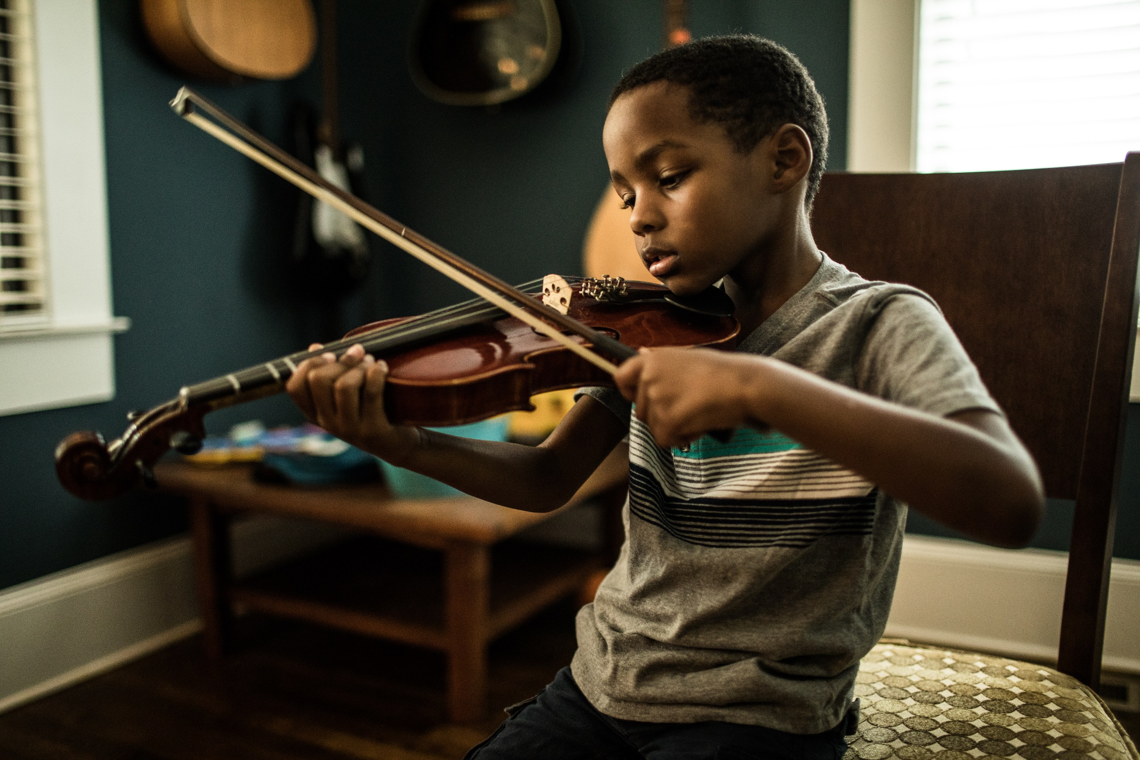
Help and encourage them to do their written work if they do not understand then do your best to explain it to them. As they go through their school year’s they will learn more about different subjects. Encourage them by finding out more about the subjects they are interested in either by using the library or via the internet. The human brain does not mature until you are 25, so until then your brain is absorbing knowledge and growing inside your skull.

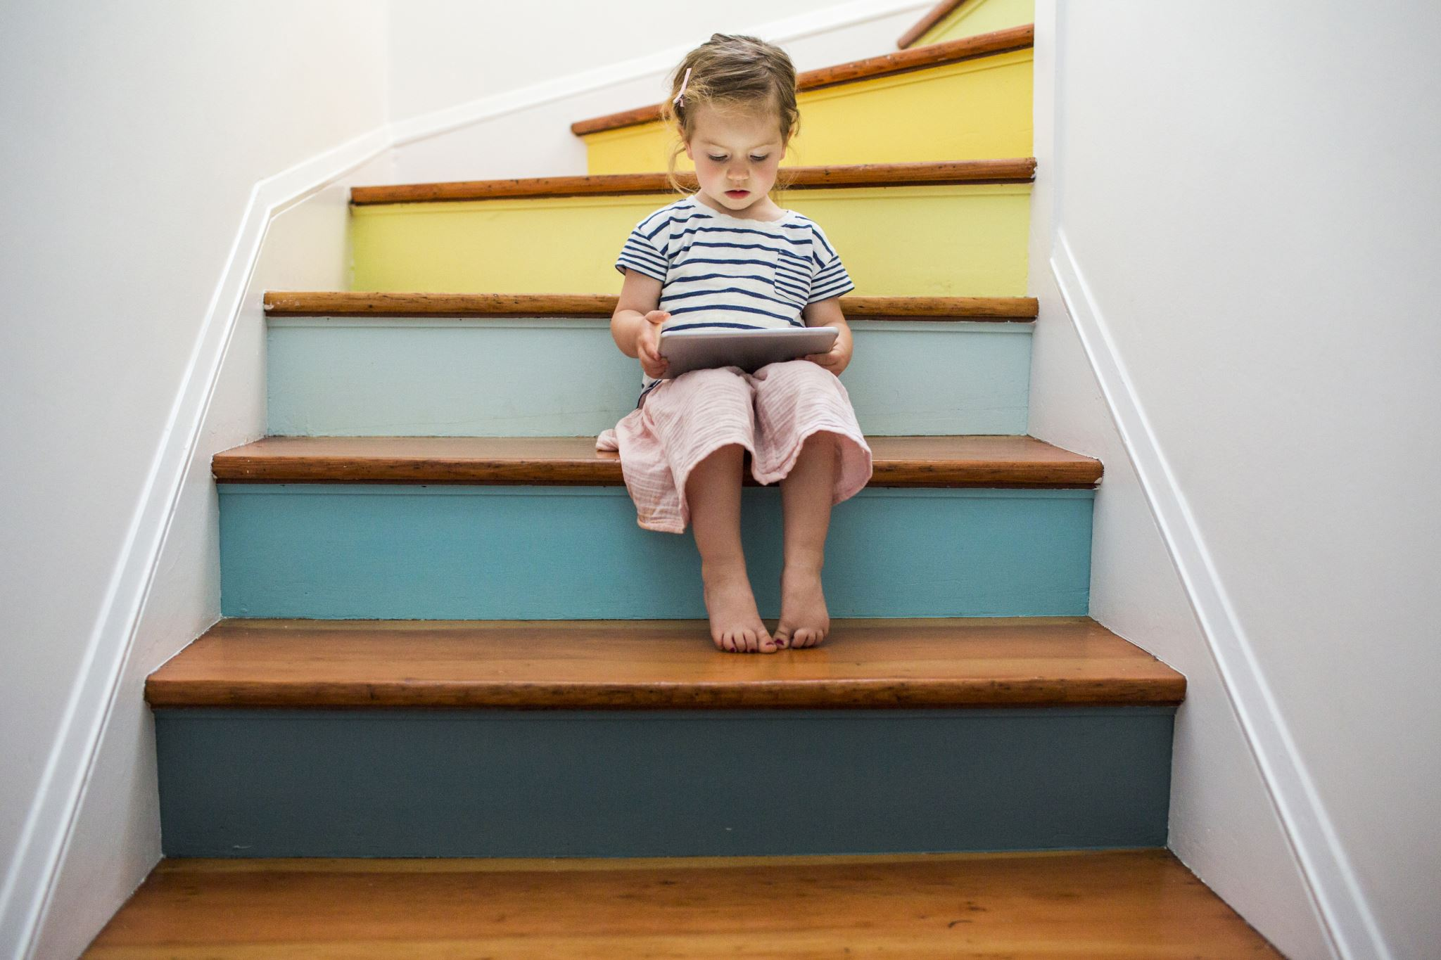
References
Ainsworth, M., & Bell, S. (1970). Attachment, Exploration, and Separation: Illustrated by the Behavior of One-Year-Olds in a Strange Situation. Child Development, 41, 49-67.
Ainsworth, M. D. S., & Wittig, B. A. (1969). Attachment and the exploratory behaviour of one-year-olds in a strange situation. In B. M. Foss (Ed.), Determinants of infant behaviour (Vol. 4, pp. 113-136.
Attachment theory is based on the joint work of John Bowlby (1907-1991) and Mary Salter Ainsworth (1913- )
Bowlby, J. (1951). Maternal care and mental health.
Bowlby, J. (1958). The nature of the child's tie to his mother. International Journal of Psycho-Analytic.
Erikson, E.H. (1950). Childhood and Society.

Flicker, Englund & Sroufe, (1992) Predicting peer competence and peer relationships in childhood from early parent-child relationships.
Frankel, K. A., & Bates, J. E. (1990). Mother-toddler problem solving: Antecedents in attachment, home behavior, and temperament.
Freud, A. (1960). Discussion of Dr. John Bowlby's paper. Psychoanalytic Study of the Child.1.
Freud, S. (1961). The ego and the id. In J. Strachey (Ed. and Trans.), The standard edition of the complete psychological works of Sigmund Freud (Vol. 19, pp. 3-66).
Goldfarb, W. (1943a). Infant rearing and problem behaviour. American Journal of Orthopsychiatry, 13, 249–265.

Marshall H. Klaus, John H. Kennell Snippet view - 1976. Parent-infant Bonding.
Masters, J. & Wellman, H. (1974). Human infant attachment.
Sroufe, L. A. (1983). Infant-caregiver attachment and patterns of adaptation in preschool.
Sroufe, L. A. (1988). The role of infant-caregiver attachment in adult development.
Waters, E. (1978). The reliability and stability of individual differences in infant-mother attachment.

Goldfarb, W. (1943b). The effects of early institutional care on adolescent personality. Journal of Experimental Education, 12, 106–129.
Goldfarb, W. (1947). Variations in adolescent adjustment of institutionally-reared children. American Journal of Orthopsychiatry, 17, 449–457.
Harlow, H. F., & Zimmermann, R. R. (1959). Affectional responses in the infant monkey. Science, 130, 421–432.
Hodges, J.& Tizard, B. (1989) Social and family relationships of ex-institutionalised adolescents. Journal of Child Psychology and Psychiatry, 30,77-97.
Lyons-Ruth, K., Easterbrooks, M. A., & Cibelli, C. D. (1997). Infant attachment strategies, infant mental lag, and maternal depressive symptoms.

