

BA(Hons) Business Management
Course Name: Management Economics
Title: Assessment 1

Student Name: Florina Carmen Teleoaca
Student Number: 2120595
Lecturer Name: Dr Taye Osadiya
Table of Contents

1. Introduction 3
2. Analysis and Discussion 3
Task 2.1 3
Task 2.2 9
Task 2.3 11
3. Conclusion 12
References 13

1. Introduction
The chosen company for this research is Apple which is a smartphone brand, widely famous for its top-quality Apple products. The company was founded by Steve Wozniak and Steve Jobs to make computers smaller so that anyone can use them anywhere. Wozniak and Jobs started this company in the year of 1976 in Jobs' garage.

The first product of the company was Apple I which was a computer without a keyboard and monitor. Apple II was their second product which performed very well in the market and sales jumped from 7.8 million dollars to 117 million dollars in just 2 years. Nowadays, the company manufactures, designs, and markets personal computers, wearables, tablets, smartphones, and other accessories (Loc.gov, 2022).

It produces handy smart electronic products with high quality. The company is operating in a highly competitive business environment where there are so many smartphone brands that provide similar or substitute products at very low prices in the market. Some of the major competitors of Apple are Samsung, Motorola, Xiaomi, and Oppo. The main market of Apple is the American market as the majority of sales come from the United States. The study aims to discuss different aspects of Apple and it will be compared with one of its major substitutes named Samsung (Laricchia, 2023).

2. Analysis and Discussion

Task 2.1
The market Equilibrium of a product occurs at a stage where the demand for that commodity equals the supply of that commodity. Each product has an equilibrium point, from which the market clearing price and the equilibrium quantity of that product are evaluated (Bernstein et al. 2021). If the demand and supply of the product are not equal, then the market deviates from the point of equilibrium. Higher supply than demand leads to a surplus of the product while the shortage of a commodity arrives when the demand is higher than supply.
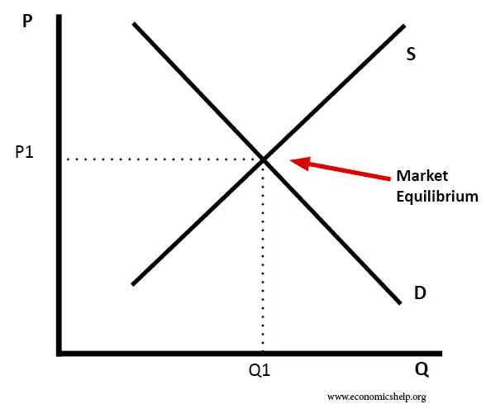
Fig. 1: Market equilibrium
(Source: Pettinger, 2019)
If the context of Apple iPhones is considered, here the market equilibrium has occurred at the point where the demand curve and the supply curves intersect each other. Therefore, the market clearing price of the iPhone is P1 and the number of iPhones to be sold at price P1 is Q1. A price over P1 will lead to the surplus of the iPhones while a price less than P1 will mean the shortage of the iPhones.

The chosen product range is the smartphones of Apple which come with the latest models of the company such as iPhone 12, 13, and 14. Substitute products can be defined as those products that can be used for the same purpose. For example, Samsung's smartphones are a substitute for Apple's smartphones as these products can be used for the same purpose. The price of S22 has been dropping since it launched and the lowest price of this product was 356.77 US dollars (Camelcamelcamel, 2022a). The iPhone 13 was launched in 2021 in the US and it is one of the most selling iPhones for Apple.

The demand for this product did not affect much due to the launch of the Samsung S22 in 2022. But the newly launched iPhones in 2022 may see a fall in demand because as per the economic theory, the demand for a good will fall if the price of alternative goods falls.
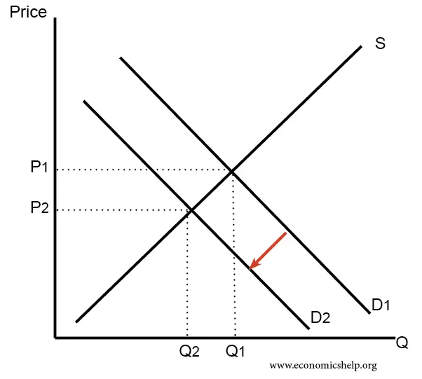
Fig. 2: Fall in demand and a leftward shift of the demand curve
(Source: Pettinger, 2019)
As discussed already, the falling price of Samsung smartphones will reduce the demand for iPhones in the US market. So, according to Figure 2, the demand curve for iPhones will shift to the left from D1 to D2. Hence, the market clearing price and quantity of iPhones both will fall.
The term complementary product can be defined as those two or more products that can be used together. In this term, products enhance the utility or value of each product through which consumers get a better experience. Apple iPhone 13 has some complementary products such as Apple chargers and Apple AirPods.

These two products are complementary and people buy these while purchasing the phone (Cleartax, 2023). In 2022, the price of iPhone chargers has increased significantly because of higher labour costs, shipping expenses, etc. So, the demand for the iPhones is expected to fall as per the general economic theory that the higher price of the complement will lower the demand for the other complement.
Fig. 3: Falling demand for an increase in complement's price
(Source: Pettinger, 2019b)
As the higher prices of iPhone chargers will lead to a fall in the demand for the iPhones, the demand curve for the iPhones will move leftwards just as shown in the above figure. Because of this, the equilibrium price of the iPhone has fallen from P1 to P2 and the quantity has also fallen from Q1 to Q2.

Users of Apple iPhones are richer as compared to the users of Android as the per year income of iPhone users in the United States is $85,000. On the other hand, per year income of Android users in the United States is around $61,000 which is 40% less than iPhone users. In the US, the personal income of households has increased steadily in the last 10 years. Even in 2022, the personal income of the US people has increased compared to that of 2020 (Statista, 2023).

Therefore, higher incomes of consumers may increase the demand for iPhones in the US market. This is because an increase in income will increase the purchasing power of the individuals so they will feel richer and hence will look to consume more of the iPhones.
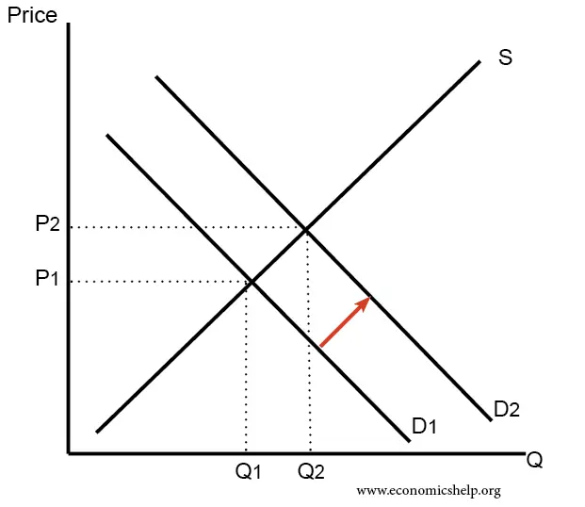
Fig. 4: Higher demand because of an increase in income
(Source: Pettinger, 2019)
An increase in consumer income will shift the demand for iPhones rightward. Therefore, the market clearing price and quantity of iPhones both will increase.
At the time of launching the iPhone 13 the people of the United States were excited to upgrade their iPhone to iPhone 13. There are several reasons behind upgrading to the new iPhone 13 series. iPhone 13 series contain the latest specifications and better user experience. Most people in the United States are upgrading to the iPhone 13 series because of the bigger battery capacity, big storage capacity, and upgraded cameras. According to a survey, 65% of iPhone users said that they want to upgrade to the new iPhone 13 series as it is far better than the iPhone 12 series. Apart from it, 50% of Android users also said that they are looking to switch to the new iPhone 13 series from Android. These statistics are based on global data. However, people in the US were not much interested in switching or upgrading to the new iPhone 13 series as compared to China and the UK. These preferences and tastes increased the demand for iPhone 13 series on a global scale.

Apple users in the US explained some major reasons to upgrade to the iPhone 13 series. 22% of people said camera, 16% people said performance, 19% people said 5G (Peterson, 2021). As US consumers still prefer iPhones highly, the demand for iPhones in the US market will remain intact rather than increase. Hence, the demand curve for the iPhones will not shift on either side or may shift to the right as more US consumers start preferring iPhones over other smartphones.
Fig. 5: Higher demand because of an increased preference for iPhones
(Source: Pettinger, 2019)
The prices of both iPhone 12 and iPhone 13 are different at the time of their launch as well as during their period of purchase. The launch price of the Apple iPhone 12 was $699 and the launch price of the Apple iPhone 13 was $799. There is around a $200 difference between the 12 and 13 prices. This difference impacted the sales of the iPhone 13. Irrespective of the prices of the iPhone 13 and iPhone 14, it is expected that the price of the iPhone 15 will be significantly higher than the price of the iPhone 14, by around 200 USD. This means that US consumers may look to purchase the iPhone 14 and other versions as the price of iPhones is expected to increase in the near future. Therefore, the demand for iPhone 14 and other versions is expected to go up at this point.
Fig. 6: Higher demand because of an expectation of price increase
(Source: Pettinger, 2019)
As the demand for iPhone 14 and other versions will go up, the demand curve for iPhone 14 and other versions of iPhones will move to the right as shown in the figure (From D1 to D2). Without any change in the supply curve, the equilibrium price of the iPhone 14 will then increase and the equilibrium quantity of the iPhones as well.

While upgrading to a new iPhone from iPhone 12, the majority of US people are more likely to upgrade to iPhone 13 rather than mini or pro max. As per statistics, 38.2% of people upgraded to the new iPhone 13. On the other hand, the rest of the users prefer to upgrade to the iPhone 13 mini, 13 pro, and 13 pro max. This indicates that the number of iPhone 13 users is more than the other three iPhone 13 (Taylor, 2023). This increase in the number of users of iPhones will increase the demand for iPhones in the US market as well.
Fig. 7: Higher demand because of an increase in customer base
(Source: Pettinger, 2019)
Higher number of iPhone users will lead to a rightward shift of the demand curve for the iPhones. This has been depicted in the figure above.

Task 2.2
iPhone 13 and Samsung S22 both are different in terms of features, brands, brand value, prices, and so on. However, the price difference between these two products is not very much in the US as the price of the S22 is around $599 and the price of the iPhone 13 is around $699. Still, $100 matters for middle-income users and Samsung provides better features and specifications in its smartphone. On the other hand, iPhone 13 also has good features and specifications alongside it also has Apple brand value. As has already been discussed, Apple iPhone users are earning 40% more than Android users in the United States (Versus, 2023).

As per some data and information, an Apple iPhone user earns $85,000 per year while an Android user earns $61,000 per year. When comparing the price of the iPhone 13 with the users' income then it can be said that the iPhone 13 is not a luxury smartphone for regular users. While looking at iPhone 13 Pro and pro max then these models can be defined as luxury products for regular iPhone users. However, it also cannot be avoided that people from the middle-income group treat the iPhone 13 as a luxury smartphone because some of the users only upgrade to a new iPhone just to show off and feel luxurious (Best products, 2022).

On the other hand, when it comes to Samsung S22 then it offers better features as compared to the iPhone 13. This smartphone can be understood as more likely to be necessary rather than a luxury because of its brand value. Apple products have always been premium and luxury products that can only be affordable by high-income groups. This model is more likely to be worth its current price. On the other hand, Apple charges extra value from consumers in return for brand value as the brand value of Apple is very high in the market. Using Apple products represents high status which has become human psychology. Samsung S22 is a mid-range smartphone in the Samsung brand and this model can be understood as a necessity for Samsung users. Some other top levels of Samsung smartphones come under the luxury category. The range of these smartphones is between $1500 to $2500 (Samsung, 2022).

As discussed above, the Apple iPhone is a luxury brand or product so it can be said that demand is more price elastic. When the price of the iPhones increases, consumers tend to move away from buying the iPhones and look to purchase smartphones that are less expensive compared to the iPhones. On the other hand, the lower price of the iPhones will push the consumers to move away from the smartphones and purchase iPhones instead. So, in this case, the impact of the substitution effect will be positive.
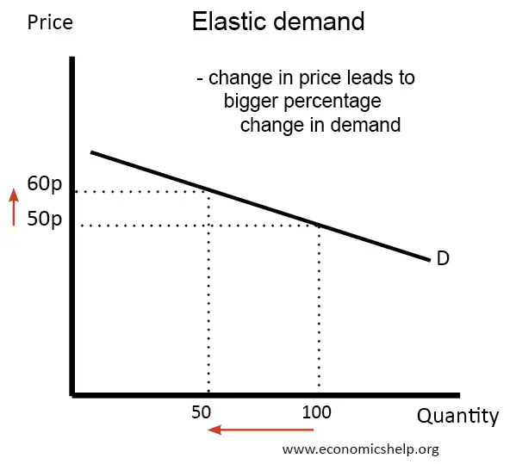
Fig. 8: Elastic demand for the iPhones
(Source: Pettinger, 2019)
As the demand for the iPhone is price elastic, the demand curve for the iPhones will be flat. A small increase in the price of iPhones will reduce the quantity demanded of the iPhones by a higher margin.

A smartphone user always focuses on his or her percentage of income while buying a new smartphone whether it is an Android or iPhone. As has already been discussed how much Android and iPhone users are earning per year (Aigner-Walder, 2015). An iPhone user is earning $85,000 per year while an Android user is earning $61,000 per year. When comparing the prices of iPhones with the iPhone users then it can be seen that an iPhone user spends a maximum of 1% of his or her annual income to purchase iPhone 13 which is very affordable for him or her.

In this case, it can be said that an iPhone 13 represents a very small portion of the consumer's annual income. When looking at this scenario from a monthly income perspective then it can be said that an iPhone user spends a decent percentage of their monthly income to purchase an iPhone 13. For example, if a person is earning $85,000 per year then his or her monthly income would be around $7,100. In this case, the iPhone 13 represents a large portion of the consumer's monthly income which is around 12-15%. This factor creates elasticity in demand because the majority of people are more likely to buy iPhone 13 at special discounts so that they can get a high-value product at low rates (Ellickson, 2013).

The income elasticity of demand for the iPhones is high as it is a luxury item. The income effect is positive here as the higher income induces the consumers to purchase more units of the iPhones.
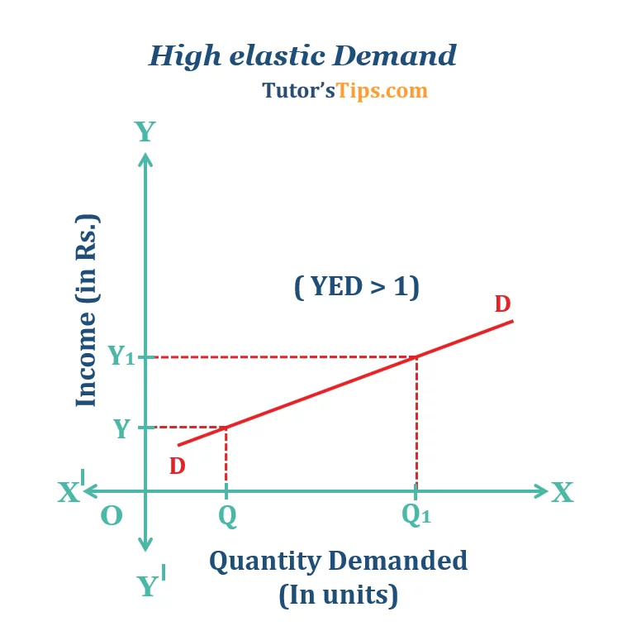
Fig. 9: High income elasticity of demand for the iPhones
(Source: Wp, 2023)
One can evaluate it mathematically as well. The number of iPhones used in 2021 was 116.3 million while in 2022, it was 124.7 million (Statista, 2022). So, % change in quantity of iPhones = [(124.7 - 116.3)/ 116.3]*100 = 7.22%. The average personal income of the US people was 21,056.62 billion USD while in 2022, it was 21,804,79 billion USD (Statista, 2022). So, % change in personal income = [(21,804.79 - 21,056.62)/ 21,804.79]*100 = 3.55 %. So, the income elasticity of demand for iPhone = 7.22%/ 3.55% = 2.03. So, as the income elasticity is greater than 1, the iPhone can be regarded as highly income elastic mathematically as well.

Task 2.3
When looking at the current pricing strategy of the company then it can be said that Apple is following a premium pricing strategy for its iPhone 13 and other models. The company believes in providing quality in return they charge a premium amount for Apple products. Apple is a leading smartphone brand in the United States and the company is also superior as compared to other smartphone brands. Innovation in smartphones, quality, and brand value of the company are the main reasons behind following the premium pricing strategy. The company manufactures the highest possible quality products which makes the product most preferred by its consumers.

No doubt the company is maintaining and following a suitable pricing strategy but still there are some ways through which the company can make some changes in pricing policies which can lead the company towards more revenue and profits. Some of the effective recommendations along with justification have been made by the researcher below (Edrawmind, 2022).

Apple products are mostly known for their luxurious status, quality, and user experience and the majority of people purchase Apple iPhones for quality and status. Due to this, the company maintains a premium pricing strategy. As a researcher, it is recommended to the company keep following the same strategy but there is a need to make some changes in the policies of this pricing strategy. As the Apple company reduces the old phone prices when new comes into the market. In this case, the company needs to decrease their old phone prices a bit more than usual.

The main reason behind it is that if Android users will get a better iPhone at the same or near price as an Android phone then there is a high probability that most Android users can try to switch to an iPhone. Once they become habitable in the iPhone ecosystem then the chances of being iPhone users for the long term will increase for them.

3. Conclusion
When summing up all the things, the essay is mainly focused on two smartphone brands named Apple and Samsung. Apple iPhone 13 is one of the most selling products in its series in the United States. Samsung S22 is discussed as a substitute for the iPhone 13 where the comparison between these two smartphones has been accomplished by the researcher. There is only a $100 difference between these smartphones and Samsung is offering better specifications as compared to the iPhone. iPhone users earn 40% more than Android users annually in the US. Apple follows a premium pricing strategy that works very well for Apple products.

References

- Aigner-Walder, B. (2015) Effects of the Demographic Changes on Private Consumption: An Almost Ideal Demand System Analysis for Austria. Journal of Economic and Social Studies, 5, 1, 33-57. https://core.ac.uk/download/pdf/153450093.pdf#page=33(Accessed: 22 July 2023).
- Bernstein, F., DeCroix, G.A. and Keskin, N.B., (2021). Competition between two-sided platforms under demand and supply congestion effects. Manufacturing & Service Operations Management, 23(5), pp.1043-1061. (Accessed: 23 July 2023)
- Camelcamelcamel, (2021). Apple Airpods (3rd generation) with MagSafe Charging Case (2021) camelcamelcamel.com. Available at: https://ca.camelcamelcamel.com/product/B09JQL3NWT (Accessed: 25 July 2023).
- Camelcamelcamel, (2022). Apple iPhone 13 (128GB) - blue (2022) camelcamelcamel.com. Available at: https://au.camelcamelcamel.com/product/B09L7R43ST (Accessed: 25 July 2023).
- Camelcamelcamel, (2022a). Samsung Galaxy S22 cell phone, factory unlocked Android smartphone, 128GB, 8K Camera & Video, night mode, brightest display screen, 50MP photo resolution, Long Battery Life, US version, green (2022) camelcamelcamel.com. Available at: https://camelcamelcamel.com/product/B09MVYVBR6 (Accessed: 26 July 2023).
- Cleartax, (2023). Complementary goods (2023) Definition, What is Complementary Goods, and How Complementary Goods works? Available at: https://cleartax.in/g/terms/complementary-goods#:~:text=If%20the%20price%20of%20one,be%20low%20on%20cross%2Delasticity (Accessed: 26 July 2023).
- Edrawmind, (2022). Apple Marketing Mix (4Ps) analysis (2022) Edrawsoft. Available at: https://www.edrawmind.com/article/apple-marketing-mix-analysis.html (Accessed: 27 July 2023).
- Ellickson, P. (2013) Market Structure and Performance. International Encyclopedia of the Social & Behavioral Sciences, Forthcoming; Simon School Working Paper No. 13-21. https://d1wqtxts1xzle7.cloudfront.net/49573072/MarketStructure-libre.pdf?1476371861=&response-content-disposition=inline%3B+filename%3DMarket_Structure.pdf&Expires=1690465293&Signature=eqQ1~zA~tkaNjTbTQaNxF84b0rz0D7paqovAA6KqF9uZL4YVQWtkyP-UpkQEKJuHxFgDIeBDW0zhf0Wi2gCWbGeH4CShfGXYlwz-B6o2FsTBcH48Uw6-e7Qyn4ePVbAyhSsKw2wPg6Irw~ZInEvPlHLXMTLHeg2sIQvMDgz3XH-HkF6mUadWYbGpihLf6PzM26ciUatnKtcBUGqDHt67gfDvMjv6NXZj0Otj4xrY3CU-8-FMra~3xxNtiX-1X3X3eguow5QZTuzUO9ATdbIyZD1N17SKYXTIV2l9vXeHF4noQ2I88bzenZL7O~TPM7~~DcAbPN0RL6cnMFpKlFKTag__&Key-Pair-Id=APKAJLOHF5GGSLRBV4ZA (Accessed: 28 July 2023).
- Loc.gov, (2022). Research guides: This Month in business history: The founding of Apple Computer, Inc.. (2022) The Founding of Apple Computer, Inc. - This Month in Business History - Research Guides at Library of Congress. Available at: https://guides.loc.gov/this-month-in-business-history/april/apple-computer-founded#:~:text=was%20founded%20on%20April%201,in%20their%20homes%20or%20offices (Accessed: 30 July 2023).
- Peterson, M. (2021) IPhone 13 pro models seeing stronger interest from consumers, survey finds, AppleInsider. Available at: https://appleinsider.com/articles/21/10/07/iphone-13-pro-models-seeing-stronger-interest-from-consumers-survey-finds (Accessed: 30 July 2023).
- Pettinger, T. (2019). Diagrams for Supply and Demand | Economics Help. [online] Economicshelp.org. Available at: https://www.economicshelp.org/1811/markets/diagrams-for-supply-and-demand/. (Accessed: 28 July 2023)
- Pettinger, T. (2019b). Market equilibrium - Economics Help. [online] Economics Help. Available at: https://www.economicshelp.org/microessays/equilibrium/market-equilibrium/. (Accessed: 28 July 2023)
- Statista. (2022). iPhone users in the US 2012-2021 | Statista. [online] Available at: https://www.statista.com/statistics/232790/forecast-of-apple-users-in-the-us/. (Accessed: 30 July 2023)
- Statista. (2023). U.S. personal income 2021. [online] Available at: https://www.statista.com/statistics/216756/us-personal-income/#:~:text=Personal%20income%20in%20the%20United%20States%20has%20risen%20steadily%20over. (Accessed: 30 July 2023)
- Taylor, P. (2023) US: Most favored model of iphone 13 2021, Statista. Available at: https://www.statista.com/statistics/1271123/apple-iphone-13-model-preference-united-states/ (Accessed: 31 July 2023).
- Versus, (2023). Apple iPhone 13 vs Samsung Galaxy S22: What is the difference? (2023) VERSUS. Available at: https://versus.com/en/apple-iphone-13-vs-samsung-galaxy-s22 (Accessed: 31 July 2023).
- Wp.com. (2023). Available at: https://i0.wp.com/tutorstips.com/wp-content/uploads/2019/10/High-elastic-Demand-.png?ssl=1 (Accessed: 19 Aug. 2023).

