
Web Development Report
Module: Introduction to Web & Database Concept ACCA4023

Assessment: HTML and CSS Development
Name: Kim Harry Lee Cleto
Student ID: 2517289
Course: IWD
Submission Date:24 April 2026
Professor: Fahad Ahmed
University of Wales Trinity Saint David
London Campus

Table of Contents
1. Introduction (Abstract) 2
2. Requirements 3
2.1 Purpose and Subject Matter 3
2.2 Target Audience 3
3. Implementation 4
3.1 Include screenshots of all website pages. 4
3.1.1 Home Page (index.html) 4
3.1.2 Dishes Page (dishes.html) 5
3.1.3 Order Page (order.html) 6
3.1.4 About Page (about.html) 7
3.2 Provide validation results (HTML & CSS). 7
3.2.1 HTML Validation (index.html) 7
3.2.2 CSS Validation 8
4. Evaluation 8
4.1 Key Web Development Concepts 8
4.1.1 Usability 8
4.1.2 Accessibility 9
4.1.3 Search Engine Optimisation (SEO) 9
4.2 Evaluation of the Completed Website 10
4.2.1 Usability and Utility 10
4.2.2 Search Engine Optimisation (SEO) 12
4.2.3 Accessibility: WCAG 2.1 Evaluation 12
4.3 Comparison of Two Live Websites 13
4.3.1 Site Descriptions 14
4.3.2 Usability 14
4.3.3 Accessibility (WAVE Tool) 15
4.3.4 SEO 16
SEO Factor 16
BBC Good Food 16
Allrecipes UK 16
Title Tags 16
Unique, descriptive titles on every page. Follow the format 'Recipe Name | BBC Good Food'. 16
Unique titles per recipe. Format: 'Recipe Name - Allrecipes'. 16
Meta Descriptions 16
Present on all pages. Well-crafted summaries that include keywords naturally. 16
Present on all pages. Slightly more formulaic but keyword rich. 16
Heading Structure 16
Strong H1/H2/H3 hierarchy throughout. Page purpose clear from heading alone. 16
Good hierarchy. Occasionally H2s used for decorative sub-labels rather than content headings. 16
Alt Text 16
Thorough alt text on editorial images. Auto-generated alts on some thumbnails. 16
Variable quality. Editorial images well described; community images less consistently tagged. 16
Mobile/Core Web Vitals 16
Strong performance scores. BBC invests heavily in technical SEO. 16
Good performance overall, though slightly lower scores on ad-heavy pages. 16
Structured Data 16
Rich snippets with recipe schema (ingredients, time, ratings) appear in Google search results. 16
Recipe schema present. Rich results with star ratings visible in Google. 16
4.3.5 Mobile Responsiveness 17
4.3.6 Overall Judgement 17
5. Conclusion 18
7. Appendices 20
7.1. Index.html 20
7.2. Dishes.html 22
7.3. Order.html 26
7.4. About.html 30
7.5 Portfolio.css 32

1. Introduction (Abstract)
This report covers the design, development, and evaluation of a four-page cooking portfolio website built for Henrietta, a home cook based in London. The site showcases her homemade dishes, gives visitors background information about her cooking, and lets them place meal orders directly through an online form.
The report is laid out as follows. The Requirements section introduces the site's purpose and audience. The Implementation section shows screen captures of every page along with the HTML and CSS validation results. The Evaluation section covers usability, accessibility, and search engine optimization (SEO), then applies those ideas to the completed site. A comparison of two live cooking websites follows at the end of the evaluation. The full HTML and CSS source code is attached in the Appendices.

2. Requirements

2.1 Purpose and Subject Matter
The website is a personal cooking portfolio for Henrietta Erica Louise Lee, a home cook of Filipino heritage currently living in London. The site's primary purpose is to showcase 12 of her homemade dishes, provide background information about herself, and allow visitors to place orders for her food. It is structured around four pages: a Home page that introduces the site and its tone; a Dishes page that displays all 12 dishes in a visual grid; an Order page containing a contact form; and an About page with a personal biography.
The subject matter centres on home cooking, with dishes ranging from savoury mains such as Pan Seared Salmon and Pork Belly to desserts such as Orange Chiffon Cake and Egg Tarts. The site reflects a personal and curated aesthetic that mirrors the care Henrietta puts into her cooking.

2.2 Target Audience
The main audience is friends, family, and acquaintances of Henrietta who already know about her cooking and want to browse her dishes or place an order. A secondary audience is anyone who finds the site through her Instagram account (@archaic.blaze) and is interested in having a home-cooked meal prepared. The audience is broadly adult, likely aged 18 to 45, and used to browsing websites on both desktop and mobile.

3. Implementation

3.1 Include screenshots of all website pages.
The following screenshots show each of the four pages of the completed website.

3.1.1 Home Page (index.html)
The Home page features the site title 'My Cooking Journey', a subtitle indicating the London, UK location, and a short welcoming paragraph. A call-to-action button directs visitors to the Dishes page. The dark background and gold typography establish the site's visual identity.
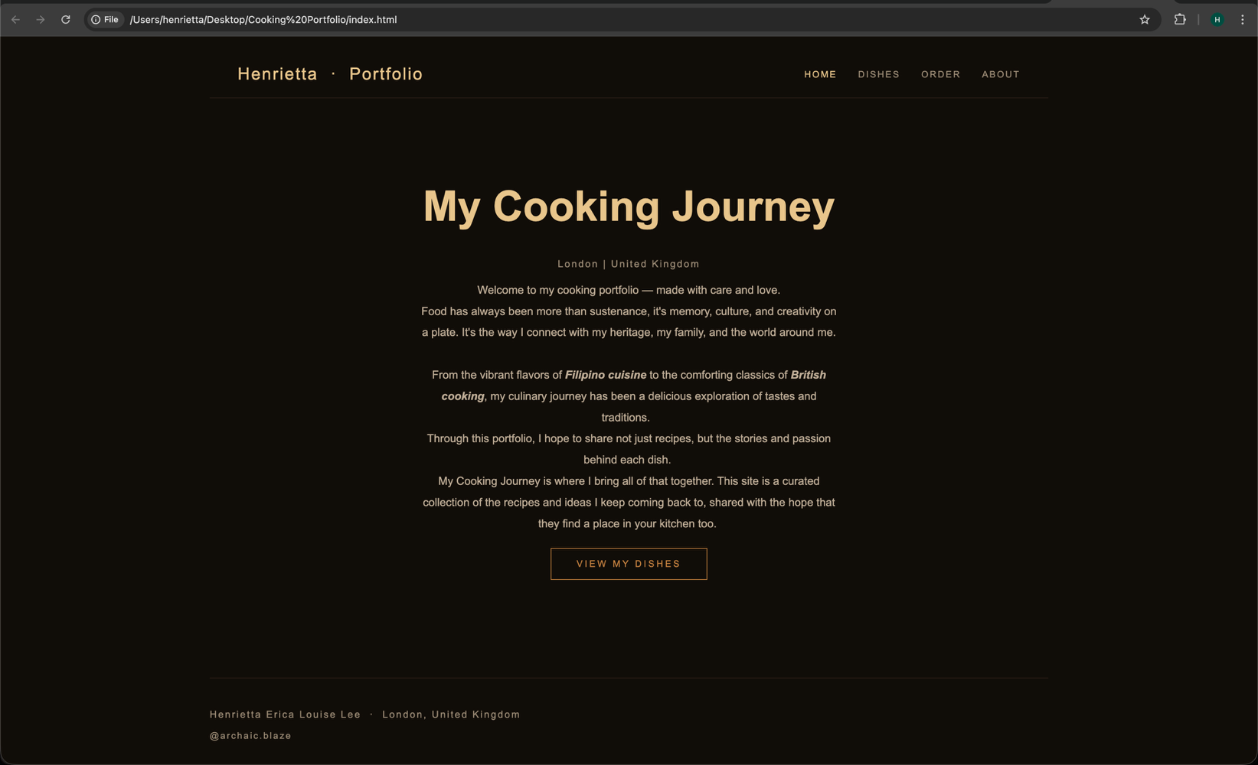

3.1.2 Dishes Page (dishes.html)

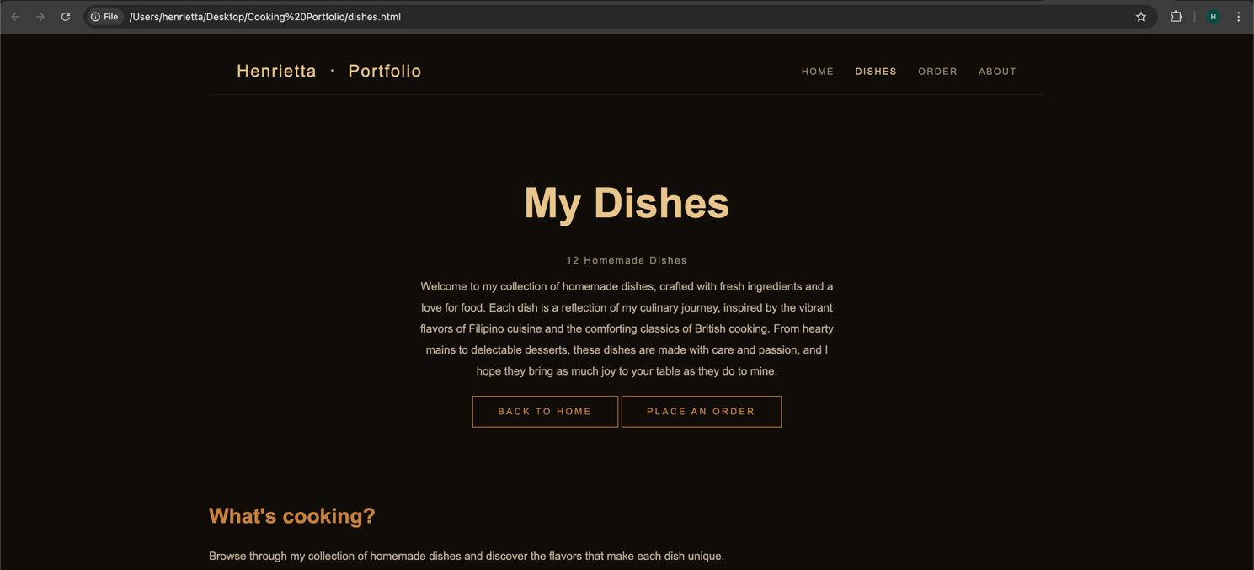
The Dishes page displays all 12 homemade dishes in a three-column CSS Grid layout. Each card shows a photograph of the dish along with its full name. Cards have a hover effect that scales them slightly and lightens the background. Two call-to-action buttons at the top and bottom link back to the Home page and forward to the Order page.
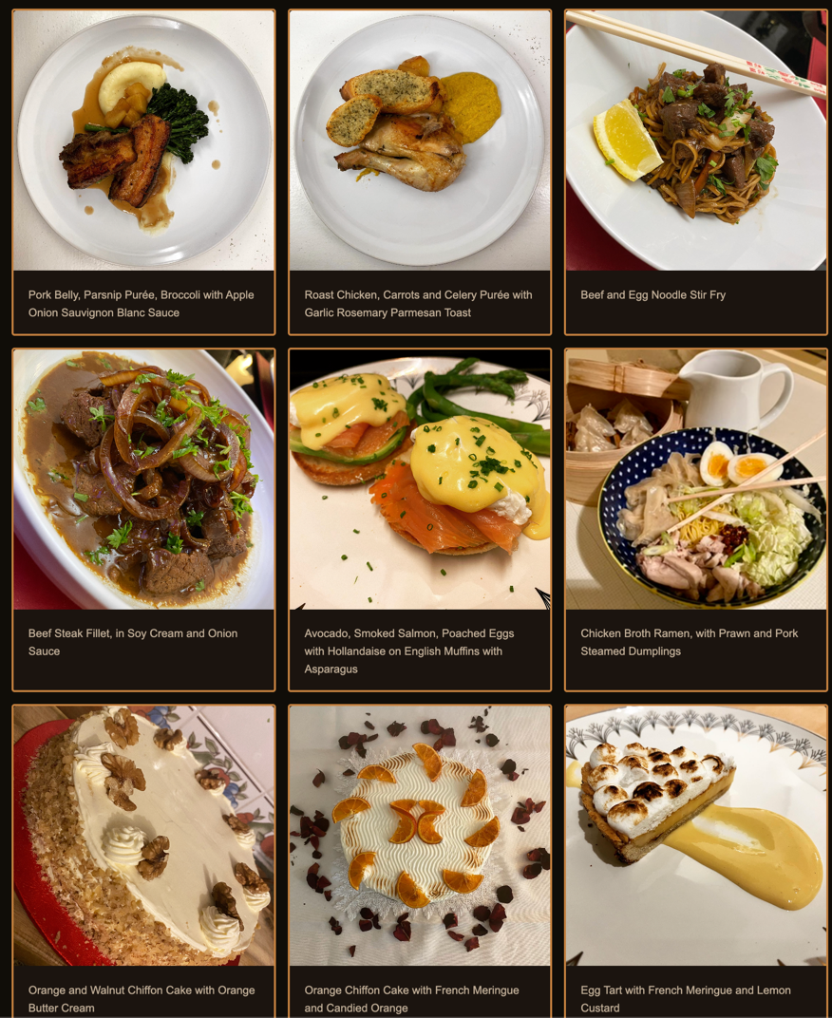

3.1.3 Order Page (order.html)

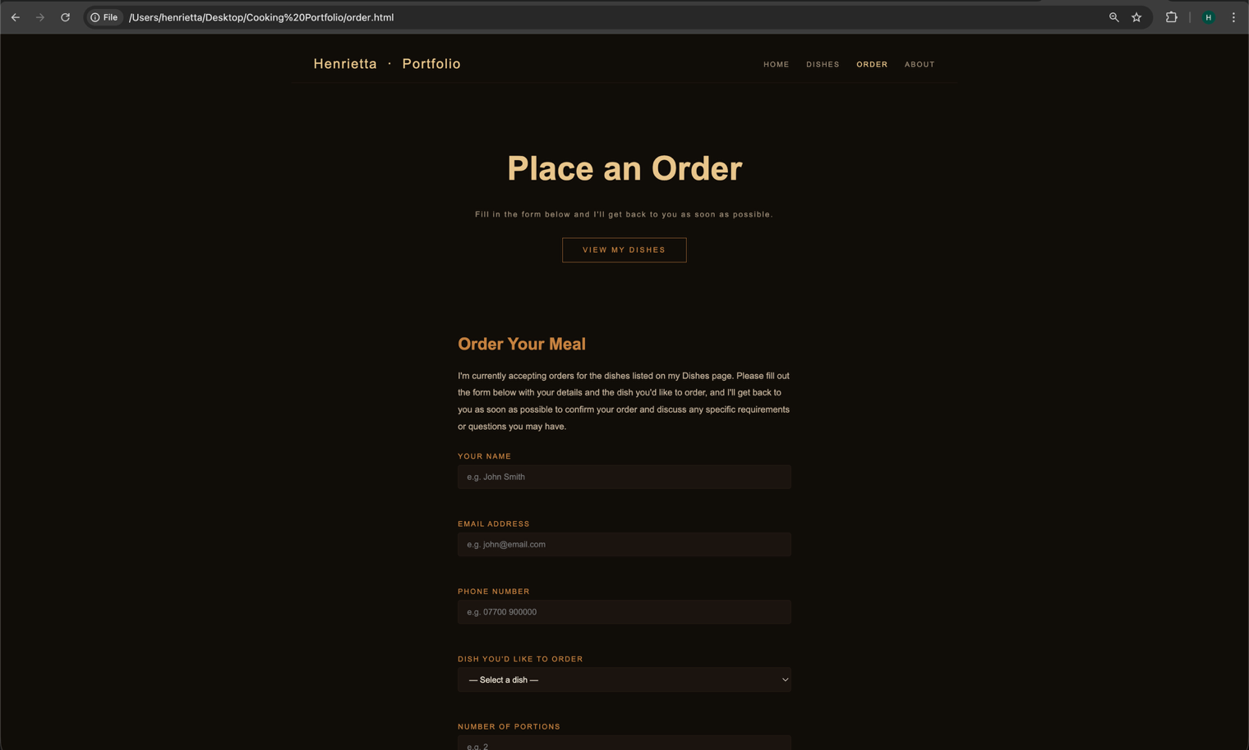
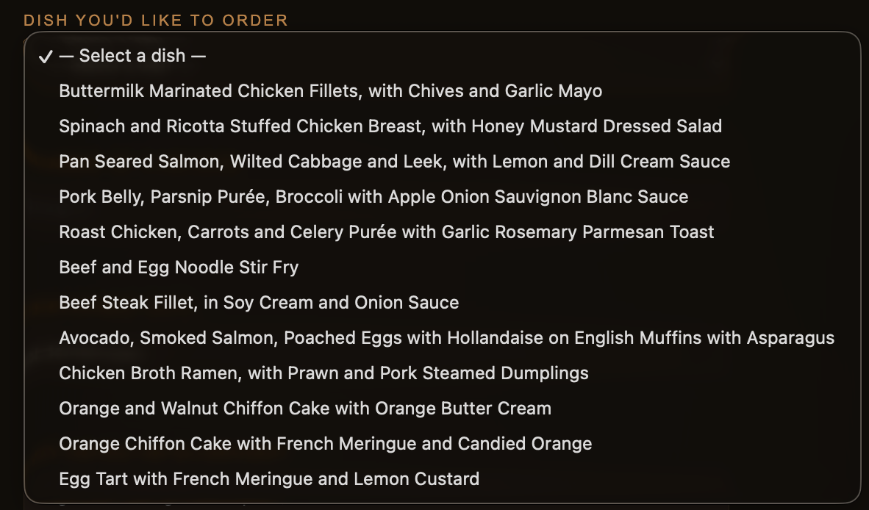
The Order page presents a contact form allowing visitors to enter their name, email address, phone number, preferred dish (via a dropdown), number of portions, preferred date, and any notes or allergy information. The form uses appropriate HTML5 input types for validation purposes.

3.1.4 About Page (about.html)

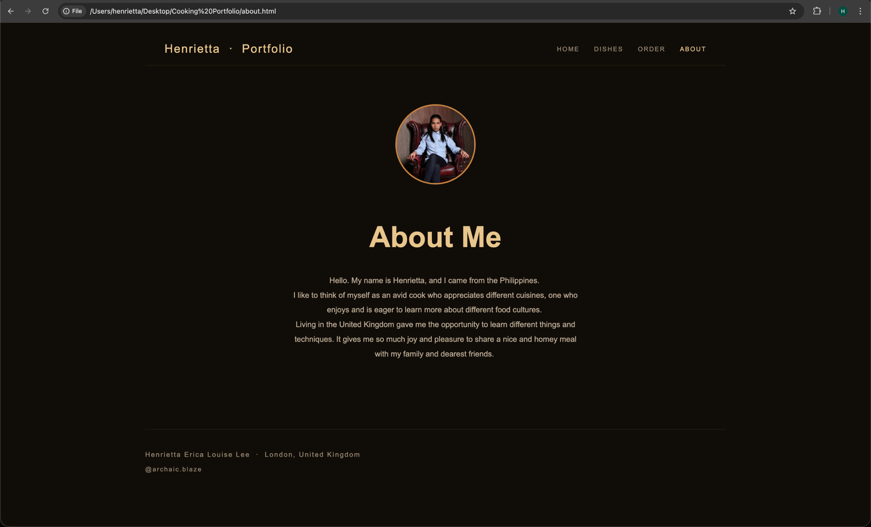
The About page includes a circular profile photograph of Henrietta, a heading, and three paragraphs describing her background, her love of food, and her experience living in the United Kingdom.
3.2 Provide validation results (HTML & CSS).

3.2.1 HTML Validation (index.html)
The home page HTML was validated using the W3C Markup Validation Service at http://validator.w3.org/.
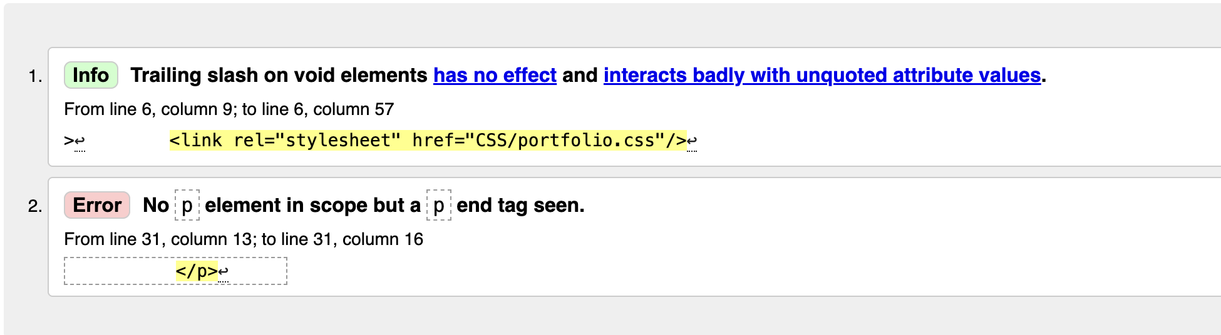
Validation outcome: The W3C validator returned one informational notice and one error.
Info (trailing slash on void elements, line 6): The validator flagged the self-closing slash on the <link> element (<link rel="stylesheet" href="CSS/portfolio.css"/>). In HTML5, void elements such as <link> do not require a trailing slash, and its presence has no effect but can interact badly with unquoted attribute values. This was corrected by removing the trailing slash, changing the tag to <link rel="stylesheet" href="CSS/portfolio.css">.

Error (stray </p> tag, line 31): The validator identified a stray </p> closing tag on line 31 that had no corresponding opening <p> tag. This was caused by the form fields being wrapped in <p class="form-group"> elements; because <p> elements cannot contain block-level children such as <input> and <select>, the browser was closing the <p> automatically before those elements, leaving the </p> orphaned. This was corrected by replacing the <p class="form-group"> wrappers with <div class="form-group"> elements, which are valid containers for form inputs.

3.2.2 CSS Validation
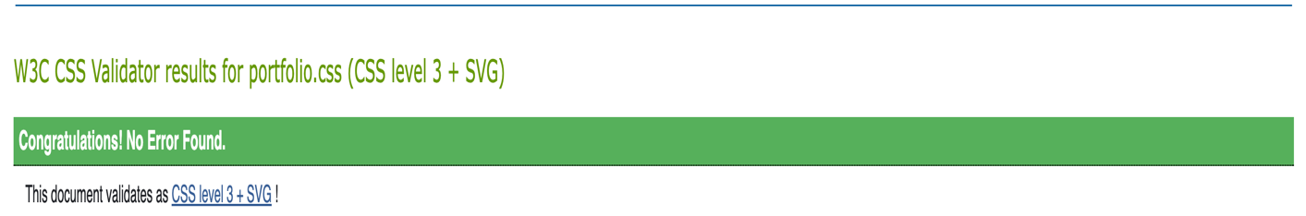
The main stylesheet (portfolio.css) was validated using the W3C CSS Validation Service at http://jigsaw.w3.org/css-validator/.

Validation outcome: The CSS passed validation with no errors. The validator confirmed that portfolio.css is valid CSS level 3. No errors or warnings were returned, confirming that all property names, values, and syntax are standards compliant.

4. Evaluation

4.1 Key Web Development Concepts

4.1.1 Usability
Usability refers to the ease with which users can interact with a website to accomplish their goals effectively and efficiently. In web development, usability covers how intuitive the navigation is, how clear the content is, and how satisfied users feel after completing a task. Jakob Nielsen, widely regarded as a leading authority on usability, defines it across five core components: learnability, efficiency, memorability, error prevention, and user satisfaction [1].
Usability has a direct impact on engagement and conversion rates. A website that is difficult to use will drive visitors away, regardless of the quality of its content. Key usability principles include maintaining consistent navigation across pages, providing clear labels and calls to action, ensuring readable typography, and minimising the number of steps required to complete a task.
Academic study: Tuch et al. (2012) studied the relationship between aesthetics and usability in a paper published in Computers in Human Behaviour. They ran two experiments that manipulated the aesthetic appeal and the usability of a website independently, so that the effect of each on the other could be measured. Their findings showed that how usable participants found a site did influence how aesthetically pleasing they rated it afterwards, but the reverse effect was weak: good looks did not substantially improve perceived usability. The paper cautioned that the common assumption "what is beautiful is usable" is not well supported by the evidence and argued that usability and aesthetics should be measured and designed for separately [2]

4.1.2 Accessibility
Web accessibility refers to the design and development of websites that can be used by all people, including those with visual, auditory, motor, or cognitive impairments. The Web Content Accessibility Guidelines (WCAG) 2.1, published by the World Wide Web Consortium (W3C), provide an internationally recognised framework for accessible web design, organised around four core principles: Perceivable, Operable, Understandable, and Robust (POUR) [3].
Accessibility is not only a matter of ethical responsibility but increasingly a legal requirement. In the United Kingdom, the Equality Act 2010 requires that digital services be accessible to disabled users. Failure to meet accessibility standards can expose organisations to legal risk and significantly limits a website's potential audience.
Academic study: Lazar et al. (2007) ran a study on the frustrations blind web users face on inaccessible sites, published in the International Journal of Human-Computer Interaction. The study involved 100 participants using screen readers over several weeks. Up to 50% of their time online was wasted on accessibility barriers such as missing alt text, lack of keyboard support, and poor heading structure. The paper made it clear that accessibility failures are not small inconveniences but serious blockers that stop users from completing basic tasks [4].

4.1.3 Search Engine Optimisation (SEO)
Search Engine Optimisation (SEO) is the practice of improving a website's visibility in organic (non-paid) search engine results. SEO covers both on-page techniques (including relevant keywords, descriptive page titles, meta descriptions, and proper heading hierarchies) and off-page techniques, such as building backlinks from other websites. For web developers, on-page SEO is particularly important as it is directly controlled through the HTML and content of the site [5].
Good SEO practice overlaps heavily with good web development in general. Semantic HTML, descriptive image alt text, fast loading times, and mobile responsiveness all help search engines rank a page and make the site easier to use.
Academic study: Ziakis et al. (2019) carried out an empirical study on the factors that influence Google search rankings, published in the Future Internet journal. The researchers examined the top 15 Google results for three different search terms ("hotel Athens," "email marketing," and "casual shoes") and used Spearman correlation to measure how strongly a range of on-page and off-page SEO factors related to ranking position. They found that the presence of an SSL certificate, the use of keywords in the URL, the number of backlinks pointing to the site, the length of the page text, and the domain age were among the strongest factors associated with higher rankings. The paper argued that both on-page signals (such as URL structure and content length) and off-page signals (such as backlinks) remain measurable and significant contributors to search visibility [6].

4.2 Evaluation of the Completed Website

4.2.1 Usability and Utility
Utility (Functionality): The website delivers its core functional requirements effectively. The Dishes page allows users to browse all 12 dishes with accompanying photographs and descriptions. The Order page provides a working HTML5 form with appropriate input types (email, telephone number, date, and a dropdown select) which provide basic client-side validation out of the box. The About page gives users contextual information about Henrietta as a cook. The site achieves what it sets out to do for its intended audience.

Usability (Look and Feel): The site uses a consistent dark colour scheme throughout all four pages, with a near-black background (#110d09), gold headings (#e8c48a), and warm amber accents (#c4813f). This creates a cohesive and distinctive visual identity that matches the premium, handcrafted feel of home cooking. Navigation is consistent across all pages, with the active page clearly indicated through colour. Hover states on navigation links, dish cards, and the CTA button provide interactive feedback to users.

Content: The content is concise and well-written. The dish names are fully descriptive, which is important for users deciding what to order. The About page provides enough personal background to build trust with potential customers. The home page copy balances warmth and professionalism.
Recommendations for improvement:
- Add a meta description tag to each page to improve click-through rates from search engine results.
- Add a viewport meta tag (<meta name="viewport" content="width=device-width, initial-scale=1">) to each page for better mobile rendering.
- Include a success message or redirect after form submission, as the form currently gives no post-submission feedback to the user.
- Add media queries to make the dish grid responsive on smaller screens; the three-column layout is likely too narrow on mobile devices.
- Consider adding aria-required attributes to key form fields (name, email, dish) and server-side validation to complement the existing client-side checks.

4.2.2 Search Engine Optimisation (SEO)
SEO Technique | Applied? | Detail / Example
Title tags | Yes | Each page has a unique, descriptive <title> (e.g. 'Henrietta - Cooking Portfolio' on index.html, 'Dishes — Henrietta' on dishes.html).
HTML lang attribute | Yes | All pages include lang="en" on the <html> element, helping search engines and screen readers identify the page language.
Semantic HTML structure | Yes | Pages use <header>, <nav>, <section>, <footer>, and <ul> for navigation and lists — all semantically appropriate.
Image alt attributes | Yes | All 12 dish images and the profile photo include descriptive alt text (e.g. alt="Pan Seared Salmon").
Heading hierarchy | Yes | Each page uses a single <h1> for the page title and <h2> for section headings, maintaining a clear hierarchy.
Charset declaration | Yes | <meta charset="UTF-8"> is present on all pages.
Meta description | No | No meta description tags are present. Adding these would improve click-through rates from search results.
Viewport meta tag | No | No <meta name="viewport"> tag is present. This is important for mobile SEO and responsiveness.
Keyword usage | Partial | The page copy naturally includes relevant terms such as 'cooking', 'homemade dishes', and 'London'. Dedicated keyword meta tags are not used (deprecated in modern SEO).
The following on-page SEO techniques were applied to the website:

The website demonstrates solid foundational SEO practice through its use of unique page titles, descriptive alt text, and semantic HTML structure. The two most impactful improvements would be adding a viewport meta tag and a meta description to each page.

4.2.3 Accessibility: WCAG 2.1 Evaluation
The WCAG 2.1 guidelines are organised around four principles, often abbreviated as POUR: Perceivable, Operable, Understandable, and Robust 3. The accessibility of the completed website is evaluated below against each principle.
Perceivable: Users must be able to perceive all content and interface elements. The website includes descriptive alt text for all images, which supports screen reader users. However, the colour contrast ratio between the body text (#c0ae97 on #110d09) should be verified against the WCAG 2.1 AA minimum ratio of 4.5:1 for normal text. Using a tool such as contrastchecker.com, the contrast ratio between #c0ae97 and #110d09 is approximately 5.8:1, which passes the AA requirement. The gold heading colour (#e8c48a on #110d09) achieves a ratio of approximately 8.2:1, comfortably exceeding the AA standard. No content is conveyed through colour alone, and all interactive elements have visible text labels.

Operable: All interactive elements (navigation links, the CTA button, and form inputs) are standard HTML elements and are therefore keyboard-navigable by default. The navigation structure lets users tab through links in a logical order. Form inputs on the Order page have <label> elements properly associated with each input via matching for and id attributes, which means clicking a label focuses the correct input and screen readers announce the label when the input is reached.

Understandable: The site language is set to English via lang="en". Page titles are descriptive. The navigation labels (Home, Dishes, Order, About) are clear and self-explanatory. Form fields use both visible <label> text and placeholder examples (e.g. 'e.g. John Smith'), so users can see what each field is for even after they start typing. Error messages are handled by the browser's default HTML5 validation, which provides clear prompts when required types are not met.

Robust: The site uses valid, standards-compliant HTML5 and CSS3, confirmed by the W3C validators. This means the site works consistently across browsers and assistive technologies. Semantic list elements (<ul>) are used for both the navigation and the dish gallery, which is appropriate since neither is an ordered sequence. The site degrades gracefully when JavaScript is disabled, as no scripts are required for core functionality.

4.3 Comparison of Two Live Websites
The following section provides a comparative analysis of two well-known cooking and recipe websites: BBC Good Food (www.bbcgoodfood.com) and Allrecipes UK (www.allrecipes.co.uk). Both sites serve a similar function to the portfolio website in that they present food content to a general audience. The comparison focuses on usability, accessibility, SEO, and mobile responsiveness.

4.3.1 Site Descriptions
Criteria | BBC Good Food | Allrecipes UK
URL | www.bbcgoodfood.com | www.allrecipes.co.uk
Owner | Immediate Media Co. / BBC Studios | Dotdash Meredith
Purpose | Recipe discovery, cooking guides, food inspiration, and magazine content | User-submitted and curated recipes with community ratings and reviews
Content Volume | Thousands of professionally produced recipes and articles | Hundreds of thousands of community-contributed recipes

4.3.2 Usability
Criterion | BBC Good Food | Allrecipes UK
Navigation | Clear top navigation with category dropdowns. Consistent mega-menu across all pages. Easy to browse by meal type, ingredient, or occasion. | Top navigation present but less prominent. Search bar is the primary navigation method, which suits frequent users but may hinder new visitors.
Layout | Clean, magazine-style grid layout with large hero images. Whitespace is used effectively to reduce clutter. | Denser layout with more cards and content per page. Can feel busier but allows more content to be discovered per scroll.
Readability | High readability. Large, legible body text (16px+). Good contrast between text and background. Recipes broken into clear steps. | Readable but slightly smaller body text in some sections. Recipe steps are clear, but the page can feel ad heavy.
User Experience | Premium feel. Minimal friction to find and follow a recipe. Step counts and cooking times prominently displayed. | Strong community feel with ratings and reviews. Adds trust but pages are more complex due to the volume of user content.

4.3.3 Accessibility (WAVE Tool)
Both websites were evaluated using the WAVE Web Accessibility Evaluation Tool (wave.webaim.org), which identifies accessibility errors, alerts, and structural features in accordance with WCAG 2.1.
WCAG Principle | BBC Good Food | Allrecipes UK
Perceivable | Most images have alt text. Some decorative images correctly use empty alt attributes. Minor contrast warnings flagged on caption text. | Most recipe images include alt text. Some user-uploaded images have missing or non-descriptive alt text. Contrast warnings noted on some filter buttons.
Operable | Keyboard navigation functional. Skip-to-content link present. Good focus indicators on interactive elements. | Keyboard navigation mostly functional. Skip link present. Some modal and dropdown components have inconsistent focus management.
Understandable | Lang attribute present. Form labels are correctly associated. Error messages are descriptive. | Lang attribute present. Search field is well labelled. Some subscription pop-up forms lack sufficient label associations.
Robust | Valid HTML structure. ARIA landmarks used appropriately. Good heading hierarchy (H1 > H2 > H3). | Generally valid HTML. ARIA roles present. Heading hierarchy occasionally inconsistent on category pages.
WAVE Errors | Very few errors (primarily related to third-party ad content). | Moderate number of errors, largely related to missing alt text on community-submitted images and some contrast issues.

4.3.4 SEO
SEO Factor | BBC Good Food | Allrecipes UK
Title Tags | Unique, descriptive titles on every page. Follow the format 'Recipe Name | BBC Good Food'. | Unique titles per recipe. Format: 'Recipe Name - Allrecipes'.
Meta Descriptions | Present on all pages. Well-crafted summaries that include keywords naturally. | Present on all pages. Slightly more formulaic but keyword rich.
Heading Structure | Strong H1/H2/H3 hierarchy throughout. Page purpose clear from heading alone. | Good hierarchy. Occasionally H2s used for decorative sub-labels rather than content headings.
Alt Text | Thorough alt text on editorial images. Auto-generated alts on some thumbnails. | Variable quality. Editorial images well described; community images less consistently tagged.
Mobile/Core Web Vitals | Strong performance scores. BBC invests heavily in technical SEO. | Good performance overall, though slightly lower scores on ad-heavy pages.
Structured Data | Rich snippets with recipe schema (ingredients, time, ratings) appear in Google search results. | Recipe schema present. Rich results with star ratings visible in Google.

4.3.5 Mobile Responsiveness
Criterion | BBC Good Food | Allrecipes UK
Layout Adaptation | Fully responsive. Grid shifts from multi-column to single column on mobile. Navigation collapses to hamburger menu. | Fully responsive. Single-column layout on mobile. Navigation collapses appropriately.
Touch Targets | Buttons and links are large enough for comfortable tapping (minimum 44x44px guideline met). | Generally adequate tap targets. Some filter chips are small and may be difficult to tap on smaller screens.
Image Scaling | Images scale correctly and do not overflow containers on small screens. | Images scale correctly. Some ad units occasionally cause minor horizontal scrolling.
Performance on Mobile | Fast load times on mobile. Images lazy loaded efficiently. | Slightly slower on mobile due to higher ad load.

4.3.6 Overall Judgement
Both websites are high-quality, professionally built platforms that perform well across all evaluation criteria. BBC Good Food has the edge in terms of usability and accessibility, offering a cleaner layout, better contrast, and more consistent use of WCAG 2.1 principles. Allrecipes UK has stronger community features and a larger content library, but its higher ad load and variable user-submitted content introduce accessibility inconsistencies.
Verdict: BBC Good Food is the stronger site for usability, accessibility, and SEO consistency. It would be a better model for a cooking or portfolio website aiming to meet modern web standards.

5. Conclusion
This project set out to design and hand-code a responsive four-page cooking portfolio website for Henrietta, a home cook based in London, and to produce a report documenting the work against the requirements of the assignment. Both parts were completed. The site covers a Home page introducing the project, a Dishes page showcasing 12 homemade meals in a three-column grid, an Order page with a working HTML5 form, and an About page with a personal biography. The HTML of the home page and the main CSS stylesheet were both submitted to the W3C validators, and the errors that were returned were corrected and documented.
The evaluation section applied the three core concepts of usability, accessibility, and search engine optimisation to the completed site. The site performs well against standard usability heuristics: navigation is consistent across every page, visual hierarchy is clear, and the handcrafted aesthetic suits the subject matter. Accessibility was assessed against the four WCAG 2.1 principles, and the site meets the AA contrast threshold on all text, uses semantic HTML throughout, and provides properly associated form labels. On the SEO side, unique page titles, descriptive alt attributes, and a clean heading hierarchy were applied, though two improvements stand out as worth adding before the site goes live: a viewport meta tag for mobile rendering, and a meta description on each page for better search result previews.
Comparing the site to two established cooking websites (BBC Good Food and Allrecipes UK) put its strengths and limitations in perspective. Both comparison sites are backed by large teams and heavy infrastructure, which shows in their mobile responsiveness, their accessibility tooling, and their rich structured data. The portfolio site does not yet match those in technical breadth, but it does hold its own on visual identity, clarity, and accessibility basics. The main practical gap is mobile responsiveness: without media queries, the three-column dish grid will not reflow sensibly on narrow screens, and this is the single highest-priority change before a real-world launch.
Working through the assignment was a useful exercise in writing standards-compliant markup by hand and then measuring the result against formal criteria rather than by eye. The validation process caught mistakes that would have been easy to miss, and the accessibility audit made clear that good-looking design and accessible design are not the same thing. The recommendations listed in section 4.2 (meta description, viewport tag, form success feedback, responsive media queries, and additional ARIA support) form a concrete roadmap for taking the site from a coursework deliverable to something ready for genuine use.

6. References
[1] J. Nielsen, Usability engineering, Morgan Kaufmann, 1994.
[2] A. N. Tuch, S. P. Roth, K. Hornbæk, K. Opwis and J. A. Bargas-Avila, "Is beautiful really usable? Toward understanding the relation between usability, aesthetics, and affect in HCI," Comput.Hum.Behav. vol. 28, no. 5, pp.1596–1607, 2012,
[3] World Wide Web Consortium (W3C), "Web Content Accessibility Guidelines (WCAG) 2.1," 2018,
[4] J. Lazar, A. Allen, J. Kleinman and C. Malarkey, "What frustrates screen reader users on the web: A study of 100 blind users," Int.J.Hum.-Comput.Interact. vol. 22, no. 3, pp.247–269, 2007,
[5] E. Enge, S. Spencer and J. C. Stricchiola,The Art of SEO: Mastering Search Engine Optimization, 3rd Ed. Sebastopol, CA: O'Reilly Media, 2015.
[6] C. Ziakis, M. Vlachopoulou, T. Kyrkoudis and M. Karagkiozidou, "Important factors for improving Google search rank," vol. 11, no. 2, pp.32, 2019,

7. Appendices

7.1. Index.html
<!DOCTYPE html>
<html lang="en">

<head>
<title>Henrietta - Cooking Portfolio</title>
<link rel="stylesheet" href="CSS/portfolio.css">
<meta charset="UTF-8">
</head>

<body>
<nav class="navbar">
<span class="nav-logo">Henrietta &nbsp;·&nbsp; Portfolio</span>
<ul class="nav-links">
<li><a href="index.html" class="active">Home</a></li>
<li><a href="dishes.html">Dishes</a></li>
<li><a href="order.html">Order</a></li>
<li><a href="about.html">About</a></li>
</ul>
</nav>

<header>
<h1 class="main-title">My Cooking Journey</h1>
<p class="location">London | United Kingdom</p>
<p class="about-text">Welcome to my cooking portfolio — made with care and love.</p>
<p class="about-text">Food has always been more than sustenance, it's memory, culture, and creativity on a plate.
It's the way I connect with my heritage, my family, and the world around me. &nbsp;</p>
<p class="about-text">From the vibrant flavors of <b><i>Filipino cuisine</i></b> to the comforting classics of <b><i>British cooking</i></b>,
my culinary journey has been a delicious exploration of tastes and traditions. &nbsp;</p>
<p class="about-text">Through this portfolio, I hope to share not just recipes, but the stories and passion behind each dish.&nbsp;</p>
<p class="about-text">My Cooking Journey is where I bring all of that together.
This site is a curated collection of the recipes and ideas I keep coming back to, shared with the hope that they find a place in your kitchen too.&nbsp;</p>
<a href="dishes.html" class="cta-button">View My Dishes</a>
</header>

<footer class="footer">
<p>Henrietta Erica Louise Lee &nbsp;·&nbsp; London, United Kingdom</p>
<a class="ig-link" href="https://www.instagram.com/archaic.blaze" target="_blank">@archaic.blaze</a>
</footer>
</body>
</html>

7.2. Dishes.html
<!DOCTYPE html>
<html lang="en">

<head>
<title>Dishes — Henrietta</title>
<link rel="stylesheet" href="CSS/portfolio.css">
<meta charset="UTF-8">
</head>

<body>
<nav class="navbar">
<span class="nav-logo">Henrietta &nbsp;·&nbsp; Portfolio</span>
<ul class="nav-links">
<li><a href="index.html">Home</a></li>
<li><a href="dishes.html" class="active">Dishes</a></li>
<li><a href="order.html">Order</a></li>
<li><a href="about.html">About</a></li>
</ul>
</nav>

<header>
<h1 class="main-title">My Dishes</h1>
<p class="location">12 Homemade Dishes</p>
<p class="about-text">Welcome to my collection of homemade dishes, crafted with fresh ingredients and a love for food. Each dish is a reflection of my culinary journey, inspired by the vibrant flavors of Filipino cuisine and the comforting classics of British cooking. From hearty mains to delectable desserts, these dishes are made with care and passion, and I hope they bring as much joy to your table as they do to mine.</p>
<a href="index.html" class="cta-button">Back to Home</a>
<a href="order.html" class="cta-button">Place an Order</a>
</header>

<section class="dishes-section">
<h2 class="section-heading">What's cooking?</h2>
<p class="about-text">Browse through my collection of homemade dishes and discover the flavors that make each dish unique.</p>
<ul class="dish-list">
<li>
<img class="dish-photo" src="Images/dish1.jpg" alt="Buttermilk Chicken">
<span class="dish-name">Buttermilk Marinated Chicken Fillets, with Chives and Garlic Mayo</span>
</li>
<li>
<img class="dish-photo" src="Images/dish2.jpg" alt="Spinach and Ricotta Stuffed Chicken Breast">
<span class="dish-name">Spinach and Ricotta Stuffed Chicken Breast, with Honey Mustard Dressed Salad</span>
</li>
<li>
<img class="dish-photo" src="Images/dish3.jpg" alt="Pan Seared Salmon">
<span class="dish-name">Pan Seared Salmon, Wilted Cabbage and Leek, with Lemon and Dill Cream Sauce</span>
</li>
<li>
<img class="dish-photo" src="Images/dish4.jpg" alt="Pork Belly">
<span class="dish-name">Pork Belly, Parsnip Purée, Broccoli with Apple Onion Sauvignon Blanc Sauce</span>
</li>
<li>
<img class="dish-photo" src="Images/dish5.jpg" alt="Roast Chicken">
<span class="dish-name">Roast Chicken, Carrots and Celery Purée with Garlic Rosemary Parmesan Toast</span>
</li>
<li>
<img class="dish-photo" src="Images/dish6.jpg" alt="Beef and Egg Noodle Stir Fry">
<span class="dish-name">Beef and Egg Noodle Stir Fry</span>
</li>
<li>
<img class="dish-photo" src="Images/dish7.jpg" alt="Beef Steak Fillet">
<span class="dish-name">Beef Steak Fillet, in Soy Cream and Onion Sauce</span>
</li>
<li>
<img class="dish-photo" src="Images/dish8.jpg" alt="Avocado, Smoked Salmon, Poached Eggs with Hollandaise on English Muffins with Asparagus">
<span class="dish-name">Avocado, Smoked Salmon, Poached Eggs with Hollandaise on English Muffins with Asparagus</span>
</li>
<li>
<img class="dish-photo" src="Images/dish9.jpg" alt="Chicken Broth Ramen">
<span class="dish-name">Chicken Broth Ramen, with Prawn and Pork Steamed Dumplings</span>
</li>
<li>
<img class="dish-photo" src="Images/dish10.jpg" alt="Orange and Walnut Chiffon Cake">
<span class="dish-name">Orange and Walnut Chiffon Cake with Orange Butter Cream</span>
</li>
<li>
<img class="dish-photo" src="Images/dish11.jpg" alt="Orange Chiffon Cake with French Meringue and Candied Orange">
<span class="dish-name">Orange Chiffon Cake with French Meringue and Candied Orange</span>
</li>
<li>
<img class="dish-photo" src="Images/dish12.jpg" alt="Egg Tart with French Meringue and Lemon Custard">
<span class="dish-name">Egg Tart with French Meringue and Lemon Custard</span>
</li>
</ul>
</section>

<div class="bottom-cta">
<a href="index.html" class="cta-button">Back to Home</a>
<a href="order.html" class="cta-button">Place an Order</a>
</div>

<footer class="footer">
<p>Henrietta Erica Louise Lee &nbsp;·&nbsp; London, United Kingdom</p>
<a class="ig-link" href="https://www.instagram.com/archaic.blaze" target="_blank">@archaic.blaze</a>
</footer>
</body>
</html>

7.3. Order.html
<!DOCTYPE html>
<html lang="en">

<head>
<title>Order — Henrietta</title>
<link rel="stylesheet" href="CSS/portfolio.css">
<meta charset="UTF-8">
</head>

<body>
<nav class="navbar">
<span class="nav-logo">Henrietta &nbsp;·&nbsp; Portfolio</span>
<ul class="nav-links">
<li><a href="index.html">Home</a></li>
<li><a href="dishes.html">Dishes</a></li>
<li><a href="order.html" class="active">Order</a></li>
<li><a href="about.html">About</a></li>
</ul>
</nav>

<header>
<h1 class="main-title">Place an Order</h1>
<p class="location">Fill in the form below and I'll get back to you as soon as possible.</p>
<a href="dishes.html" class="cta-button">View My Dishes</a>
</header>

<section class="order-section">
<h2 class="section-heading">Order Your Meal</h2>
<p class="about-text">I'm currently accepting orders for the dishes listed on my Dishes page. Please fill out the form below with your details and the dish you'd like to order, and I'll get back to you as soon as possible to confirm your order and discuss any specific requirements or questions you may have.</p>

<form class="order-form">

<p class="form-group">
<label class="form-label" for="name">Your Name</label>
<input class="form-input" type="text" id="name" name="name" placeholder="e.g. John Smith">
</p>
<p class="form-group">
<label class="form-label" for="email">Email Address</label>
<input class="form-input" type="email" id="email" name="email" placeholder="e.g. john@email.com">
</p>
<p class="form-group">
<label class="form-label" for="phone">Phone Number</label>
<input class="form-input" type="tel" id="phone" name="phone" placeholder="e.g. 07700 900000">
</p>
<p class="form-group">
<label class="form-label" for="dish">Dish You'd Like to Order</label>
<select class="form-input" id="dish" name="dish">
<option value="">— Select a dish —</option>
<option>Buttermilk Marinated Chicken Fillets, with Chives and Garlic Mayo</option>
<option>Spinach and Ricotta Stuffed Chicken Breast, with Honey Mustard Dressed Salad</option>
<option>Pan Seared Salmon, Wilted Cabbage and Leek, with Lemon and Dill Cream Sauce</option>
<option>Pork Belly, Parsnip Purée, Broccoli with Apple Onion Sauvignon Blanc Sauce</option>
<option>Roast Chicken, Carrots and Celery Purée with Garlic Rosemary Parmesan Toast</option>
<option>Beef and Egg Noodle Stir Fry</option>
<option>Beef Steak Fillet, in Soy Cream and Onion Sauce</option>
<option>Avocado, Smoked Salmon, Poached Eggs with Hollandaise on English Muffins with Asparagus</option>
<option>Chicken Broth Ramen, with Prawn and Pork Steamed Dumplings</option>
<option>Orange and Walnut Chiffon Cake with Orange Butter Cream</option>
<option>Orange Chiffon Cake with French Meringue and Candied Orange</option>
<option>Egg Tart with French Meringue and Lemon Custard</option>
</select>
</p>
<p class="form-group">
<label class="form-label" for="portions">Number of Portions</label>
<input class="form-input" type="number" id="portions" name="portions" placeholder="e.g. 2" min="1">
</p>
<p class="form-group">
<label class="form-label" for="date">Preferred Date</label>
<input class="form-input" type="date" id="date" name="date">
</p>
<p class="form-group">
<label class="form-label" for="notes">Any Notes or Allergies?</label>
<textarea class="form-input form-textarea" id="notes" name="notes" placeholder="e.g. no nuts, vegetarian option, etc."></textarea>
</p>
<button class="cta-button" type="submit">Send Order →</button>

</form>

</section>

<footer class="footer">
<p>Henrietta Erica Louise Lee &nbsp;·&nbsp; London, United Kingdom</p>
<a class="ig-link" href="https://www.instagram.com/archaic.blaze" target="_blank">@archaic.blaze</a>
</footer>
</body>
</html>

7.4. About.html
<!DOCTYPE html>
<html lang="en">

<head>
<title>About — Henrietta</title>
<link rel="stylesheet" href="CSS/portfolio.css">
<meta charset="UTF-8">
</head>

<body>
<nav class="navbar">
<span class="nav-logo">Henrietta &nbsp;·&nbsp; Portfolio</span>
<ul class="nav-links">
<li><a href="index.html">Home</a></li>
<li><a href="dishes.html">Dishes</a></li>
<li><a href="order.html">Order</a></li>
<li><a href="about.html" class="active">About</a></li>
</ul>
</nav>

<header>
<img class="profile-photo" src="Images/henrietta.jpeg" alt="Henrietta">
<h1 class="main-title">About Me</h1>
<p class="about-text">Hello. My name is Henrietta, and I came from the Philippines.&nbsp;</p>
<p class="about-text">I like to think of myself as an avid cook who appreciates different cuisines, one who enjoys and is eager to learn more about different food cultures.&nbsp;</p>
<p class="about-text">Living in the United Kingdom gave me the opportunity to learn different things and techniques. It gives me so much joy and pleasure to share a nice and homey meal with my family and dearest friends.&nbsp;</p>
</header>

<footer class="footer">
<p>Henrietta Erica Louise Lee &nbsp;·&nbsp; London, United Kingdom</p>
<a class="ig-link" href="https://www.instagram.com/archaic.blaze" target="_blank">@archaic.blaze</a>
</footer>
</body>
</html>

7.5 Portfolio.css
/* ── CSS ───────────────────────────────────────────────────────────────── */

body {
font-family: Arial, sans-serif, Helvetica;
background-color: #110d09;
color: #f0e8d8;
padding: 20px;
max-width: 1200px;
margin: 0 auto;
}

header {
text-align: center;
padding: 80px 40px 60px;
}

header .about-text {
max-width: 600px;
margin: 0 auto;
}

.main-title {
font-size: 60px;
color: #e8c48a;
text-align: center;
}

.location {
font-size: 14px;
color: #9a8a74;
letter-spacing: 2px;
text-align: center;
}

.section-heading {
font-size: 30px;
color: #c4813f;
margin-top: 50px;
}

.about-text {
font-size: 16px;
color: #c0ae97;
line-height: 1.9;
}

.footer {
margin-top: 80px;
padding: 30px 0;
border-top: 1px solid #2a1f16;
text-align: left;
font-size: 14px;
color: #9a8a74;
letter-spacing: 2px;
}

.ig-link {
color: #9a8a74;
text-decoration: none;
letter-spacing: 2px;
font-size: 13px;
}

.ig-link:hover {
text-decoration: underline;
color: #e8c48a;
}

.navbar {
display: flex;
justify-content: space-between;
align-items: center;
padding: 20px 40px;
border-bottom: 1px solid #2a1f16;
}

.nav-logo {
font-size: 24px;
color: #e8c48a;
letter-spacing: 2px;
}

.nav-links {
list-style: none;
display: flex;
gap: 30px;
margin: 0;
padding: 0;
}

.nav-links a {
color: #9a8a74;
text-decoration: none;
font-size: 13px;
letter-spacing: 2px;
text-transform: uppercase;
}

.nav-links a:hover {
text-decoration: underline;
color: #e8c48a;
}

.profile-photo {
width: 160px;
height: 160px;
border-radius: 50%;
object-fit: cover;
object-position: top;
border: 3px solid #c4813f;
margin-bottom: 30px;
}

.nav-links a.active {
color: #e8c48a;
}

.dish-list {
list-style: none;
padding: 0;
max-width: 1100px;
margin: 0 auto;
display: grid;
grid-template-columns: 1fr 1fr 1fr;
gap: 16px;
}

.dish-list li {
background-color: #1b1410;
border-left: 3px solid #c4813f;
border-bottom: 3px solid #c4813f;
border-top: 3px solid #c4813f;
border-right: 3px solid #c4813f;
padding: 0;
border-radius: 4px;
transition: background-color 0.2s;
overflow: hidden;
}

.dish-list li:hover{
background-color: #241b14;
transform: scale(1.05);
}

.dish-name {
color: #c0ae97;
font-size: 15px;
line-height: 1.6;
display: block;
padding: 16px 20px;
}

.dish-photo {
width: 100%;
height: 350px;
object-fit: cover;
border-radius: 4px 4px 0 0;
display: block;
margin-bottom: 5px;
}

.bottom-cta {
text-align: center;
padding: 40px 40px 60px;
}

.cta-button {
display: inline-block;
width: fit-content;
margin: 20px auto 0;
padding: 14px 36px;
border: 1px solid #c4813f;
color: #c4813f;
text-decoration: none;
font-size: 13px;
letter-spacing: 3px;
text-transform: uppercase;
transition: all 0.3s ease;
}

.cta-button:hover {
background-color: #c4813f;
color: #110d09;
}

.order-section {
max-width: 600px;
margin: 0 auto;
padding: 20px 40px 60px;
}

.order-form {
display: flex;
flex-direction: column;
gap: 24px;
}

.form-group {
display: flex;
flex-direction: column;
gap: 8px;
}

.form-label {
color: #c4813f;
font-size: 13px;
letter-spacing: 2px;
text-transform: uppercase;
}

.form-input {
background-color: #1b1410;
border: 1px solid #2a1f16;
color: #f0e8d8;
padding: 12px 16px;
font-size: 15px;
font-family: Arial, sans-serif, Helvetica;
border-radius: 4px;
outline: none;
}

.form-input:focus {
border-color: #c4813f;
}

.form-textarea {
height: 120px;
resize: vertical;
}

