
Joseph Belcher
1803210

Science coursework
(M3X01513)

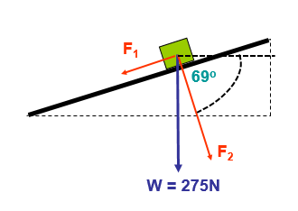
1)
The diagram shows a box which is resting on an inclined plane. Forces F₁ and F₂ represent the component of weight which acts parallel to the slope and perpendicularly into the slope respectively.

A1)*The magnitude of friction
F₁ = 275 x SIN(21)
= 98.55

A2) The angle between the direction of the force of friction and the vertical

21°

90° 69°

A3)*The normal reaction between the box and the plane
F₂ = 275 x COS(21)
= 256.73
*
The answers for A1 and A3 are correct, however would be facing in the opposite direction to F₁ and F₂ on the diagram. The opposite to F₁ would be F_{F} (friction), and opposite of F₂ would be F_{N} (normal). The reason the answers are still the same is because the box is at rest.

B) Newton’s second law states that the resultant force is proportional to the rate of change of momentum. Given that, Momentum = mass × velocity

B1) Write out the above statement mathematically
P = M x V

B2) State the units of momentum
kg⋅m/s

C) Newton’s second law is commonly written as, Resultant force = mass × acceleration or F = ma

C1) Considering this, what would be the required magnitude of a force that pointed parallel to the slope, and in the opposite direction to F₁ so that the box would accelerate up the slope at 2.5ms⁻²

Mass = $\frac{Weight}{Gravity}$

Mass = $\frac{275}{9.81}$

Mass = 28.03kg

F = M x A
F = 28.03 x 2.5
F = 70.1N

This force must be added to the opposite in order to accelerate it at the given rate. Therefore,

= 70.1 + 98.55
= 168.65N

C2) What would be the change in momentum between the moment just before the box began to move up the slope and when its velocity reached 7.5ms⁻¹

P = M x V
P = 28.03 x 7.5
P = 210.23N

The moment before the box is moving it is at rest therefore the momentum is 0, meaning the sum of difference is;

210.23 – 0 = 210.23N

C3) Using the statement given in B, What resultant force would be required to increase the velocity of a 5kg box from rest to 12.5ms⁻¹ in 3.2s.

A = $\frac{V}{t}$

$\frac{12.5}{3.2}$

= 3.91m/s²

F = M x A

F = 5 x 3.91

F = 19.55N
The circuit shown below shows a 12V battery connected to a combination of three resistors and a thermistor.

2)

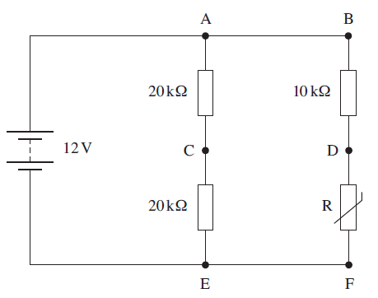

A1) Calculate the total resistance of the circuit

20 + 20 = 40

10 + 5 = 15

$\frac{1}{40}$ + $\frac{1}{15}$ = $\frac{1}{Rt}$

$\frac{3}{120}$ + $\frac{8}{120}$ = $\frac{11}{120}$

120 ÷ 11 = 10.91

=10.91KΩ

A2) Calculate the current leaving the battery

I = $\frac{V}{R}$

12 ÷ 10.91kΩ

= 1.1mA

A3) Calculate the power used by each of the three resistors and the thermistor

Working out points B-F.

I_{BF} = $\frac{I}{R}$ x R_{AE}

I_{BF} = $\frac{0.0011}{55}$ x 40

I_{BF} = 8x10⁻⁴

I_{BF} = 0.0008a

V = I x R

V = 0.0008 x 10,000
V = 8v

P = I x V
P = 0.0008 x 8
P = 0.0064w (resistor B to D)

Resistor DF is also on the same branch as resistor BD, this means it must receive the same current. And seems as the resistance in resistor DF is half what the resistance is in BD, it should use half the power. To prove this point;

V = 0.0008 x 5,000
V = 4v

P = I x V
P = 0.0032w (resistor D to F)

Current going from A-E therefore must be equal to the sum of;
I – I_{BF} = I_{AE}

0.0011 – 0.0008 = 0.0003

V = I x R
V = 0.0003 x 20,000
V = 6v

P = I x V
P = 0.0003 x 6
P = 0.0018w (resistor A to C)

Resistor CE will use the same power as resistor AE due to the fact they are both supplied the same current (0.0003a) and both have the same resistance (20Ω).

B) A voltmeter is used to measure the potential difference (PD) between points on the circuit. What PD would you expect to see between points:

B1) A-C

PD = 6v

B2) D-F

PD = 4v

B3) C-D

PD = 2v

3A) Define the moment of a force about a point.

Moment = Force x Distance

3B) The diagram below shows a ‘gripper’ used for hand strengthening exercises.
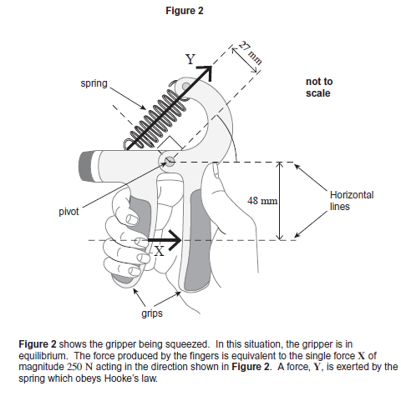

B1) Calculate the moment of force X about the pivot. State an appropriate unit

Moment = 250 x 0.048
Moment = 12Nm

B2) Calculate the force Y

Moment = 250 x 0.027
Moment = 6.75Nm

B3) The extension of the spring is 15mm. Given the fact that ‘Hooke’s Law’ states that the applied force is proportional to the extension, or;
F = kx

K = $\frac{X}{F}$

K = $\frac{0.015}{6.75}$

K = 0.002

B4) Given that; Work done = Force × Distance,
Calculate the work done on the spring to squeeze it to the position shown in figure 2.

Work Done = Force x Distance
Work Done = 250 x 0.015
Work Done = 3.75Nm

C) Given the definition, Power is the rate of working

C1) Write down an equation for Power in terms of Energy and Time stating its units.

Power = $\frac{Energy}{Elapsed time}$

P = $\frac{J}{t}$

C2) Assuming it takes 2.2s to squeeze the trigger, what is the power being applied.

P = $\frac{12}{2.2}$

P = 5.45w

D) If the total amount of energy that was used during the exercise session was 3.2kJ, how many times will the trigger be squeezed.

$\frac{3200}{12}$

= 266.6

For the purpose of the question I would round the answer to either 266 or 267 due to the fact you can’t really count half a squeeze.

