Name: Emyr Jones

Student Number: 1701036
__________________________________________________________

WORKSHEET 1 – TESTING (Using Variables)

- Original code:
Surname = input("Please enter your surname here: ")
Nin = input("Please enter your national insurance number here: ")

flag = 0
while flag == 0:
try:
Age = int(input("Please enter your age: "))
except ValueError:
print("This is not a number, try again")
else:
flag = 1

flag = 0
while flag == 0:
try:
Hours = float(input("Please enter the hours you worked this week: "))
except ValueError:
print("This is not a number, try again")
else:
flag = 1

- Code Testing

For each test below, run your code and enter the values provided. Present a screenshot of the programme running. Did the programme behave correctly or did it do something unexpected, and if so, why?

Surname:
- Enter JONES
- Leave blank
- Enter A
- Enter 123

National Insurance Number:
- Enter PE534121B
- Leave blank
- Enter AB11223344556677 (ie too long for National Insurance number format)
- Enter 22PE4088A (ie wrong format)

Age
- Enter 34
- Enter 150
- Enter -4
- Enter a letter

Number of working hours per week:
- Enter 37.5
- Enter 150
- Enter 0
- Enter -2

Fill in a box for each test above. You should present 16 separate boxes, 1 for each test. (Note: the first two boxes are provided as a template)

Test:
Surname i. Enter JONES

Screenshot(s) of output:
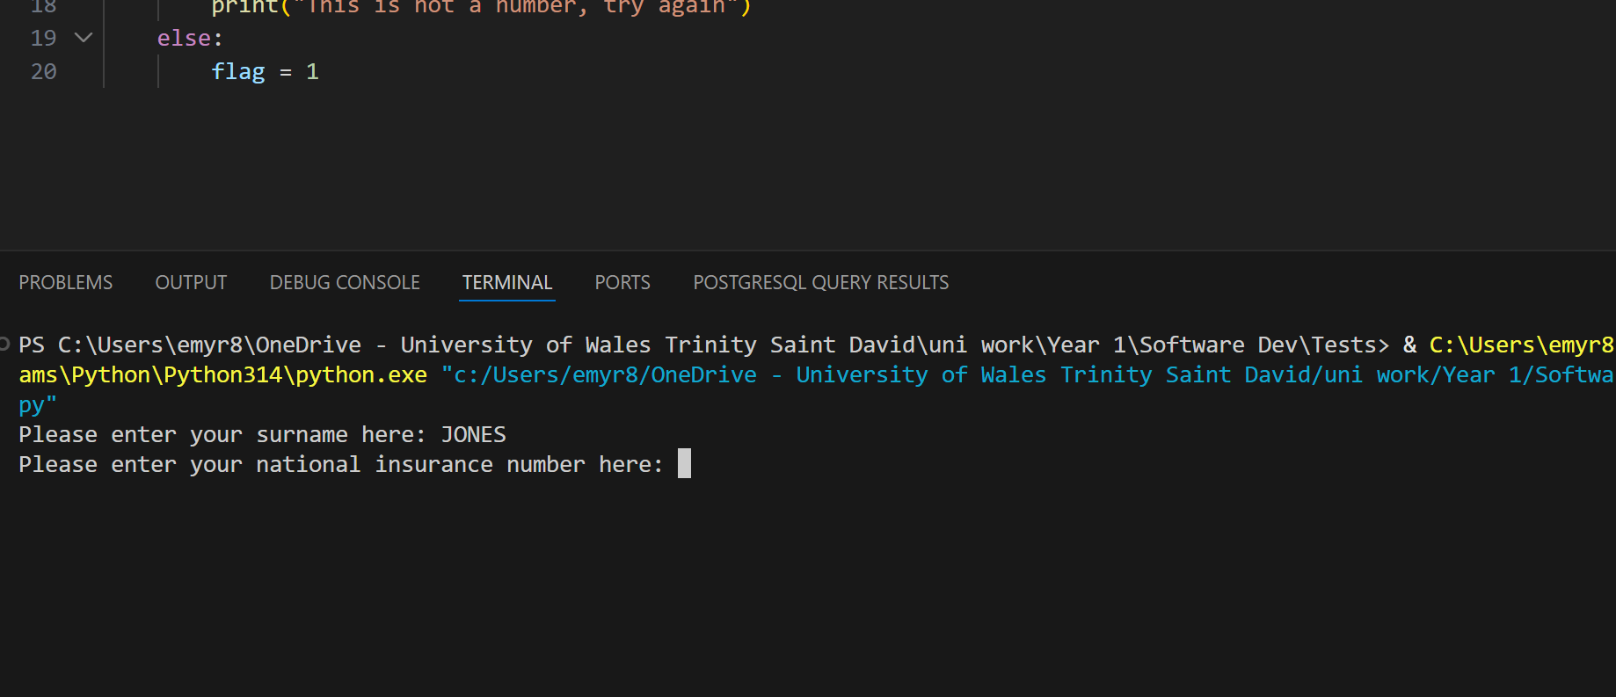

Result: Did the programme behave as expected ie syntactically and logically correct?
YES
If NO, what went wrong?
If YES, comment on what happened
Program behaved as expected accepting the Last name of Jones

Test:
Surname ii Leave blank

Screenshot(s) of output:
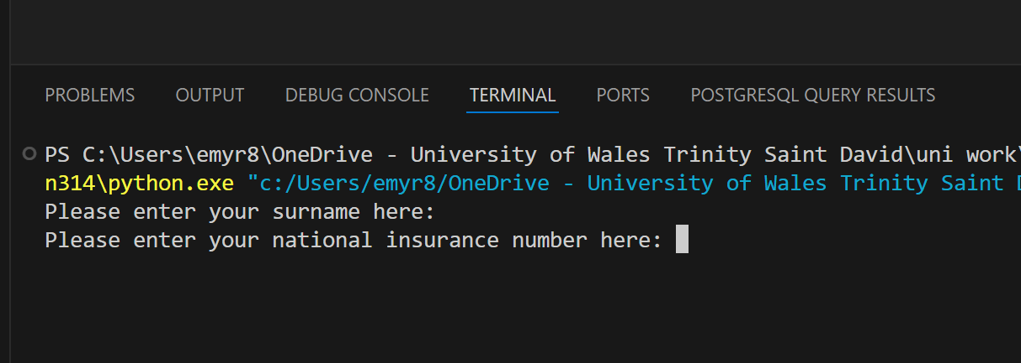

Result: Did the programme behave as expected ie syntactically and logically correct?
NO
If NO, what went wrong?
The program didn’t check to make sure the user input a name and moved onto the next input

Continue the rest of the tests below. (Copy and paste a box for each one)

Test:
Surname iii Enter A

Screenshot(s) of output:
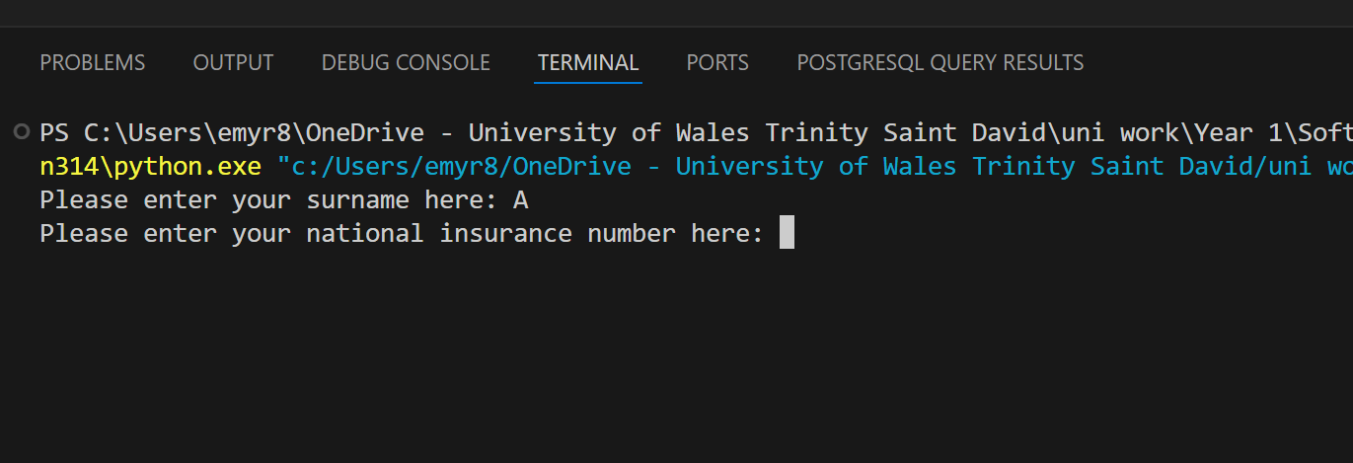
Result: Did the programme behave as expected ie syntactically and logically correct?
NO
If NO, what went wrong?
The program doesn’t validate to make sure the surname is at a certain length.
The program accepts “A” as a valid surname and moves onto the next input

Test:
Surname iv Enter 123

Screenshot(s) of output:
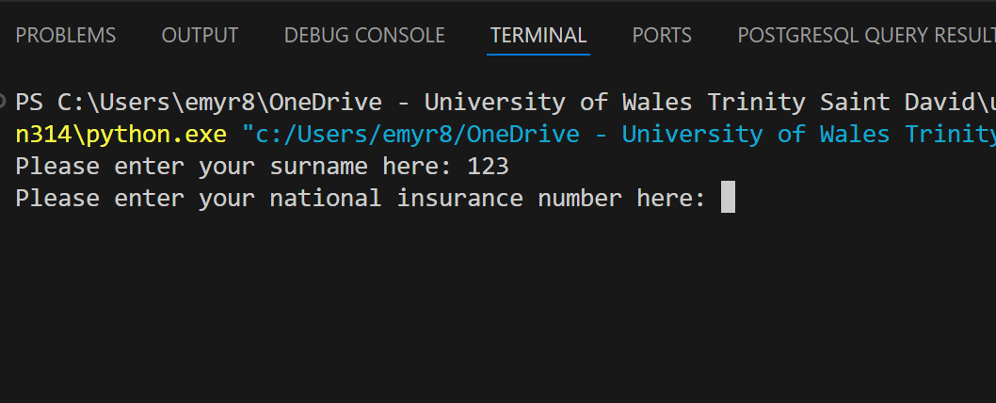
Result: Did the programme behave as expected ie syntactically and logically correct?
NO
If NO, what went wrong?
The program doesn’t validate to make sure the surname isn’t a number and accepts “123” as a valid surname

Test:
National Insurance Number i Enter PE534121B

Screenshot(s) of output:
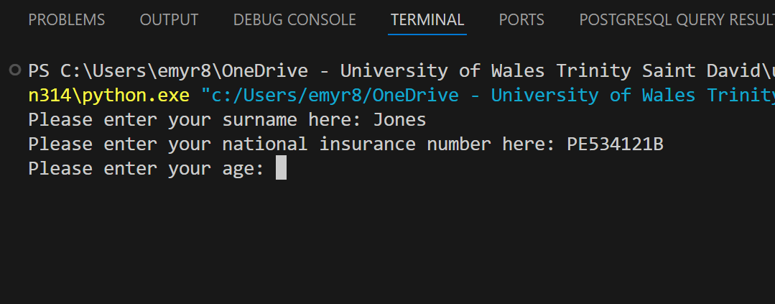
Result: Did the programme behave as expected ie syntactically and logically correct?
YES
If YES, comment on what happened
The program accepts the input as it is the correct input

Test:
National Insurance Number ii Leave blank

Screenshot(s) of output:
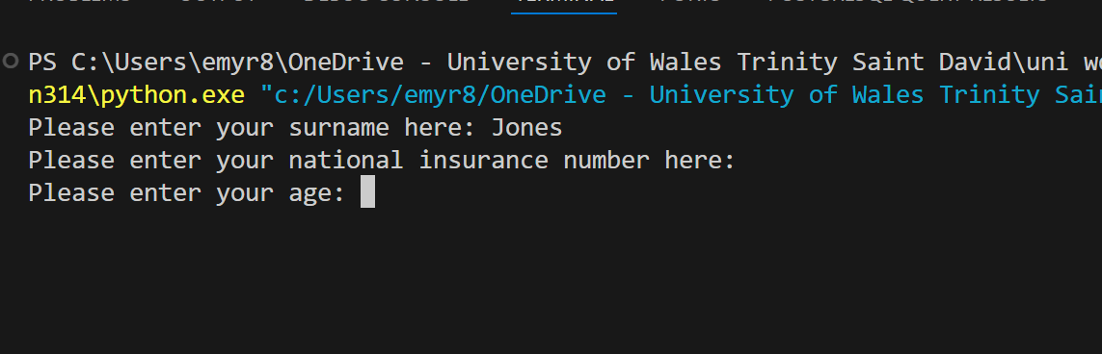
Result: Did the programme behave as expected ie syntactically and logically correct?
NO
If NO, what went wrong?
The program doesn’t check to make sure the user is inputting anything and moves onto the next input with a blank national insurance number

Test:
National Insurance Number iii Enter AB11223344556677 (ie too long for National Insurance number format)

Screenshot(s) of output:
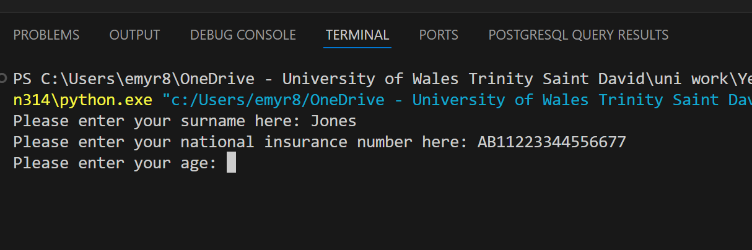
Result: Did the programme behave as expected ie syntactically and logically correct?
NO
If NO, what went wrong?
The program doesn’t validate to make sure the national insurance number has been formatted correctly and is the correct length.

Test:
National Insurance Number: iv. Enter 22PE4088A (ie wrong format)

Screenshot(s) of output:
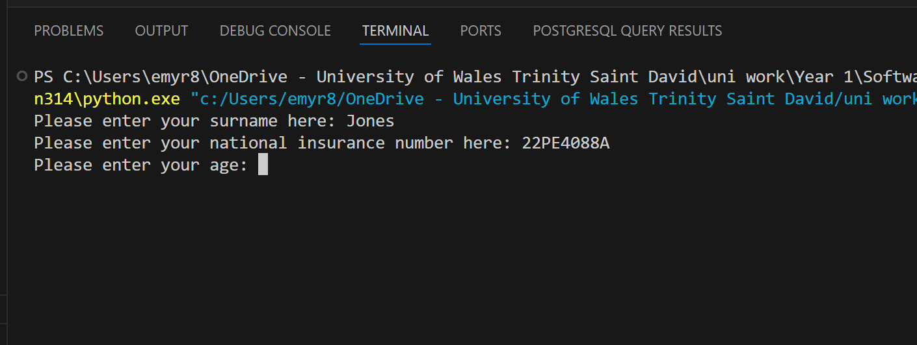
Result: Did the programme behave as expected ie syntactically and logically correct?
NO
If NO, what went wrong?
The program doesn’t validate to make sure that the user enters a national insurances number in the correct format.

Test:
Age i. Enter 34

Screenshot(s) of output:
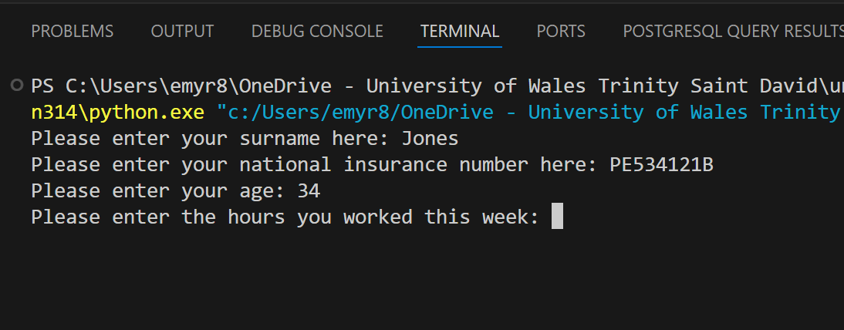
Result: Did the programme behave as expected ie syntactically and logically correct?
YES
If YES, comment on what happened
The program accepts the valid age.

Test:
Age ii. Enter 150

Screenshot(s) of output:
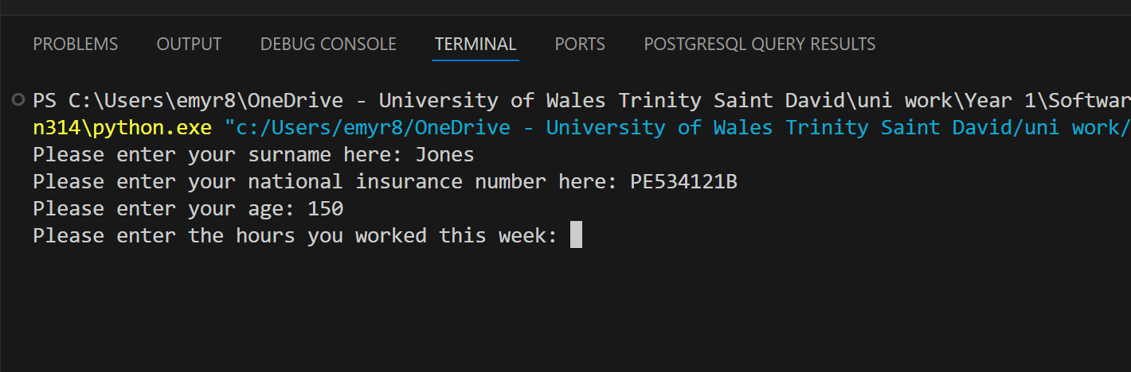
Result: Did the programme behave as expected ie syntactically and logically correct?
NO
If NO, what went wrong?
The program doesn’t check to make sure that the user has entered a valid age.

Test:
Age iii. Enter -4

Screenshot(s) of output:
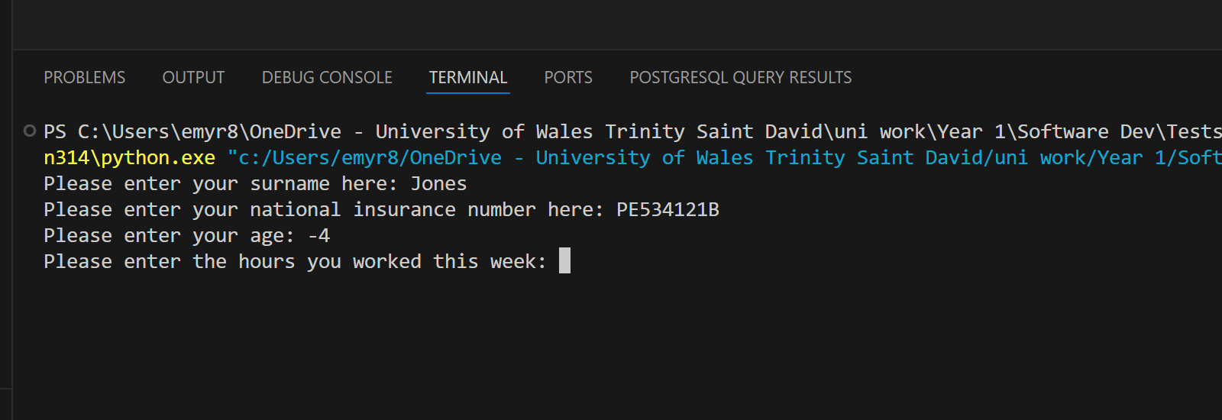
Result: Did the programme behave as expected ie syntactically and logically correct?
NO
If NO, what went wrong?
The program doesn’t check to see if the user entered a valid age

Test:
Age iv. Enter a letter

Screenshot(s) of output:
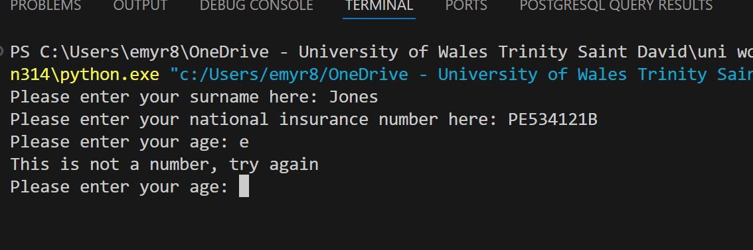
Result: Did the programme behave as expected ie syntactically and logically correct?
YES
If YES, comment on what happened
When the user enters a letter it will ask the user to enter a number

Test:
Number of working hours per week: i. Enter 37.5

Screenshot(s) of output:
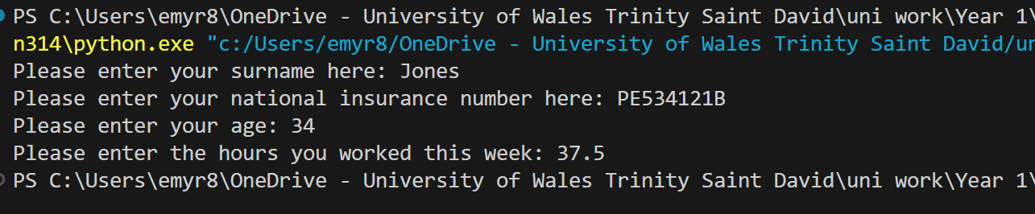
Result: Did the programme behave as expected ie syntactically and logically correct?
YES
If YES, comment on what happened
Program accepts the valid input and ends program.

Test:
Number of working hours per week: ii. Enter 150

Screenshot(s) of output:
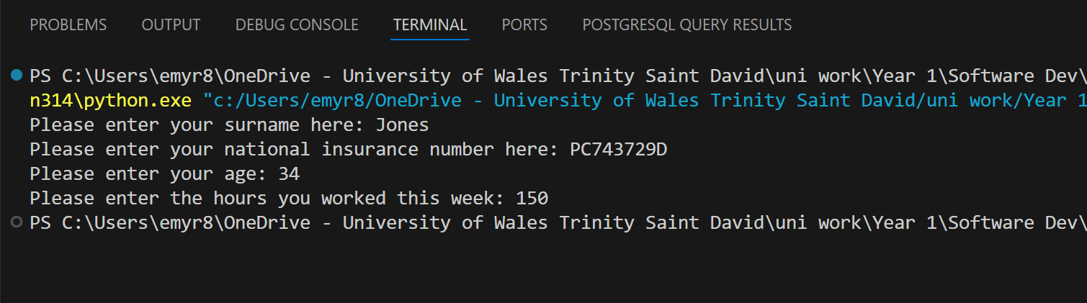
Result: Did the programme behave as expected ie syntactically and logically correct?
NO
If NO, what went wrong?
Program doesn’t validate to make sure the user enters a valid amount of hours for hours worked.

Test:
Number of working hours per week: iii. Enter 0

Screenshot(s) of output:
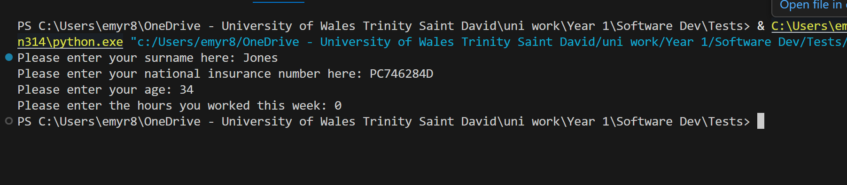
Result: Did the programme behave as expected ie syntactically and logically correct?
NO
If NO, what went wrong?
Program doesn’t validate to make sure that the user is entering a valid number of hours worked.

Test:
Number of working hours per week: iv. Enter -2

Screenshot(s) of output:
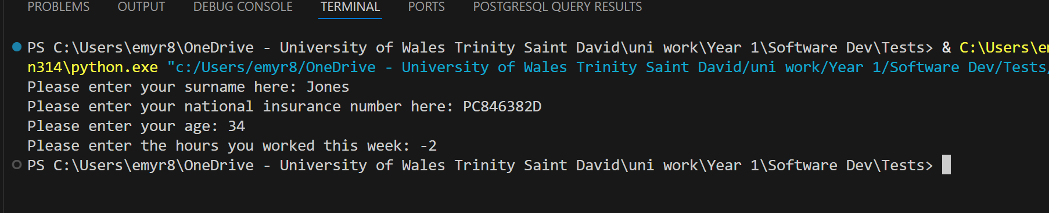
Result: Did the programme behave as expected ie syntactically and logically correct?
NO
If NO, what went wrong?
Program doesn’t validate to make sure that the user is entering a valid number of hours worked.

- Consider the results of the above tests and revisit your code in order to solve the problems. (Note: you may not be able to solve all of them, but solve as many as you can.)

Paste your revised code here:

flag = 0
while flag == 0:
Surname = input("Please enter your surname here: ")
if Surname.isalpha() == False:
print("This is not a valid surname, try again")
elif Surname == "":
print("This is not a valid surname, try again")
elif Surname.isnumeric() == True:
print("This is not a valid surname, try again")
elif len(Surname) < 2:
print("This is not a valid surname, try again")
else:
flag = 1

flag = 0
while flag == 0:
Nin = input("Please enter your national insurance number here: ")
if len(Nin) != 9:
print("This is not a valid national insurance number, try again")
elif Nin[0:2].isalpha() == False or Nin[8].isalpha() == False:
print("This is not a valid national insurance number, try again")
else:
flag = 1

flag = 0
while flag == 0:
try:
Age = int(input("Please enter your age: "))
except ValueError:
print("This is not a number, try again")
continue

if Age < 0:
print("This is not a valid age, try again")
elif Age > 110:
print("This is not a valid age, try again")
else:
flag = 1

flag = 0
while flag == 0:
try:
Hours = float(input("Please enter the hours you worked this week: "))
except ValueError:
print("This is not a number, try again")
continue

if Hours <= 0:
print("This is not a valid number of hours, try again")
elif Hours > 100:
print("This is not a valid number of hours, try again")
else:
flag = 1

