

Digital Transformation in the Health and Care Professions
Module: BMHP6026
Student Number: 2336478
Student Name: Vilma Rodrigues

Table of Contents
Introduction 3
Overview of the Digital Innovation 3
Impact on Workforce 5
Positive Impacts 5
Negative Impacts 5
Critical Evaluation 7
Impact on Service Delivery 7
Positive Impacts 7
Negative Impacts 8
Critical Evaluation 9
Impact on Patients and Service Users 9
Positive Impacts 9
Negative Impacts 10
Critical Evaluation 10
Impact on Communities 10
Positive Impacts 10
Negative Impacts 11
Critical Evaluation 11
Conclusion 11
References 13

Introduction
Digital transformation in health and social care is the process of using digital technologies to enhance the quality, efficiency and accessibility of health and social care services (Stoumpos, Kitsios and Talias, 2023). One of the biggest developments in the NHS over the last few years has been the use of virtual wards to provide in-home hospital care using remote monitoring and digital communications. In 2021, guidance was given on the implementation of virtual wards and nationally these were launched from 2022 to meet the pressures for hospitals, such as higher numbers of admissions, a lack of staffing, and concerns around the lack of available beds (Lindsay et al, 2025). Virtual wards offer both step-up and step-down care, to avoid admission to hospital and to help patients to be discharged at an appropriate time with continued clinical support. Patients could now receive acute care without the need to move into a hospital bed using digital monitoring equipment, telehealth consultations, and multidisciplinary care. This paper reviews and critically evaluates the use of virtual wards in NHS England. In particular, it explores its effect on workforce training, service provision, experiences of patients and patient communities (both good and bad). Using this analysis, the paper evaluates whether virtual wards are a feasible and viable digital innovation in health and social care in the UK.

Overview of the Digital Innovation
Virtual wards allow for hospital level care for a patient in their home setting that would otherwise be required to go to a hospital ward (NHS England, 2024). They work with patients who have diseases like respiratory disorders, cardiovascular disease, frailty and post-operative recovery by conducting continuous monitoring and multidisciplinary interventions (Norman et al., 2023). Their effectiveness depends on the use of digital technologies, such as pulse oximeters, blood pressure monitors, thermometers, scales and remote monitoring such as patient monitoring devices (TriMedika, 2025). Patients use mobile or web apps to enter data, seen on digital dashboards (McGowan et al., 2024). Electronic patient records improve patient information sharing and continuity of care (Tsai et al., 2020). Consultation using telecommunication, either by phone or video, also helps to minimize hospital attendance (Bulto, 2024).


Figure 1: An Image showing a patient using finger bp monitor at Home
Virtual wards are sets of patients who are assigned a specific community provider and are managed by hospital staff to prevent the hospital from being overrun with non-emergency cases. By September 2023, approximately 10,000 virtual ward beds supported about 240,000 patients, reflecting the digitalisation and the commitment to integrated, resilient care that is central to NHS priorities (HomeLink Healthcare Ltd, 2023).
Figure 2: Virtual Wards in NHS England by September 2023 (AI generated)
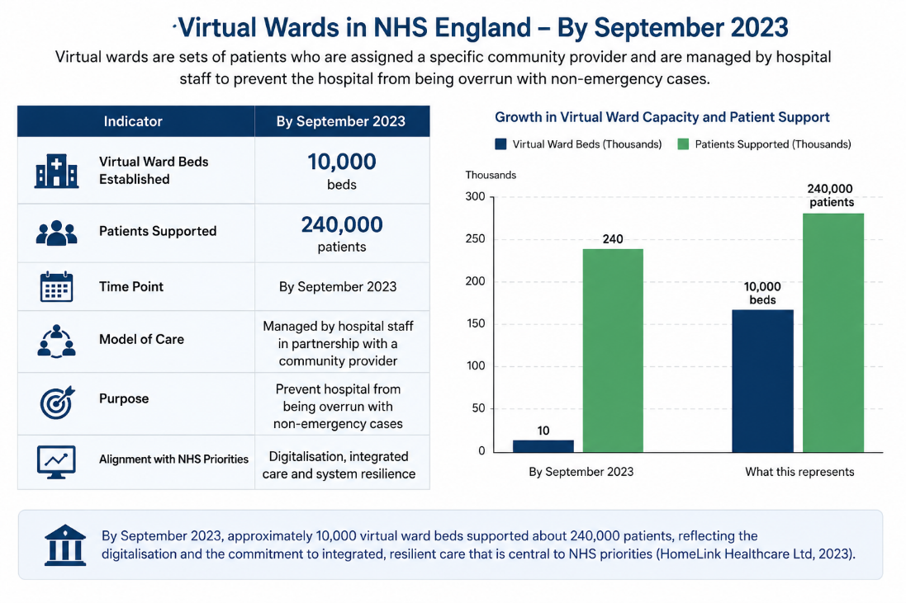

Impact on Workforce

Positive Impacts
Virtual wards have been transforming workplace duties and offered new prospects for professional growth. The emergence of digital nursing, remote care coordinators, specialist pharmacists reflect the transformation of healthcare roles due to technological advancements (Cucurachi et al., 2025). The need to integrate traditional clinical skills with digital skills is increasing, thus forming what is now a tech-savvy workforce of staff.
In addition, virtual wards have boosted collaboration between different teams. Nurses, doctors, pharmacists, therapists and community healthcare workers use the same digital tools to share and collaborate on decisions and provide care to the individual (Bulto, 2024). Immediate patient information enables physicians to recognize issues earlier and take prompt action before problems arise. As a result, therapy is quicker and more evidence based.
Additionally, remote monitoring provides more flexibility of configuration in terms of working procedures. For healthcare staff, this enables them to handle patients without having to always be physically present, increasing staff efficiency. Delivering care in innovative ways and being able to support patients in their home reduces some staff job dissatisfaction (NHS England, 2023).

Negative Impacts
Despite the advantages, there is still several workforce issues arising from virtual wards. Substantial investments in training and digital literacy are necessary to enable it to be successfully implemented. Many healthcare professionals must acquire new competencies related to digital technologies, remote assessments and telehealth communication. There are indications that staff did not feel confident in utilizing digital platforms, and there is a need for continued support and training (Sunny et al., 2025). While hospital ward occupancy benefits from virtual wards, they also involve staff dealing with vast amounts of data produced by patients and alerts to respond to. There may be extra administrative requirements and strain on already over-extended health care staff time associated with continuous monitoring.
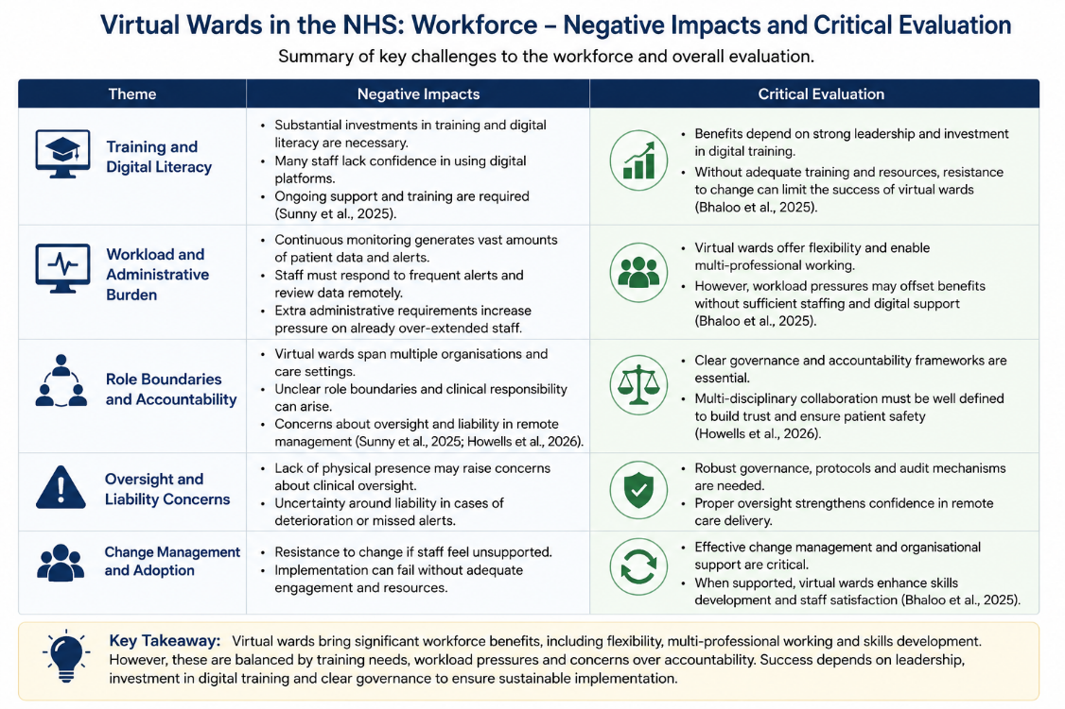
Figure 3: Negative Impacts of Virtual Wards (AI generated)

Another issue is role boundaries and accountability. The clinical roles are well defined within traditional hospital settings whereas the virtual ward can span several organisations and care settings (Sunny et al., 2025). This may lead to doubts about clinical responsibility, especially where care is provided by more than one discipline working together in the hospital setting, such as hospital specialists, community nurses and primary care providers (Howells et al., 2026). Others in the healthcare field have raised concerns with a lack of oversight and liability in lieu of remote management practices.

Critical Evaluation
The benefits of virtual wards to the workforce are great, especially flexibility, multi-professional working and skills development. But these benefits come with also a rise in training requirements, workload pressures, and concerns over accountability (Bhaloo et al., 2025). Positive outcomes in the workforce are dependent mostly on proper leadership, investments in digital training and organisation support. Virtual wards can fail to deliver benefits when there is a lack of staff training and resources, and the resulting resistance to change.

Impact on Service Delivery

Positive Impacts
The impact on service delivery has been dramatic with the introduction of Virtual wards. One of their greatest impacts has been in the reduction of hospitalisation rates, as they allow people to get acute health care at home rather than the hospital (Cathers and Lally, 2025). Virtual wards have been shown to avoid significant numbers of hospital admissions and the likelihood of re-admission amongst vulnerable groups through NHS evaluations.
Virtual wards also help discharge people from the hospital earlier. When a patient is clinically stable, they may be able to receive the treatment and monitoring at home which allows for a reduced number of days in bed and more beds available (Jalilian et al., 2024). Virtual wards have been found to have a positive impact on hospital capacity management and on tackling capacity-related issues such as overcrowding and delayed detaching.
Figure 4: An image highlighting how virtual ward works
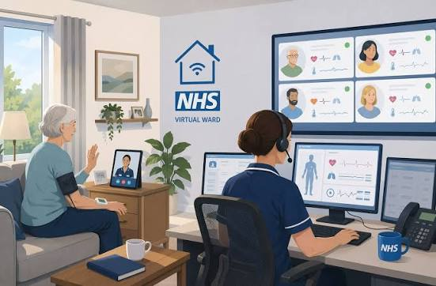

The use of digital technologies further enhances resource efficiency. Real-time data collection can help prioritize patients in need of immediate treatment, promote better coordination of care, and minimize in-person visits (Jalilian et al., 2024). More speedy health care access can also enhance health care outcomes because of timely intervention.

Negative Impacts
However, the Virtual ward still has the burden of digital infrastructure. This can be due to technical challenges, internet connectivity and device failures, which could impact service quality and patient safety (Sunny et al., 2025). These issues are significant in rural and socioeconomically disadvantaged areas, where digital networks might not be well established.
Issue with seamless integration between healthcare organisations too. Lacking information sharing, inefficiencies and suboptimal use of different digital platforms by hospital systems, primary care providers and community services makes it difficult (Sunny et al., 2025). In other instances, staff still use manual processes to update patient records, which means that the benefits of digital transformation are diminished. In addition, issues of equitable access to services and supports have been a major worry. Differences in access to level of knowledge, internet and an appropriate home environment could potentially mean that virtual ward programmes are not available to patients without these facilities or skills.

Critical Evaluation
Research indicates that virtual wards can provide enhanced service efficiency and reduce hospital demand. There are financial benefits associated with fewer admissions and less time spent in the NHS, several studies report (NHS England, 2024). The implementation issues, however, remain high such as the cost of technology, corporate IT security, workforce orientation and incorporation of the system. The sustainability of virtual wards in the long-term will relies on continued investment of new wards and investment in the existing infrastructure, though they may be increasingly cost-efficient as programmes consolidate. Virtual wards are therefore to be seen as an additional service and not as an alternative to in-patient services.

Impact on Patients and Service Users

Positive Impacts
Virtual wards offer several advantages to patients, including enabling care within their comfortable home setting, facilitating independence and minimising disruption with hospitalisation. In addition, home setting-based care may reduce deconditioning status and facilitate quicker recovery and particularly older adults (Arsenault-Lapierre et al., 2021). Furthermore, patients have shorter exposure to hospital-acquired infections and involve more in self-care monitoring, resulting in improved self-efficacy and patient-centred care (Teng et al., 2025). Patients' satisfaction has been reported as high, and clinical outcomes as similar to hospital-based care.

Negative Impacts
Virtual wards are not working well for everyone, though. Digital exclusion is a dominant issue. Some groups of people, particularly older adults, those with disabilities or from disadvantaged backgrounds can find it difficult to use digital technologies effectively (Xue et al., 2026). Lack of digital literacy may make it harder for people to participate and help from family members may also hinder participation. Not all patients are comfortable with the self-monitoring duties, or confident in their understanding of symptoms and/or in their ability to use self-monitoring equipment properly. Still others are deprived of the comfort of personal interactions with health care workers and view video interactions as impersonal. Patient trust can be complicated as well by privacy and data security issues. Digital platforms aim to safeguard patient data but there is still some concern about patients sharing their health information digitally.

Critical Evaluation
These can help patients to be more independent, comfortable and engaged in care decisions, and in theory, improve patient-centred care. However, these benefits are not rightfully enjoyed by everyone suffering from the disease. While some people with low digital skills and supportive families might benefit enormously, others, possibly more vulnerable, might have reduced access to and participation in digital media (Akinluyi et al., 2025). So, it's still crucial to maintain alternative pathways in order to preserve equitable access to health care.

Impact on Communities

Positive Impacts
Virtual wards have the potential to bring about important benefits at community level. They provide a more convenient place for people to receive care, especially for those in rural and remote communities (Dean et al., 2024). This streamlines the care pathway for patients and members of the public; means they don't have to travel as far and carries fewer cost and administrative implications. Virtual wards also promote more family carer participation in care. Family members can be more involved in making decisions and in offering support in a comfortable family setting (Ko et al., 2023). In addition, adding care provision to services in their communities helps to achieve NHS wider goals on the preventative care and population health management agenda.

Negative Impacts
Although these are positive, virtual wards can lead to greater inequalities in health. Reliability of internet access and digital devices and skills are very unevenly distributed across communities. This effectively means that people living in disadvantaged circumstances are more likely to be disadvantaged when accessing digitally enabled services (Saeed and Masters, 2021). Family carers may also find themselves in an increased role and vulnerable to further responsibilities and stress. Practical caring aspect of monitoring equipment, and communication with health professionals can add to stress and burnout (Wennberg et al., 2025). Also, NHS policy talks of co-production and engaging with community, but this takes form in practice when services are rapidly introduced, with minimal opportunity for meaningfully engaging the public in service design (NHS England, 2023).

Critical Evaluation
The effect of virtual wards on a wider community is reliant to a great extent on the effectiveness with which digital inequalities are tackled. Virtual wards can enhance access and promote more community-based care but may also be detrimental to people with no access to technology, or support networks (Anawade et al., 2024). Digital inclusion measures and meaningful patient and community engagement need to be emphasized and prioritised in future development to maximise benefits with minimised inequalities.

Conclusion
Virtual wards are a key digital innovation in the UK health and social care, where provision and monitoring are enabled at an individual home or in a broader geographical community, in a similar fashion to that provided in a hospital setting. There is evidence that they lower the number of patients, lead to shorter hospital stays and better patient experiences and promote more effective use of NHS resources. They have been fostering skills training and multidisciplinary research groups. However, there are still areas that need improvement, such as staff training, technological barrier, accountability issues, and digital exclusion. The limitations are usually outweighed by the benefits, but ongoing investment in digital infrastructure and skills, and the implementation and improvement of policies to ensure there is equality of access to care for all patient groups is essential for longterm success.

Referenceс
Akinluyi, A., Ogunfusika, O.H. and Brown, A. (2025). The Effectiveness of Virtual Wards
Compared to Inpatient Beds in Clinical Outcomes of Frail Older Patients With Chronic Conditions: A Systematic Review. Cureus, [online] 17(11), p.e97487. doi:https://doi.org/10.7759/cureus.97487.
Anawade, P.A., Sharma, D. and Gahane, S. (2024). A comprehensive review on exploring
the impact of telemedicine on healthcare accessibility. Cureus, [online] 16(3). doi:https://doi.org/10.7759/cureus.55996.
Arsenault-Lapierre, G., Henein, M., Gaid, D., Le Berre, M., Gore, G. and Vedel, I. (2021).
Hospital-at-Home interventions vs in-hospital stay for patients with chronic disease who present to the emergency department. JAMA Network Open, [online] 4(6), p.e2111568. doi:https://doi.org/10.1001/jamanetworkopen.2021.11568.
Bhaloo, T., McVey, C., Peterson, J. and Williams, M. (2025). A scoping review of virtual
nursing models in inpatient, noncritical care settings. Journal of Nursing Regulation. [online] doi:https://doi.org/10.1016/j.jnr.2025.08.005.
Bulto, L.N. (2024). The role of nurse‐led telehealth interventions in bridging healthcare gaps
and expanding access. Nursing Open, [online] 11(1), pp.1–3. doi:https://doi.org/10.1002/nop2.2092.
Cathers, S. and Lally, C. (2025). POSTnote 744 Virtual wards and hospital at home
Overview •. [online] Available at: https://researchbriefings.files.parliament.uk/documents/POST-PN-0744/POST-PN-0744.pdf.
Cucurachi, S., Lydon, S., Moens, L.L., Manser, T. and O’Connor, P. (2025). Barriers and
Facilitators to the Use of Virtual Wards: A Systematic Review of the Qualitative Evidence. PubMed. [online] doi:https://doi.org/10.1093/intqhc/mzaf065.
Dean, K., Chang, C., McKenna, E., Nott, S., Hunter, A., Tall, J.A., Setterfield, M., Addis, B.
and Webster, E. (2024). A retrospective observational study of vCare: a virtual emergency clinical advisory and transfer service in rural and remote Australia. BMC Health Services Research, 24(1). doi:https://doi.org/10.1186/s12913-023-10425-7.
HomeLink Healthcare Ltd (2023). Virtual wards and how the independent sector can enable
their success - HomeLink Healthcare. [online] HomeLink Healthcare. Available at: https://homelinkhealthcare.co.uk/resource/virtual-wards-and-how-the-independent-sector-can-enable-their-success/ [Accessed 20 Jun. 2026].
Howells, K., Bradley, F., Gasteiger, N., Whittaker, W., Vardy, E., Dowding, D., Blakeman, T.
and Sanders, C. (2026). Shifting boundaries of risk-work in virtual wards in North-West England: a multisite qualitative evaluation. BMJ Quality & Safety, p.bmjqs-2025-020002. doi:https://doi.org/10.1136/bmjqs-2025-020002.
Jalilian, A., Sedda, L., Unsworth, A. and Farrier, M. (2024). Length of stay and economic
sustainability of virtual ward care in a medium-sized hospital of the UK: a retrospective longitudinal study. BMJ Open, 14(1), pp.e081378–e081378. doi:https://doi.org/10.1136/bmjopen-2023-081378.
Ko, S.Q., Min, C., Koh, S.H., Lim, Y.W. and Shorey, S. (2023). Experiences of patients and
their caregivers in a Virtual Ward in Singapore: A descriptive qualitative study. International Journal of Medical Informatics, 177, pp.105111–105111. doi:https://doi.org/10.1016/j.ijmedinf.2023.105111.
Lindsay, R.K., Cunnington, P. and Dixon-Woods, M. (2025). Why is implementing remote
monitoring in virtual wards (Hospital at Home) for people living with frailty so hard? Qualitative interview study. Age and Ageing, [online] 54(1). doi:https://doi.org/10.1093/ageing/afaf003.
McGowan, L.J., Graham, F., Lecouturier, J., Goffe, L., Echevarria, C., Kelly, M.P. and
Sniehotta, F.F. (2024). The Views and Experiences of Integrated Care System Commissioners About the Adoption and Implementation of Virtual Wards in England: Qualitative Exploration Study. Journal of Medical Internet Research, [online] 26, p.e56494. doi:https://doi.org/10.2196/56494.
NHS ENGLAND (2023). NHS England» Supporting clinical leadership in virtual wards – A
guide for integrated care system clinical leaders. [online] www.england.nhs.uk. Available at: https://www.england.nhs.uk/long-read/supporting-clinical-leadership-in-virtual-wards-a-guide-for-integrated-care-system-clinical-leaders/ [Accessed 20 Jun. 2026].
NHS England (2021). NHS England» A guide to setting up technology-enabled virtual wards.
[online] England.nhs.uk. Available at: https://www.england.nhs.uk/long-read/a-guide-to-setting-up-technology-enabled-virtual-wards/ [Accessed 20 Jun. 2026].
NHS England (2023). Co-production. [online] www.england.nhs.uk. Available at:
https://www.england.nhs.uk/always-events/co-production/ [Accessed 20 Jun. 2026].
NHS England (2024). Virtual Wards Operational Framework. [online] England.nhs.uk.
Available at: https://www.england.nhs.uk/long-read/virtual-wards-operational-framework/ [Accessed 20 Jun. 2026].
Norman, G., Bennett, P. and Vardy, E.R.L.C. (2023). Virtual wards: a rapid evidence
synthesis and implications for the care of older people. Age and Ageing, 52(1). doi:https://doi.org/10.1093/ageing/afac319.
PPL (2024). South East Region Virtual Wards Evaluation Final Report. [online] Available at:
https://ppl.org.uk/wp-content/uploads/2024/05/ANONYMISED-South-East-Region-Virtual-Wards-Evaluation-Final-version-1.3.pdf [Accessed 20 Jun. 2026].
Saeed, S.A. and Masters, R.M. (2021). Disparities in Health Care and the Digital Divide.
Current Psychiatry Reports, [online] 23(9), p.61. doi:https://doi.org/10.1007/s11920-021-01274-4.
Stoumpos, A.I., Kitsios, F. and Talias, M.A. (2023). Digital Transformation in healthcare:
Technology Acceptance and Its Applications. International Journal of Environmental Research and Public Health, [online] 20(4). Available at: https://www.mdpi.com/1660-4601/20/4/3407.
Sunny, T., Ravichandran, N., Broughan, J., McCombe, G., Loughman, S., McDonald, K.,
Starr, N. and Cullen, W. (2025). Practitioners’ perspectives on implementation of acute virtual wards: A scoping review. PLOS Digital Health, 4(5), p.e0000858. doi:https://doi.org/10.1371/journal.pdig.0000858.
Teng, T., Sun, G., Yu, Z., Liu, Z., Wang, T., Wu, Q., Qin, R., Wang, M., Chen, R., Xu, J.-C.,
Zhang, N., Song, B., Liu, X., Zhang, Y. and Yu, H.-C. (2025). Efficiency of remote monitoring and guidance in blood pressure management: a randomized controlled trial. BMC Medicine, 23(1). doi:https://doi.org/10.1186/s12916-025-04278-6.
TriMedika (2025). Virtual Wards & The Future of Care: Why Accurate Devices Matter.
[online] Trimedika.com. Available at: https://trimedika.com/virtual-ward-technology-remote-monitoring/ [Accessed 20 Jun. 2026].
Tsai, C.H., Eghdam, A., Davoody, N., Wright, G., Flowerday, S. and Koch, S. (2020). Effects
of electronic health record implementation and barriers to adoption and use: A scoping review and qualitative analysis of the content. Life, [online] 10(12), pp.1–27. doi:https://doi.org/10.3390/life10120327.
Wennberg, E., Mohmand, Z., D’Arienzo, D., Majeed Grant, S., Uleryk, E., Vyas, M.V.,
Wanigaratne, S. and Guttmann, A. (2025). Virtual Care Among Adults Facing Language Barriers. JAMA Network Open, [online] 8(6), p.e2513906. doi:https://doi.org/10.1001/jamanetworkopen.2025.13906.
Xue, Z., Zhou, N., Wu, Y. and Qi, H. (2026). Digital exclusion in healthcare services: a
scoping review. International Journal for Equity in Health. doi:https://doi.org/10.1186/s12939-025-02755-1.

