Rhobyn Grant
2110734
Level 5
Semester 3
Module 7

Assignment 1 (2000 words, 50%)

1. Choose 3 print advertisements currently in circulation and provide detailed analyses of their use of tone of voice and mode of address (c. 500 words each in total).
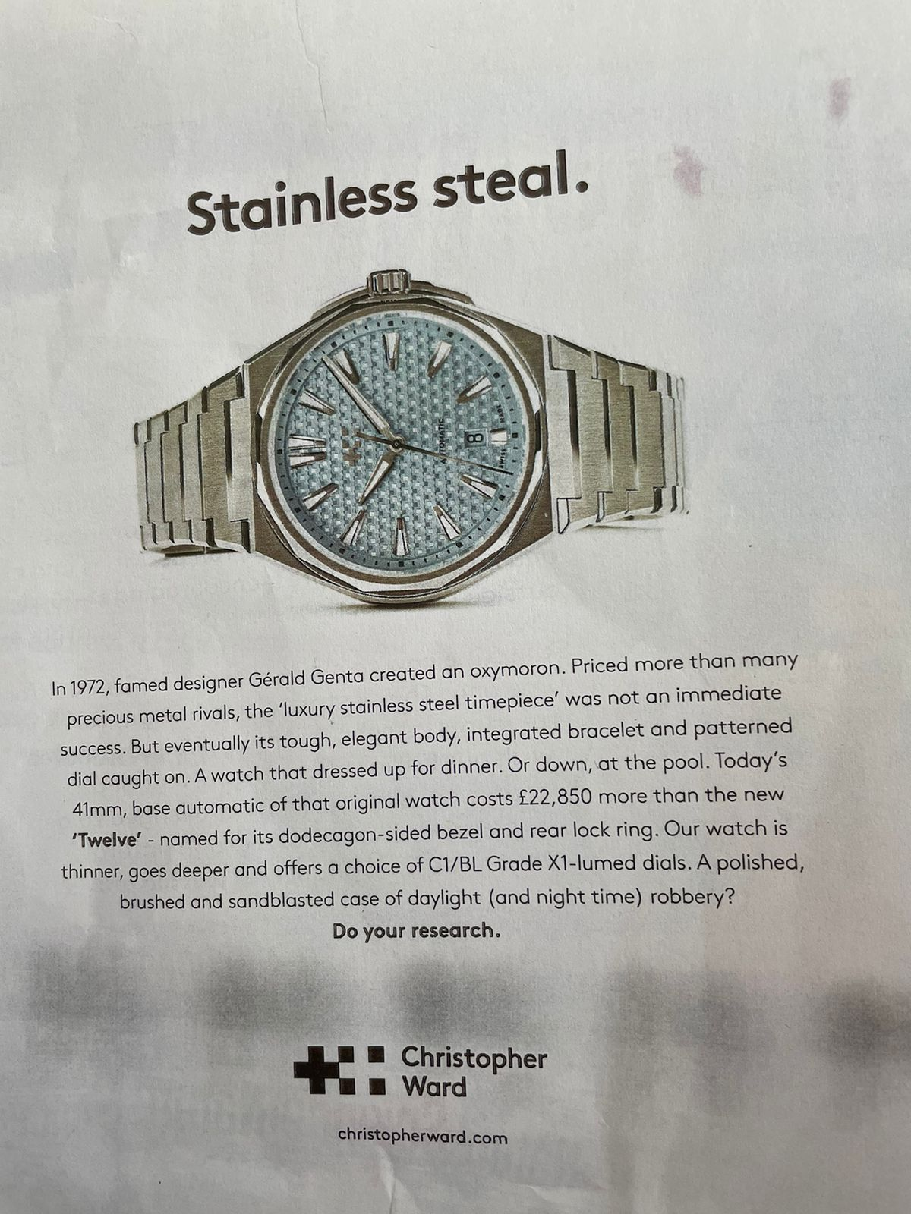
The ad's tone is educational and assertive. It displays the watch's history and features in a straightforward manner, emphasising its distinctive attributes and contrasting it with its predecessor. The advertisement is intended to appeal to people who value the craftsmanship and design of timepieces.
The ad is simplistic which allows for clear and focused communication. By removing extraneous features, the ad's essential message—that the watch is made of stainless steel—becomes more visible and easily understood. This simplicity can help viewers grasp the primary selling point fast and without distractions. This is further emphasized by the place on words “Stainless Steal”. It communicates the idea that the watch is incredibly valuable, and the intricacy of the craftsmanship is more than meets the eye.
A minimalist approach can result in a visually appealing and elegant advertisement. The ad portrays a sense of refinement and modernity by utilising clean lines, ample white space, and a simple colour palette. This aesthetic can complement the image of a high-quality stainless-steel watch, which is generally connected with durability and timeless design.
Additionally, A simple and clear advertisement can leave an indelible impact. A minimalist approach can help an ad stand out and be memorable when it is surrounded by more complicated and visually cluttered advertising. The commercial can make a powerful impression on viewers by focusing on a single key aspect, such as the stainless-steel material.
Simplicity tends to have a universal appeal. The ad can speak to a wide spectrum of consumers who enjoy clean and uncluttered designs by minimising clutter and superfluous features. This broad appeal can assist attract a varied customer base, extending the ad campaign's reach.
The voice of the ad sounds authoritative and knowledgeable. It provides information on the creation, design, and features of the watch in a comprehensible manner. The usage of terms like "thinner, goes deeper" and "daylight (and night-time) robbery" provides a sense of humour and intrigue to the voice.
The mode of address in the ad is direct and persuasive. It speaks directly to the reader, using phrases like "Do your research" to encourage potential customers to explore and learn more about the product. The mention of the brand name, Christopher Ward, and the website address suggests a call to action, inviting readers to visit the website and consider making a purchase.

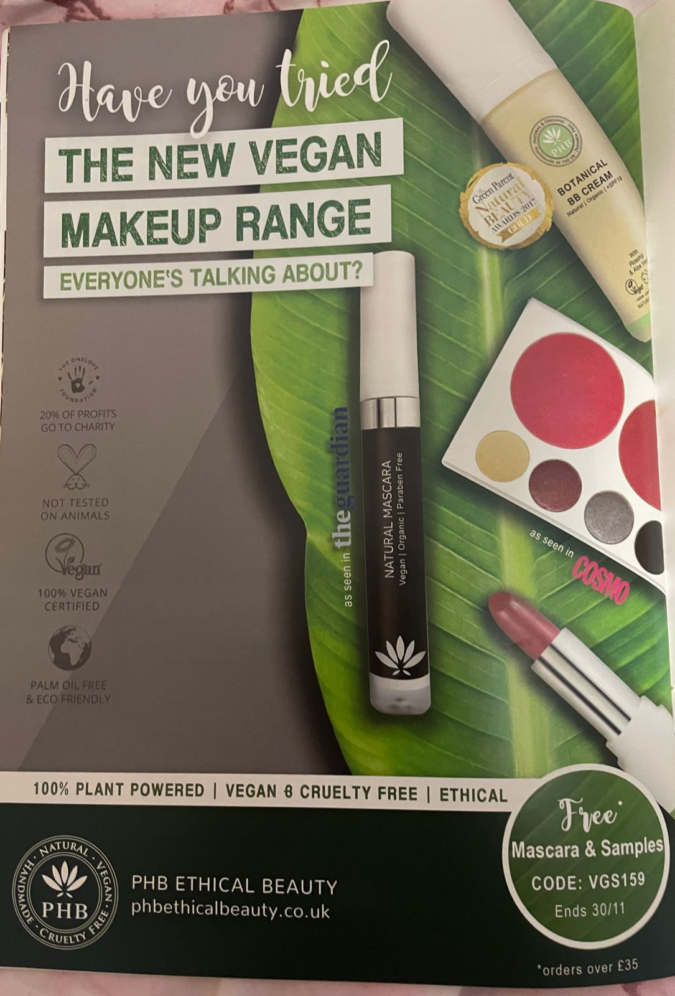
The tone of the advertisement is informational and persuasive, with the goal of capturing the reader's attention by emphasising the essential features and benefits of the vegan makeup line.
The ad's voiceover is confident and informed, positioning the product as a must-try choice that everyone is talking about. It exudes competence and authority, emphasising the brand's dedication to natural and ethical beauty.
The ad's manner of address is a mix of direct and indirect. The use of questions such as "Have you tried" and "EVERYONE'S TALKING ABOUT?" instantly engages the reader, creating a sense of curiosity. Furthermore, the advertisement uses bullet points and brief words to convey quick information and appeal to a wider audience. The use of codes, special deals, and limited-time promotions conveys a sense of urgency and exclusivity.
Overall, the advertisement employs a confident and informed voice to inform and persuade the reader about the vegan makeup collection. It also uses both direct and indirect ways of communication to engage the audience and showcase the product's major characteristics and benefits.
By citing respected publications such as The Guardian and Cosmo, you can use their authority and credibility to boost the perceived quality and legitimacy of your vegan beauty brand. Because readers may identify these sources with trustworthy information, seeing your product published in them might increase trust.
By using well-known publications to promote the vegan beauty brand; the advertisement conveys a message of favourable brand affinity. As a result, prospective customers may regard their items as modern, fashionable, and in line with the most recent beauty industry standards. Customers who are affected by popular media and want products backed by reputable sources will be keen on purchasing as a result.
The ad also appeals to more than one type of consumer. citing The Guardian may appeal to those who care about the environment and ethical products because that journal covers sustainability and social issues. On the other hand, Cosmo will appeal to those interested in beauty and fashion trends. All in all, it’s a win-win to have credibility from both magazines stated on the advertisement.


The ad's tone is confident and aggressive. It makes big assertions about the product's effectiveness using powerful, clear language. The tone is authoritative and professional, with the goal of making N°7 the foremost skincare brand in the UK. The address is direct, with the speaker appealing directly to the audience and urging action with imperatives like "Reverse" and "Don't regret, just reverse."
The effectiveness of tone, voice, and method of approach is determined by the target audience's preferences. If the audience values direct, results-oriented communication, this technique may be beneficial in capturing their attention and inspiring them to act. Superlatives such as "UK's N°1 skincare brand" and "world first peptide technology" can serve to create a sense of exclusivity and superiority to other products. The ad sort of bombards potential buys with scientific jargon to feed them into the narrative that the product is revolutionary.
Additionally, using a black, older woman as the model in the advertisement is a step towards more diversity and inclusivity. It challenges conventional beauty standards while also providing representation for marginalised ethnicities. This may appeal to customers who value brands that embrace diversity and support inclusivity.
Since the target audience is older or concerned about reversing skin damage, utilising an older model can help them connect with the product and its intended benefits. Seeing someone who is their age and possibly shares their skin concerns can boost the ad's efficacy.
However, on the downside, while advertising frequently features models with flawless skin, it is critical to avoid setting excessive expectations. Unrealistically smooth skin might generate unrealistic goals and perhaps set people up for disappointment.

Nevertheless, the ad attempts to maintain some semblance of reality by keeping the wrinkles in her face and by using a model with gapped teeth, thus strategically balancing the portrayal of skin improvement with realism.

The repetition of the brand name, N°7, throughout the ad reinforces brand recognition and may contribute to brand loyalty. The mention of reversing visible signs of skin damage in just four weeks appeals to those seeking quick results and may generate interest in the product. Additionally, the call to action, which provides multiple options for purchasing (in-store, online, through the app, or the N°7 Beauty website), makes it convenient for customers to engage with the brand.
Overall, the tone, voice, and mode of address in the ad aim to position N°7 as a trusted and innovative skincare brand and seemingly effectively communicate the product's key benefits to the target audience. I say seemingly because, the scientific jargon does not necessarily come across as though they want the everyday person to truly understand what is being stated but that they just aim for them to assume that it must be good for them.

2. Select an existing product or brand and write two short pieces of copy (50-250 words each) for separate advertisements. Adopt the following formats in each case:

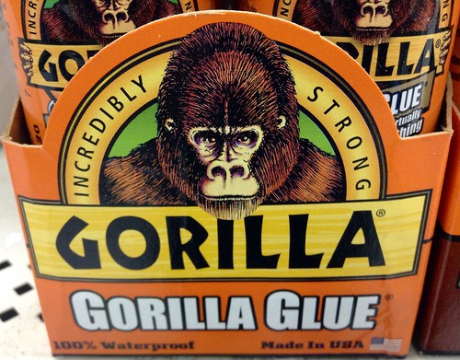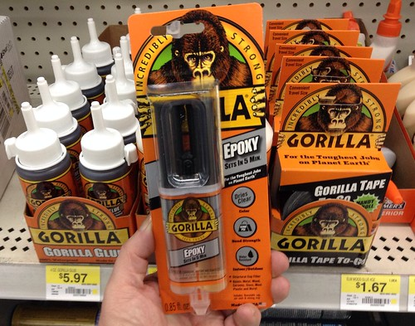
This Photo by Unknown Author is licensed under CC BY
This Photo by Unknown Author is licensed under CC BY
- a direct mode of address.
Attention, Problem-Solvers and Craftsmen Extraordinaire!
Are you sick of weak adhesives that break down under stress? Do you desire a connection that is as strong as your spirit? Gorilla Glue is the best option for all your bonding needs, so look no further!
Let us present you to the adhesive powerhouse that will revolutionise your projects, builders, and handy people. Gorilla Glue is a game-changer that defies assumptions; it's not your typical glue. You are the true heroes who make things happen and Gorilla Glue is your secret weapon in the fight against flimsy ties whether you're building, crafting, or mending.
Our adhesive provides a firm grip that withstands even the most rigorous tests on a variety of materials, including ceramics, metal, and plastics. Gorilla Glue is here to make sure your work endures the test of time, so there's no need to second-guess or redo it!
However, there's still more! Our unique compound strengthens the bond for unmatched strength by expanding into hidden crevices and crannies. Gorilla Glue is steadfast and prepared to take on whatever task you throw its way, regardless of the weather—rain, shine, heat, or cold. Don't accept less, my fellow labourers and craftsmen. Accept the strength of Gorilla Glue and feel the thrill of seeing your creations stand the test of time. Become one of the countless happy customers that use Gorilla Glue exclusively.
Get your hands on Gorilla Glue today and watch your projects soar to new heights. The world is eager to see your brilliance, and Gorilla Glue is here to help. Let your inner gorilla loose and the connection begin!
Gorilla Glue – The Choice of Champions!

- an indirect, ‘slice-of-life’ mode of address.
Unlock the potential of your projects with a bonding solution that will not budge. Introducing Gorilla Glue, the adhesive phenomenon that has won the faith and admiration of countless crafters, artists, and do-it-yourselfers.
Every masterpiece begins with the appropriate tools, and Gorilla Glue is the ultimate creative companion. Its exceptional capacity to combine multiple materials is nothing short of astounding. Gorilla Glue bravely confronts wood, metal, ceramics, and plastics, building bonds that last the test of time.
Consider a glue that not only attaches but also outperforms expectations. The unique composition of Gorilla Glue stretches to engulf surfaces with a firm grip. No project is too difficult or too difficult for this extraordinary adhesive. Gorilla Glue brings your concept to reality, from delicate repairs to huge projects.
The elements are no longer an impediment with Gorilla Glue. Rain or shine, heat or cold, your masterpieces stand firm, defying nature's forces. Take pride in your work, knowing that the tenacious bond of Gorilla Glue ensures permanence and durability.
Join the ranks of dedicated artisans who have used Gorilla Glue to improve their products. Feel the joy of watching your efforts not only take shape but also last, captivating hearts and minds for years to come.
Don't accept mediocrity. Unleash your imagination and the power of Gorilla Glue. Take your projects to new heights and enjoy the satisfaction of seeing your work endure. Your imagination is limitless, and so are the possibilities with Gorilla Glue.
Gorilla Glue - where ingenuity meets excellence.

Reference list
Elena (2017) ‘phb ethical beauty ’, The Vegan; The vegan society magazine [Preprint], (4).
No 7 beauty (2023) No 7 UK. Available at: https://www.no7beauty.co.uk/ (Accessed: 20 May 2023).

