
International Market Entry Strategy for IKEA: A Critical Analysis of Expansion into Uruguay
Student Name: Ranjit Masaribhai Modhwadiya
Student ID Number:2529489
Programme: Master of Business Administration (MBA)
Module: International Business Concepts
Module Code: LCMB7034
Contribution to Overall Module Assessment: 100%
Lecturers:
Akshay Narayanan (London)
Mansoob Murshed (Birmingham)
Internal Verifiers
Vasilios Tavlaridis
Hoang Nguyen
Assignment Title: Strategic Analysis of IKEA's Expansion into Uruguay
Word Count: 5,000 words (±10%)
Submission Deadline: Friday, 31 July 2026, by 2:00 pm
Return Date of Provisional Marks and Written Feedback: 28 August 2026
Table of Contents
Introduction 3
1. Organisational Classification and Global Strategy 4
2. Macro-Environmental Appraisal and Market Attractiveness 6
2.1 Political Environment 6
2.2 Economic Environment 7
2.3 Legal Environment 9
2.4 Cultural Environment 10
2.5 Application of Dunning's Eclectic Paradigm (OLI Framework) 11
3. Entry Mode Strategy and Strategic Synthesis 12
3.1 Historical Pattern Recognition 12
3.2 Strategic Fit, Justification and Recommendations: 14
Section 2: Reflective Account Using Gibbs' Reflective Cycle Feelings 17
Description 18
Feelings 18
Evaluation 19
Analysis 19
Conclusion 21
Action Plan 21
References: 22

Introduction
Multinational corporations (MNCs) are greatly expanding their operations into the international market to ensure sustainable growth, to enhance their competitive advantage and to gain access to fresh customer markets. In addition to assessing their own competence, however, organisations have to consider the political, economic, legal and cultural attributes of the countries they are interested in before investing significant resources (Hill and Hult, 2024). Evaluation helps companies to spot opportunities, reduce risks and choose the right market entry strategy for future competitive success. The choice of the right market entry strategy is thus a complex decision, which affects the organisational performance, operational control and long-term value creation. This report examines the pros and cons of IKEA, the Swedish multinational home goods company, expanding into Uruguay, a country in which IKEA has no significant presence. This paper first categorizes IKEA's international strategy according to the framework of Bartlett and Ghoshal (1989) and then investigates how the global configuration can lead to competitive advantage. It then conducts a critical analysis of Uruguay's macro-environment (political, economic, legal and cultural) and evaluates the attractiveness of the market. Based on this analysis, Dunning's Eclectic Paradigm (OLI Framework) is used to assess the strategic reasons for FDI and whether or not Uruguay offers enough ownership, location and internalisation advantages for foreign direct investment to work.
Finally, the report analyses the entry modes that IKEA adopted in the past and suggests the most suitable entry mode for Uruguay and provides evidence-based strategic recommendations. The assessment ends with a reflective account using Gibbs' Reflective Cycle (1988) which reflects on, and critically considers, the research process, learning and development of analytical skills, preparation of the report.

1. Organisational Classification and Global Strategy
IKEA is one of the biggest multinational home furnishings retailers in the world. It was created in Sweden in 1943, and is run in a unique franchise model, with Inter IKEA Group being the managers of the brand and the business concept, and Ingka Group owning and running the majority of retail stores (Inter IKEA Group, 2025; Hill and Hult, 2024). IKEA is an internationally well-established company with a global footprint in Europe, North America, Asia, the Middle East and Oceania, with cheap, design-driven and sustainable interior products. This international success is not due to geographical expansion alone, but also to its capacity to standardise with a certain degree of selective adaptation to the local markets. Bartlett and Ghoshal international strategy framework (1989) IKEA can best be described as a transnational corporation. A transnational strategy involves the ability for firms to operate efficiently on a global basis, as well as being able to solve the problems of the local markets and learning inside the organisation (Bartlett and Ghoshal, 1989). IKEA's strategy is neither purely global, a strategy which stresses standardisation, nor a multidomestic, a strategy which stresses local responsiveness; rather, it is a combination of the two to give the firm competitiveness in different markets.
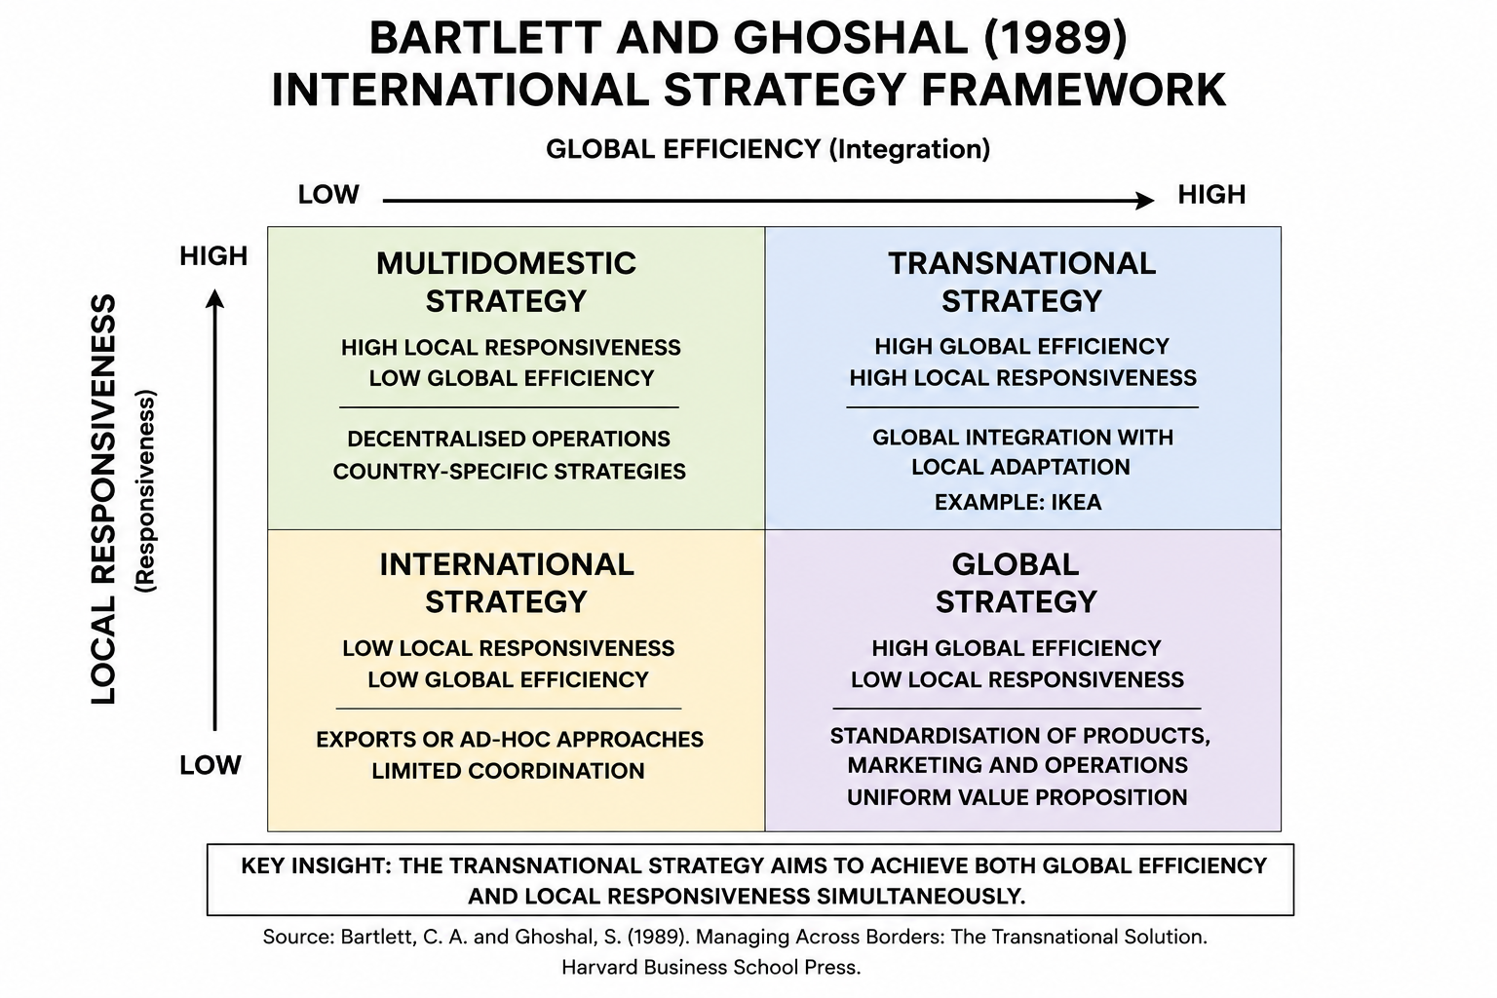
Figure 1. Bartlett and Ghoshal's (1989) International Strategy Framework
Source: Author's own illustration, based on Bartlett and Ghoshal (1989).
The IKEA's strategy towards integration is its global standardisation of the major components of its business model: Scandinavian design, custom-made flat-pack, self-service retail, and centralised product development. The practices create economies of scale, improve brand consistency and helps to lower production and logistics costs (Hill and Hult, 2024). But IKEA does not only use standardisation. The company tailor’s product lines, store design, advertising and promotions, and food selections to suit local consumer tastes and expectations. This selective adaptation ensures IKEA's relevance in various markets and maintains its global identity. The approach of the company is supported by its transnational value chain. IKEA's wide reach elsewhere in the world also gives it a competitive edge, as it can share knowledge, experience and best practices from one market to the other. IKEA's success in the developed and emerging economies enables it to adapt to shifting consumer tastes, new technology and competition. Concurrently, its global sourcing and distribution system offer purchasing power and economies of scale which smaller competitors may be unable to attain (Hill and Hult, 2024). Such a balance of global efficiency and local responsiveness brings long-term value through operational flexibility, innovation and the capability to maintain a uniform brand image and brand image value in different market conditions.
IKEA does not own most of the manufacturing facilities; it has a network of suppliers in over 50 countries, with central control over product design, quality and sustainability criteria (Bellamy, Dhanorkar and Subramanian, 2020). This model can boost efficiency, drive costs down and lead to greater geopolitical risk, supply chain disturbances and transport expenses. As a result, IKEA has made continual efforts to mitigate these risks through investments in supply chain resilience and digital technologies (Mandal, 2025). IKEA's approach of integration globally with locally adaptation and ongoing knowledge sharing are all together very supportive of the international expansion. However, adaptation to the Uruguayan market, consumer demands and regulations will be necessary to enter the market successfully and sustain long-term growth.

2. Macro-Environmental Appraisal and Market Attractiveness
Besides firm's capabilities, the attractiveness of the external environment in the country where the firm wants to enter is also crucial. According to Peng (2022), there is a sustainable competitive advantage when the strategic competencies of the firm and their institutions and markets environment are aligned. In view of this, rather than providing a description of Uruguay's macro-environment, a critical analysis of the political and economic conditions that are most significant for IKEA's retail business concept and future growth plans will be provided. Political stability, economic resilience and consumer buying power are the most important factors influencing a successful market entry, especially in the context of IKEA's large-scale foreign direct investment (FDI) and integrated supply chains and long-term market commitment (Dunning, 1988).

2.1 Political Environment
Political stability is among Uruguay's key competitive strengths and an appealing prospect for foreign companies like IKEA. The country is known for its transparent governance, low corruption and strong institutional quality, providing long-term investment with a business environment that is predictable (Odilla and Bidegain, 2025). Stable political institutions also mean lower investment risk and greater facilitation for strategic planning, especially for IKEA, which has to invest a lot in retail outlets and logistics and distribution channels. In addition, Uruguay welcomes foreign direct investment with equal treatment for domestic and foreign investors, and has clear regulations (Uruguay XXI, 2025). All of these conditions are in accordance to IKEA's long-term strategy for international expansion. But political stability is not enough to make for commercial success. Uruguay has a comparatively small population which reduces the size of the market and potential sales. Thus, the institutional risk in the country would be lower when IKEA would consider the political environment but the country's market demand and commercial viability were also essential for assessing the country's overall attractiveness (Hill and Hult, 2024).

Table 1. Political Factors Influencing IKEA's Proposed Market Entry into Uruguay
Political Factor | Critical Implication for IKEA
Stable democratic governance | Reduces political uncertainty and supports long-term investment decisions.
Strong institutional quality | Enhances investor confidence and operational predictability.
Favourable FDI policies | Facilitates foreign ownership and business establishment.
Small domestic market | May constrain future store expansion despite political stability.
Source: Adapted from World Bank (2025) and Uruguay XXI (2025).
Table 1 provides an overview of the institutional risks mitigating dynamics that make Uruguay more appealing to foreign direct investment on a long-term basis. Stable governance, transparent institutions and policies that are friendly for investment all contribute to provide a reliable business environment for multinational companies like IKEA.

2.2 Economic Environment
When it comes to expand internationally, IKEA's business model relies on the two factors purchasing power and macroeconomic stability and efficient logistics, which is why the economic environment is an important factor. Uruguay's economy is relatively stable, and has moderate economic growth and relatively high income as compared to Latin America (International Monetary Fund (IMF), 2025). Such conditions are conducive to Ikea’s value for money products being demanded by the public, especially the expanding middle class. Furthermore, the high level of urbanisation and the growing digitalisation contributes to IKEA's omnichannel retailing by boosting their e-commerce and home delivery services (OECD, 2025). But economic opportunities come with a number of drawbacks. The relatively small size of the Uruguayan population reduces the potential for the market compared to neighbouring Brazil and Argentina, and currency fluctuations and transportation costs can add to the cost of the supply chain (Inter IKEA Group, 2025). However, Uruguay's strategic position brings opportunities to build regional logistics and distribution networks. Hence, IKEA can make use of the growth opportunities using phased investment strategy while keeping the commercial risk under control.
Table 2. Economic Factors Influencing IKEA's Proposed Market Entry into Uruguay
Economic Factor | Strategic Implication for IKEA
Stable economic growth | Supports long-term business planning and investment.
Growing middle-income consumers | Increases demand for affordable, value-based furniture.
High digital readiness | Supports omnichannel retailing and e-commerce expansion.
Small domestic market | Limits short-term sales growth and economies of scale.
Strategic regional location | Strengthens logistics and future expansion across the Southern Cone.
Source: Adapted from International Monetary Fund (2025), OECD (2025) and Inter IKEA Group (2025).
Table 2 provides an overview of the economic aspects that will be relevant for IKEA's market entry in Uruguay. While the favourable investment environment as a result of economic stability, purchasing power and digital readiness, the relatively small domestic market makes it difficult to see immediate growth opportunities. So, a better way to expand the market in terms of long-term sustainability would involve a phased expansion plan, with efficient logistics and regional distribution in place.

2.3 Legal Environment
Multinational corporations need a transparent legal system as it helps to reduce uncertainty in investment and ensure long-term sustainability of companies (Peng, 2022). Uruguay offers an attractive legal climate for IKEA, whose business model relies on large-scale retail ventures, Intellectual Property protection and sustainable supply chains. The country is equal in its treatment of domestic and foreign investors, and has robust property rights and a clear regulatory environment. These institutional attributes lower the risks of regulation and boost investor confidence. Along the same lines, Uruguay has an open foreign investment regime, barring any local participation requirements, international companies can operate on the local market with 100 per cent foreign capital (Uruguay XXI, 2025). This versatility matches IKEA's approach to operating uniformity and safeguarding its world-renowned brand. Moreover, the country's intellectual property protection assures the security of IKEA's trademark, product design and retail concepts against imitation. However, there could be extra costs for labour and environmental law. The rules are, however, in line with the sustainability strategy and Environmental, Social and Governance (ESG) commitments of IKEA. Thus, although legal compliance involves extra investment, it does not constitute a major obstacle to entry, but may contribute to a company's long-term competitive advantage and its legitimacy.
Table 3. Legal Environment Supporting IKEA's Proposed Market Entry into Uruguay
Legal Factor | Strategic Implication for IKEA
Strong property rights | Protects trademarks, product designs and brand reputation.
Open FDI policy | Supports foreign ownership and operational control.
Transparent regulations | Reduces legal uncertainty and investment risk.
Labour and environmental laws | Increase compliance costs but reinforce sustainability objectives.
Source: Adapted from World Bank (2025), Uruguay XXI (2025) and Peng (2022).
The transparent legal system and investment guarantee in Uruguay contribute to minimizing the regulatory risks associated with foreign investment and ensure long-term investment.

2.4 Cultural Environment
An important factor of IKEA's international expansion is cultural compatibility. While the company's business model is very standardized in all its operations, its success relies on the ability to selectively adapt products and marketing to local consumer preferences (Bartlett and Ghoshal, 1989). As the majority of Uruguay's population lives in urban areas, the country's growing awareness of environmental issues and the need for convenient, functional furniture are well suited to IKEA's value proposition (OECD, 2025). But total standardisation can lead to a lessening of market acceptance because consumer preferences for furniture design and shopping behaviour vary from country to country. So, IKEA should focus on sustaining its brand globally but change certain ranges of products, showroom designs and promotions as per the local taste (Alzghool, 2020). This balance is a manifestation of IKEA's transnational approach and will most likely contribute to customers' acceptance and to operational efficiency and competitiveness in Uruguay in the long run. IKEA's well known sustainability ethos is another significant cultural consideration. In Uruguay, environmental awareness has been steadily growing thanks to government policies and consumers' backing of responsible business practices. The opportunity for IKEA to further strengthen its circular economy efforts, such as sustainable materials, recycling initiatives and energy-efficient products, thus reinforcing the corporate image and customer confidence in IKEA (Inter IKEA Group, 2025).
Table 4. Cultural Factors Influencing IKEA's Proposed Market Entry into Uruguay
Cultural Factor | Strategic Implication for IKEA
Urban consumer lifestyle | Supports demand for practical and space-efficient furniture solutions.
Growing environmental awareness | Reinforces IKEA's sustainability strategy and circular economy initiatives.
Increasing digital engagement | Facilitates omnichannel retailing, e-commerce and home delivery services.
Local design and shopping preferences | Requires selective adaptation of product ranges, showroom layouts and marketing activities while maintaining global brand identity.
Source: Adapted from OECD (2025), Alzghool (2020), Inter IKEA Group (2025) and Bartlett and Ghoshal (1989).
The cultural characteristics of Uruguay suggest a favorable environment for IKEA's expansion, provided that the company maintains its global competitive advantages while responding selectively to local consumer expectations. Such a balanced approach reflects IKEA's transnational strategy and is likely to strengthen customer acceptance, operational effectiveness and long-term market competitiveness.

2.5 Application of Dunning's Eclectic Paradigm (OLI Framework)
Applying Dunning's Eclectic Paradigm (OLI Framework) includes findings from the political, economic, legal and cultural analysis to assess if Foreign Direct Investment (FDI) is strategically justified. IKEA's ownership advantages are its worldwide reputation, low-cost supply chain, sustainability efforts and online retail skills. Uruguay has interesting location conditions, such as political stability, transparent institutions, investment-friendly policies and an increasing digital readiness and predictable business environment. The location-specific benefits support IKEA's strategy to set up long-term operations on markets where institutional conditions are predictable and there are opportunities to develop sustainable business. Uruguay has a relatively small domestic market, but its political stability and geographic strategic location in the Southern Cone offers opportunities for future expansion in the region and for an efficient distribution network. However, the profits that are restricted due to the size of the markets are somewhat compensated for by the institutions of the country, making it an appealing place for well-planned foreign investment (Lubis and Muniapan, 2024).
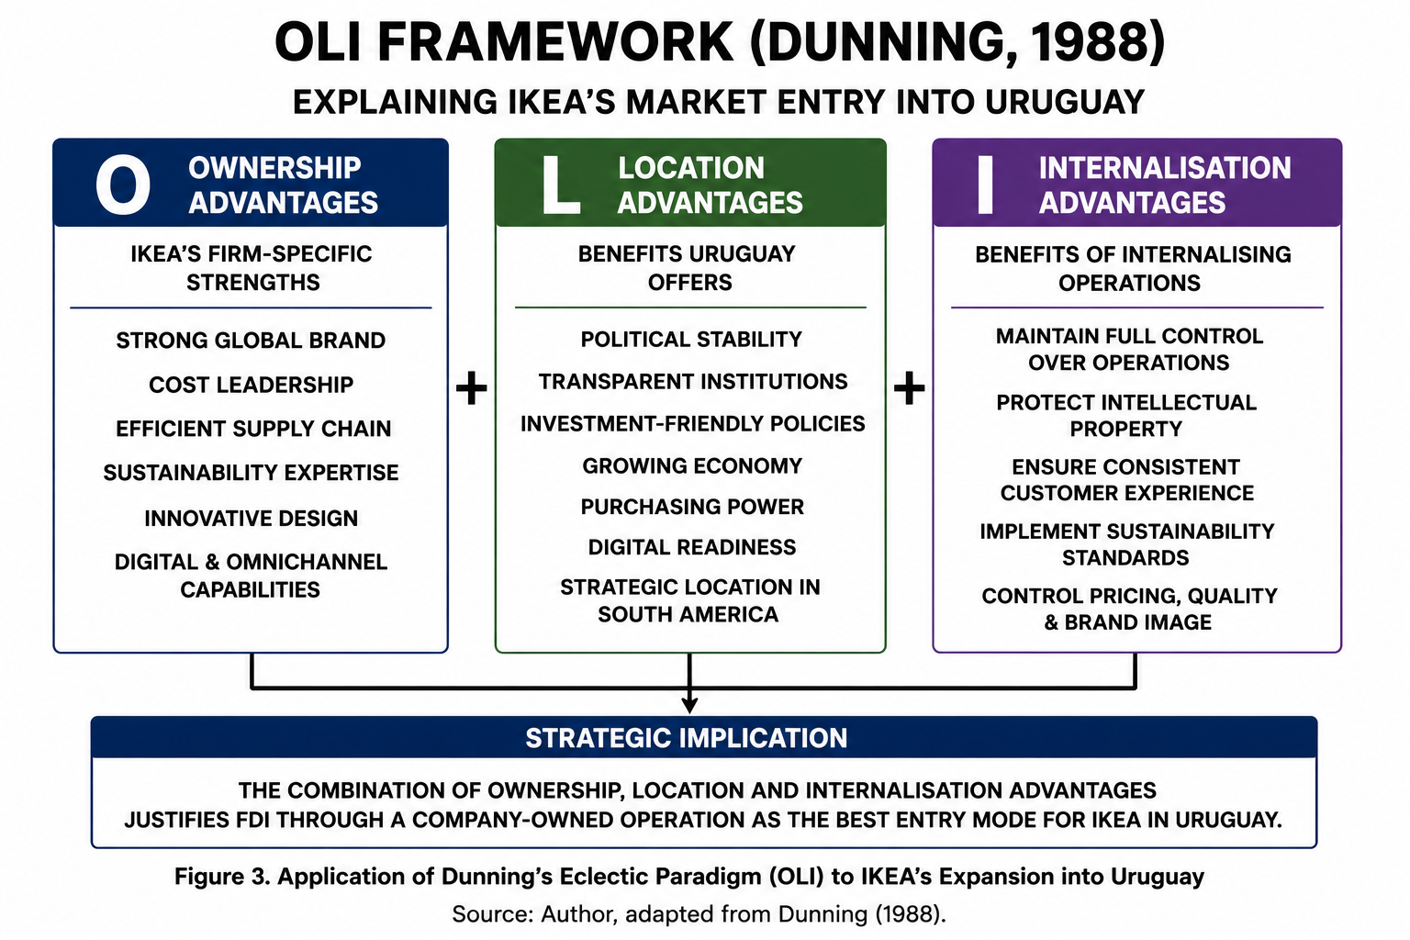
Figure 2. Application of Dunning's Eclectic Paradigm (OLI Framework) to IKEA's Market Entry into Uruguay
Source: Author, adapted from Dunning (1988).
Lastly, internalisation benefits enable the retention of direct ownership, safeguarding against the risks of intellectual property, customer experience and the effective realisation of IKEA's sustainability and omnichannel plans. Overall, these benefits suggest that a company-owned investment is the most appropriate for IKEA's entry into Uruguay (Dunning, 1988).

3. Entry Mode Strategy and Strategic Synthesis

3.1 Historical Pattern Recognition
When a multinational corporation (MNC) decides to enter a market, choosing the right market entry mode is a crucial strategic decision, which affects the amount of investment and the degree of control and long-term competitive advantage that can be realized by the MNC (Hill, 2024).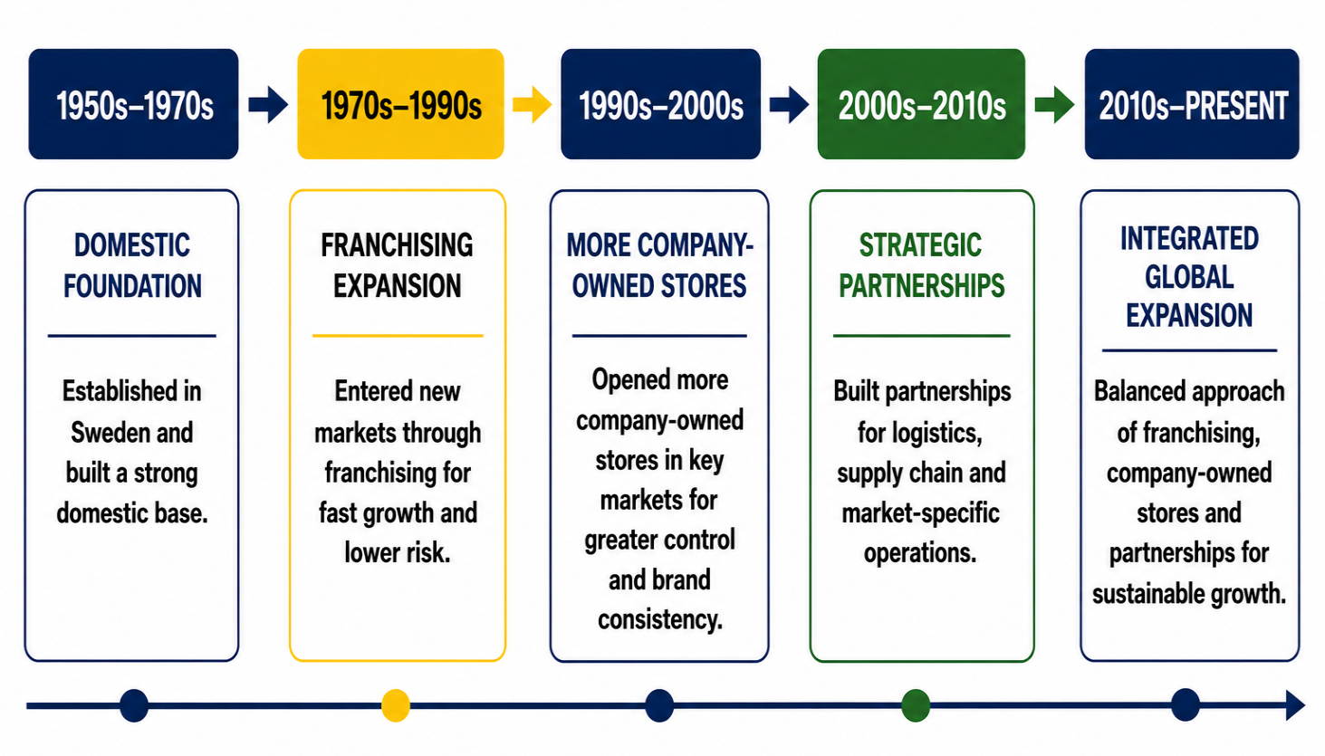
Figure 3. Evolution of IKEA's International Market Entry Strategy
Source: Adapted from Inter IKEA Group (2025), Hill and Hult (2024) and Peng (2022).
IKEA has never followed a single universal strategy, but instead a combination of franchised and company operated stores depending on the strategic significance and institutional context of the host market. This adaptable expansion approach has allowed the company to balance its need for rapid international expansion with effective brand management and minimise financial risk (Lubis and Muniapan, 2024). Franchising has been IKEA's preferred international entry mode in the past. The business structure of IKEA is based on its most of the stores as being franchises, which are granted by Inter IKEA Systems B.V. that allows them to use IKEA's internationally recognised brand, retail concept and operational standards with the aim of ensuring the same customer experience across international markets (Hagberg and Jonsson, 2022) By doing this, IKEA can invest in new markets where capital requirements are lower and also have the advantage of having the local market knowledge while also splitting operational risks between the franchisor and the franchisee (Peng, 2022). Therefore, franchising has played a major role in the rapid expansion of IKEA and maintaining a consistent brand internationally. But IKEA hasn't just been using franchising. The company has more and more invested in strategically important or mature markets via company owned operations, mainly run by Ingka Group. This way, the company has more control over retail operations, customer experience, pricing and sustainability efforts. The increase in ownership also enables IKEA to implement digital transformation, omnichannel retailing and circular economy practices more quickly, all of which are now an integral part of IKEA's global business strategy (Tran, 2021). As such, IKEA's past growth has been pragmatic and entry modes have been selected due to the market potential, the institutional quality and the long-term strategic goals.
Table 5. Historical Entry Modes Adopted by IKEA in International Expansion
Entry Mode | Evaluation | Strategic Purpose
Franchising | Dominant | Rapid international expansion with lower financial risk and strong local market knowledge.
Company-owned stores | Selective | Greater operational control, brand consistency and long-term strategic investment.
Strategic partnerships | Limited | Support logistics, supply chain development and market-specific operations where required.
Source: Adapted from Inter IKEA Group (2025), Hill and Hult (2024) and Peng (2022).
IKEA's transformation from being almost entirely a franchise-based international business to a blend of company-owned stores and franchises, as shown in Table 4, is a way for the company to maintain a consistent brand across the globe while gaining strategic control in lucrative markets. In general, the market entry pattern of IKEA is seen as dictated by the strategic purposes and not by organisational tradition. This balanced approach is a good starting point in considering the most suitable entry mode into Uruguay, a country that offers institutional stability and good investment conditions, which can warrant a different degree of ownership and resource investment than previous emerging markets.

3.2 Strategic Fit, Justification and Recommendations:
Ikea has traditionally used the franchise model to enter into new territories with lesser risk of capital expenditure, but this may not be the right model for Uruguay. Rather, a retail business owned by the company and backed by strategic agreements with local logistics companies brings more value to the business in the long term. The stability of the political system, as well as transparent laws and investment-friendly policies, are conducive to foreign direct investment and lessen the need for risk mitigation strategies such as franchising (World Economic Forum, 2025). These institutional advantages allow IKEA to have a larger share of the ownership and to better establish long-term strategic control. An IKEA owned operation would also secure the brand's competitive edge, such as its retail concept, customer experience, sustainability efforts, and digital solutions. With direct ownership, the company can ensure continuity in pricing, merchandising, marketing and operations, and facilitate the introduction of omnichannel retailing, click-and-collect and home delivery services (Hill and Hult, 2024). This will ensure a consistent brand and improve customer satisfaction. But there are drawbacks to this approach as well. The relatively small population of Uruguay makes the initial customer base small and can lengthen the investment recovery period. Further, the costs and reliance on imported goods may rise the operating costs in IKEA's global supply chain. Commercial risks are present due to these factors despite the country's favourable institutional environment. In order to overcome such issues, IKEA should follow a phased market entry strategy. An initial move should be setting up a flagship store in Montevideo, along with a robust e-commerce platform. This slow process would enable IKEA to test the waters, fine-tune their supply chain and tailor their offering to customer preferences before rolling out on a larger scale (Yu, 2023). Strategic alliances with local logistics and last mile delivery companies would help to enhance operational efficiency without compromising ownership and strategic control. Overall, this entry strategy will offer a good balance between market opportunity, flexibility and long term sustainable competitive advantage.
Table 5. Recommended Entry Mode Strategy for IKEA's Expansion into Uruguay
Evaluation Criterion | Company-Owned Operation | Strategic Assessment
Political Risk | Low | Stable governance supports long-term foreign investment.
Financial Commitment | High | Significant initial investment but greater long-term value creation.
Operational Control | Very High | Ensures consistency in pricing, customer experience and sustainability practices.
Flexibility | Moderate | Slower expansion than franchising but greater strategic coordination.
Long-term Strategic Fit | Excellent | Supports IKEA's global brand, digital strategy and sustainability objectives.
Source: Author, based on Dunning (1988), Inter IKEA Group (2025) and Hill and Hult (2024).
The suggested approach to entry is contained in Table 5, which involves a phased entry starting with a company-owned flagship store with e-commerce and local logistic links. This helps to balance investment commitment with operational control and helps in a gradual expansion of the market.
Overall, while in the past IKEA's international growth has been dominated by the franchising model, the market situation in Uruguay means that having a higher degree of ownership is more advantageous in terms of strategic benefits (Garrone, 2024). The stable political climate, transparency of the legal system and investment policies make institutional risk comparatively low in Uruguay, enabling IKEA to prioritise strategic control over short-term financial flexibility. However, the implementation process must be done in stages and with caution because the market size in the country is relatively small and risk for commerce is too high. Finally, these are the recommendations for this report, IKEA should expand to Uruguay via a company-owned flagship retail store, in conjunction with local logistics partnerships and an integrated omnichannel. The approach is aligned with IKEA's long-term international growth plans, reinforces the execution of the sustainability and digital transformation agenda and optimises the ownership and internalisation benefit of the Eclectic Paradigm (Tomakh, 2025). Hence, this entry mode offers IKEA the best combination of operational control, long-term value creation and sustainable competitive advantage, and will lead to a successful expansion in the Uruguayan market and the Southern Cone in general.

Section 2: Reflective Account Using Gibbs' Reflective Cycle Feelings
Gibbs' Reflective Cycle (1988) is a reflective framework that enables individuals to critically evaluate experiences, identify lessons learned and develop strategies for future improvement through six structured stages.

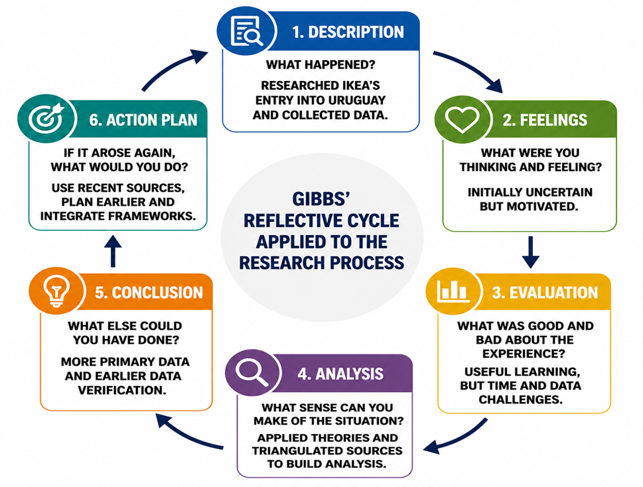
Figure 4. Gibbs' Reflective Cycle Applied to the Research Process
Source: Adapted from Gibbs (1988).
Figuar 4 illustrates the progression of the research process from selecting an appropriate case study and collecting evidence to evaluating findings, reflecting on learning outcomes and identifying improvements for future academic research.

Description
This assignment critically examined the possible expansion of IKEA to Uruguay based on international business theories and secondary evidence available. The challenge was to not only find an appealing market but also to find out if the planned expansion made strategic sense. First, a number of international companies and countries were taken into consideration. But these were eliminated from the list after considering official company data in view of the assessment requirements. In the end, IKEA and Uruguay were chosen because, at 1 June 2026, IKEA doesn't have any significant retail operations in Uruguay, and Uruguay provided a stable institutional environment, favourable conditions for foreign direct investment (Vansvik and Friskytt, 2024). A systematic literature review was conducted based on peer-reviewed journal articles, academic textbooks and institutional reports. The political, economic, legal and cultural environment of Uruguay was assessed by gathering information from Google Scholar, university library databases, the World Bank, the International Monetary Fund (IMF), OECD and Uruguay XXI. Furthermore, the strategic priorities of IKEA were analysed by using IKEA's Annual Summary and Sustainability Report 2025 (Inter IKEA Group, 2025). Bartlett and Ghoshal's (1989) transnational strategy framework, PELC (Political, Economic, Legal, and Cultural) analysis, and Dunning's (1988) Eclectic Paradigm (OLI) were combined to make evidence-based recommendations. This holistic approach allowed for a systematic transition from organisational analysis to market entry strategy and final recommendations.

Feelings
The selection of a suitable company and host country proved to be more difficult than at the start of this assignment. The subject of international market entry seemed to be quite a straightforward one at the start, but the need for the company to have no major operation in the country where they would enter the market, made the research process more complex. This involved thorough checking of the numbers on the official company reports and not on secondary sites or assuming. First, this caused some confusion as some of the possible case studies fell short of the requirements of the assessment. Initially, as the research went on, confidence began to grow. Academic articles were read in parallel with company reports to gain insight into both the theoretical concepts and the practical business decisions that were made. It seemed like more than just finding a market that's favourable, there are several factors to be taken into account when entering into foreign markets. This experience gave confidence in the interpretation of the academic theories as well as an evaluation of real-world business environments.

Evaluation
A particular strength of this assignment was that it used a combination of academic theory and contemporary business evidence to generate evidence-based conclusions which avoided a descriptive discussion. The framework used for the explanation of IKEA's international strategy was based on the Bartlett and Ghoshal's model (1989), and a structured evaluation of the suitability of Uruguay for foreign direct investment was conducted using Dunning's OLI framework (1988). This combination of these models enhanced the overall strategic analysis. Moreover, the study leveraged the credibility of the macro-environmental assessment through the use of relevant secondary sources such as the IMF (2025) and OECD (2025) reports, adding to the reliability of the report. But there were some problems in conducting the research. Sometimes economic indicators varied among international organizations due to reporting time differences and methodological differences. Also, choosing the most suitable market entry mode involved a trade-off between theoretical recommendations and business considerations. It highlighted the need to look at multiple sources of information and not just one specific publication to make strategic decisions.

Analysis
This assignment has very much helped me understand the concept of international market entry because I realised that to enter an international market is not just as simple as choosing an attractive market but involves organising one's capabilities to be able to enter the market successfully. Prior to doing this research, I thought of market entry as mainly being the discovery of favourable economic opportunities. Applying Bartlett and Ghoshal's (1989) transnational strategy framework, however, revealed that multinational corporations need to be simultaneously efficient globally, responsive locally and learning organization to be a competing advantage. In the case of IKEa, it was found that they manage to create a global brand while respecting the local market needs by standardising the product across countries while adapting it to customers' preferences. The implementation of Dunning's (1988) Eclectic Paradigm (OLI) also reinforced my understanding of foreign direct investment decisions. This framework didn't just look at the political and economic factors in Uruguay, but also at the synergies of IKEA's ownership and Uruguay's location, as well as the significance of maintaining internal control. One of the key findings of this analysis was that while Uruguay is a politically stable country with an investment-friendly environment, the country's relatively small market size demands a step-by-step approach to the market. I thus realised that one should not only look at favourable market characteristics for successful internationalisation, but also at the opportunities and possible risks.
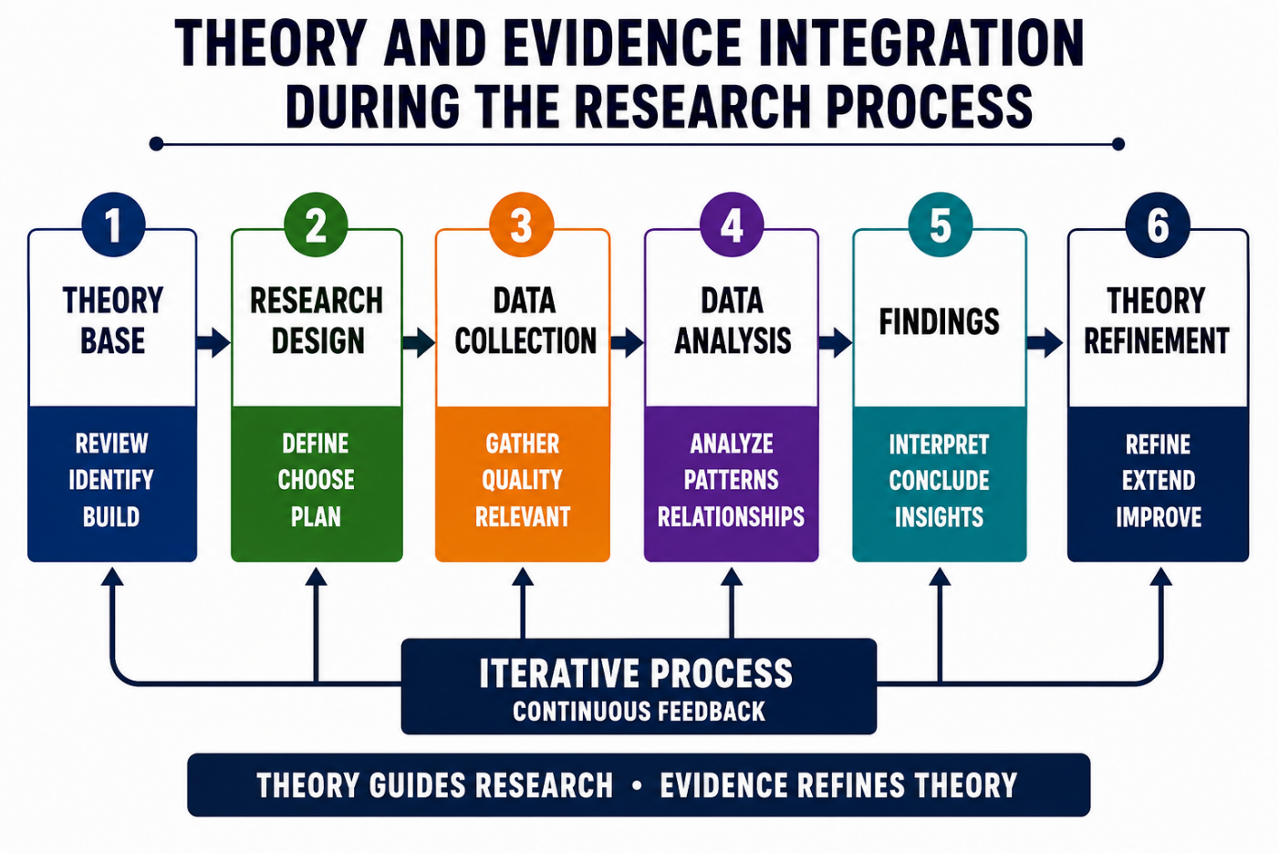
Figure 5. Integration of Theory and Evidence During the Research Process
Source: Author, adapted from Gibbs (1988), Bartlett and Ghoshal (1989), Dunning (1988) and Saunders, Lewis and Thornhill (2023).
Another key learning outcome was identifying the importance of comparing information from a number of reliable sources. In the research process, sometimes the data on economic indicators and investments varied between the reports released by IMF (2025), OECD (2025) and Uruguay XXI (2025). The comparison of these sources brought my analysis accuracy and the need for source triangulation in academic research to the fore. In addition, the combination of lectures, seminar discussions and recommended readings provided an impetus to bring theoretical models into my evaluation instead of simply using them, and to make the evaluation more coherent and evidence-based. As shown in Figure 4, the academic theories, institutional evidence and company-specific information was combined during the research process to create evidence-based strategic recommendations.

Conclusion
In general terms, this module on International Business Strategy developed a stronger understanding of the theoretical aspects and practical challenges of expanding into the international markets. The assignment showed that to be able to enter a foreign market successfully, a company has to analyse both the external business environment and its internal capabilities and then choose the most suitable international strategy. The application of recognised frameworks such as Bartlett and Ghoshal's Transnational Strategy and Dunning's Eclectic (OLI) Paradigm, helped to achieve a more critical evaluation of strategic decisions as opposed to descriptive observations. These models helped them make evidence-based arguments based on the academic literature and reliable institutional data.

Action Plan
Looking back on this experience, there are certain improvements that I see that can be made in future research. In the initial stage I will check the companies' information using official companies' reports and once I have checked, I will choose a case study which will meet the assessment requirements. Second, I will use more recent peer-reviewed journal articles to enhance critical analysis and to provide up-to-date academic evidence for recommendations. Lastly, I will refrain from discussing various theories separately but with them integrated in one analytical structure. This will help make my assignments better in the future and help me to make better decisions in complex international business situations through evidence and rigorous analysis.

References:

Alzghool, M. (2020) An evaluation of IKEA's global position and marketing standing. ResearchGate. Available at: https://www.researchgate.net/ (Accessed: 25 July 2026).
Bartlett, C.A. and Ghoshal, S. (1989) Managing Across Borders: The Transnational Solution. Boston, MA: Harvard Business School Press.
Bellamy, M.A., Dhanorkar, S. and Subramanian, R. (2020) 'Administrative environmental innovations, supply network structure, and environmental disclosure', Journal of Operations Management, 66(7–8), pp. 895–932.
Dunning, J.H. (1988) 'The eclectic paradigm of international production: A restatement and some possible extensions', Journal of International Business Studies, 19(1), pp. 1–31. Available at: https://doi.org/10.1057/palgrave.jibs.8490372 (Accessed: 25 July 2026).
Garrone, M. (2024) Furniture as a service to reduce the impact of the industry. Bachelor's thesis. South-Eastern Finland University of Applied Sciences. Available at: https://www.theseus.fi/handle/10024/866603 (Accessed: 25 July 2026).
Gibbs, G. (1988) Learning by Doing: A Guide to Teaching and Learning Methods. Oxford: Oxford Polytechnic.
Hagberg, J. and Jonsson, A. (2022) 'Exploring digitalisation at IKEA', International Journal of Retail & Distribution Management, 50(13), pp. 59–76. Available at: https://doi.org/10.1108/IJRDM-12-2020-0510 (Accessed: 25 July 2026).
Hill, C.W.L. and Hult, G.T.M. (2024) International Business: Competing in the Global Marketplace. 15th edn. New York: McGraw Hill.
Inter IKEA Group (2025) About Inter IKEA Group. Available at: https://www.inter.ikea.com/ (Accessed: 25 July 2026).
International Monetary Fund (IMF) (2025) Uruguay and the IMF. Available at: https://www.imf.org/en/Countries/URY (Accessed: 25 July 2026).
Kohli, N. (2025) Sustainable Business Practices in IKEA: A Study on Consumers' Perceptions. Bachelor's thesis. South-Eastern Finland University of Applied Sciences.
Lubis, M. and Muniapan, B. (2024) 'International market development strategies for enhancing global expansion in the export industry', Involvement International Journal of Business, 1(1), pp. 14–28.
Mandal, S. (2025) Strategic Business Responses to Shifts in Promoting Sustainable Supply Chain Management (SSCM) in Business Practices. Master's thesis. University of Vaasa.
Odilla, F. and Bidegain, G. (2025) 'Innovative but feeble: Civil society and political financing accountability in Uruguay', Journal of Civil Society, 21(2), pp. 159–179. Available at: https://doi.org/10.1080/17448689.2024.2413524 (Accessed: 25 July 2026).
Organisation for Economic Co-operation and Development (OECD) (2025) Going Digital Toolkit. Available at: https://goingdigital.oecd.org/ (Accessed: 25 July 2026).
Peng, M.W. (2022) Global Business. 5th edn. Boston, MA: Cengage Learning. Available at: https://www.cengage.com/ (Accessed: 25 July 2026).
Tomakh, V. (2025) 'Planning of business processes of the enterprise within the framework of sustainable development', Development Management, 24(2). Available at: https://doi.org/10.63341/devt/2.2025.45 (Accessed: 25 July 2026).
Tran, D. (2021) Green Outbound Logistics in E-commerce: Opportunities and Challenges: A Case Study on IKEA Finland and Zalando. Bachelor's thesis. South-Eastern Finland University of Applied Sciences. Available at: https://www.theseus.fi/ (Accessed: 25 July 2026).
Uruguay XXI (2025) Invest in Uruguay. Available at: https://www.uruguayxxi.gub.uy/en/ (Accessed: 25 July 2026).
Vansvik, S. and Friskytt, I. (2024) How to Succeed with a Large Retail Expansion into an Emerging Market: How Can Multinational Retail Companies Conquer the Challenges Presented by a Brazilian Venture and What Strategies Lead to Long-Term Success? Bachelor's thesis. University of Gothenburg.
World Economic Forum (2025) The Global Competitiveness Report 2025. Geneva: World Economic Forum. Available at: https://www.weforum.org/reports/ (Accessed: 25 July 2026).
Yu, H., Sedlezky, S., Wong, K., Hernandez, T., Larsen, P. and Stephenson, G. (2018) Pop-up Retail Strategies in an Omnichannel Context. Toronto: Ryerson University. Available at: https://pressbooks.library.torontomu.ca/popup/ (Accessed: 25 July 2026).

