Name:_Mathis Villa

Student Number: 2501611

WORKSHEET 5 – TESTING (Hunting for Treasure)
For this worksheet, the program can be implemented in a number of different ways and demonstrate different features.
Create your own test set to demonstrate strengths and/or limitations of your solution. Use as many of the template boxes below as you need.
Test: Entering a normal guess(8)

Screenshot(s) of output:
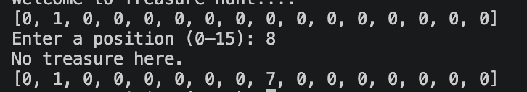

After entering a value between 0 and 9, in this instance 8, the programme tells the user the guess is wrong and there is no treasure here. This shows the programme behaved as expected and lets the user play the game as intended.
Result: Did the programme behave as expected ie syntactically and logically correct?
YES
If YES, comment on what happened.
If NO, what went wrong and why? Comment on how you would fix the problem.

Test: Entering A

Screenshot(s) of output:

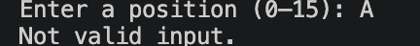

After entering the letter A, the programme realises that this is not a valid number, rejects the input and tells the user the following “Not valid input”. Therefore, the programme behaved as expected due to validation.
Result: Did the programme behave as expected ie syntactically and logically correct?
YES
If YES, comment on what happened.
If NO, what went wrong and why? Comment on how you would fix the problem.

Test: Finding the treasure

Screenshot(s) of output:

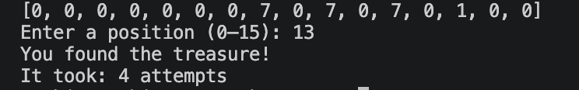

The following screenshots show the user that the programme works as expected as after 4 attempts, the user finds the correct position (13). In addition, it tells the user that it took them 4 attempts.

Result: Did the programme behave as expected ie syntactically and logically correct?
YES
If YES, comment on what happened.
If NO, what went wrong and why? Comment on how you would fix the problem.

Test: Entering 999

Screenshot(s) of output:

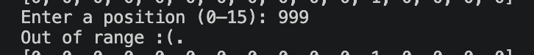

After entering a value above 15, in this instance 99, the programme knows it is out of range and tells the user the input is out of range. While this is good, adding the option of trying again instead of shutting the code down may be better. In this case it will be added.
Result: Did the programme behave as expected ie syntactically and logically correct?
YES
If YES, comment on what happened.
If NO, what went wrong and why? Comment on how you would fix the problem.

Test: Entering a negative number

Screenshot(s) of output:

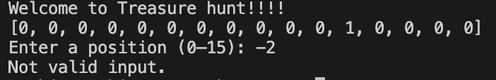
After entering a negative number, the programme has validation rejecting negative numbers. Therefore, it tells the user it’s not a valid input and shuts the code down. As mentioned before, adding the option where the user can try again may be beneficial and will be added in the next version of the programme.

Result: Did the programme behave as expected ie syntactically and logically correct?
YES
If YES, comment on what happened.
If NO, what went wrong and why? Comment on how you would fix the problem.

Final code:

[Copy and paste your code here – note, do not use a screenshot.

Note that there is no “before” and “after” code for this Worksheet because it is “Open” – not done in class. Therefore just post your final code below]

import random

treasuremap = [0, 0, 0, 0, 0, 0, 0, 0, 0, 0, 0, 0, 0, 0, 0, 0]

treasureposition = random.randint(0, 15)
treasuremap[treasureposition] = 1

attempts = 0
maxattempts = 5

print("Welcome to Treasure hunt!!!!")

while attempts < maxattempts:
print(treasuremap)

guess = input("Enter a position (0–15): ")

if guess.isdigit():
guess = int(guess)
else:
print("Not valid input.")
break

if guess < 0 or guess > 15:
print("Out of range :(. ")
else:
attempts = attempts + 1

if treasuremap[guess] == 1:
print("You found the treasure!")
print("It took:", attempts, "attempts")
break
else:
print("No treasure here.")
treasuremap[guess] = 7

if attempts == maxattempts:
print("Game over! :(")
print("The treasure was at position", treasureposition)

