
ACCA5024
ADVANCED NETWORKING
Part 1 (IN-CLASS ASSESSMENT - 20 Marks)
  - Lab Activity 1 (5 Marks) – Self Marking Packet Tracer Activity
  - Lab Activity 2 (5 Marks) – Self Marking Packet Tracer Activity
  - Skill Integration Challenge (10 Marks) – Self Marking Packet Tracer Activity
Part 2 (Topology – 80 Marks)
Network | Scheme
Network A | 192.168.10.0/25
Network B | 10.10.10.0/30
Network C | 172.16.1.0/27
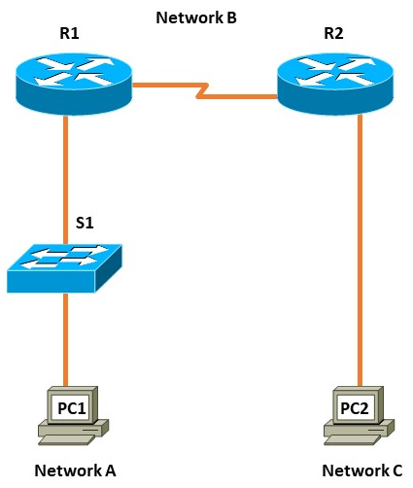

- IP Addressing Worksheet (5 Marks)
Description | Network A | Network B | Network C
Number of bits in the subnet | 1 | 6 | 3
Maximum number of usable Host (including the 0th subnet) | 126 | 2 | 30
Network ID | 192.168.10.0 | 10.10.10.0 | 172.16.1.0
First IP Host address | 192.168.10.1 | 10.10.10.1 | 172.16.1.1
Last IP Host address | 192.168.10.126 | 10.10.10.2 | 172.16.1.30
Broadcast ID | 192.168.10.127 | 10.10.10.3 | 172.16.1.31
Subnet Mask | 255.255.255.128 | 255.255.255.252 | 255.255.255.224

- Addressing Table (5 Marks)
Record your IP Address in the table below.
        - Assign the second usable IPv4 address of Network A to R1’s Gig Interface connected to S1.
        - Assign the last usable IPv4 address of Network A to PC1 and appropriate Default Gateway.
        - Assign the first usable IPv4 address of Network A to S1
        - Assign the first usable IPv4 address of Network B to R1’s Serial Interface connected to R2.
        - Assign the last usable IPv4 address of Network B to R2’s Serial Interface connected to R1.
        - Assign the first usable IPv4 address of Network C to R2’s Gig Interface connected to PC2
        - Assign the last usable IPv4 address of Network C to PC2 and appropriate Default Gateway.
Device | Interface | IP Address | Subnet Mask | Default Gateway
R1 | Interface connected to S1 | _192.168.10.2_  2001:db8:acad:10::2 | 255.255.255.128  /64 | N/A
 | Interface connected to R2 | _10.10.10.1__  2001:db8:acad:a::1 | 255.255.255.252 /64 | N/A
 | Loopback1 | 200.200.200.200  2001:ABCD:CEED:20::20 | /255.255.255.255  /64 | N/A
R2 | Interface connected to R1 | _10.10.10.2__  2001:db8:acad:a::2 | 255.255.255.252  /64 | N/A
 | Interface connected to PC2 | _172.16.1.1_  2001:db8:acad:1::1 | 255.255.255.224 /64 | N/A
S1 | S0/1/0 | 192.168.10.1  2001:db8:acad:10::1 | /64 | 192.168.10.2
PC1 | NIC | _192.168.10.126__  Address | 255.255.255.128 | 192.168.10.2
PC2 | NIC | _172.16.1.30__  Address | 255.255.255.224 | 172.16.1.1
- Device Basic Configuration (20 marks)

On all devices,
  - Before configuring, Erase the startup-config file on the Routers and switch: Write the command here: _ erase startup-config _______ (1 Mark)
  - Delete the vlan.dat file on the Switch: Write the command here: del vlan.dat (1 Mark)
  - Reload the Routers and switch: Write the command here: __ reload _ (1 Mark)
  - Verify the Switch SDM Template: Write the command here: __ show sdm prefer ___ (1 Mark)
  - Configure hostname on all devices (1 Mark)
  - Set privilege EXEC password – “cisco123” (1 Mark)
  - Configure line console password – “ciscocon123” (1 Mark)
  - Set logging synchronous (1 Mark)
  - Configure line VTY password – “ciscovty123” (1 Mark)
  - Disable DNS lookup (2 Marks)
  - Set password encryption (2 Marks)
  - Set banner “Authorized Users Only!” (2 Marks)
  - Configure all the interfaces with appropriate IPv4 and IPv6 addresses as derived from the above addressing scheme. (10 Marks)

- Route Configuration (40 Marks)
- On R1, configure IPv4 static route to R2 network, excluding Lo1 network.
- On R2, configure IPv4 static route to R1 network.
- Configure default static route appropriately to reach Lo1 network using next-hop IP address.
- Set the bandwidth on serial links to 512kbps.
- Set the clock rate on DCE to be 64000
- On R1, configure IPv6 static route to R2 network, excluding Lo1 network.
- On R2, configure IPv6 static route to R1 network.
- Configure IPv6 default static route appropriately to reach Lo1 network using next-hop ip address.
- Using 1024-bit RSA keys configure SSH access on R1. Use domain acca5024.com, username: admin and password: S023ITN.

- Network connectivity (10 marks)
Using ping command, verify end-to-end connectivity for both IPv4 and v6 networks:
- From PC1, ping PC2. Is it successful? ___yes/no_____
- From PC1, ping Lo1. Is it successful? ___yes/no_____
- From PC2, ping Lo1. Is it successful? ___yes/no_____
- Verify SSH connectivity:
From PC1, establish telnet connection to R1. Is it successful? __yes/no____(this should fail)
From PC1, establish SSH connection to R1. Is it successful? ___yes/no____

Submission Requirement
The packet tracer file should be saved as “studentname_id” and uploaded onto Moodle. In addition to packet tracer file, you must also submit

- the output of show running-configuration command in a text file for all devices configured.
- This document with Addressing Scheme and Task 5 completed

All documentation for your solution should be submitted electronically on Moodle.
It is your responsibility that you submit all the outputs and files correctly.

