[Title Here, up to 12 Words, on One to Two Lines]
Calum Fuge
Student P# 1704470

Table of Contents
Abstract 3
What is Echo?......................................................................................................................4
Design 4
Capabilities………………………………………………………………………….....................................5
Conclusion…………………………………………………………………………......................................6
References……………………………………………………………………………….............................…7

Abstract
Smart Technologies are loosing their place as accessories to our lives, and becoming necessities. More and more we are seeing the implementation of electrical technology to all aspects of everyday life, combining fashion with functionality, and productivity, we are slowly transitioning toward a sci-fi dystopia.

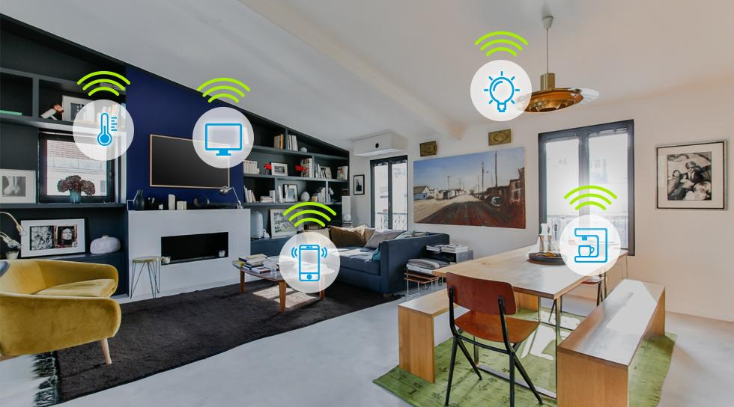

What is ‘Echo’?

One advancement of SMART technology, that has taken the world by storm recently, is Amazons Echo Device. More commonly known as ‘Alexa’, Amazon have created a friendly personal home assistant, who’s possibilities seem to be ever expanding.

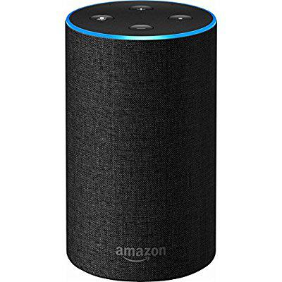
Design

Amazons Echo device is one of the better looking home assistants. Featuring a fabric exterior along with some brushed aluminum on the top, the echo device feels as high tech as it appears. Over all, the device is very aesthetically pleasing, making it a comfortable accessory in anyone’s home.
On the side of functionality, amazons ‘Echo’ device is easy to use, having as little buttons on the device as possible has helped to declutter the device and avoid confusing the user with too many options. The voice control integrated into the device makes it extremely easy to use, and by diminishing all needs for other forms of input (such as keyboard, mouse and display) many people will be able to perform simple operations on the device without have ever using a computer or smart phone.
One of the best features that helps with the functionality of the device, that I found, was the ergonomic volume controller. The integration of the twisting top to adjust the volume, left to lower and right to higher, allowed me to easily pick up the device and operate it with initiative. It is one of the smoothest and best implement features on a device I have seen recently, and strongly influenced my opinion of the device. In my opinion, this is where the device flourishes. The 360 degree speaker is more than capable of filling the majority of homes, while still providing rich and deep tones, making the device a suitable replacement for a home hi-fi system. However, the smaller version, the 'dot', offered by Amazon is quite lacking in the audio department, leaving room for improvement on accessories.

Capabilities.
Having been designed as a personal home assistant, amazons Echo has functionality in mind for every aspect of its design. The best features to be offered by the 'Echo' is clearly the voice recognition software that comes with the device. Being made with voice control as the primary medium of input, the 'echo' does really perform best when used this way.
Here’s a list I have made of some of Echo's voice controlled capabilities.
Task | Third- Party Software needed | Satisfaction (5- Highly Satisfactory, 1 – Unsatisfactory)
Play Music | Amazon prime, Spotify, TuneIn | 5 – In my opinion this is the best integrated feature
Read Audio Books | Kindle or audio book software needed | 5 – works as well the music playing feature, as long as you already own the audiobooks
Control lighting | Unless you live in a modern built smart home, a third party socket will be needed to set up lamps to be controlled by Echo | 5 – Very quick and efficient. Saves walking back into a room to turn off lights you’d forgotten.
Control heating | Again, unless you live in a smart home, third party accessories will be needed to control your home heating. | 5 – works quickly and effectively
Order / Shop | Not needed | 1 - This feature hasn’t yet been properly integrated in the UK, and therefore is not really a feature present on our device,
Make & Receive phone calls |  | 1- Hasn’t yet been properly implemented in the UK

From the table above, you can see Echo has a strong list of capabilities. In my opinion, the best set of features to be included in Echo are the home control features. Allowing users to control lighting and heating with their voice, along with an array of other devices, is an extremely innovating feature, and is one that I see making its way into a lot more of our devices and homes. Whether you wish to save time by controlling all devices in your house by voice, or just want to be apart of the technological movement Echo is a device that many of us will be finding in our homes within the next few years.

Conclusion.
Overall, I think the amazon Echo is a very useful device, who’s main purpose is innovation. Although some features do not work perfectly yet, and depending on your location you may not be able to perform some functions, such as the shopping and phone call services, the Echo is still a great leap forward in terms of Smart Home technology, and is doing a lot more, in terms of innovating the industry, than other companies are doing.
The echo is still a great accessory to any home, and will continue to get better as third-party companies continue to create new uses

References

Reference | Description | Page #
https://www.amazon.co.uk/Amazon-Echo-2nd-Generation-Charcoal-Fabric/dp/B06Y5ZW72J | Picture of Amazon Echo device for illustration purposes | 4
https://www.techradar.com/reviews/audio-visual/hi-fi-and-audio/audio-systems/amazon-echo-1272454/review | Review of Amazon Echo used as research | -
https://www.cnet.com/uk/pictures/what-can-amazon-echo-and-alexa-do-pictures/ | Echo’s Capabilities | -
https://www.amazon.co.uk/dp/B06Y5ZW72J?tag=googhydr-21&hvadid=224389937650&hvpos=1t1&hvexid=&hvnetw=g&hvrand=17307731048744455881&hvpone=&hvptwo=&hvqmt=e&hvdev=m&ref=pd_sl_5a451lrvs7_e | Amazons website for specification and research on Echo | -
http://uk.businessinsider.com/best-alexa-devices | What accessories can be bought for Echo
https://www.bluefountainmedia.com/blog/tuesday-technicalerts-the-future-effect-of-google-and-amazon-smart-home-devices/ | Smart Homes of the Future | 3

