BMPF7315D -Managing Work-based Projects - Assessment Component 2

Alex J Scott - 2319581
Table of Contents
Introduction 3
Base Methodologies 3
Planning the Hybrid Methodology 4
Designing the Hybrid Methodology 4
Lessons Learned 6
Future Use and Suitability 6
Conclusion 7
References 8

Introduction
In the workplace, tasks are often organized within projects, which provide clear start and end points, define constraints, and guide daily activities. Effective project management is crucial for organizing workloads and milestones, and to this end, project management methodologies are used (Project Management Institute, 2012).
These methodologies consist of systematic activities that divide the project into manageable phases. The intent of these methodologies is to inform team members of their goals, responsibilities, and progress, whilst ensuring everyone is working towards the project’s established objectives (Nokes & Kelly, 2007).
Many of these methodologies are well aligned with existing and upcoming project environments, yet some aspects are better suited than others. Devising a hybrid methodology for a specific project is a way to get the desired results from a specific environment that may not meet the ideal criteria (Rahimian & Ramsin, 2008).
This essay will explore the development of an Agile-Waterfall hybrid methodology for a software development project undertaken by a small IT and technical team within a local council workforce. After outlining, I will then assess the resulting suitability for the project and future use.

Base Methodologies
The two methodologies identified within the first assessment component as suitable for the project were the implementation of responsive Agile working principles, and the progression focused Waterfall methodology.
Agile principles are not a strict methodology, and instead defined in the Agile Manifesto, which outlines Agile Values and Agile Practices. The values are given to define an Agile working environment and provides four values to strive for: responding to changes over following a plan, working software having priority over comprehensive documentation, placing priority on individuals and interactions over processes and tools, and a focus on customer collaboration over contract negotiation (Beck, et al., 2001). The practices proposed in the manifesto are to provide suggestions to maintain the presented values.
Utilising agile principles within software development can be beneficial when implemented with a small, experienced team (Layoan, 2024), and when focusing on projects that can have short cycles of iteration with regular stakeholder involvement (Cohen, et al., 2004).
The generic Waterfall methodology is named as such because the process resembles a waterfall, where each element flows in to the next sequentially. Waterfall methodology often consists of five stages: determining requirements, designing the implementation, implementation and development, verification of requirement completion, and control or maintenance (Hoory & Bottorf, 2023). This progression is accompanied by in depth documentation of each stage in the process to further keep a project on track.
Waterfall is often utilised within software development since it was developed as a software development process initially (Royce, 1970), with the determined progression path giving the ability to forecast and predict costs, as well as minimise interaction with stakeholders during the development phase to reduce possible scope creep.
However, both development tools are not without fault. Agile practices have the potential to fall victim to complexity and scope creep due to lacking rigid structure (Kupersmith, 2011), while Waterfall lacks the flexibility afforded by agile development when responding to stakeholder criticism, and late feedback from stakeholders could mean redoing earlier stages, incurring significant time and resource costs (Hoory & Bottorf, 2023) .

Planning the Hybrid Methodology
When considering the downsides of both Agile and Waterfall processes, it seems logical that combining the two would help ease the shortcomings of both. This also helps keep the methodology appropriate for a small team, by providing structure, yet also providing independent development flows with the overarching goals laid out before starting.
The target project of this hybrid methodology is an internal web application, used as a monitoring tool for workplace metrics. This application is a bespoke system developed within the IT team, and currently being re-written to maintain functionality and future-proof the organisation’s reliance on this tool.
The existing system was slightly reworked over time to the same purpose, but this has led to extreme complexity in the original’s design, and therefore the project is a ground-up redesign and rewrite of the original yet maintaining all functionality. Devising this methodology will be regarding the ideal scenario in which to undertake this project.
To first outline the hybrid process, the first two stages would be essentially unchanged from the waterfall process. The would be followed by a replacement of the implementation stage, in the iterative loop often used to illustrate an Agile development process. Here the team would undertake the development process with shorter cycles, or sprints, of development punctuated by checking in with stakeholders.
The final two stages of the waterfall process would also remain relatively similar. This would mean making use of the initially created documentation and evaluate the deliverables against the requirements laid out at the beginning of the process with the stakeholders.

Designing the Hybrid Methodology
As stated, the intended stages of the methodology will closely follow a regular Waterfall methodology, beginning with a requirements document. This document should contain key elements such as the proposed stages of development along with projected costs, assumptions made, risk analysis and mitigation, criteria for success, and estimated timelines for stage completion. To accommodate for potential directional changes, this should be a living document. Revisions to documents need to be logged with versioning, ensuring past version accessibility to all involved. The most important aspect is that all document revisions are signed off by stakeholders to cover issues with discrepancy in project direction.
This would be followed by a design stage, in the creation of a living technical document. This would be the creation of a high-level design brief and scope to provide stakeholders. Once agreed, the team will plan the technical implementation of the project, and determine which development tools, practices, and collaborative methods will be used. After this is complete, the division of work is determined, and the deliverable milestones would be planned.
Overall schedules will be determined using the Agile development cycle. Here, each sprint timescale would be determined, and the desired deliverables allocated to each sprint. An ideal sprint time for this project would likely be 3 to 4 weeks before checking in with the stakeholders to demonstrate deliverables. Any requested deviations from the requirements need to be accommodated, either using established mitigation strategies or documentation alteration.
The testing stage resumes the waterfall pattern by implementing test cases derived from the current requirements document and providing a thorough evaluation of the deliverables. If any major deviations occurred during development, these should have been accommodated for by revisions to the initial requirements to better align stakeholder and developer expectations. While quick testing is outlined within the sprint pattern, this final testing phase would be implemented to check against the requirements document as a formal process to be documented.
The final stage would be deployment of the tested deliverables and determining measures to put in place for maintenance. A referral document should be created to enable maintenance of the deliverables if none of the original team are available to deal with issues, and the development team should make a final pass over all aspects of the application to add readability and comments where to ease transition to maintenance.
A prospective design outline devised from this layout is as follows in Figure 1:
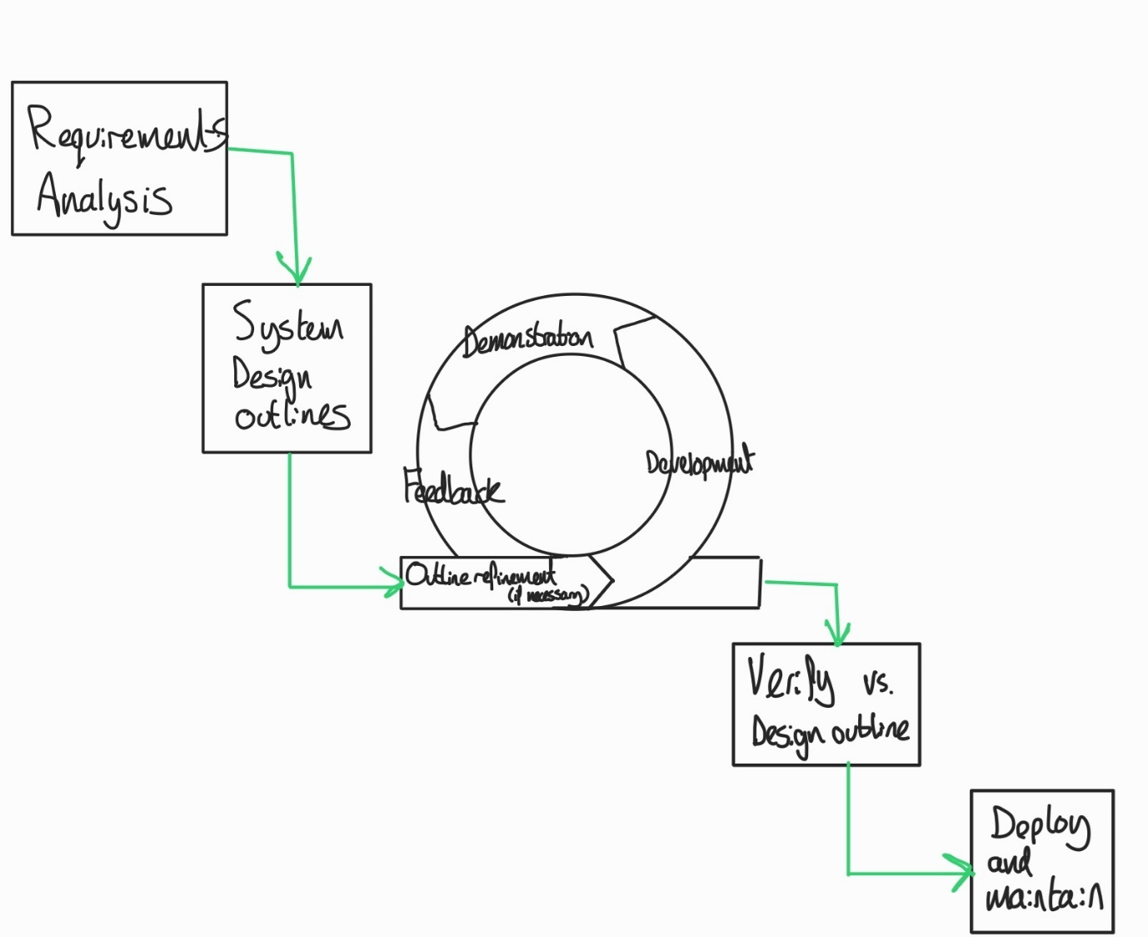
Figure 1 - Illustration of Example Process Map

Lessons Learned
In devising and evaluating this hybrid methodology against its intended project, it has revealed several key elements to consider going forward. Primarily, devising with regards to project inception as opposed to devising to accommodate in-progress development was not the ideal way to map out the process, since adhering to my own devised process is near impossible to do due to lack of existing documentation.
In attempting to retrofit the planned documentation, the first two phases of the hybrid methodology had to be passed over, as the project hadn’t generated any existing paper trail for me to utilise, nor would using available time to write extensive documentation be a good use of development time.
Through bypassing these stages, it has revealed implementation of the flexibility provided by the agile working sprints has been greatly beneficial. The agile sprints and regular check ins have provided constant opportunity to consult with stakeholders and determine the development path responsively as opposed to rigid structure and phases.
The second most critical lesson learned was the importance of communication and understanding of collaborative tools used to assist project development. Whilst having a set development structure and outline to focus sprints, it has been up to each individual to structure their organization as needed for the current sprint.
Overall, I have found right balance between detailed planning and iterative flexibility has been difficult to maintain as a result of accommodating in-progress development.

Future Use and Suitability
The conclusions drawn for usage of the hybrid methodology can be divided by two distinct scenarios, in retrofitting the methodology into an existing project and undertaking a project with this methodology in place at inception.
When considering the future of the methodology when trying to fit it into an existing project, I would not recommend doing so. While it has seen some success even with bypassing the first two initial stages due to lack of documentation, and Agile check-ins with stakeholders have been something that has provided great benefit to all in regard to progression and feedback, using time within the project to generate documentation for latter stages would likely be time that could be better used elsewhere.
However, I feel that with the existing successes brought to light through the Agile stage of the methodology, that if implementing this hybrid at inception of a project, it would likely provide significant benefit to the workplace. As it stands, there are no strict development guidelines for any projects within the workplace, let alone projects as complex as the target for this model. The workplace had previously considered PRINCE2, but the time and training investments needed to for the methodology were not feasible. However, I feel that good implementation of the presented hybrid could firstly provide significant advantage over no development standard within the team, but also over the implementation of PRINCE2, as it would be a cheaper and more cost-effective way to create necessary documentation and implement strong structural guidance within a development cycle.

Conclusion
In conclusion, whilst devising and applying the hybrid methodology presented provided invaluable insight in to how the project’s development could be better guided with both structure and flexibility, this is not demonstrated by applying it in retrospect as opposed to from inception. The attempted backtracking of the first two documentation heavy phases proved to be too much, and as such a priority shift to utilising the development cycle onward was implemented. In this way, it is clear that the hybrid approach devised was not as beneficial as I had hoped.
However, I do feel that there is potential showing in the current implementation ongoing that if implemented from the beginning of a project, the methodology could succeed in its goal of providing robust documentation with flexible development. Following the structure would cause less issues with being unable to find documentation after initiating development of deliverables, and help the team navigate themselves and the stakeholders through the process with more control than is present without these elements. I feel overall the devised approach could become a powerful tool for the current team and future projects in this vein.

References
Beck, K., Beedle, M. & James, G., 2001. Manifesto for Agile Software Development. [Online]
Available at: https://agilemanifesto.org/
[Accessed 16 09 2024].
Cohen, D., Lindvall, M. & Costa, P., 2004. An introduction to agile methods.. Adv. Comput., 62(3), pp. 1-66.
Hoory, L. & Bottorf, C., 2023. What Is Waterfall Methodology? And Can It Help Your Project Management Strategy?. [Online]
Available at: https://www.forbes.com/uk/advisor/business/what-is-waterfall-methodology/
[Accessed 16 09 2024].
Kupersmith, K., 2011. Agile is a Fad. [Online]
Available at: https://www.batimes.com/articles/agile-is-a-fad/
[Accessed 16 09 2024].
Layoan, S., 2024. What is Agile methodology? (A beginner’s guide). [Online]
Available at: https://asana.com/resources/agile-methodology
[Accessed 13 09 2024].
Nokes, S. & Kelly, S., 2007. he Definitive Guide to Project Management: The Fast Track to Getting the Job Done on Time and on Budget.. s.l.:Pearson Education.
P. M. I., 2012. A guide to the project management body of knowledge (PMBOK). 7th ed. Newtown Square, PA: Project Management Institute.
Rahimian, V. & Ramsin, R., 2008. Designing an agile methodology for mobile software development: A hybrid method engineering approach. 2008 Second International Conference on Research Challenges in Information Science, 1(1), pp. 337-342.
Royce, W. W., 1970. Managing the Development of Large Software Systems, Los Angeles: Technical Papers of Western Electronic Show and Convention (WesCon).

