Cultural Awareness

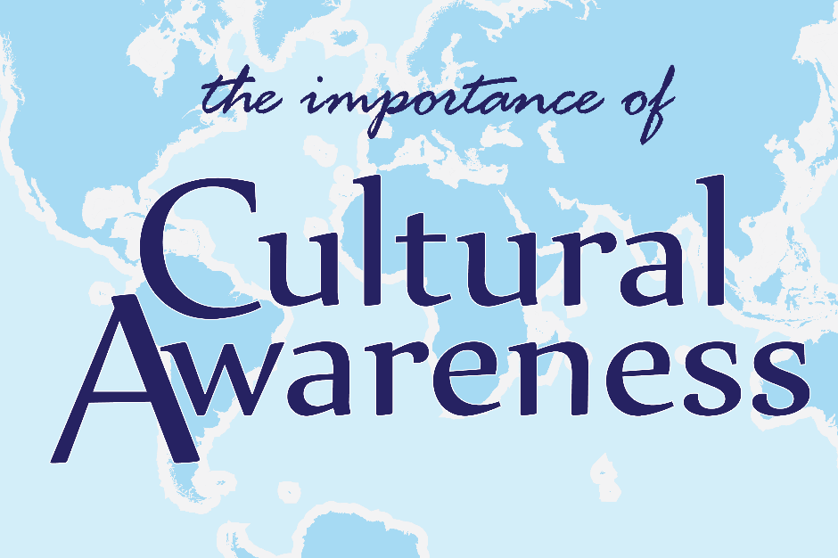

Name: Simona-Ancuta Stefan
Student Number: 1817699
Module Code: M5X 0193
Assignment Title: Produce an Aide Memoire for hotel staff to help manage guest service experiences for the international visitor.
Module Lecturer’s Name: Dale Clarke

Table of contents

Introduction …………………………………3
General…………..…………….……………..4
Turkey…………………………………………5
Greece………………….……………….….....6
Egypt…..………………………………………7
Conclusion…………………………...………8
References……………………………………8

Introduction
Cultural awareness is all about acknowledging and knowledge that we are all have unique beliefs influenced by our various cultural experiences. What we believe to be the 'normal' conduct is in a particular country can be completely different in the other.
By Means Of being polite of everyone else and taking people's views, human rights and attitudes – despite the fact that they are unique towards our own – we have allowed each other to build the greater popular individual and professional connections and profit from social variety.
Various important things to bear in mind when you interact with the new and diverse cultures:
- Civilization is constantly developing and changing.
- Society fluctuates between people; we should all be able to see and understand what is happening around us in a different way.
- Countless of us to consider ourselves as human being global although it doesn't suggest that we're all creatively informed and may be able to communicate efficiently throughout cultures.
- Culture is culturally diverse.
- Ambiguity is your pal as well as the if you are uncertain about the following question due to the fact that nobody possesses all the answers!
Collective-in accordance with the multiplicity, social awareness, and implicit prejudice that exercises has turned into a huge business in the United States as corporations have been turned into mutually progressively more varied and preoccupied with topics of environment and social integration. Expectation is that the supporting workers with professional development will allow them to successfully challenge and speech to their individual and others’ prejudices from inside the companies (Dobbin & Kalev, 2013, 2016; Paluck & Green, 2009; Pendry et al., 2007). The Above-Mentioned trainings are usually intended explicitly to be addressed a problem of prejudice within an organization under the assumption that people inside the organization are mutually accountable for the prejudice and have the obligation to respond to the unfairness.

General
Hotels meet the fast-evolving guest behaviour patterns, inclinations, and anticipations. Characteristics that can deliver an unforgettable experience all through exceptional amenities, private comes into contact, and glamorous client service is going to be rewarded with a repetition enterprise, key word-of-cheek recommendations, and favourable reviews on social networking sites. If you are looking for ways to enhance guest house visitor pleasure at your real estate, take into consideration these eight has been demonstrated approaches.
Once employing a staff member for your inn, you're going to have to look outside their fundamental skills and experience and explore their temperament. There are the things that you must be searching for in your client service members. If you want to start, should everyone employee who is to be welcoming, greeting and friendly. Each person who is staying on your hotel is getting to need to look like they are having a home-grown away from home, and that indicates that they ought to be able to request any visitor at any point in time for assistance or aid. While You're questioning persons for positions at your resort, you should pay attention to their performance in the past, throughout and following the job interview. It is imperative that they themselves are sociable and that they're enjoying working together with human beings.
It is also essential for your resort squad members to being patient. Although it can be annoying to agreement with unhappy invitees or with individuals who have being prepared to work correctly with you, it’s required that they stay calm in the instant and try to resolve the matter at your fingertips. At a hotel, the organization's staff will be dealt with persons from all strolls of living and from all parts of the globe. Persistence is greater than a good value once you are a resort worker – it’s a prerequisite.
If you are taking the steps that are required to employ individuals who are about to be decent customer service workers, it's going to be easy accommodations have been carefully appointed to the visitors to the hotel who will remain with you. Anyone who works at hotel's excellent facilities and services should acknowledge that they are a part of a squad, and that as a group, they will have to provide an outstanding experience for every single hotel guest.

Turkey

Turks appreciate to commemorate or understand and widespread phrases that are applicable to numerous every day or extraordinary events and times. Would a colleague become ill; an answer should be “Gecmis Olsun” in the sense get back to normal as quickly as possible. Please type the store and you can hear the adage of “Hos Geldiniz” meaning the greeting. The catalogue goes on as well as on although the good news for outsiders is that Turks are comfortable if you happen to visit the nation. Discovering a couple proverbs will make you a wonderful admiration, although do not perspiration the little stuff, due to the fact to the Turks, you have been a welcome visitor in their own country. Turks are welcoming and frequently extend an invitation to new acquaintances across to their home for a supper party.
Official decorum is key to Turkish civilization, regulating most social relationships as well as the use of outer space. Turkish philosophy has an accurate vocal method for virtually every opportunity. Etiquette necessitates the proclamation of the appropriate methods for the following occasions.
Strict etiquette regulates between generations and opposite gender relations. If they are not close friends or family members, senior citizens are spoken to be officially. For instance, elderly men should be dealt with the headline "Bey" (Mister) and women with the title "Hanim" (Lady). Younger people are expected to be reserved in their attendance. Adult People of the opposite sexual characteristics are projected to refrain from act informally or displaying warmth toward one another in the public eye. Families of the identical gender might take hand over and say hello to each other with the rubs on your cheek. Immediately following the meeting, males shake hands, but a gentleman makes it impossible to stir a woman's touch except to the extent that that woman reaches it toward him.
Do  - Do be aware of the month of Ramadan.  - Do learn some Turkish words  - Do bargain  - Do drink tea and coffee  - Do try the hammam, Turkish bath  - Do visit the local and historical bazaars | Don’t  Don’t diss Atatürk  Don’t get into an argument about the football with the locals  Don’t take pictures of people without permission

Greece
Country's official language is Greek, and that is spoken by most citizens. Additional languages consist of Albanian, spoken by the biggest immigrant community in the nation, Turkish, which constitutes one of the most acknowledged smaller languages, Bulgarian, and Russian. Alternative dialects have no formal status in Greece. The most prevalent overseas languages been taught by Greek people are English, German, French, and Russian. English is commonly expressed by the more youthful inhabitants, especially in the wealthy neighbourhoods and tourist attractions. Although Greeks sustain a vocational attitude throughout business gatherings, it is important to understand the social positions that control such matters. Most importantly, personal contacts are the basis on which any commercial transactions are constructed. Greeks massively choose face-to-face conferences instead of communicating through the phone or by email, as this is helping to create a personal relationship with a prospective corporate partner. The dress code is European standard.
Considerably Greater social life has been taking place inside an end group of relatives and friends. Collective activities turn around eating, drinking, playing games, listening to music, dancing, and animated debate and conversation. These meetings frequently objective at the attainment of kefi, the feeling of high-level spirits and can enjoy the relaxing atmosphere that occurs when one is blissfully conveyed by the present time and the company. Drinking may contribute to the achievement of kefi but getting more and more tipsy is deemed shameful.

Do  - Do always care a bit of cash  - Do speak English  - Do learn some common Greek words and phrases to use in conversation  - Do get a prepaid euro currency credit card for shopping  - Do be aware that stores usually close mid-day around 2-3 pm | Don’t  - Don’t get into taxis without asking how much they will charge you  - Don’t decide to go grocery shopping on Sundays  - Don’t hesitate to ask for help  - Don’t be afraid of traveling alone in Greece as a woman

Egypt
Egypt is the worldwide applied name although not the name used by the people of the country. Municipal reticence in dress and attitude is highly appreciated in Egypt. This is the common sense wherein masking exists in Egypt, but the issue is volatile, with a great deal of assortment. Numerous women are not cloak at all. What is appropriate, or necessary, or needed, is hotly discussed in the modern Egypt. The reasons for hiding are many and the spectrum from those who accept that this is a prerequisite of Islam to people who cover their own basically to satisfy their family members, male and female. Men are also instructed to dress modestly, but the alterations are not as impressive, containing for example loose-fitting pants and long coats. For both men and women, the fundamental principle is that their garments should mask the shape of the body.
Do  - Dress modestly and not too extravagant  - Spend time talking to the people  - Enjoy the country as much as you can  - Leave tips  - Do bargain | Don’t  - Don’t kiss your partner in the street  - Don’t drink tap water  - Don’t kiss or hug persons of the opposite sex  - Don’t take pictures to their women

Conclusion
Certain elements of the visitor fulfilment are endless. Business and Leisure Travelers want to remain in a hotel with clean rooms, nice facilities and amenities provides excellent tasty meals. They would like to communicate with workers who are friendly and attentive. They wish to be in a fundamental part of the chosen destination so that they will be able to enjoy the nearby area.
However, these considerations do not exclusively decide the outcome of the visitor involvement. Moreover, technology has been playing a more and more significant role in the familiarity of any guest at a hotel.

References
https://www.siteminder.com/r/trends-advice/hotel-management/ways-improve-guest-services-hotel/ Accessed on 5.05.2020
https://www.commisceo-global.com/resources/country-guides/egypt-guide/ Accessed on 5.05.2020
https://www.kwintessential.co.uk/resources/guide-to-greece-etiquette-customs-culture-business Accessed on 06.05.2020
Westby, C., Burda, A., & Mehta, Z. (2003, April 29). Asking the right questions in the right ways: Strategies for ethnographic interviewing. The ASHA Leader . Retrieved from https://doi.org/10.1044/leader.FTR3.08082003.4
https://www.ncbi.nlm.nih.gov/pmc/articles/PMC4788642/ Accessed on 06.05.2020

