

Data Handling and Business Intelligence Report

Program Name: BA Business Management
Module name: Data handling and business intelligence
Code: LCBB5000
Assignment title: Assessment Component 2: Written Report
Lecturer’s name: Dr. Eric Osei
Name: Carmen-Ioana Hodoroaba
Student id: 2109656

Table of Contents
Introduction 3
Part 1 4
Meaning of data visualization 4
Making Use of Excel 4
Pivot Table Analysis 4
Demonstration 6
Using pivot tables and pivot charts 6
Steps of preparing Dashboard 12
Creating Slicer and Report connection 15
Interactive Dashboard for Supermarket Sales 19
Effectiveness in Producing Good 20
Result according to branch 20
Comparing Findings Based on Gender 20
SPSS Descriptive Statistics 21
Part 2 22
SPSS Tool 22
Benefits 22
Example 22
Importance of Understanding the Data Mining Process Cycle 23
Significance 24
Conclusion 25
Reference 26

Introduction

This study will analyse the supermarket store's long-term trend using Excel's graphical features. The data was collected from the secure site named “Kaggle” for this study. It has data from three branches. The study is broken up into two parts. The supplied retail data will then be used to populate an Excel dashboard. The information in the dashboard can be used to get a feel for how things are going in the shop. The dashboard's ability to give a rapid, visual overview of the company's performance makes it an essential tool for every enterprise. The dashboard will consist of various charts and slices, including column, bar, and line graphs. The final diagrams will be well-organized and give a clear picture of how the shop functions. The study also provides templates for the following dashboard's construction. In the second part, we'll assess the data mining process's efficacy and the SPSS tool's advantages and disadvantages.

Part 1

Meaning of data visualization
The dashboard is the most accurate method of monitoring business performance. Audience can understand the company's performance without reading the detailed reports and tables. The dashboard is useful for providing quick and easy access to information that may inform data-driven business decisions. When it comes to reporting on shop performance for management, the dashboard provides a no-frills option. Several kinds of graphs, such as pie charts, column graphs, bar graphs, and line graphs, are used (Kraak and Ormelling, 2020). The charts' purpose is to offer a rapid visual snapshot of the status of a certain organization, such as a grocery shop. By analysing the charts that show the most recent fads in the store, the owners may get useful information about the future of the company.
It may be analysed over the phone, and it's easy to learn and understand. To help businesses make educated choices, dashboards collect and display relevant data in an easily digestible format. The visualization is used to assess the quality of the object. The graphics need minimal effort to comprehend (Lin, et. al., 2022). The visual nature of the dashboard eliminates the necessity for reading lengthy reports.

Making Use of Excel
Market trends may be easily analysed using Excel. It also contains resources that companies may use to create basic dashboards for their clients (Guerrero, Guerrero and Rauscher, 2019). Almost every kind of organization uses Excel, making it one of the most known and used programs in existence. Data may be stored, cleaned, analysed visually (through charts), and tested statistically (both predictively and inferentially). The dashboards are built using a variety of analytical instruments, including pivot tables, charts, and slicers. Excel's charting capabilities are extensive (Meyer and Dykes, 2019). There are many kinds of graphs, each with its special function and potential use in assessing an organization's options.

Pivot Table Analysis
When utilized in a dashboard setting, the Pivot Chart's interactive and dynamic display characteristics shine. It may help to reduce mountainous data sets to more manageable chunks. Users may use a Pivot Chart to graphically analyse and display complicated data fast. Users may choose from a variety of charts, including bar, column, line, and pie charts. Due to the dynamic nature of the data and the need of keeping an up-to-date dashboard, it will quickly learn to rely on Pivot Charts (Constantinescu and Anghelescu, 2022). Pivot Charts are an excellent resource for producing an easily digestible and visually appealing dashboard.
Excel charts may be used to visually depict any kind of data. Many different kinds of charts may be used to visually depict data. Column charts help show how data has changed over time and for making cross-category comparisons. In a column chart, the columns represent the categories and the rows represent the data. Line charts are a kind of graph in which data from a time series is shown continuously along a linear axis. Because of this, they are great for depicting patterns in data over long periods.
On the horizontal axis of the bar chart, the category data is shown uniformly. The vertical axis always represents values, as expected. Doughnut charts have each data point drawn to scale based on its relevance. The doughnut chart is similar to the pie chart, except it may show more information all at once. The data at hand may be filtered by the user using the slicer. It helps by describing the data in real-time (Hai-Jew, 2019).

Data pre-processing: Sorted the data into three months: January, February and March.
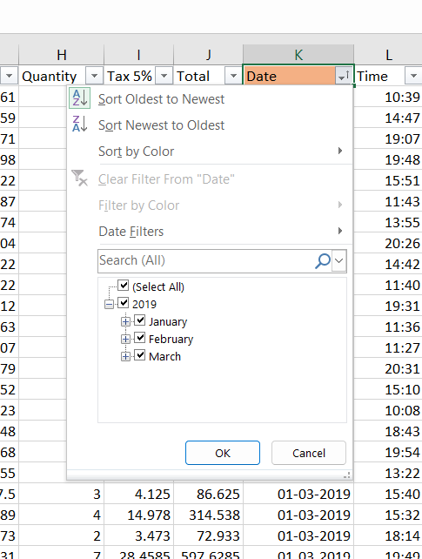

Demonstration

Using pivot tables and pivot charts

Steps 1: Select the entire data through the shortcut “CTRL + A” go to the insert tab and click on the Pivot table option.
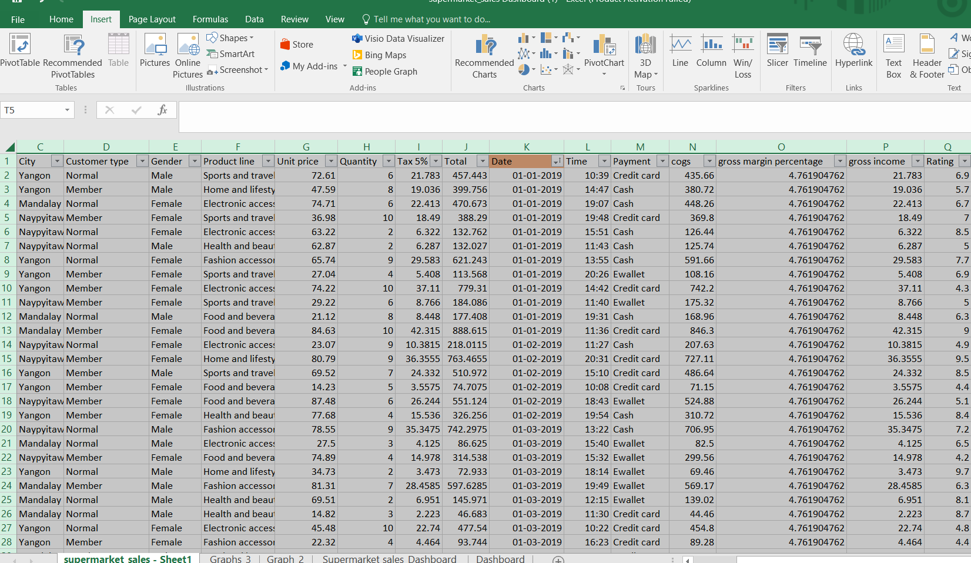

Step 2: A display box appeared labelled “Create PivotTable”. Select the New Worksheet option and then click OK (Luna, Martin and Ivonchyk, 2022).
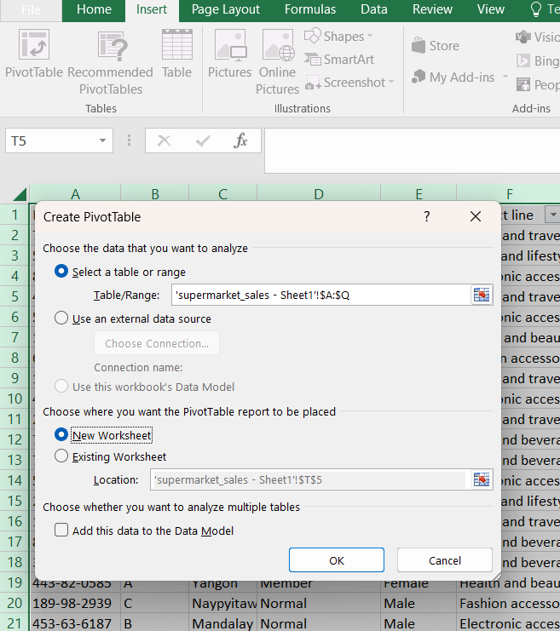

Step 3: Drag the “Date” into Rows and “Total sales” into Values. Then click on the side arrow and a display box of value field setting box appeared. Choose the option “Sum” and click OK.
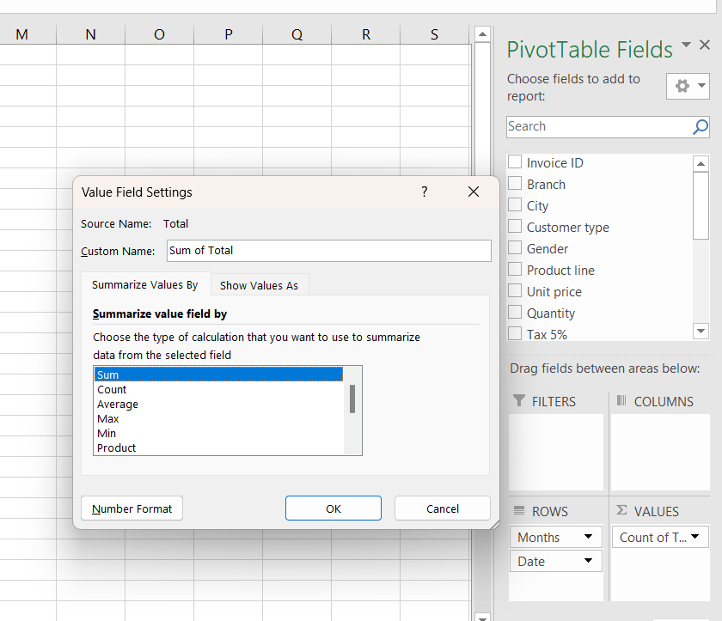

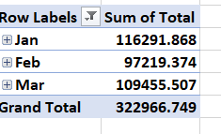
A pivot table appeared like this.

Step 4: Selected any cell in the pivot table. Analyse and Design tab in the ribbon has appeared. Clicked on the Pivot chart option and choose the desired chart to present the data visually. (Choose line chart). Click OK.
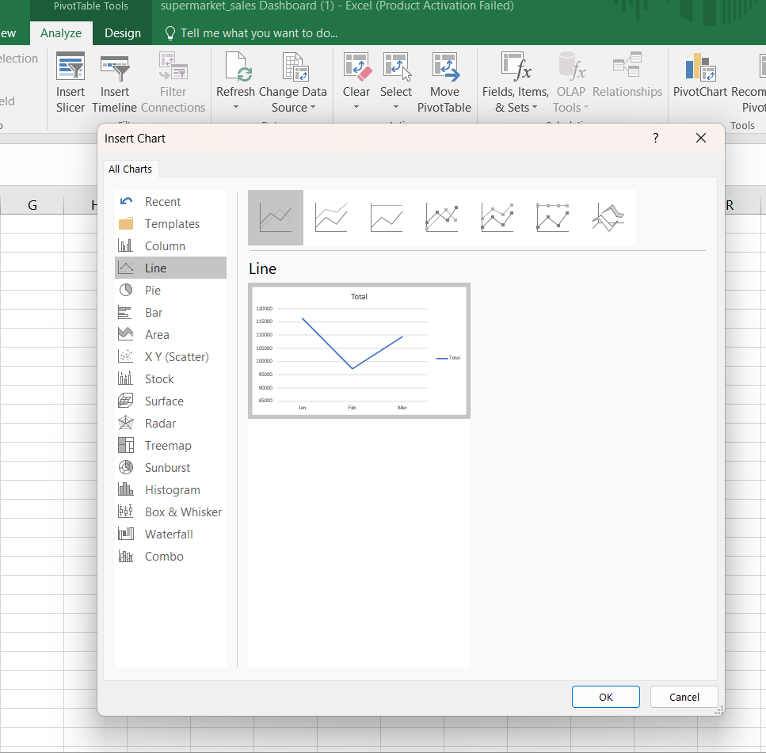

Step 5: Hide all filtered buttons
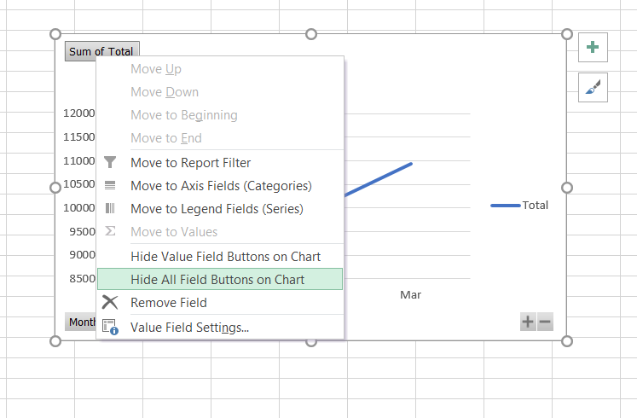

Step 6: Clicked on the chart and click the “+” option and arrange the settings. Such as Chart title.
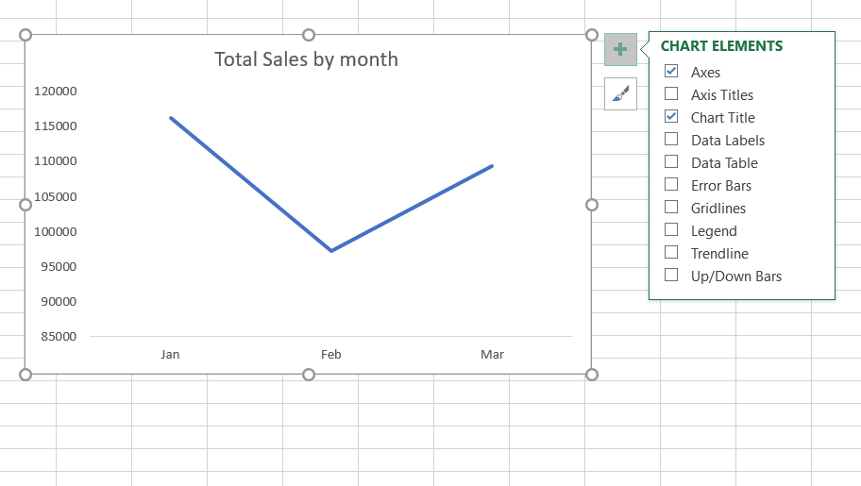

Steps 7: Double on the chart, and the “Format Axis” dialog box appeared. Here the colour of the chart changed.
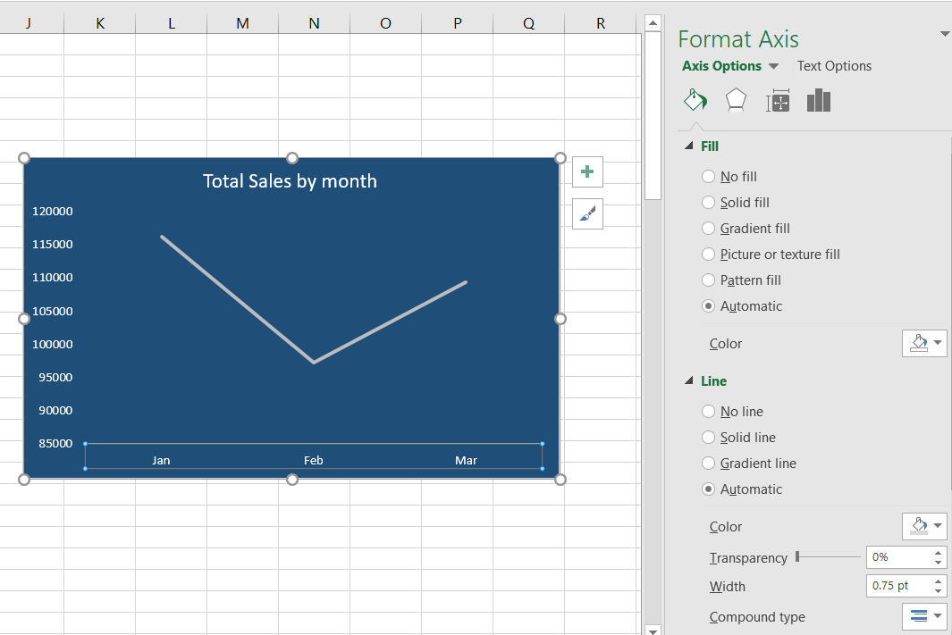

Step 8: Repeat 1-7 steps for each creating each chart with a different chart type and visualization.

Steps of preparing Dashboard
Step 1: Clicked on the Insert tab and choose the “text box” option.

Step 2: Created the text box and clicked on the “Format” tab. Choose the “Shape Fill” option to colour the text box.
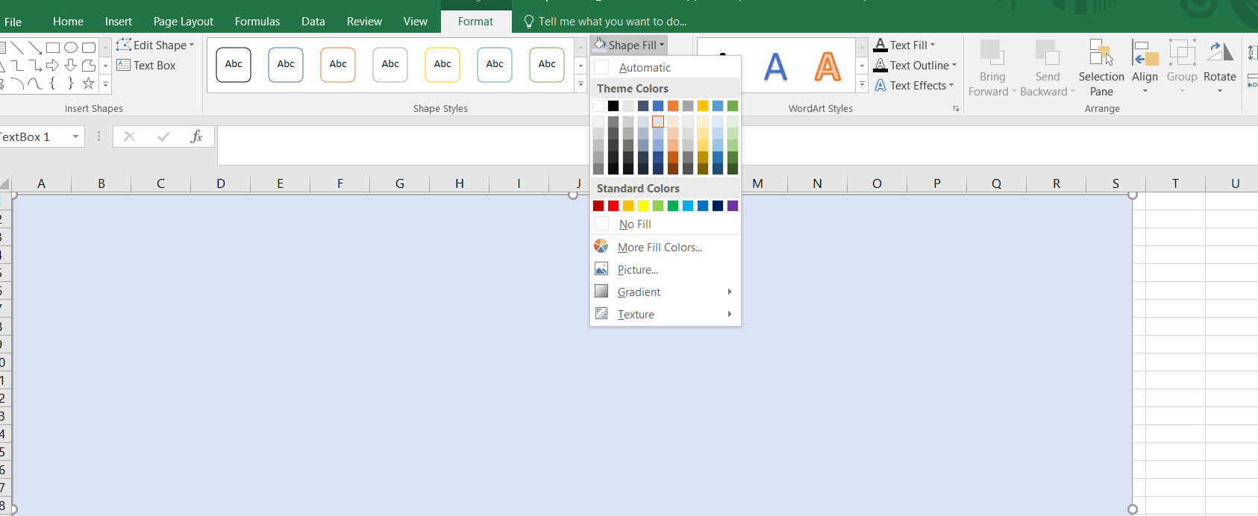

Step 3: Created another “Text box” for the header, insert the text “Supermarket Sales Dashboard” and designed it by filling in colours and the “Shape Effect” option.
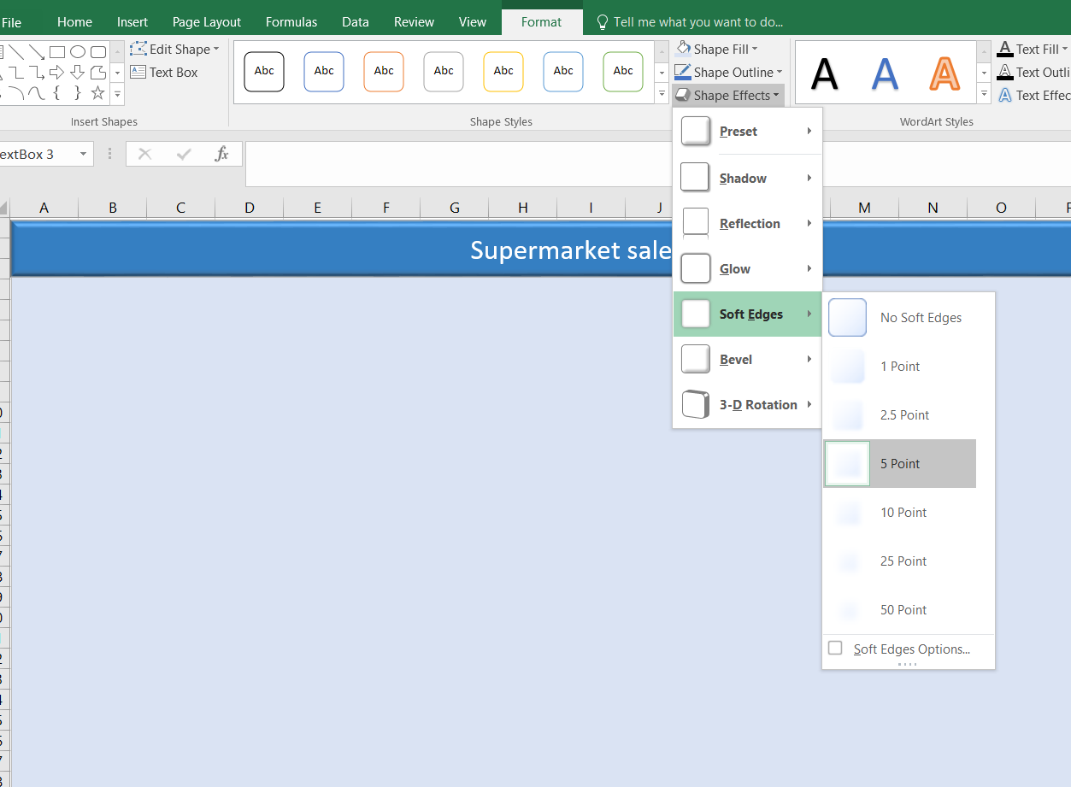

Step 4: Pasted all the charts in the dashboard worksheet for arranging it.
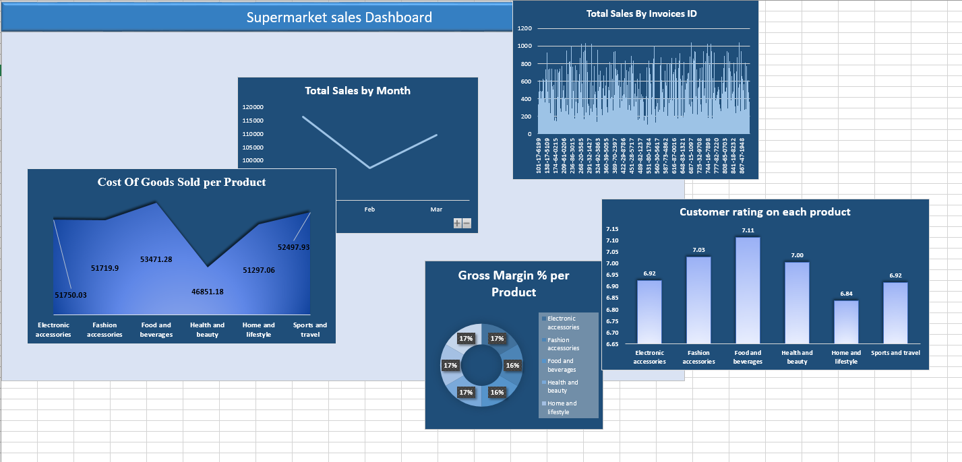
After this step, charts were arranged on the “Text Box”

Creating Slicer and Report connection
Step 1: Clicked on the insert tab and chose the “Slicer” option.


Step 2: A dialog box appeared named “Insert Slicer”, chose “Product line” and clicked OK.
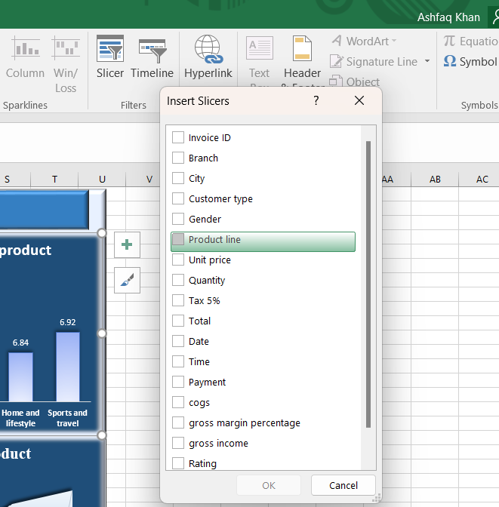

Step 3: To make the connection right click on the slicer and clicked on the “Report Connection” option.
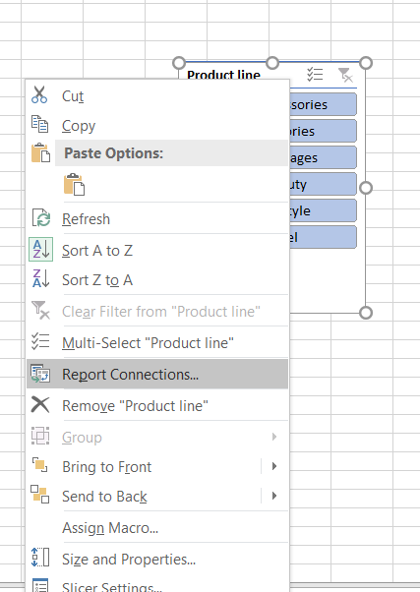

Step 4: Checked all the checkboxes to connect all the Pivot tables and charts. Clicked OK (Microsoft, 2023).
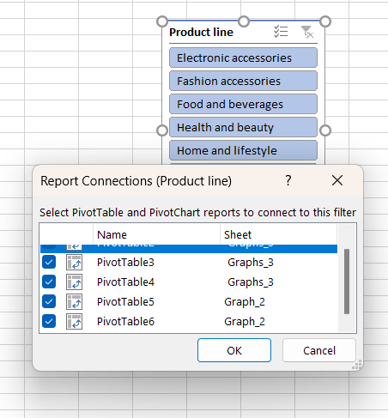
Step 5: Repeat the above steps for creating two more slicers for “Branch” and “Gender”. And arrange the slicer on the “Text Box”.

Interactive Dashboard for Supermarket Sales
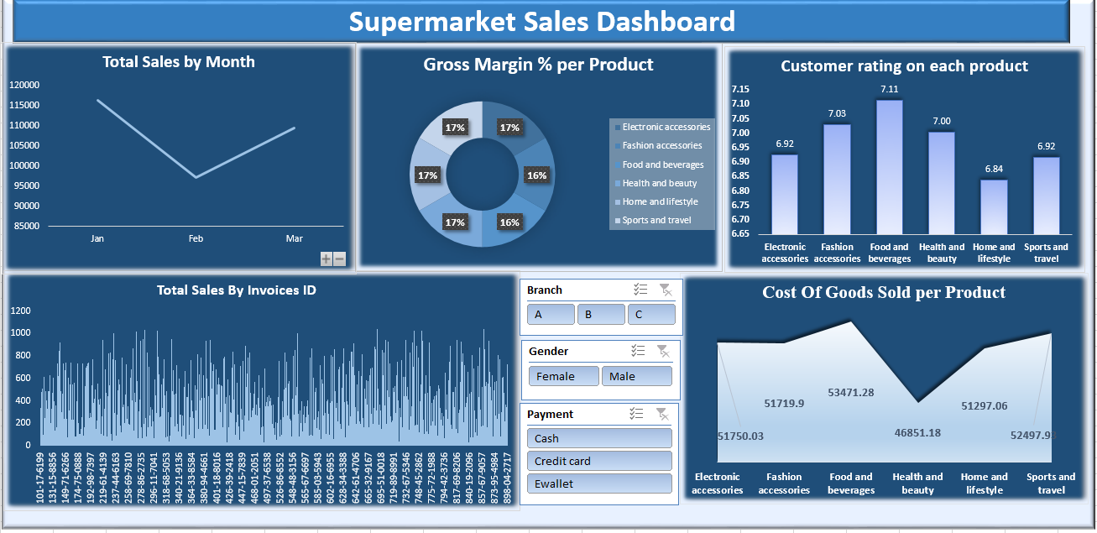
Figure 1 Interactive Dashboard for supermarket sales

The store's prosperity is visually shown. A column chart better illustrates sales broken down by user id. Individual purchase histories are shown, with the ID most responsible for driving sales growth or decline highlighted. The doughnut chart shows that all companies have about the same profit margins. The line represents the average daily sales for the three months of January, February, and March. The area graph in the dashboard shows the retailer's total cost for the items. The prices of food and drink are broken down for the reader. Those on a tighter financial budget who are seeking health and beauty help should rejoice at this development. The chart showing the distribution of income by various demographic variables, such as gender, might be informative. Customers' opinions on different offerings were plotted in an area chart for easy comparison. The slicer interprets data such as product kind, client profile, sales channel, and payment method. The dashboard's three-month performance summary is a valuable resource for gauging the megastore's success (Fernandes, et. al., 2020).

Effectiveness in Producing Good
Customers often paid with cash at the register. To a large extent, the shop relies on customers’ spending money to sustain itself. The store's health and beauty section bring in the most money. In line with other studies, it has been shown that cash is the most popular form of payment among consumers. E-wallets are rapidly rising in popularity as supplementary payment options for online shoppers. The customer's need to keep track of cash is eliminated since they paid using their phone. In addition, the business does well with home and leisure goods. A simple glance at the dashboard's graph might provide this information. Even if credit card usage is on the decline, a sizable portion of all internet transactions are still made using plastic.

Result according to the branch
Individuals may use the chart and slicer functions to analyse the superstore's A, B, and C departments separately. As compared to the other two possibilities, option C stands out as the most fruitful. Because it brings in the greatest money for the company. The C Branch is the largest contributor to the company's bottom line even though all of the other branches have the same gross margin. Both Branches A and B provide the same functions, however, Branch B serves more people. Even with a drop in foot traffic, Branch A continued to generate solid earnings. Location B has the greatest cost of goods sold, yet Location C is likewise quite successful.

Comparing Findings Based on Gender
Every shop must know who its customers are and where most of its money comes from. This suggests that females are the target market for this product. The business went with something from the food and drink sector. Cosmetic and wellness items might be a money-saver for stores. The individual is also a supplier to the megastore. The most lucrative market for men's goods is the health and beauty sector. They realize the greatest profit margin on consumables like food and drink. The store's success over the last three months may best be shown on the dashboard.

SPSS Descriptive Statistics
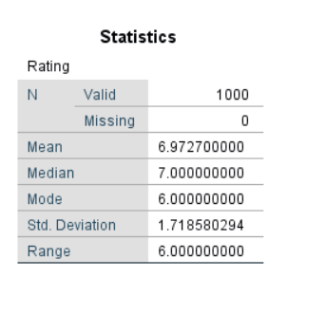
SPSS was used to analyse the data from the descriptive tests. Its in-built function makes computation simple, and the result is a clear summary of the data in no time. The table below summarises comments from our customers. According to the numbers, there are 1,000 users in total. On average, customers rate companies 6.97 out of 10. The most typical score from customers is 7. The supermarket's mean and the national mean are the same. According to the median, most consumers gave a rating of 6. 1.71 standard deviations above or below the mean characterize by the typical customer review. The largest and smallest values are separated by six standard deviations.

Part 2

Excel, SPSS, and Tableau are just a few of the many data analysis programs available; each has its advantages and disadvantages. Although SPSS is the go-to for big datasets and rigorous statistical analysis, Tableau is where it's at when it comes to smart data visualization and storytelling.

SPSS Tool
This kind of statistical analysis software has numerous uses outside the classroom. Its extensive variety of statistical characteristics and functionalities has made it a benchmark in the area of data science. In this discussion, several real-world cases analyse to examine the benefits and drawbacks of utilizing SPSS.

Benefits
SPSS offers a wide variety of statistical analyses, including descriptive statistics, correlation analysis, regression analysis, and multivariate analysis. Because of this, it is a powerful instrument for digging through large datasets in search of insights and patterns. SPSS's creators aimed to make the program as user-friendly and natural as possible so that even novices can quickly pick it up and start producing results. With features like syntax and output window generation, as well as a straightforward interface, this application is an excellent analytical aid. Because of SPSS's speed and efficiency, it is often used to analyse data from surveys, clinical trials, and scientific research involving large datasets. Researchers may benefit from using datasets containing hundreds of variables and millions of records to get insight from enormous data.
Users using SPSS have the option of adding new variables to their analyses, altering pre-existing ones, and even writing their syntax code. Users may modify the analysis to answer their questions and theories.

Example
A market researcher searching for customer behaviour trends may do an SPSS analysis. The analyst may utilize this information to better understand consumer preferences, locate unrealized market potential, and craft highly specific advertising strategies.

Consequences of Using SPSS
SPSS is a licensed, subscription-only application that is beyond reach for most people and start-ups. Some individuals may not be able to afford it, which reduces the market for the product. While SPSS was designed with the layman in mind, there is still a learning curve. The process of becoming familiar with the software and its many features and functions is laborious and time-consuming. As SPSS was created mainly for statistical analysis, it has few choices for data visualization. While the software can generate basic charts and graphs, it may require additional software for more complex visualization methods.
There are certain statistical assumptions upon which SPSS is built; if the data does not fit within these parameters, SPSS may produce inaccurate results. For example, if the data is not normally distributed, the results of statistical tests might be misleading.

Importance of Understanding the Data Mining Process Cycle
The process of systematically extracting meaningful information from large datasets is known as "data mining." Better judgment may be achieved as a result of discovering these relationships and patterns in the data. Data mining is a powerful technique with numerous potential uses in areas including business, medical, as well as marketing. Not only will be continuing this process, but will also be expanding it. Instead, think of data mining as an iterative multi-step process (Wing, 2019).
The data mining process starts with a careful selection of relevant data. The first stage in doing any research is gathering relevant data for analysis. The data must be reliable and relevant to the problem at hand. The accuracy of the results relies greatly on the accuracy of the data utilized in the research (Schuh, et. al., 2019). The second step is known as "data pre-processing," and it comprises cleaning the data, making it consistent, and making it ready for analysis. Several tasks, such as removing duplicates, filling in gaps, and standardizing the data, may fall under the umbrella of "data pre-processing."
When the data has been cleaned and organized, the next step is data transformation. The first step is to change the data into a form suitable for analysis. Data may be altered in a variety of ways, including through aggregation, discretization, and normalization. The next stage, "data mining proper," involves mining data. Several algorithms must be used for the data to conclude. Among the various data mining techniques accessible are association rule mining, cluster analysis, and classification. It depends on the problem at hand and the data collection to determine which data mining technique is ideal.
The next phase, after data mining, is to evaluate the findings. The outcomes must be assessed for both their quality and their applicability. There are a variety of tools at a researcher's disposal for doing an assessment, including cross-validation and hypothesis testing. The last step of data mining is termed "deployment." This requires making deliberate decisions in light of the research. Tools for deployment include visualization and reporting (Nguyen, et. al., 2019).

Significance
To extract value from data, the data mining cycle must be used. Data analysts can guarantee the quality of their results and lower the possibility of bias by adhering to a standardized procedure. It also aids analysts in gaining a tactical edge, refining their judgment, and seeing openings they hadn't previously considered. In today's corporate world, data mining has emerged as a powerful tool for optimizing processes and obtaining a competitive advantage. The data mining process is cyclical, consisting of the processes of data selection, pre-processing, transformation, mining, assessment, and deployment. Organizations may get the greatest insight from their data and advance their operations by following this method.

Conclusion

In this research, Excel's graphical capabilities was used to examine the grocery store's long-term pattern. The dashboard's data may be utilized to get insight into the inner workings of the operation. The dashboard is an essential piece of equipment for every business since it provides an instant visual review of the company's performance. The dashboard is a collection of various charts and slices, including but not limited to column, bar, and line graphs. The completed schematics were laid together in a way that gave clients a transparent view of the business. The research assessed the value of the data mining process and considered the pros and cons of utilizing SPSS.

Reference

CONSTANTINESCU, Ș. and ANGHELESCU, A., 2022. USING EXCEL IN PROJECT MANAGEMENT. LIMBI STRĂINE ȘI COMUNICARE, p.38. http://lsc.rs.utcb.ro/docs/BS_LSC_1_2022.pdf#page=40
Fernandes, A., Ginde, P., Monatt, A. and Saglani, N., 2020. Comprehending Workforce Management in an Organisation using a Dashboard. Zeichen Journal. https://www.researchgate.net/profile/Arya-Monatt/publication/342394015_Comprehending_Workforce_Management_in_an_Organisation_using_a_Dashboard/links/5ef234d6a6fdcc158d22413d/Comprehending-Workforce-Management-in-an-Organisation-using-a-Dashboard.pdf
Guerrero, H., Guerrero and Rauscher, 2019. Excel data analysis. Springer International Publishing. https://link.springer.com/content/pdf/10.1007/978-3-030-01279-3.pdf
Hai-Jew, S., 2019. Creating a Simple PivotTable in Excel 2016. C2C Digital Magazine, 1(10), p.13. https://scholarspace.jccc.edu/c2c_online/vol1/iss10/13/
https://ieeexplore.ieee.org/abstract/document/9903288/
Kraak, M.J. and Ormeling, F., 2020. Cartography: visualization of geospatial data. CRC Press. https://books.google.com/books?hl=en&lr=&id=nPvvDwAAQBAJ&oi=fnd&pg=PP1&dq=data+visual&ots=O7ZWlIPs8d&sig=7ROc39t6FbaDdwwI8Ps5zAUTDCI
Lin, H., Akbaba, D., Meyer, M. and Lex, A., 2022. Data hunches: Incorporating personal knowledge into visualizations. IEEE Transactions on Visualization and Computer Graphics, 29(1), pp.504-514.
Luna-Reyes, L.F., Martin, E.G. and Ivonchyk, M., 2022. 6.1 Creating PivotTables. Data Analytics for Public Policy and Management. https://pressbooks.pub/decisions/chapter/5-1-creating-pivot-tables/
Meyer, M. and Dykes, J., 2019. Criteria for rigor in visualization design study. IEEE transactions on visualization and computer graphics, 26(1), pp.87-97. https://arxiv.org/pdf/1907.08495
Microsoft (2023). Use Slicers to filter data - Microsoft Support. [online] Microsoft.com. Available at: https://support.microsoft.com/en-us/office/use-slicers-to-filter-data-3517fa12-353e-4907-b94d-b8e9b500ee33 [Accessed 24 Mar. 2023].
Nguyen, G., Dlugolinsky, S., Bobák, M., Tran, V., López García, Á., Heredia, I., Malík, P. and Hluchý, L., 2019. Machine learning and deep learning frameworks and libraries for large-scale data mining: a survey. Artificial Intelligence Review, 52, pp.77-124. https://link.springer.com/article/10.1007/s10462-018-09679-z
Schuh, G., Reinhart, G., Prote, J.P., Sauermann, F., Horsthofer, J., Oppolzer, F. and Knoll, D., 2019. Data mining definitions and applications for the management of production complexity. Procedia CIRP, 81, pp.874-879. https://www.sciencedirect.com/science/article/pii/S2212827119305220
Wing, J.M., 2019. The data life cycle. Harvard Data Science Review, 1(1), p.6. https://assets.pubpub.org/hzllsv80/e3005d85-fea9-4b60-8ba0-f5409ca0905e.pdf

‌

