Student name: Alexandra Iugan
Student number: 1918146
Module name: Psychology in Health and Social Care
Module code: BMHP4019
Assignment title: Written Assignment (Case Study)
Lecturer: Rebecca Kavanagh

Table of content

Introduction
Faßnacht (2000, in Uher, 2016) defined behaviour as “those ongoing events of an organism or emanating from an organism that can be externally perceived”. The aim of this report, using psychological theories, is to help the youth offending team to understand possible causes for Mason's behaviour, on 17 years old offender who has been served an 18-month custodial sentence for drugs possession with the intent to supply.
The discussion in the report will be focused on Tajfel’s Social Identity Theory, Ajzen’s Theory of Planned Behaviour and Dollard’s Frustration Aggression Hypothesis, explaining what each of these theories means and the way it can be applied to the case study, in order to help the team to understand Mason’s behaviour, so that they can develop a support plan for Mason. This report also contained statistics about reoffending rates for children and young people, the category Mason is in, and about the dropout rates for teenagers from families with a low income.

Social Identity Theory (SIT)
The origins of Social Identity Theory come from Henri Tajfel (1972), who described social identity as a person’s perception about himself or herself based on their group memberships (Hogg and Vaughan, 2014). Tajfel also stated that groups the individuals belong to where are an essential source that helps to form a positive self-concept and defines our behaviour.
Stets and Burke (2000) explain very clear the three main processes included in social identity theory: social categorisation, social identification, and social comparison. In the social categorisation process, we allocate people to categories that give us information about them; and then defining them by group characteristics, omitting the singularity of person. The persons who are similar or in-group and persons with differences are out-group. In the social identification process the individual adopts the identity of the group he belongs to and the person’s self-esteem is depending on group membership. In the process of comparison, people find more similarities within the group or in-group and more differences among the group or out-group (Hornsey, 2008), and this leads to in-group being judged positively and the out-group being judged negatively (Stets and Burke, 2000).
Considering Social Identity Theory, there are few ways to approach Mason’s situation, and try to understand his behaviour. First, maybe Mason considered himself as being in-group with the members of the parole board commission because they have had the same goal, Mason’s release, and they all wanted Mason to continue his studies. After he got released, he has not been attending his college course, but he has been seen with his former associate, which is also known by the local police. And this was happening because maybe Mason identified himself as being in the same group with his former partner just like before he went to jail, and his colleagues from college being in another group (or out-group), he do not belong to. Seeing the Youth Offending Team during the probation visit as part of another group also, his group and Youth Offending Team being in opposite sides of the law, can be a possible cause for Mason's aggressive reaction and behaviour, even if the team is trying to help him (to finish the college and get a diploma instead to be reoffended).
According to Youth Justice Board/Ministry of Justice(2020), the statistics shows that at the end of March 2018, children and young people had the highest reoffending rate, with 38.4%, compared to 29% for young adults (aged 18-20) ad 28.5% for adults (aged 20+).
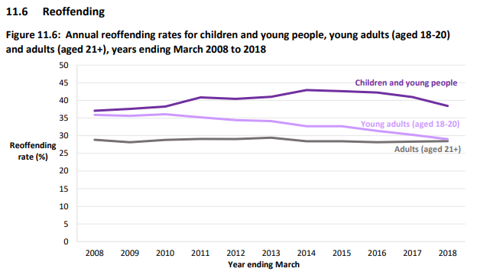

Theory of Planned Behaviour (TPB)
This theory was developed by Icek Ajzen in 1991, and it is an extension of Theory of Reasoned Action (Armitage and Conner, 2001). Theory of Planned Behaviour assumes that behaviour is planned, and it is determined by the person’s intention to engage or not in it (Sniehotta, Presseau and Aranjo-Soares, 2014). According to Ajzen (Godin et al., 1992), there are three factors or determinants that can influence behavioural intention: the attitude towards the behaviour, subjective norms and the perceived control. Ajzen (1991) explain each of these factors; the attitude towards the behaviour refers to the perspective or point of view the person has about the behaviour in question; the subjective norms refer to the other people’s attitude regarding the behaviour, if it is favourable or not; and the last one, the perceived control, refers to the person’s beliefs as to how difficult or easy it is to perform that behaviour. Ajzen (1991) also states, as a general rule, the more favourable these factors are, the stronger is the intention to perform the behaviour.

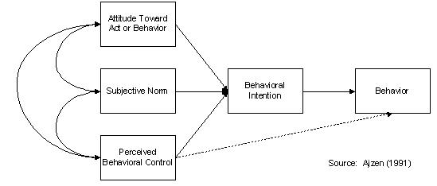

Frustration Aggression Hypothesis (FAH)
Aggression is described by Berkowitz (1993, in Brown, 2006) as an act “involving behaviour, either physical or symbolic, performed with the intention of harming someone”. There are many theories of aggression developed over the years; in the report the focus will be on the Frustration Aggression Hypothesis. This hypothesis was developed by Dollard et al. in 1939, and its aim is to understand and explain aggression in humans (Berkowitz, 1989). Dollard et al. state dot aggression appear when frustration is experienced (Breuer and Elson, 2017). Anderson and Bushman (2002) define frustration as the obstruction or the impediment of gold achievement. Dollard et al. suggest that the targets of the strongest aggressive reactions are the perceived sources of the frustration; but, if the person is not able to express their frustration on the perceived source, then the aggressive reactions can and will be resurrected toward individuals, objects or situations that are not responsible for the failure in achieving the goal (Breuer and Elsen, 2017).
Aggression
Frustration

Mason’s behaviour during a probation visit, the fact he was verbally aggressive and leaving the meeting may be considered an aggressive reaction to his frustrations. Lack of money can be a reason and source of his frustration. If the distance between his house and college is too long, he needs to take a bus to attend his college course. But if he does not have the money to pay for his bus pass, then there is an impediment which stops him to accomplish his goal. And because he cannot express his frustration on money, he redirected his aggressive reactions toward the Youth Offending Team, even if they were not responsible for his lack of money or the fact he could not attend the college course.
National Center for Education Statistics (2015) released a report that present the statistics on high school dropout rates based on the family income, between the years 1972- 2012. These statistics shows that in each year the higher rates of dropout school have the students with a low family income.

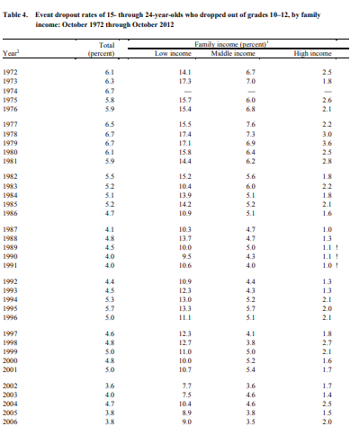

Source: National Center of Education Statistics (2015)

Conclusion

References
- Anderson, C., A. and Bushman, B., J. (2002) ‘Human Aggression’ Annual Review of Psychology. 53. p. 27-51. Available at: https://search-proquest-com.ezproxy.uwtsd.ac.uk/docview/205753750/fulltextPDF/B0C22F344A04840PQ/1?accountid=130472
- Ajzen, I. (1991) ‘The Theory of Planned Behaviour’, Organizational Behaviour and Human Decision Processes. 50, 179-211. Available at: https://www.dphu.org/uploads/attachements/books/books_4931_0.pdf
- Armitage, C., J. and Conner, M (2001) ‘Efficacy of the Theory of Planned Behaviour: A meta-analytic review’, British Journal of Social Psychology, 40, 471–499. Available at: http://citeseerx.ist.psu.edu/viewdoc/download?doi=10.1.1.1066.9830&rep=rep1&type=pdf
- Berkowitz, L. (1989) ‘Frustration-Aggression Hypothesis: Examination and Reformulation’ Psychological Bulletin, Vol. 106. No. 1, p. 59-73. Available at: https://web-a-ebscohost-com.ezproxy.uwtsd.ac.uk/ehost/pdfviewer/pdfviewer?vid=1&sid=84fa9448-799c-4c35-9467-484da654df4b%40sdc-v-sessmgr01
- Breuer, J., & Elson, M. (2017). Frustration-Aggression Theory. In P. Sturmey (Ed.), The Wiley Handbook of Violence and Aggression (pp. 1-12). Chichester: Wiley Blackwell. https://doi.org/10.1002/9781119057574.whbva040
- Brown, C. (2006) Social Psychology. London: Sage Publications.
- Godin, G. et al. (1992) ‘Research report: Predictors of smoking behaviour: an application of Ajzen’s theory of planned behaviour’, British Journal of Addiction, 87, 1335-1343. Available at: https://d1wqtxts1xzle7.cloudfront.net/46206802/Predictors_of_smoking_behaviour_An_appli20160603-8571-av8by0.pdf?1464983045=&response-content-disposition=inline%3B+filename%3DPredictors_of_smoking_behaviour_an_appli.pdf&Expires=1616533881&Signature=YHTPQTOCiFjmAfIb1kbLKrPwpVaRcEkmnrGZqZazYcYdRn83e1OizMb3rM7yNaDdjQTLUQmGacbT1FtTsJM3WrMX5oBjCc7uXrzmLCO-Q-9szTAq2r5c4afrNrurcU2-7GeLjQh9EGIHuCigDUTDBWuvPGfml7gY9fUd8AMIENuAGiqewJdCw33P7USRubcZkS6YgGVIPflym9IdJOUWPnRb~xSCRlXINyGvEB9qTOYetyQZzMwREzyHJ0gHNSyW1~KM2Mg2tayl0fLKmPpGcHkOVFe2IAIVJCTb-C~4LXijRYsCxWTjKqDlVZYX44QDwjIJbZKZs4G0H~tZhRHFNA__&Key-Pair-Id=APKAJLOHF5GGSLRBV4ZA
- Hogg, M., A. and Vaughan, G., M. (2014) Social psychology. 7th Ed. Harlow: Pearson Education Limited.

- Hornsey, M., J. (2008) ‘Social Identity Theory and Self-categorization Theory: A Historical Review’, Social and Personality Psychology Compass, 2/1, pag 204–222. Available at: https://d1wqtxts1xzle7.cloudfront.net/37117312/Hornsey-20082.pdf?1427342763=&response-content-disposition=inline%3B+filename%3DSocial_Identity_Theory_and_Self_categori.pdf&Expires=1616520419&Signature=MN0GOPeADnDqB-f6trzRqmDQ4pShTNl7-K3oloeB-XJ1gksO~C6E2mXcM7eyJD9cDq44r27nnYVen1vnXmRdZm4EDBuxWj6UX3F3k0h5YW5xlFjNYbjVoRe5AebsEj3vbrll6NCRzQJYgFw0v67Q9pTsIIslyPuNjL-KCJylJinHbKstUAL5yqhw426czFGu9u-wkAHToWURswJiTEGFX7odBGomNrOeCmaYhLtUFi6VBS4rDVrhfzGQHNJk4wnwoHAEZUmgDr0iwcuspjQDgUQXGRsfQA9b9edShnbhyaEnugE4fcIYGjjGTNRIiCSaMTXx~RBKVlpyUlX~J1-FFw__&Key-Pair-Id=APKAJLOHF5GGSLRBV4ZA
- National Center of Education Statistics (2015) Trends in High School Dropout and Completion Rates in the United States: 1972-2012. Available at: https://nces.ed.gov/pubsearch/pubsinfo.asp?pubid=2015015 (Accessed: 24 March 2021)

- Stets, J., E. and Burke, P., J. (2000) ‘Identity theory and social identity theory’, Social psychology quarterly, vol. 63, no. 3, pp. 224-237. Available at: https://search-proquest-com.ezproxy.uwtsd.ac.uk/docview/212780126/fulltextPDF/8C67E907226C4AFEPQ/1?accountid=130472

- Sniehotta, F. F., Presseau, J. and Aranjo- Soares, V. (2014) ‘Time to retire the theory of planned behaviour’, Health Psychology Review, 8:1, 1-7. Available at: https://doi.org/10.1080/17437199.2013.869710

- Uher, J. (2016) ‘What is Behaviour? And (when) is Language Behaviour? A Metatheoretical Definition.’ Journal of the Theory of Social Behaviour. Vol. 46 Issue 4, p475 27p. Available at: https://web-b-ebscohost-com.ezproxy.uwtsd.ac.uk/ehost/detail/detail?vid=0&sid=09772d87-1dce-4969-8c0b-0f5d4c5e3942%40sessionmgr103&bdata=JnNpdGU9ZWhvc3QtbGl2ZQ%3d%3d#db=s3h&AN=119974702

- Youth Justice Board / Ministry of Justice (2020) Youth Justice Statistics 2018/19 England and Wales. Available at: https://assets.publishing.service.gov.uk/government/uploads/system/uploads/attachment_data/file/862078/youth-justice-statistics-bulletin-march-2019.pdf (Accessed: 24 March 2021)

