u
Julie-Ann Higgins (1907809)
University of Wales Trinity St. David, MBA Sustainability Leadership
Leading Sustainability Change (BMSP7004D)
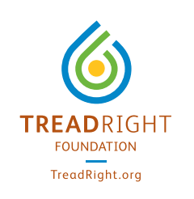
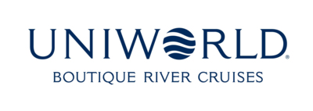
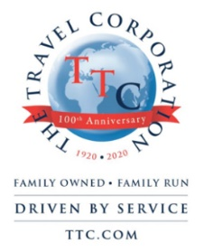
ELEVATING ENGAGEMENT.
Introduction

“ The secret of change is to focus all of your energy not on fighting the old
but on building the new”. – Socrates
With the recent release of our corporation-wide sustainability strategy „How We Tread Right” (HWTR) (TTC 2021), we have taken a deeper look at our organization as a whole and assessed our current status against that of our intended status for 2025. We have analyzed the 11 goals stated within HWTR and agreed that our organization, as one of 40 within this corporation, can have a direct impact upon 10 of these 11 goals. We have committed time, effort, and resources, both financial and human, towards defining the necessary operational adjustments and implementations needed in the achievement of each of these 10 goals. We have even undergone our first sustainable implementation across our fleet: a food waste management system which is aimed at impacting goal #3 – Reduce food waste by 50% across all hotels and ships by 2025. The success of which has been analyzed since implementation, and findings recorded in an internal report entitled „Return to Business: Food for Thought” (Higgins 2021a). And indeed, this first implementation may certainly be considered as overall successful, with 75% of the KPIs being achieved, and even exceeded, in its first year of use. Yet the single KPI which we have failed in attaining until now should not be underestimated, as it is this one in particular which may dictate our ultimate success in the achievement of every single goal within our strategy: that of Employee Satisfaction and Engagement.
During the vlog entitled „Employee Engagement: A Sustainability Leadership Challenge” (Higgins 2021b), we delved further into employee engagement and its relative importance within our strategy implementation, gaining further insight into the influence our leadership team has on engagement levels and the corresponding relation to trust, the need for innovation and long term perspective, as well as the importance of employee development. These factors all reinforce the understanding that we have the ability to influence whether our shift towards sustainability is successful, or not, and with the aid of a robust action plan in place, we can then harness the power of an engaged workforce to the benefit of the organization itself and each employee.

Objective
And here lies the purpose of this report and accompanying action plan: to propose several steps of change that are considered necessary to facilitate increased engagement across our workforce and gain the buy-in for our HWTR strategy and its intended outcomes, according to an appropriate change model. The chosen model of change, and all of its elements are explained here within according to the following structure:
- Our Change Management Approach
- A- Creating Awareness
- D- Increasing Desire
- K - Increasing Knowledge
- A - Increasing Ability
- R - Reinforcing Change
The proposed change action plan may be found here attached as an Appendix, and is designed to reach our objective of creating, and then maintaining, an engaged workforce that is actively involved across all levels of the organization in the realization of our How We Tread Right Sustainability Strategy by 2025. Engagement level will be measured in Q4 of 2022 against the desired NPS rating of 75% in a targeted employee survey.

Our Change Management Approach
Change is ever constant and unavoidable, and different individuals or teams react to change in very different ways, never entirely predictable, nor identical. Depending on the identified needs of an organization, there exist many models for change management, each with its various, and sometimes overlapping, stages, phases or points of consideration, all aimed at guiding an organization through the process of change (Cameron, Green 2019).
For the purpose of our objective, Hiatt’s ADKAR model has been selected as a suitable basis on which this plan is built upon and its concept may be seen here below in Diagram 1.
Diagram 1: ADKAR Model (Hiatt 2006)
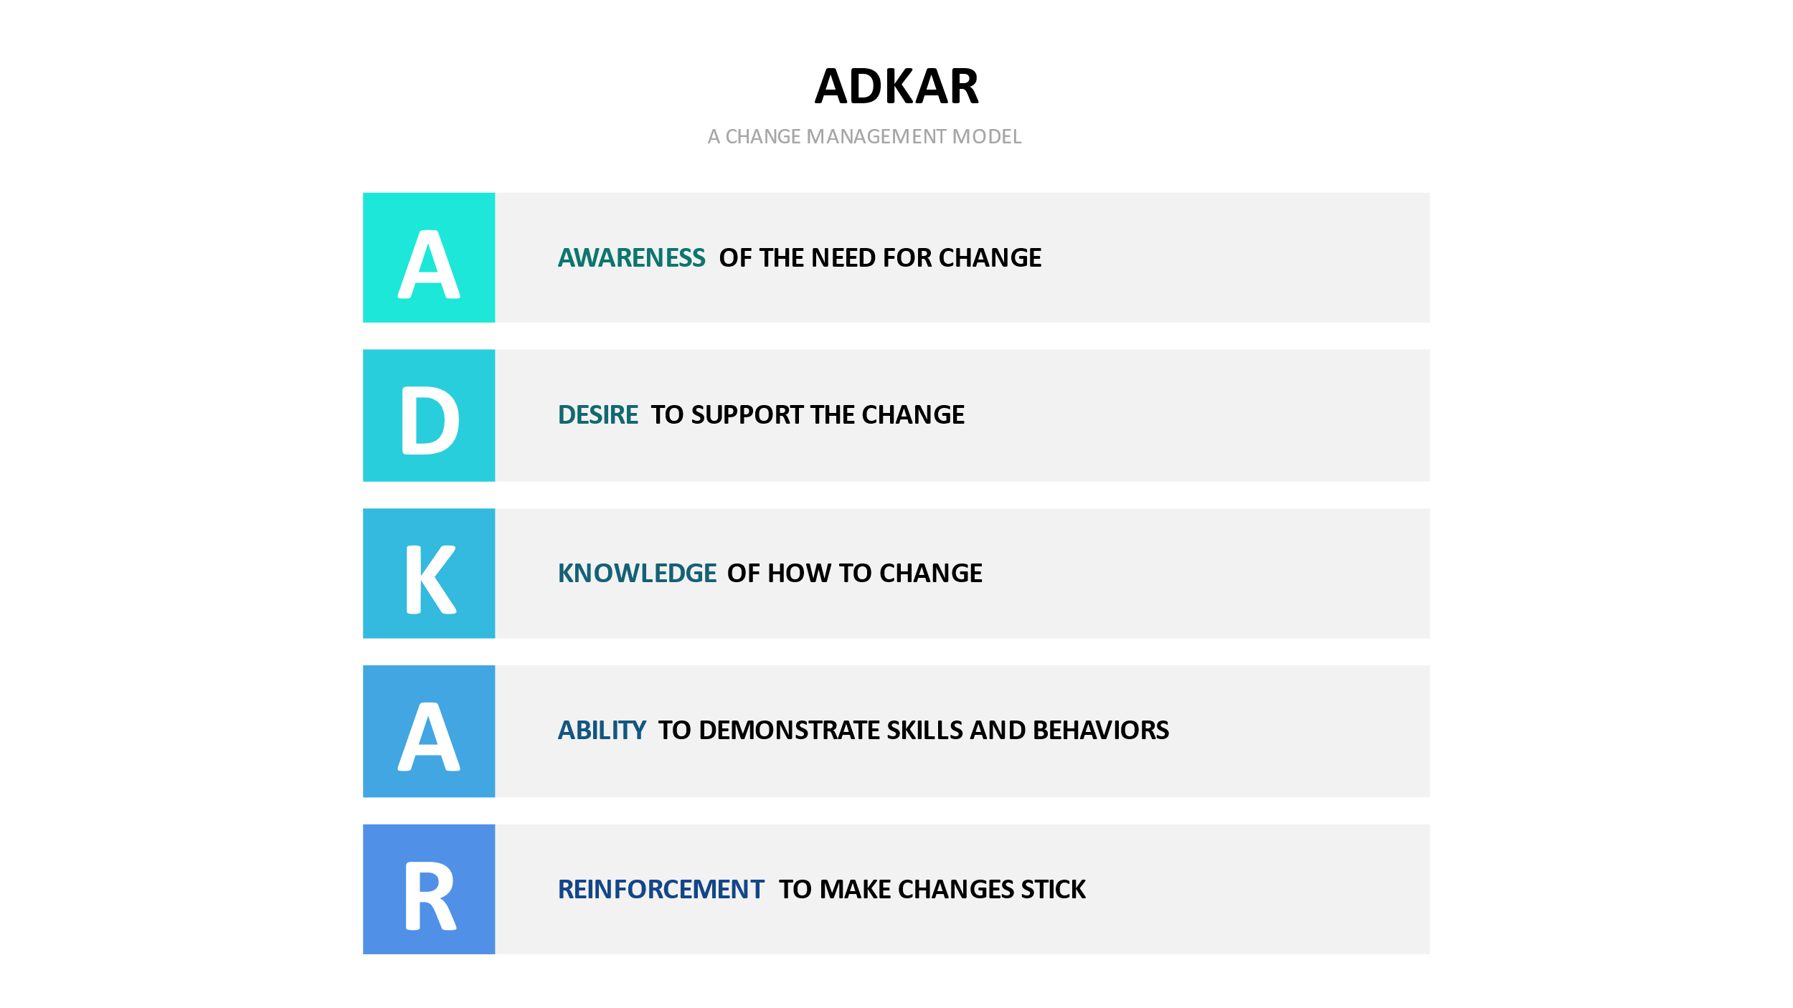
This bottom-up approach is one of flexibility, investigating why change is or is not working, and why the desired results are not being obtained. It is exactly this flexibility and bottom-up approach which some may consider as a weakness of this model, and may not always be a suitable choice when larger transformations are necessary, as it misses a directional aspect needed in larger projects. (Higgins 2021c). Yet the 5 elements of this model provide us with a suitable framework for managing the human aspect throughout our process of change (Hiatt 2006) and supports us in being able to identify which of the 5 aspects may be resulting in the lower engagement level of our sustainability strategy and implementations, and ensuring we consider this when planning next actions to be taken (Boca 2013). It zooms into each individual, with an underlying ethos of change on any scale begins with each individual and their change process (Tudor 2014) which is a fitting match with our current sustainability challenge on increasing employee engagement.
However, some also argue that no change model exists which can fully guarantee successful change within an organization, and these models have been labeled as one-dimensional in certain instances (Caldwell 2003) and as not capable of incorporating the full surrounding complexity or that they are based upon an approach not designed to withstand the continuous change in which change itself operates (By 2005). It is with this argument in mind, and to counteract the shortcomings of the ADKAR model, that several elements from other change models have been incorporated here within to create a unique hybrid model on which this proposed action plan is thus based.
Throughout this ADKAR process, the change management team will aim to:
- Better prepare the organization for change by creating greater awareness of our HWTR strategy and the need for change and promoting the desire for our employees to actively participate in and support this change
- Support employees in gaining knowledge and understanding on how to change
- Support employees in improving their abilities to implement the new strategy and achievement of its goals, and reinforcing the change in engagement level by creating a culture of ownership and reward
A - Creating Awareness
As we have realised, creating awareness is about more than simply announcing our intended change and implementation of HWTR. There needs to be a broad understanding within our employees of the „Why” behind our change – Why do we need to change? Why do we need to change now? (Tudor 2014).
Organizational Readiness for Change
The implementation of another model here will assist us in assessing our current level of awareness and readiness for change. There is a direct link between employee acceptance and commitment during the process of organizational change (Savolainen 2016), and the Kűbler-Ross change curve, as seen below in Diagram 2, is a tool that allows for tracking an individual or an organization’s emotional perception of, and their ability to transition through, change. If we can develop a method of assessing our employees' current emotional acceptance of our sustainable transition, it may then assist us in better understanding our current level of readiness for change, as well as to accelerate the progression of our employees through this curve towards acceptance and ultimately to commitment.
Diagram 2: Kubler Ross Change Curve (Kübler-Ross, Wessler et al. 1972)
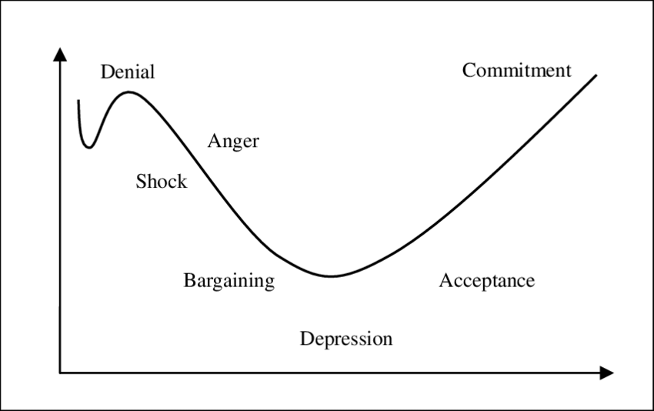

Thus, in order to gauge current awareness, knowledge and acceptance of our HWTR strategy implementation, and ultimately to increase commitment and engagement across all levels, as well as to initiate the first feedback loop, it is proposed as an initial step within the action plan to send out an online survey with questions aimed at gaining further insight into the following:
- Awareness of HWTR strategy
- Desire to participate with our transformation
- Identifying concerns or fears with the proposed change
- The existing level of knowledge of HWTR strategy and the concept of sustainability
- Appreciation of the organization's intention
- Skills that can be used to the benefit of the strategy/skills which require further development
Guiding Coalition of Change Leaders
ADKAR is also as mentioned a bottom-up approach, which necessitates involvement across all levels of the organization, to solidify inclusion and engagement on all levels (Cameron, Green 2019). It is important however that a core leadership team is guiding our organization through this entire process, and as you will see within the attached action plan, this is one of our first required implementations, and which will henceforth be referred to as our guiding coalition of change leaders, involving our top level of leaders and spanning each department within our organization, led by our Managing Director who is central to any decision being taken.
It is here that the 4 Change Principles of Kotters updated 8 step model may be seen as relevant and applicable within our engagement strategy and is also aligned with what was spoken about within our Employee Engagement vlog (Higgins 2021b) and the potential influences of leadership on the success of a change initiative. Kotter's model was initially offered to the business world more than 4 decades ago and then later reimagined to incorporate these 4 principles. Aptly dubbed „Accelerate!”, they were integrated into the model to better meet the rapid pace in which the world now operates, and to counter the top-down and directive approach this model previously became known for (Kotter 2012). It is recommended that these 4 principles are applied during the formation of our guiding coalition of change leaders.
- Leadership plus Management:
- Meaning: All levels of management must support the change as required by top-level leaders for any change to be successful.
- Takeaway: We will incorporate different levels of leadership within our core guiding team
- Head plus Heart:
- Meaning: Buyin to any new concept, such as our strategy, is triggered by communicating with emotion, and not just based on logic. By showing passion and authenticity we are communicating on a level which human beings best understand. (Gentry, Eckert et al. 2014)
- Takeaway: Leaders involved need to have the ability to connect and build relationships, and communicate on an emotional level to engage. This skill development will be an inclusion within our learning strategy.
- Select few and diverse many:
- Meaning: Effective Change teams need to incorporate and involve people across all levels of the organization in order to be successful (Kotter 2012)
- Takeaway: Besides a core Leadership team guiding the change, a wider secondary team will be formed to head up sustainability initiatives and implementations in diverse locations across our fleet
- „Have to” plus „Want to”:
- Meaning: Changes happens in a smoother and faster way when there is free will involved.
- Takeaway: Involvement should be one of voluntary status

Channels for sharing of information
As we emerge from this era of an operational halt due to Covid, we emerge with a far greater understanding of the importance of internal communications across our organization, having spent the last 14 months communicating via social media channels to keep our employees engaged and informed. This should not be abandoned upon our restart, but rather enhanced and cultivated as a norm.
Studies conducted have shown that organizations that create effective channels of internal communications that facilitate bottom-up communication, as well as top-down sharing of information, are more successful than those that do not, as it leads to a better understanding of the organization's goal, and thus results in a higher engagement and productivity level (Genç 2017). As mentioned by Saunders, Social Media and sustainability share common values of transparency and collaborative mechanisms (Saunders 2021) and complement each other in their ability to enable inclusive and two-way dialogue which allows for the sharing of information and ideas across all levels. The ability to share real-time information also allows for an increased sense of urgency when necessary (Pollack, Pollack 2015)
It is thus recommended that we formalize our company-wide communication channel and open up our internal site, Yammer to all employees, not only upper level and use this as our primary channel for sharing information on our strategy progression.

D – Increasing Desire
Acknowledging concerns
For change to occur, the change must be desired by the ones implementing the change itself, and desire for change can be fostered within employees. Change acceptance is reliant upon several factors, such as commitment to the organization itself, the amount of support provided by managers, and ultimately the existing trust level the employees have for their leaders, and as change is subconsciously linked with loss, we need to identify these perceptions of loss and address them, ensuring our strategy is focused on increasing benefit to offset the loss (Stouten, Rousseau et al. 2018). In our previously mentioned employee survey, we will gain feedback on perceived concerns from the employees’ perspective, and these should be acknowledged and addressed by our Directors level in a public manner, such as a Town Hall event.
Sustainability Ambassadors
The 4th change principle of Kotters „Accelerate” model is once again applicable within this context: „Have to” plus „Want to” (Kotter 2012). With our aim of increased engagement and involvement across all layers of our organization, the formation of a „volunteer army” or sustainability ambassadors will play a vital role in this by harnessing their existing commitment and passion to influence colleagues who are not yet convinced (Grossman 2018), and it is thus included within our action plan to allow employees to step forward, from any single given layer of our organization, and volunteer as one of our sustainability ambassadors. Here we put a focus on empowering our employees to play an active role within this shift towards sustainability, and their roles will include:
- Communications on provided internal social platforms
- Influencing positive perception
- Implementation/overseeing of new initiatives onboard their ship
- Participating in idea sharing workshops
- Additional training based on Needs assessment
These ambassadors will also be used as public figures on various social media channels, aimed at not only increasing our brand presence, however ultimately increasing individual employees' perception of involvement and participation in our strategy and transformation (Smith, Kendall et al. 2018). By implementing a program such as PostBeyond, whereby our organization can make applicable and appropriate content available to these employees for posting minimizes concerns of risk to brand reputation.
Recognition and Reward
Studies show beyond any doubt that an effective reward system, based on incentivized individual and team performance results in significantly increased levels of engagement and desire to be involved (Lardner 2015). Rewards should not only be associated with financial gain, however also allow for recognition across the organization and from the leadership level or benefits such as increased opportunities for learning and participation in specialized projects, as well as the prospect of career development (Taufek, Fatini Hanim Binti Mohamed, Zulkifle et al. 2016). It should also be taken into account when formulating our reward system that incentivized targets increase competitiveness, resulting in increased engagement (Hoole, Hotz 2016).
Sustainability needs to be incorporated within our existing reward and bonus structure, and Directors should work on an adequate inclusion of this topic within their departments. With the incorporation of sustainability targets, care must be taken to set SMART targets which are publicized, to avoid any perception of prejudice or unfairness in the allocation of these rewards (Ramus 2001) which would only serve to dismantle increased engagement.
K – IncreasINGknowledge
Over the last few years, we have been quite successful in creating a culture of learning across our organization, with a focus on both technical and soft skills, and embraced within each department and each level of our hierarchy. However, we have yet to incorporate the topic of sustainability and our HWTR strategy as a learning opportunity. Now is the time for this.
Learning is key within any organization as it increases adaptability during changing times, supports innovation, and increases competitive edge (Crouse, Doyle et al. 2011). There are several aspects and methods to learning that are suitable to implement here in this action plan:
- Formalized theoretical learning: Our corporation has recently launched a training library that covers all topics of our HWTR strategy and is built into the Litmos platform. It is hereby proposed that all employees across all levels of our company should gain access to this learning library, and are actively encouraged and incentivized to participate in this initial learning channel.
- Coaching: It was mentioned during our employee engagement vlog that the implementation of a coaching program led by our leaders leads to increased trust, and thus increased engagement (Higgins 2021b). However it is not only about building trust, mentoring and coaching programs are a vital element in the building of confidence and ability within individuals in order to perform to the level needed for successful transitions (Boca 2013).
- Informal learning channels: By implementing an internal communication platform such as Yammer, our employees have the chance to learn from each other by open communication and sharing of ideas. Facilitation of workshops will allow for sharing of ideas and possible future implementations.
- Innovation Program: Creating channels whereby employee creativity is encouraged and developed is a key resource when it comes to innovative solutions for sustainability challenges which we are currently facing (Ramus 2002) as well as increasing learning opportunities. It is advised here to invite our employees to submit business plans for sustainable solutions or interventions for specific challenges we may face. This should be implemented with an award to the selected winner/s along with the implementation of their proposal. Thie purpose here is not only to find feasible solutions, but the demonstration of belief our organization has in the innovation and idea generation of our own employees will play a crucial role in increasing commitment from our employees (Nijhof, Krabbendam et al. 2002)
A – Increasing ability
This element focuses on leaders and management and their influence on employee ability development and the allowance to demonstrate it, or in simplified terms: have we created an environment whereby our employees continue to learn and practice the newly acquired skills set about in knowledge creation, guided by coaches and mentors and whereby barriers are rapidly identified, acknowledged, resolved or removed to allow the ability to be demonstrated and further developed (Shepherd, Harris et al. 2014)?
By continuously evaluating our working environment, updating standard operating procedures to align with our sustainability strategy, and ensuring all tools are provided which are necessary, we create a workplace that allows for what we are asking of our employees, and by removing barriers throughout this process, we lessen the risk of frustration and disengagement.
R – Reinforcing Change
This element ensures we keep our focus on the individual, and the acknowledgment of when desired outcomes are being achieved (Calder 2013). Our previously implemented feedback channels are critical here, and leaders need to emphasize regular feedback with employees and allowing for two way dialogue, and this may include the following channels:
- Employee appraisals
- One on one short feedback discussions
- Group discussions
Best practices across our fleet should be shared regularly, together with the deserved recognition of individuals and teams involved, and rewards are given according to the preset bonus and reward scheme, and once again, communication and acknowledgment are key here (Shepherd, Harris et al. 2014)
Conclusion
By basing our change initiative, which is aimed at increasing employee engagement, on a change model that focuses on the human aspect, we are minimizing the risk that important elements needed for effective change are not overlooked and that our action plan encompasses implementations aimed at targeting the very individuals who are expected to carry out this transformation. By harnessing the passion of our already engaged employees, those barriers created by doubt, fear, and perhaps lack of understanding or knowledge can be overcome, and by involving our team at every level, ensuring that we facilitate adequate learning and communication channels, and celebrating achievements and successes, whether that of an individual or a team, we create an environment that not only survives but thrives.

Bibliography
BOCA, G.D., 2013. Adkar model VS. quality management change, International Conference Risk in Contemporary Economy; Faculty of Economics and Business Administration, Dunarea de Jos University of Galati: Galati, Romania 2013.
BY, R.T., 2005. Organisational change management: A critical review. Journal of change management, 5(4), pp. 369-380.
CALDER, A.M., 2013. Organizational change: Models for successfully implementing change.
CALDWELL, R., 2003. Models of change agency: a fourfold classification. British Journal of Management, 14(2), pp. 131-142.
CAMERON, E. and GREEN, M., 2019. Making sense of change management: A complete guide to the models, tools and techniques of organizational change. Kogan Page Publishers.
CROUSE, P., DOYLE, W. and YOUNG, J.D., 2011. Workplace learning strategies, barriers, facilitators and outcomes: A qualitative study among human resource management practitioners. Human Resource Development International, 14(1), pp. 39-55.
GENÇ, R., 2017. The importance of communication in sustainability & sustainable strategies. Procedia Manufacturing, 8, pp. 511-516.
GENTRY, W.A., ECKERT, R.H., STAWISKI, S.A. and ZHAO, S., 2014. The challenges leaders face around the world: More similar than different. Center for Creative Leadership White Paper.Retrieved January, 6, pp. 2015.
GROSSMAN, D., 2018-last update, Influencers Can Help Implement Change and Make It Stick. Available: https://www.yourthoughtpartner.com/blog/bid/77212/influencers-can-help-implement-change-and-make-it-stick [Apr 27, 2021].
HIATT, J., 2006. ADKAR: a model for change in business, government, and our community. Prosci.
HIGGINS, J., 2021a. Return to Business: Food for Thought. Internal Uniworld report. Unpublished.
HIGGINS, J., 2021b. Employee Engagement:A Sustainability Leadership Challenge. [Online video]. Available: https://youtu.be/QpzsnGlyUnM [Apr 29, 2021].
HIGGINS, J., 2021c. Week 6 discussion forum, activity 2, Apr 18, 2:14PM
HOOLE, C. and HOTZ, G., 2016. The impact of a total reward system of work engagement. SA Journal of Industrial Psychology, 42(1), pp. 1-14.
KOTTER, J.P., 2012. Accelerate! Harvard business review, 90(11), pp. 44-52, 54.
KÜBLER-ROSS, E., WESSLER, S. and AVIOLI, L.V., 1972. On death and dying. Jama, 221(2), pp. 174-179.
LARDNER, S., 2015. Effective reward ensures effective engagement. Strategic HR Review, .
NIJHOF, A., KRABBENDAM, K. and LOOISE, J.C., 2002. Innovation through exemptions: building upon the existing creativity of employees. Technovation, 22(11), pp. 675-683.
POLLACK, J. and POLLACK, R., 2015. Using Kotter’s eight stage process to manage an organisational change program: Presentation and practice. Systemic Practice and Action Research, 28(1), pp. 51-66.
RAMUS, C.A., 2002. Encouraging innovative environmental actions: what companies and managers must do. Journal of world business, 37(2), pp. 151-164.
RAMUS, C.A., 2001. Organizational support for employees: Encouraging creative ideas for environmental sustainability. California management review, 43(3), pp. 85-105.
SAUNDERS, S., 2021. Week 7 discussion forum, activity 2, Apr 15, 10:29AM

SAVOLAINEN, S., 2016. Could Acceptance Predict Commitment in Organisational Change? Impact of Changes Caused by Succession From the Viewpoint of Non-family Employees in Small Family Firms. Management, 4(5), pp. 197-215.
SHEPHERD, M.L., HARRIS, M.L., CHUNG, H. and HIMES, E.M., 2014. Using the Awareness, Desire, Knowledge, Ability, Reinforcement Model to build a shared governance culture. Journal of Nursing Education and Practice, 4(6), pp. 90.
SMITH, B.G., KENDALL, M.C., KNIGHTON, D. and WRIGHT, T., 2018. Rise of the brand ambassador: Social stake, corporate social responsibility and influence among the social media influencers. Communication Management Review, 3(01), pp. 6-29.
STOUTEN, J., ROUSSEAU, D.M. and DE CREMER, D., 2018. Successful organizational change: Integrating the management practice and scholarly literatures. Academy of Management Annals, 12(2), pp. 752-788.
TAUFEK, FATINI HANIM BINTI MOHAMED, ZULKIFLE, Z.B. and SHARIF, MOHAMED ZULFADHLI BIN MOHD, 2016. Sustainability in employment: Reward system and work engagement. Procedia Economics and Finance, 35, pp. 699-704.
TTC, 2021-last update, How We Tread Right 2025. Available: https://ttc.com/hwtr/ [Apr 27, 2021].
TUDOR, L., 2014. Change management–challenge and opportunity for sustainable development of Romanian companies, Proceedings of the International Management Conference, Faculty of Management, Academy of Economic Studies, Bucharest, Romania 2014, pp. 466-476.

Appendix A: Action Plan
 | Organizational Change Activity | Persons/Teams responsible for Implementation | Required Completion Date | Expected Cost Involved
A | Online Employee Assessment Questionnaire | Learning & Development | Q2 2021 | No
A | Formation of a guiding coalition of Change Leaders | Managing Director | Q2 2021 | No
A | Incorporating HWTR Strategy into Recruitment Strategy | Employee Branding & Recruitment Manager | Q3 2021 | No
A | Granting access to Yammer to all levels of employees | Managing Director/IT Department | Q3 2021 | Yes - Licensing fee per person
D | Recruit Volunteer Ambassadors | Learning and Development | Q3 2021 | No
D | Address fears/barriers | Directors Level | Q3 2021 | No
D | Restructure bonus system to include HWTR and publish | Directors Level/  Managing Director | Q3 2021 | No
D | Design and implement recognition program fleetwide | Learning & Development | Q3 2021 | No
K | Access Litmos HWTR library training across all levels | Learning & Development/ TTC | Q3 2021 | Yes - Licensing fee per person
K | Opening group channels for sharing on Yammer | Change Leaders Coalition | Q3 2021 | No
K | Creation and implementation of specialized soft skills for change leaders based on individual needs | Learning & Development | Q4 2021 | No
K | Creation of Innovation Program | Change Leaders Coalition/ Learning & Development | Q1 2022 | Yes – Agreed upon financial Award
A | Assessing barriers | Change Leaders Coalition | Ongoing | No
A | Enable action by barrier removal | Change Leaders Coalition | Ongoing | Dependant upon barrier assessments
A | Updating Standard Operating Procedures to allign with HWTR | Change Leaders Coalition/ Directors Level | Q1 2022 | No
R | Establishment of feedback loops | Change Leaders Coalition | Q3 2021 | No
R | Measure change according to Preset KPIs | Change Leaders Coalition | Q1 2022 on bi monthly basis | No
R | Changing of policies and procedures | Change Leaders Coalition/ Directors Level | As needed based on feedback and KPI analysis | Possible

