

Matthew Benjamin

Computational Modelling of Ballistic Impact

School of Applied Computing
Ordnance, Munitions, and Explosives (OME)

BEng Hons
Academic Year: 2024 - 2025

Abstract
This report discusses the failure mechanisms of 4340 steel under ballistic impact using finite element analysis in Abaqus. The Johnson-Cook models were applied to simulate projectile impacts at velocities of 800 m/s and 1000 m/s. Therefore, simulation outputs, including the Max Principal Stress and S23 shear stress, were applied to determine whether tensile or shear-dominated failure modes caused the failure. The analysis reveals that tensile spalling occurs at 800 m/s, while adiabatic shear banding and plug formation dominate at 1000 m/s.

Additionally, the report discusses the limitations of micro-scale modelling to real-world, macro-scale armour applications. Furthermore, the overall structure and phrasing within this report are by the professional, scientific writing conventions outlined by Silyn-Roberts [1].

Introduction

Background
Ballistic impact, a central theme, is a complex phenomenon described by extremely high strain rates, large deformations, and intense energy degradation over short intervals. It is prevalent in military and defence environments, where projectiles strike protective structures, such as armour. Therefore, understanding the characteristics and behaviour of materials is essential for designing effective armour systems that can withstand or absorb ballistic kinetic energy, according to J. Dean and T.W. Clyne [2]. Conventional ballistic resistance testing through live-fire trials offers valuable results but is often expensive and time-consuming.
To overcome these limitations, computational modelling, especially finite element analysis (FEA), has emerged as a productive solution. This outcome allows engineers to model the high-speed impacts of projectiles in a controlled environment. More importantly, this method enables the analysis of failure modes, stress propagation, and deformation across various impact speeds and material conditions [3]. Among the many models developed for this purpose, a key aspect discussed is the Johnson-Cook (J–C) plasticity and failure model, one of the most widely adopted in high-strain-rate applications. The J–C model accounts for strain hardening, strain-rate sensitivity, and thermal softening in the key behaviours of metals observed during ballistic penetration and failure. In brief, the J-C failure model facilitates the simulation of progressive damage. The evidence suggests it is the most suitable for simulating ductile fracture under impact [4]
In this report, finite element simulations will investigate the failure mechanisms of a 4340 steel plate under ballistic impact from a rigid metal at two velocities: 800 m/s and 1000 m/s. The primary aim is to determine whether the plate fails due to direct stress tension, compression, or shear stress by examining Max Principal Stress and S23 shear stress contours. These two outputs from Abaqus allow a detailed inspection of where and how material failure initiates and propagates.
For instance, Figures obtained from these simulations at different time frames —11, 51, 126, and 211 —will provide visual evidence for this failure analysis, which will be presented further in the report. The key aspect of this report is to discuss the limitations of modelling ballistic impact in a micro-scale simulation and how those limitations affect applicability to real-world macro-scale armour systems.
Finally, the findings are particularly relevant to ordnance and munitions engineering (OME), focusing on material selection and design for ballistic systems. The report's structure includes a methodology outlining model setup and material properties, a detailed section on simulation results and analysis, including images and figure references, a discussion of failure mechanisms and simulation constraints, and final conclusions and recommendations.

Methodology and Material Parameters
This section outlines the simulation setup in Abaqus/Explicit, detailing the impact configuration, mesh structure, and the constitutive and failure models applied to replicate the ballistic behaviour of 4340 steel under two high-velocity conditions: 800 m/s and 1000 m/s.

Simulation Overview
The simulation replicates a controlled ballistic test in which a cylindrical, rigid metal impacts a stationary 4340 steel plate. A 3d explicit finite element model was developed in Abaqus/Explicit, selected for its capacity to handle nonlinear dynamic events, such as high-speed impacts and failure propagation [1]. The model consists of:
- Projectile: Will have a defined velocity speed of (800 m/s or 1000 m/s).

- Target Plate: Rectangular 4340 steel plate (material defined using Johnson–Cook).

- Interaction: Surface-to-surface contact with a rigid body.
The simulation was conducted using an axisymmetric finite element model, which further supports the evidence for the use of FEA in validating failure characteristics in a controlled environment, as described by Suo et al [5].

Material Model Plasticity and Failure
The (J–C) constitutive model is widely used for high-strain-rate applications such as ballistic impacts. It incorporates strain hardening, strain rate dependence, and thermal softening.

Johnson–Cook Plasticity Model
The Johnson-Cook dynamic flow stress model is defined using the following equation:
$$σ=\left(A+{Bε}^{n}\right) \left( 1+ C\text{ln} \frac{\dot{ℇ}}{\dot{ℇο}}\right){\left(1-T^{*}\right)}^{m}$$Where:
$σ$ = Flow stress (Elastic + Plastic Components)
$ε$ = Plastic strain
$\dot{ℇ}$ = Reference strain rate
$\dot{ℇο}$ = Plastic strain
$T^{*}$ = Homologous temperature
$A,B,{C,}^{n,m}$ = Material constants

This model was implemented in Abaqus Explicit for simulating plastic deformation resulting from ballistic impact. The use of this high-velocity impact simulation using 4340 steel is illustrated in detail by Burley et al [4].

Johnson–Cook Failure Model
The J-C failure model uses a damage initiation based on the corresponding plastic strain equation:

$$ε_{f}=\left(D_{1}+D_{2}e^{D \frac{σ}{{3σ}_{m}}}\right) \left( 1+ D_{4}\text{ln} \frac{\dot{ℇ}}{\dot{ℇο}}\right) \left(1+D_{5}T\right)$$
Where:
$ε_{f}$ = Failure strain
$D_{1}$to$5$ = Damage constants
$σ/σ_{m}$ = Ratio of stress triaxiality
$σ$ = Flow stress (Elastic + Plastic Components)
$\dot{ℇ}$ = Reference strain rate
$\dot{ℇο}$ = Plastic strain
$T$ = Homologous temperature

Material Parameters for AISI 4340 Steel
Material measurements for AISI 4340 steel were obtained from [6] . They represent a realistic behaviour profile for ductile failure under ballistic strain rates, using the specified parameters.

A | 850 MPa | Yield stress
B | 360 MPa | Hardening modulus
n | 0.304 | Strain hardening exponent
C | 0.072 | Strain rate sensitivity
M | 0.513 | Thermal softening exponent
Melting Temp | 1793 | K
Reference strain rate | $$\dot{ℇο}$$ | $${1s}^{-1}$$
Table 1 – AISI 4340 steel material properties

D1 | 0.05
D2 | 3.44
D3 | -2.12
D4 | 0.002
D5 | 0.61
Table 2 - J-C Damage constants

These parameters were applied within Abaqus as material properties for AISI 4340 steel, thereby enabling the simulation of stress and failure responses. The use of both plasticity and failure models ensured the realistic calculation of failure between tension and shear for this category of steel.

Output Variables
The following stress measures were selected for visualisation and processing for the following:

- Max Principal Stress: To detect tensile failure areas

- S23 (Shear Stress Component): To identify shear failure areas

- Velocity Magnitude: To assess the projectile and target energy absorption

Furthermore, these outputs were exported across frames 11–211 to capture the progression and the apex of failure.

Analysis of Results and Failure
The key aspect of this section presents the simulation results for projectile impact on a 4340-steel plate at velocities of 800 m/s and 1000 m/s, using Max Principal Stress and S23 shear stress plots. These visual outputs are interpreted to determine whether direct stress, tensile stress, compressive stress, or shear stress is responsible for failure in each case.

Failure Mode Analysis: 800 m/s
The data show that at 800 m/s, the projectile initiates impact with a high compressive load directly beneath the contact area (Figures 1 and 2).

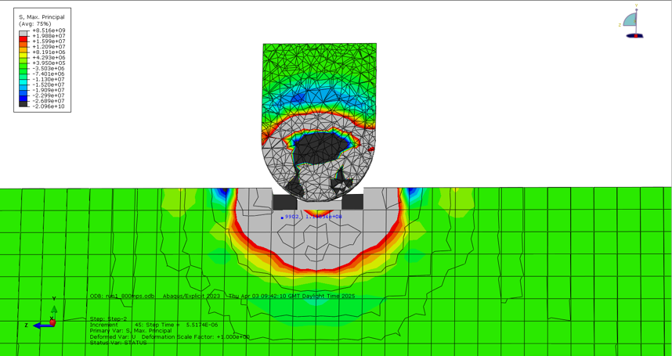

Figure 1 – Max Principal Stress (800 m/s – Initial Impact - 11)

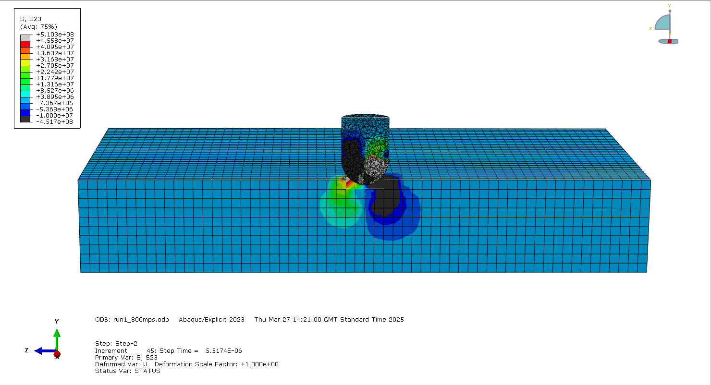

Figure 2 – S23 (800 m/s – Initial Impact - 11)

This compressive wave propagates through the plate thickness, causing a stress reflection at the rear surface, where tensile stresses accumulate. This can result in a back-face spalling response in ductile plates, as observed in the study by [7].
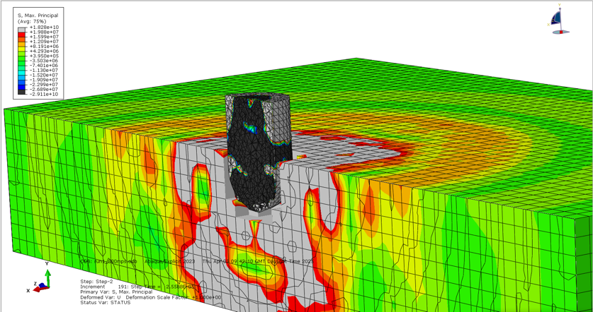

Figure 3 – Max Principal Stress (800 m/s – Mid Penetration - 51)

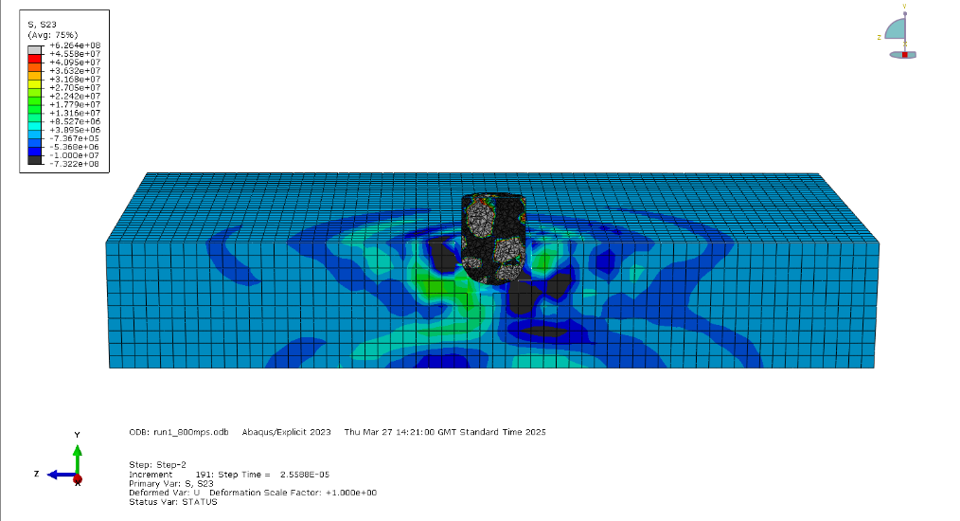
Figure 4 – S23 (800 m/s – Mid Penetration - 51)

By mid-penetration, evidence of shear stress, indicating friction and sliding, is visible as the projectile propagates through.

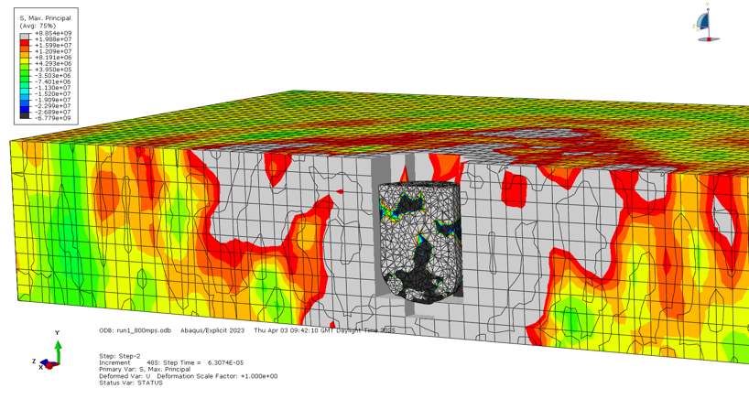

Figure 5 – Max Principal Stress (800 m/s – Rear Face Failure 126)

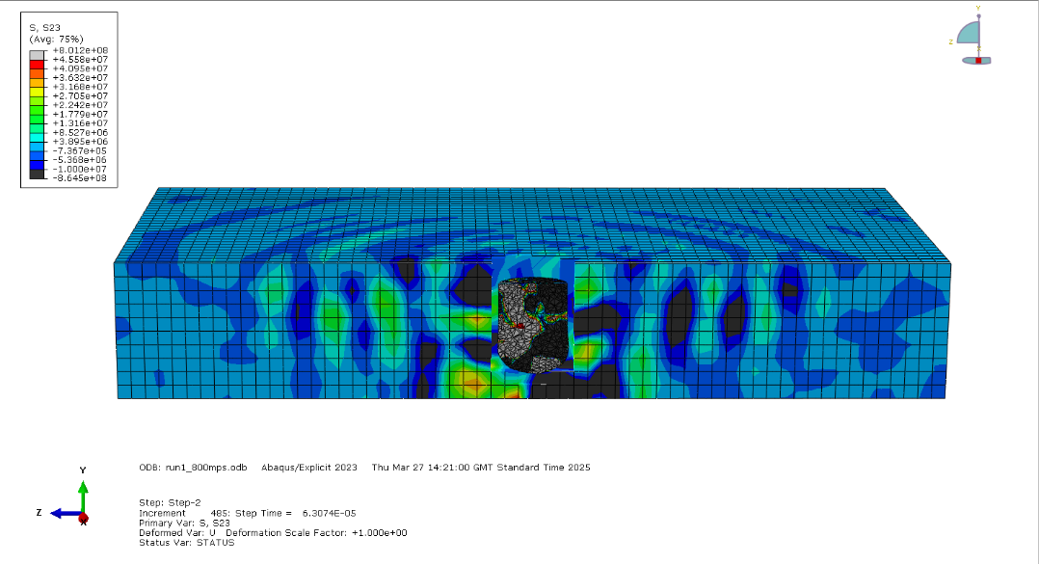
Figure 6 – S23 (800 m/s – Rear Face Failure 126)

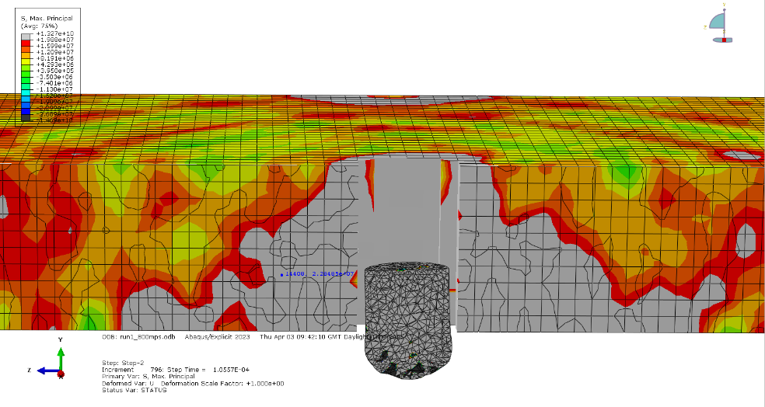

Figure 7 – Max Principal Stress (800 m/s – Final frame 211)
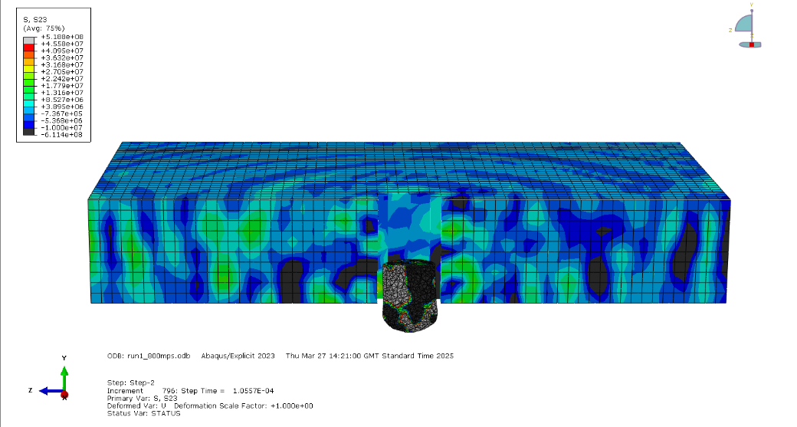

Figure 8 – Max Principal Stress (800 m/s – Final frame 211)

Failure Mode Analysis: 1000 m/s
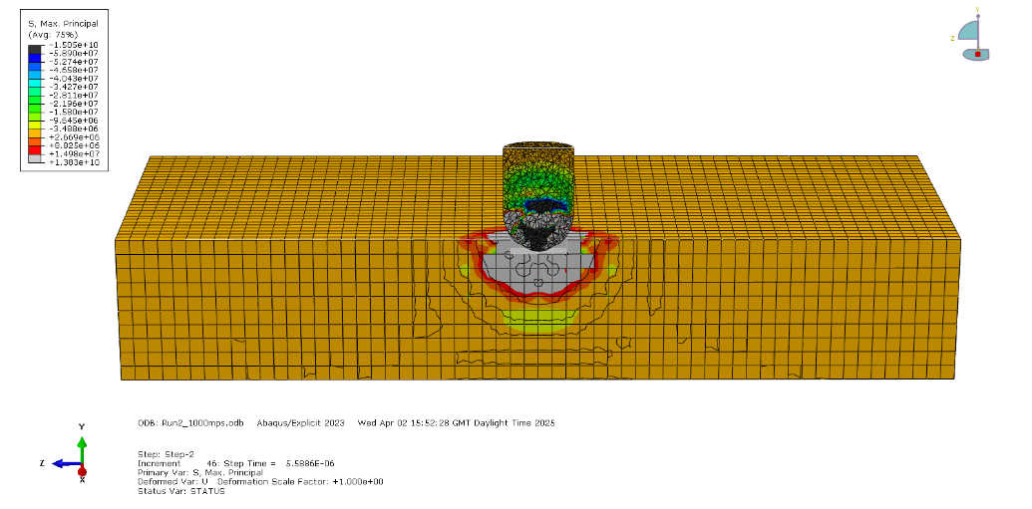
The data show that at 1000 m/s for S23

Figure 9 – Max Principal Stress (1000 m/s – Initial Impact - 11)
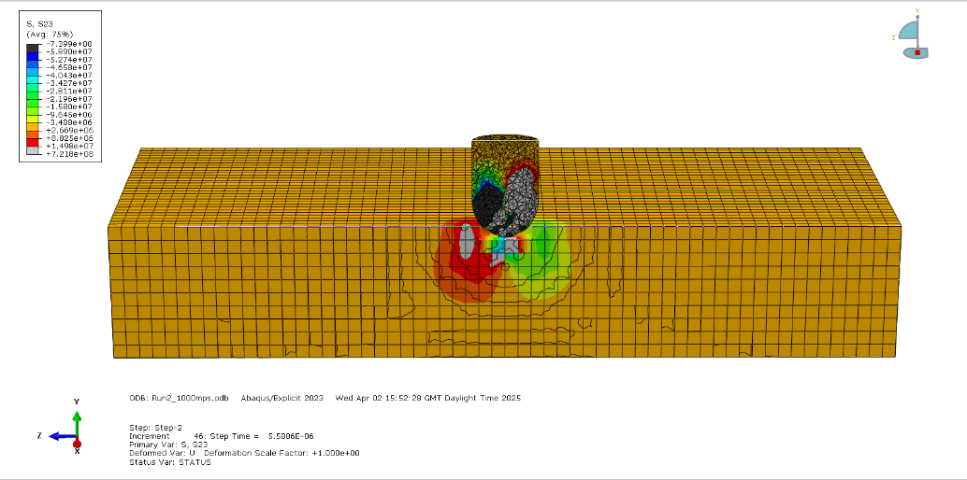

Figure 10 – S23 (1000 m/s – Initial Impact - 11)
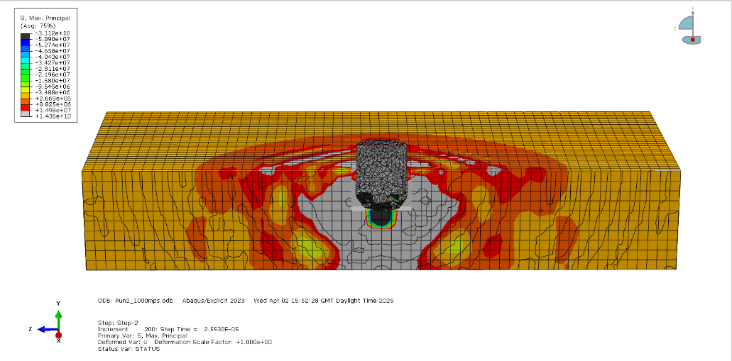

Figure 11 – Max Principal Stress – Mid Penetration - 51)

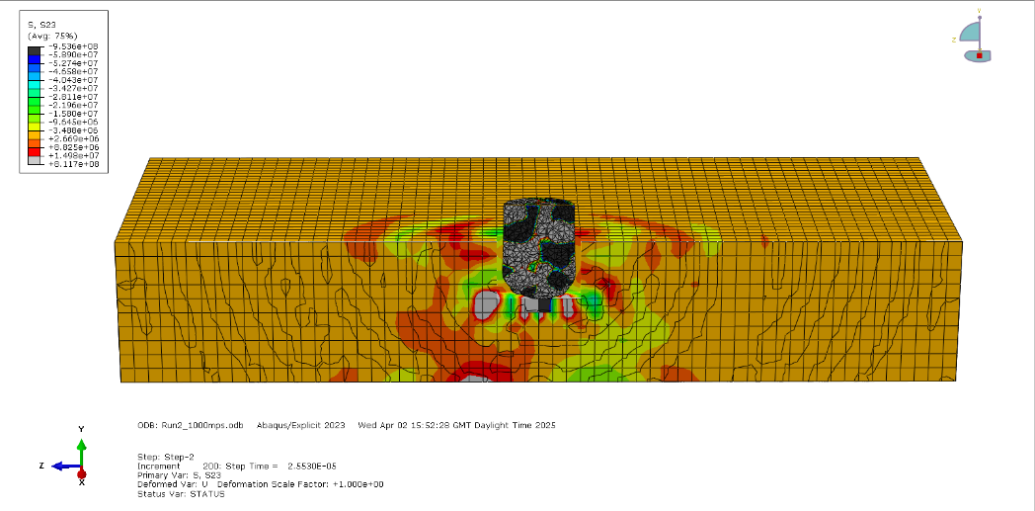

Figure 12 – S23 – Mid Penetration - 51)

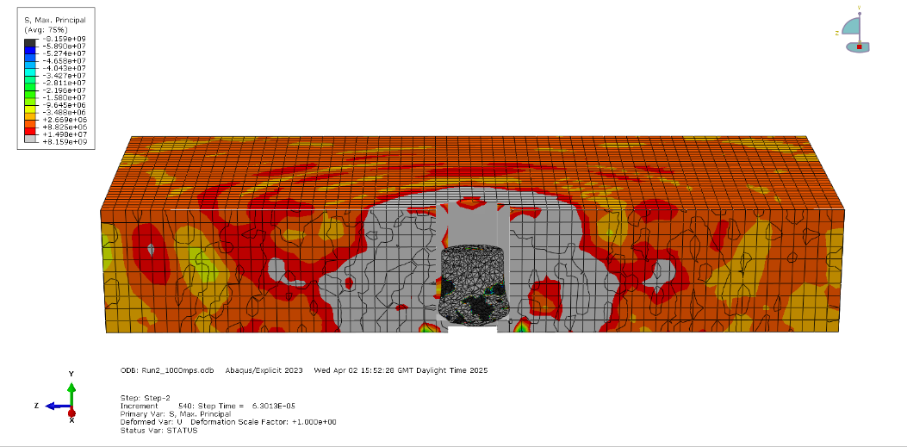

Figure 13 – Max Principal Stress – Rear Face Failure - 126)

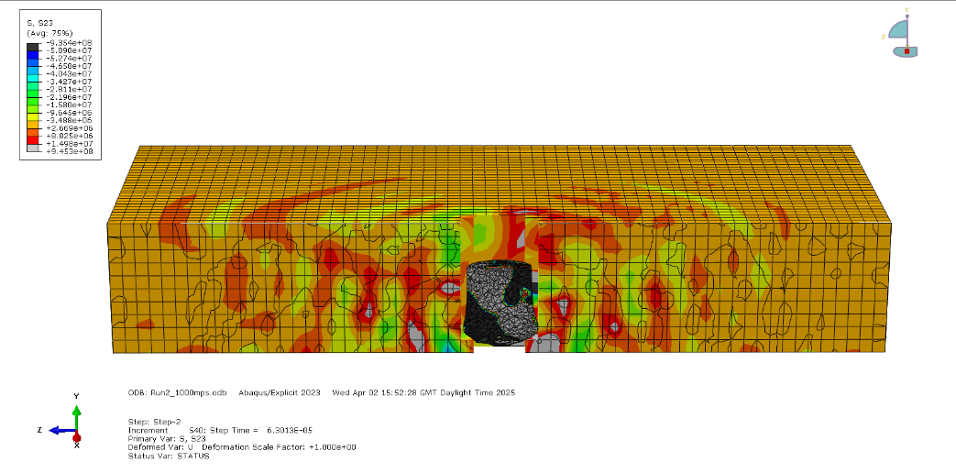

Figure 14 – S23 – Rear Face Failure - 126)

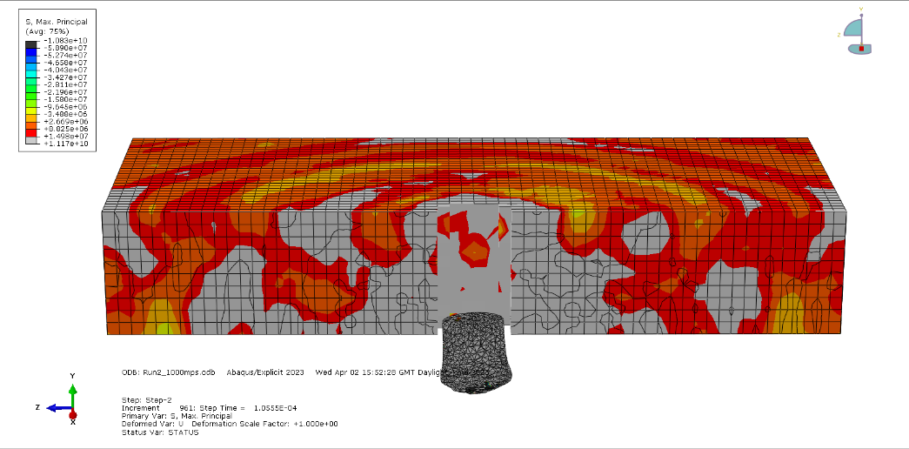

Figure 15 – S23 – Final frame - 211)

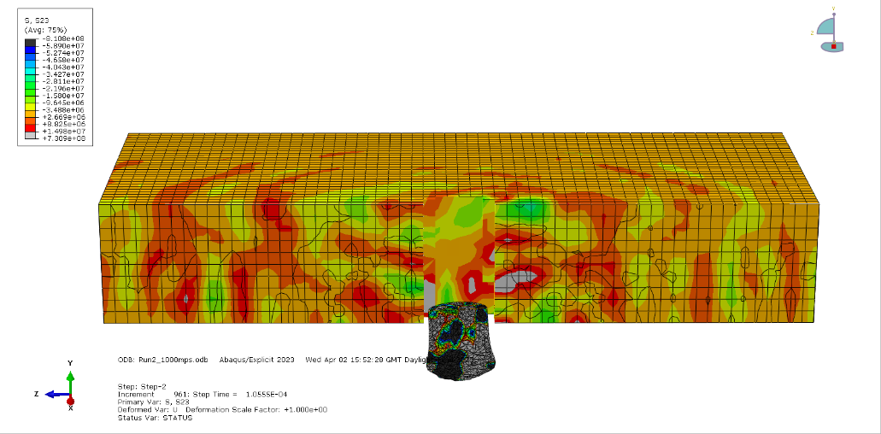
Figure 16 – S23 – Final frame - 211)

As seen in the Max Principal Stress plots (Figures 2 and 3), the appearance of tension zones at the rear face becomes evident as penetration increases. This evidence suggests that tensile bands are gradually increasing due to the reflected stress waves, consistent with tensile failure (direct stress), as described in high-strain-rate fracture mechanics [2].

By the final frame (Figure 7), the rear face has opened due to the release of stored elastic energy in the plate, confirming tensile-induced spall failure. In summary, the velocity profile (Figure 16) indicates a steady deceleration of the projectile, suggesting elastic–plastic energy absorption without catastrophic plug failure.
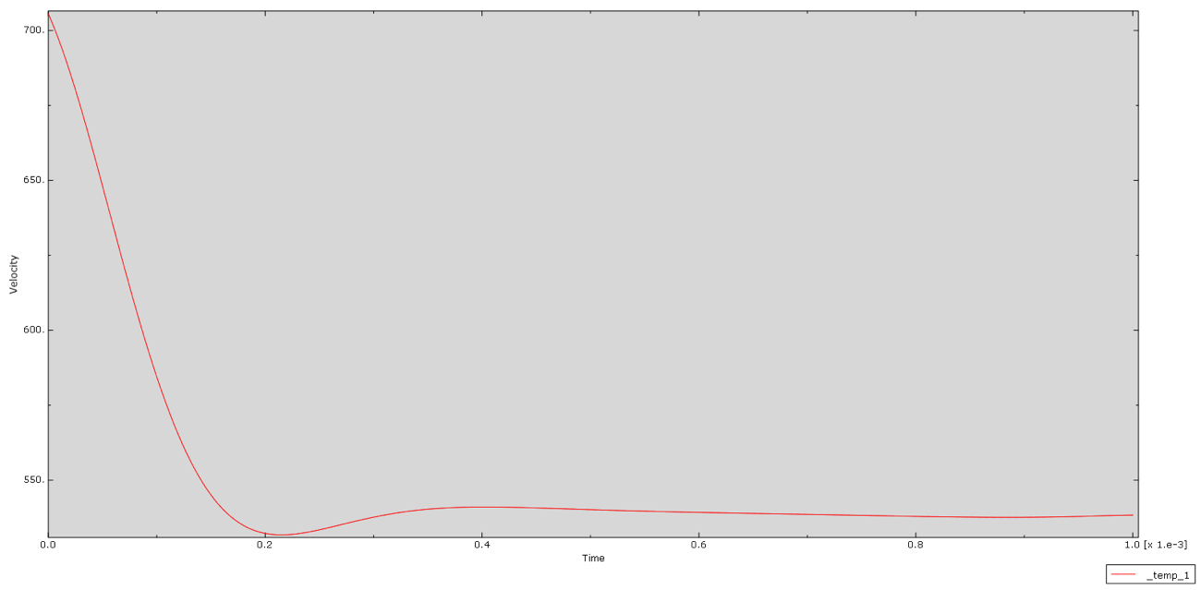

Figure 17 – Velocity profile for (800 m/s simulation)

Summary of Failure at 800 m/s identified during the Abaqus simulation.
• Failure Type: Direct stress (tensile)
- Failure Region: Rear face

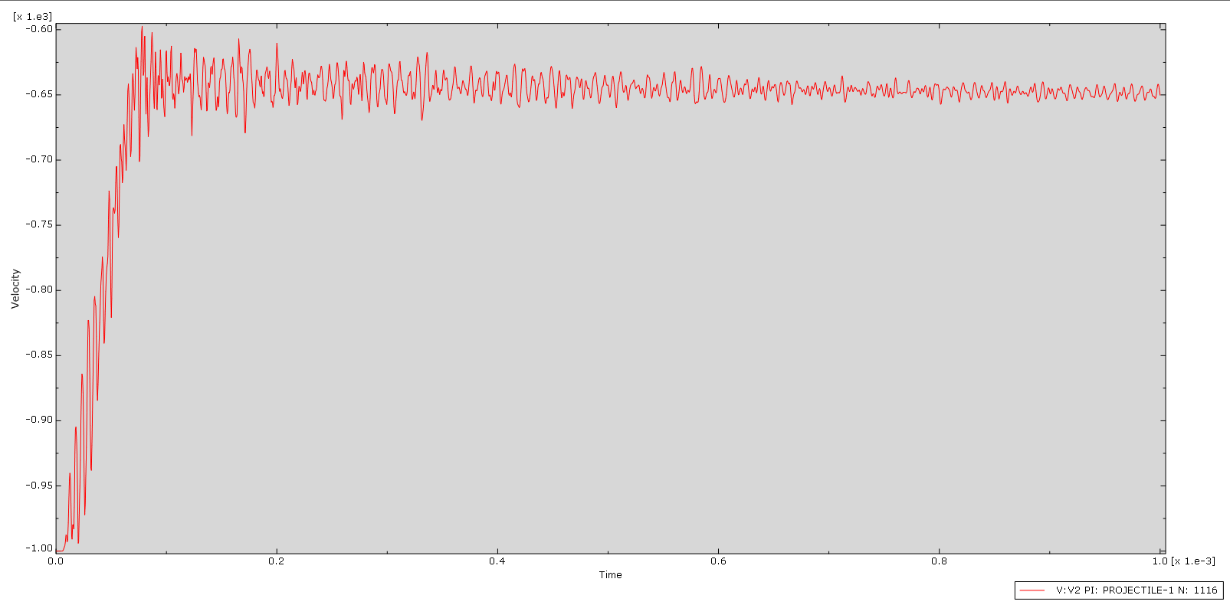

Figure 18 – Velocity profile for (1000 m/s simulation)

Summary of Failure at 1000 m/s identified during the Abaqus simulation.
• Failure Type: Shear stress (tensile)
- Failure Region: Central Plug Path

Discussion

Direct vs Shear Stress Failure Mechanisms
The simulations demonstrate that the dominant failure mode in the steel (4340) is due to impact velocity and equivalent stress wave.

At 800 m/s, the failure is primarily recognised to direct stress, specifically tensile stress developing at the rear surface of the plate. More importantly, this is due to the reflection of stress waves. The evidence suggests that when the tensile stress exceeds the dynamic tensile strength of the material, spalling occurs, characterised by the appearance of a brittle-like rear-surface fracture; otherwise, ductile metals exhibit ductile behaviour under high strain rates, as discussed in Non-linear Mechanics of Materials [7].

Similarly, at 1000 m/s, the simulation indicates a shift toward shear-dominated failure, as evidenced by the formation of shear bands starting from the impact point. This change aligns with the high strain rates. The development of shear bands indicates shear localisation due to factors such as thermal softening and strain hardening, an occurrence captured by the J-C model's parameters, as evident in the findings of [3], [4].

The J-C damage model supports this interpretation. At 1000 m/s, the increased plastic work elevates local temperature, activating the ${\left(1-T^{*}\right)}^{m}$ softening term. Simultaneously, the high strain rates intensify the accumulation of damage. Together, these processes enable shear banding and plug formation, which are distinct from the tensile fracture observed at lower velocities.
In conclusion, the transition from tensile to shear failure is crucial in OME applications, particularly in the design of armour to resist impact across a range of ballistic effects. Therefore, there is a need for models that accurately account for both stress modes, not just one. For instance, by conducting further FEA simulations to test the integrity of various types of metal, we can establish the dynamic behaviour of materials to determine the optimal stiffness-to-weight ratio for ballistic impacts, including failure rates at multiple velocities.

Error Estimation and Simulation Limitations
Despite the insights gained from the simulations, several limitations and potential sources of error can arise in micro-scale computational models.

Micro-Scale Model Assumptions
Mesh Density: A uniform mesh was utilised; however, using a finer mesh near the expected shear zones could enhance the resolution of shear bands.

Projectile Deformation: The projectile is modelled as a rigid body. If it were deformable, local stress distributions would differ, especially at high velocities.

Damage Model Calibration: The J-C parameters are based on literature values. Any deviation from this could introduce a variation in failure strain and threshold parameters.
Implications for Macro-Scale Armour Systems: The micro-scale simulation to macro-scale application must be considered in armour design, and all the parameters.

Recommendations for Future Work
To improve the realism of the simulation results, the following steps are recommended:

- Mesh Refinement: Conduct a mesh convergence test focused on shear localisation to improve ASB resolution.

- Macro-Scale Assemblies: Extend the model to multi-layered targets or plates with boundary clamping to simulate real-world configurations.

- Angle-of-Impact Studies: Vary the projectile angle to assess irregular shear or tensile responses relevant to real combat scenarios.

These steps will close the gap between numerical simulation and battlefield application, which is crucial in the design of ordnance and protective systems.

Conclusion
This report presents a detailed (FEA) of the response of 4340 steel plate to high-velocity projectile impacts at velocities of 800 m/s and 1000 m/s, utilising the Johnson–Cook plasticity and failure model within Abaqus. The aim was to determine the primary failure mode — tensile or shear — using simulation outputs for Max Principal Stress and S23 shear stress, and to evaluate the transition from micro-scale simulation insights to macro-scale armour implications.

The results show a clear distinction in failure mechanisms between the two velocities:

At 800 m/s, the plate experiences tensile spalling at the rear face, caused by stress wave reflection. Max Principal Stress plots reveal progressive tensile buildup leading to rear-surface tearing. S23 stress plots remain relatively weak, confirming that direct stress, specifically tension, governs failure.

At 1000 m/s, the behaviour shifts to shear-dominated failure, evidenced by the development of adiabatic shear bands and the eventual formation of a plug. S23 plots show strong, localised shear bands while velocity-time profiles and rear deformation confirm perforation. This validates shear stress as the dominant failure mode at higher velocity.

In summary, this study confirms that:
• Tensile failure dominates at sub-critical impact speeds.
• Shear failure governs above critical velocity thresholds

In conclusion, the simulation outputs, such as maximum principal stress and S23 stress, supported by Johnson–Cook modelling, provided valid insights into ballistic performance and failure.

References
[1] H. Silyn-Roberts, Writing for science and engineering: papers, presentations, and reports, 2nd edition. in Elsevier insights. Amsterdam: Elsevier, 2013.
[2] J. Dean and T. W. Clyne, ‘Extraction of plasticity parameters from a single test using a spherical indenter and FEM modelling’, Mechanics of Materials, vol. 105, pp. 112–122, Feb. 2017, doi: 10.1016/j.mechmat.2016.11.014.
[3] K. Gopinath, V. Narayanamurthy, S. N. Khaderi, and Y. V. D. Rao, ‘Determination of Parameters for Johnson-Cook Dynamic Constitutive and Damage Models for E250 Structural Steel and Experimental Validations’, J. of Materi Eng and Perform, vol. 33, no. 20, pp. 10940–10960, Oct. 2024, doi: 10.1007/s11665-023-08733-4.
[4] M. Burley, J. Campbell, J. Dean, and T. Clyne, ‘Johnson-Cook parameter evaluation from ballistic impact data via iterative FEM modelling’, International Journal of Impact Engineering, vol. 112, pp. 180–192, Feb. 2018, doi: 10.1016/j.ijimpeng.2017.10.012.
[5] Y. Suo, Z. Deng, B. Wang, Y. Gong, and P. Jia, ‘Constitutive model of metal matrix composites at high strain rates and its application’, Materials Today Communications, vol. 27, p. 102328, Jun. 2021, doi: 10.1016/j.mtcomm.2021.102328.
[6] M. Muaz and S. H. Khan, ‘Failure mechanics analysis of AISI 4340 steel using finite element modeling of the milling process’, The Journal of Strain Analysis for Engineering Design, vol. 57, no. 7, pp. 582–595, Oct. 2022, doi: 10.1177/03093247211058038.
[7] J. Besson, G. Cailletaud, J.-L. Chaboche, and S. Forest, Non-Linear Mechanics of Materials, vol. 167. in Solid Mechanics and Its Applications, vol. 167. Dordrecht: Springer Netherlands, 2010. doi: 10.1007/978-90-481-3356-7.
[8] R. Shivpuri, X. Cheng, and Y. Mao, ‘Elasto-plastic pseudo-dynamic numerical model for the design of shot peening process parameters’, Materials & Design, vol. 30, no. 8, pp. 3112–3120, Sep. 2009, doi: 10.1016/j.matdes.2008.11.031.
[9] E. Corona and G. Orient, ‘An evaluation of the Johnson-Cook model to simulate puncture of 7075 aluminum plates.’, SAND2014-1550, 1204105, 505013, Feb. 2014. doi: 10.2172/1204105.

Data used for the Abaqus Simulation
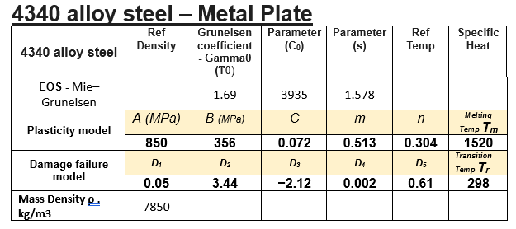

Figure 3 - Mie–Gruneisen equation of state for 4340 steel - referenced in: Elasto-plastic pseudo-dynamic numerical model for the design of shot - EOS 4340 [8].
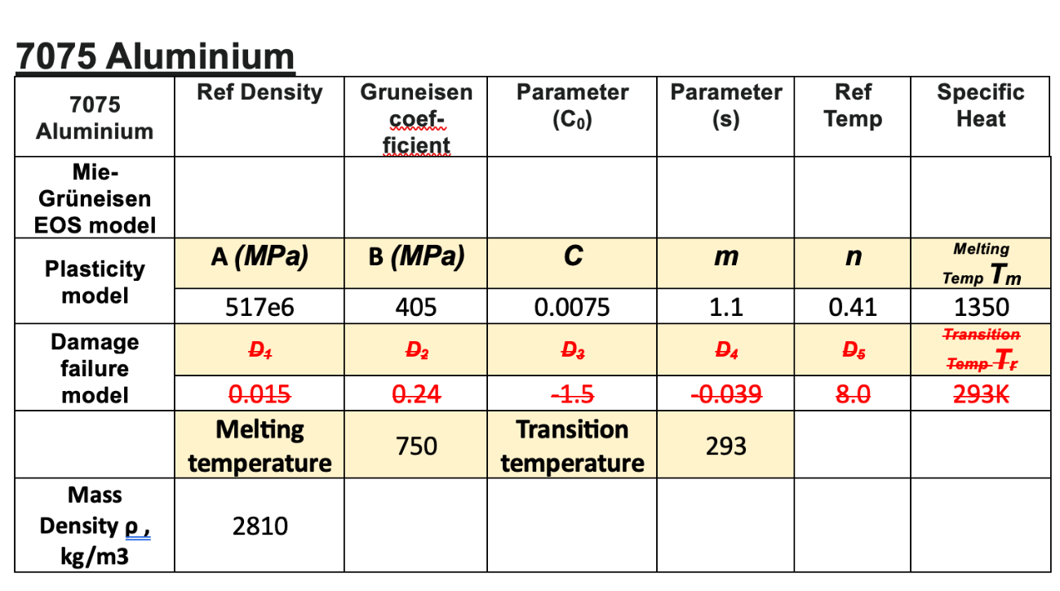

Figure 4 - 7075 Aluminium parameters, referenced in: An Evaluation of the Johnson-Cook Model to Simulate Puncture of 7075 Aluminium Plates [9]

