Introducing the Modern Workplace
LCCB4003
Group report No.2:
Vasile Miculas ID:2120834-Introduction and Conclusion
Daniela Stochita ID:2113969- Hybrid and Flexible working arrangements
Silvia Borcila ID:2118502-Pro&Cons
Ana-Maria Parau ID:2123792-Recomandations

Table of Contents

Introduction 3
Hybrid working and flexible working arrangements 5
Hybrid work (Daniela Stochita 2113969) 5
A hybrid work model arrangement at Workplace 6
Survey your employees to find out what they need 6
Build the infrastructure that supports flexibility 7
Invest in company culture 7
Create a great workplace experience 8
Develop employee personas 8
Flexible working: 8
Hybrid Working (>> Daniela S) 8
Pros and Cons about hybrid and flexible working arrangements 9
Pro of Flexible Working 9
Pros of Hybrid Working 9
The Cons to flexible working 10
The Cons to Hybrid Working 11
Recommendations to improve current practices 12
Behavioural approach to management - Hybrid and Flexible Work in modern Workplace 12
Behavioural science approach 12
Applying Abraham Maslow Theory 12
Applying Douglas McGregor X and Y Theory 13
Applying Herzberg Theory 14
Conclusion 15
References 17

Introduction
A modern workplace is a type of environment that is designed to improve the quality of work for its employees and businesses. This concept involves the development of new procedures and technology that are designed to meet the specific needs of its employees. Another type of workplace is activity-based working, which combines the use of dedicated areas and open spaces. This type of working allows workers to work from anywhere they want (Angouri, Jo., 2018). It can also accommodate different activities and tasks. For instance, employees in Microsoft using a hot desk while they're working, or they set up an audio proofed booth so they can make calls. In addition to being able to work from their home or office, this type of working also allows them to meet in designated meeting spaces. The modern workspace will feature a variety of technology and productivity tools to provide employees with the best possible work environment. It will also allow them to connect with their colleagues through video conferencing. In addition, employees will have the opportunity to work from home. One of the most important factors that Apple considers when it comes to hiring and retaining top talent is the availability of communication and collaboration tools. According to a survey, more than 90% of employees prefer a working environment that features a dedicated communication room (Batuk and Özer, 2021). This type of environment can help boost the productivity of an organization and attract and retain top talent, as well.
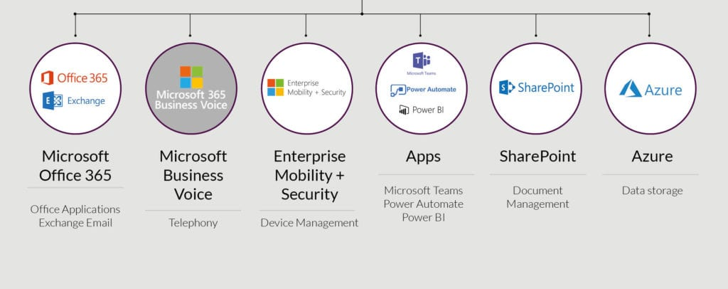
Picture: Corporates using modern workspace software
Source: (Vasconcelos et. al, 2020)

Microsoft Office: One of the latest features in Microsoft 365 that can help improve the communication between employees is the ability to create groups.
Yammer Groups: One of the most popular ways for employees to keep up with the latest changes in their communication is through group messaging app known as Yammer Groups combining Office 365 and Microsoft Office.
Microsoft Teams: One of the most popular collaboration tools is Microsoft Teams, which is a chat-based platform like Slack. It features a variety of features such as one-on-one messaging and channels (Batuk and Özer, 2021).
One Drive: One Drive is a cloud storage service that allows users to store and manage their files and documents. It can be accessed through offline access and synchronization across various devices.
Microsoft OneNote: One of the most popular collaboration tools is Microsoft OneNote, which is a program that allows users to organize and share free-form information.
Shifts: A mobile app from Microsoft, Shifts, is designed to help teams manage their schedules and tasks. It can be used to view their schedule, request time off, and manage other tasks (Angouri, Jo., 2018).
Skype for Business: One of the most popular business communication tools is through the use of a software known as Skype for Business, which allows users to make audio, video, and conference calls.
Ask Cody: One of the most popular collaboration tools that can help teams reduce their labor-intensive tasks is Ask Cody, which is a tool that simplifies the process of booking meetings through Microsoft 365 and Outlook.

Hybrid working and flexible working arrangements
Hybrid working is a concept that allows employees to work from home or in-office while still being able to meet their professional requirements. It’s a great compromise for management, as it allows them to accommodate employees who prefer to be at home (Booth et. al, 2019). Although hybrid work is a revolutionary concept, it is only available to employees who can physically attend to their job in-person. Over half of the workforce doesn’t have this luxury, and deskless workers and frontline workers need flexible working arrangements to be included in the discussion about the future of work.

Hybrid work
A hybrid work arrangement is a flexible method that allows employees to work from home or the office while still being able to split their time between both.
- Hybrid at-will: At-will allows employees to choose the day they would like to come into the office. Employees can also change their own schedule.
- Hybrid split-week: The company's hybrid split-week arrangement allows employees to work from home or on-site. It also assigns certain days for remote work (Booth et. al, 2019).
- Hybrid manager-scheduling: A hybrid manager-scheduling system allows managers to pick the day that their team will come into the office.
- Hybrid mix: A hybrid mix is a combination of three options. It can be a combination of all three options or a combination of all three.
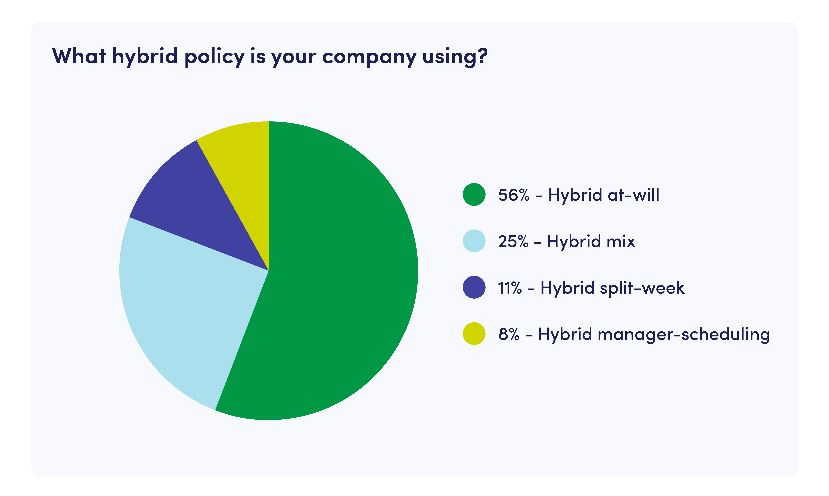
Picture: (%) of Corporates using Hybrid policy
Source: (Brown, 2021)
The goal of a hybrid workplace is to provide employees with a better work-life balance and flexibility. It should allow them to work from wherever they are (Brown, 2021). Employees should feel like they can easily switch between the office and their home when needed.

A Hybrid Work Model Arrangement at Workplace
Before you start implementing a hybrid work model, you need to make sure that the right people and technology are in place. This article will give you a few key factors that you should consider when it comes to adopting a new approach to work.

UK Companies using hybrid work:
Almost 70% of UK companies are currently using or planning on implementing a hybrid work model, which is a type of flexible work arrangement that's designed to help them manage their workforce. About 27% of these companies have a hybrid plan in place during the COVID-19 pandemic, while 47% had one before the outbreak.
- Apple revealed that its employees would be working from home two days a week. The company also said that it would allow them to work from the office three days a week.
- Employees of Microsoft can work from anywhere in the world for up to 50% of the week.
- Shopify is a digital by default company. The term 'digital by default' refers to the way the company is operated.

Survey your employees to find out what they need
Before you start implementing a hybrid work model, it's important that you first speak with your employees about their needs. This will allow you to create a work model that will help them embrace change and keep them motivated. One of the most effective ways to gauge employee sentiment about hybrid work is through a survey (Brown, 2021). This method will allow you to ask specific questions about the type of working environment that they would like to experience. If you are considering a hybrid work model, here are some of the key factors that you should consider: • Would you like to work on-site or collaborate with your team? • If you have a space close to home, would you prefer to use it instead of driving to the office? Once you have identified the types of people who will benefit from hybrid work, you can then start to customize the work model according to their needs. For instance, if people are looking for a flexible work environment, you can provide meeting room management services that are seamlessly integrated into the hybrid model.

Build the infrastructure that supports flexibility
Work in hybrid mode will allow employees to work together seamlessly from both the on-site and remote locations. This can be achieved by investing in technology such as video conferencing equipment and remote communication tools. Having the right tools can help you make the most of your time and improve the efficiency of your organization (Hobson, 2021). To create a culture that encourages employees to set clear expectations, establish a communication framework that includes clear communication goals and procedures. Office schedules can help manage the flow of traffic in the workplace and provide employees with more flexibility. There are a variety of ways to approach this, such as implementing a hybrid work model. For instance, you can create an at-will policy that allows employees to choose which day they come into the office, or you can create a hybrid manager-scheduling system that allows managers to set their own schedules.

Invest in company culture
Your company culture is the most important factor that you can consider when it comes to developing a hybrid work model (Mezgár, 2017). It can help you attract and retain talent and improve the success of your business. According to a survey conducted by At Work, 88% of companies are offering incentives to get their workers back on-site. These include perks such as happy hours and food and beverage programs. Implementing these programs can help boost employee morale and encourage them to choose to work at the office (Mezgár, 2017). It’s important that your company’s core values are reflected in the design of its hybrid workplace. For instance, if you have a team-building activity that you want to arrange, you can use the Donut Slack integration to invite people to participate. At Envoy, we encourage our employees to connect with other teams through a peer learning exchange.

Create a great workplace experience
The success of your hybrid work model depends on the quality of the experience that your employees have in the workplace. While it’s important that your workers are on-site every day, it’s also important to make sure that the environment is intentional and purposeful. Having more people on-site can help improve the interaction between your team members and help them meet their goals (SPRINGER, 2022). A successful hybrid workplace is about having an enjoyable experience for the employees. In this post, we'll talk about some of the steps that you can take to create a better experience for your workers.

Develop employee personas
One of the most important factors that you can consider when it comes to implementing a hybrid work model is the quality of the feedback that your employees provide. To keep up with the changes in the environment and the needs of your team, you should create a set of employee personas (Vasconcelos et. al, 2020). These are fictional characters that represent the various characteristics of your employees. A good strategy for managing your space and keeping agile is to have a variety of personas that help you create new experiences for your team members. These tools will allow you to keep track of all the changes that are happening in the workplace.

Flexible working
In flexible working, employees can set their own schedule and work from wherever they want. It can be beneficial for employees as it allows them to make their own decisions regarding their work (Brown and Pechman, 2019). There are varying types of businesses that can accommodate this type of arrangement, such as small businesses.

Hybrid Working
The end of working from home guidance in the UK last month marked the start of a new era for millions of workers. According to the London Evening Standard, some commuters experienced delays as workers made their way to the office. However, for others, it was a mixed reaction. Many of them were eager to get back to work, while others were still hesitant to do so. According to Alanah Mitchell, the concept of Covid-19 has changed the way people work (Bass and Stogdill, 2019). It will allow employees to spend more time at home and less time at the office. There are many advantages and disadvantages of this type of working model.

Pros and Cons about hybrid and flexible working arrangements

Pro of Flexible Working
- Providing employees with flexible working arrangements makes a more inclusive workplace possible. It allows them to work from wherever they want, and it helps them balance their personal lives with their work.
- One of the most critical factors that businesses need to consider when it comes to making flexible work is having the right technology (Teasdale, 2019). Unfortunately, many small and medium-sized enterprises (SMEs) are not able to find the right technology solutions.
- Getting the most out of your digital tools can be very challenging for small businesses. This guide will help you navigate the various steps involved in digital transformation. It will also teach you how to keep up with the changes and how flexible working can help boost your business.

Pros of Hybrid Working
Greater Flexibility
According to BusinessToday's Rajiv Sodhi, the rapid emergence and evolution of hybrid operating models has created an unprecedented level of change. No two work structures are the same, and employees are now getting a new social contract. According to Sodhi, every organization has its own approach to meeting the needs of its workers. Employees are demanding the best possible work environment and are not tied to a single address. According to Jenny Darmody, a senior analyst at Grow Remote, the best option for both employers and employees is a flexible-hybrid model (Nyoni, 2021). This allows workers to do their jobs remotely and live wherever they want. According to an article by i news, many companies in the UK could start offering flexible working days due to the pandemic. Rebecca Thornley-Gibson, an employment law specialist, said that people have shown a preference for flexible working.

Multiple Cost Savings
According to Guruprasad Srinivasan, the COO of Quess Corp, a hybrid model is beneficial for both the employee and the company. It allows employees to be closer to their families and improve their mental and physical health. It also allows them to work more efficiently and has the potential to create a wider talent pool. In November, a study conducted by Virgin Media O2 Business and Cebr revealed that hybrid working could save the NHS around £4 billion annually (Wildsmith, 2021). It noted that the flexible working option could help reduce the burden on the healthcare system and provide more time for family and friends. The report also stated that the benefits of hybrid working could help lower the incidence of fatal diseases and improve mental health. The study found that increasing hybrid working could result in the employment of around 3.8 million people who were previously unable to work. It could also boost the country's GDP by £48 billion annually.

The Cons to flexible working
No understanding or buy-in from senior leadership In the UK, a third of workers are denied their right to request flexible working. This is due to a lack of clarity regarding how flexible arrangements can be implemented in different roles.
Lack of digital tools Having an overview of the locations of all of your employees is very important to ensure that they are able to connect with their colleagues easily (Olmsted and Smith, 2018). Having the right digital workplace solution is also very important to ensure that everyone can access the information they need.
Closed culture The culture of a company needs to be changed to support the new ways of working. Having a flexible work option is one of the most important factors that employers can consider when it comes to providing their employees with a variety of options. A company intranet can help employees manage their options and keep track of what's happening in the company.
Overworking and overcompensating During the pandemic, many remote workers experienced an additional two hours of work per day (Bass and Stogdill, 2019). They were overcompensating because they were afraid that their employers would not believe that they were working hard.
Disconnection It's no secret that people who work from home are more likely to be unable to connect at the end of their day.
Difficulty switching off According to a survey, overworking is often the reason why employees start to feel disconnected from their work. Only 14% of workers feel connected. Having a variety of shared spaces can help employees connect with one another (Bass and Stogdill, 2019).
Missing out on promotions When employees are split between working from home and staying at the office, there's a potential for one group to be favored. Lack of visibility and the belief that commitment equals commitment are some of the factors that prevent remote workers from receiving a bonus.

The Cons to Hybrid Working
Heavy Emotional toll
According to BBC journalist Alex Christian, the concept of a part-time, part-office schedule is the future of work, but some employees are complaining about their tired schedules. Some workers were excited about the new setup, but it quickly became apparent that the novelty of hybrid work had worn off. According to a study conducted by employee engagement platform, Tinypulse, hybrid working is often considered to be emotionally taxing. It found that over 80% of leaders said that the set-up was very taxing on their employees (Nyoni, 2021). Workers also noted that it was more taxing than traditional office-based work.
Weak Staff Loyalty
According to Emma Jacobs, in the Financial Times, hybrid work can weaken workers' loyalty. It can reduce their social ties and make them less likely to work with their employers. She explained that workers might spend less time together, which could affect their attachment to the company. As the culture of the workplace continues to evolve, companies will continue to experiment and learn more about how to improve the experience of their employees, according to HR expert and Hewlett-Packard Enterprise APAC HR leader, Rohini Sachitanand. She noted that employees will embrace new ways of working if they are given the necessary resources and flexibility to do so.

Recommendations to improve current practices

Behavioural approach to management - Hybrid and Flexible Work in modern Workplace
The goal of management is to understand the human aspect of workers so they can treat them as valued assets to achieve goals. This can help employees feel like they are part of a special group.

Behavioural science approach
The future of work is hybrid. In the past year, thousands of workers have shifted away from their desks and into their bedrooms to work from their kitchen and bedroom tables. We’ve also seen more of our cats and children. Despite the easing of restrictions in the UK, many companies are still reluctant to put a halt to the hybrid working experiment (Wildsmith, 2021). For instance, Morgan Stanley and Goldman Sachs are forcing their employees to go back to the office. They have no choice but to do so due to lack of flexibility. Amazon, on the other hand, has also deferred its expected January 2022 in-person attendance date (SPRINGER, 2022). It's clear that having no strategy for hybrid working will not work in the long-run. To avoid this, employers must first build a body of evidence that shows what works and what doesn't. This is about finding a solution that's right for everyone.

Applying Abraham Maslow Theory
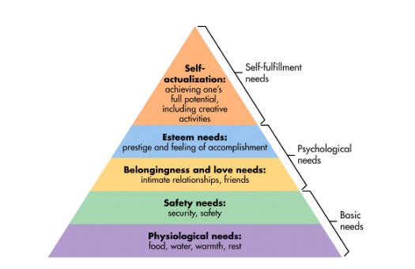
Picture: Abraham Maslow Theory
Source: (Brown and Pechman, 2019)
1. Physiological needs: The first set of needs is food, water, and shelter. In modern workplaces, these are usually reflected in the pay and benefits that employee receive. There are also toilets and water stations in the office.
2. Security needs: Being worried about your own safety is not good for work. It can prevent you from being motivated and engaged in your job (Olmsted and Smith, 2018). This is a good reminder that the most basic needs of workers can be met if the safety environment is properly maintained.
3. Social needs: Despite how important it is to be motivated and engaged in your job; many people don't realize that their social needs are also at risk. During the pandemic, the increasing number of people experiencing loneliness and isolation has prompted researchers to call this phenomenon the Loneliness Pandemic.
4. Esteem needs: Being able to receive genuine recognition and appreciation from your peers is very important in order to motivate and improve your performance. This is also beneficial for developing a healthy self-esteem. Having a positive relationship with one's peers can help improve one's self-esteem.
5. Self-actualization: Being motivated and engaged in your job is also important in order to achieve a deeper sense of belonging and satisfaction in what you do (Brown and Pechman, 2019). This is because it allows us to connect with the greater meaning of life and to understand who we are. It can take a long time to fully realize this need.

Applying Douglas McGregor X and Y Theory
According to Theory X, employees are incapable of working due to their lack of motivation. They need to be supervised and always controlled. This theory also states that since they avoid responsibility, they need to be enticed or threatened to produce results. This combination of beliefs leads to a tighter control and management style. On the other hand, Y Theory says that employees are capable of self-motivating, creative, and proactive. They are also willing to take responsibility for their actions. This type of management is decentralized (Hobson, 2021). Leaders encourage employees to make suggestions, provide them with opportunities to take on more responsibilities, and accept their creative ideas. In addition to being able to monitor the work being done by their subordinates, managers also need to have a structured environment that allows them to get the most out of their employees. This is done through the establishment of a tight control over the employees' activities. Theory Y states that managers need to show the necessary direction to their subordinates.
A Fit bit at work is a type of software that allows employees to track their working habits and improve their performance. It can also help the managers identify areas of their team that they can improve. For instance, if the manager has the necessary information about the time spent on various activities, such as meetings and social networking sites, he can easily implement a set of activities that can help improve the team's productivity (Vasconcelos et. al, 2020). One of the most effective ways to improve the work-life harmony of your employees is by having a tool that allows them to monitor their daily activities. This can help them identify areas of improvement and reduce their stress levels.

Applying Herzberg Theory
There are numerous ways that companies can implement Herzberg’s principles in order to improve their employee motivation and hygiene. Some of these include: new policies that promote healthy and happy workplaces, and training programs that help employees improve their performance (Olmsted and Smith, 2018).
1. Give employees more autonomy: One of the most important factors that employers can consider when it comes to giving their employees more autonomy is ensuring that they are able to feel that they are responsible for their work. This will allow them to feel more motivated and inspired to perform at their best.
2. Provide feedback: It’s important to provide feedback to your employees so they can see how they’re doing. Doing so can help improve their motivation and make them feel valued in the workplace (Vasconcelos et. al, 2020). Having a good relationship with your team members can help build trust and make them feel like they have a voice.
3. Improve working conditions: One of the easiest ways to improve the working conditions of your employees is by providing them with a clean and safe environment. This can be done through the establishment of a well-designed office. Besides having a well-designed and attractive workspace, other factors such as the lighting and the design of the office can also help improve work hygiene.
4. Poll employees: One of the most effective ways to get a sense of what motivates your team members is by conducting a survey (Booth et. al, 2019). This will allow you to identify areas of improvement and what kinds of job factors are most important to your employees.
5. Take a macro view of employee welfare: According to Herzberg’s two-factor theory, employers can't choose between improving employee welfare and keeping their workers motivated. They must instead focus on improving both the hygiene and motivation of their employees (Batuk and Özer, 2021). This can be done through the establishment of policies that are geared toward improving both. In addition to having a well-designed and attractive environment, other factors such as the lighting and the design of the office can also help improve work hygiene.

Conclusion
Today, we can understand the various facets of the modern workplace. In this article, we have talked about four strategies that companies can use to improve the performance of their employees. Being valued as a whole person is very important to workers, and it will help them stay at a company longer. This can also help lower employee churn and provide long-term savings. Today, many companies recognize that employees are looking for an organization that is committed to developing their skills and improving their performance (Vasconcelos et. al, 2020). Therefore, it is important that they are able to invest in training and development. Besides being able to improve their satisfaction, this type of investment can also help boost the productivity of your organization. The belief that seniority equals competence is a major factor that drives the demotivating behavior of millennials and Zoomers. The modern office is focused on creating a conducive environment for collaboration and building relationships. It encourages team meetings and regular brainstorming sessions (Booth et. al, 2019). Companies are improving the performance of employees is by having scheduled meetings. These meetings can help break down the barriers that prevent independent workers from meeting with their colleagues. They can also help signal to those who may be frequenting other offices to find a more appropriate space. For improving the performance of their employees is the availability of meeting management software (Hobson, 2021). For instance, if you want to create a more professional environment, you might need to add more meeting rooms or convert the coffee corner into a more café-style area. A survey conducted by Coopers revealed that employees and employers consider the office to be a vital part of their work environment. The top factors that were cited as important factors that made the office a great place to work were collaboration and training and development (Booth et. al, 2019). One of the most important factors that office workers consider when it comes to improving the performance of their employees is the availability of meeting management software. This type of software can help them manage their meetings and keep track of their guests (Vasconcelos et. al, 2020). After having a better understanding of the changes that have occurred in the workplace over the past few years, it is important that you start implementing a modern design strategy for your office.

References
Angouri, Jo. (2018). Aspects of the modern workplace
Batuk, S., and Özer Torgalöz, A. (2021). Remote and Hybrid Working. Frankfurt a.M.: Peter Lang GmbH, Internationaler Verlag der Wissenschaften.
Booth, A., Melling, J., and Booth, A (2019). Managing the modern workplace.
Brown, W. (2021). The evolution of the modern workplace. Cambridge: Cambridge University Press.
Hobson, J. (2021) The evolution of modern capitalism.
Mezgár, I. (2017). Knowledge based hybrid systems. Amsterdam [etc.]: North-Holland.
SPRINGER. (2022). FLEXIBLE WORKPLACE. [S.l.].
Vasconcelos, P., Furtado, E., and Pinheiro, P. (2020). A Hybrid Approach for Modeling Alternatives of Flexible Working. Procedia Computer Science, 55, 748-757. doi: 10.1016/j.procs.2015.07.162
Zgheib, P. Business ethics and diversity in the modern workplace.
Brown, C., and Pechman, J. (2019). Gender in the workplace. Washington, D.C.: Brookings Institution.
Gibson, V. (2018). Flexible working needs flexible space? Journal Of Property Investment andAmp; Finance, 21(1), 12-22. doi: 10.1108/14635780310468275
Olmsted, B., and Smith, S. (2018). Managing in a Flexible Workplace. New York: Amacom.
Sharma, R. Managing diversity at workplace.
Teasdale, N. (2019). Fragmented Sisters? The Implications of Flexible Working Policies for Professional Women's Workplace Relationships. Gender, Work andAmp; Organization, 20(4), 397-412.
Bass, B., and Stogdill, R. (2019). Bass and Stogdill's handbook of leadership. New York: Free Press.
Forrest, J., Nicholls, J., Schimmel, K., and Liu, S. Managerial decision making.
Nyoni, T. Managerial Theories and the Principal Agent Problem (2021). The Conflict between Managers' and Shareholders' Objectives.
Tosi, H. (2019). Theories of organization. Los Angeles: SAGE.
Wildsmith, J. (2021). Managerial theories of the firm. London: Robertson.

