Designing an overhead gantry crane
Stress Analysis & Dynamics

Joseph John Garland
Tata Steel

Summary

This assignment firstly looks at uses Slope and Deflection Theorem to aid with the selection of a steel girder appropriate for lifting 5000kg with a minimum deflection of 10mm.
It then takes an in depth look into different types of strain gauges used across the engineering industry, their uses, operation and make up and advances/ development of future strain gauges.
Finally using the extensive research carried out on strain gauges, their uses and applications an appropriation strain gauge for the steel girder in question for the overhead pendant crane was decided.

Contents
Summary 2
Introduction 4
Q1. 6
Figure 1 – Question 1 calculations 6
Figure 2 – Further question 1 calculation 7
Q2. 8
Q3. 9
Strain Gauges 9
Electrical Resistance Gauges 9
Figure 3 – examples of strain gauge bridge circuits 11
Pneumatic Strain Gauges 11
Figure 4 – Pneumatic strain gauge diagram 12
Mechanical Strain Gauges 14
Acoustic Strain Gauge 15
Figure 5 – Acoustic strain gauge diagram 15
Piezoresistive Strain Gauges 16
Figure 6 – Piezoresistive strain gauge diagram 17
Inductance strain gauges 17
Figure 7 – Inductance strain gauge diagram 18
Capacitance Strain Gauges 18
Figure 8 – Capacitance strain gauge diagram 19
Future Advances and Development of Strain Gauges 20
Q4. 21
Bibliography 23

Introduction

As assignment will look at the use of appropriate knowledge and formulae in order to determine the size of a girder on an overhead pendant crane needed in order to withstand a load of 5000kg.
Detailed research on strain gauges, their uses and application are then to be carried out. This must show an understanding of the make up of each strain gauge and their operation. Following this a looking into advances in future development of strain gauges must be carried out.
Finally, following the research carried out on strain gauges an appropriate gauge for the a steel girder on overhead gantry crane must be determined.

Q1.

Figure 1 – Question 1 calculations


Figure 2 – Further question 1 calculation



Q2.

In-order to complete what was asked in question 1, it was appropriate to make a number of assumptions to ensure an answer was provided.
The first assumption made was the length of the girder in question. This was assumed as it was not provided in the assignment brief and was critical to the workings out required for the second moment of area. The length assumed was 15 meters.
It was then assumed the girder in question was simply supported, this assumption was made following analysis of the diagram given in the assignment brief and personal knowledge and experience of pendant cranes. It’s was visible to see two perpendicular parallel support beams at either end of the girder.
The girder in question was also assumed to that of a universal or “I” beam. This detail was required to be known in-order to determine the appropriate size girder to safely withstand the 5000kg load required.
The final assumption made was that load on the girder was a centralised point load as this is where the maximum deflection of the girder is most likely to occur.

Q3.

Strain Gauges

The primary purpose of strain gauges in engineering is to measure a variety of different types of strain that may be exerted on an object. Strain gauges are used to measure forces in torsion, bending moments and direct strain. Each strain gauge is influenced by several different factors/ components such as lead wires, bond, temperature and alignment.
Throughout industry there are a number of different strain gauges available depending on there intended uses. These include;
- Electrical resistance
- Mechanical or extensometers
- Pneumatic
- Acoustic
- Piezoresistive gauges
- Inductance gauges
- Capacitance gauges

Electrical Resistance Gauges

The electrical resistance strain gauge is by far the most commonly used strain gauge device for measuring. An electrical strain gauge produces an electrical signal/measurement as a result of mechanical strain an object it is attached to experiences. The two most popular types of electrical strain gauges are foil and wire strain gauges and have both been extensively developed. They have been applied to various different problems and equipment during use to ensure a high level of accuracy.
Each device is often bonded to the surface of the component it is required to take a strain measurement from whilst under static or dynamic load, e.g a pendant crane beam. The gauges are made up of a resistance grid using either foil or wire. During operation the foil or wire bonded to the test material is stretched or compressed which as a result creates a change in resistance (R). The change in resistance in the strain gauge is directly proportional to the strain the intended material is attached to. The gauge is often part of some form of bridge circuit which allows the gauge to transmit the strain a material experiences during loading by sending signals to a galvanometer or resistor. If, however the material intended for measurement is subjected to dynamic loads/ strains it will be indicated through an oscilloscope where the signals received are plotted in graph form in order to better gauge the strains experienced during motion. Dummy gauges are commonly used on the opposite side of a bridge circuit as a way of compensating for the effect’s temperature may have on the material.
Gauge sensitivity is determined by the ratio of change in resistance divided by the strain experienced, this is known as the “gauge factor”. Each gauge uses a number of different arrangements can be used depending on what kind of strain is intended to be measured. For example, if there were a two-dimensional stress being exerted on a material a “rosette” strain gauge arrangement would be appropriate. A strain gauge rosette is made up of 3 separate gauges all set up different angles to each other, the reason for this is that is believed that the stress being experienced by a material and the direction of the stress can be determined with the use of three gauges.

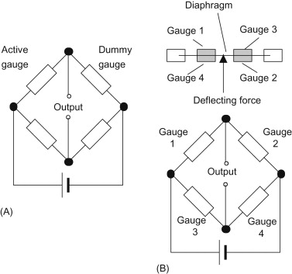

Figure 3 – examples of strain gauge bridge circuits

A strain gauge intended to measure a metal object will typically experience an increase in resistance when it is stretched and a decrease in resistance when the material in compressed. Any changes in resistance are usually very small hence the use of Wheatstone bridge circuits. The bridge circuit must be set to a datum before any test readings are taking in-order to get as accurate a result as possible. Strain gauges may consist of full bridge, half bridge or quarter bridge circuit depending on the level of accuracy required, external factors and intended measurement.

Pneumatic Strain Gauges

Pneumatic gauges were first developed and put to use in the 1920’s when a French company “Sakma” produced strain gauges of solex type. A pneumatic strain gauge is an instrument used for the measurement of change in linear dimensions of an object. The measurement is taken by determining the flow rate of air able to travel over a mechanical object or mechanism. In order to measure the intended part/ mechanism is placed in front of an air source that is aimed directly at the part via a nozzle, the initial flow rate of air that passes over the part will give you a datum allowing you to calibrate the pneumatic gauge. Any changes in flow rate of air over the part or mechanism would suggest a change in the linear dimensions of the part thus implying the part is under some form of strain.
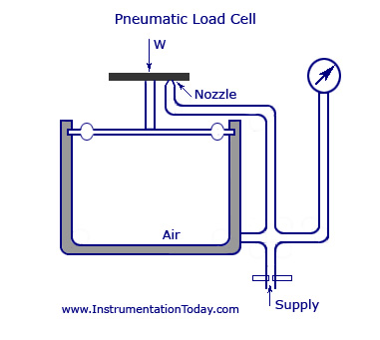

Figure 4 – Pneumatic strain gauge diagram

A pneumatic strain gauge consists of a number of different elements such as bellows, piping, elastic or slack diaphragms, nozzles, preparation unit, pressure gauges, flow meter and tubular springs. Prior to the air travelling over the item a air preparation system that ensures the air that travels over the item being measured is clean and of a stable pressure. Once the air has passed over the item a control device such as a flow meter is used to produce a reading of the flow rate, this is then converted to a distance in-order to give a dimensional value.
Pneumatic gauges are most commonly used in the active monitoring of systems of mechanisms in constant operation. Pneumatic strain gauges are best suited to this as they are able to continuously operate using air from the atmosphere. The constant operation of the pneumatic strain gauge ensures that if the mechanism or system is subjected to excesses strain it is registered straight away helping minimise the chances of damage of failure of the mechanism/ system.
One of the main advantages to a pneumatic gauge is the simplicity of its design. Whereas other strain gauges have to be mounted or bonded to the item it is measuring, the design of pneumatic strain gauge allows it to measure objects without making contact with them. Thus, not potentially interfering with the item’s operation or functionality. Other advantages to a pneumatic strain gauge include:
- High level of accuracy
- Surface being measured is constantly cleaned by the flow of air over its surface
- Continuous gathering of data
- Ability to determine changes in size of the object (damage)
- Magnification of results
Some of the disadvantages of pneumatic strain gauges are the need for clean air at a stable pressure in order to operate effectively, temperature variations of measured item, inertia within the pneumatic system.
The combination of the use of inductive transducers and pneumatic strain gauges is promising for future development.

Mechanical Strain Gauges

Mechanical strain gauges are mainly used for the measurement of the change in length or deformation of an object. Mechanical gauges are more commonly known as Demec gauges or Whittmore gauges. Unlike other forms of strain gauges mechanical strain gauges operation is not influenced by the effects of time or temperature. Demountable mechanical strain gauges or extensometers are portable allowing them to be reused several times for the measurement of many different test items. Mechanical strain gauges are also relatively cheap in comparison to other strain gauges such as the electrical gauges. This however does result in the measurement of specimens becoming quite labour intensive.
Mechanical gauges are made up of two conical locating points, one being able to pivot and the other fixed. Any movement from the pivot point is then measured using a digital or dial gauge.
Another form of mechanical gauge used throughout the engineering industry is a dial test indicator gauge, more commonly known as a DTI. DTI gauges are also portable and provide a measurement in displacement of an object, whether it be around its axis or over a horizontal/ vertical plane. A DTI gauge is commonly used for machining processes to ensure the work piece is rotating true to its axis and on loaded structures as a method of measuring deflection/ deformation. A DTI usually consists of a spring-loaded needle, pivot arm, weighted magnetic base and a dial or digital gauge. The needle is placed onto the test specimen and the DTI is re calibrated in-order to find datum, any deviation in the test specimen will cause movement in the contact needle subsequently providing a measurement on the dial.

Acoustic Strain Gauge

Acoustic strain gauges or otherwise known as vibrating wire gauges are used for the measurement of strain on a wide variety of different materials such as concrete and steel. Acoustic strain gauges can be used to measure effects of load such as stress, strain and pressure. They are made up of two end blocks specific to the specimen being measured. Between the two end blocks is a length of steel wire that is under tension. As the test specimen experiences load the tension of the wire between the end blocks will change accordingly to the strain it is under. This causes the resonating frequency of the wire differ depending on the wire tension. Within the gauge there is a magnetic/ coil mechanism that is used to pluck the wire whilst it is under tension, providing a measurement of frequency of vibration.
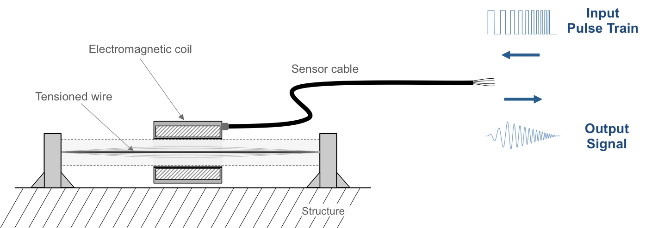

Figure 5 – Acoustic strain gauge diagram

Each acoustic gauge is can be both portable and stationary and are often designed to be welded or embedded to the surface of the material intended for measurement.
Advantages of using acoustic strain gauges include:
- Gauge is very stable
- Measurements taken from the gauge can be taken over long periods of time with zero anomalies in readings produced
- Highly sensitive/ high degree of accuracy
- Ability to send reading signals over large distances
- Immune to environmental influences such as electrical noise and wet wiring

Piezoresistive Strain Gauges

Piezoresistive strain gauge consists of a semi-conductive material which experiences changes in resistance when a material is under load. Piezoresistive strain gauges are made up from either type N or P silicon and are manufactured separate to the other components of the strain gauge, such as a sensing diaphragm or silicon chip sensing diaphragm.
The surface of a piezoresistive gauge is connected to a Wheatstone bridge circuit that is used to detect minor changes in resistance. A small amount of current is then passed through the gauge via the Wheatstone bridge. As the resistance changes are then detected by the Wheatstone bridge resulting in measurement of change in pressure. Changes is resistance cause current to pass through the pressure sensor.
Resistance within a piezoresistive gauge varies widely during compression or torsion of the sensor. The frequency produced by a piezoresistive gauge has a far greater gauge factor than that created by a typical wire or foil gauge. As a result, the millivolts per volts (mV/V) have much higher sensitivity and produce far less noise.
Piezoresistive gauges are either bonded to the test material or embedded via an ion implantation process. Ion implanted gauges are capable of a far more consistent performance due to the added stability it has compared to bonded gauges. This is due to the gauge being imbedded with ions creating the perfect bond between the boundary of the two materials.

Figure 6 – Piezoresistive strain gauge diagram
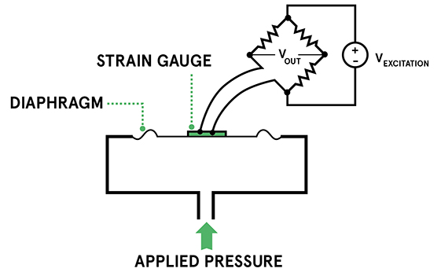

Inductance strain gauges

Inductance strain gauges are made up by two coils positioned side by side, each coil is wound in a signal layer around a thin flat tubular frame. Place centrally between the two coils there is a moveable iron armature.

Inductance strain gauges are primarily used to measure vary small changes is resistance, this is due to an inductance strain gauges being extremely sensitive. In-order to gather a measurement the item is connected to one end of the iron armature and then placed between the wire coil cores. The strain produced then results in the iron armature moving to either core. If the armature moves to the left in mean there is an increase in inductance in the left coil and a decrease in inductance in the coil to the right. Alternatively, if the armature moves to the right, it means there is an increase in inductance in the coil on the right and a decrease in inductance in the coil on the left.
Each coil produces its own independent bridge circuit creating an output of voltage proportional to both the displacement in the armature and the strain encountered.

Figure 7 – Inductance strain gauge diagram
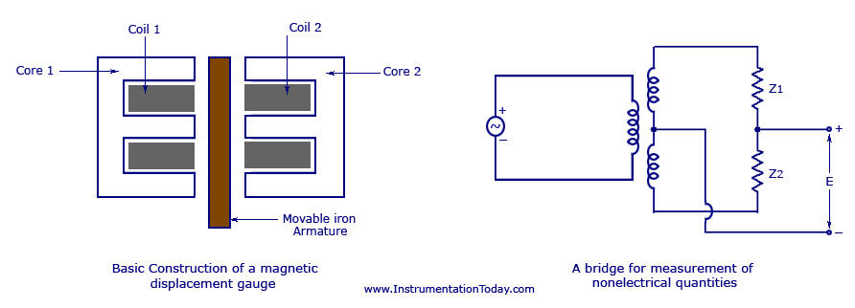

Capacitance Strain Gauges

A capacitance strain gauge use changes in capacitance to measure voltage and weight. A capacitance strain gauge is made up of two plates of opposite charge positioned closely together within the body of the gauge. As a load is applied it force the two plates within the gauge become closer to each other as a result of this current passes through negatively and positively charges plates as it attempts to find equilibrium. Capacitance is then created bas a charge is stored between the two plates. The voltage produced as a result of this is then transferred to a digital gauge where a reading can be taken.
Advantages of capacitance strain gauges are they require very little start up costs as they are pre-calibrated and do not require recalibration once installed. As a result of their design and build materials capacitance gauges are extremely sensitive and are capable of measuring very small amounts of movement. Maintenance of capacitance strain gauges is simple as the gauge does not consist of a larger number of components. Capacitive strain gauges an able to be produced in a number of different sizes and from many different materials. This makes them very versatile and can be used for a number of different applications.
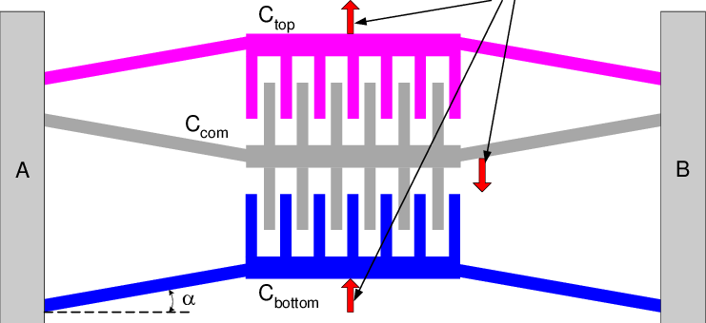

Figure 8 – Capacitance strain gauge diagram

Future Advances and Development of Strain Gauges

Strain gauges are constantly being developed in order to ease the monitorisation of strain exerted on materials. Recent advances in areas such as semiconductor strain gauges mean that due to special circuit arrangements of the semiconductor gauges are able to carry out static strain readings in temperatures of up to 400 degrees Celsius. Developments in new strain gauge alloys also now mean the operation temperature range is now as high as 1000 degrees Celsius.
A new ultra-sensitive strain gauge film has also been developed. The new film strain gauge significantly reduces the limitations of the design of gauges and material due to its extremely high sensitivity. The new film gauge is 90% smaller and 500% more sensitive that a standard strain gauge. Its reduction in size now allows the gauge to be installed to minute measuring points. Also, as the gauge is in the form of a thin film it is suitable for measurement over any size area.

Q4.

I believe that an electrical resistance strain gauge is best suited to be used on the pendant crane girder. I believe this for a number on different reasons being; a high level of sensitivity, bonded to the beam, good for detection of deflection in the beam, resistance to high temperature, low maintenance water resistant and long lasting.
- High level of sensitivity - I believe a high level of sensitivity to be imperative for the girder as it would be essential to know if the crane beam is being overloaded as it would be a matter of safety.
- Bonded to the girder - Having the electrical resistance strain gauge bonded to the under side of the steel girder for the pendant crane would allow for best detection of any slope or deflection the girder experiences.
- Low maintenance – due to the positioning the strain gauge would need to be and the difficulty of accessing it manually I decided the electrical resistance strain gauge would be suitable for the pendant crane due to its low maintenance requirements.
- Long lasting – due to the frequent use of pendant cranes within factories I decided an electrical resistance strain gauge would be best suited as frequent down time to change strain gauge may impair on day-to-day tasks and running of the factory.
- Resistance to environmental factor – pendant cranes are often exposed to high temperatures above production line or water from leaks in the factory roof. Therefore, I saw it fit to select an electrical resistance strain gauge as it is both water resistance and capable of withstanding high temperatures.

Bibliography

- APEC USA. 2021. 8 Advantages of Capacitive Digital Load Cells | APEC USA. [online] Available at: <https://www.apecusa.com/blog/8-advantages-of-capacitive-digital-load-cells/> [Accessed 23 April 2021].
- 2021. [online] Available at: <https://www.mindat.org/glossary/acoustic-strain_gage#:~:text=An%20instrument%20for%20measuring%20strains,linings%20to%20shafts%20or%20roadways.&text=The%20measurement%20made%20is%20that,be%20made%20with%20great%20accuracy.> [Accessed 23 April 2021].
- Irp-cdn.multiscreensite.com. 2021. [online] Available at: <https://irp-cdn.multiscreensite.com/c5a3b2fd//files/uploaded/image20fc.pdf> [Accessed 23 April 2021].
- Sciencedirect.com. 2021. Electrical Resistance Strain Gauge - an overview | ScienceDirect Topics. [online] Available at: <https://www.sciencedirect.com/topics/engineering/electrical-resistance-strain-gauge#:~:text=The%20electrical%20resistance%20strain%20gauge,resistance%20when%20subject%20to%20strain.&text=The%20active%20gauge%20is%20mounted,induced%20resistance%20changes%20cancel%20out.> [Accessed 22 April 2021].
- Sciencedirect.com. 2021. Mechanical Strain - an overview | ScienceDirect Topics. [online] Available at: <https://www.sciencedirect.com/topics/engineering/mechanical-strain> [Accessed 23 April 2021].
- Teams.microsoft.com. 2021. Microsoft Teams. [online] Available at: <https://teams.microsoft.com/_?culture=en-gb&country=GB&lm=deeplink&lmsrc=homePageWeb&cmpid=WebSignIn#/pdf/viewer/teams/https:~2F~2Fuowtsd.sharepoint.com~2Fteams~2FStressAnalysisDynamicsStressPT2021_GRP~2FShared%20Documents~2FGeneral~2FTopic%204%20-%20Experimental%20Stress%20Analysis~2FExperimental%20Stress%20analysis%20(2).pdf?threadId=19:a39153bcb6a642b98dac253350c7d7c4@thread.tacv2&baseUrl=https:~2F~2Fuowtsd.sharepoint.com~2Fteams~2FStressAnalysisDynamicsStressPT2021_GRP&fileId=41ca858a-e6b0-4ab1-b614-e5f9bf7c81ba&ctx=files&rootContext=items_view&viewerAction=view> [Accessed 23 April 2021].
- Sciencedirect.com. 2021. Piezoresistive Sensor - an overview | ScienceDirect Topics. [online] Available at: <https://www.sciencedirect.com/topics/engineering/piezoresistive-sensor> [Accessed 23 April 2021].
- TheFreeDictionary.com. 2021. Pneumatic Gauge. [online] Available at: <https://encyclopedia2.thefreedictionary.com/Pneumatic+Gauge> [Accessed 22 April 2021].
- ResearchGate. 2021. Recent advances in strain gauges. [online] Available at: <https://www.researchgate.net/publication/231041430_Recent_advances_in_strain_gauges> [Accessed 23 April 2021].
- Minebeamitsumi.com. 2021. Successful Development of New Product, High Sensitivity Strain Gauge Film - MinebeaMitsumi. [online] Available at: <https://www.minebeamitsumi.com/english/news/press/2017/1195219_8993.html> [Accessed 23 April 2021].

