

The impact of livestreaming internet celebrity on Chinese younger consumers’ online shopping behaviours

Quantitative Research Methods (LCDB 7011)

Module Lead: Dr Abdullah Promise
DBA Student Name: Xuanyi Yan (Elena）

Word Count: 7852

TABLE OF CONTENTS
Table of Contents.......................................................................................................2

1. Introduction............................................................................................................3

1.1 Research purpose and significance.....................................................................3
  - Research aim, objectives and questions.............................................................8

1.3 The purpose and significance of this study........................................................8
1.4 The structure of this research.............................................................................9

2. Literature Review...................................................................................................9

2.1 Definition of livestreaming e-commerce and internet celebrity......................10
2.2 Conceptual framework........................................................................................10
2.3 The development of theoretical frameworks.....................................................12
2.4 Research hypothesis statements..........................................................................15

2.5 Summary of literature review.............................................................................15

3. Research Methodology..........................................................................................16

3.1 Research paradigm and strategy selection........................................................16

3.2 Research design....................................................................................................17
3.3 Constructs and measurement items ..................................................................18
3.4 Questionnaire survey...........................................................................................20

3.5 Research data collection and analysis................................................................21
3.6 Reliability and validity ........................................................................................22
3.7 Research ethical considerations..........................................................................23

4. Finding and Discussion..........................................................................................23

4.1 Findings of the four constructs...........................................................................23

4.2 Regression analysis..............................................................................................37

4.3 Critical analysis and discussion..........................................................................39

5. Conclusion with Limitation...................................................................................41

6. Recommendation and self-reflection....................................................................43

Bibliography...............................................................................................................44

Appendix.....................................................................................................................52

1. Introduction

  - Research purpose and significance

Throughout the years, as e-commerce in China has grown quickly, a new sales model has emerged online, which is to use the influence and expressiveness of internet celebrity to interact with viewers through livestreaming, thus facilitating a large number of customers to place group orders (Si, 2021). Given the very high commercial potential of this rapidly emerging industry, as well as the researcher's own background of several years in related industries and the own keen interest in the livestreaming e-commerce, the researcher has conducted extensive literature research on this topic.

Based on the novelty of this theme, it is easily found that there is not much literature on the attractiveness factors of internet celebrity in livestreaming, especially the lack of research on how much impact young Chinese generations are influenced by internet celebrity in livestreaming.

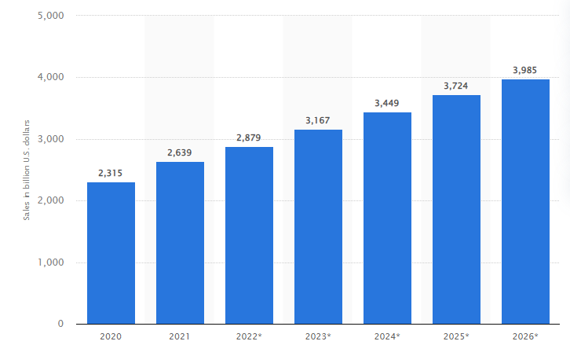
Figure 1.1: The retail e-commerce sales in China for 2020, 2021 with forecast to 2026 (Source: Statistic, 2022 via KPMG, 2022)
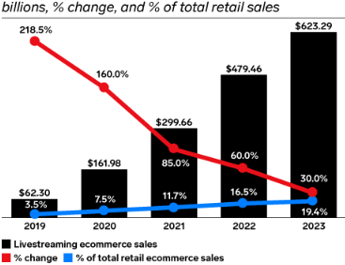
Figure 1.2: Livestreaming e-commerce sales in China 2019 to 2023 (Source: eMarketer, 2022)

1.1.1 Background
The Chinese e-commerce is expected to continuously grow over the courses of the next decade, and this has further fuelled the innovative competitive landscape among the business to lead the success (Tan et al., 2017). The growth is not only driven by the continuously economic success, rising income and increasing spending power for the consumers, but also to directly reflect in the form of growing focus for the convenience, transparent but also interactive shopping experiences for the Chinese consumers (Khan et al., 2020).

In recent years, the livestreaming has emerged as the catalyst to drive the success and growth for booming Chinese e-commerce. According to eMarketer (2022), China livestreaming e-commerce has grown by 10 folds from $62 billion in 2019 to over $600 billion in 2023 and the market share for the livestreaming of the total e-commerce retail sales have also grown from 3.5% to 19%, and expected to continuously to grow over the times (Xi et al., 2020).

1.1.2 Reasons for the rise of livestreaming in China
While there are many myths around the sudden popularities for the livestreaming e-commerce in the areas, there are two main factors for the booming Chinese market. First, with the growing competitions for the e-commerce, livestreaming has created the unique interactivity for the consumers. Rather than letting consumers to seek the product information, compare the competitive alternatives and make the own judgements, livestreaming has enabled the business to integrate all the information and make the recommendations (Clemes et al., 2014).

It can be seen that more interactive and dual way communication for the e-commerce between the livestreaming hosts and clients, but also to create the peer pressures among the clients by taking advantage of the highly collectivism nature for the Chinese society. This may show that when livestreaming is showing, many potential clients are watching peer customers making the purchase and thus create the peer pressures to lead the impacts (Park et al., 2020) .

The second impact is associated with Covid-19: China implemented the strict ‘zero Covid-19 policy’, and many of the Chinese consumers have experienced the continuous and prolonged lockdown (Yoon, 2019). This addresses that growing numbers of clients staying at home, and livestreaming has created the highly interactive and entertaining experiences to match the clients’ needs to lead the proliferation for the livestreaming e-commerce.

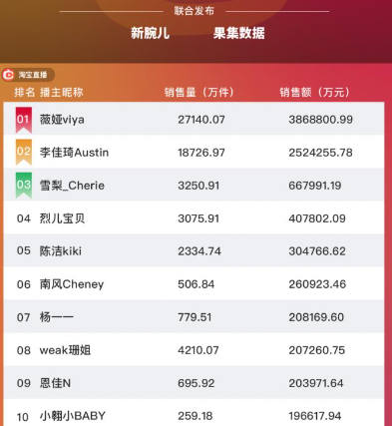
Figure 1.3: Top livestreming celebrities in China e-commerce places
(Source: China Daily, 2021)

1.1.3 The huge role of livestreaming celebrity
Alongside with the increasing popularity of livestreaming e-commerce in the Chinese market, the livestreaming celebrities have also emerged to support and catalyse the change in the market. Internet celebrities have shown two key features for leading the huge impacts on the successfulness: the first factor is associated with the personal skills, attractiveness and brand recognition for the livestreaming celebrities (Si, 2021).

Taking example of Austin, who has been well-known for the “King of Lip Stick”, he does not only have the extensive knowledge for all kinds of the lipsticks, but also able to communicate in the friendly but also convincing manner (Taobao, 2022). Austin Li has famously sold over 5 billions of lipstick in China via the successful livestreaming, account for up to 50% of the market share. Thus the successful and strong personality and skills for the livestreaming celebrities are becoming the catalyst to lead the success for the livestreaming e-commerce (Zhang et al., 2021).

The second key themes for the livestreaming celebrities have proven that great concentrations for the market. The top 10 livestreaming celebrities have accounted for nearly 50% of the market and this kind of the scalability will provide the livestreaming celebrities and their retrospective teams for even bigger bargaining powers with suppliers, partners and stakeholders, and therefore to create the Matthew effect (Luo et al., 2021). This is likely to create the further consolidations for the industry, and play the pivotal role for even raising the level of competitiveness in the industry (Gulfraz et al., 2022).

All of these factors have thus raised the questions over the competitiveness for the livestreaming internet celebrity for the e-commerce, including the potential reference group impact on the clients, the creation and raising profile for the brand equity, as well as the effectiveness on the brand endorsements.

1.1.4 The gaps in the previous literature
As Si (2021) states, the review has implied that while livestreaming has gained the huge success and popularity, there are only some isolated and disconnected studies focused on the diversified areas. By analysing the relevant literature from the UWTSD library, CNKI, Google Scholar, ScienceDirect, or another authorized academic website, the researcher believes that it is lack of the integrative and comprehensive studies over the effectiveness of livestreaming celebrity on convincing the Chinese consumers. Out of all the Chinese consumers, there is a particular shortfall for focusing on the younger Chinese consumers.

On one hand, Hua et al. (2022) states that the younger Chinese consumers represent the major spending powers for the emerging livestreaming e-commerce in China. Besides, they will become ever more important with the career progress and rising incomes. On the other hand, according to Si (2021) argues, younger Chinese consumers are the most active online purchasers in fast growing Chinese market, and also lacking of the academic areas. Therefore study is positioned to capture this academic shortfall, to therefore critically evaluate the key influencing factors for livestreaming interest celebrities on convincing younger Chinese consumers to make the online purchases.

1.2 Research aim, objectives and questions
The core aim is to critically evaluate how the livestreaming internet celebrity impacts on online shopping behaviours for Chinese younger clients. By test the hypotheses and questions, this study aims to lead the finding, and promotes the insights for the consumer appetites. Furthermore, the analysis can benefit to drive the recognition of live streaming e-commerce, the role of internet celebrity, the consumer shopping behaviour and finally the future shopping trend. This provides the comprehensive coverage to lead the success for the business.

Research objectives:
- To critically discuss the importance and recognition of livestreaming celebrity in e-commerce in China
- To evaluate the emerging influence of livestream internet celebrity, Chinese online retail and consumer behaviour of younger Chinese consumers
- To make recommendations to relevant stakeholders on gaining the success

Research questions:
- What is the awareness and recognition of the livestreaming industry among Chinese consumers, especially targeting the 18 to 34-year-old young demographic?
- Are these young adults heavily influenced by internet celebrity marketing when they spend money in livestreaming?
- What factors deeply attract customers during livestreaming internet celebrity broadcasts?

1.3 The purpose and significance of this study
The reasons and rationales for selecting the topic are due to the following:
- Academically: the area has some academic studies but lacking academic focus for young Chinese consumer for livestreaming e-commerce.
- Business: the topic selection could benefit wide range of the stakeholders, including e-commerce business, livestreaming celebrities and other measures to drive the success in the areas (Chen et al., 2019) .
- Practicality: research uses the questionnaire survey to collect the opinions from the targeted participants, and improves the feasibility for the research to provide the benefit (Creswell, 2018).
Thus all of these factors may contribute to the selection for the academic research.

1.4 The structure of this research
The research structure has been emphasized below in order to accomplish the aforementioned research's aim and objectives.:
- Introduction outlines the background for the research, highlighting the academic gaps and shortfalls and developing the research aim and objectives.
- Literature review covers key theories including the consumer behaviours, brand equity and also the impact of livestreaming celebrity on consumer decision influences, this also drives the formation for research hypotheses.
- Research methodology has briefly outlined the research strategy selection, the design for the research, data collection, analysis and ethical consideration (Bryman, 2004).
- Finding and discussion are showing the SPSS outcomes from the selected questionnaire, and then the conclusion on hypotheses and associated discussion (Feild, 2018).
- Finally, study provides the brief summary for study, the conclusion for research and recommendations
- Reference and appropriate appendix are included in the report as well

2. Literature Review

Efron et al. (2018) claims that literature review provides opportunity to capture academic and empirical studies. The review covers the areas of online e-commerce, livestreaming celebrity and associated brand equity; then this also focuses on the consumer decision and influencing factors to lead the goal forward.

2.1 Definition of livestreaming e-commerce and internet celebrity
Livestream e-commerce industry: According to Si (2021), live e-commerce is the marketing and selling of products through live broadcasting. Fundamentally, live streaming is essentially a traffic-generating strategy with the end goal of boosting sales and turnover. It's a novel marketing strategy that combines internet buying and live streaming.

Internet celebrity: According to Rojek (2001, p. 29), celebrity has an impact on "public consciousness" because it captures the public's attention and royalty while maintaining the social distance. In addition to agreeing, Juntimwasarakij (2018) notes that internet celebrity frequently serve as public role models for their followers and inadvertently have some impact over their actions.

2.2 Conceptual framework

2.2.1 A shift way to attract customers by internet celebrity
Livestreaming is the emerging trend for the e-commerce approach in the contemporary business environment. In the past, e-commerce marketing and promotion is much more associated with the “Push” approaches, where business owners are spending money in order for the advertisement to reach to the targeted and tailored clients, converting the interests into the purchase actions, before making the buying (Fei et al., 2021).

In contrast, livestreaming e-commerce is much more addressed on “Pull”, by leveraging on the personal identity, celebrity influence and most importantly the strong bargaining powers against the suppliers to get the best deals to the audiences. As mentioned, the popularity of the livestreaming e-commerce has also been accelerated with the Covid-19 pandemics, where the more interactive and even entertaining livestreaming has gained the popularity, and this is particularly the case for the role for the internet celebrity to become the key attractive factors (Wang et al., 2022).

2.2.2 The concept map
Maxwell (2008) suggests using a tool called concept mapping, which was developed by Joseph Novak, to make the theoretical framework's creation more plain and understandable (Novak & Gowin, 1984, cited in Maxwell, 2008). The researcher draws a concept map for this paper to show that how these theoretical frameworks are related in a progressive manner as below.

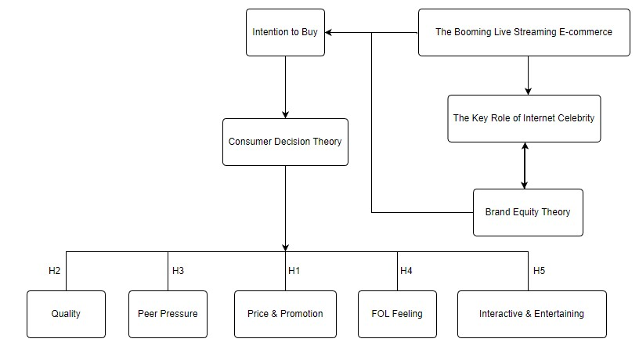
Diagram 2.1: Concept Map

2.3 The development of theoretical frameworks

2.3.1 Brand equity theory
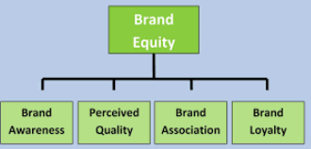
Diagram 2.2: Brand equity theory (Qian et al., 2022)
One of the key implications for the livestreaming internet celebrity is associated with brand equity and they both influence each other and complement each other. First, internet celebrity may promote the brand awareness, and millions of existing and prospective clients are following their favourite celebrities in the rigorous manner, and further fulfil the Pull marketing strategy on leading the success (Qian et al., 2022). Additionally, livestreaming internet celebrity could also promote the brand association, enabling the livestreaming to extend the coverage for the products and services.

Equally, brand equity is the direct reflection for the perceived quality, which has strongly associated with the strong trust from the clients into the celebrity via the livestreaming business. High quality brand perception also enhances customer acceptance of internet celebrity (Zhou et al., 2021). Hence, the strong brand equity for the livestreaming is delivering the success for promoting the areas.

2.3.2 Consumer decision theory
According to Park et al., (2020), consumer decision is one of the most classic theories on evaluating the influencing factors for the consumers. This also provides the opportunity for business on optimising the business model and capturing the market opportunity.

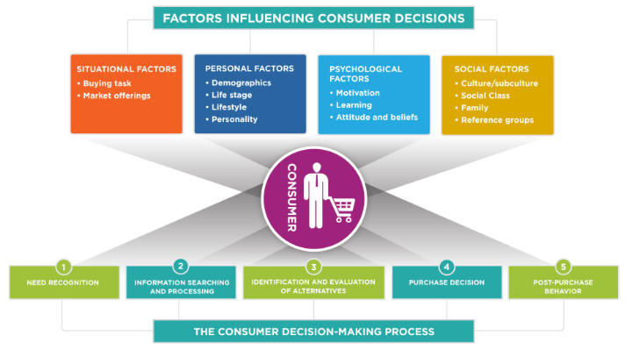
Figure 2.3: Consumer decision process and influencing factor (Liu et al., 2022)

The consumer decision theory can be divided into different stages: the clients may have the need recognitions, which are growingly relied on the external incentives and stimulus such as advertising and marketing to lead the impacts; then the rising level of e-commerce, internet and social media provide more capabilities on evaluating the alternatives to find the best options (Wong et al., 2020).

However, the theory argues that employees will have bigger influences on post-purchase behaviours, using social media to share the feedbacks to lead the impacts. The finding witnesses that a variety of influencing elements, such as situational factors, individual factors, psychological factors, and social factors, are having significant effects. (Li et al., 2021). This demonstrates how diverse decision-making processes inside businesses drive success.

According to the review, some of the major determining factors for livestreaming e-commerce growth and potential effects on consumer choice and purchase include:

Factors | Key interpretation for influencing factors
Price&Promotion | Price could be the key factors for attracting clients by offering the best value for money and promotion also allows the short term and every emotion incentives to motivate them.  The low price is directly reflecting the level of affordability for the clients by the products to lead the implications (Wang et al., 2022). Besides, promotion is often associated with short term and temporary discounts or benefits to capture the short term emotions for the clients (Fernandes et al., 2022).  For e-commerce internet celebrity, their popularity may provide the huge scale of economy on attracting the clients, and therefore the bargaining power against business partners and suppliers to seek for the best deals.
Quality | Quality can also be regarded as the key feature for the products and services, and this is directly reflecting in the areas of value for money. With the rising living standard and increasing incomes, Chinese consumers are growingly focused on the high quality products and service, rather than the lowest costs and priced ones to lead the impacts (Zhang et al., 2022).
Peer Pressures | According to Hofstede (2022), China has shown one of the key national cultural features as the collectivisms. This has seen rather than making the personal judgment and decision, consumers are much more likely to follow the expectation and perceptions from others. Thus livestreaming may successfully capture the interests from clients by taking advantage of the collectivism national culture, to lead the associated impacts and convince the Chinese clients to make the purchases (Lou et al., 2020)
FOL Feeling | A derived collectivism nature culture impacted consumer behaviour is also the fear of missing out: during the livestreaming programme, viewers are going to see the purchase volumes, and getting pressures that others are buying the advertised products (Wang et al., 2022). The fear of missing out feeling could further motivate the employees to make the purchase via the livestreaming e-commerce, promoting the success for the sales to the clients.
Interactive & Entertaining | The traditional e-commerce communication is much more associated with presenting the information in the static manner, such as picture and videos. However, the livestream has created the renewed experience to promote on the highly interactive dialogue between the celebrity host and clients, leading to the more dynamic conversations and interactive shopping experiences (Wang et al., 2021). This may also raise the entertainment requirements for further enriching the experiences.

Table 2.4: The key influencing factors and interpretations for the consumer influences

2.4 Research hypothesis statements
While questions are frequently used in quantitative studies, a formal research statement uses hypotheses (Creswell, 2008). According to large number of relevant literature, the research conducts these five hypothesis to connect with the research questions and objectives. The following research hypotheses as below:

- Hypothesis 1: Attractiveness of Internet celebrity in livestreaming e-commerce relates positively to the purchase intention of the competitive price and promotion to consumer.
- Hypothesis 2: Customers hold a positive relationship with confidence in the quality of products sold via livestreaming internet celebrity.
- Hypothesis 3: The collective buying environment created by internet celebrity correlates positively with customers' purchase intention.
- Hypothesis 4: The feeling of losing out if not to buy, created by the livestreaming celebrity lead, has a positive correlation with customer buying behaviour.
- Null Hypothesis: There is no significant relationship between the highly interactive and entertaining experience of livestreaming celebrity with the customer shopping behaviour.

2.5 Summary of literature review
The literature review delivers the comprehensive insights for the key academic theories, covering the nature for the increasing popularity of e-commerce, the benefits and impacts to clients and merchants, the role for livestreaming and also the importance for the personal brand of internet celebrity. This also delivers the comprehensive review on consumer decision and key influencing. As Park et al., (2020) indicates, the academic gap is lacking of understanding on how the internet celebrity in livestreaming analysis capturing the consumer decision to drive the goal. Thus the formation of the research hypotheses are forming the backbone for the research.

3. Research Methodology

3.1 Research paradigm and strategy selection
The study describes the purpose of the investigation and the theoretical framework in order to explore the selections of ontology and epistemology, which are included in the paradigm. The research questions and objectives are highly objective, as it focuses on understanding the consumer decision, and particularly the influencing factors on the livestreaming and associated internet celebrity. Therefore, the research conducts the positivism paradigm and objectivism epistemology (Crotty, 1998), which has focused on conducting the research in the defined manner to lead the conclusive outcomes. Positivism research philosophy focuses on independence of the researcher, promoting the highly reliable outcomes.

Additionally, this paper adopts quantitative method because of the nature of these research question (Lincoln and Guba, 1985). To support the positivism research philosophy, the study uses the deductive research approach and collect quantitative data from questionnaire, which has proven the adaptions to lead the coherent process.

The research reviews the existing researches and academic researches, in order to drive the formation of research hypotheses. Then the targeted data collection is conducted to lead the quantitative analysis and conclusion for the finding. The positivism philosophy and deductive approach are viewed as appropriate the appropriate for the study (Creswell, 2018). Due to the nature for the lack of existing finding for impact of livestreaming celebrity, the research uses the primary research to capture the goal. Then this quantitative research uses numbers and statistical outcomes to drive the quantitative and conclusive analysis.

By taking all the considerations, the researcher uses the questionnaire survey as the main research strategy. Questionnaire survey can be used to drive the design for the tailored and bespoke questions against the collection for the business; then questionnaires are distributed to the participants, collected, returned and analysed in the comprehensive manner. Importantly, the researcher should make sure the participant understands the questions in the questionnaire the same way as the researcher do to ensure suitability (Burgess, 2001,) .

Questionnaire provides the benefits for collecting the data in the comprehensive manner via the large number of participants, giving the more representative outcomes (Saunders et al., 2019). The study delivers the comprehensive successfulness to drive the statistical proven outcomes. Additionally, the finding from questionnaire may also drive the critical discussion and evaluations for the research.

3.2 Research design
The first part is associated with research design, and much of the study focused on the design of the questionnaire. The questionnaire is carefully designed in order to capture the targeted information, to therefore directly address on the research aim and objectives. The questionnaire adapted the Likert scaled questions, leading to the considerations for the levels of agreements for the questions (Creswell, 2018). This provides the more quantitative proven data, to therefore drive the research forward.

By conducting the extensive review, the researcher conducts the four constructs in the following areas:
- Recognitions of the live streaming e-commerce: this leads to the understanding for the overall perceptions towards the livestreaming e-commerce, and set the backbone for the understanding.
- Role of the internet celebrity in livestreaming e-commerce: this part of the question focuses on evaluating the implication, personal brand and associated impacts for the internet celebrity, which is often seen as the catalyst for the success for the livestreaming.
- The attractiveness for consumer shopping behaviour: this forms the core for the bodies of the research, as each of the key influencing factors for the business. This aligns with the research hypotheses established earlier, and plays the key role to drive the establishments for the analysis (Cheng et al., 2022).
- Future shopping behaviours and trends: this analyses the future trend for the livestreaming shopping behaviours, leading to drive the business forward.

3.3 Constructs and measurement items
Creswell (2008) addresses that separate measurements are made for the independent and dependent variables. Usually, the dependent variable comes after the researcher has written the independent variable. Here lists the SCALE:
(1) Independent Variable: Attractiveness for online purchase intention via internet celebrity in the booming livestreaming e-commerce
(2) Dependent Variables: Price & Promotion; Product Quality ; Peer Pressure;FOL Feeling and Interactivity & Entertaining

Construct | Scale items | Sources(Adapted/Adopted from)
Recognition of Live Streaming E-commerce (LSE) | LSE 1: Live streaming e-commerce has gained the significant recognitions in China.  LSE 2: A lot of my friends are spending time for the live streaming e-commerce.  LSE 3: Live streaming e-commerce is a popular and interactive manner to raise the interests from clients.  LSE 4: Live streaming is a very innovative approach to deliver new shopping experiences to clients. | Li (2021);  Ma, Y.(2021);  Si (2021) ;  Han K.(2021)
Role of Internet Celebrity (ICR) | ICR 1: Internet celebrity is the spirit for the live streaming e-commerce.  ICR 2: Internet celebrity could make the live streaming e-commerce much more interactive and attractive to the audiences.  ICR 3: Many of the consumers follow internet celebrity to conduct their online shopping. | Park et al. (2020);  Javadi et al.(2012);  Yong (2021)
Attractiveness of Internet Celebrity (ICA) | ICA 1: I trust the internet celebrity to recommend the best deal for me in the live streaming e-commerce.  ICA 2: This model provides the highly competitive priced offers, as internet celebrity uses his/her strong bargaining powers.  ICA 3: Internet celebrity gives me confidence on the quality of product purchased via online.  ICA 4: Internet celebrity delivers the highly interactive promotions, which makes the deal highly attractive to me.  ICA 5: I do feel motivated for purchase via internet celebrity based online sale as thousands of other people are buying.  ICA 6: Internet celebrity in live streaming makes me fear of losing out if not purchase.  ICA 7: Internet celebrity has made the shopping experience easy, interactive and also entertaining. | Li (2021);  Han (2020);  Geng, R. (2020);  Park et al. (2020);  Cheng, H. (2022);  Cai, J. (2019);  Han K.(2021);  Yong (2021)
Future Shopping Behaviours (FSB) | FSB 1: I may spend more for the online shopping over high street shopping going forward.  FSB 2: I will continuously spend time on live streaming e-commerce chancel.  FSB 3: I believe that online celebrities will become an even greater catalyst for making our lives better. | Si (2021);  Han (2020);  Yong (2021)
Table 3.1: Measurement Items

3.4 Questionnaire survey
Creswell (2008) believes utilizing specific questions to gauge attitude, perception, and behavior is the main focus of survey research. The questionnaire-based survey must be done in a proper step to prevent sampling errors, improve the generalization scope and enhance response rate.Following the components of the survey research process by Burgess (2001), the researcher identifies that sample of 100 suitable participants selected from around among the 18-34 year-old population in China and send the tailored questionnaire by email to them, then keep tracking of respondents for collecting and analysing the data.

After finishing the questionnaire questions, first of all, the researcher should invite a few friends to trial and pilot the questionnaire in order to collect the feedback from piloted participants, and it is beneficial for making the words clear by making tweaks, removing the ambiguity for the world and promote the clarities for the study (Bryman and Bell, 2014). This has been viewed appropriate to lead the impact, promoting the improvement for the quality for the research.

Second, the questionnaire is validated by the supervisor who has leveraged on the experience for the finding to lead the goal. Based on the feedback, the researcher has significantly reduced the sub-questions for recognition of livestreaming e-commerce, role of internet celebrity and future shopping behaviours. It contributes to made the research much more feasible and suitable for this quantitative research.

3.5 Research data collection and analysis
In the normal circumstance, besides emailing to centain samples, the research data collection also can be conducted in the areas of online survey, where the researcher may use the platform such as MonkeySurvey, and invite the friends, families and other targeted participants. However, due to the time constrains, the research takes some direct feeding into the questionnaire research. Once the data has been collected, the figure will be first recorded in the Excel or input into SPSS directly, and then the research uses the SPSS analytic software to conduct the study.

The following consideration for the research analysis are included in the analysis (Field, 2018):
- The Cronbach Alpha plays the key role to provide the focus for the reliability and validity for the study alongside with the internal consistency for the data. This is the key measure to ensure the quality for the finding.
- The general descriptive statistics to outline key features such as choices of selections, the average, standard deviations and distributions. This helps the general understanding for the consumer perceptions.
- Then the result show some more proven statistical analysis, including the correlation to outline the relationship among the key influencing factors, or the regression analysis to provide the statistical importance on testing the significance for the relationship.

Thus the above finding provides the good coverage for the research on collecting the sufficient information and data. This also includes the opportunity to drive the critical discussion by combining of the academic theories with the empirical findings, to provide the interpretation and coverage to the research aim and objectives (Denscombe, 2010).

3.6 Reliability and validity
According to Field (2009), it is known that the validity and reliability of the research must be guaranteed. The degree of the study's reliability and validity will determine how much useful interpretations may be made from it. Reliability and validity are needed throughout the whole research.

Firstly, as the above table 3.1 shows, each scale item is derived from proven literature and most of these sources have adopted quantitative studies, which can prove and demonstrate the reliability and validity of this constructs and measurement items. Then the researcher can start to send the survey.

Subsequently, after receiving the survey data, it is routinely processed for missing data and kicking out the abnormal value which lower the benchmark. Before analysing the SPSS-derived data, the researcher must ensure that the data satisfy a normal distribution by checking skewness and kurtosis estimates, or check bell-shaped histogram plots (Field, 2005, 2009).

“Reliability Core Decsriptive Statistics includes mean values, Standard Deviation, and Cronbach's Alpha; meanwhile, Validity Statistics includes Correlation Coefficients, Factor Analysis Statistics.”

After ensuring the reliability and validity of the data, the following step is to run a regression analysis to test the hypotheses (Field, 2005).

3.7 Research ethical considerations

Due to the nature of the primary research, the study maintains the high research ethical standard, including the areas of data protection, personal information protection, personal consultant, exclusivity usage for the study and other rights, as a result, to provide complete coverage in line with research ethics (Cohen et al., 2007).

4. Finding and Discussion

4.1 Findings of the four constructs

4.1.1 Recognitions for livestreaming e-commerce

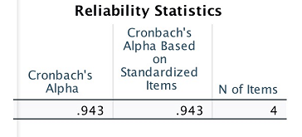
Figure 4.1: Reliability statistics for Cronbach Alpha for recognition of livestreaming e-commerce

The finding displays Cronbach’s Alpha is 0.943, and this means that high level of the internal consistency and reliability for the data, for perception towards clients’ recognitions on livestreaming e-commerce (Burns et al., 2008).

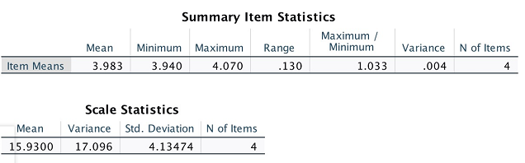
Figure 4.2: Summary statistic analysis for recognition of livestreaming e-commerce

The finding shows that mean for the level of agreement is 3.983, and this has seen as the high level of agreement as clients are towards the popularity for livestreaming e-commerce. Furthermore, the finding can be viewed the very small variance of 0.004, and there is a largely universal agreement as consumers are recognising importance for the e-commerce livestreaming.

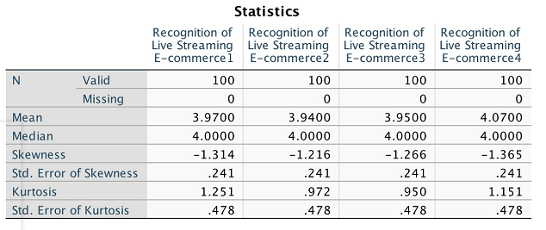
Figure 4.3: The detailed questions for the recognition of livestreaming e-commerce for recognition of livestreaming e-commerce

The finding above has provided the comprehensive insights for the areas, including the nature for the statistics to lead even more recognitions to the success.

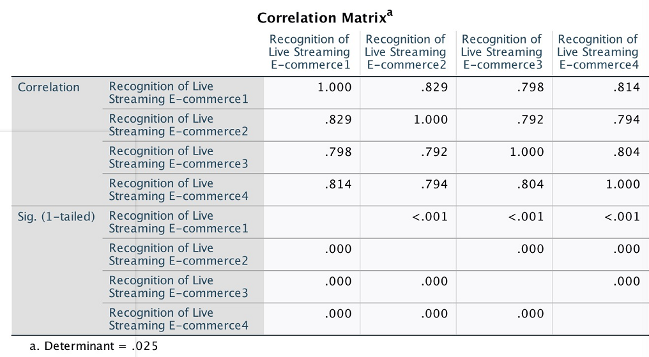
Figure 4.4: The correlation analysis for the recognition of livestreaming e-commerce for recognition of livestreaming e-commerce

The correlation analysis further indicates the relationship among the factors, and there is no surprise that due to the high consistency for the data such as low variance identified above. All factors are strongly correlated against each, and the statistical significances are showing the exceptionally strong considerations (Burns et al., 2008).
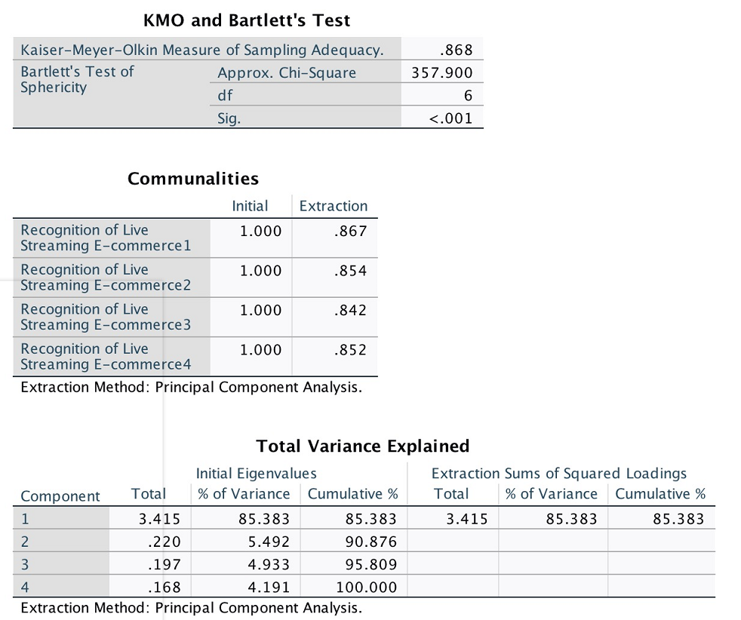
Figure 4.5: The other tests for the recognition of livestreaming e-commerce for recognition of livestreaming e-commerce

Other statistical tests displays the KMO and Bartlett tests and delivers the strong recognitions for the key factors, and can be supported by the communalities among the study. This demonstrates the strong correlated and universally recognition for the importance (Argyrous, 2011) .

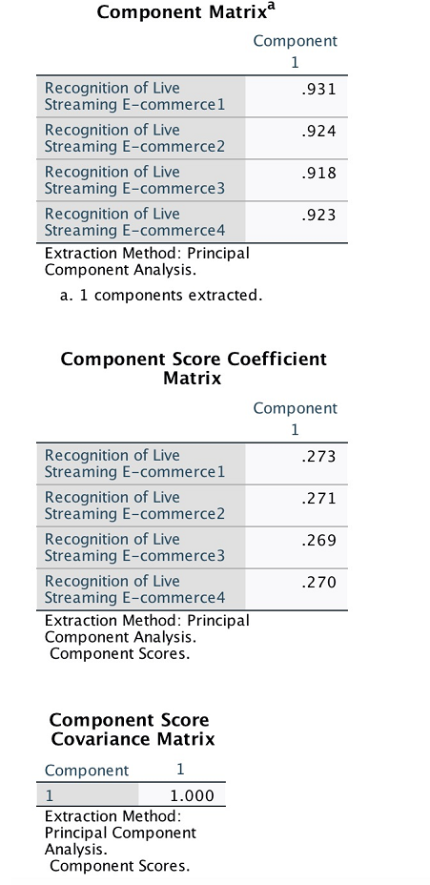
Figure 4.6: The component matrix, and score coefficient matrix for the recognition of livestreaming e-commerce for recognition of livestreaming e-commerce

Overall, the finding proves that the Chinese consumers are strongly recognising the increasing popularity and penetration for the livestreaming e-commerce and this can be associated with outcomes that more consumers are moving their shopping trend online, and also the livestreaming has gained the recognition among the fast moving e-commerce Chinese market to lead the success.

4.1.2 Role of internet celebrity
This part of the study emphasises on the role of internet celebrity in the livestreaming, and understanding their perceptions in terms of consequence over the importance for the outcomes.

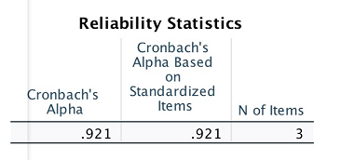
Figure 4.7: Reliability statistics for Cronbach Alpha for recognition of role of internet celebrity

The research delivers the high level of the reliability, showing the high consistency for the finding. This delivers the proven outcomes for showing the quality for the information on further analysis.

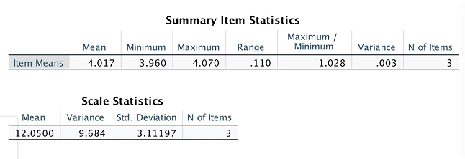

Figure 4.8: Summary statistical analysis for role of internet celebrity

The summary statistics shows the consistent level of the agreement. The mean is 4.017 showing the high level of agreement, where the ranges and variances are showing at 0.110 and 0.003 respectively. The universal and consistent level of agreement among the participants towards the recognitions for internet celebrity among the livestreaming e-commerce, and this has once again shown the consistency for the business.

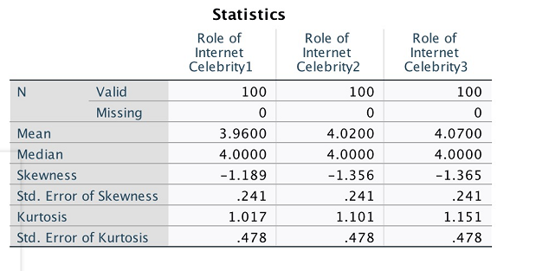
Figure 4.9: The detailed questions for the recognition of livestreaming e-commerce for recognition of role of internet celebrity

The finding above shows the detailed recognition and the consistency among the three sub-questions to promote the role of internet celebrity in the livestreaming e-commerce.

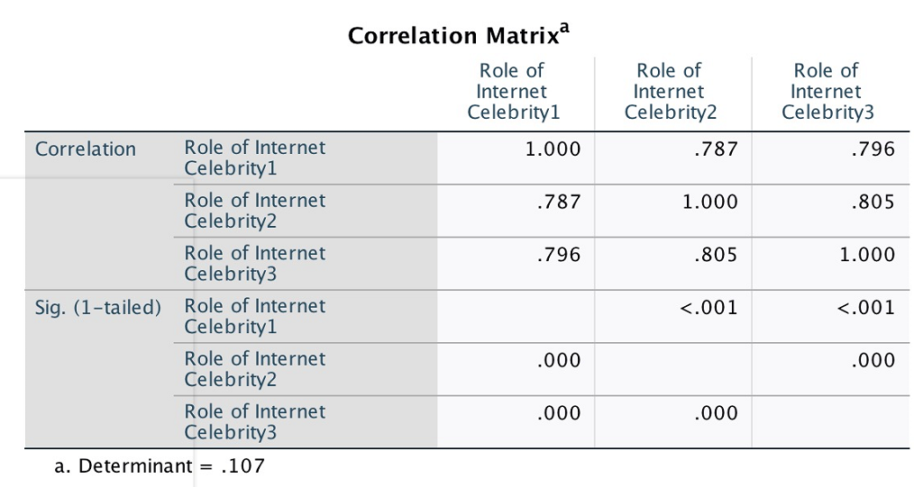
Figure 4.10: The correlation for the recognition of livestreaming e-commerce for recognition of role of internet celebrity

The correlation analysis for the internet celebrity can be seen that the correlation are all in the areas between 0.7 and 0.8, indicating the strong correlation among the key factors.

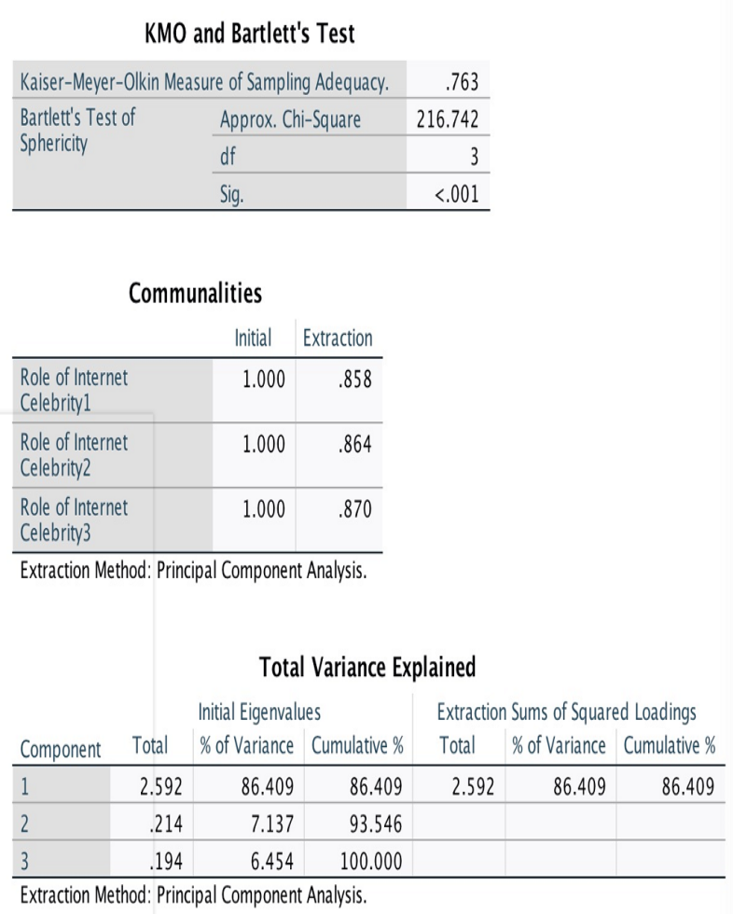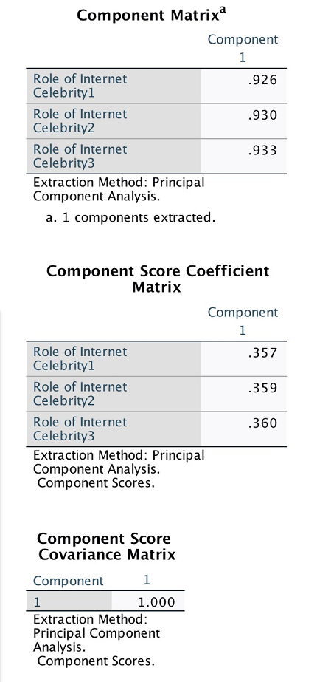
Figure 4.11: The component matrix, and score coefficient matrix for the recognition of livestreaming e-commerce for recognition of role of internet celebrity

The SPSS further replicates the various statistical analyses in the areas of KMO, Bartlett Test, Communalities, Variance explanations, component matrix and component score coefficient matrix to deliver the insights (Argyrous, 2011) . Overall, the finding provides the key coverage for the business, driving the success for understanding implications for the success, showing the huge important role for the internet celebrity in the livestreaming e-commerce to gain the success (Zhao et al., 2022).

4.1.3 Attractiveness of internet celebrity
This part of the study forms the core for the research, illustrating the impacts for the influencing factors for the attractiveness of internet celebrity on livestreaming e-commerce, in order to deliver the impact to drive the success.

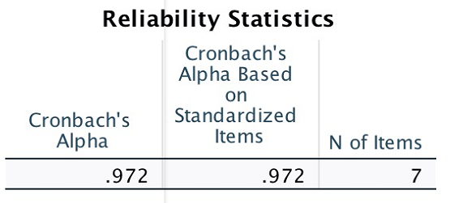
Figure 4.12: Reliability analysis for attractiveness of internet celebrity in livestreaming e-commerce

The finding displays that Cronbach’s Alpha is very strong at 0.972, showing the high reliability and consistency for the study, and promoting the recognitions for the data and value to the research among the 7 key factors.
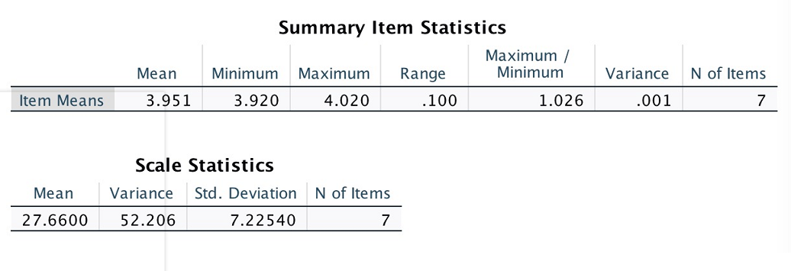
Figure 4.13: Statistical analytic analysis for attractiveness of internet celebrity in livestreaming e-commerce

The finding continues the trend with earlier recognition for livestreaming e-commerce and recognition for the internet celebrity, showing the high level of the agreement and even lower for the variance for the consistent.
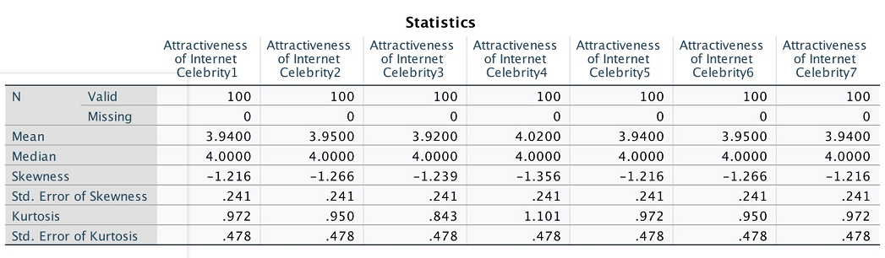
Figure 4.14: Statistical summary for attractiveness of internet celebrity in livestreaming e-commerce

The statistical summary finding for the attractiveness of internet celebrity in livestreaming e-commerce exhibits the consistent high level of the agreement, with the average agreement score stays around 4 out of 5.

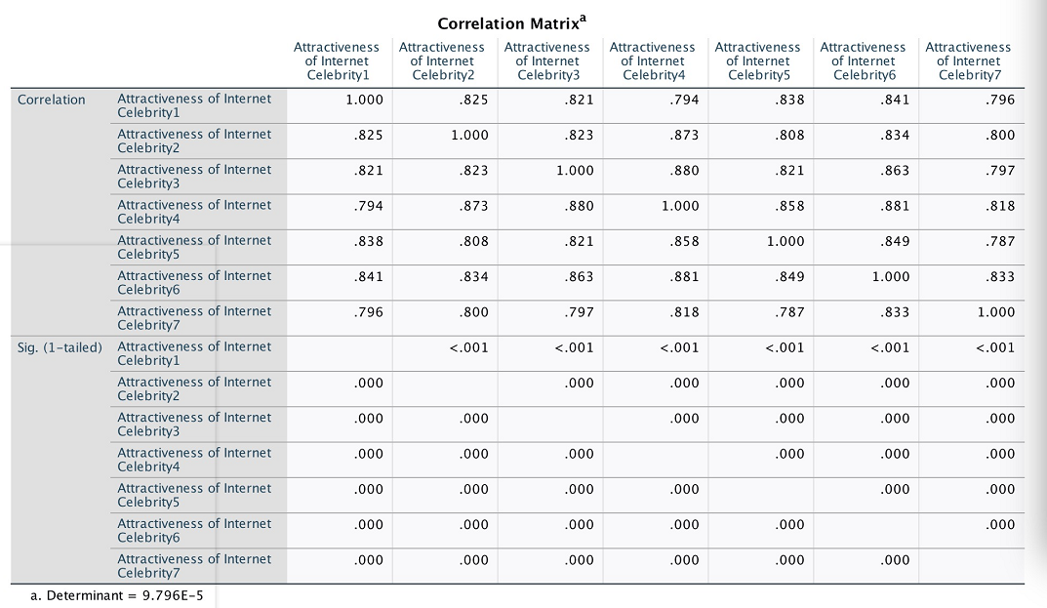
Figure 4.15: Correlation for attractiveness of internet celebrity in livestreaming e-commerce

The correlation analysis demonstrates the relationship among the key attributes and factors for the study, and once again showing the high level of the correlations among the key factors. It further proves as the significance ta 0.000 at all relationship, showing that statistical proven relationship among the key factors.
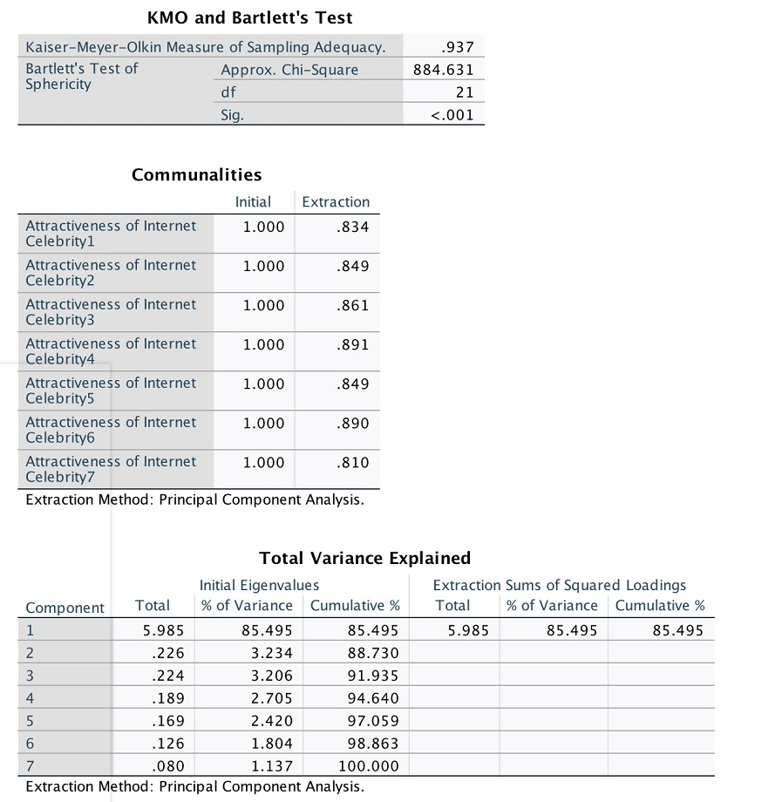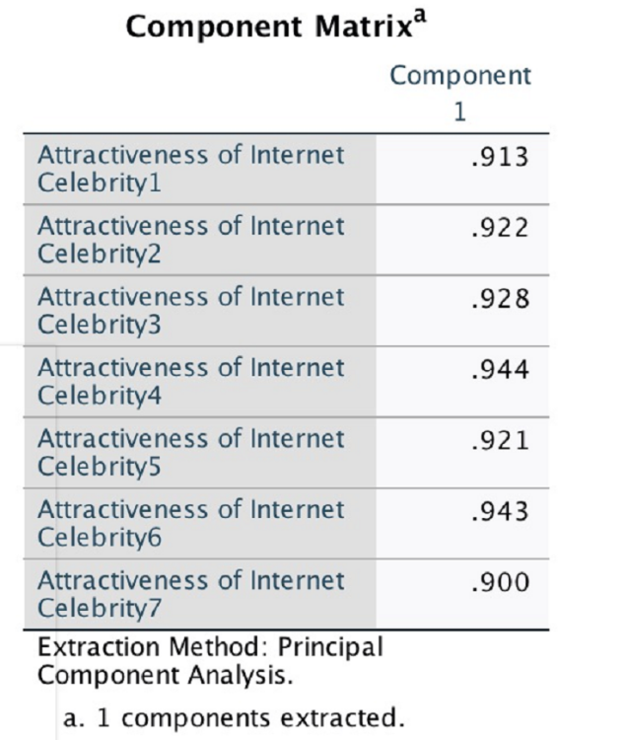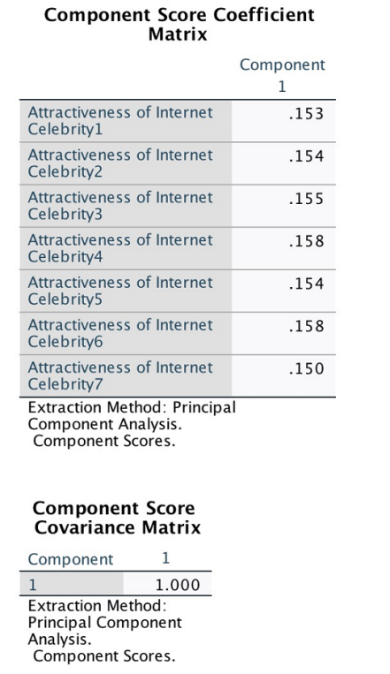
Figure 4.16: Statistical tests for attractiveness of internet celebrity in livestreaming e-commerce

The last part of the analysis for the attractiveness analysis shows that different factors are delivering the success for the research. For the KMO and Bartlett Test, the measure is 0.937 as showing the strong correlations among the key factors. The component score coefficient matrix, which is mainly evenly divided, shows that the success will be driven by highly connected insights. The attractiveness for the internet celebrity in the e-commerce are driven by distinctive influencing factors: this provides the key insights to lead the diversified outcomes to drive the business forward (Liu et al., 2022). This may provide the benefits for the core attractiveness and benefits to renewed shopping experiences.

4.1.4 Future shopping

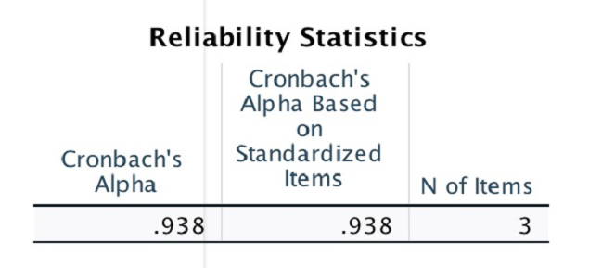
Figure 4.17: Reliability analysis for future shopping model with livestreaming e-commerce

The reliability provides the high coherence for the data at Cronbach Alpha at 0.938, providing the high reliability and consistency for the information.

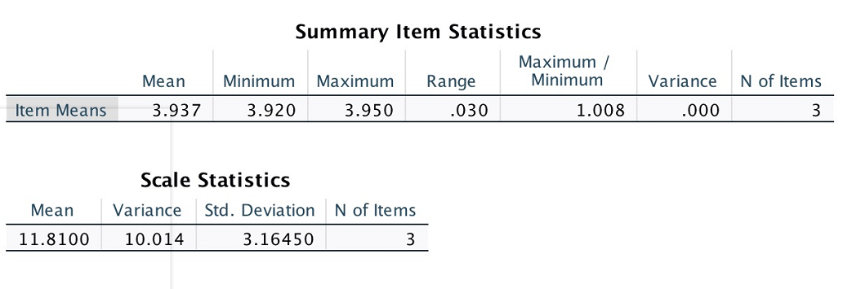
Figure 4.18: Statistical analysis for future shopping model with livestreaming e-commerce

The tables reveals that high level of agreement, that there is a high level of agreement for the future shopping model to provide further credentials to the business.
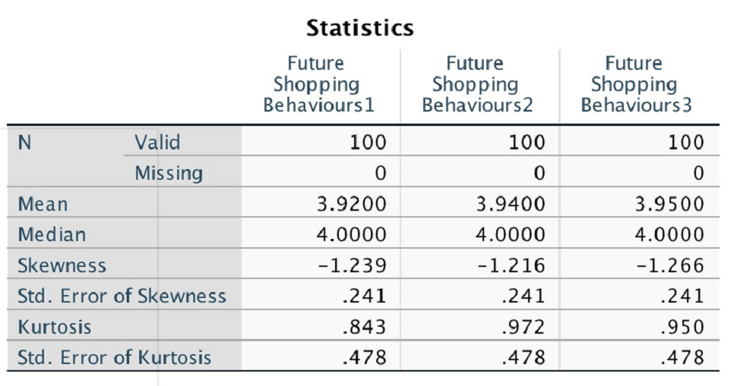
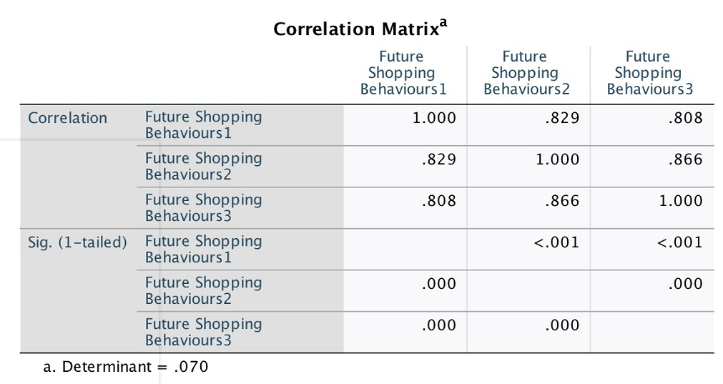
Figure 4.19: Finding and correlation for future shopping model with livestreaming e-commerce

The study indicates the high level of agreements to drive the insight over the future shopping model. There are even higher level of correlations for the business, promoting the internal consistency for the information.
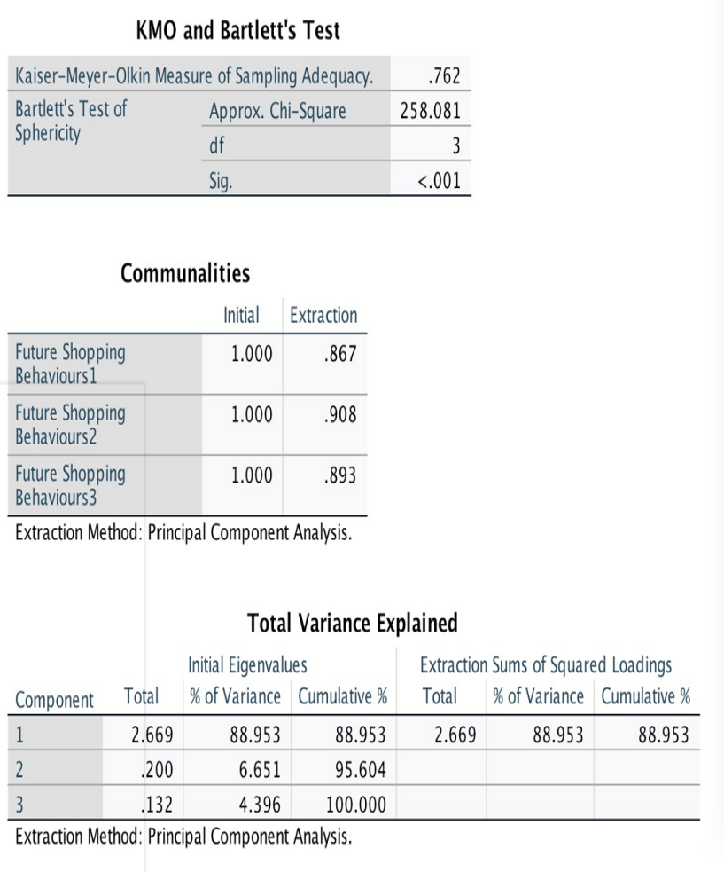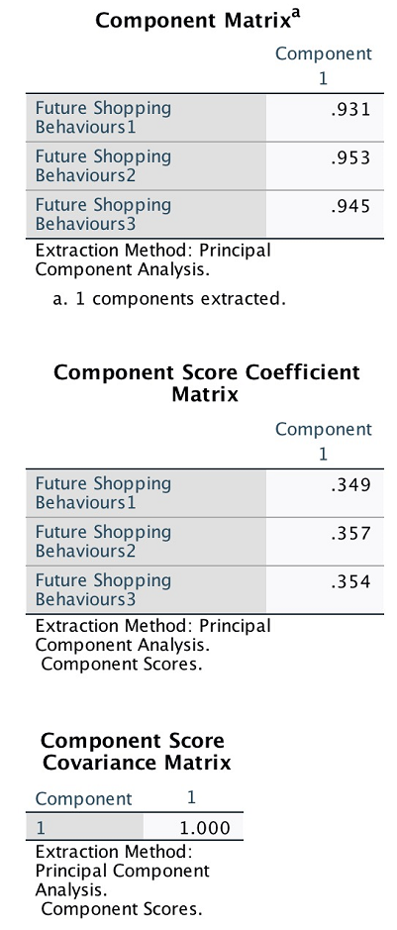
Figure 4.20: Other statistical analysis for future shopping model with livestreaming e-commerce

The research further conducts the analysis to understand the variances and also the relationship among the key factors. Besides, the high level of consistency among the key factors, shows the strong agreement in the areas (Field, 2018).

These figures concludes that the livestreaming e-commerce has not only gained the huge popularity and recognitions among the contemporary business environment, but also to gain the confidence to lead the trend for the future shopping model. This may drive the business in the future to lead the long term impacts.

4.2 Regression analysis
While the above studies delivers the comprehensive insights for the relevant topics, the study has lacked the considerations for the research outcomes. As a result, the regression analysis is implemented below to provide the insight for the analysis.

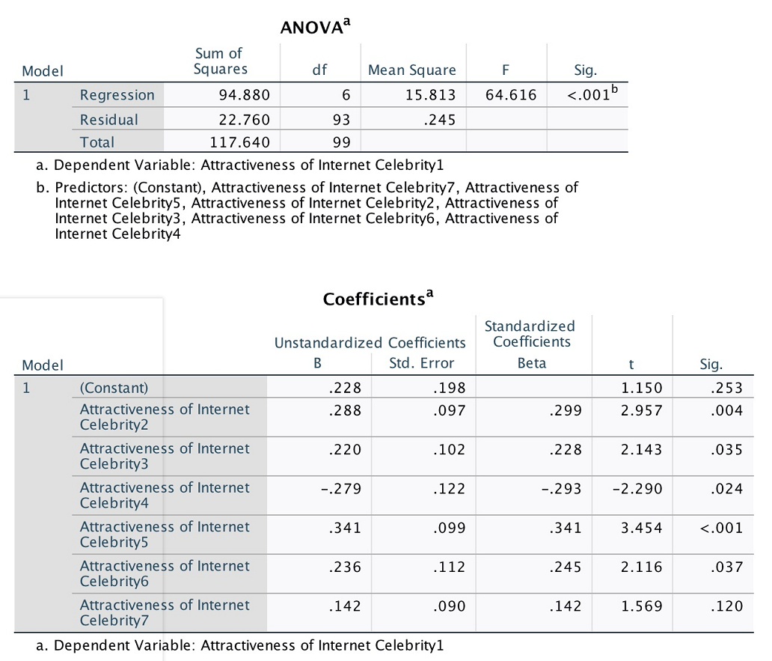
Figure 4.21: Regression analysis for the attractive factors of consumer in livestreaming e-commerce

The ANOVA outlines the regression relationship for the relevant influencing factors against the livestreaming e-commerce, and the significance level is below 0.001. The factors are delivering the statistical contributions to the outcome in the areas.

It exposes that distinctive significance level among the key factors, and the only the last factor (interactivity and entertaining experiences) has the significance of 0.12, showing that this has not formed the statistical significance. In contrast, the low price (factor 1) and peer pressures (Factor 4) are showing the significant level lower than 0.01 or at 99% of the confidence level, and this provides the strong recognitions for the statistical importance. While other factors have seen weaker but still positive statistical importance at 95%confidence level.

Based on the finding, the decisions based on research hypotheses are made in the following areas:
Hypothesis | Decision
Hypothesis 1: Attractiveness of Internet celebrity in livestreaming e-commerce relates positively to the purchase intention of the competitive price and promotion to consumer. | Strongly accepted
Hypothesis 2: Customers hold a positive relationship with confidence in the quality of products sold via livestreaming internet celebrity. | Accepted
Hypothesis 3: The collective buying environment created by internet celebrity correlates positively with customers' purchase intention. | Strongly accepted
Hypothesis 4: The feeling of losing out if not to buy, created by the livestreaming celebrity lead, has a positive correlation with customer buying behaviour. | Accepted
Null Hypothesis: There is no significant relationship between the highly interactive and entertaining experience of livestreaming celebrity with the customer shopping behaviour. | Accepted
Figure 4.22: Decision making for the research hypotheses

4.3 Critical analysis and discussion
The study delivers the comprehensive analysis and evaluations by the SPSS based statistical analysis. This has created the distinctive finding:

The first finding shows that there are strongly alignments between the academic finding and empirical outcomes. The academic and industry analysis displays the huge growth and popularity for the emerging livestreaming e-commerce to play the bigger role in the fast growing Chinese e-commerce market. The empirical finding delivers the utmost supports: the universally and consistently agreement that the consumers are recognising the importance and usage for the livestreaming e-commerce in the areas; furthermore, there is also highly agreement for seeing the role of internet celebrity to drive the success for the livestreaming e-commerce (Rungrunngjit et al., 2022). It further replicates for the trend for the industry, seeing that some of the top livestreaming e-commerce stars are getting the huge success. This has seen the alignments between the academic studies and empirical studies to drive the business forward.

Furthermore, the finding has not only seen that empirical studies are promoting the recognitions nowadays, but also the strongly recognitions for the livestreaming e-commerce in the future. This is likely to see that livestreaming e-commerce are getting the huge success in the areas.Then the study discusses all the key influencing factors to drive the success for the livestreaming e-commerce.

Despite with the new form of the e-commerce, competitive price is still viewed as extremely vital to inspire the desire to shop. While the top internet celebrity may see the face for the livestreaming e-commerce, it is the scale, supply chain management and scale of economy and associated bargaining powers are the key (Wang et al., 2021). Taking example of Austin Li (Taobao, 2022), he has the team for over 500 people in the areas of supplier management, procurement and marketing, to ensure Austin’s livestreaming has always got the best deals and supplies. This may be particularly the case that Chinese consumers who are very price sensitive, and make the internet celebrity in the positive loops: more audience and clients giving them more bargaining powers against the suppliers, this leads to better and competitively priced products to further attract audience and clients.

The trend could be particularly amplified in the Chinese society, and this reflects that the peer pressure has also gained the huge recognitions among the clients. The livestreaming e-commerce creates the unique business environment, where the clients are not only seeing the advertised products, but also the actions from other peer clients. This could often been associated with additional features such as time specific and fixed amount of the sale products to create the additional pressures if not incentives to the clients (Jin et al., 2022). Additionally, it might fit with the highly collectivist structure of Chinese society, which has observed that decisions are being made in accordance with external pressures, expectations from others to drive success, and effects on peers' customers.

However, while the factors such as quality, promotion and fear of losing out have gained reasonable level of recognitions, it is surprised to see that interactivity and entertainment is not statistical important for attracting people into livestreaming e-commerce, which is against the odd of the expectations. The finding for this may see that while some clients may see livestreaming e-commerce as the entertaining process, this is the key factors for their purchase (Quyang et al., 2021). They are still looking for the best deals in terms of competitive price, good quality and good promotions, but not relied on the interactive and entertaining experiences for the livestreaming for the success. Thus it may be proven some of the useful insights and findings to drive the outcomes and conclusion.

5. Conclusion with Limitation
The research provides the comprehensive finding in order to understand the perception, impacts and understanding for the popular livestreaming e-commerce and associated internet celebrity in China. The research has found that there is a universal and consistent agreement that livestreaming e-commerce is gaining huge recognition and popularity among the Chinese clients, across both the academic finding and empirical finding (Si, 2021).

Furthermore, the livestreaming e-commerce is likely to create the last lasting impact and become the growth engine for the e-commerce in China. It is extremely surprised to see that rather than the expected interactive and entertaining experience, clients are looking for the traditional factors such as competitive prices and quality as the key attractive factors to make the purchase (Liu et al., 2022). However, livestreaming e-commerce alongside with internet celebrity personal actions may create the sense of peer pressures, to therefore take advantage for the collectivism nature for Chinese culture. Thus the finding has seen both expected and unexpected outcomes in the areas.

Definitely, there are some obvious limitations to this literature. Bryman (2004) argues that there are inherent disadvantages to quantitative research, such as the fact that the research process is linear and therefore rigid and homogeneous, and the fact that it is more difficult to probe deeply into the reasons that explain behavioural choices without direct interview with the participant.

In addition to this, there are particular limitations to this paper. For instance, the sample size of the questionnaire is only 100, which is too small and unrepresentative for this study to be convincing, given that the target population is the young Chinese demographic aged 18-34, therefore this small sample sizes are unreliable in a certain degree. Moreover, there are far more not enough connected questions referred to the corresponding constructs and measurement items especially about the one “Interactivity & Entertaining”, a distinctive no relationship conclusion by using only one relevant question is not fully convincing to the researcher and readers. These limitations are largely the result of the short time frame of the current quantitative study and the limited length of this assignment. In the final dissertation, the researcher will definitely overcome each of these limitations in order to analyse the research findings with more reliability and validity.

- Recommendation and Self-reflection
6.1 Recommendation
From the recommendation perspective, the study recommends all merchants to seriously take the considerations for their e-commerce strategy in China, and embed some elements of the livestreaming communication and marketing actions. This could help the business to capture the more energy and also fast growing opportunity of e-commerce and lucrative Chinese e-commerce market for the years to be.

Furthermore, while livestreaming and internet celebrity may play some roles for convincing the clients, the consumers are still relied on the core features and competitiveness for the product and services, such as competitive prices and promotions, quality, and other key factors (Zhu et al., 2022). Thus the study recommends that business can rely on but not over-rely on the livestreaming and internet celebrity in their e-commerce strategy.

6.2 Benefits from this course
From the personal reflection perspective, the author has found the research and whole experience extremely valuable. Benefiting from the quantitative lectures, the researcher has learnt great deals of the relevant quantitative analysis, the exercise has made me to apply the knowledge into the real business research. This is great way in terms of the personal development, not only making me much more confidence with the usage of the software tools like the SPSS, but also the areas of the overall design for the research, data collection and analysis, and beyond to benefit long term academic lives and careers.

6.3 Methodological choice for the final dissertation
Honestly, having studied qualitative and quantitative research systematically and read the relevant methodological literature, I believe that my research topic is more suitable for purely qualitative research instead of quantitative method. Because the subject about attractiveness factors of livestreaming hosts to customers explored is full of subjectivity, the truths here are multiple and not the only universal. Besides, I have some personal resources about the live celebrity who can be conducted a deep semi-structured interview and observation by me, in order to explore the diversity of the lives and experiences of the interviewees during doing the livestreaming e-commerce online (Erlingsson et al., 2013; Byman et al., 2015; Creswell, 2003). Overall, the researcher has found the topic exceptionally value adding and beneficial to academic and career lives.

Bibliography
Argyrous., G., (2011) Statistics for research: with a guide to SPSS 3rd ed., Los Angeles: Sage.

Bryman, A. (2004), Quantity and Quality in Social Research, Routledge, New York: USA.

Burgess, T.F., 2001. Guide to the Design of Questionnaires. A general introduction to the design of questionnaires for survey research, 30(4), pp.411-432.

Burns., R., Burns., R., (2008) Business research methods and statistics using SPSS, London, Sage.

Cai, J. and Wohn, D.Y., 2019. Live streaming commerce: Uses and gratifications approach to understanding consumers’ motivations.

Chen, Y. and Xiong, F. (2019) ‘The Business Model of Live Streaming Entertainment Services in China and Associated Challenges for Key Stakeholders’, IEEE access, 7, pp. 116321–116327. doi:10.1109/ACCESS.2019.2935005.

Cheng, H., Huang, Y.T. and Huang, J., 2022. The Application of DEMATEL-ANP in Livestream E-Commerce Based on the Research of Consumers’ Shopping Motivation. Scientific Programming, 2022.

Clemes et al (2014). An empirical analysis of online shopping adoption in Beijing, China. Journal of Retailing and Consumer Services, Volume 21, Issue 3, Pages 364-375

Cohen, L.; Manion, L. and Morrison, K. (2007), Research Methods in Education, 6th edn, Routledge, New York: USA

Creswell, J.W. 2003. Research design: qualitative, quantitative, and mixed method approaches. SAGE.

Creswell, J. W. (2008). Qualitative inquiry and research design. CA: Sage.

Creswell, J.W.2018. Qualitative Inquiry & Research Design 4e. SAGE Publishing.

Crotty, M. (1998). The Foundations of Social Research: Meaning and Perspective in the Research Process. London: SAGE Publications Ltd

Efron, SE, & Ravid, R. (2018) Writing the Literature Review : A Practical Guide, Guilford Publications, New York. Available from: ProQuest Ebook Central. [5 May 2022].

Erlingsson, C. and Brysiewicz, P., 2013. Orientation among multiple truths: An introduction to qualitative research. African Journal of emergency medicine, 3(2), pp.92-99.

Fei et al (2021). Promoting or attenuating? An eye-tracking study on the role of social cues in e-commerce livestreaming. Decision Support Systems, Volume 142, 113466

Field, A., (2018) Discovering statistics using IBM SPSS statistics 5th ed., London: Sage

Fernandes et al (2022). Measuring the impact of online reviews on consumer purchase decisions – A scale development study. Journal of Retailing and Consumer Services, Volume 68, 103066

Geng, R., Wang, S., Chen, X., Song, D. and Yu, J., 2020. Content marketing in e-commerce platforms in the internet celebrity economy. Industrial Management & Data Systems, 120(3), pp.464-485.

Guba, E.G. and Lincoln, Y.S., 1994. Competing paradigms in qualitative research. Handbook of qualitative research, 2(163-194), p.105.

Gulfraz et al (2022). Understanding the impact of online customers’ shopping experience on online impulsive buying: A study on two leading E-commerce platforms. Journal of Retailing and Consumer Services, Volume 68, 103000

Hua, Q. and Chiu, C.L., 2022. Analysis of Young Chinese Purchase Intention on TikTok Live Streaming. Management Review: An International Journal, pp.65-99.

Javadi, M.H.M., Dolatabadi, H.R., Nourbakhsh, M., Poursaeedi, A. and Asadollahi, A.R., 2012. An analysis of factors affecting on online shopping behavior of consumers. International journal of marketing studies, 4(5), p.81.

Jin et al (2022). Consumer responses to genetically modified food in China: The influence of existing general attitudes, affect and perceptions of risks and benefits. Food Quality and Preference, Volume 99, 104543
Juntimwasarakij S (2018). Framing emerging behaviors influenced by internet celebrity. Kasetsart Journal of Social Sciences, Volume 39, Issue 3, Pages 550-555

Ke Han (2021). Research on the influencing factors of users’ purchase intention in e-commerce live broadcast - Taking Taobao as an example. CNKI

Khan et al (2020). Understanding multiscreening phenomenon for online shopping through perspective of self-regulation and dual process theory: Case of Chinese young generation. Electronic Commerce Research and Applications, Volume 42, 100988

Li et al (2021). Strategic manipulation of online information in duopolies: Inducing fight-back? Electronic Commerce Research and Applications, Volume 47, 101052

Liu et al (2022). Consumers’ decision-making process in redeeming and sharing behaviors toward app-based mobile coupons in social commerce. International Journal of Information Management, Volume 67, 102550

Liu et al (2022). The impact of expectation discrepancy on food consumers’ quality perception and purchase intentions: Exploring mediating and moderating influences in China. Food Control, Volume 133, Part B, 108668

Liu et al (2022). Consumers’ decision-making process in redeeming and sharing behaviors toward app-based mobile coupons in social commerce. International Journal of Information Management, Volume 67, 102550

Li li (2021). Research on the influence mechanism of internet celebrity e-commerce livestreaming on cunsumers’ purchase intention. CNKI

Lou et al (2020). An improved consumer decision model for rural residential development: A theoretical framework and empirical evidence from China. Habitat International, Volume 105, 102266

Luo, H., Cheng, S. and Zhou, W., 2021, March. The Factors Influencing Sales in Online Celebrities' Live Streaming. In 2021 IEEE International Conference on Information Communication and Software Engineering (ICICSE) (pp. 233-237). IEEE.

Ma, Y., 2021. To shop or not: Understanding Chinese consumers’ live-stream shopping intentions from the perspectives of uses and gratifications, perceived network size, perceptions of digital celebrities, and shopping orientations. Telematics and Informatics, 59, p.101562.

Maxwell, J.A., 2008. Designing a qualitative study. The SAGE handbook of applied social research methods, 2, pp.214-253.

Meng et al (2021). The impact of online celebrity in livestreaming E-commerce on purchase intention from the perspective of emotional contagion. Journal of Retailing and Consumer Services, Volume 63, 102733

Park, H.J. and Lin, L.M., 2020. The effects of match-ups on the consumer attitudes toward internet celebrities and their live streaming contents in the context of product endorsement. Journal of Retailing and Consumer Services, 52, p.101934.

Qian et al (2022). Gamification for value creation and viewer engagement in gamified livestreaming services: The moderating role of gender in esports. Journal of Business Research, Volume 145, Pages 482-494

Qiao Y. Yong (2021). A study of the relationship between social presence, consumer trust and continued purchase intention in a live e-commerce context. CNKI

Quyang et al (2021). Understanding preferences for and consumer behavior toward cheese among a cohort of young, educated, internationally mobile Chinese consumers. Journal of Dairy Science, Volume 104, Issue 12, Pages 12415-12426

Rojek, C., 2001. Celebrity. Reaktion Books.

Rungrunngjit et al (2022). What drives Taobao live streaming commerce? The role of parasocial relationships, congruence and source credibility in Chinese consumers’ purchase intentions. Heliyon, Volume 8, Issue 6, e09676

Saunders, M., Lewis, P., Thornhill, A., (2019) Research methods for business students, 8th ed., Harlow: Pearson.

Shen et al (2018). Lead-based paint in children's toys sold on China's major online shopping platforms. Environmental Pollution, Volume 241, Pages 311-318

Si, R., 2021. China Livestreaming E-commerce Industry Insights. Springer Singapore.

Tan et al (2017). Business-to-business adoption of eCommerce in China. Information & Management, Volume 44, Issue 3, Pages 332-351

Wang et al (2021). Factors influencing consumers' purchase decision-making in O2O business model: Evidence from consumers' overall evaluation. Journal of Retailing and Consumer Services, Volume 61, 102565

Wang et al (2021). The power of social learning: How do observational and word-of-mouth learning influence online consumer decision processes? Information Processing & Management, Volume 58, Issue 5, 102632

Wang et al (2022). Consumer culture in traditional food market: The influence of Chinese consumers to the cultural construction of Chinese barbecue. Food Control, Volume 143, 109311

Wang et al (2022). Increase hedonic products purchase intention through livestreaming: The mediating effects of mental imagery quality and customer trust. Journal of Retailing and Consumer Services, Volume 69, 103109

Wang et al (2022). The impact of government intervention measures on recycling of waste electrical and electronic equipment in China considering consumer decision. Energy Policy, Volume 160, 112697

Wong et al (2020). The role of live streaming in building consumer trust and engagement with social commerce sellers. Journal of Business Research, Volume 117, Pages 543-556

Xi et al (2020). The impacts of same day delivery online shopping on local store shopping in Nanjing, China. Transportation Research Part A: Policy and Practice, Volume 136, Pages 35-47

Xiao Y. Han (2020). A mechanistic study of the role of e-commerce anchor attributes on consumers’ online behavioral intentions. CNKI

Xu et al (2014). The effects of collectivism and polychronic time orientation on online social interaction and shopping behavior: A comparative study between China and France. Technological Forecasting and Social Change, Volume 88, Pages 265-275

Yoon (2019). The effects of national culture values on consumer acceptance of e-commerce: Online shoppers in China. Information & Management, Volume 46, Issue 5, Pages 294-301

Zhang et al (2022). Waste flow of wet wipes and decision-making mechanism for consumers’ discarding behaviors. Journal of Cleaner Production, Volume 364, 132684

Zhang, T., Qian, J., Sun, X., Ma, D. and Yuan, Y., 2021, October. Live streaming shopping in China: an interpretation from the perspective of major market participants. In 5th International Conference on Crowd Science and Engineering (pp. 150-154).

Zhao et al (2022). What determines consumers' acceptance of electric vehicles: A survey in Shanghai, China. Energy Economics, Volume 108, 105805

Zhou et al (2021). Characterizing Chinese consumers’ intention to use live e-commerce shopping. Technology in Society, Volume 67, 101767

Zhu et al (2022). Pricing and quality decisions with conspicuous consumers. Logistics and Transportation Review, Volume 165, 102857

Appendix:

Appendix 1: Recognition of livestreaming e-Commerce
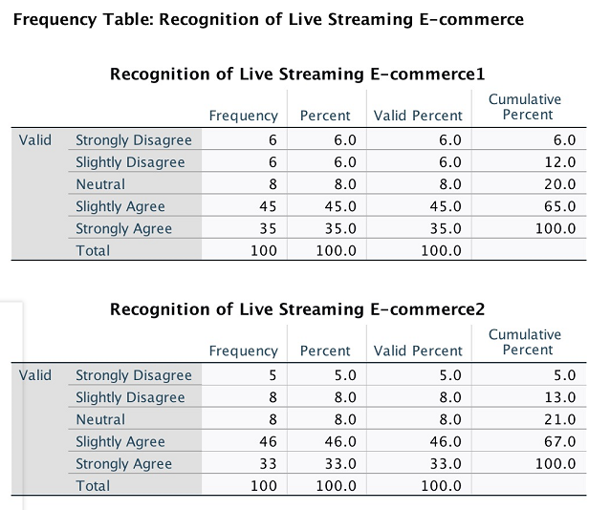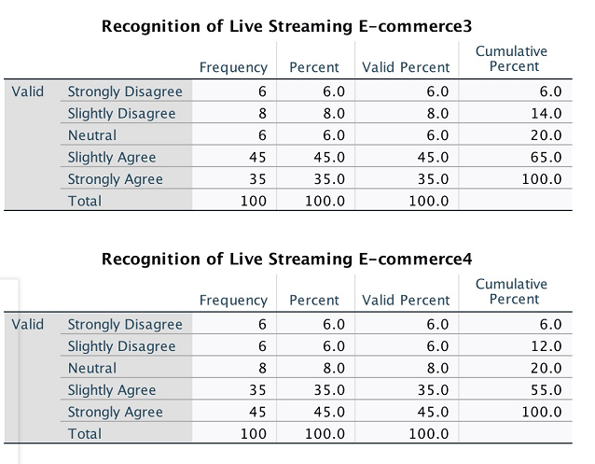

Appendix 2: Recognition for role of internet celebrity in livestreaming e-Commerce

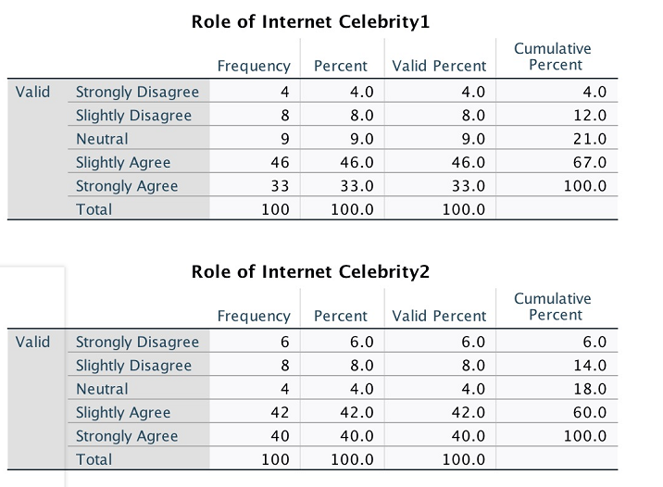
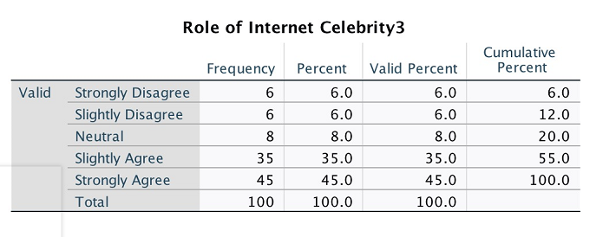

Appendix 3: The key attractiveness factor in livestreaming e-Commerce
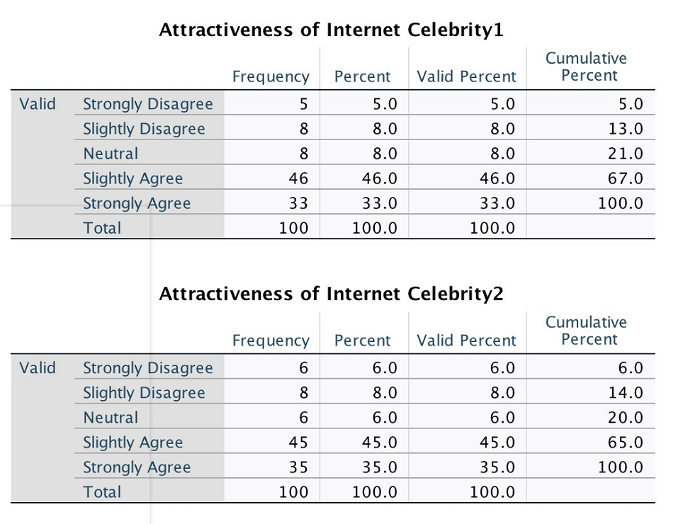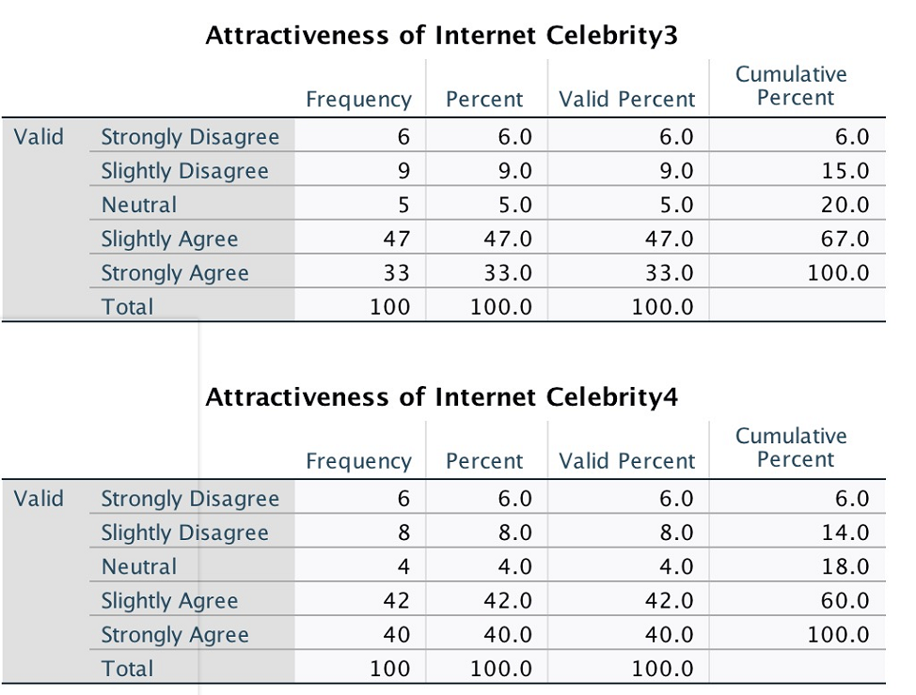
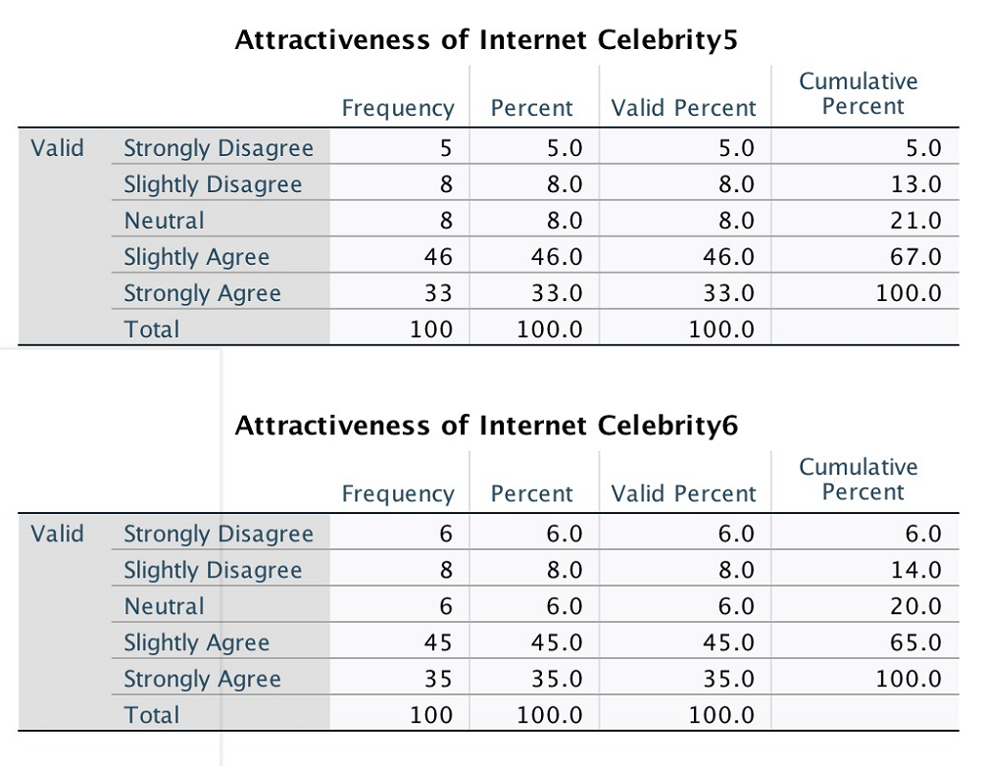
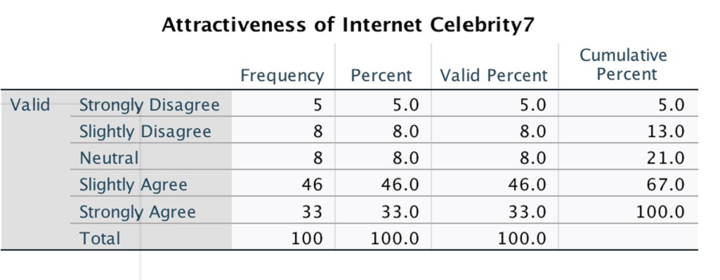

Appendix 4: The future shopping behaviours

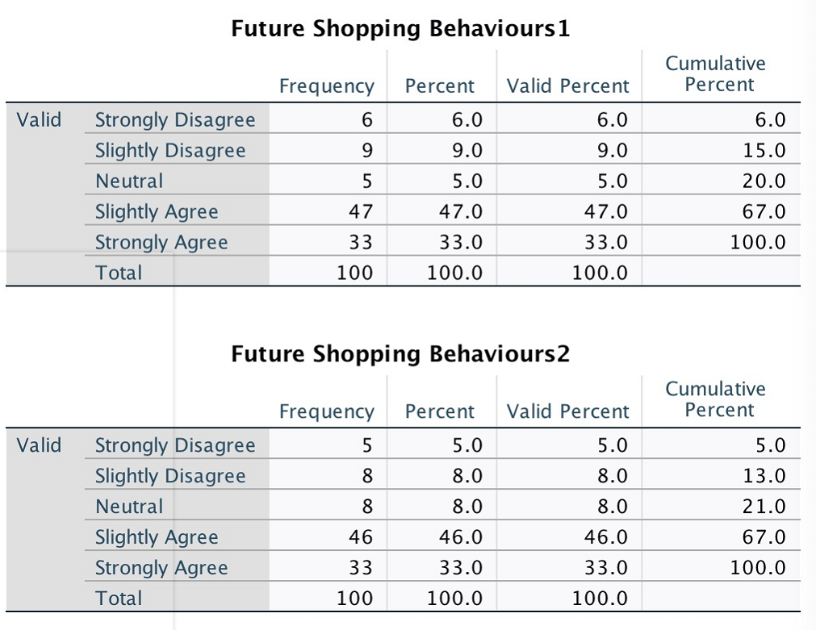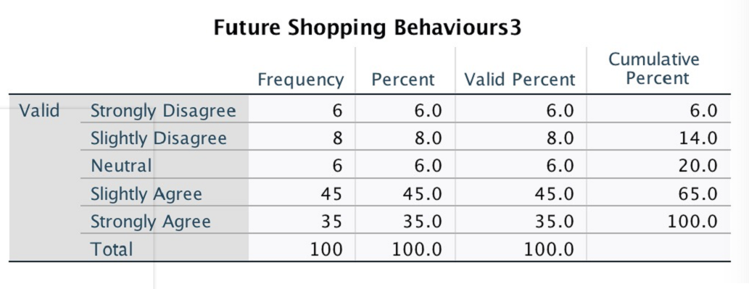

Appendix 5: Sampled questionnaire

Further Details for Creating the Dataset for your Assignment

Assuming you have carried out a questionnaire survey, and after doing missing data analysis, you have 100 suitable questionnaires for use in the analyses for your study. Using the proportion shown for each variable of each construct, create a dataset which you will use to undertake analysis for this study.
Instructions: Please, use a 5-point likert-scale as described below:
1 - Strongly Disagree
2 – Slightly Disagree
3 – Neutral
4 – Slightly Agree
5 – Strongly Agree

Construct A – Recognition of live streaming E-commerce

No. | Statements | Scale

 |  | 1 | 2 | 3 | 4 | 5
LSE 1 | Live streaming e-commerce has gained the significant recognitions in China. | 6 | 6 | 8 | 45 | 35
LSE 2 | A lot of my friends are spending time for the live streaming e-commerce. | 5 | 8 | 8 | 46 | 33
LSE 3 | Live streaming e-commerce is a popular and interactive manner to raise the interests from clients. | 6 | 8 | 6 | 45 | 35
LSE 4 | Live streaming is a very innovative approach to deliver new shopping experiences to clients | 6 | 6 | 8 | 35 | 45

Construct B – Role of Internet Celebrity in Live Streaming E-commerce

No. | Statements | Scale

 |  | 1 | 2 | 3 | 4 | 5
ICR 1 | Internet celebrity is the spirit for the live streaming e-commerce. | 4 | 8 | 9 | 46 | 33
ICR 2 | Internet celebrity could make the live streaming e-commerce much more interactive and attractive to the audiences. | 6 | 8 | 4 | 42 | 40
ICR 3 | Many of the consumers follow internet celebrity to conduct their online shopping. | 6 | 6 | 8 | 35 | 45

Construct C – Attractiveness of Internet Celebrity on the Live Streaming E-commerce

No. | Statements | Scale

 |  | 1 | 2 | 3 | 4 | 5
ICA 1 | I trust the internet celebrity to recommend the best deal for me in the live streaming e-commerce. | 5 | 8 | 8 | 46 | 33
ICA 2 | This model provides the highly competitive priced offers, as internet celebrity uses his/her strong bargaining powers. | 6 | 8 | 6 | 45 | 35
ICA 3 | Internet celebrity gives me confidence on the quality of product purchased via online. | 6 | 9 | 5 | 47 | 33
ICA 4 | Internet celebrity delivers the highly interactive promotions, which makes the deal highly attractive to me. | 6 | 8 | 4 | 42 | 40
ICA 5 | I do feel motivated for purchase via internet celebrity based online sale as thousands of other people are buying. | 5 | 8 | 8 | 46 | 33
ICA 6 | Internet celebrity in live streaming makes me fear of losing out if not purchase. | 6 | 8 | 6 | 45 | 35
ICA 7 | Internet celebrity has made the shopping experience easy, interactive and also entertaining. | 5 | 8 | 8 | 46 | 33

Construct D – Future Shopping Behaviors and Channels

No. | Statements | Scale

 |  | 1 | 2 | 3 | 4 | 5
FSB 1 | I may spend more for the online shopping over high street shopping going forward. | 6 | 9 | 5 | 47 | 33
FSB 2 | I will continuously spend time on live streaming e-commerce chancel. | 5 | 8 | 8 | 46 | 33
FSB 3 | I believe that online celebrities will become an even greater catalyst for making our lives better. | 6 | 8 | 6 | 45 | 35

Part F: Demographics

Gender Age
37
63
62
Male Female Between 18 and 24
17
Between 25 and 30
Industry Type
57
21
Student Between 31 and 34

Service
20

Manufacturing Qualifications
16
49
Postgraduate Degree
7
Wholesale
13
First Degree
13
Others (please specify) ………… High School Certificate
13
Primary School Certificate
12
No Certification

