Reflective Essay
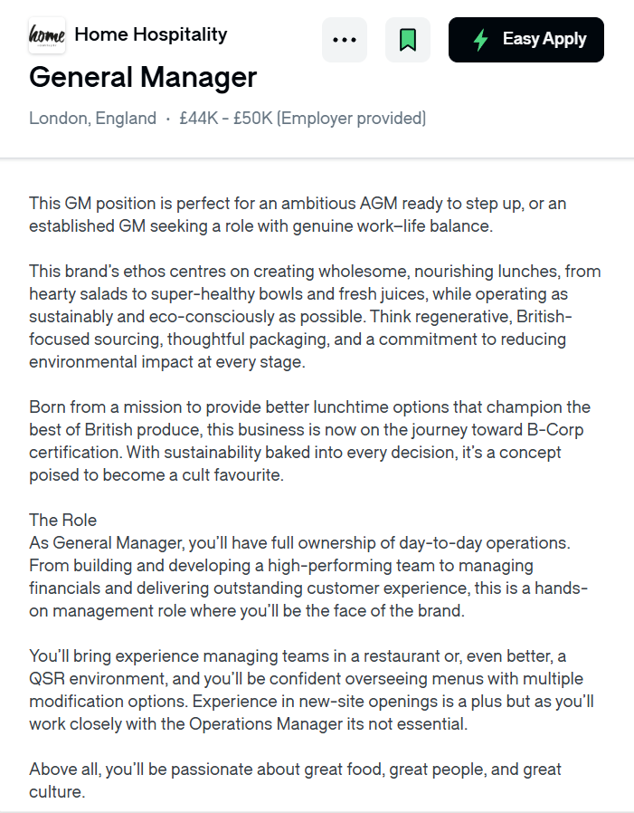
Task- 1.

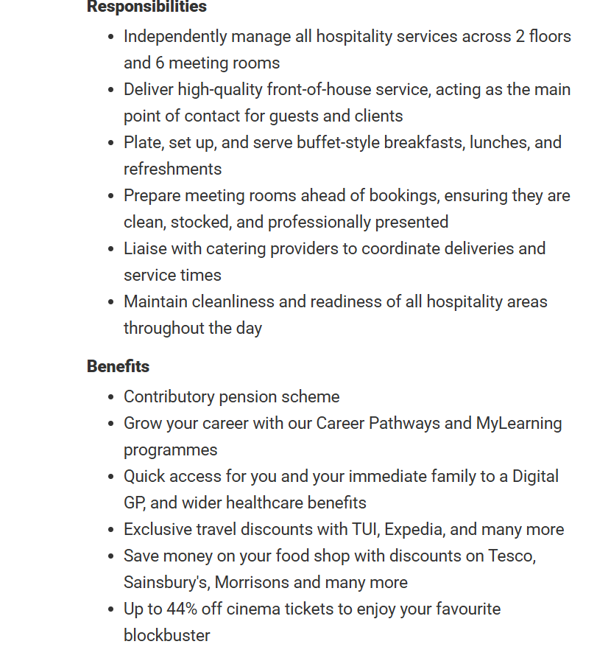
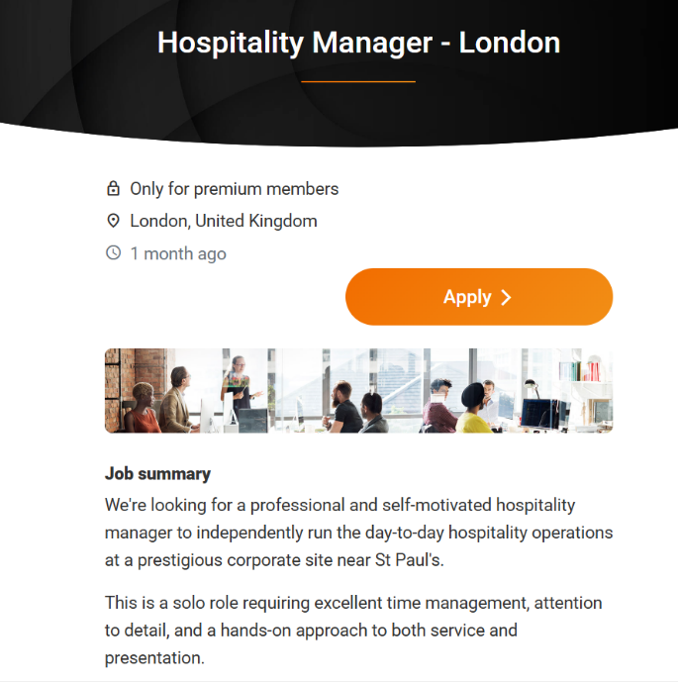
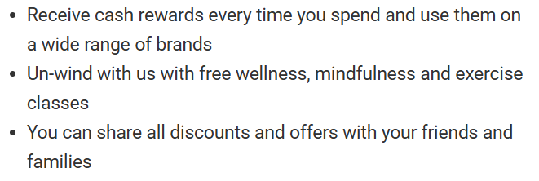

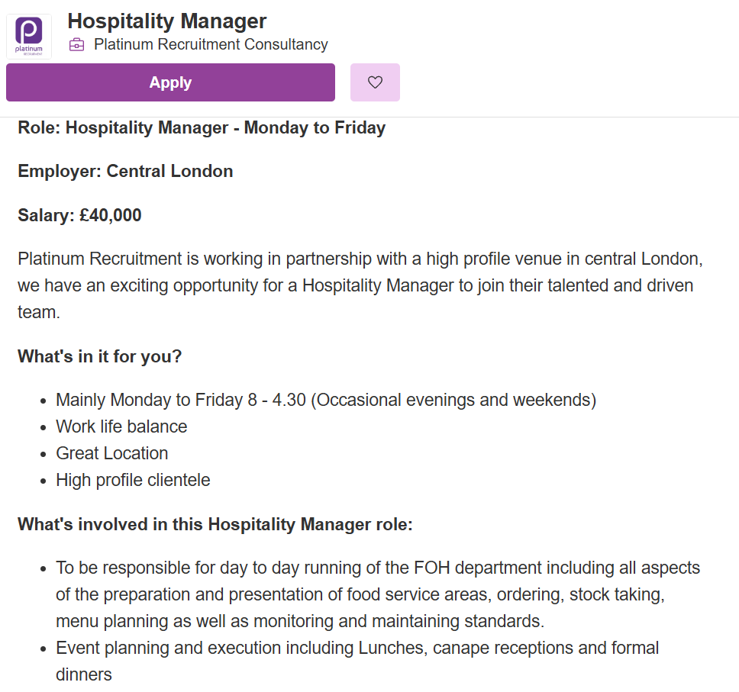
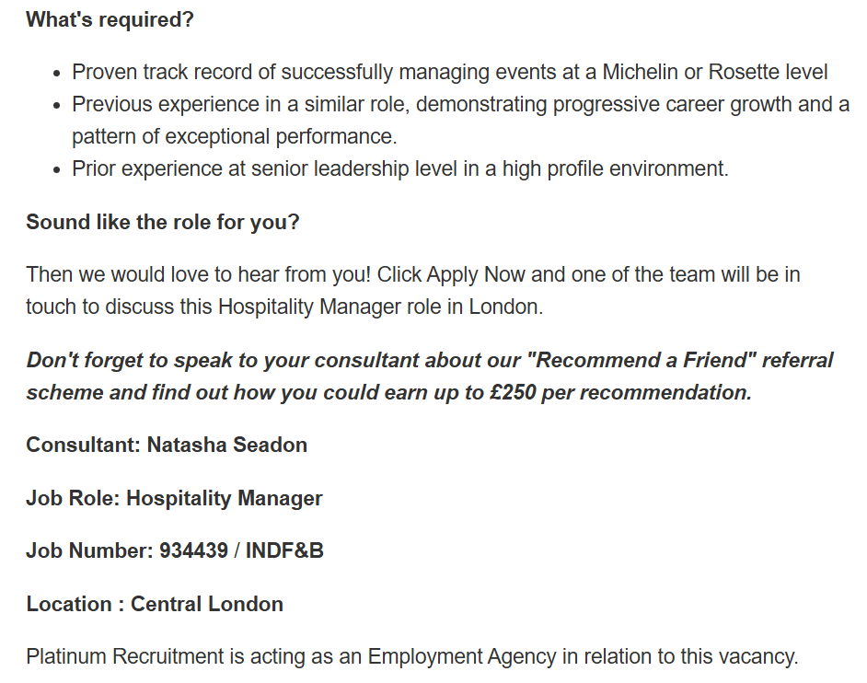

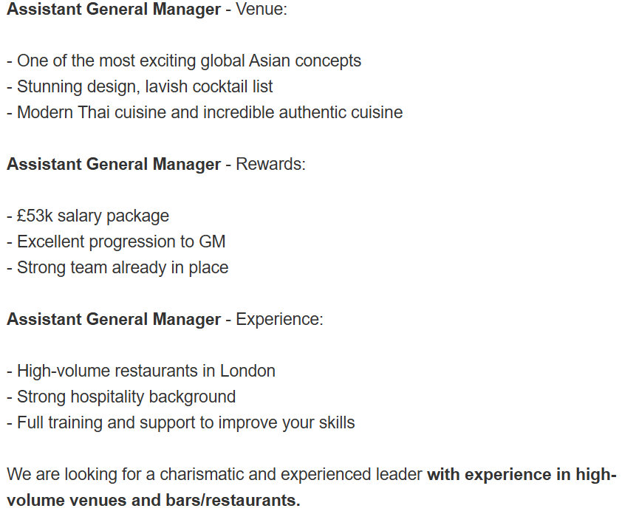
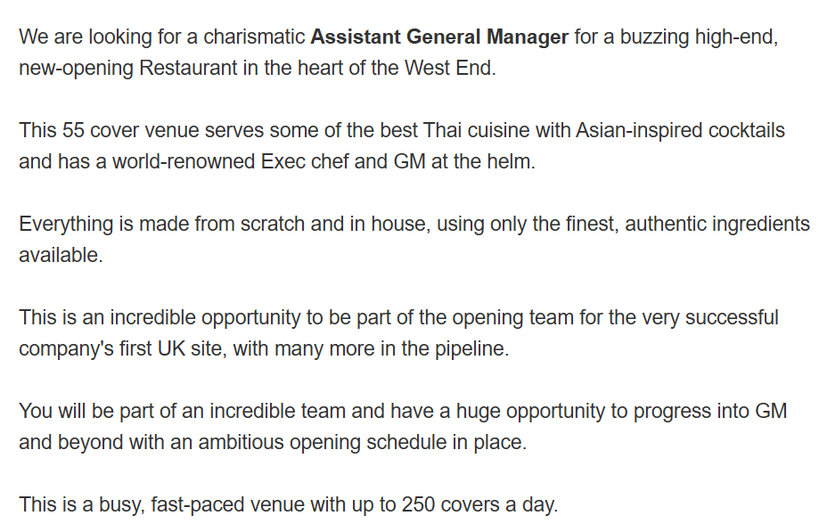
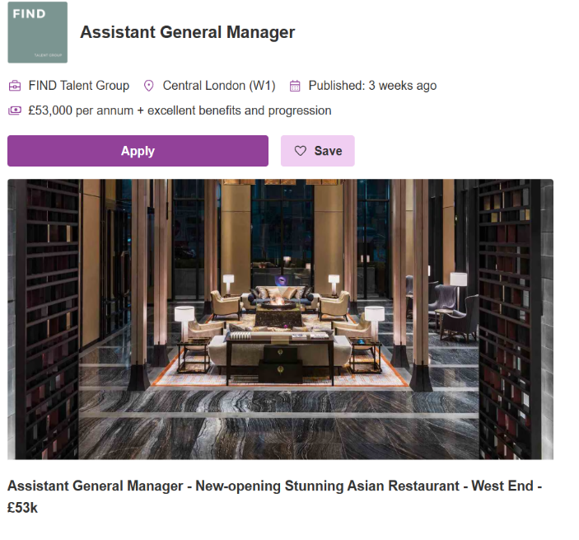
Task-1
Between, these four selected job adverts, several common skills and knowledge areas are mentioned that define the expectations for hospitality managers in London. Leadership and team management is consistently highlighted, with each role requiring the ability to inspire, train, and staff to deliver high-quality service. This aligns directly with my experience as a Production Supervisor, where I’ve managed supplier agreements and motivated team leaders.
Another recurring theme is customer service excellence. Whether at Appetite 4 Recruitment, F1Arcade, or Home Hospitality, the adverts stress the importance of creating memorable guest experiences. My background in guest satisfaction and hospitality awards demonstrates strong alignment here.
Food safety and compliance is a critical requirement, particularly in Appetite 4 Recruitment’s role. These positions demand strict adherence to hygiene protocols, echoing my certifications in Level 3 Food Hygiene and my operational experience at Greencore Ltd.
Operational and financial management also feature noticeable. From cost control at Home Hospitality to budgeting at Platinum Recruitment, employers expect managers to balance efficiency with profitability. And my proven record of reducing food waste and controlling costs by measurable percentages provides strong evidence of readiness.
Finally, event delivery and adaptability distinguish certain roles. Home Hospitality and Platinum Recruitment require event planning and menu development, while Appetite 4 recruitment emphasizes adaptability in fast-paced environments. My Mediterranean culinary knowledge and recipe development experience position me well to adapt to diverse culinary environments and event settings.
In summary, the adverts collectively highlight leadership, customer service, food safety, operational management, and event delivery as core efficiency. This overlap strongly matches with my CV, demonstrating that I’m already possess many of the skills employers seek, while also identifying areas—such as specialized event performance—could enhance my employability skills more. By, aligning my strengths and these skills, I can position myself as a strong candidate.
Task 2: Self-Assessment and Evidence of Readiness
Self-Assessment (SWOT Analysis)
- Strengths
  - Strong leadership and team motivation skills, demonstrated as Production Supervisor at Greencore Ltd.
  - Proven ability to manage food safety, hygiene, and allergen protocols, supported by Level 3 Food Hygiene certification.
  - Operational efficiency: reduced food waste by 5% and controlled food costs by 6%.
  - Excellent communication and guest service skills, recognized through hospitality awards and guest satisfaction scores.
  - Multilingual (Bangla, English, Hindi, Urdu), enhancing communication in diverse teams and customer bases.
- Weaknesses
  - Limited exposure to specialized cuisines beyond Mediterranean, which may restrict opportunities in niche restaurants.
  - Developing confidence in public speaking and presenting to larger groups.
  - Delegation skills: tendency to take on too much responsibility rather than empowering team members.
- Opportunities
    - Expanding culinary knowledge into Japanese or event-driven cuisines to match roles like Zuma or F1Arcade.
    - Leveraging academic study (CertHE Business Skills for the Workplace) to strengthen management and business acumen.
    - Networking within London’s hospitality sector to access senior management opportunities.
    - Building on extracurricular interests (fitness, social events, experimenting with recipes) to enhance creativity and resilience.
  - Threats
    - Highly competitive hospitality market in London, with many candidates holding advanced degrees or niche expertise.
    - Economic transformations affecting restaurant profitability and job stability.
    - Risk of overcommitment and burnout if workload is not balanced effectively.
  - Evidence of Readiness
My readiness for employability and advancement is demonstrated through a combination of academic achievements, work experience, and extracurricular activities:
  - Academic Achievements:
    - Currently studying CertHE Business Skills for the Workplace, which provides a foundation in management, communication, and organizational skills.
    - Completed Level 3 Food Hygiene certification, ensuring compliance with industry standards.
    - Strong academic record in English, Maths, and IT, supporting analytical and administrative capabilities.
  - Work Experience:
- As Production Supervisor at Greencore Ltd, managed supplier agreements, reduced food waste, controlled costs, and trained staff — all evidence of operational leadership.
- Experience at Single Resource Ltd and Wok to Walk developed multitasking, customer service, and fast-paced food preparation skills.
- Recognition through a hospitality excellence award and guest satisfaction scores highlights my ability to deliver quality service.
  - Extracurricular Activities:
  - Fitness activities demonstrate discipline, stamina, and resilience — qualities essential for demanding hospitality roles.
  - Organising social events shows initiative, creativity, and event management skills.
  - Experimenting with recipes reflects culinary curiosity and innovation.
- Feedback from Mentors:
  - Positive feedback on teamwork, problem-solving, and guest service excellence reinforces my professional reputation.
  - Recognition from colleagues for motivating others and maintaining high standards indicates leadership potential.

Through my experience and opinion, this self-assessment highlights that I’m already well-adapted with leadership, operational management, food safety, and guest service skills and more. At the same time, it identifies the areas for further development, such as expanding culinary expertise and improving delegation and public speaking. With my academic progress, proven work experience, and extracurricular strengths, it demonstrates clear about my readiness for employability and personal advancement in London’s hospitality sector.

Task 3: Employment Goals and Personal Development Plan
Employment Goals
Short-Term Goals (1–2 years)
- Expand culinary knowledge beyond Mediterranean cuisine: Enroll in workshops or short courses on Japanese, Middle Eastern, or event-driven cuisines to broaden expertise. This will make me more versatile and competitive for roles in diverse restaurants such as Zuma or F1Arcade.
- Improve public speaking and presentation skills: Attend training sessions or join groups such as Toastmasters to build confidence in addressing larger teams and stakeholders. This will strengthen my ability to lead meetings and present ideas clearly.
- Enhance delegation skills: Practice empowering team members by assigning responsibilities and monitoring outcomes. This will reduce overcommitment and improve efficiency in management roles.
Long-Term Goals (3–5 years)
- Secure a senior hospitality management role in London: Aim for positions such as General Manager or Operations Manager, where I can oversee multiple teams and venues. This aligns with my aspiration to grow into senior leadership.
- Develop FreshFood Hub into a sustainable street food business: Use my culinary creativity and operational knowledge to establish and expand my own venture. This goal reflects my entrepreneurial ambition and passion for food innovation.
- Advance into hospitality leadership and ownership: Long-term, I aspire to manage or own a restaurant, combining my operational expertise with strategic leadership.
These goals are important because they directly address my current weaknesses (specialized cuisine knowledge, public speaking, delegation) while aligning with my career aspirations of becoming a senior leader and eventually an entrepreneur in the hospitality sector.
Personal Development Plan
Weakness | Action | Timeline | Resources Needed | Measurement of Progress
Limited exposure to specialized cuisines | Enroll in culinary workshops (Japanese, event catering) | Within 12 months | Local cooking schools, online courses | Completion certificates, ability to prepare new dishes
Public Speaking Confidence | Join Toastmasters or attend presentation workshops | 6-12 months | Membership fees, mentor guidance | Delivering presentations confidently, feedback from peers
Delegation Skills | Practice structured delegation at work, track team outcomes | Ongoing | Support from supervisors, leadership training | Improved team efficiency, reduced personal workload
Overcommitment Risks | Implement time management tools (planner, digital apps) | 3-6 months | Productivity apps, coaching
  Balanced workload, fewer missed deadlines

By setting clear short-term and long-term goals, I create a roadmap for professional growth that directly addresses my weaknesses. Expanding culinary knowledge will broaden my employability, while improving public speaking and delegation will strengthen my leadership capacity. The personal development plan provides actionable steps, timelines, and measurable outcomes to ensure progress. Together, these strategies positions me for success in securing senior hospitality management roles and achieving my long-term aspiration of building a sustainable food business in London.
Beyond addressing weaknesses, Task 3 also highlights the importance of cultivating resilience and adaptability in a rapidly changing hospitality industry. Setting goals is not only about career progression but also about building confidence in handling unexpected challenges, such as economic shifts or evolving customer expectations. By committing to continuous learning, networking with industry professionals, and embracing innovation, I would like to strengthen my ability to remain competitive and future‑ready while pursuing long‑term leadership and entrepreneurial ambitions.
Through completing this report by written Task 1, Task 2 and Task 3, I have been able to reflect on my career path and future ambitions in hospitality management. By comparing four job adverts, I identified the common skills employers are seeking, such as leadership, customer service, food safety, and operational management. This exercise helped me to understand where my current strengths match industry expectations and where I need to improve further.
In Task 2, my SWOT analysis highlighted my strong leadership, communication, and operational skills, alongside weaknesses such as limited exposure to specialized cuisines and public speaking confidence. I also provided evidence of readiness through my academic achievements, work experience, and extracurricular activities, which demonstrate that I am prepared to take the next step in my career.
Task 3 allowed me to set clear short-term and long-term goals. In the short term, I aim to improve my culinary knowledge and presentation skills, while in the long term I aspire to secure a senior management role and eventually grow my own food business. This report has given me a structured plan to follow, ensuring that I remain competitive in London’s hospitality sector and continue progressing toward my future career aspirations.

