

Student Name: Madalina Nagy
Student Number: 2019619

Module: Managing Guest Service Operation (BMIH6003)
LEVEL 6
Programmes: BA (Hons) International Hotel Management
School of International Hotel Management

Student Learning Log for Housekeeping

and back of house areas

-Cardiff Marriott Hotel-

Lecturer: Rodrigo Fernandes Aguilera

Executive Summary
The focus of the report is on the improvising skills of student and increasing their ability to work for getting the placement. The enhancement of the performance delivery based on the skills learnt at academic level as well as the vocational and self-development is mandatory to analysed before opting for placement and getting selected in an organization. Therefore, the study aims at finding how fast a student is grasping the required knowledge for placement process.

Table of Contents

Introduction 4
Overview of the placement 5
The operational issue faced during placement management cell 5
The solutions for the management issue 5
Learning Log 6
Gibbs Reflective Cycle 6
Applied Theories on Placement Work 9
Skill Development during Placement 9
Conclusion 10
References 11

Introduction

The report aims at designing a log of student learning. However, student learning log is a reflection of their interest in the particular subject, the improvement in the skills they learnt in academic stage; it also focused on the entire placement development record to understand the ability of students to track the progress of student revolving around the subjects that are studied at the academic level (González-Pérez and Ramírez-Montoya, 2022).
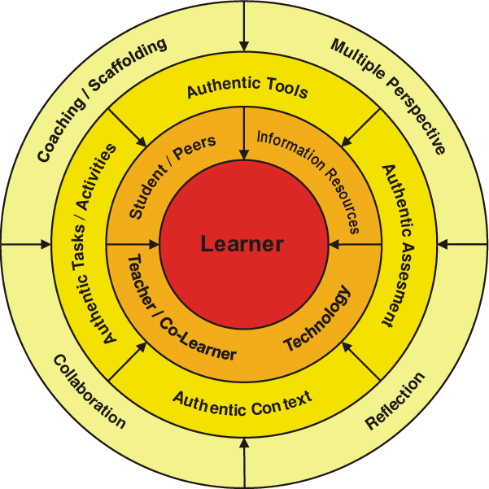
Figure 1: Student Cantered Placement Cell
(Source: researchgate.net, 2023).

Overview of the placement

Considering the Housekeeping and hospitality sector, it is necessary to have a good knowledge about cleaning techniques and procedural practices (Bardi, 2010). Moreover, this study reflects a student with strong abilities of learning and good potential to participate in similar activities. Considering the UK, the nature of the placement is student-centric, and the rate of placement given to students is above 75% till F.Y. February 2023 including both part time works as well as full time employees. However, the basic values of housekeeping industry are cleanliness and care services therefore for the placement in the hospitality sector the necessity for me is to understand the typicality in used furniture, fittings in hotels for taking good care of different hotel departments, for example, housekeeping management (Casado, 2012).

The operational issue faced during placement management cell.
The primary issue faced by the placement management team was to help and guide the students to develop their skills in the recruitment process and to structure the job interviews for the possible candidates (Ronksley-Pavia and Neumann, 2022). The obvious reason behind this issue was the lack of experience of the students to conduct the interviews as well as the fear of missing out many details in the process with the comparison of other candidates (Hagg, 2013). However, the ability to conduct the interview and the approach to applying for the placement process varies from student to student. Therefore, students find it more difficult to initiate the entire recruitment process on their own, especially for hotels (Fallon and Rutherford, 2010).

The solutions for the management issue
The initiatives taken by management for arranging the sessions that will help student for boosting confidence as well as arranging the technical seminars for better understanding. All the 10 to 10 Meetings every morning where all department managers are present together with the General Manager are the best management sessions for students to understand the entire technical process that the hotel goes through day by day. Additionally, initiatives like personality development activities and the event where academy people could help students to build an attractive housekeeping interview guide.

Learning Log

Gibbs Reflective Cycle
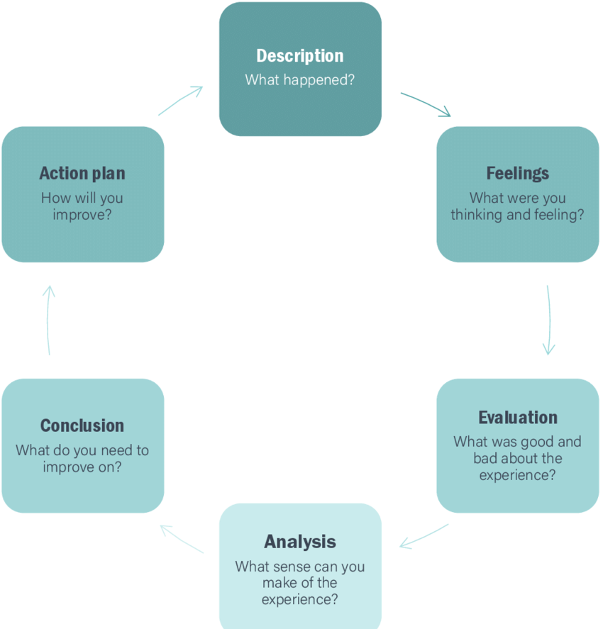
Figure 2: Gibb's Reflective Cycle
(Source: researchgate.net, 2023).
- Description: The academic placement was important to conduct along with the training for me to understand the services offered by hospitality sector.
- Feelings: I feel very responsible while going through the overall process of placement as it was my duty to fulfil the expectation of hotel staff from me as a candidate.
- Evaluation: I evaluate the skills and strategies based on vocational, academic and self-development. Additionally, academic development played an important role in placement process (Vallen, et al., 2014).
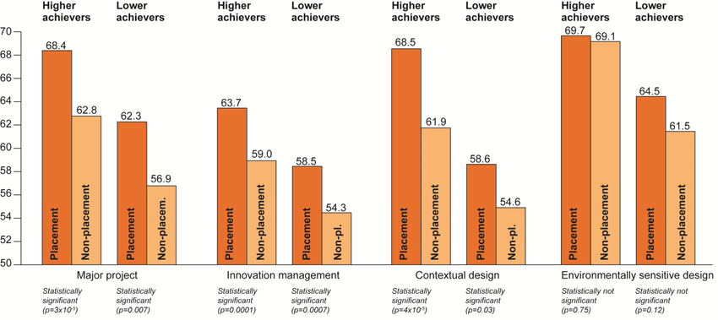Figure 3: Statistics of Academic Development
(Source: researchgate.net, 2023).
Analysis: The overall analysis on the placement and the skills required to pass the interviews was necessary to conduct (Johnston, et al., 2012).
Conclusion: According to the conclusion there are yet some cleanliness procedures and techniques required to learn for me.

Action plan:
Target | Milestone | By Date | Activity/s | Status of Activity
Specific | Understanding the process of placement. | 01/05/2023 till  15/05/2023 | Preparing for getting placed in the housekeeping and hospitality industry. | Completed successfully yet improving.
Measurable | Improving knowledge by giving tests. | 01/05/2023  till 15/05/2023 | Communication skills.  Learning Social skills.  Learning the procedures and ethics in hospitality industry. | Work in Progress
Relevant | To learn the importance of developing academic, vocational, and personal strategies. | 01/05/2023  till  15/05/2023 | Developed Vocational Skills, academic skills as well as learn the self-development skills. | Successfully completed.
Attainable | The speed of giving test per day. | 01/05/2023  till  15/05/2023 | Studying every day for aptitude tests.  Try to learn 50 vocabulary words per day.  Try to improve reading Speed. | Completed
Time Bound | Scheduled time for getting selected. | 01/05/2023  till  15/05/2023 | The process of preparing for interviews and understanding the eligibility criteria for getting selected. | Completed

Applied Theories on Placement Work
According to the Meta theories from experts, the vocational developments are inclusive of the domains that I am interested to work in. Also, it makes the ability to take the decisions based on vocational development a lot more easily than that of earlier. Additionally, Meta theories also states that vocational abilities help students to socialize and learn to communicate with professionals (Johnston, et al., 2012).

Skill Development during Placement
- Self-management and development: The evaluation of self-development that I did result into realizing my abilities to work in professional working environment (Edú-Valsania, et al., 2022). Moreover, self-development made me realize about my ambitions and goals in life. Following the courses of this University, I managed to learn the theoretical notions necessary in the hotelier and hospitality industry and through the placement I had the opportunity to put into practice all this information acquired from self-development within the theoretical courses. Additionally, throughout the placement process I realized how important it is to work on developing your personality to understand working ethics and office manners for housekeeping sector in clearer way (Wood, 2012).
- Task management: The process of vocational development varies from person to person or student to student. For example, the people from old age group were habitual to make this a short process but the youngsters are more focused on switching their career pathways as well as they aim at doing multiple jobs therefore, they spend more time on vocational development, making it a lengthy process.
- Applying initiative in workplace problems: The vocational, academic, and personal developments are an architecture that helped me to amend the quality thinking process with engaging skills.
- Communication: I realised that to have or developed certain amount of engaging communication skills that will help me to address the sector within depth knowledge is essential to appear for an interview.
- Application of knowledge: The appropriate knowledge about operation management of placement cell, the issues that could be faced while placement and the solutions to overcome the problems mandatory for me to proceed in the housekeeping sector.

Conclusion

In the conclusion part of the report, it can be stated that the entire process of placement conducted by academy helped to improve the skills and abilities to work. Otherwise, it would have become very challenging and tough for me to fit for a profile which matches with my area of interests and passion. Additionally, the sense of a career choice is more important to serve the hospitality industry so that it will be easy to add a value into an organisation (Casado, 2012).
In order to manage an operational department such as Housekeeping, you must have very well-developed practical skills related to the care, checking and maintenance of the interior and exterior areas of the hotel. Also, there must be a very good interdepartmental communication with the Front Desk and Engineering Department, to always have a real execution time and keep the rooms clean. It is a rather demanding department, which must be well managed to offer the guests the services at the expected standards.

Word count: 1.263

References
- Bardi, J. (2010) Hotel Front Office Management, Wiley, London
- Casado,M. (2012) Housekeeping Management, Wiley, London
- Edú-Valsania, S., Laguía, A. and Moriano, J.A., (2022). Burnout: A review of theory and measurement. International journal of environmental research and public health, 19(3), p.1780.
- Fallon,M. & Rutherford, D. (2010) Hotel Management and Operations, Wiley, London
- González-Pérez, L.I. and Ramírez-Montoya, M.S., (2022). Components of Education 4.0 in 21st century skills frameworks: systematic review. Sustainability, 14(3), p.1493.
- Hagg, E (2013) Internship Guide Eleven, The Hague
- Johnston, R.Clark, G. Shulver, M. (2012) Service ☒Operations Management, Pearson, London
- QAA, 2018 UK Quality Code, Advice and Guidance: ☒Work-based Learning, QAA, London
- researchgate.net, 2023 [Online] Available at: https://www.researchgate.net/figure/Characteristics-of-career-education_fig2_362785208 [Accessed on 1 June 2023].
- researchgate.net, 2023 [Online] Available at: https://www.researchgate.net/figure/Comparison-of-the-academic-performance-of-placement-and-non-placement-students_fig5_303021918 [Accessed on 1 June 2023].
- researchgate.net, 2023 [Online] Available at: https://www.researchgate.net/figure/Student-Centred-Learning-Environment_fig2_269698691 [Accessed on 1 June 2023].
- researchgate.net, 2023 [Online] Available at: https://www.researchgate.net/figure/Gibbs-Reflective-Cycle-Source-Gibbs-1988_fig5_345447745 [Accessed on 1 June 2023].
- Ronksley-Pavia, M. and Neumann, M.M., (2022). Exploring educator leadership practices in gifted education to facilitate online learning experiences for (re) engaging gifted students. Education Sciences, 12(2), p.99.
- Vallen, G.K. &Vallen, Jerome J. (2014) Check-in check-out: managing hotel operations Ninth edition.; Pearson new international.,
- Wood,R. (2012) Key Concepts in Hospitality Management, Sage, London

