Creative Practice 4 M5X01569

Project Outline

I will be producing a 20 minuet EP; I will be composing UK Rap and Afro Beat instrumentals along with pre-recorded vocals. I will start to compose ideas and drafts and then evolve some of those ideas into songs with structure throughout the next 8 weeks. I chose to do this EP in this style because I’m interested in the genre and I’ve taken an interest to write this type of music, hoping to produce more and work with likeminded people in the future.

Aims & Objectives

- To be able to Improve my knowledge of basic production skills, such as mixing and mastering.

- Improve my skills by keep on practicing and exploring different techniques that Logic X has to offer.
- Research better techniques by scouting through the internet, looking at help articles, books and videos on social platforms. Also, to look into what mixing techniques make a well-produced EP, this could be done by noting down what my inspirations have done with their EP’s
- (Incorporate into research) Communicate with my fellow course colleagues or contacts who use mixing and mastering software regularly.
- Develop my own Workflow, so my methods I will be using become second nature.

- To Improve my time management and problem solving

- Make sure to even out work production to ensure workload is not is not strained. Even out a work plan, take short breaks, stay up to date with work.
- To spot and analyse problems and obstacles and to figure out solutions. Stop and review my work before overtime I finish for the day. Take notes of problems and fix them.
- Evaluate at the end of the project and reflect weather I managed to improve my time management and problem solving.

- To manage a workflow
- To make sure I manage a productive work ethic.
- To do so I will need to maintain a tidy workspace, stay hydrated, stay well rested and don’t over work myself.

Inspirations

Krept & Konan

Krept and Konan are a British rap duo. Both aged 30, they officially banded together in 2009. They formed their friendship back in 2005 where they met through a mutual friend and were both in the same gang called ‘Gipset’ located in Gipsy Hill, which Krept’s cousin “Cadet was also involved in. They then decided to make music together in a serious manner in 2010 and then that’s when their first official mixtape was released, titled “Redrum” then went on to release their second mixtape titled “Tsunami” featuring several mainstream artists including Ghetts, Giggs, Schorcher and Lil Nova.

They then released a cover of Jay-Z and Kanye West’s single called “Otis”. Within the first week it hit 5 Million views on the video social platform, YouTube, which was eventually removed by Jay-Z’s team. After the major setback which would have been their road to fame. Notoriously known, Skepta invited them to come join and perform their mixtapes on Skepta’s tour.

After touring with Skepta, who at the time was probably UK’s biggest grime artist, they then worked on their first album by releasing their promotional single for the album, called “Don’t Waste My Time” in 2014. The Hit track then featured high profile artists, such as Chipmunk, wretch 32, French Montana all contributing remixes of the single. Which then raised the profile of Krept and Konan.

In 2015 they released their debut album “Long Way Home” which peaked at UK Number 2 and topped the UK R&B charts at number 1.

Since the start of their journey they’ve not only used music to their financial advantage. They opened up their own restaurant called “Krepes & Kones” and released their own clothing merchandise, got their own radio show on Beats Radio and a TV programme on BBC Three. They’ve used their music as an advantage to make more income and offer more to their local community by offering jobs to local people.

Steel Banglez

Steel Banglez AKA Pahuldip Singh Sandhu was born in 15th February 1987. He grew up in Forrest Gate, London. During his early life he grew up around music. He describes that his mum use to listen to Bollywood music when his mum use to cook for the family. He also uses to listen to pollical poetry that originates from Punjab, which Steel Banglez describes it as “Our version of afro basement.” Where there was a lot of anger within the lyrics that mentions about the civil war and real-life events, similar to how Hip Hop first came around.

He then managed to catch D Double E and gave him a CD with his sampled tracks on at the age pf fourteen. This is where his name began to be mentioned more. Eventually shadowing D Double E, he managed to get into clubs at the age of fourteen with D Double E. when he was sixteen, he was caught for underage absence in the club. That’s what presumably happened. He got a sentence of 6 years but served 3. In prison he got the name Steel Banglez after the steel bracelet he wore on his wrist.

After he was released from prison aged 21, he managed to start making beats, and he managed to grow more popular at the same time as Giggs. Since then he’s managed to produce beats for J Hus’s track called fisherman and No words by Dave. He also has solo releases titled ‘Bad’, ‘Money’ and ‘Your Lovin’’. He managed to get his single ‘Bad’ to number 29 and ‘Your Loving’’ to 47 in the UK Charts, with ‘Fashion week’ getting into the top 10 and peaking at number 7.

Wretch 32

Wretch 32, also known as Jermaine Scott Sinclair, was born on 9th March 1985 in Tottenham. He came through London’s Tiverton estate projects in his hometown. Artists such as Stormzy, Devlin, Kano, Chipmunk and Skepta. In the late 2000’s he joined the mainstream grime movement with hit mixtapes such as ‘Teachers Training Day’ in 2007 and his first studio album ‘Wretchrospective’ in 2008. He began to rise in popularity, making a name for himself in Great Britain. He attracted attention from record labels.

In 2011 he then released his first major labelled single called ‘Traktor’. The single went onto peaking at number 5 on the UK’s singles charts. Later on, in the same year he released a second studio album titled ‘Black and White’. Which was then followed by his UK number 1 single ‘Don’t go’ and ‘unorthodox’ in 2012.

He then returned in 2014 with his new single titled ‘Six Words’ which hit number 8 in the UK singles charts. His third album was his most honest and narratives, critics claimed. Wretch then continued to continuously progress on his follow up album ‘FR32’.

Since his upcoming and rise into a mainstream artist. He has taken that opportunity to appear in the 2012 adidas advert for the Olympics and manage to release a book called ‘Rapthology: Lessons in life and lyrics.’ The books reflect upon his lyrical meaning within his songs. He breaks down how he writes he songs and what happens in his mind when he writes it. The book is also part biography. He now also produces and mixes in his studio.

Today he is considered by many MC’s and producers along with fellow rappers as a “wordsmith” is the UK rap industry. He is highly rated throughout the UK music industry and continues to expand himself as the years progress.

Project Development

For this project, I had to create a 20 minuet EP (Extended Play record). Before even creating my first song I had an idea what I was going for with my EP. I decided to have a link between UK and US Rap. Where I would apply some instrumentation to different ones, Linking the two to each other. I named this EP the ‘Lockdown EP’ where I produced this EP while on lockdown due to the coronavirus limiting our social behaviour. I thought to myself that linking two sounds to one another would be a way to bring something closer. This EP would have a social meaning behind it.

When creating a project on Logic, I first try and find or create a sample of what I like the sound of, this usually is the main melody or a pad layer that I think might fit the melody. Once I listen to the melody, I would input that into my session, knowing that’s going to be the melody of the song, it would also be the main hook. If not, I would try and edit that same melody and make it into a hook for the verse or such thing similar to that.
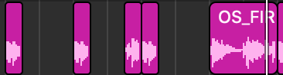
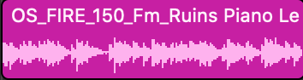

Above is an example of how I would transform the melody into a hook. The picture of left shows the melody I found on a loop software called ‘Splice’. The picture on the right shows the hook I crated from the melody. I did this by cutting and arranging the cut-out sound files to create a new melody which would become the hook. In the song ‘National Plug’ in my EP the hook is used in the chorus and then the original melody is progressed through to the chorus. This creates more atmosphere and fullness into the track making the chorus one of the main catches to the track. I also did this on the track ‘Break the law’ where I applied the same process.
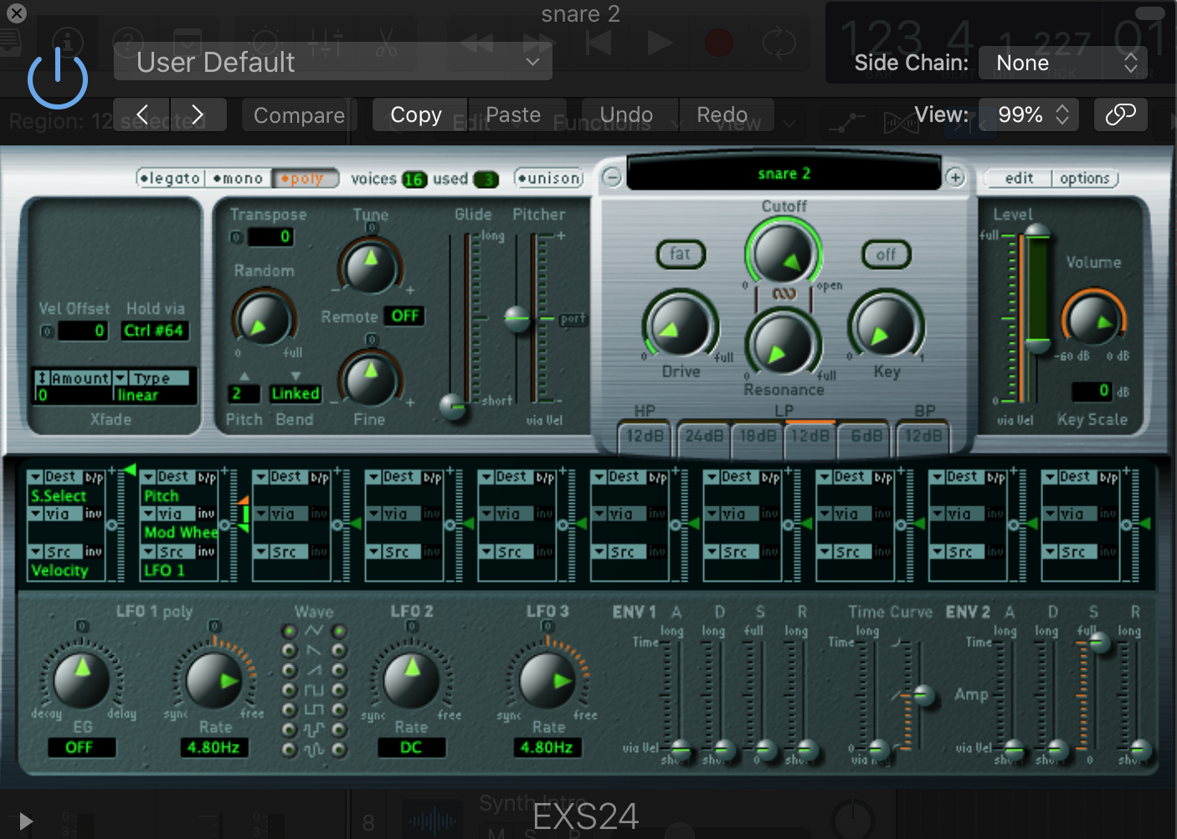
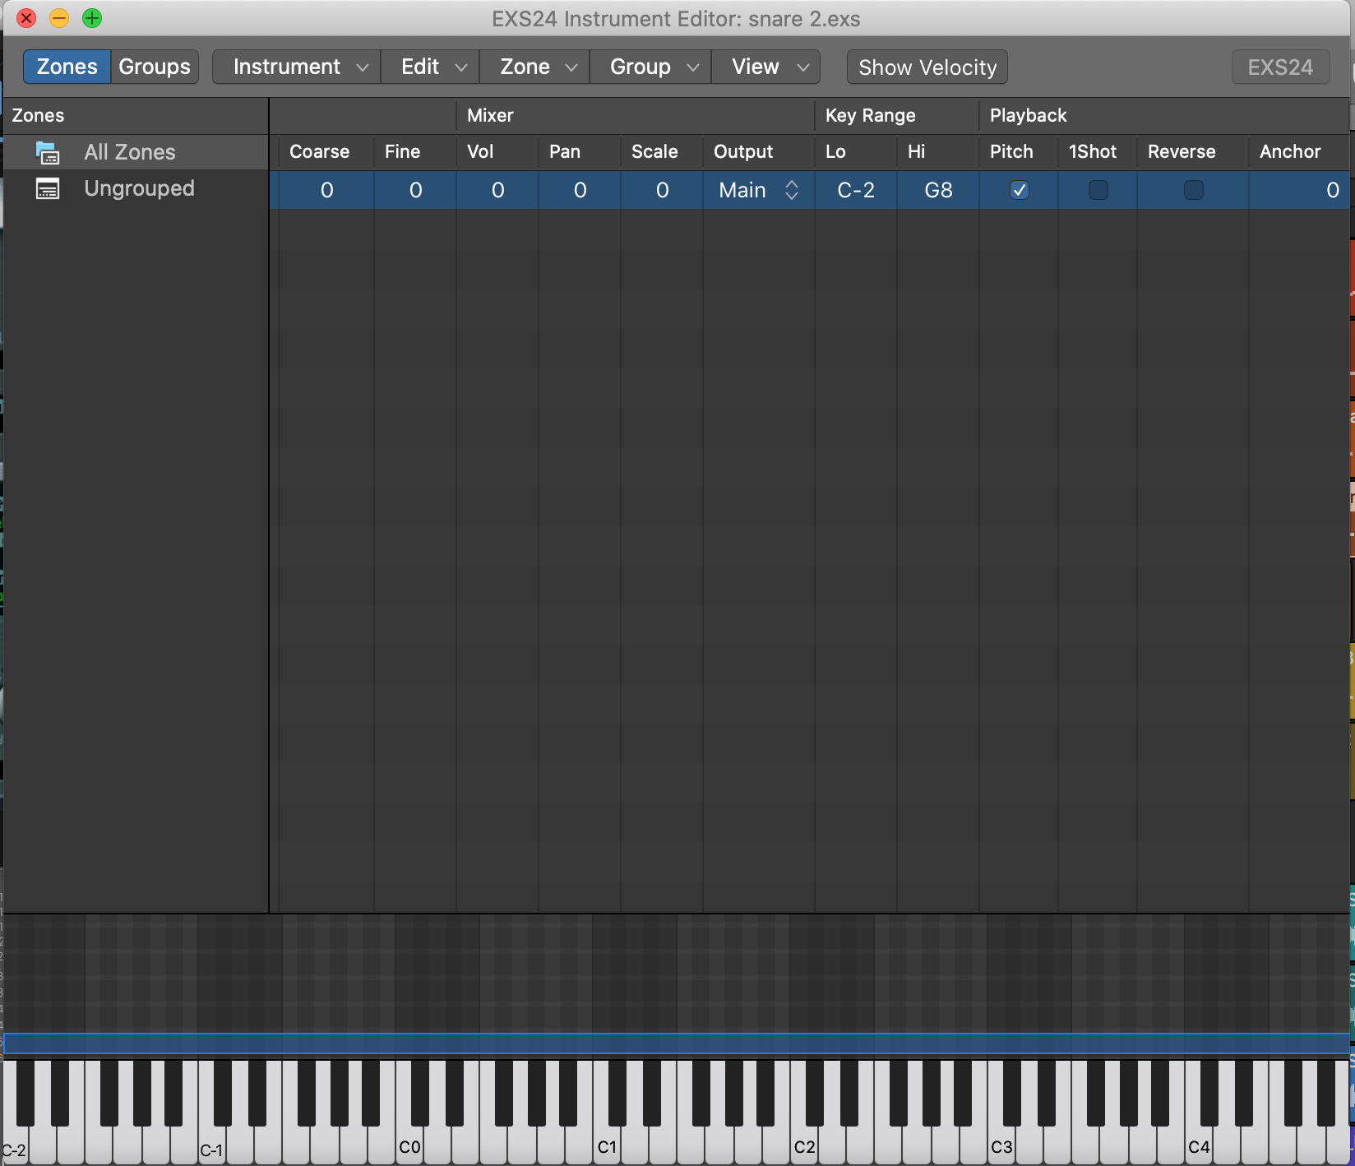
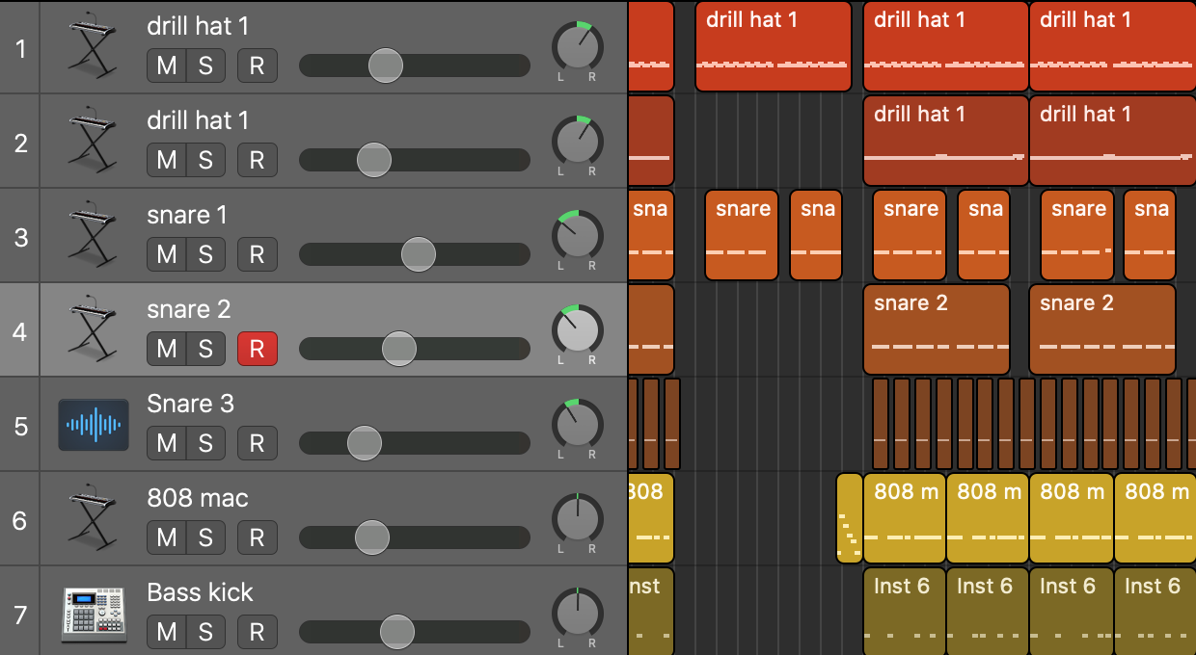
After finding the melody I would use the EXS24 Sampler on logic. I would look for one-shots on my music library and input them into the sampler. As you can see in the annotation. I’ve imputed a one shot that I found on my sound library and I used that in my song as a MIDI file. I did this of majority of the Ep. I layered them up and uses different drums for different parts of the song, so I would either layer up 2 snare sounds to get a unique snare sound that I thought would sound good with the rest of the instrumental. This also applied for bass kicks, 808’s and hi-hats. Also, in a similar principle with some of the keys, I just simply layered them up but with one being a higher octave then the original. This keeps the song evolving and changing and just helps the instrumental to become less repetitive. This helps my instrumentals in the EP.

While producing these songs for my EP, I tried to structure it differently with my ‘National plug’ track. I flipped the whole feel of the track. This switched feel to the track would surprise first time listeners which would make the sound stand out to usual rap instrumentals.

During this project. The university was closed down due to the UK going on a national lockdown. This hit my project hard as I couldn’t go into the studios the university offers. Therefor my mixing and mastering processes were limited, and I’d have to use what I had at my own disposal. Luckily, I had a stereo speaker set up and studio headphones to listen and mix between.

Personal Development

Throughout the project I managed to create a rota. Seeing as lectures were cancelled, I decided to create my own timetable and make sure my workflow stayed consistent and I was always on top of what I had to do. I managed to create a new song and get the structure and mixing down all within between 1-2 weeks of each other. Which gave me enough time make sure each track was worked on equally with efficiency and carefulness.
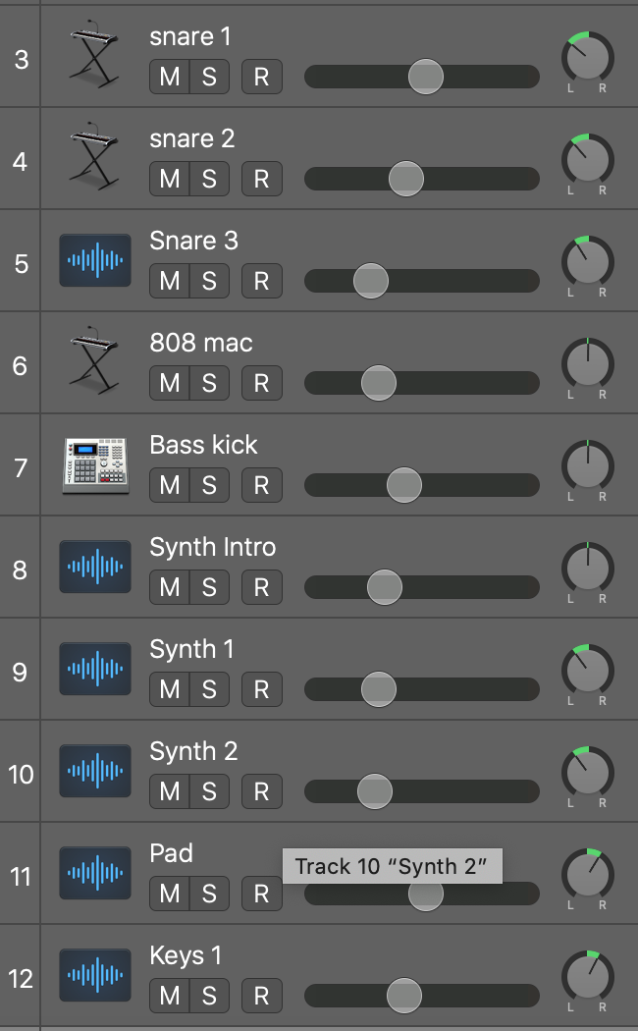
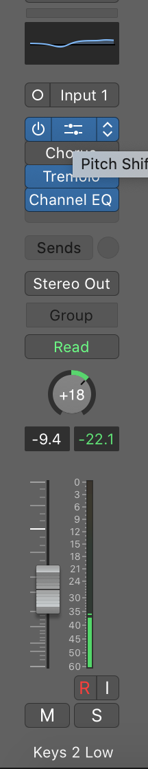
During producing my EP, I wanted to find a way of producing, mixing and mastering I was comfortable and efficient in. so during production I tried out different methods. The usual method that I was familiar with was mixing from the main window. I did this for most of the tracks I produced. I would just mix the gain for each individual audio track on the logic session, along with individually applying plug ins for each audio track. Doing this was the fastest way of me producing my songs, as it was the way I’ve always produced and worked on logic pro. However, one of my aims and objectives was just master my producing and mixing skills. So, I scrolled through tutorials on YouTube. I found a few tips to follow and I applied those tips on my track called ‘Millions’. I grouped instruments in the sections I wanted them to be in. so vocals being in one, along with drums, bass, keys, pads and flutes. I did this in a separate mixing window and colour coordinated them so it easier to navigate through the mixing window. I then bussed them to separate Aux tracks. This makes it easier when it comes down to mixing. For example, if the drums are too loud. I can just turn down the drums channel that all the drums are bussed to. This makes the process quicker and easier. The images below shoe my mixing window. I used the window to properly mix and master my track on. The second image shows the bussed channels and a reference channel that I used while mixing the song so I could go back to the original recording.
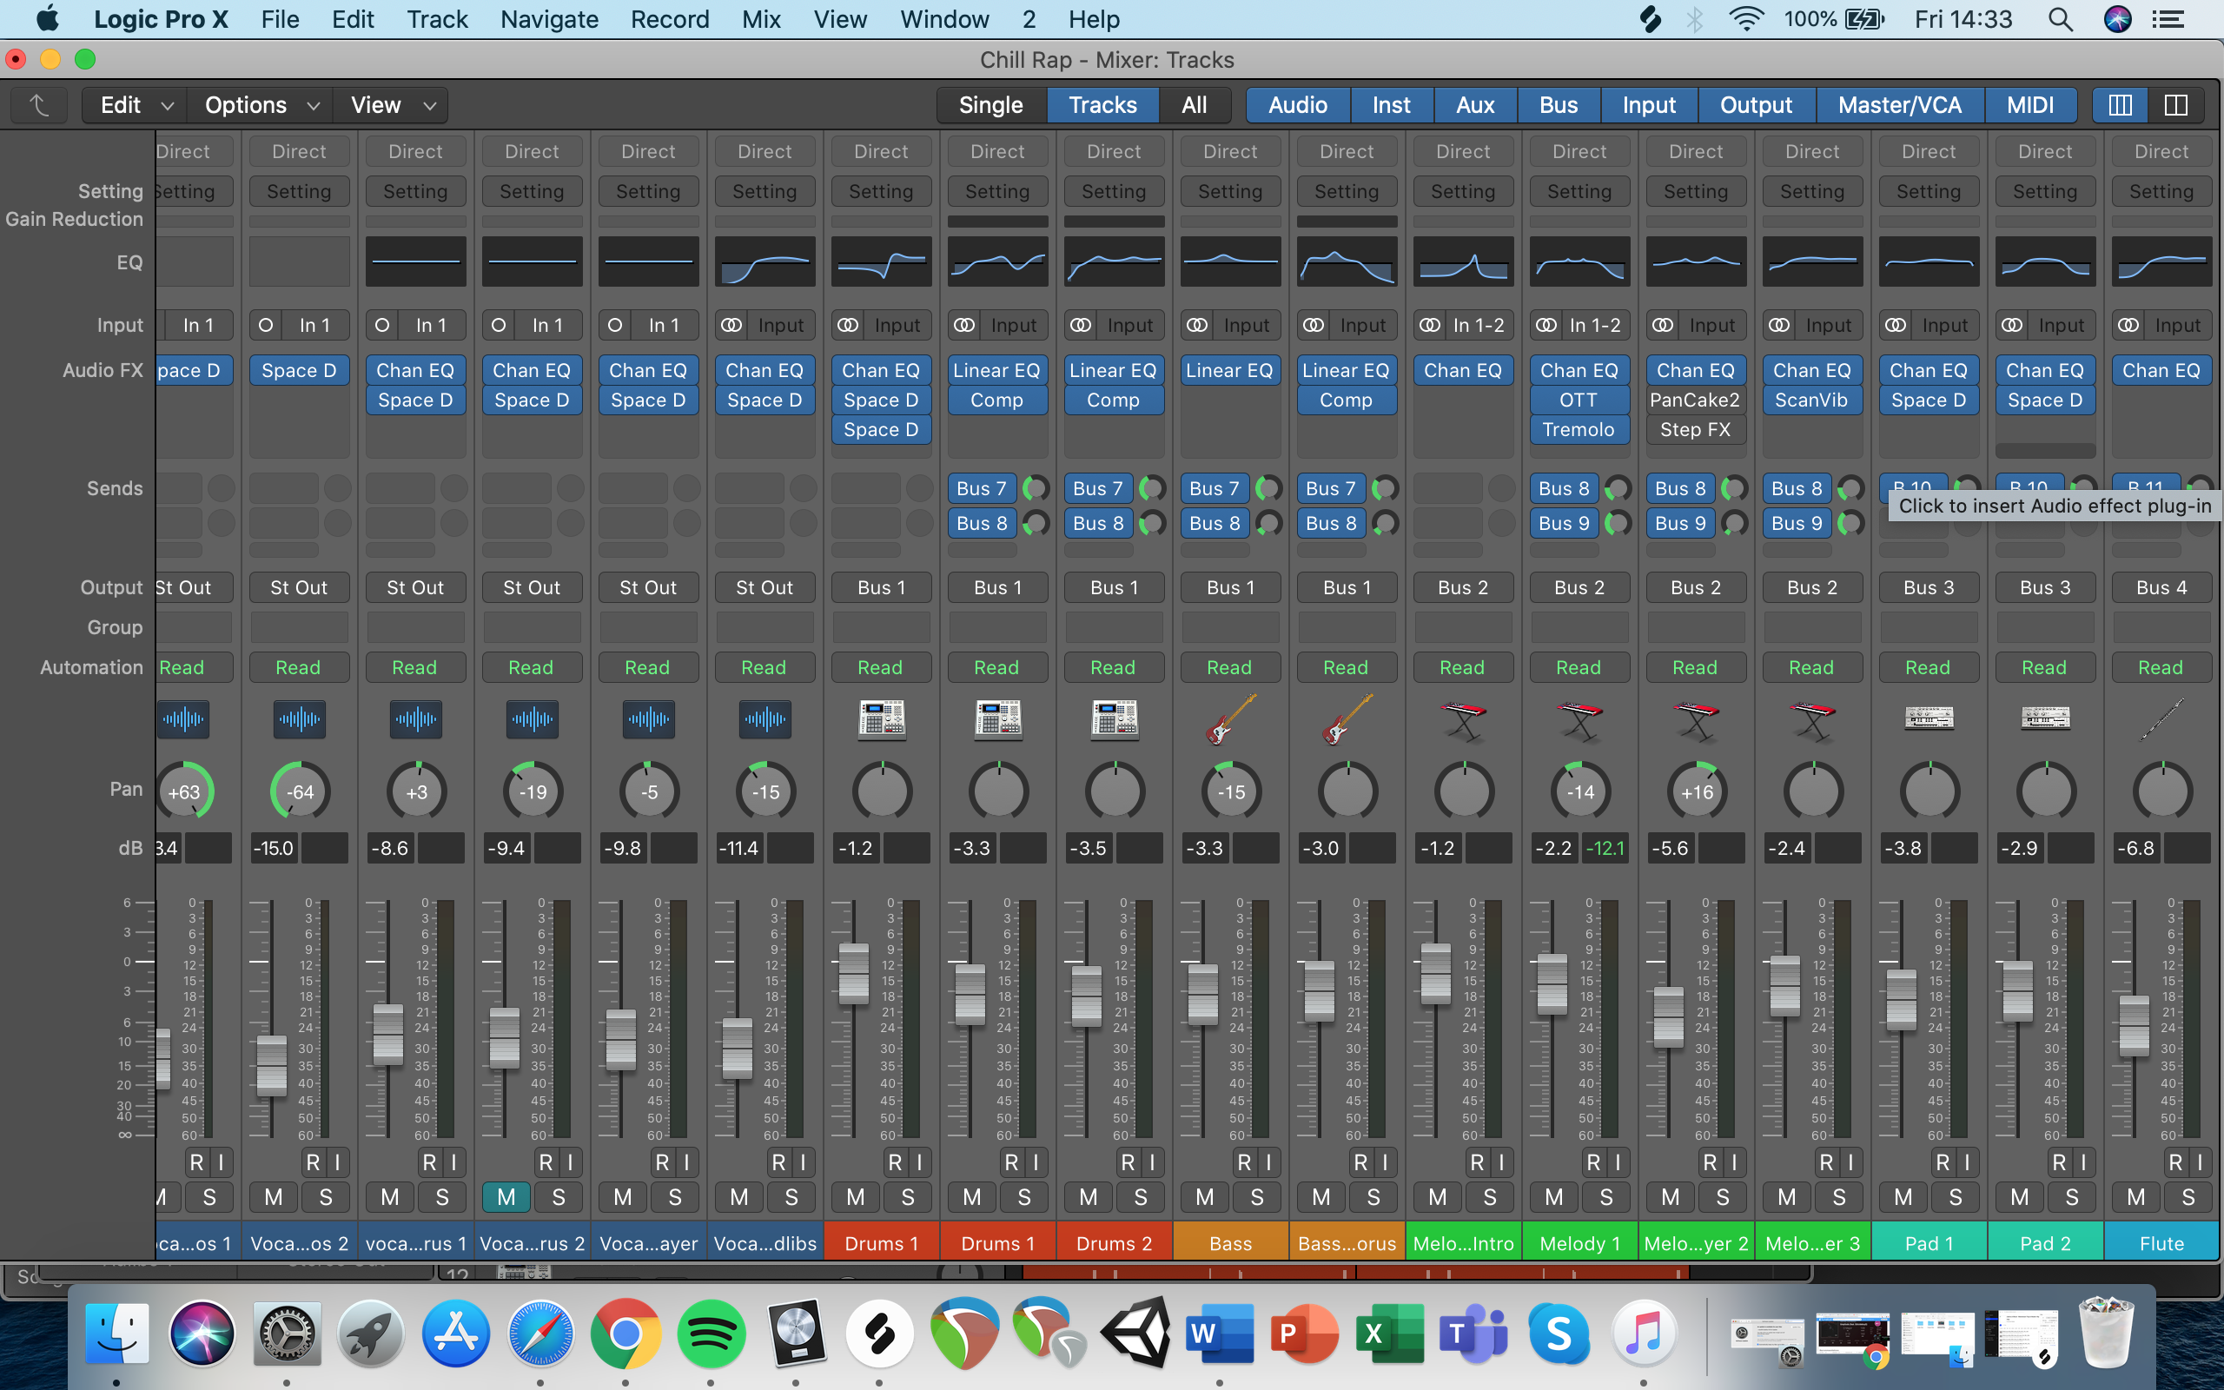
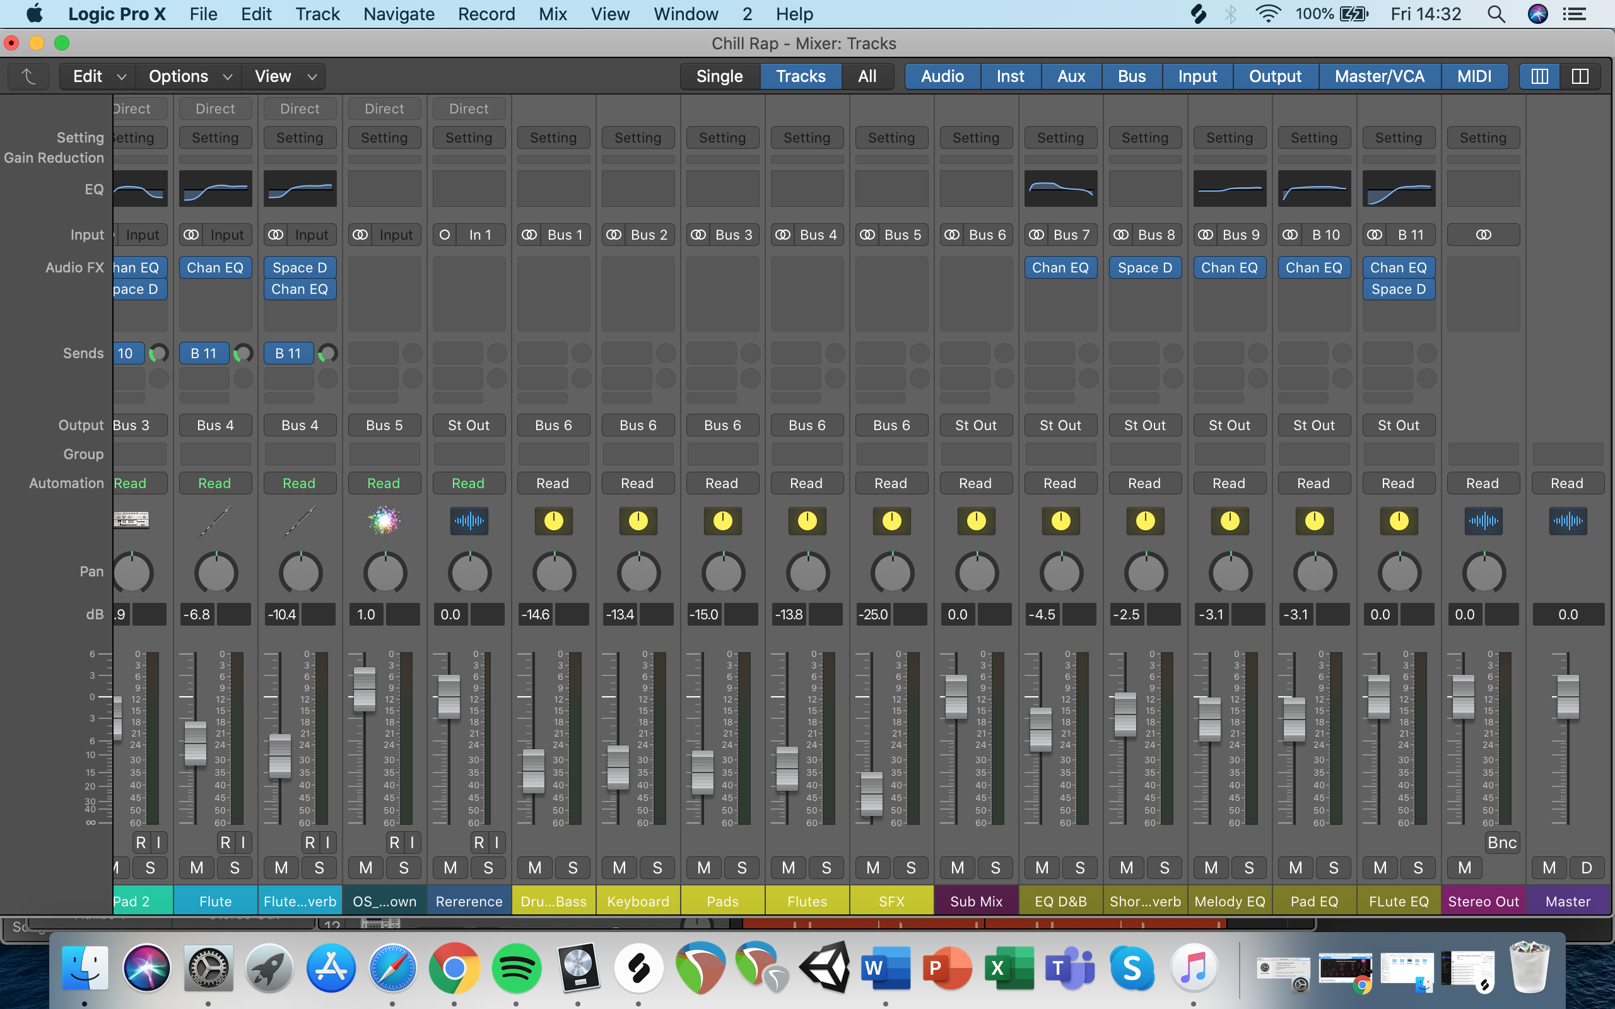
I also have separate channels for some plugins to control what I wanted the EQ or reverb to be like and how prominent I wanted them to be.

This method really helped me organise my logic session. Learning this method helped me with my producing skills and also my organising skills. I always knew where everything was and also had clear understanding what was what, such as what I needed to turn down or what reverb I needed to lengthen out and so on.

Project Summary

In conclusion for my project. Looking back at what I set out to achieve, I believe I have achieved a lot of aims and objectives. Firstly, I wanted to improve and master my mixing skills, after repeatedly mixing the songs I’ve produced and spending hours mastering them, I have managed to say I have grown confidence in my mixing ability and I’m happy with where my skills are with it all. I followed how I was going to do it by practicing and looking up tips on the internet/social media. Applied the knowledge I gathered and managed to use new techniques to better my mixing skills to a more professional level.

This leads me to the next aim. I wanted to improve my problem solving and time management. During my time producing my EP, I came across many obstacles, such as trying to develop my ideas into a structured song that I could be proud of. I manage to track back on my methods and manage to reroute issues that would lead to them being solved. At the end of every session I manage to review what I did in that session and make notes on what I needed to progress on when it came down to the next time I carried on with the project.

Also, with my time management, I made sure I set a rota that I could work for a respectable amount of time without forcing my work production. This made sure that I would fully concentrate on my project and manage to go into with a correct mindset. This helped me manage to get as much work done in the time that I allocated to myself.

Lastly this leads me to reviewing my workflow. I can say that the rota and timetable I made for myself helped me manage a productive workflow, I made sure I had water by me to hydrate me and I gave myself short breaks in-between producing sessions. I came back to the tracks after the breaks and this helped me keep my mind and ears fresh.

Upon reflection, If I could change anything during my project I would of liked to focus on my MIDI composition a little more, as much as I did add some MIDI into my project. I certainly did more sampling than midi and would have liked to even it out a bit more. However, saying that I did improve my sampling skills and I’m more confident on that.

I managed to stick to my timetables and routine I set. This helped me achieve all my objectives and aims I set for myself and I’m happy with the outcome of this project.

References

MusicRadar. 2008. 21 Pro Mixing And Processing Tips. [online] Available at: <https://www.musicradar.com/tuition/tech/21-pro-mixing-and-processing-tips-151526> [Accessed 20 April 2020].

Blake, M., 2019. Wretch 32 On Rapthology: ‘This Is A Step Forward For English Literature’. [online] Penguin.co.uk. Available at: <https://www.penguin.co.uk/articles/2019/nov/wretch-32-interview-rapthology/> [Accessed 14 April 2020].

Collins, H., 2020. Krept And Konan: The Secrets of Young Kingz' Success. [online] the Guardian. Available at: <https://www.theguardian.com/music/2013/sep/12/krept-konan-young-kingz-mixtape-success> [Accessed 13 April 2020].

Johnston, K., 2019. Meet Steel Banglez, The Super Producer Driving The UK Rap Resurgence. [online] British GQ. Available at: <https://www.gq-magazine.co.uk/article/steel-banglez-interview> [Accessed 14 April 2020].

YouTube. 2019. Mixing In Logic Pro X (Everything You Need To Know). [online] Available at: <https://www.youtube.com/watch?v=vry9ZDGr56E&t=608s> [Accessed 16 April 2020].

