INTRODUCTION TO MODERN WORKPLACE
  - COCA-COLA

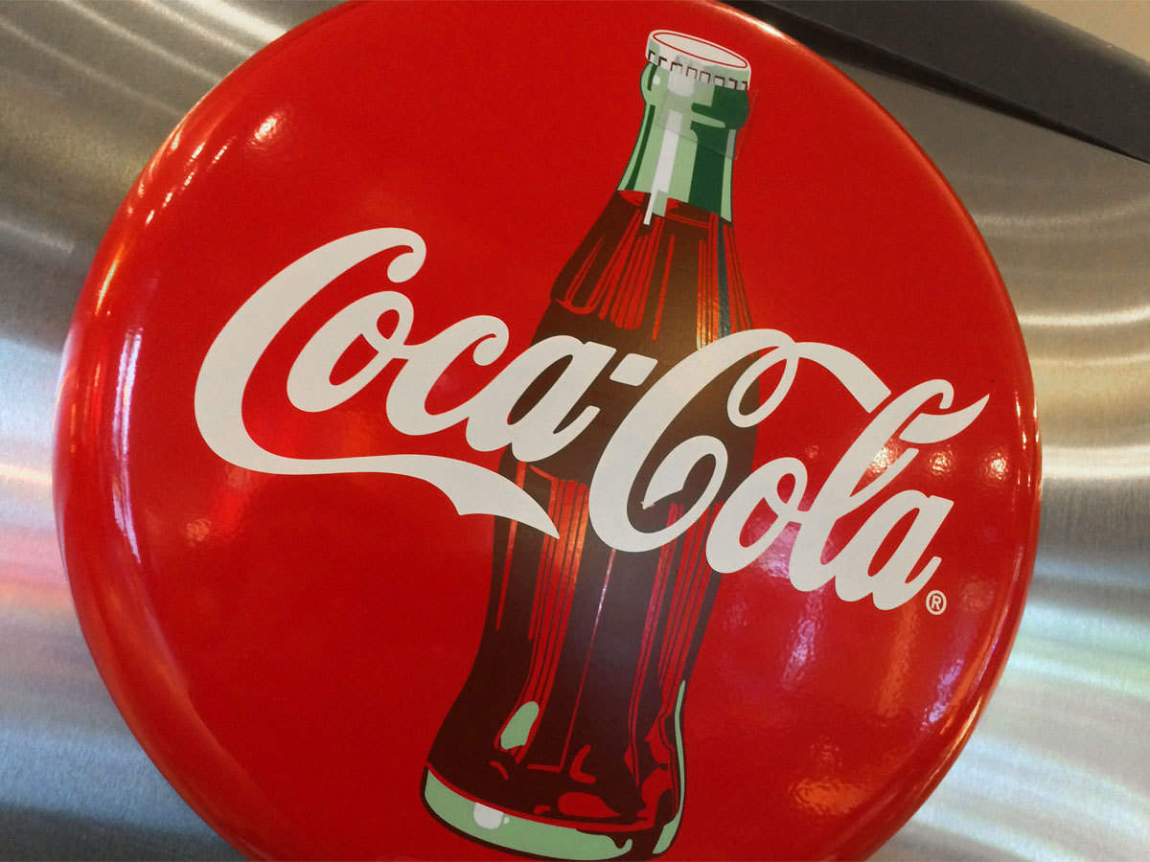
University of Wales Trinity Saint David
Name: Alexandru Ionut Stefaroi
Student Id: 1914985

Table of Contents
ESSAY 3
REFERENCES 8

ESSAY
The global effort towards economic development has open various opportunities for businesses to open and establish easily. However, this support is also affected by the various external environmental factors but organizations which successfully adapt to these factors show remarkable growth (Simon, 2013). Overall, the increasing opportunity has also increased competition among organizations, as customers now have various alternatives to choose from (Tziner, 2017). The essay below will present a critical analysis of the organizational performance is affected by its relationships between individuals, the governance structure and culture. The discussion will be in the context of an American multinational beverage corporation Coca-Cola. The company is headquartered at Atlanta, Georgia; and is currently the world’s largest non-alcoholic beverage company. The company has more than 500 brands under its portfolio, selling to more than 200 countries (Coca-Cola, 2020).
The organizational performance is strongly influenced by the organizational culture, structure and people. According to Tziner (2017), an organization comprises of different department and individuals, which must be integrated and managed all together effectively for success and growth. These are the internal factors and therefore under the control of the management, however, there are various external influences which are not under the control of the organization but has a strong influence on the decision-making (Pinder, 2014). Thus, the internal environment must be adjusted to the external environment for success. Coca-Cola believes that the organizational structure must be such that it maintains the balance between corporate governance and flexibility. Therefore, for the management of different segments/departments, there are different levels in the hierarchical structure, so that enough attention to be given on each (Altman et al. 2013). As per the company annual reports of 2019, the company currently has one president for the Asia Pacific segment; one for Africa, the Middle East and Europe and one for the Latin America Group. Apart from that, it has 9 senior vice presidents, one chairman of the Board of Directors, one CEO, one president of Chief Operating Officer and an Executive Vice President. Fisher and To (2012) suggest that in the age of globalization, diversity is an essential need and having individuals in the decision-making body as that of the governance of Coca-Cola helps in better global performance, customer satisfaction and innovation.
Major organizations having global footprint such as Coca-Cola has may operate with freedom in their local markets, however operating in international markets requires consideration of certain constraints by the management, which is predefined. This predefined framework according to Fisher and To (2012) can effectively safeguard the business from various uncertainties of the future. For example, if an organization advertising hurts the religious or cultural sentiments of people overseas, it will lose its reputation and may also be boycotted, leading to a failure (Altman et al. 2013). DuBrin (2013) suggests that working within this operational constraint reduces the opportunity or scope of experiments and innovation, it is still not suggested to organizations whose offerings already have significant demand. It also guards the business against various other risks such as paralysis and stagnation.
Pinder (2014) defines organizational culture as a collection of values and norms which the individual working within an organization use to interact with each other and their surroundings. Nahavandi et al. (2013) further add that the organizational culture is also strongly related to the organizational performance and hence is a key towards gaining a competitive edge in the modern business environment. Multinational organizations have a multicultural workforce and hence management becomes more complex and challenging. DuBrin (2013) stated that the theory of dimensions of culture suggests that the characteristics and behaviour of different individuals living within the same nation are affected by the collective norms, rules and regulations defined by the administrative bodies. Its evidence can also be seen in the governance structure of Coca-Cola, where the individuals in the authoritative position belong to different backgrounds (Maisoni et al. 2019). Geer-Frazier (2014) suggested that having such organizational culture can go a long way in providing great and innovative ideas and suggestions, which are necessary to meet the diverse needs of their customer bases with the international expansion of the business (DuBrin, 2013). Thus, the organizational culture at Coca-Cola understands and respects the interpersonal differences between the individual, making its workplace diversity inclusive. At Coca-Cola, governance and decision-making are strongly influenced by the social structure of the market, thus relies heavily on market research and customer satisfaction (Coca-Cola, 2020). This way, the company identifies the values and traditions of the people and then customize its advertising methods which match them and hence create a strong impact. This is primarily necessary for the business, given the fact that the beverages served by Coca-Cola have heavily relies on the consistent advertisement and customer satisfaction (Maisoni et al. 2019). Thus, it can be understood that depending upon the organization’s size, the approach to be undertaken for developing the unique brand image is affected by certain rules and regulations, which also helps the decision-making bodies to maintain a balance between the product differentiation and common perception of the brand (Altman et al. 2013). Fisher and To (2012) further stated that it also maintains flexibility among its workforce and help the decision-making and leadership positions to identify and adopt the best practices according to the local culture.
Coca-Cola is a worldwide leader in the non-alcoholic beverage sector and its huge success and global footprint can be credited to its leaders and managers, who support and promote high standards of quality and performance, along with maintaining enough flexibility to adapt to the changes or variations of different markets (Bowers et al. 2017). The decision-making entities at Coca-Cola takes a result-based approach for the strategic growth of the business. Nahavandi et al. (2013) suggest that having a result-based approach reduces the risk and uncertainty factor, hence ensures growth in terms of performance and quality. The organizational culture at Coca-Cola affects the industrial relations between the employees and their managers, thus having an organizational culture which appropriately considers the well-being of both is vital for its success (Asif and Palus, 2014).
As per the governance structure of Coca-Coal, the leaders and the managers make sure that their approach complies with their overall organizational aims and objectives of the business. Therefore, the HRM at Coca-Cola emphasizes on developing leadership skills development programs for their employees, with an aim to enhance their inherited skills and talents instead of generalizing it on all (Coca-Cola, 2020). Robbins and Judge (2012) suggest that this method uses the skills taught by the academic rigour, leaders, mentors application and senior executive sponsorships, to coach the employees and enhance their employability skills as per the current employability competencies. This in return also helps Coca-Cola with its innovation and decision-making, to evolve the business according to the business environment of its international markets (Geer-Frazier, 2014). As the company sells beverages which are consumed by their customers, complying with the safety, hygiene and quality standards is extremely necessary for business success. Therefore, the management at The Company pays attention to the quality and safety compliances of its beverages at every step of production (Widodo, 2014). The managers, therefore, follow a well-defined set of procedures to ensure all the quality and safety requirements are met and is maintained consistently within every market.
Coca-Cola serves its product to more than 200 countries around the world and hence employs individuals from diverse backgrounds. Thus, the HRM has to pay special attention to managing diversity at its workplaces to find and implement the right integration of various skills and talents possessed by them. As per the Company reports, Coca Cola takes the "Laissez-faire" for managing its workforce, which beliefs in the delegation of roles and responsibilities within similar level subordinates. According to Nahavandi et al. (2013), this suggests that the company requires highly skilled workforce so that there is no requirement of critical monitoring and control over them, ensuring a holistic approach towards problem-solving and quality compliance. For the management of workplace diversity, the company has a Diversity Advisory Council which comprises of representatives of different employee groups at different levels of its hierarchy (Lawrence and Beamish, 2012). This council recommends or assists the management for diversity management by representing the opinions, suggestions and well-being of employees. Coca-Cola also has an Employee Forum for their employees because the company understands that contributing the community will improvise the organization ability to attract, retain and enhance diverse skills, ideas and talents to gain a competitive edge (Asif and Palus, 2014). The Employee Forum allows the employees to develop a network with the individuals who have the same or similar backgrounds and interests. This way, the company maintains the integration between diverse skills and talents, by taking a behavioural approach to encourage acceptance and inclusivity for all among its workforce (Moore et al. 2012). The employees under such guidance understand the significance of respecting the interpersonal difference between them and their colleagues (Moore et al. 2012). Wagner and Hollenbeck (2014) proposed another major challenge for organizations which is the consistency in the performance of employees who perform repetitive and monotonous jobs. For this, Robbins and Judge (2012) suggest that employees should be given more than just rewards and bonuses to maintain their dedication and passion for their roles. Thus, the leaders and the managers at Coca-Cola also practice authoritative commanding to deal with this issue and maintain consistency.
According to Osland et al. (2015), when the financial requirements and expectations are met, they look further towards other reinforcement factors within their workplaces to find motivation. Such requirements can be either recognition or to feel valued by the company, which together serves to the self-esteem of the individual. For this, Coca-Cola HRM takes a behavioural approach to manage them and look for ways to reward their performance and efforts made towards organizational growth. This also ensures that there is enough job satisfaction, whether it is in terms of workplace culture, workplace atmosphere or their salaries. Supporting this theory, Osland et al. (2015) also stated that the all the achievements and favourable efforts should always be recognized by the management and the leaders for a long term success and consistency in performance. The management at Coca-Cola understand this very well and therefore won many awards too for its HRM strategies.
Wagner and Hollenbeck (2014) suggest that the processes and operations are effectively controlled when the ones who are involved in the fieldwork are also considered or involved in the decision-making. In support to this, Gagné (2018) also stated that the upper segments of any organization should maintain clear and coherent communication with the lower segments of the hierarchy so that their exact needs can be identified and their perception and thinking towards their work roles can be critically assessed. The management at Coca-Cola understands this aspect and therefore its success can be traced back to its collaborative work approach to leverage upon its power, skills and knowledge of its workforce. According to Bishop (2013) the Hersey and Blanchard's situational theory in the context of Coca-Cola, the HRM practices delegating and participating style leadership, which concludes that the workforce is highly skilled through their training and development programs. But Waldman and Balven (2014) suggest that the company has a mixed style of leadership, and along with the participating and delegating style, the management at Coca-Cola also practices selling style, strictly according to the maturity, knowledge and work experience of its employees.
The essay shed lights on the different organization management practices adopted at Coca-Cola and used the quantitative data collected from a range of academic resources such as company websites and online articles. The discussion concludes that overall the management practices aim at aims at promoting interpersonal relationships shared between every individual within the organization, whether they are the labours or the senior-most individuals. The corporate culture helps the management to focus on the 3 essential factors, which are the efficiency of performance, collective performance and collaboration; and individual performance. The company also invests a significant amount in its skills development programs for its employees which helps them to practice delegating and selling leadership style. Thus, these practices together enhance the overall performance and aids to its competitive edge, making it a global leader in the non-alcoholic beverages industry.

REFERENCES
Altman, S., Valenzi, E. and Hodgetts, R.M., 2013. Organizational behavior: Theory and practice. Elsevier.
Asif, V. and Palus, C.J., 2014. Leadership strategies for societal impact. A White Paper. Greensboro, NC: Center for Creative Leadership.
Bishop, W.H., 2013. The elements of leadership in a global environment. Global Business and Organizational Excellence, 32(5), pp.78-85.
Bowers, M.R., Hall, J.R. and Srinivasan, M.M., 2017. Organizational culture and leadership style: The missing combination for selecting the right leader for effective crisis management. Business Horizons, 60(4), pp.551-563.
Coca-Cola, 2020. Annual Reports 2018. (Online) Available at: https://www.annualreports.com/Company/coca-cola (Accessed on 29 August 2020)
DuBrin, A.J., 2013. Fundamentals of organizational behavior: An applied perspective. Elsevier.
Fisher, C.D. and To, M.L., 2012. Using experience sampling methodology in organizational behavior. Journal of Organizational Behavior, 33(7), pp.865-877.
Gagné, M., 2018. From strategy to action: transforming organizational goals into organizational behavior. International Journal of Management Reviews, 20, pp.S83-S104.
Geer-Frazier, B., 2014. Complexity leadership generates innovation, learning, and adaptation of the organization. Emergence: Complexity and organization, 16(3), p.105.
Lawrence, J.T. and Beamish, P.W. eds., 2012. Globally responsible leadership: Managing according to the UN global compact. Sage.
Maisoni, H., Yasri, Y. and Abror, A., 2019, April. Effect of Organizational Culture, Leadership and Compensation on Employee Engagement in Coca-cola Amatil Indonesia Central Sumatra. In 2nd Padang International Conference on Education, Economics, Business and Accounting (PICEEBA-2 2018). Atlantis Press.
Moore, C., Detert, J.R., Klebe Treviño, L., Baker, V.L. and Mayer, D.M., 2012. Why employees do bad things: Moral disengagement and unethical organizational behavior. Personnel Psychology, 65(1), pp.1-48.
Nahavandi, A., Denhardt, R.B., Denhardt, J.V. and Aristigueta, M.P., 2013. Organizational behavior. Sage Publications.
Osland, J., Devine, K. and Turner, M., 2015. Organizational behavior. Wiley Encyclopedia of Management, pp.1-5.
Pinder, C.C., 2014. Work motivation in organizational behavior. psychology press.
Robbins, S.P. and Judge, T., 2012. Essentials of organizational behavior.
Simon, H.A., 2013. Administrative behavior. Simon and Schuster.
Tziner, A., 2017. Human resource management and organization behavior: Selected perspectives. Taylor & Francis.
Wagner III, J.A. and Hollenbeck, J.R., 2014. Organizational behavior: Securing competitive advantage. Routledge.
Waldman, D.A. and Balven, R.M., 2014. Responsible leadership: Theoretical issues and research directions. Academy of Management Perspectives, 28(3), pp.224-234.
Widodo, D.S., 2014. Influence of leadership and work environment to job satisfaction and impact to employee performance (Study on Industrial manufacture in West Java). Journal of Economics and Sustainable Development, 5(26), pp.2010-2015.

