Name- Amit Tiwari
Student ID - 2526931
Programme: MSc Public Health and Social Care in Practice
Module: Health Care System Organisation and Leadership
Module code: LCHS7002
Lecturer: Tonia Babalola

TABLE OF CONTENTS
- Introduction
- Background of the Case
- Leadership in Health and Social Care
- Overview of Leadership Theories
- Centralisation vs Decentralisation
- Importance of Leadership in Change and Crisis
- Main Analysis
2.1 Problem Identification and System Context
- Description of the Incident
- Global and National Statistics
- System Weaknesses and Governance
- Level of Governance Influencing the Problem
- Rich Picture Overview
2.2 System Structure: Centralisation vs Decentralisation
- NHS Structure
- Centralisation within the Case Study
- Decentralisation within the Case Study
- Impact on Decision-Making and Accountability
2.3 Leadership Analysis
- Application of Leadership Theories
- Evaluation of Leadership Effectiveness
2.4 Improvements and Lessons Learned
- Key Issues Identified
- Evidence-Based Improvements
- Lessons for Healthcare Organisations
- Linking Leadership, Governance, and System Structure
- Continuous Improvement and Accountability
- Recommendations
- Conclusion
- References

- Introduction

- Background of the Case
This is a report about a serious patient safety incident in the National Health Service, where a 4-week-old baby was administered a morphine overdose of almost twenty times higher than intended. At first glance, it may look like a clinical error, but I hope to illustrate how it was caused by many underlying systematic errors, including failed communication, prescribing and governance processes. This is a prime example of how errors in healthcare rarely happen as standalone events, but are always due to multiple systematic breakdowns. The aim of this report is to critically analyse how leadership, the organisation and the system played a part in this incident (World Health Organization, 2017)
- Leadership in Health and Social Care
Leadership in health and social care is the ability to persuade individuals and teams to work towards a common goal, in this case, providing safe, effective, high-quality care. However, in reality, it is much more than that. Lack of effective leadership can lead to errors in large, complex systems like the NHS, and small mistakes are allowed to develop into serious incidents, as seen here (Singh et al., 2024)
- Overview of Leadership Theories
Different leadership theories can be used to help explain how organisations behave. Transformational leaders ensure high motivation and continual improvement from staff, while transactional leaders rely on applying the rules. Situational leaders identify complex situations and are able to adapt and behave accordingly. In reality, a blend of these theories is needed to ensure safety in healthcare; too much of one can be bad (Aarons, 2020)
- Centralisation vs Decentralisation
Healthcare systems commonly function in both centralised and decentralised ways. Although centralisation enables policy and decision-making at higher organisational levels, decentralisation empowers local teams to respond flexibly to patients’ needs. The NHS is a hybrid system, but this case study illustrates how risk can be created when there are gaps between central policy and local response, especially if communication and accountability is poor. It also demonstrates that system structure is insufficient to ensure safety without leadership (NHS England, 2022)
- Importance of Leadership in Change and Crisis
Selecting an appropriate leadership style is critical for successfully managing change and responding to crises in healthcare. Proactive leaders can help identify risks earlier and prevent harm, whereas reactive leaders will respond to the problem only after it has occurred. Therefore, this report will look at this case from a systems thinking perspective using leadership theory and governance to identify problems, evaluate the large project system structure, evaluate leadership effectiveness and provide recommendations for improvement (Sfantou et al., 2017)
- Main Analysis

  - Problem Identification and System Context

- Description of the Incident
In this incident, a four-week-old infant was administered a morphine dose twenty times higher than intended due to a concentration error (100mcg/ml instead of 5mcg/ml) during the transition from hospital to primary care (NHS England North East and Yorkshire, 2023). While this appears to be a clinical prescribing mistake, it is primarily a systemic failure occurring at the interface of care. Using the Swiss Cheese Model, it is evident that the hospital’s centralised 'RED' drug protocols—which restrict high-concentration morphine to specialist settings—were not digitally integrated with the GP’s decentralised prescribing system (NHS England, 2022b). This created a 'governance blind spot' where the safety barriers of the tertiary hospital did not transfer to the community setting. Consequently, the error passed through multiple stages, from discharge documentation to pharmacy dispensing, without being intercepted by a system-wide safety mechanism. This highlights how fragmented communication and a lack of interoperable electronic systems create opportunities for catastrophic patient injury within complex healthcare organisations (World Health Organization, 2017a)
- Global and National Statistics
Medication errors are understood by many to pose a significant challenge to patients across the globe. The World Health Organisation estimates that millions of patients experience medication-related harm each year, causing significant morbidity and mortality around the world. WHO estimates that billions of dollars are spent on healthcare costs and patient suffering as a result of medication errors that could have been avoided. Medication errors occur most commonly during prescribing, dispensing and administering medications, particularly when the flow of information among healthcare providers is broken (World Health Organization 2017b)
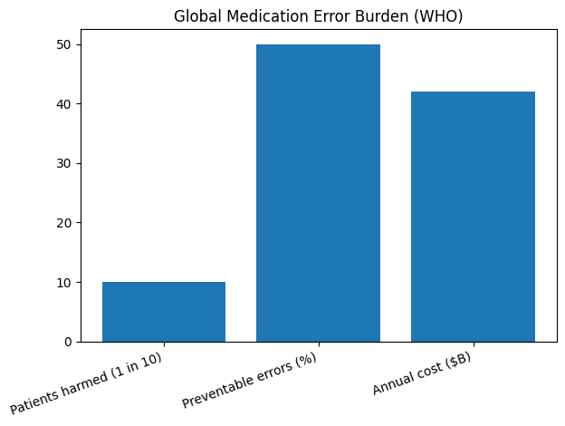.
Fig. 1: Global Medication Error Burden (WHO). The World Health Organization has published data on medication errors around the world. According to this research, approximately one in every ten patients will have experienced some type of injury due to medications prescribed. Of these individuals, it is estimated that 50% of medication errors can be avoided or prevented, which results in a global burden of economic costs (World Health Organization 2017a)
The problem is also illustrated on a national level. Patient safety incidents caused by drug prescribing errors are reported as one of the top reported patient safety incidents by the National Health Service, where medication errors account for thousands of reported events each year. The majority of these medication incidents are due to prescribing errors and communication failures. Medication errors that occur when giving medication to children are especially troubling due to the differences in the way children are dosed compared to adults, and the use of high-risk medications (e.g., opioids). Small errors in dosing can have very detrimental effects when giving medication to infants (Alrowily et al., 2024)
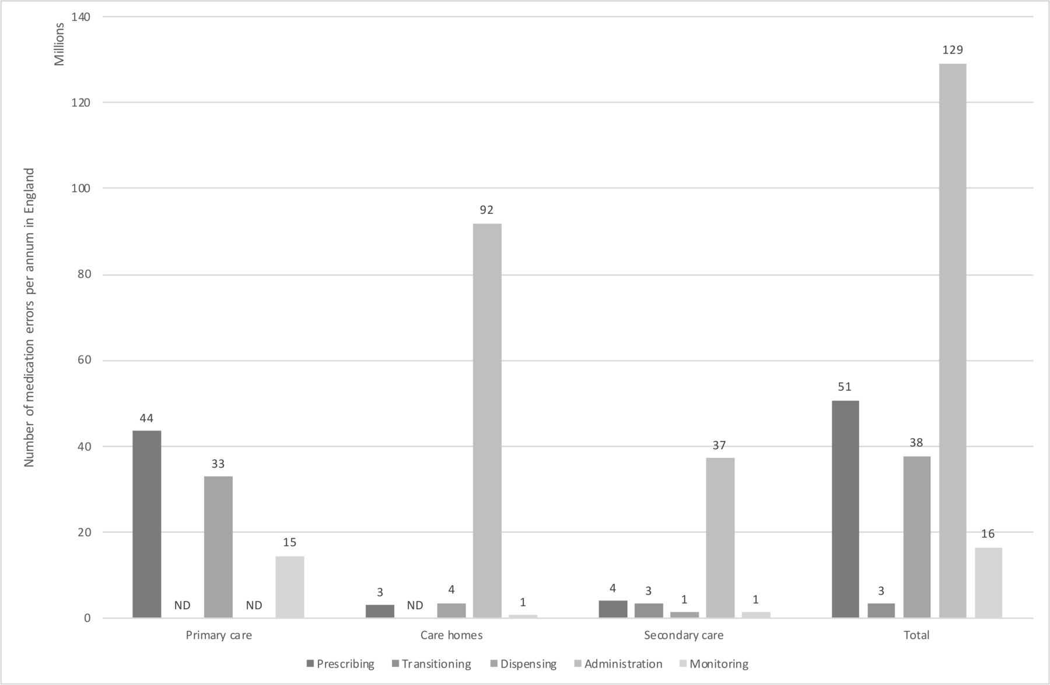
Fig.2: Medication Error Burden in NHS (UK). This figure provides data regarding medication errors occurring within the UK’s health care system. These statistics clearly show how many medication errors took place compared to the total number and number of clinically significant errors that occurred. Consequently, they show the urgency of enhancing the communication and governance around medication safety (Elliott et al., 2021)
According to the Institute for Healthcare Improvement, medication errors continue to be a significant issue throughout the many health systems in the world. The institute identifies that many medication errors are preventable and are commonly due to ineffective communication, a lack of standardization, and a lack of safety checks related to medication administration. These conclusions support the notion that the infant’s morphine overdose was the product of a more broad-based systemic issue as opposed to being an isolated incident (West et al., 2014)
In terms of global and national statistics, this is both a significant local and an international case. The reasons for this incident—communication breakdown and prescribing errors—in conjunction with the statistics regarding the incident, demonstrate similarities to what is seen globally in healthcare settings (Reinhard et al., 2008)
- System Weaknesses and Governance
This incident can be seen as highlighting many of the organisation's weaknesses from a systems-thinking perspective. A significant failure was the communication between hospital staff and primary care physicians. The patient was discharged without proper documentation, which increased the risk that the staff would misinterpret the patient's order. Since there was no structured means of verifying doses, the wrong dose was continued throughout prescription writing and dispensing (Howick et al., 2024)
There were also problems with the governance of this incident. Prescribing things like morphine normally requires strict procedures and safety checks; however, they were not followed in this case. This indicates that there were governance structures, but they were not properly enforced. The lack of an electronic prescription system would have also prevented any type of automated checking of the dose or alerts (Dixon-Woods et al., 2014).
Lack of accountability represents another issue regarding the error that occurred. While multiple healthcare professionals play an integral role in the medication pathway, there is no one person responsible for verifying the dosage. The diffusion of responsibility produces a greater likelihood of error than if one person were responsible for the verification process (Tariq et al., 2024).
High levels of system pressure may also have impacted the decision-making of the healthcare professionals in this situation. Many of the healthcare professionals involved were working under high levels of workload, which would limit the amount of time available to double-check prescriptions. In addition, the ongoing shortages within the healthcare workforce, as well as the growing number of requests for service from the public, may create further reliance on assumption than on verifying the assumptions prior to prescribing (Guan et al., 2020).
- Level of Governance Influencing the Problem
There were multiple failures in the governance of this incident at all levels. At the hospital, there were not enough safety checks prior to discharging patients from the hospital. At the regional level, there was poor communication between the hospital and community services. At the national level, there were policies in place for managing high-risk medications, but none of those policies was properly implemented. This shows how the governance gaps at different levels can all come together to create a potential for adverse outcomes. (Charles, Naylor and Murray, 2021)
The lack of integrated digital systems reveals that there are also more systemic-level issues happening here. In addition to electronic prescribing and dose-checking tools potentially catching the error before medication had been dispensed, there was a lack of consistency in the adoption of these technologies across healthcare settings that contributed to this particular failure (Department of Health and Social Care, 2021)
- Rich Picture Overview
A Rich Picture was developed to represent the complex, non-linear relationships within the medication dispensing process, as this method allows for a holistic visualization of multi-agency stressors and communication breakdowns (Conte and Davidson, 2020).
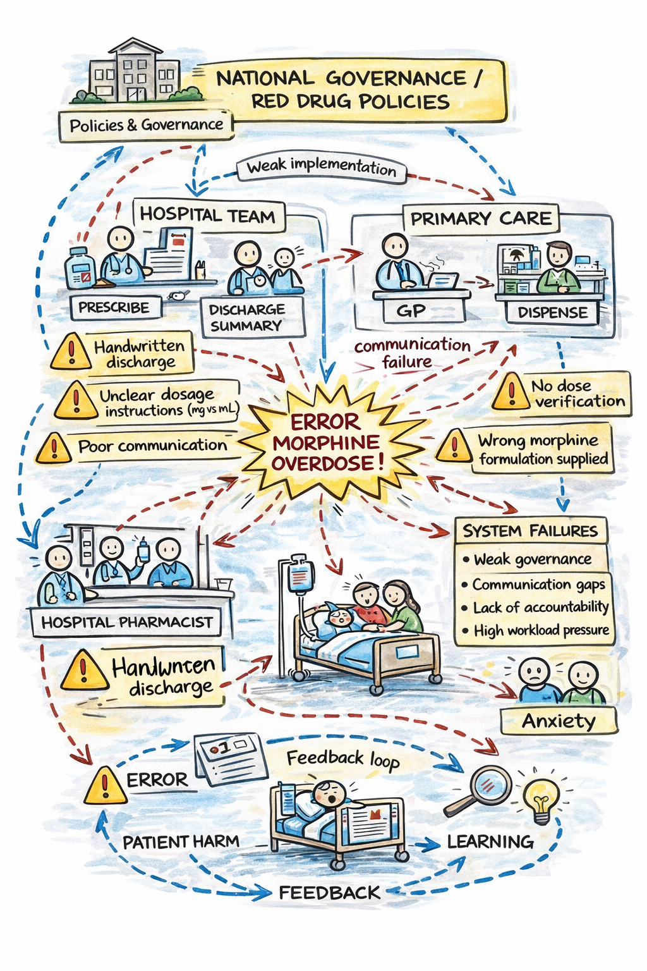
Fig.3
The Rich Picture serves as a diagnostic tool to visualize the non-linear relationships and 'soft' human factors that contributed to the morphine incident. Rather than a simple flow chart, the diagram highlights the fragmented communication loops between the tertiary hospital and primary care. The 'clash' lines in the picture represent the conflict between centralised safety protocols and decentralised execution. Specifically, it illustrates the accountability gap where the community pharmacy and GP were operating in information silos, isolated from the hospital’s electronic alert systems. This visual representation clarifies how a lack of system interoperability allowed a high-risk 'RED' drug to pass through multiple unchecked boundaries, demonstrating that the failure was a result of poorly managed interfaces rather than a single point of human error (Checkland and Poulter, 2006).
2.2 System Structure: Centralisation vs Decentralisation
- NHS Structure
A hybrid model of governance and service delivery is used by the National Health Service. Centralized national bodies provide policy direction, safety level, and prescription guidelines to local providers of health care as they implement those policy decisions. Integrated Care Systems (ICSs) were also created to coordinate service delivery and to give providers in the community more of a say in the decisions of those providers, even though the governance of the ICS is still under the oversight of national bodies. The intent of ICS is to improve health outcomes for people living in their communities, to increase the productivity of the health care system in delivering services to people living in those communities, and to better coordinate between organizations providing similar services within the same community (Lalani et al., 2024).

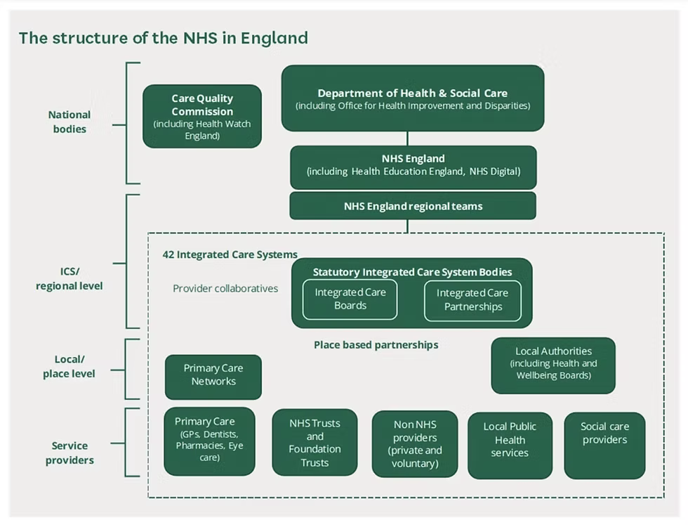
Fig.4: The structure demonstrates that decision-making flows from national leadership to regional bodies and then to frontline services. While national policies provide standardisation, local clinicians maintain authority over prescribing and discharge decisions. In the infant morphine overdose case, this hybrid structure influenced how the error occurred. Central guidance existed for safe prescribing, but decentralised implementation allowed the incorrect dose to progress without verification (Suhaani, 2024).
- Centralisation within the Case Study
The NHS utilizes centralised governance to standardise safety through national directives, such as the ‘RED’ drug classification for high-concentration morphine (NHS England, 2023).
Advantages in this case
The primary advantage is the creation of uniform 'Macro-level' safety barriers. Centralisation provides a consistent evidence-based framework intended to reduce clinical variability across the system. In this incident, the national standards already existed to protect the patient; the literature confirms that such standardised protocols are essential for monitoring safety incidents and establishing corrective actions globally (NHS England, 2022a).
Disadvantages and System Failure
However, this incident exposes a critical 'implementation gap'—the primary disadvantage of centralisation. While the ‘centre’ mandated safety protocols, the structural fragmentation of the NHS meant these barriers were not digitally integrated at the meso-level. Because Primary Care operates as a decentralised network, there was no 'hard stop' in the GP's software to block the hospital-only concentration. This demonstrates that centralisation creates a 'false sense of security' if the system architecture lacks the interoperability required to bridge the gap between national guidance and local frontline practice (Krenyacz and Revesz, 2025).
- Decentralisation within the Case Study
Decentralisation in this case is evidenced by the professional autonomy granted to the GP and Community Pharmacist, who operate as independent entities within the broader Integrated Care System (ICS).
Advantages of Decentralised Authority
The primary advantage of this structure is local responsiveness and agility. Decentralisation allows clinicians to tailor care to the specific needs of the infant and family, facilitating quicker decision-making without the delays of a massive central bureaucracy (Royal College of Physicians, 2017). This autonomy is essential for maintaining professional flexibility and ensuring that care remains patient-centred within local community settings.
Disadvantages and Systemic Silos
However, this incident reveals a critical disadvantage: the creation of organisational silos. While professionals worked collaboratively, the lack of a shared electronic prescribing system meant that accountability was fragmented. This resulted in an 'assumption of safety' where the GP deferred to the hospital’s discharge summary, and the pharmacist deferred to the GP’s prescription. This demonstrates that in a decentralised system, professional autonomy can inadvertently lead to a coordination breakdown if there is no unifying governance mechanism to ensure cross-agency verification (Sapkota et al., 2023).
- Impact on Decision-Making and Accountability
Crisis management and accountability were affected by the hybrid nature of the structure. Central policies provided direction but were not consistently followed due to decentralised implementation. The discharge process relied on individual judgment and allowed no verification by a third party. Thus, the incorrect dose was not detected prior to dispensing (Health and Social Care, 2024).
The fragmented decision-making resulted in decreased accountability. Multiple practitioners were involved, but no single practitioner had the ultimate responsibility for verifying/administering the medication. The distribution of responsibility made the detection of the error less rapid. More highly structured controls from a central source, such as electronic prescribing alert systems and mandatory verification by a licensed pharmacist, could have prevented this incident (Avery et al., 2013).
Patient safety report data show that medication errors are frequently present at the time of transition to a new level of care (e.g., in the hospital at the time of discharge). Transitions of care have a decentralised nature due in part to multiple professionals making decisions and the use of shared communication between professionals. Limited time due to workforce pressures also decreases the chances for verification and increases risk during transitions of care (Elliott et al., 2024).
2.3 Leadership Analysis
- Application of Leadership Theories
The catastrophic failure to intercept the morphine overdose highlights a significant deficit in Transformational Leadership across the multi-agency care interface. Transformational leaders are essential for fostering a 'psychologically safe' environment where staff at all levels feel empowered to challenge senior-level decisions (NHS England, 2022b). In this incident, the lack of this leadership style resulted in a culture of 'passive compliance' rather than 'proactive inquiry.' Instead of verifying the 100mcg/ml concentration, the GP and pharmacist deferred to the hospital’s written record, illustrating that leadership had not successfully embedded the 'Speak Up' culture necessary for high-risk medication safety (Ystaas et al., 2023). National NHS Staff Surveys consistently demonstrate that organisations with high scores in "supportive leadership" experience significantly fewer patient safety incidents; however, the approach here remained purely Transactional, focusing on bureaucratic completion rather than the critical evaluation of patient risk (Steinmann, 2018).
Furthermore, the incident reveals a failure in Behavioural Leadership, specifically the imbalance between task-oriented and people-oriented governance. From a task-oriented perspective, leadership failed to establish structured validation procedures—such as a mandatory pharmacist double-check for 'RED' drugs—leaving the process vulnerable to individual human error (Ceri-Booms et al., 2017). However, the more profound failure was the absence of the people-oriented leadership required to facilitate Collective and Distributed Leadership (West et al., 2015). Collective leadership distributes accountability across the entire Integrated Care System (ICS), ensuring every professional feels responsible for the outcome. In this case, the division of responsibilities made it difficult to hold any one individual accountable; had a distributed model been in place, leaders would have encouraged a culture
cooperative checking rather than isolated assumptions, significantly improving patient outcomes (Dirik et al., 2026).
Finally, a critique of the Situational Leadership applied during the discharge reveals a mismatch between the leadership style and the clinical risk level. Situational theory suggests that as the risk of a task increases, directive oversight must also increase (Needham, 2024). The discharge of an infant on high-concentration opioids demanded directive, proactive leadership to ensure closed-loop communication; instead, leadership was notably absent, leaving decision-making uncoordinated. This was compounded by a lack of Emotional Intelligence (EI) among leaders, as they failed to create an environment where team members felt comfortable questioning confusing prescriptions. Governance mechanisms, such as the digital protocols mandated by the Health and Care Act (2022), must be supported by adaptive, purpose-driven leadership to be effective. Moving forward, the organisation must transition toward an emotionally intelligent, collective model that prioritizes systemic safety and open communication over individual compliance (Needham, 2024; Health and Care Act, 2022).
- Evaluation of Leadership Effectiveness
The leadership strategy employed here seems reactive rather than proactive because risks were not foreseen, and the decision was made based on personal judgment. The division of responsibilities made it difficult to hold someone accountable and thus led to the morphine dosage error getting through all phases. There was inadequate supervision by leaders and poor coordination among the hospital staff, general physicians, and pharmacists, which hindered effective communication. From the research on patient safety, leadership is critical in enhancing communication and developing a positive safety culture to prevent medication mistakes. Likewise, there is evidence that suggests that patient outcomes improve when there is good staff involvement and leadership support (Dirik, Theiakouli and Efstathiou, 2026).
Greater distributed leadership may have helped the coordination process as leaders can delegate some of their responsibilities among all clinicians, such as those working at the hospital, GPs, and pharmacists. The encouragement of cooperative checking of the dosage, along with effective communication, will help in minimising assumptions. Emotional intelligence skills can also be used by the leaders while encouraging their team members to bring forward any issues regarding confusing prescriptions. Safety mechanisms, like using the e-prescription system and the review done by pharmacists, can ensure that the governance is effective (Health and Care Act, 2022).
2.4 Improvements and Lessons Learned
- Key Issues Identified
The morphine overdose in infants by the NHS shows how the leadership, governance, and systems structure were interconnected in causing harm to patients. Rather than being caused by one specific factor, the accident can be attributed to several system failures that include poor communication, ambiguous prescriptions, lack of verification and fragmented accountability. The hospital discharge process included ambiguous dosing orders that were interpreted by the general practitioner and the community pharmacist but never confirmed. This shows a governance problem because there is a lack of collaboration and structured communication in the discharge process (Alrowily et al., 2024).
In terms of accountability, there are multiple people who should have verified the dose. However, none of them did that, which is another failure of the healthcare system that caused the overdose. Furthermore, the absence of electronic prescribing added to the risk because it makes it much easier to make a mistake when writing down medication orders by hand. Therefore, it is important to note that the decision made by the leadership about adopting new technologies also influences patient safety in the organization (NICE, 2015).
- Evidence-Based Improvements
To address the multi-faceted failures identified in the morphine overdose case, a series of evidence-based improvements are required. These improvements focus on strengthening clinical governance, technological integration, and the leadership culture within the Integrated Care System (ICS).
Priority | Improvement Area | Leadership Alignment | Evaluation Metric
1: Critical | Digital Prescribing & Automated Verification(Ammenwerth et al., 2008) | Transactional: Strengthening governance protocols (Steinmann, 2018). | Monthly audit of 'hard-stop' alert overrides and transcription error rates.
2: High | Mandatory Pharmacy Clinical Review (Royal Pharmaceutical Society, 2022) | Behavioural: Task-oriented oversight of high-risk drugs (Ceri-Booms et al., 2017). | Percentage of high-risk discharges reviewed by a pharmacist within 24 hours.
3: High | Standardised Communication Templates (Patra et al., 2020) | Collective: Removing silos through shared data (West et al., 2015). | Compliance rates with mandatory fields in discharge summaries.
4: Medium | Proactive Safety Culture & Feedback Loops (IHI, 2023) | Transformational: Building psychological safety (Ystaas et al., 2023). | Freedom to Speak Up (FTSU) index scores in the annual Staff Survey.
Table 1: Prioritization and Evaluation of System Improvements
Technological Improvements: Electronic Prescribing and Digital Verification
The most immediate improvement involves the transition from manual, handwritten documentation to Electronic Prescribing Systems (EPS). Manual processes at the transition point of care are a primary driver of medication errors. By introducing EPS with automated dose checking, the system can provide real-time alerts for high-risk medications such as 100mcg/ml morphine. This technology allows for centralised governance while maintaining a decentralised clinical decision-making approach. An automated system would likely have flagged the incorrect dose before dispensing, significantly reducing the over-reliance on individual memory or fragmented paperwork (Ammenwerth et al., 2008).

Clinical Governance: Mandatory Pharmacist Verification
Technological fixes must be reinforced by human oversight through Mandatory Pharmacist Verification. The current case demonstrated an ineffective verification process across health systems. Evidence suggests that the involvement of clinical pharmacy leads directly to fewer medication errors at discharge. By building a governance structure that requires a pharmacist to review all "RED" category (high-risk) orders, the NHS can provide an additional layer of safety. This lowers the reliance on a single clinician's judgment and distributes accountability across the professional interface, ensuring that the pharmacist acts as a critical safety net (Royal Pharmaceutical Society, 2022).

Structural Improvements: Standardised Discharge Communication
To resolve the communication breakdowns identified in clinical transitions, the system must implement Standardised Discharge Templates (Reinhard et al., 2008). The use of structured documentation improves clarity and reduces the ambiguity that led to the morphine error. Leaders must ensure that these templates include mandatory confirmation of medication concentrations and clear administration instructions. This enhancement of governing protocols ensures that critical data—such as the specific concentration of an opioid—cannot be omitted during the transfer from secondary to primary care (Markiewicz et al., 2025; Patra et al., 2020).

Cultural Improvements: Distributed Leadership and Safety Culture

The final improvement area focuses on moving from reactive learning to a Proactive Safety Culture. The diffusion of responsibility seen in this case—where multiple professionals assumed others had checked the dose—can only be corrected through a Distributed Leadership Model. This model promotes collaborative effort and shared accountability among hospital staff, GPs, and pharmacists (Charles, 2022; Health Research Authority, 2025).
Furthermore, this culture must be underpinned by Open Incident Reporting and feedback loops. Organisations with a strong safety culture tend to report fewer accidents because they treat "near misses" as learning opportunities rather than occasions for blame. By encouraging staff to report medication mistakes and utilizing feedback loops to identify risks sooner, leaders can intervene before a systemic weakness results in patient harm (Dixon-Woods et al., 2014; IHI, 2023).
- Lessons for Healthcare Organisations
This case provides important lessons for healthcare organisations. First, the system structure cannot guarantee access to safe care, as they need both centralised policies with decentralised decision-making supported by strong leadership and governance. In the current case, there were central prescribing guidelines, but due to the decentralised implementation of these guidelines, the error was able to continue for too long. This illustrates the need to have a level of coordination between different organisational levels. Second, there needs to be a proactive approach by the leadership, verifying processes and easily understandable communication should be established before discharging patients, especially when high-risk medications are involved (NHS England, 2022c).
Third, effective communication from one care setting to another is also critical, as the greater the fragmentation with regard to information, the greater the risk during transitions. Fourth, there should be clear lines of accountability; governance frameworks should include assigning verification responsibilities so that errors can be determined as soon as possible to continue to protect patient safety (NICE, 2015).
- Linking Leadership, Governance, and System Structure
This case study illustrates the interaction of leadership, governance, and the system structure to produce the outcome in this case. The centralised governance provided safety guidance; however, the decentralised decision-making system eliminated accountability. The leadership did not ensure that all teams had coordination, which allowed communication gaps between teams to exist. The pressure on the systems made any safety checks even weaker (Care Quality Commission, 2026).
Feedback loops also impacted the outcomes. Poor communication resulted in the wrong medication being prescribed to a patient, causing them harm; thus, leading to an investigation and subsequently to a recommendation of changes to avoid similar future occurrences. This reactive feedback loop demonstrates a need for leadership to be proactive and continuously monitor and assess situations (Frydenberg and Brekke, 2012).
- Continuous Improvement and Accountability
Communication between health care service providers is crucial to ensure that patient safety is always guaranteed. Open communication between your doctor and the hospital can ensure you receive the appropriate treatment and care for the healthcare condition you have suffered; In contrast, communication with your pharmacy will help ensure that your medication is properly administered for safe use (NHS Digital, 2021).
In addition to maintaining an open line of communication with health services, you must also understand what is expected of you when you visit your doctor or pharmacy. You have the absolute right to request that any of the medications you take be reviewed by a physician prior to taking them. If you are using a health services provider that does not allow you to review your medication prior to taking it, I strongly suggest that you seek out a different provider (NHS England, 2019).
- Recommendations
The primary objective for the National Health Service (NHS) is to evolve systems of governance, leadership, and communication to eliminate the "accountability gaps" observed in the morphine overdose incident. Based on the case analysis, the following strategic actions are recommended to ensure systemic resilience.

I. Leadership Styles for Sustained Improvement
To sustain safety improvements, a hybrid of Transformational and Behavioural leadership styles is recommended. Transformational leadership is essential to shift the organisational culture from one of "passive compliance" to "proactive safety." Leaders must foster psychological safety, encouraging staff to be honest and open when raising concerns about high-risk prescriptions (NIH, 2020). Simultaneously, Behavioural leadership must be applied to enforce task-focused protocols, such as mandatory independent double-checks. By combining these styles, the organisation develops a culture where staff are both empowered to "Speak Up" and disciplined in following safety-critical procedures.

II. Strengthening Governance, Communication, and Systems Integration
Governance must be strengthened through the mandatory implementation of Electronic Prescribing Systems (EPS)with integrated clinical decision support. This eliminates over-reliance on handwritten documentation and reduces transcription errors. To address fragmented care, the NHS must implement Integrated Electronic Healthcare Records linking primary care, pharmacy, and hospital services. This ensures that high-risk drug concentrations (e.g., 100mcg/ml morphine) are visible to all stakeholders in real-time, facilitating Collective Leadership across the care continuum (NHS England, 2024).

III. Enhancing Technical and Allocative Efficiency
To improve technical efficiency, the NHS should automate the dose-checking process, reducing the time clinicians spend on manual verification and minimising duplication of effort. Allocative efficiency can be enhanced by optimising pharmacy resources; specifically, redistributing clinical pharmacists to high-risk discharge interfaces. Targeted redistribution ensures that high-risk patients receive appropriate specialist resources—such as a Mandatory Pharmacist Review—without unnecessarily increasing the burden on general staff (RCPCH, 2023; Spencer et al., 2014).

IV. Continuous Learning, Stakeholder Engagement, and Co-Production
Future incidents must be prevented through a robust Continuous Learning framework. This involves:
- Incident Reporting: Moving from reactive blame to proactive risk mitigation by encouraging the reporting of "near misses" (Dixon-Woods et al., 2014).
- Stakeholder Co-Production: Involving physicians, pharmacists, and families in the design of discharge protocols. By educating caregivers on specific morphine concentrations, they become an active "final check" in the safety chain (CQC, 2024).
- Feedback Loops: Utilizing quarterly board-level reviews of safety data to adjust protocols based on real-world staff feedback.

V. Implementation and Evaluation Framework
Action | Priority | Implementation Strategy | Evaluation Method
Pharmacist Sign-off | Immediate | Protocol change for 'RED' drugs. | 100% compliance audit of signatures.
Digital Integration | Long-term | ICS-wide IT procurement. | Med-reconciliation error rate analysis.
Culture Training | Ongoing | Leadership workshops on EI. | NHS Staff Survey "Speak Up" index.

- Conclusion

The infant morphine overdose case study reviewed an incident relating to safety from morphine use within the NHS and its impact on patients. The findings indicate that this incident stemmed from many systemic issues (including a lack of clearly defined procedures, inadequate verification of dosages, lack of accountability, and no available integrated digital systems) rather than one single error. By using a systems thinking framework, it was demonstrated how different types of healthcare workers (hospital employees, GPs and pharmacists) failed to create a seamless process for delivering the incorrect dosage of morphine to the infant. Evidence of poor centralised and decentralised structures highlighted that national guidelines were not well enforced at the local level (meaning there was a lack of accountability in how they were written or implemented), which ultimately led to delayed detection of problems when they occurred during the provision of care (NHS England North East and Yorkshire, 2023)

The analysis of leadership also showed that transformational, transactional and situational leadership principles were not put into practice effectively. In fact, leadership had become almost reactive instead of being proactive; thereby limiting communication and hindering shared responsibilities. Improvements to governance structures would have improved the ability of the NHS to implement medication safety policies. Finally, the overall conclusion of this study reinforces the requirement for effective leadership to fit within established governance frameworks for proper documentation, effective communication and collaborative decision making related to patient care to be achieved (Nazir et al., 2025).
On the whole, the case study emphasises the necessity of leadership, governance, and systems thinking for improvement in health care organisations. Leadership contributes to building a culture of safety, governance supports accountability, while systems thinking helps recognise interconnections in terms of potential risks. The combination of these factors makes it possible to manage risks effectively, learn continuously, and enhance patient safety. Discharge procedures, computerised prescription management, and leadership practices can be applied to ensure positive changes (NHS England, 2024).

- References

Aarons, G. (2020). Transformational and Transactional Leadership: Association with Attitudes toward Evidence-Based Practice. Psychiatric Services, [online] 57(8), pp.1162–1169. doi:https://doi.org/10.1176/appi.ps.57.8.1162.
Alrowily, A., Alfaraidy, K., Almutairi, S., Alamri, A., Alrowily, W., Abutaleb, M., Zaitoun, M., Sarawi, W. and Aljead, M. (2024). High-risk Medication errors: Insight from the UK National Reporting and Learning System. Exploratory Research in Clinical and Social Pharmacy, [online] 17(100531), p.100531. doi:https://doi.org/10.1016/j.rcsop.2024.100531.
Ammenwerth, E., Schnell-Inderst, P., Machan, C. and Siebert, U. (2008). The Effect of Electronic Prescribing on Medication Errors and Adverse Drug Events: A Systematic Review. Journal of the American Medical Informatics Association, 15(5), pp.585–600. doi:https://doi.org/10.1197/jamia.m2667.
Avery, A.J., Ghaleb, M., Barber, N., Dean Franklin, B., Armstrong, S.J., Serumaga, B., Dhillon, S., Freyer, A., Howard, R., Talabi, O. and Mehta, R.L. (2013). The prevalence and nature of prescribing and monitoring errors in English general practice: a retrospective case note review. British Journal of General Practice, 63(613), pp.e543–e553. doi:https://doi.org/10.3399/bjgp13x670679.
Care Quality Commission (2024). State of health and adult social care in England: 2023 to 2024. [online] GOV.UK. Available at: https://www.gov.uk/government/publications/state-of-health-and-adult-social-care-in-england-2023-to-2024.
Ceri-Booms, M., Curşeu, P.L. and Oerlemans, L.A.G. (2017). Task and person-focused leadership behaviors and team performance: A meta-analysis. Human Resource Management Review, 27(1), pp.178–192. doi:https://doi.org/10.1016/j.hrmr.2016.09.010.
Charles, A. (2022). Integrated Care Systems Explained. [online] The King’s Fund. Available at: https://www.kingsfund.org.uk/insight-and-analysis/long-reads/integrated-care-systems-explained.
Charles, A., Naylor, C. and Murray, R. (2021). Integrated care systems in London Challenges and opportunities ahead . [online] Available at: https://assets.kingsfund.org.uk/f/256914/x/084d2c5253/integrated_care_systems_london_2021.pdf.
Checkland, P. and Poulter, J. (2006). Learning for action a short definitive account of soft systems methodology, and its use for practitioners, teachers and students. Hoboken, N.J. [U.A.] Wiley.
Conte, K.P. and Davidson, S. (2020). Using a ‘rich Picture’ to Facilitate Systems Thinking in Research Coproduction. Health Research Policy and Systems, 18(1). doi:https://doi.org/10.1186/s12961-019-0514-2.
Cqc.org.uk. (2026). Governance, management and sustainability - Care Quality Commission. [online] Available at: https://www.cqc.org.uk/care-services/local-authority-assessment-reports/sandwell-0326/theme4/governance [Accessed 18 Apr. 2026].
Department of Health and Social Care (2021). Department of Health and Social Care Outcome Delivery Plan: 2021 to 2022. [online] GOV.UK. Available at: https://www.gov.uk/government/publications/department-of-health-and-social-care-outcome-delivery-plan/department-of-health-and-social-care-outcome-delivery-plan-2021-to-2022.
Department of Health and Social Care (2022). Health and Care Act 2022 Impact Assessments Summary Document and Analysis of Additional Measures. [online] Department of Health and Social Care. Available at: https://assets.publishing.service.gov.uk/media/6363d911e90e0705a8c35457/health-and-care-act-2022-summary-and-additional-measures-impact-assessment.pdf.
Department of Health and Social Care (2024). Hospital Discharge and Community Support Guidance. [online] GOV.UK. Available at: https://www.gov.uk/government/publications/hospital-discharge-and-community-support-guidance/hospital-discharge-and-community-support-guidance.
Dixon-Woods, M., Baker, R., Charles, K., Dawson, J., Jerzembek, G., Martin, G., McCarthy, I., McKee, L., Minion, J., Ozieranski, P., Willars, J., Wilkie, P. and West, M. (2014). Culture and Behaviour in the English National Health Service: Overview of Lessons from a Large Multimethod Study. BMJ Quality & Safety, [online] 23(2), pp.106–115. Available at: https://qualitysafety.bmj.com/content/23/2/106.
Elliott, R.A., Angley, M., Criddle, D.T., Emadi, F., Liu, S. and Penm, J. (2024). Editorial: Achieving safe medication management during transitions of care from hospital: time for a stewardship approach. Australian Prescriber, [online] 47(4), pp.106–108. doi:https://doi.org/10.18773/austprescr.2024.034.
Elliott, R.A., Camacho, E., Jankovic, D., Sculpher, M.J. and Faria, R. (2021). Economic Analysis of the Prevalence and Clinical and Economic Burden of Medication Error in England. BMJ Quality & Safety, [online] 30(2), pp.96–105. doi:https://doi.org/10.1136/bmjqs-2019-010206.
Franklin, B.D., Reynolds, M., Sadler, S., Hibberd, R., Avery, A.J., Armstrong, S.J., Mehta, R., Boyd, M.J. and Barber, N. (2014). The effect of the electronic transmission of prescriptions on dispensing errors and prescription enhancements made in English community pharmacies: a naturalistic stepped wedge study. BMJ Quality & Safety, 23(8), pp.629–638. doi:https://doi.org/10.1136/bmjqs-2013-002776.
Frydenberg, K. and Brekke, M. (2012). Poor communication on patients’ medication across health care levels leads to potentially harmful medication errors. Scandinavian Journal of Primary Health Care, 30(4), pp.234–240. doi:https://doi.org/10.3109/02813432.2012.712021.
Guan, X., Ni, B., Zhang, J., Zhu, D., Cai, Z., Meng, W., Shi, L. and Ross-Degnan, D. (2020). Association Between Physicians’ Workload and Prescribing Quality in One Tertiary Hospital in China. Journal of Patient Safety, 17(8), pp.e1860–e1865. doi:https://doi.org/10.1097/pts.0000000000000753.
Ham, C., Charles, A. and Wellings, D. (2018). Shared responsibility for health. [online] The King’s Fund. Available at: https://www.kingsfund.org.uk/insight-and-analysis/long-reads/shared-responsibility-health.
Hasan Fehmi Dirik, Chrysanthi Theiakouli and Efstathiou, N. (2026). The Influence of Nursing Leadership Styles on Medication Safety: A Mixed-Methods Systematic Review. PubMed, 73(1), pp.e70166–e70166. doi:https://doi.org/10.1111/inr.70166.
Health Research Authority (2025). UK Policy Framework for Health and Social Care Research. [online] Health Research Authority. Available at: https://www.hra.nhs.uk/planning-and-improving-research/policies-standards-legislation/uk-policy-framework-health-social-care-research/[Accessed 20 Apr. 2026].
Health, I. (2019). Medication safety in high-risk situations. [online] Who.int. Available at: https://www.who.int/publications/i/item/medication-safety-in-high-risk-situations.
Howick, J., Weston, A.B., Solomon, J., Nockels, K., Bostock, J. and Keshtkar, L. (2024). How does communication affect patient safety? Protocol for a systematic review and logic model. BMJ Open, [online] 14(5), pp.1–8. doi:https://doi.org/10.1136/bmjopen-2024-085312.
IHI (2023). Improving Health and Health Care Worldwide | IHI - Institute for Healthcare Improvement. [online] www.ihi.org. Available at: https://www.ihi.org. [Accessed 20 Apr. 2026].
Krenyacz, E. and Revesz, E.E. (2025). Consequences of centralized healthcare systems: changing role and autonomy of hospital managers – insights from a Hungarian case. Journal of Health Organization and Management, [online] 39(9), pp.177–191. doi:https://doi.org/10.1108/jhom-08-2024-0358.
Lalani, M., Peters, M., Thavapriya Sugavanam, Crocker, H., Caiels, J., Hay, H., Gunn, S., Hogan, H., Page, B. and Fitzpatrick, R. (2024). New Ways of Working to Manage and Improve Quality in Integrated Care Systems in England. International Journal of Health Policy and Management, 14(1). doi:https://doi.org/10.34172/ijhpm.8424.
Markiewicz, O.M., Menon, A., Acharya, A., D’Lima, D., Lorencatto, F., Darzi, A. and Judah, G. (2025). What influences preparations of discharge documentation at patient discharge? An interview study with hospital health professionals based on the theoretical domains framework. BMJ open, [online] 15(6), p.e090753. doi:https://doi.org/10.1136/bmjopen-2024-090753.
National Institute for Health and Care Excellence (NICE) (2015). Introduction | Medicines optimisation: the Safe and Effective Use of Medicines to Enable the Best Possible Outcomes | Guidance | NICE. [online] Nice.org.uk. Available at: https://www.nice.org.uk/guidance/ng5/chapter/Introduction. [Accessed 19 Apr. 2026].
Nazir, M.A., Gautam, S. and Zhu, X. (2025). Transforming Care in the United Kingdom: How Leadership and Culture Drive Healthcare Professionals’ Engagement and Performance in the NHS. Transforming Care in the United Kingdom: How Leadership and Culture Drive Healthcare Professionals’ Engagement and Performance in the NHS. doi:https://doi.org/10.22541/au.174230708.80344925/v1.
Needham, A. (2024). Situational Leadership in Healthcare. [online] www.salford.ac.uk. Available at: https://www.salford.ac.uk/spd/situational-leadership-in-healthcare.
NHS England (2019). NHS England» Improving hospital discharge. [online] England.nhs.uk. Available at: https://www.england.nhs.uk/urgent-emergency-care/improving-hospital-discharge/[Accessed 20 Apr. 2026].
NHS England (2020). NHS England and NHS Improvement Patient Safety Incident Response Framework 2020 an Introductory Framework for Implementation by Nationally Appointed Early Adopters. [online] Available at: https://www.england.nhs.uk/wp-content/uploads/2020/08/200312_Introductory_version_of_Patient_Safety_Incident_Response_Framework_FINAL.pdf [Accessed 20 Apr. 2026].
NHS England (2021). Classification: Official NHS Patient Safety Strategy: 2021 update. [online] Available at: https://www.england.nhs.uk/wp-content/uploads/2021/02/B0225-NHS-Patient-Safety-Strategy-update-Feb-2021-Final-v2.pdf [Accessed 20 Apr. 2026].
NHS England (2022a). NHS England - Medicines Optimisation. [online] www.england.nhs.uk. Available at: https://www.england.nhs.uk/medicines-2/medicines-optimisation/[Accessed 20 Apr. 2026].
NHS England (2022b). Patient Safety Incident Response Framework. [online] www.england.nhs.uk. Available at: https://www.england.nhs.uk/patient-safety/patient-safety-insight/incident-response-framework/[Accessed 20 Apr. 2026].
NHS England (2022c). Safety culture: Learning from Best Practice. [online] www.england.nhs.uk. Available at: https://www.england.nhs.uk/long-read/safety-culture-learning-from-best-practice/[Accessed 20 Apr. 2026].
NHS England (2023). Medication Safety Management. [online] NHS. Available at: https://www.england.nhs.uk/long-read/medication-safety-management/[Accessed 20 Apr. 2026].
NHS England (2024). NHS England» Medication Safety. [online] www.england.nhs.uk. Available at: https://www.england.nhs.uk/patient-safety/patient-safety-insight/patient-safety-alerts/enduring-standards/standards-that-remain-valid/medication-safety/[Accessed 20 Apr. 2026].
NICE (2015). Overview | Medicines optimisation: the Safe and Effective Use of Medicines to Enable the Best Possible Outcomes | Guidance | NICE. [online] Nice.org.uk. Available at: https://www.nice.org.uk/guidance/NG5. [Accessed 19 Apr. 2026].
NIH (2020). Transformational Leadership and Evidence-Based Management. [online] Nih.gov. Available at: https://www.ncbi.nlm.nih.gov/books/NBK216194/[Accessed 20 Apr. 2026].
Patra, K.P., Mains, N., Dalton, C., Welsh, J., Iheonunekwu, C., Dai, Z., Murray, P.J. and Fisher, E.S. (2020). Improving Discharge Outcomes by Using a Standardized Risk Assessment and Intervention Tool Facilitated by Advanced Pediatric Providers. Hospital Pediatrics, 10(2), pp.173–180. doi:https://doi.org/10.1542/hpeds.2019-0109.
RCPCH. (2023). Medication safety: Best practice for effective paediatric ward rounds - clinical practice guideline. [online] Available at: https://www.rcpch.ac.uk/resources/medication-safety-clinical-practice-guideline.
Reinhard, S.C., Given, B., Petlick, N.H. and Bemis, A. (2008). Supporting Family Caregivers in Providing Care. [online] Nih.gov. Available at: https://www.ncbi.nlm.nih.gov/books/NBK2665/.
Royal College of Physicians (2017). National Early Warning Score (NEWS) 2 Standardising the assessment of acute-illness severity in the NHS. [online] Available at: https://www.rcp.ac.uk/media/a4ibkkbf/news2-final-report_0_0.pdf.
Royal Pharmaceutical Society (2022) Professional Standards for Hospital Pharmacy Services. London: Royal Pharmaceutical Society.
Serious Incident Case Study: Infant Morphine Overdose Investigation Summary & Learning. (2023). Available at: https://northyorkshireccg.nhs.uk/wp-content/uploads/2023/07/July-2023-NHS-NEY-INFANT-MORPHINE-OVERDOSE-CASE-STUDY.pdf?UNLID=193374120245125844.
Sfantou, D., Laliotis, A., Patelarou, A., Sifaki-Pistolla, D., Matalliotakis, M. and Patelarou, E. (2017). Importance of leadership style towards quality of care measures in healthcare settings: A systematic review. Healthcare, 5(4), p.73. doi:https://doi.org/10.3390/healthcare5040073.
Silva, J.A.M., Mininel, V.A., Agreli, H.F., Peduzzi, M., Harrison, R. and Xyrichis, A. (2022). Collective Leadership to Improve Professional practice, Healthcare Outcomes and Staff well-being. Cochrane Database of Systematic Reviews, [online] 2022(10). Available at: https://pmc.ncbi.nlm.nih.gov/articles/PMC9549469/.
Singh, P., Singh, S., Kumari, V. and Tiwari, M. (2024). Navigating healthcare leadership: Theories, challenges, and practical insights for the future. Journal of Postgraduate Medicine, [online] 70(4), pp.232–241. doi:https://doi.org/10.4103/jpgm.jpgm_533_24.
Spencer, R., Bell, B., Avery, A.J., Gookey, G. and Campbell, S.M. (2014). Identification of an updated set of prescribing-safety indicators for GPs. British Journal of General Practice, 64(621), pp.e181–e190. doi:https://doi.org/10.3399/bjgp14x677806.
Steinmann, B. (2018). The Path Is the goal: How Transformational Leaders Enhance Followers’ Job Attitudes and Proactive Behavior. Frontiers in Psychology, [online] 9(2338). doi:https://doi.org/10.3389/fpsyg.2018.02338.
Suhaani S (2024). Structure of the NHS in 2026 - How The NHS in England Works. [online] TheUKCATPeople. Available at: https://www.theukcatpeople.co.uk/post/structure-of-the-nhs-how-the-nhs-in-england-works-health-and-care-systems?srsltid=AfmBOoqqao8moON8mXsxoDkkgg0QJTfDQVdSaD2ocpXStpmQvtkZFDMT [Accessed 19 Apr. 2026].
Sujata Sapkota, Amshu Dhakal, Rushton, S., Edwin van Teijlingen, Marahatta, S.B., Balen, J. and Andrew CK Lee (2023). The impact of decentralisation on health systems: a systematic review of reviews. BMJ Global Health, 8(12), pp.e013317–e013317. doi:https://doi.org/10.1136/bmjgh-2023-013317.
Tariq, R., Scherbak, Y., Vashisht, R. and Sinha, A. (2024). Medication dispensing errors and prevention. [online] National Library of Medicine. Available at: https://www.ncbi.nlm.nih.gov/books/NBK519065/.
Tu, H.-N., Shan, T.-H., Wu, Y.-C., Shen, P.-H., Wu, T.-Y., Lin, W.-L., Yang-Kao, Y.-H. and Cheng, C.-L. (2023). Reducing medication errors by adopting automatic dispensing cabinets in critical care units. Journal of Medical Systems, [online] 47(1). doi:https://doi.org/10.1007/s10916-023-01953-0.
West, M., Armit, K., Loewenthal, L., Eckert, R., West, T. and Lee, A. (2015). Leadership in Health Care: a Summary of the Evidence Base. [online] Available at: https://assets.kingsfund.org.uk/f/256914/x/9ccade5367/leadership_in_health_care_summary_february_2015.pdf.
World Health Organization (2017a). Medication without Harm. [online] www.who.int. Available at: https://www.who.int/publications/i/item/WHO-HIS-SDS-2017.6 [Accessed 20 Apr. 2026].
World Health Organization (2017b). WHO launches global effort to halve medication-related errors in 5 years. [online] www.who.int. Available at: https://www.who.int/news/item/29-03-2017-who-launches-global-effort-to-halve-medication-related-errors-in-5-years [Accessed 20 Apr. 2026].
Ystaas, L.M.K., Nikitara, M., Ghobrial, S., Latzourakis, E., Polychronis, G. and Constantinou, C.S. (2023). The impact of transformational leadership in the nursing work environment and patients’ outcomes: A systematic review. Nursing Reports, [online] 13(3), pp.1271–1290. doi:https://doi.org/10.3390/nursrep13030108.

