Assignment Title:
The cyclical fatigue failure mode – The Liberty ships

Cyclic fatigue i.e., delayed failure under cyclically varying loads, is the most pervasive, yet last understood, form of fracture, accounting for 80% or more of all “in service” failure. It is manifest throughout the human experience, being the cause of major disasters such as bridge, ship, aircraft and train crashes, the failure of automobile components, structural problems in the nuclear and power industries (Ritchie & Y. Murakami, 2003)
Fatigue is appropriately defined as the progressive and localized damage of a material’s molecular structure, which occurs when the material is subject to cyclic loading, eventually weakening the material. The repeated stress, strain, force and tensile load acting in such a situation is one of the reasons why the load needed for fatigue failure is far less than the ultimate tensile strength of the material. (Schjive, 2007)
The Liberty ships were a so-called "emergency" class of ships developed during World War II. Described variously as "dreadful looking" and an "ugly duckling," the Liberty class of ships nonetheless came to represent the immense industrial might of the United States early on in the war effort. Nearly 3000 of the ships were built in an extremely short period. The short timescale from design to construction, however, led to the inclusion of several fatal flaws in the ship design, and many ships were lost due brittle steel failures. The Liberty class was designed to fill a void in merchant marine ships as the United States rapidly ramped up its war effort. They were given the designation "EC2-S-C1," the EC standing for emergency cargo. The ships were designed to minimize labour and material costs, this was done by replacing many rivets with welds. This was a new technique, so workers were inexperienced and engineers had little data to go on. Additionally, much of the shipyards’ labour force had been replaced with women as men joined the armed forces. Because of this, early ships took quite a long time to build – the first ship constructed was the Patrick Henry taking 244 days – but the average building time eventually came down to just 42 days. The ships were 441.5 feet long, with a 57 foot beam (width at widest point) and a 28 foot draft (vertical distance between the waterline and the bottom of the hull).

Material selection
Steel is one of the most popular materials used for ships and has consistently been the material of choice for the past century. Its high strength, durability, resistance to abrasion, and relatively low cost are some of the main reasons why steel is widely used in the industry although The steel that the liberty ships were made from was of poor quality and poor toughness due to the general steel shortage at the time, high quality steel was barely available during world war II. Consequently, the mild steel utilized for the liberty ships did not comply with modern impact absorption standards. The material failure was actually caused because the grade of steel used, it failed due to embrittlement. The steels utilized for the liberty ships were known to be acceptable for riveted ships, however, a propagating crack in riveted construction will be stopped at the latest once it arrives at a joint between two plates, since these two plates are laying over one another. In a weld contrast, two plates are joined via metallic bonding, a propagating crack will therefore not be stopped by a weld, but go right through it. All-welded constructions rely on high fracture toughness of the material even at low temperatures. Although this problem remained not entirely understood, riveted seam straps across the deck were added to prevent cracks from propagating. (Van Duyne, 1994)

Design Geometry
Standardization of the type of ship to be built was the first essential for the success of the emergency program. In the United States Nationwide standardization gave two major advantageous specifications and drawings to guide ship construction, once prepared, could rapidly reproduce for use in additional yards; and the procurement of components could be organized in a steady, flexible flow from a number of vendors supplying interchangeable articles to a number of shipyards. (Lane, Blanche, Fischer, & Tyler, 2001) The Liberty ship design had a few major flaws which were the result of the failures. The hatches, on the upper deck of the ship were square, the sharp corners caused a large build-up of stress. The ships were often overloaded, increasing mechanical stress levels, and a big wave or sea swell could start crack initiation at some weak spot. The square corner of a hatch that coincided with a welded seam, for example, was found to be such a place. Cracks, after initiation, could run large distances, right through a weld seam into the next plate. With rivets, cracks would have been arrested at the end of a plate. The ship could be considered as a girder where variable forces are acting, the unequal distribution of cargo and ballast along with wave bending moments would cause the ship to “hog” which would result in a maximum tensile stress in the deck or to “sag” causing a peak compressive force in the bottom of the ship. In various reports following failures in the liberty ship design the cracks propagated from hatch numbers 3 and 4 which were in the middle of the upper deck where the tensile stress was greatest while the ship was to Hog.
Photograph of Liberty ship Schenectady in the Portland shipyard split in two while still under construction in 1943
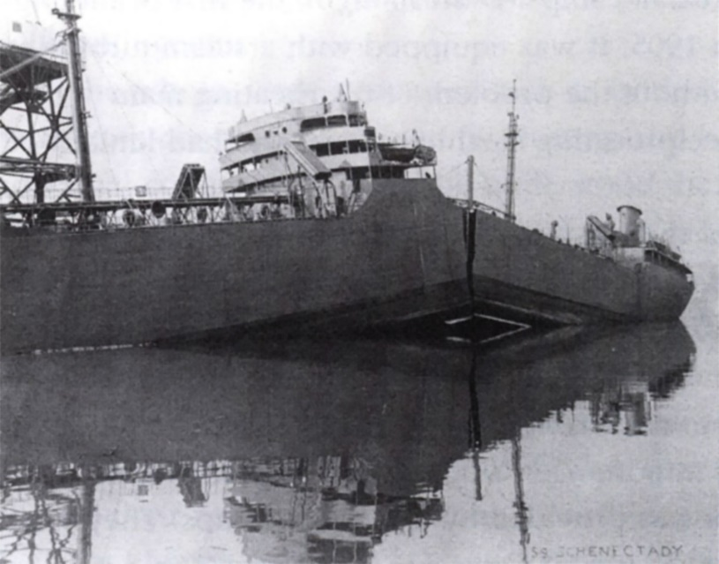

Manufacturing Methods
Pre-World War II ships were constructed using rivets, Rivets are cylindrical metals shafts with a head at one end. These provide a watertight join when pushed glowing hot through drilled holes in two pieces of metal. Once in place, the plain end is deformed to nearly twice its size. The rivet contracts as it cools and holds the metal pieces together. The installation of each rivet requires two workers. On one side, a person pushes the rivet through the metal piece and on the other side, a second person hammers the rivet’s plain end in place. An engineer Henry J. Kaiser, whose company had been the prime contractor for the Hoover, Bonneville, and Grand Coulee dams and the San Francisco-Oakland Bay Bridge, and who had never constructed a ship in his life until 1940. Before Kaiser entered the business ships were constructed from the keel up by one crew of workers; a process that took as long as six months. Kaiser adapted mass production techniques to shipbuilding, instituting modular construction and assembly techniques in which the ship sections were welded together instead of riveted. The introduction of welding into shipbuilding during World War II permitted faster and cheaper ship construction. Larger pieces of metal could be joined together to make the ship’s hull than was possible with riveting. The manufacturing process required a smaller and less-skilled workforce. The joints were more water tight and oil tight than rivets. The vessel was lighter and with a smooth hull. It moved through water with less friction than a riveted ship (Kielmas, 2017). Liberty ships represented the assembly line fully realized. The keel was laid in traditional fashion but the ship was then constructed from prefabricated sections welded together in the graving dock. Although it took 244 days to build the Patrick Henry, the average dropped to a mere 42 days per ship by the middle of the war. One Liberty, the SS Robert E. Peary, was built in an astounding four days at the Kaiser shipyard in Richmond, California. This was largely a publicity and morale stunt, however, and the feat was not repeated (Long, 2009).

Environmental Conditions
The purpose of the liberty ships was to transport essential resources across the Atlantic and pacific oceans, mostly to England and France but later also Australia and New Zealand. During the winter months between 1943 and 1944 the ships fractured due to the steel reaching low enough temperature to become brittle. The sea and air temperature constantly hovered around 0⁰C and a large sea swell put extra stress and strain on the ship. Another Environmental Factor to take into account was that the ships were built in damp and wet conditions of the ship yard, hydrogen embrittlement in the welds caused by electrode welding in the wet and damp conditions, although this does not appear to be a dominant reason.

Workforce
The Second World War brought about two major innovations in the merchant shipbuilding industry. Mass production, and the employment of women. The two were not independent of each other, for it was the transformation of shipbuilding from a skilled to a semi-skilled craft that made it possible to employ, with minimum training, not only unskilled men, but also women. Unfortunately, in the United States, neither innovation carried into the post-war period. While women were tolerated in shipyards during the war, no-one expected them to remain after it ended. The attitudes of the make workers largely reinforced this assumption. Besides, the level of skill acquired by women during the war proved to be inadequate after it, when shipbuilding reverted to highly skilled methods of construction. (Francis, 1989)
Photograph of Women welders
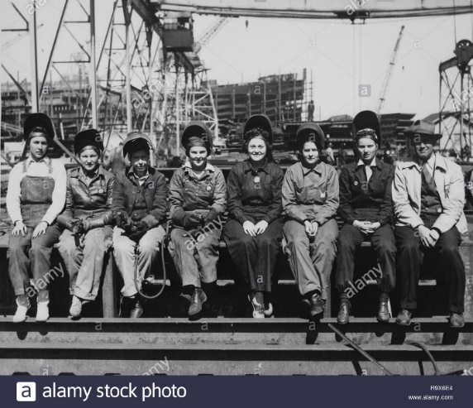

S-N curves for failure
Fatigue properties of materials are often described using the fatigue limit or the S-N curve (fatigue curve, Wöhler curve). The S-N curve describes the relation between cyclic stress amplitude and number of cycles to failure. The figure below shows a typical S-N curve. On the horizontal axis the number of cycles to failure is given on logarithmic scale. On the vertical axis (either linear or logarithmic) the stress amplitude (sometimes the maximum stress) of the cycle is given.
S-N curves are derived from fatigue tests. Tests are performed by applying a cyclic stress with constant amplitude (CA) on specimens until failure of the specimen. In some cases the test is stopped after a very large number of cycles (N>10^6). The results is then interpreted as infinite life. (Horman, 2018)
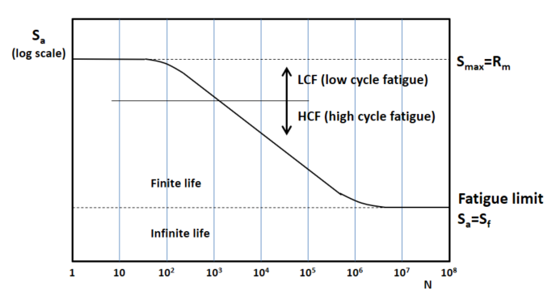
Material Testing
The Charpy impact test measures the energy absorbed by specimen (in this case steel) while breaking under an impact load. It testes the energy absorbed by the sample during fracture by measuring the height the pendulum reaches after the impact on the sample. The difference in potential energy of the pendulum equals the energy that has been absorbed by the sample during the fracture. Materials that have high toughness absorb a lot of energy when fractured whereas brittle materials absorb very little energy. As this is a simple and quick test, it is suitable for investigations of fracture toughness at varying temperatures, which are needed for determination of the ductile-to-brittle temperature susceptible materials. Common characteristics of steel is that transitions from ductile to brittle in decreasing temperatures, All (simple) steels will become brittle at temperatures low enough. The steel for the Liberty ships had a relatively high ductile-to-brittle transformation temperature, and in the cold North Atlantic this temperature was easily reached. That was the main problem. The steel used for the Liberty ships was worse than what was available around that time. This is neatly demonstrated by the figure below. (Nisbett, 1997)
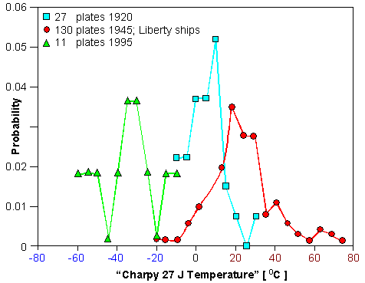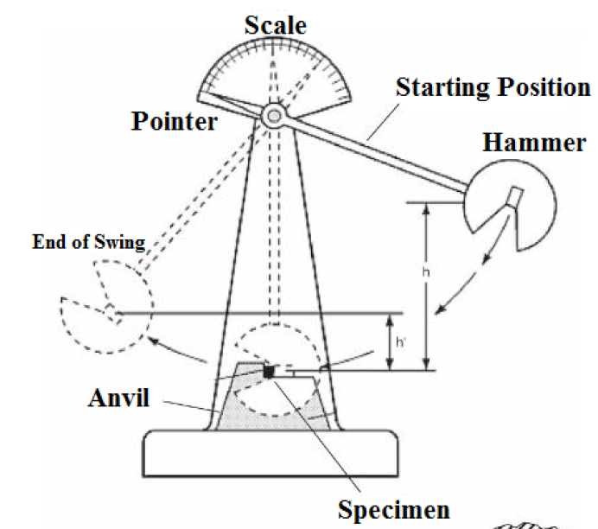

Fracture Mechanics
In order to understand the reasons for the failure of so many Liberty Ships, it is necessary to understand some fracture mechanics. For ductile materials, there is a critical combination of stress and crack length leading to instable crack growth and catastrophic failure. Ductile failures are associated with large amounts of plastic deformation. As a result of plastic deformation, localized necking or distortion is often present. In contrast to ductile failures, brittle fracture usually occurs without any noticeable deformation. Brittle fractures are generally flat, with little or no evidence of localized necking. The brittle fractures are characterized by rapid crack propagation, which occurs with sonic speed and perpendicular to the direction of the applied tensile stress (Callister, 2000). (Callister, 2000).
Factors promoting brittle failures are:
• High yield strengths that allow storage of high elastic energy level;
• Low temperature that cause a ductile-to-brittle transition in BCC metals;
• Large grain sizes that build up stress from dislocation pileups;
• High strain rates that do not allow time for stress redistribution;
• Coarse carbides or other inclusions that are themselves susceptible to cracking;
• Deep notches that create constraint at the crack tip;
• Thick sections that cause plane-strain loading.

Fracture mechanics, which have only been developed after the occurrence of a series of unexplainable brittle failures, allows us to quantify the relationship between materials properties, stress levels, the presence of crack-producing flaws and crack propagation mechanisms.
The strength of a material is a function of the cohesive forces between the atoms; however, the actual material strength is usually at least 10 to 1000 times below this theoretical value. According to Griffith, who predominantly studied amorphous and ceramic materials, this discrepancy between theoretical and observed fracture strength can be explained by the presence of very small, microscopic flaws and cracks that always exist under normal conditions (Callister, 2000). In a stressed component, the stress has to amplify at the flaw or crack since this area cannot transmit any forces. Hence, the actual localized maximal stress, which appears at the tip of the flaw or crack is a multiple of the nominal applied stress. Furthermore, the sharpness of a crack tip has significant influence on the material behaviour as the tip of the crack alters the stress mode from a unidirectional tensile load to a multiaxial stress mode. Therefore, these flaws and cracks are sometimes called stress raisers; the ratio of maximal stress divided by the nominal applied tensile stress is called the stress concentration factor. Stress concentration is deemed as one of the major factors influencing fracture resistance in materials and complex structures. This stress concentration caused localized areas of high stress, which contributed to the brittle fracture of the ships. Local design should consider the design of critical structural details for reduction of stress concentrations and for producibility. Stress concentration is not restricted to microscopic flaws; in fact, this also applies to macroscopic discontinuities such as sharp changes of diameter, sharp corners or notches.
It is important to note that the effect of stress raisers is much more significant in brittle than in ductile materials. If the maximum stress exceeds the yield strength of ductile materials, plastic deformation reduces the sharpness of the crack tip towards a blunt, rounded tip. This leads to a more uniform distribution of the stress in the vicinity of the flaw and the maximum stress concentration factor is lower than the theoretical value. In brittle materials, such a redistribution of stress is not possible as the theoretical yield strength of the material is higher than the ultimate tensile strength. A crack will propagate once the maximal stress exceeds the cohesive strength of the atoms at the tip of the flaw. This results in an increase of the crack size and a consequent increase of the stress concentration factor. Therefore, a propagating crack in a brittle material cannot be stopped, and will proceed through the entire member of the structure.
The critical value for fracture is fracture toughness. The key element of the fracture toughness is that it relates the applied stress conditions, flaw size, and the material’s fracture resistance. Generally, the relation between fracture toughness K, critical stress σC and crack length α are written as follows:
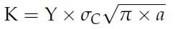
Where Y is a constant related to crack geometry and specimen/loading parameters.
Under certain circumstances, materials that generally show ductile behaviour can lose their fracture toughness and become brittle, likely resulting in catastrophic failure. Such circumstances can be fulfilled, if the crack length in a component is large enough that an applied stress is supercritical even
With a fairly high fracture toughness that one would usually consider ductile.
Brittle behaviour of usually ductile materials is probably more commonly experienced under the following circumstances:
• BCC or HCP metal;
• Low temperatures being;
• Loaded with high strain rates under tensile stress with significant stress concentration often coinciding with multiaxial stress mode.
Applying high strain rates results in the raising of the yield-point of a material; sometimes, it can be raised by as much as a factor of three, compared with the static test. Under these conditions, the yield point is likely raised above the ultimate tensile strength of the material. This means that the material will suffer a catastrophic fracture, before it would yield (Tripper, 1962).
The raising of the yield-point is caused by the delay-time to yield. This time increases at lower temperatures as less activation energy is available for the motion of dislocations in slip planes. Furthermore, a change in the mechanism of deformation can be observed; a normal slip is superseded by the formation of twins, and the yield-point strain is reduced. The result of these observations is a lowered impact absorption capacity at low temperatures.
The higher susceptibility of Body Centered Cubic (BCC) and Hexagonal Close Packed (HCP) structured metals to brittle failure in comparison to Face Centre Cubic (FCC) structured metals is based on the lower activation energy needed in FCC metals in order to move a dislocation in the closest packed plane. Although BCC and FCC crystals have the same amount of slip systems, the activation energy for these slip systems is higher in BCC metals due to the longer distance between two energy minima (Gottstein, 2001).

Mitigation methods to avoid this type of failure.
Two different anti-fracture design changes were made. The first was to redraw the Liberty ship plans to round off the troublesome hatch corners. The second was to install crack-arresting devices also called gunwale bars, to stop cracks from propagating through the hulls. It had been observed that fractures were generally stopped by perpendicular barriers such as riveted or especially strong seams. In the early Class I failures, the cracks had been able to travel completely through the hull. (Anderson, 1994) The gunwale bars were successful. No ship with gunwale bars ever failed in service.

References
Anderson, T. L. (1994). Fracture Mechanics, Fundamentals adn Applications .
Callister, W. (2000). materials science and engineering - an intruduction. New York.
Francis, T. &. (1989). Women shipyard workers in the second world war . The International history review.
Gottstein, G. (2001). Physikalisch Grundlagen der Materialkunde. Germany.
Horman, J. (2018, February 20). description of a S-N curve. Retrieved from Fatec Engineering: https://www.fatec-engineering.com/2018/02/20/description-of-a-s-n-curve/
Kielmas, M. (2017, September). The Difference Between a Welded Vessel & a Riveted Vessel. Retrieved from https://careertrend.com/the-difference-between-a-welded-vessel-a-riveted-vessel-13653850.html.
Lane, F. C., Blanche, C. D., Fischer, G. J., & Tyler, D. B. (2001). Ships for Victory.
Nisbett, E. G. (1997). Steel forging.
Ritchie, R., & Y. Murakami. (2003). Comprehensive Structural Integrity.
Schjive, J. (2007). Fatigue of structures and materials .
Tripper, C. (1962). The brittle fracture story. Cambridge University press.
Van Duyne, S. (1994). Liberty ship breakups.

