Smoking Initiatives that Influences the Health and Well-being of Individuals within in the United Kingdom.

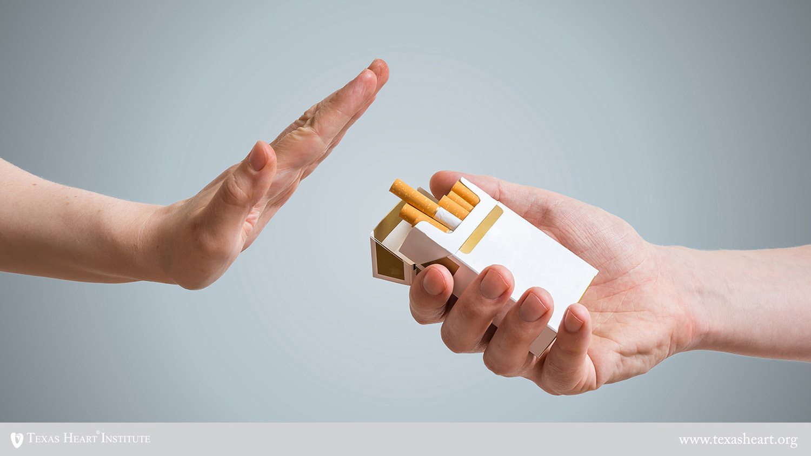

https://www.sickchirpse.com/how-does-smoking-affect-your-sports-performance/

Contents Page

- Intoduction……………………………………………………………………………3

- Smoking………………………………………………………………………………4

- Plain Packaging………………………………………………………………………5

- Car Ban………………………………………………………………………………..7

- Stoptober…………………………………………………………………………….8

- Conclusion……………………………………………………………………………9

- Reference Page………………………………………………………………………10

- Appendix……………………………………………………………………………11

Introduction

This critical essay shall describe what smoking is and the affects it has on the body and mind of an individual, it will also describe three different initiatives the Government have provides to help decrease the health issues that happens because of smoking. The tree initiatives are plain packaging on the cigarette packaging, Stoptober, and the ban on smoking in a car with an underage passenger. The essay will also assess if these initiatives work or not.

Smoking

Smoking is the process of inhaling smoke from burning tobacco. It is the leading cause of premature death in adults as said by the National Health Service (NHS). Smoking leads so many health problems such as cancer, emphysema, heart disease and more. It damages the lungs clogging the alveoli with tar and mucus that the lungs produce in a bid to sooth the irritation that the smoke causes, this leads to congestion that causes chest infections that can become severe enough to lead to bronchitis. The cilia (the small hair like structures that help the lungs to clean out dust and dirt and they line the airways) also become paralysed by the smoke which prevents the body from naturally ridding itself of the build of mucus in the lungs, this causes the smoker to have a ‘smoker’s cough’ this is when the smoker must cough really hard so that they can move the build up of mucus and dirt out of their airways as their cilia no longer work properly. (Ouit, 2019)
Some smokers self-medicate with nicotine because of concentration problems or because they are stressed, so they smoke to calm themselves down however this will lead to a nicotine addiction as smokers will feel withdrawal if they do not receive the next dose of nicotine, as withdrawal symptoms will cause the smoker to feel stressed and emotional leading to a vicious cycle. (MHF. 2019)
Throughout history there have been people who have been for and against smoking since it was discovered by Columbus in the 1400’s when he first discovered America when he saw the Native Americans used it for rituals and medicine. In the beginning tobacco was used for medical reasons such as for tooth ache, asthma and cancer, however some people like King James I of England say that smoking is "custome lothesome to the eye, hateful to the nose, harmful to the brain, dangerous to the lungs, and in the black and stinking fume thereof, nearest resembling the horrible stygian smoke of the pit that is bottomless". He was also the first person to put a tax on tobacco. Over the next six centuries we have had people use tobacco for medical reasons and we have had people ban smoking from certain areas for example a pope in the 1600 century banned smoking from holy places only that law to be repealed in the 1700 century by Pope Benedict XIII. It is only in the last two centuries with medical research that the general conclusion about smoking is that it is bad for not only for the smoker but also for the people around them. (ASH. 2017)
Smoking can cause male impotence, as it damages the blood vessels that supply blood to the penis. It can also damage sperm, reduce sperm count and cause testicular cancer. Up to 120,000 men from the UK in their 20s and 30s are impotent as a direct result of smoking, and men who smoke have a lower sperm count than those who are non-smokers. For women, smoking can reduce fertility. One study found that smokers were over three times more likely than non-smokers to have taken more than one year to conceive. The study estimated that the fertility of smoking women was 72% that of non-smokers. Smoking also increases the risk of cervical cancer. People who smoke are less able to get rid of the HPV infection from the body, which can develop into cancer. (Pietrangelo, A. 2016)
Cigarette smokers often report that smoking helps to relieve feelings of anxiety and stress. The high smoking prevalence among people facing social and economic deprivation suggests that smoking may be used as a self-medicating method of coping with stress. However, instead of helping people relax; smoking actually increases anxiety and tension. The feeling of relaxation is temporary and soon gives way to withdrawal symptoms and increased cravings. So, although smoking reduces withdrawal symptoms, which are similar to the feelings of anxiety, it does not reduce anxiety or deal with the underlying causes. While the self-medication theory is widely believed by many people working in mental health, smoking is not, in fact, an effective means of managing a mental health problem. (Ash, 2016)

Plain Packaging

The Plain Packaging method is a Government initiative that makes tobacco brands sell their wares in plain packaging of grey, black or light brown cardboard with warnings of the consequences of smoking. (ASH.2019)
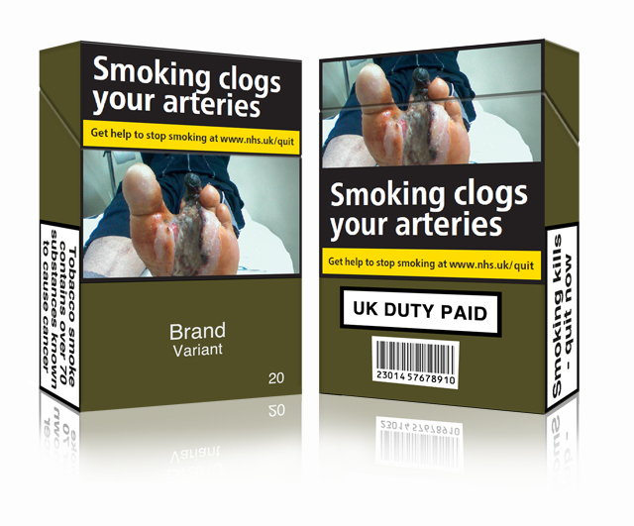
(This is an example of the type of packaging used now in the United Kingdom (ASH.2019))

The first Country to implement this strategy is Australia in December 2012, it was found in a comprehensive study that Australia’s method of using plain packaging with real imaged of the consequences of smoking proved to decrease the amount of people smoking and to increase the number of smokers looking to quit the habit. Britain followed Australia’s lead in this and implemented the same strategy the next year after the research had been constructed. Research done by the Cancer Council, published by the journal Tobacco Control proved that the number of smokers who want to quit smoking went up from 20% to 27% after the plain packaging was introduced. (Pearlman, 2015)
While some had claims that this method would increase the black-market sales of cigarettes a study by the Cancer Council proves that is a lie as during the early years of the initiative it is thought that the rate of smokers had not gone down as much as predicted, instead they had moved from cigarettes to vaping.
It has been shown that plain packaging works as a deterrent to smoking as a study shown by Hogarth (2014) proves that people are less likely to buy cigarettes if they come in the plain packaging compared to being more likely to buy cigarettes in the branded packaging. A study by Maynard (2015) provides that people who smoke from the plain packaging that the experience is more negative and that the warning photo is more impactful.
This Government initiative has proven to be a method that works well to help bring down the rate of smoking in the counties that use them, with very little negatives to the method as it is a form of advertisement in showing the bad effects it has on the person.

Car Ban

On 1st October 2015 the law changed so that it was illegal to smoke in a car or other vehicles with anyone under the age of 18, this is to prevent the damage of second-hand smoke on children. Bothe the passenger and driver could be fined £50 if caught smoking with an underage person in the care, this law applies to everyone in Wales and England. However, this law does not apply to those who use e-cigarettes, a convertible with its the roof down and a seventeen-year-old in the car by themselves. In February 2014 the British Lung Foundation provided a study that said that almost 300,000 children need primary care and 10,000 have hospital admissions every year because of second-hand smoke. To give more credit to the impacts of second hand a 2007 report in the United States reveal that a significant amount of toxins remains in the car even with the parents or adults taking precautions by opening the windows or putting the air conditioning on. The statistics released by the British Lung Foundation show that in England up to 430,000 children aged between 11-15 years old are exposed to second-hand smoke once a week in their cars by their families. The health conditions that these children have are headaches, eye irritation, nausea, dizziness, breathing difficulties and irritation of the throat by coughing. Chronic exposure to second hand smoke have a correlation to lung disease, cardiovascular disease and lung cancer.
However, introducing this new law took up to five years to get this legislation passed as they met resistance as people did not like the thought that they were being policed in their own cars and was seen as an infringement on their personal liberties. The legislation finally passed as it was for the benefit of the children who did not have the benefit of a smoke free journey. The motion had a lot of support from the Members of Parliament and the Lords to have the debate on the legislation move forward to finally be passed after being discussed for three years on the regulations and two years for the final legislation to be passed in February 2015. (Fogarty, 2015)
This Government legislation has help to reduce the health problems of children being admitted to hospital every year and to reduce the smoking in adults as they have less time to smoke, as smoking in the car could be some of the only times that a parent could have a couple of minutes to have a cigarette. However, this may not be as regulated in more rural areas as smoking in the car may pass un-noticed by authorities.

Stoptober

Stoptober is a scheme created by the Public Health England and later adopted by Public Health Wales, it is an annual mass event where the public will quit smoking for 28 days in October. This event was launched in 2012 in England and 2013 in Wales, the main aim of this movement was to have the public quit smoking, as evidence shows that if you stop smoking for 28 days you are more likely to quit by up to five time the normal rate. This campaign received most of its knowability from social media like twitter which had #stoptober trending throughout the month of October in 2012, which gave the members of the public using the campaign the support from others who are also doing the campaign to stick to it, this also spread the movement to people who had not heard about the campaign before and to other countries like Wales who later followed England’s lead and also did the movement the next year. Every year more people joined the movement and every year more people managed to either reduce the amount they smoke or to quit smoking altogether. This campaign is also a very good way of helping people to quit as it is not just one person quitting it is hundreds upon hundreds quitting, this give people a sense of support and achievement as it is not just themselves who are struggling and beating the withdrawal symptoms, they have throughout the 28 days. (GOV. 2017) the only downside of this movement is the fact it is mostly done through social media, which mean people who do not use social media will not hear about the movement unless it is by word of mouth.

Conclusion
Smoking is terrible to a person’s health and well-being and not just physically but also mentally on a person. Smoking causes people to have cancer in the lungs, ruin the fertility of an individual and can become a stressor on them as well. However, the British Government has taken action against smoking by bringing in initiatives like Stoptober and plain packaging and by putting forward new legislations that ban smoking form areas like in a car to lessen the amount of resources used during hospital visits by people effected by second hand smoke. For recommendations the government could go into schools, colleges and universities to teach and spread the word of these movements against smoking and help stop them from smoking or turning to smoking, also this would help spread the word to the students families.

Referencing Page

- Action on Smoking and Health. (2017) Key dates in the history of anti-tobacco campaigning. [online] Available at file:///C:/Users/User/Downloads/170918-keydates-update%20(1).pdf (Accessed 18-12-18)

- Mental Health Foundation. (2019) Smoking and mental health. [online] Available at https://www.mentalhealth.org.uk/a-to-z/s/smoking-and-mental-health (Accessed 18-12-18)
- Quit. (2019) Effects of smoking on your body. [online] Available at https://www.quit.org.au/tools/effects-smoking-your-body/ (Accessed 18-12-18)
- Public health wales observatory (2019). Smoking. [online] Available at http://www.publichealthwalesobservatory.wales.nhs.uk/smoking (Accessed 17-12-18)
- Maynard, O et al. (2015) Effects of first exposure to plain cigarette packaging on smoking behaviour and attitudes: a randomised controlled study. BMC Public Health. (15)240
- Hogarth, L et al. (2014) Plain cigarette packs do not exert Pavlovian to instrumental transfer of control over tobacco‐seeking. Addiction. (110)1
- Pearlman, J. (2015) Australia’s plain cigarette packets succeed in making smoking less appealing. [online] Available at https://www.telegraph.co.uk/news/worldnews/australiaandthepacific/australia/11482751/Australias-plain-cigarette-packets-succeed-in-making-smoking-less-appealing.html (Accessed 27-12-18)
- Action on Smoking and Health. (2019) Standardised Plain Packaging. [online] Available at http://ash.org.uk/category/information-and-resources/packaging-labelling-information-and-resources/standardised-plain-packaging/ (Accessed 10-1-19)

- Government. (2019) Smoking in vehicles. [online] Available at https://www.gov.uk/government/news/smoking-in-vehicles (Accessed 6-1-19)

- Fogarty, M. (2015) U.K. Bans Smoking in Cars with Children. Oncology Times. (37)19
- Dunne, C. (2015) Smoking Ban in Cars When Children Are Present: New Law Effective 1 October 2015. [online] Available at https://www.ibblaw.co.uk/insights/blog/smoking-ban-cars-when-children-are-present-new-law-effective-1-october-2015 (Accessed 7-1-19)
- http://ash.org.uk/files/documents/ASH_120.pdf
- https://assets.publishing.service.gov.uk/government/uploads/system/uploads/attachment_data/file/743844/Stoptober_2017_campaign_evaluation.pdf
- http://ash.org.uk/media-and-news/press-releases-media-and-news/babies-exposed-to-secondhand-smoke-have-higher-risk-of-developing-allergies/
- https://www.nhs.uk/news/pregnancy-and-child/third-hand-smoke-danger/

Appendix



